AI ACADEMY · STUDENT · ai-4/32

Proxy Features and Fairness
Project: Responsible Plant Classifier

Before you start
Week 30: a shortcut can correlate with labels without representing the intended concept.

01. Your mission

Your learning target
I can identify possible proxy features.
I can explain why removing one field does not guarantee fairness.
I can propose a contextual review with concrete evidence.

Remember before reading
Close your notes first. A rough first answer helps us choose the right starting point; it is not a score for your ability.
Without opening the old lesson, explain one key idea from Subgroup Performance. Give an example and a mistake that the idea helps you avoid.
Without opening the old lesson, explain one key idea from Feature Engineering. Give an example and a mistake that the idea helps you avoid.
Without opening the old lesson, explain one key idea from Reproducible Experiments. Give an example and a mistake that the idea helps you avoid.
After trying, check the relevant lesson or ask your teacher. Change the part of your explanation that the evidence shows was wrong.
A feature may indirectly encode sensitive identity or context, creating unjustified differences even when the original field is absent.
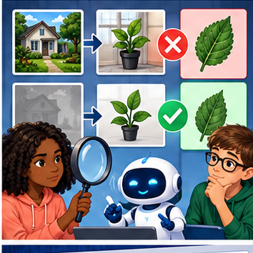
LEARNING TARGET A leaf model performs well using location ID alone. Explain a possible proxy problem and design a diagnostic evaluation.
Builder name and experiment date:

Readiness for the connected explanation
Does equal overall accuracy prove fair treatment?

This week’s end goal
By the end, I can explain proxy features and fairness using a traced example and a stated limitation.

02. Notice the evidence
PICTURE ENTRY

Notice → Predict → Explain
Begin with visible evidence; do not explain more than the picture and information support.
MYSTERY The team must use proxy features and fairness to solve a model-building problem. What information do they have? What important evidence is still missing?
Name three visible details without interpreting them.
Predict the data, model, or evaluation decision being made.
Identify one hidden assumption that could change the result.
State what evidence would confirm or reject your prediction.
My prediction and supporting evidence:

A closer explanation
An input can carry information about a characteristic without naming it. In a fictional school-device dataset, device code may be associated with building or access to newer equipment. Removing a building field does not remove all related information. Do not infer a real student identity or protected characteristic in this exercise.
Use fictional classroom data throughout this investigation. Keep the task, units, reference labels and data split visible as you reason. Earlier weeks supplied the model-building process; this week examines proxy features and fairness.

03. See how it works
ML MECHANISM

Input → Model → Evidence
Trace the information, fitted behavior, and evaluation proof separately.
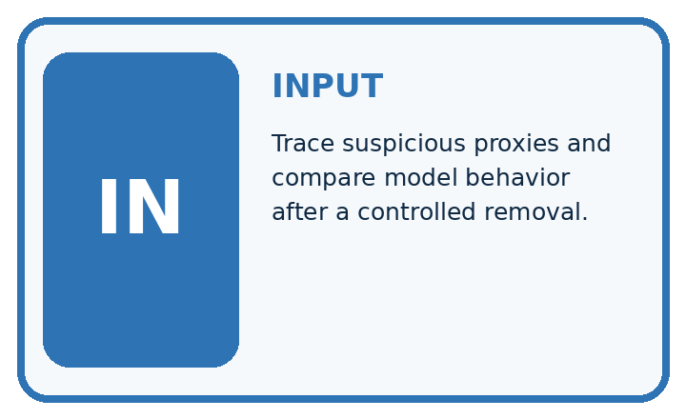
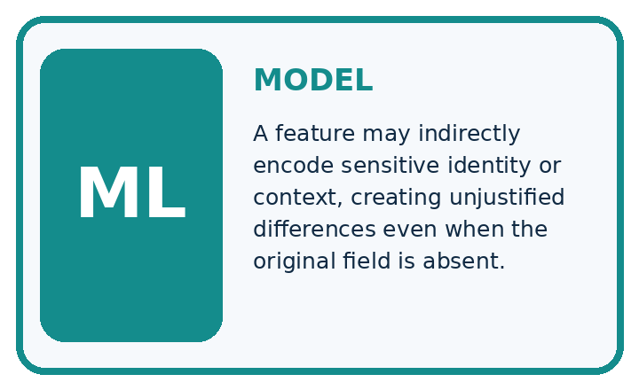
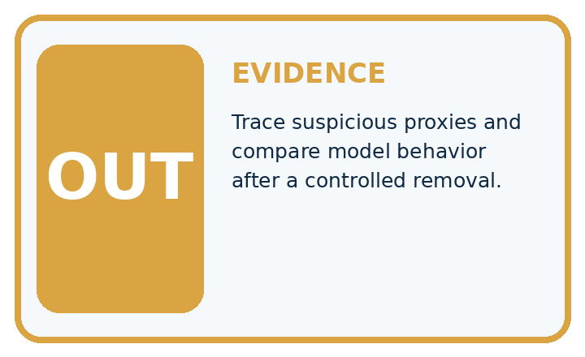
QUESTION Trace suspicious proxies and compare model behavior after a controlled removal.
MODEL IDEA A feature may indirectly encode sensitive identity or context, creating unjustified differences even when the original field is absent.
PROOF NEEDED Use an unseen case, visible calculation, error analysis, and a stated limitation.
UNDER THE HOOD Photo background predicts classroom location and is correlated with camera quality. Model uses background as a shortcut for health labels.
Draw a fresh data → model → prediction → evaluation trace:

A closer explanation
Fictional records show device code X on 8 of 10 north-building examples and 2 of 10 south-building examples. Device and building are associated in this sample. This does not prove device causes model errors or that every X device comes from north. The remaining cases contradict such a universal rule.
Before continuing, underline the decision rule and circle the evidence that supports the conclusion. Explain the example to a partner without replacing the counts or conditions with a stronger claim. Keep the distinction between an observed result and a proposed next step.

Connect the picture and the explanation
Point to the input, the deciding step and the result in this week’s visual. Explain the same step in ordinary words. A picture helps when you can say what each part represents.

04. Compare the cases
EVALUATION DESIGN

Four Tests, Four Kinds of Evidence
A system is not understood until it survives more than one comfortable example.




NORMAL Expected data and expected behavior.
BOUNDARY Value close to a threshold, ambiguous label, or uncertain prediction.
MISSING Necessary field, label, source, or measurement is unavailable.
SHIFTED New lighting, species, device, subgroup, or time condition.
RELEASE RULE Passing one case never proves generalization. Predefine expected behavior for all four categories.
Which case most threatens today's claim, and why?

Change one thing in the pictured case
Change: Camera codes are assigned independently of setting in a new balanced dataset.
Prediction: camera_code no longer perfectly identifies setting in that dataset.
Reason: The observed mapping changed; other retained fields may still contain setting information.

05. Words that unlock the idea
VOCABULARY

Words You Can Calculate and Defend
A definition matters when it lets you interpret a new dataset, model, or result.
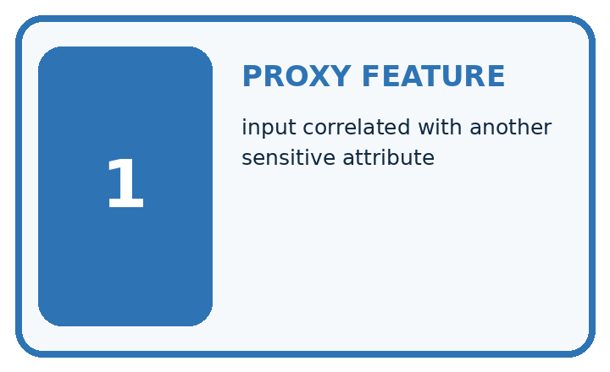
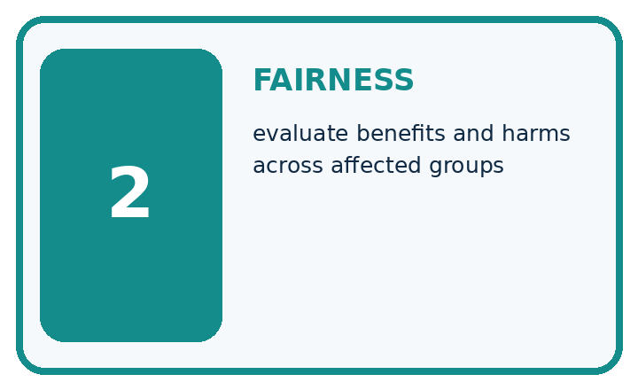
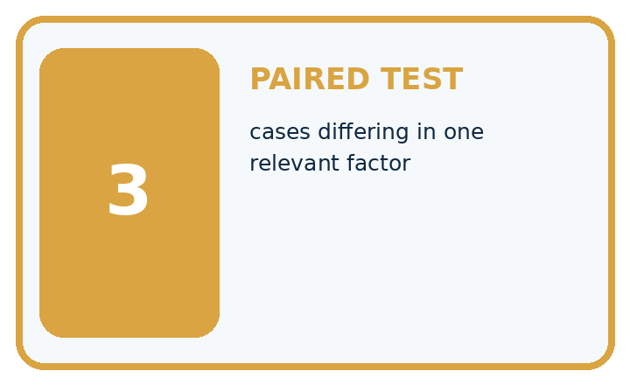
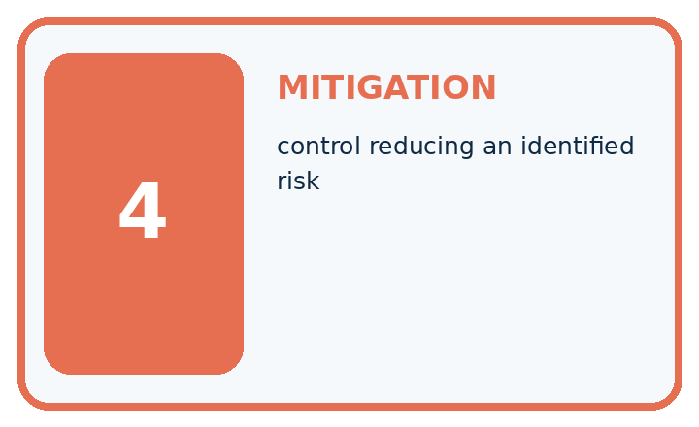
Term | Precise meaning | My ML example
proxy feature | input correlated with another sensitive attribute
fairness | evaluate benefits and harms across affected groups
paired test | cases differing in one relevant factor
mitigation | control reducing an identified risk
MISCONCEPTION TO REPAIR Removing a sensitive column guarantees the model cannot use related information.
Repair the claim using a definition, calculation, or test record:

Words used in the closer explanation
Word | Meaning
Proxy feature | A variable that can stand in for another characteristic
Correlation | An observed association, not proof of cause
Sensitive attribute | A characteristic requiring particular care in a context
Ablation | A comparison that removes a feature or component

06. Follow a worked example
WORKED EVIDENCE

Reason Step by Step
Predict first. Then check each step. A correct answer without visible evidence cannot be audited.
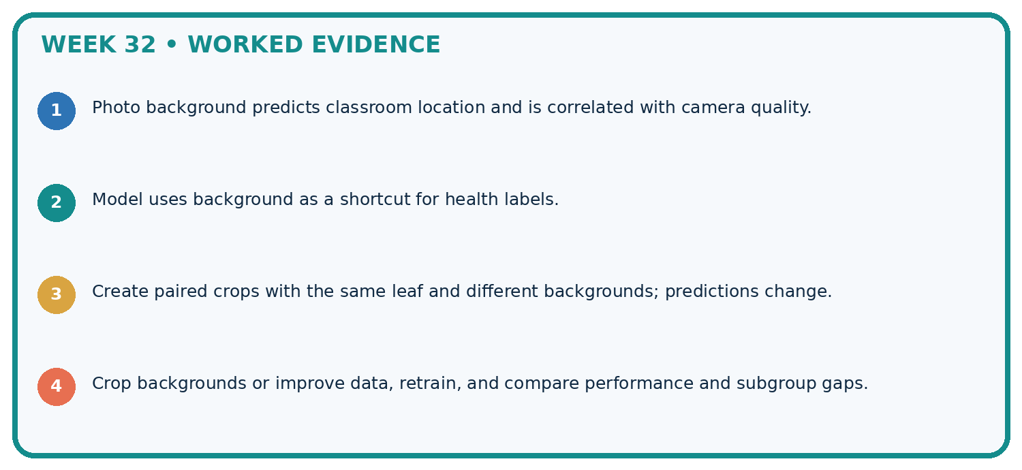
STEP 1 Photo background predicts classroom location and is correlated with camera quality.
STEP 2 Model uses background as a shortcut for health labels.
STEP 3 Create paired crops with the same leaf and different backgrounds; predictions change.
STEP 4 Crop backgrounds or improve data, retrain, and compare performance and subgroup gaps.
CHECK Verify the denominator, unit, split, class definition, and data version before interpreting a score.
Recalculate, retrace, or restate the evidence independently:

A closer explanation

Proxy features and fairness at a glance
Part | Evidence or action | Interpretation
North examples | 8 X of 10 | 2 other devices
South examples | 2 X of 10 | 8 other devices
Review question | What does code represent? | Check context and errors
A feature may be legitimate for one purpose and inappropriate for another. Ask what is measured, when it is available, why it predicts and who might be disadvantaged. A correlation alone neither authorizes use nor proves harm. Talk through the intended decision and available alternatives.

Why might removing building but keeping device code leave related information? Explain the steps or evidence behind your response.
________________________________________________________________
________________________________________________________________
________________________________________________________________
________________________________________________________________

Learn from the worked case
Cover the result before checking it. Say what is given, choose the procedure, and follow one step at a time. Then uncover the result and explain your first mismatch. Ask why a step is allowed, not only what number it produces.

A pictorial worked case: Proxy Features and Fairness
Removing an obvious setting field may leave another field that carries the same information.

The facts we will use
Toy table has location=greenhouse/desk and camera_code=G/D. Every G record is greenhouse; every D record is desk. The team drops location.
All inputs and outcomes in this worked example are invented classroom data; no real model run is claimed.
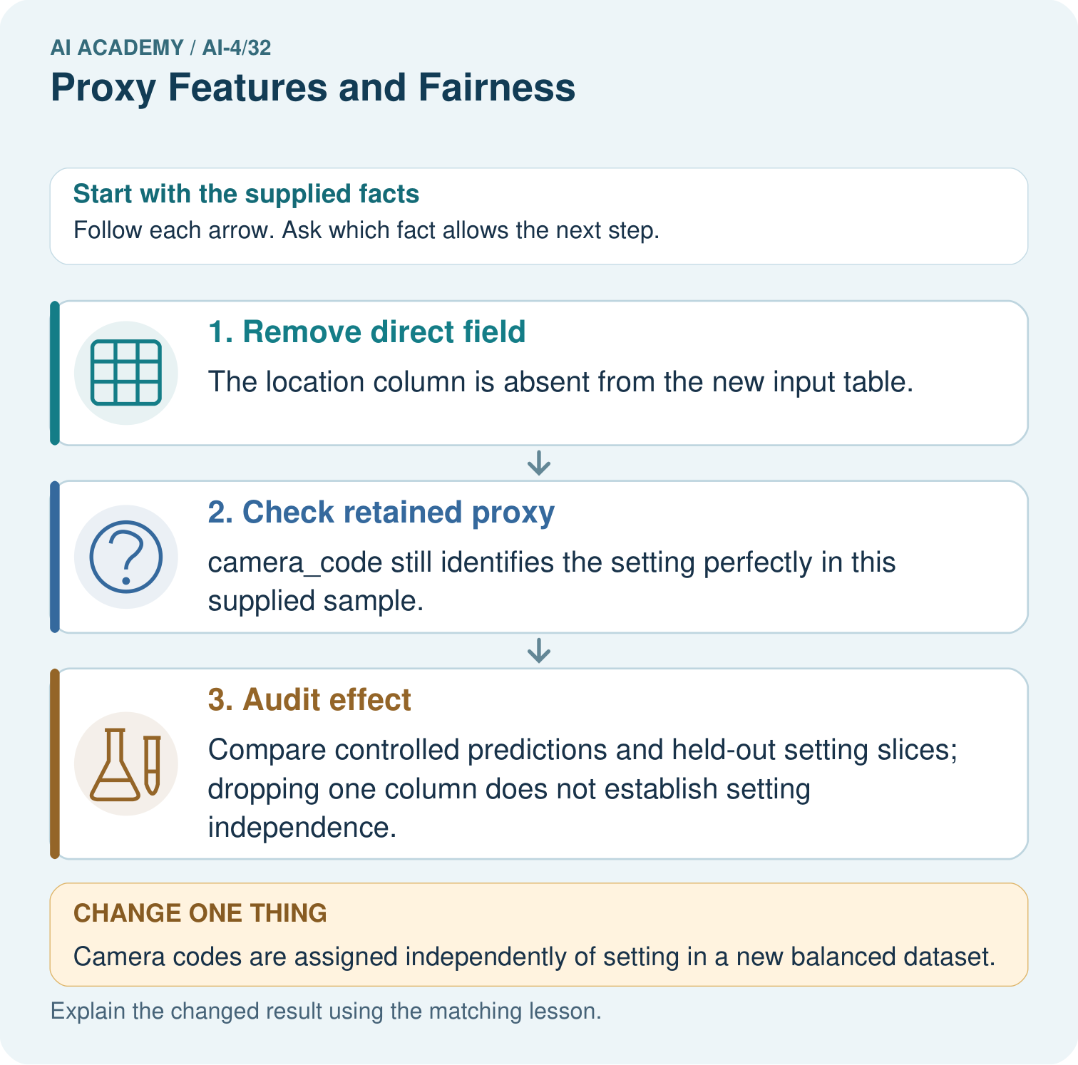

Read the picture one step at a time
Step | What happens and why
1. Remove direct field | The location column is absent from the new input table.
2. Check retained proxy | camera_code still identifies the setting perfectly in this supplied sample.
3. Audit effect | Compare controlled predictions and held-out setting slices; dropping one column does not establish setting independence.
Match each pictured step to the supplied facts. This is a worked teaching case, not an independent assessment.

Why this result follows
Read the picture in order. Compare controlled predictions and held-out setting slices; dropping one column does not establish setting independence. The arrows show which recorded input or intermediate result each decision uses. Explain the deciding step aloud before checking the changed case; pointing to the final answer alone does not show how it follows.

What this example does not establish
A correlated field is not necessarily harmful in every use; assess task relevance, consequences and actual model behaviour.

07. Find and repair a mistake
ERROR DETECTIVE

Compare → Diagnose → Repair
Do not patch the answer. Find the earliest unsupported assumption, data problem, or experiment error.
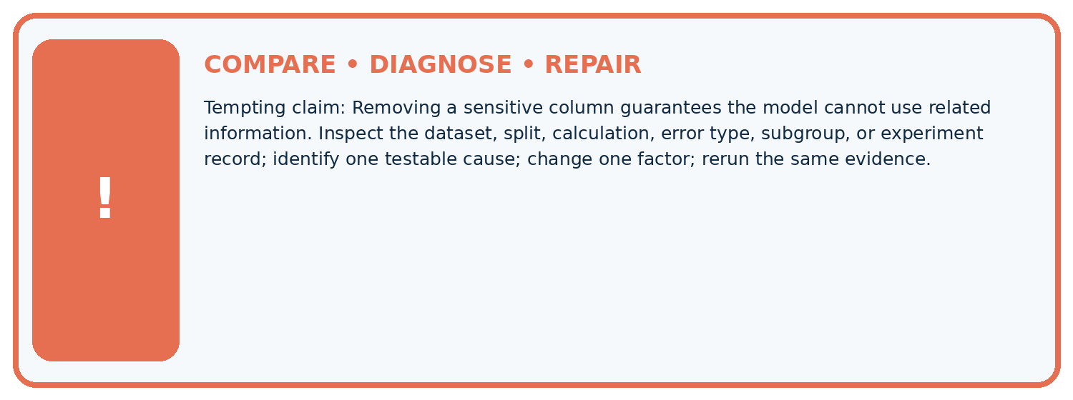
Evidence record | Expected | Actual | Likely cause / next test
normal case | passes
boundary case | defined behavior
missing case | safe fallback
shifted case | measured limit
CLAIM TO CHALLENGE Removing a sensitive column guarantees the model cannot use related information.
Diagnose one cause and name the cleanest next experiment:

A closer explanation
Do not advertise fairness through unawareness merely because names or a sensitive field were removed. A classroom audit should state unresolved questions, intended non-use and a human review path. Never collect sensitive student information simply to fill this exercise.

Does unchanged accuracy after removing a proxy prove fairness?
________________________________________________________________
________________________________________________________________
________________________________________________________________
________________________________________________________________

08. Practise together
ML STUDIO

Specify Before You Run
A trustworthy result can be reproduced from the recorded data, code, settings, and evaluation rule.


Experiment record
QUESTION + intended use + success threshold
DATA version + grouped split + leakage check
CODE/preprocessing + features + model + settings + seed
METRICS + positive class + units + denominators
PREDICTIONS + errors + subgroup slices + limitations
HUMAN reviewer + release, revise, limit, or stop decision
Write the minimum record needed to reproduce today's result:

A closer explanation
Compare versions with and without device code on the same validation cases, while checking subgroup errors and useful task performance. This ablation measures a change in that experiment; correlated inputs may still carry similar information. Retain group definitions and denominators, and avoid using the final test for repeated feature decisions.

Practise with less help: Find a proxy risk
Use workbook W2 for the connected example “Proxy features and fairness”. First fill the input and rule boxes. Try the middle steps before asking for a hint. After a hint, try the next step yourself.
Plan | Do | Check
What is given? Which rule or procedure applies? | Record each intermediate step. | Does the result follow? What remains unknown?
Explain your trace to a partner. Your partner points to one step to check. Swap roles on the next case. Each person writes their own explanation.

Check your reasoning
Use the worked case for Proxy features and fairness. Proposed explanation: “A final answer is enough”. Decide whether this explanation is supported. Point to the step or supplied fact that decides; explain your repair if needed.
Answer on your own before discussion. If you are unsure, say which step you need help with.

Explain the picture
What evidence contradicts the original “all setting information removed” claim? Point to the relevant step in the picture, then write the changed result and the rule or evidence that supports it.

My explanation using a pictured step and the given facts
________________________________________________________________
________________________________________________________________
________________________________________________________________
________________________________________________________________
This is supported practice. Keep the separately named independent case for an attempt before feedback.

09. Run the investigation
EVIDENCE LAB

Predict → Run → Calculate → Interpret
Keep the test conditions fixed, record every result, and change only one planned factor.
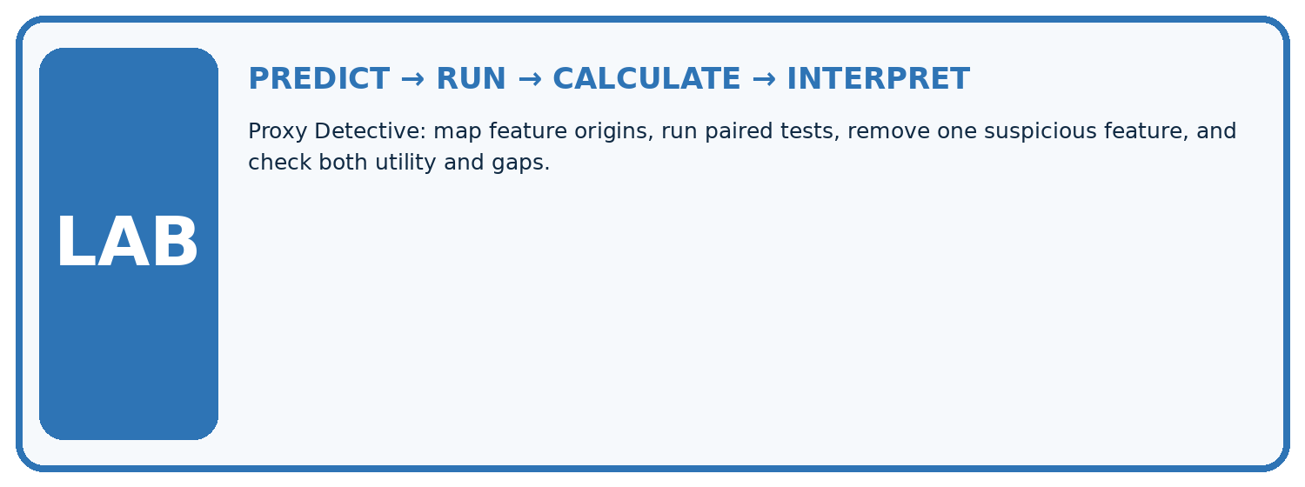
1. Write the hypothesis and expected evidence before running.
2. Proxy Detective: map feature origins, run paired tests, remove one suspicious feature, and check both utility and gaps.
3. Run one normal, one boundary, one missing, and one shifted case.
4. Calculate the metric from raw counts or row-level errors.
5. Interpret what changed, what did not, and what remains unsafe or unknown.
Case | Prediction | Actual | Calculation / evidence | Meaning / next test
Normal
Boundary
Missing
Shifted

Plan → try → check
Before trying: what do I expect, and why? While trying: which step could first go wrong? Afterwards: what did I actually observe, and what should change? Keep “not run” if you only traced the procedure.

10. Build your understanding
MASTERY

From Knowing the Word to Owning the Idea
Move upward only when you can produce evidence without copying the example.

DEFINE Use all four terms precisely: proxy feature, fairness, paired test, mitigation.
CALCULATE Reproduce the worked evidence with units and denominator.
TRACE Explain the data, code or decision path.
DIAGNOSE Removing a sensitive column guarantees the model cannot use related information.
TRANSFER Solve a fresh dataset or model case.
IMPROVE Change one cause and rerun fixed evidence.
DEFEND State intended use, metric, limitation, and human responsibility.
MASTERY RULE A coached calculation becomes mastery only after a different case is completed independently.

11. Connect your project
CUMULATIVE PROJECT

Responsible Plant Classifier
Every week adds one reviewable artifact to the same evidence-based capstone.
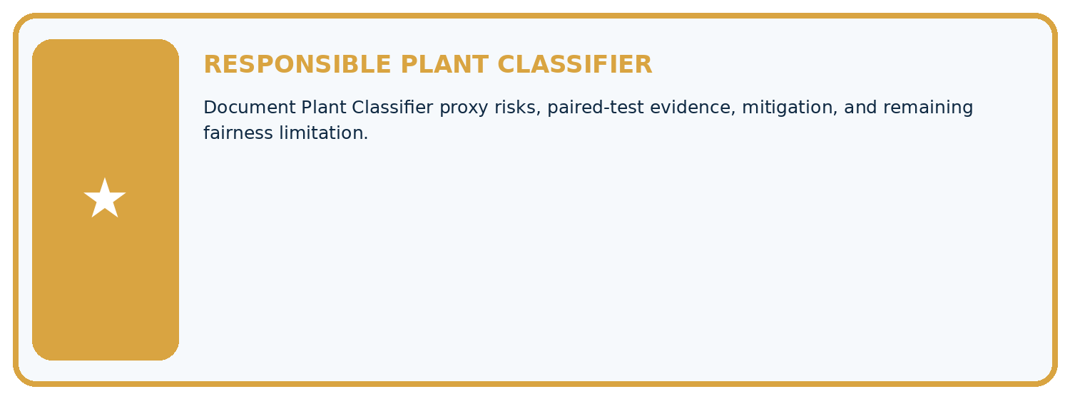
THIS WEEK'S CHECKPOINT Document Plant Classifier proxy risks, paired-test evidence, mitigation, and remaining fairness limitation.
Which requirement or risk does this artifact address?
Which dataset, split, code, and metric version does it use?
What normal and shifted cases were tested?
What remains uncertain or weak?
What decision still belongs to a teacher or qualified human?
RESPONSIBLE RELEASE Never use this classroom prototype for medical, pesticide, agricultural, or other consequential decisions.
My evidence-linked project decision:

Evidence for your project
For your Responsible Plant Classifier, save the input, procedure, observed result and limitation of this check. Label this worked example as practice; use a different, previously unreviewed case when checking independent understanding.

12. Show what you know
INDEPENDENT PROOF

Explain • Calculate • Transfer • Defend
Complete this with a fresh case after guided practice and compare it with the mastery criteria.
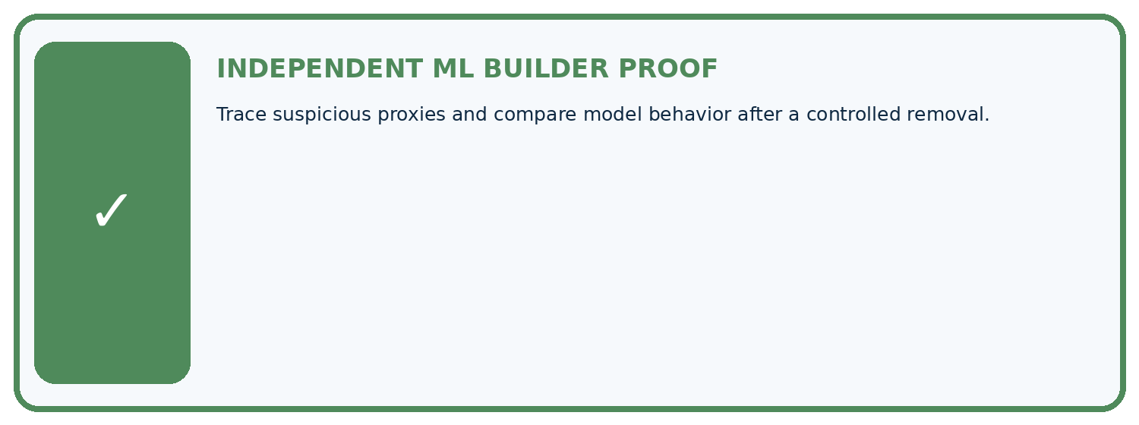
REQUIRED PROOF Trace suspicious proxies and compare model behavior after a controlled removal.
□ Define the task, feature/target roles, and intended-use boundary.
□ Show the calculation, code trace, or experiment record.
□ Test a normal case and one revealing boundary, missing, or shifted case.
□ Diagnose one failure without changing several factors at once.
□ Name a limitation, fairness concern, and the human-review action.
Independent evidence and defense:
My level: □ Not yet □ With one hint □ Independently □ I can teach and defend it
NEXT BRIDGE Carry the experiment evidence into: Model Cards and Human Review.

13. Study a complete case

Week 32 Worked case
Use the supplied details to practise the weekly concept before attempting the independent question. This case extends the illustrated lesson.

The situation
Background colour tracks collection location, associated with plant types.

The question
Explain proxy risk and test.

Worked explanation
Background can be a location shortcut rather than leaf evidence. Test leaf types across backgrounds and locations and compare slices.

Explain it in your own words
Which detail supports the answer, and why does it matter?

Write or draw your reasoning and evidence.
________________________________________________________________
________________________________________________________________
________________________________________________________________
________________________________________________________________
________________________________________________________________

Trace the supplied case visually

Test whether a proxy replaces leaf evidence
Evidence or stage | Value or result
Background colour | Tracks collection location
Location | Associated with plant type
Risk | Model uses shortcut
Test | Cross leaf types with backgrounds and locations
Background colour tracks collection location, associated with plant types.
Explain proxy risk and test.
Background can be a location shortcut rather than leaf evidence. Test leaf types across backgrounds and locations and compare slices.

14. Try a new case independently

Independent case: Apply independently
A team removes postcode but retains school code and claims all location-related information is gone. Evaluate the claim and request evidence.

My independent explanation, trace and limits
________________________________________________________________
________________________________________________________________
________________________________________________________________
________________________________________________________________
________________________________________________________________
________________________________________________________________
________________________________________________________________
Attempt this case before feedback. Record any help. Earlier examples below are further practice; a case already practised with feedback cannot establish fresh transfer.

Week 32 Independent application
Close the worked explanation. Apply the idea to this different question without copying.
A plant classifier uses camera_model, and one species was photographed mostly on a single camera. What shortcut might it learn and how could you investigate?
My answer, with a trace, calculation or supporting evidence

Write or draw your reasoning and evidence.
________________________________________________________________
________________________________________________________________
________________________________________________________________
________________________________________________________________
________________________________________________________________

Create and test
Change one relevant detail. Predict the result before testing. Include a boundary or missing-information case when it helps reveal a limit.
My changed input and expected result

Write or draw your reasoning and evidence.
________________________________________________________________
________________________________________________________________
________________________________________________________________
________________________________________________________________
________________________________________________________________

Connect to your project
Document Plant Classifier proxy risks, paired-test evidence, mitigation, and remaining fairness limitation.
The evidence I will keep

Write or draw your reasoning and evidence.
________________________________________________________________
________________________________________________________________
________________________________________________________________
________________________________________________________________
________________________________________________________________
Your teacher has the independent answer and scoring criteria. Complete the matching workbook week to keep your practice evidence together.

Transfer practice from the original programme
A leaf model performs well using location ID alone. Explain a possible proxy problem and design a diagnostic evaluation.

Explain the mechanism, evidence and one limit.
________________________________________________________________
________________________________________________________________
________________________________________________________________
________________________________________________________________
________________________________________________________________
________________________________________________________________
________________________________________________________________

Use feedback to improve
Attempt the independent case before hints. Record whether you worked alone, used a hint or followed a model. After feedback, fix the first unsupported step and explain why it changed. A later check uses a changed case, not a copied answer.

