AI ACADEMY · STUDENT · ai-5/4

Activation functions
Project: Image-pattern Network Investigation

Before you start
For z = 2 times width - height - 3 at [3, 3], what are the score and class under z >= 0?

01. Your mission

Your learning target
I can trace identity ReLU and sigmoid on a numerical score.
I can explain how a nonlinear activation changes a computation.
I can distinguish an activation output from a final class or verified probability.

Remember before reading
Close your notes first. A rough first answer helps us choose the right starting point; it is not a score for your ability.
Without opening the old lesson, explain one key idea from Bias terms and decision boundaries. Give an example and a mistake that the idea helps you avoid.
Without opening the old lesson, explain one key idea from Representing inputs as vectors. Give an example and a mistake that the idea helps you avoid.
After trying, check the relevant lesson or ask your teacher. Change the part of your explanation that the evidence shows was wrong.
This week you will practise:
Trace identity ReLU and sigmoid on a numerical score
Explain how a nonlinear activation changes a computation
Distinguish an activation output from a final class or verified probability

Retrieve what you already know
For z = 2 times width - height - 3 at [3, 3], what are the score and class under z >= 0?

My starting explanation
________________________________________________________________
________________________________________________________________
________________________________________________________________

This week’s end goal
By the end, I can explain activation functions using a traced example and a stated limitation.

02. Notice the evidence
First compute an affine score z = w dot x + b. An activation then returns a = f(z). In a network this value may become an input to another layer; it is not automatically a class prediction. We will compare three functions using the same incoming scores so that only the activation changes.
Identity returns z unchanged. ReLU, pronounced ree-loo, returns the larger of zero and z. Thus ReLU(-2) = 0, ReLU(0) = 0 and ReLU(2) = 2. Positive scores keep their magnitude; ReLU does not turn every positive value into 1.
Incoming z | Identity output | ReLU output
-2 | -2 | 0
0 | 0 | 0
2 | 2 | 2
These are fixed arithmetic functions. Selecting a function or changing its input is not itself a training procedure. Later weeks will introduce losses and parameter updates.

List the given facts and one fact that is not supplied.
________________________________________________________________
________________________________________________________________
________________________________________________________________

03. See how it works
Sigmoid is 1 / (1 + exp(-z)). Here exp(t) means e raised to power t, where e is approximately 2.718. A calculator or the supplied Python code can evaluate it; no calculus is required this week. For z = -2, 0 and 2, sigmoid outputs are approximately 0.1192, 0.5 and 0.8808.
For every finite mathematical input, sigmoid is strictly between 0 and 1, though computer rounding can produce an endpoint for extreme scores. Negative inputs produce values below 0.5, zero gives 0.5, and positive inputs give values above 0.5. A class rule still needs to be stated: if class 1 means sigmoid(z) >= 0.5, these three predictions are 0, 1 and 1.
from math import exp
def sigmoid(z):
if z >= 0:
return 1 / (1 + exp(-z))
e = exp(z)
return e / (1 + e)
for z in [-2, 0, 2]:
print(z, max(0, z), round(sigmoid(z), 4))
The two algebraically equivalent branches avoid taking exp of a large positive number. A value within [0, 1] is not automatically a reliable probability: its interpretation depends on the fitted task and evaluation evidence.

Connect the picture and the explanation
Point to the input, the deciding step and the result in this week’s visual. Explain the same step in ordinary words. A picture helps when you can say what each part represents.

04. Compare the cases

Compare a familiar case with a changed case
Use the lesson sigmoid values for -2, 0, 2. Predict classes under a >= 0.5, then explain the zero-score case.

Keep the procedure fixed. Explain what changed in the inputs and result.
________________________________________________________________
________________________________________________________________
________________________________________________________________
________________________________________________________________
________________________________________________________________

Change one thing in the pictured case
Change: Replace ReLU with identity.
Prediction: h becomes-2, 0, 1 and outputs become-4, 2, 5.
Reason: Identity retains the negative intermediate value instead of clipping it.

05. Words that unlock the idea
Word | Meaning
Activation function | A function applied to a computed score
ReLU | The function max(0, z), retaining positive scores and replacing negative scores with zero
Sigmoid | The function 1 / (1 + exp(-z)), mapping finite real scores into the interval between 0 and 1
Nonlinear function | A function that cannot be represented by one fixed slope and offset over its entire domain

Use two terms to explain a step in this week’s example.
________________________________________________________________
________________________________________________________________
________________________________________________________________

06. Follow a worked example

Three functions receive the same score
Same incoming score | Apply one function | Activation output
z is -2 | Identity of z | -2
z is -2 | ReLU of z | 0
z is -2 | Sigmoid of z | About 0.1192
Each row starts again from the same score -2 and applies one function. The functions are alternatives here, not successive steps. These outputs are activation values, not class labels.

For z = -1 and z = 1, give identity and ReLU outputs. Using sigmoid(-1) = 0.2689 and sigmoid(1) = 0.7311, give classes under the rule a >= 0.5.
________________________________________________________________
________________________________________________________________
________________________________________________________________
________________________________________________________________

Learn from the worked case
Cover the result before checking it. Say what is given, choose the procedure, and follow one step at a time. Then uncover the result and explain your first mismatch. Ask why a step is allowed, not only what number it produces.

A pictorial worked case: Activation functions
See what ReLU removes before the next weighted step.

The facts we will use
Toy network z=x-3; h=max(0, z); y=3h+2. Inputs x=1, 3, 4.
All inputs and outcomes in this worked example are invented classroom data; no real model run is claimed.
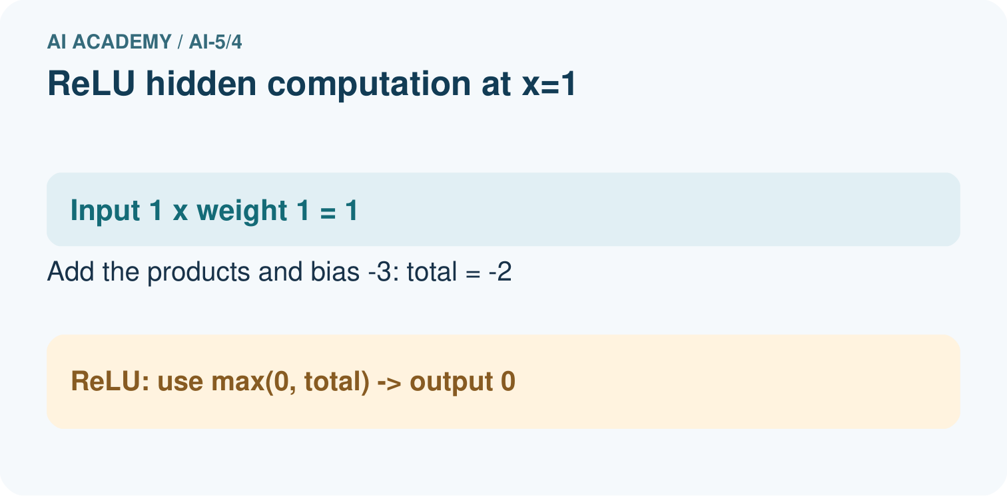
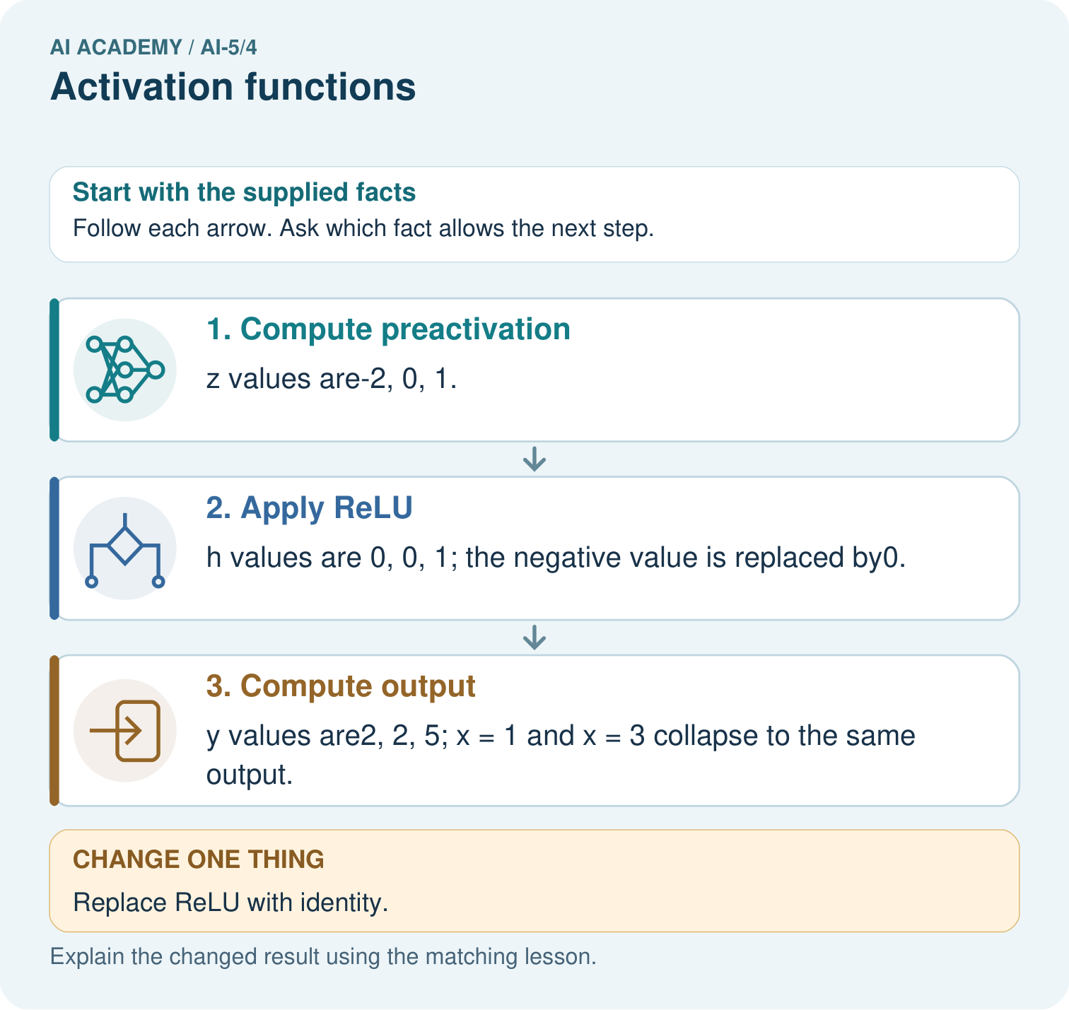

Read the picture one step at a time
Step | What happens and why
1. Compute preactivation | z values are-2, 0, 1.
2. Apply ReLU | h values are 0, 0, 1; the negative value is replaced by0.
3. Compute output | y values are2, 2, 5; x = 1 and x = 3 collapse to the same output.
Match each pictured step to the supplied facts. This is a worked teaching case, not an independent assessment.

Why this result follows
ReLU means keep a positive value and replace a negative one with zero. The output layer receives that transformed value, not the original input. Inputs one and three therefore both deliver zero to the final layer and produce two. Replacing ReLU with identity changes the procedure: negative intermediate values now remain available to the next layer.

What this example does not establish
ReLU is one activation choice. Clipping negatives does not itself train the network or prove useful representation.

07. Find and repair a mistake
An affine function has one fixed slope. ReLU has slope zero on the negative side and slope one on the positive side, so no single straight line fits the whole function. For a concrete check, inputs -2, 0, 2 give outputs 0, 0, 2. The average of the endpoint outputs is 1, but the output at the midpoint 0 is 0. This differs from an affine function, which preserves midpoints.
For a one-input chain with identity between stages, h = 2x + 1 followed by y = 3h - 2 collapses to y = 6x + 1. Insert ReLU instead: h = max(0, 2x + 1), y = 3h - 2. At x = -1, the identity chain gives -5 while the ReLU chain gives -2. At x = 1, both give 7. The nonlinear step can change the overall family of functions.

Locate the earliest unsupported step
Compare ReLU at inputs -2, 0, 2. Give the average of the two endpoint outputs and the output at the midpoint; explain what this shows.

State one repair and the checks you would rerun.
________________________________________________________________
________________________________________________________________
________________________________________________________________
________________________________________________________________
________________________________________________________________
________________________________________________________________

08. Practise together
For scores -2, 0, 2, list identity and ReLU outputs. Explain why ReLU(2) is not 1.

For z = -1 and z = 1, give identity and ReLU outputs. Using sigmoid(-1) = 0.2689 and sigmoid(1) = 0.7311, give classes under the rule a >= 0.5.
________________________________________________________________
________________________________________________________________
________________________________________________________________
________________________________________________________________

Explain your prediction to a partner before comparing results.
________________________________________________________________
________________________________________________________________
________________________________________________________________
________________________________________________________________

Practise with less help: Apply a declared class rule
Use workbook W2 for the connected example “Activation functions”. First fill the input and rule boxes. Try the middle steps before asking for a hint. After a hint, try the next step yourself.
Plan | Do | Check
What is given? Which rule or procedure applies? | Record each intermediate step. | Does the result follow? What remains unknown?
Explain your trace to a partner. Your partner points to one step to check. Swap roles on the next case. Each person writes their own explanation.

Check your reasoning
Use the worked case for Activation functions. Proposed explanation: “ReLU returns a class label”. Decide whether this explanation is supported. Point to the step or supplied fact that decides; explain your repair if needed.
Answer on your own before discussion. If you are unsure, say which step you need help with.

Explain the picture
Which original inputs cannot be distinguished by this network’s final output? Point to the relevant step in the picture, then write the changed result and the rule or evidence that supports it.

My explanation using a pictured step and the given facts
________________________________________________________________
________________________________________________________________
________________________________________________________________
________________________________________________________________
This is supported practice. Keep the separately named independent case for an attempt before feedback.

09. Run the investigation

Predict, investigate and preserve the evidence
Use the lesson sigmoid values for -2, 0, 2. Predict classes under a >= 0.5, then explain the zero-score case.
from math import exp
def sigmoid(z):
if z >= 0:
return 1 / (1 + exp(-z))
e = exp(z)
return e / (1 + e)
for z in [-2, 0, 2]:
print(z, max(0, z), round(sigmoid(z), 4))
Record | Your evidence
Given input and fixed rule
Prediction before checking
Actual result, or “not run”
First mismatch and one explanation
Boundary or missing input and expected response
On paper, trace the supplied procedure. If code is provided, predict before running it in a local practice file. Never write an expected answer as though it were an observed run.

Plan → try → check
Before trying: what do I expect, and why? While trying: which step could first go wrong? Afterwards: what did I actually observe, and what should change? Keep “not run” if you only traced the procedure.

10. Build your understanding

Explain → apply → challenge
For scores -2, 0, 2, list identity and ReLU outputs. Explain why ReLU(2) is not 1.
Compare ReLU at inputs -2, 0, 2. Give the average of the two endpoint outputs and the output at the midpoint; explain what this shows.
A model returns a sigmoid value 0.9 on one case. Does the numerical range alone establish a calibrated 90 percent probability? Explain what needs checking.

Explain which evidence supports your conclusion and which claim remains unproved.
________________________________________________________________
________________________________________________________________
________________________________________________________________
________________________________________________________________
________________________________________________________________

11. Connect your project
Add a labelled activation functions evidence sheet to Image-pattern Network Investigation. Show how you can trace identity relu and sigmoid on a numerical score. Use the supplied fictional case and keep its inputs, intermediate steps, calculation or prediction, and limitation. Connect this record to last week’s record; a matching answer without a trace is insufficient.
Project evidence | Record
Component and version
Inputs permitted at prediction time
Trace and comparison with earlier work
Failure, limit and human review

Evidence for your project
For your Image-pattern Network Investigation, save the input, procedure, observed result and limitation of this check. Label this worked example as practice; use a different, previously unreviewed case when checking independent understanding.

12. Show what you know
A nonlinear activation allows a network to represent relationships that a chain of affine operations alone cannot express. It does not guarantee that training will find a useful model or that more layers will help. ReLU can erase differences between negative scores; sigmoid can compress very large scores into nearly identical values. The architecture, data and training procedure still matter.

A learner reports sigmoid(2) is about 0.8808 and concludes the system will be correct 88 percent of the time for every future case. What does the calculation establish, and what evidence is still missing?
________________________________________________________________
________________________________________________________________
________________________________________________________________
________________________________________________________________
Next week, we will compose layers while keeping every intermediate value and its role visible.
A model returns a sigmoid value 0.9 on one case. Does the numerical range alone establish a calibrated 90 percent probability? Explain what needs checking.

My limited claim and a useful next check
________________________________________________________________
________________________________________________________________
________________________________________________________________
________________________________________________________________

13. Study a complete case

Complete evidence record

Three functions receive the same score
Same incoming score | Apply one function | Activation output
z is -2 | Identity of z | -2
z is -2 | ReLU of z | 0
z is -2 | Sigmoid of z | About 0.1192
Each row starts again from the same score -2 and applies one function. The functions are alternatives here, not successive steps. These outputs are activation values, not class labels.
Follow the input through the stated procedure to its result. Cover the result first, predict it, then explain every intermediate step. The text/table accompanies the figure so the example can be read without colour.

My complete trace of the worked case
________________________________________________________________
________________________________________________________________
________________________________________________________________
________________________________________________________________
________________________________________________________________
________________________________________________________________

14. Try a new case independently

Independent case: Trace a new chain independently
Let z = x - 2, a = ReLU(z), y = 2a + 1. For x = 0, 2, 5, record every z, a and y. Then replace ReLU with identity and give all three y values. Which inputs have the same ReLU output, and why?

My independent explanation, trace and limits
________________________________________________________________
________________________________________________________________
________________________________________________________________
________________________________________________________________
________________________________________________________________
________________________________________________________________
________________________________________________________________
Attempt this case before feedback. Record any help. Earlier examples below are further practice; a case already practised with feedback cannot establish fresh transfer.

Attempt this without hints
Let z = x - 2, a = ReLU(z), y = 2a + 1. For x = 0, 2, 5, record every z, a and y. Then replace ReLU with identity and give all three y values. Which inputs have the same ReLU output, and why?

My independent procedure, result and limitation
________________________________________________________________
________________________________________________________________
________________________________________________________________
________________________________________________________________
________________________________________________________________
________________________________________________________________
________________________________________________________________
________________________________________________________________
Record support used: none, hint or teacher explanation. After feedback, a different case is needed to demonstrate independence.

Use feedback to improve
Attempt the independent case before hints. Record whether you worked alone, used a hint or followed a model. After feedback, fix the first unsupported step and explain why it changed. A later check uses a changed case, not a copied answer.

