AI ACADEMY · STUDENT · ai-5/8

Loss functions
Project: Image-pattern Network Investigation

Before you start
Does knowing a network output tell us whether it is accurate?

01. Your mission

Your learning target
I can calculate per-example squared error and mean squared error.
I can distinguish residual cancellation from a low loss.
I can separate training loss from independent evaluation.

Remember before reading
Close your notes first. A rough first answer helps us choose the right starting point; it is not a score for your ability.
Without opening the old lesson, explain one key idea from Parameters and architecture. Give an example and a mistake that the idea helps you avoid.
Without opening the old lesson, explain one key idea from Composing layers. Give an example and a mistake that the idea helps you avoid.
Without opening the old lesson, explain one key idea from Dot products and weighted sums. Give an example and a mistake that the idea helps you avoid.
After trying, check the relevant lesson or ask your teacher. Change the part of your explanation that the evidence shows was wrong.
This week you will practise:
Calculate per-example squared error and mean squared error
Distinguish residual cancellation from a low loss
Separate training loss from independent evaluation

Retrieve what you already know
Does knowing a network output tell us whether it is accurate?

My starting explanation
________________________________________________________________
________________________________________________________________
________________________________________________________________

This week’s end goal
By the end, I can explain loss functions using a traced example and a stated limitation.

02. Notice the evidence
A loss assigns a numerical penalty to a prediction compared with a target. For this regression lesson, residual e = prediction - target, and squared error is e squared. Squaring makes both positive and negative residuals contribute nonnegative penalties. We use ordinary mean squared error without a one-half factor.
Example | Target | Prediction | Residual | Squared error
A | 1 | 2 | 1 | 1
B | 3 | 2 | -1 | 1
C | 2 | 4 | 2 | 4
The mean squared error, or MSE, is (1 + 1 + 4) / 3 = 2. It summarises these three examples, not every possible future input. If targets use cm, residuals use cm and MSE uses square cm.

List the given facts and one fact that is not supplied.
________________________________________________________________
________________________________________________________________
________________________________________________________________

03. See how it works
For targets [1, 3] and predictions [2, 2], the mean residual is zero because 1 and -1 cancel. MSE is 1, correctly recording that both predictions miss. A mean residual can describe directional tendency, but it is not a substitute for an error magnitude.
def mse(predictions, targets):
if not targets or len(predictions) != len(targets):
raise ValueError("Need equal nonempty sequences")
errors = [(p - t) ** 2
for p, t in zip(predictions, targets)]
return sum(errors) / len(errors)
print(mse([2, 2, 4], [1, 3, 2])) # 2.0
print(mse([2, 2], [1, 3])) # 1.0
The guard prevents silently ignoring an unmatched example or dividing by zero. It still assumes paired, numeric, valid records. Wrong row alignment produces a meaningless comparison even when list lengths agree.

Connect the picture and the explanation
Point to the input, the deciding step and the result in this week’s visual. Explain the same step in ordinary words. A picture helps when you can say what each part represents.

04. Compare the cases

Compare a familiar case with a changed case
Targets [0, 4] have predictions [2, 2]. Compare mean residual and MSE.

Keep the procedure fixed. Explain what changed in the inputs and result.
________________________________________________________________
________________________________________________________________
________________________________________________________________
________________________________________________________________
________________________________________________________________

Change one thing in the pictured case
Change: Choose MAE instead of MSE as the sole criterion.
Prediction: A and B tie at MAE1.
Reason: Squared error penalises B’s concentrated error more, while absolute errors both sum 2.

05. Words that unlock the idea
Word | Meaning
Target | The recorded value a model is intended to predict
Residual | Prediction minus target under the sign convention used here
Squared error | The square of a numerical residual
Mean squared error | The average squared error over the evaluated examples

Use two terms to explain a step in this week’s example.
________________________________________________________________
________________________________________________________________
________________________________________________________________

06. Follow a worked example

Use the same targets and denominator
Candidate predictions | Squared errors | MSE
P is [2, 2, 4] | [1, 1, 4] | 6 divided by 3 is 2
Q is [1, 2, 2] | [0, 1, 0] | 1 divided by 3
Baseline is [2, 2, 2] | [1, 1, 0] | 2 divided by 3
Each row evaluates a separate candidate against targets [1, 3, 2]. Q has the lowest MSE on these three cases. The comparison alone does not establish performance on unseen examples.

Candidate R predicts [0, 3, 3] for targets [1, 3, 2]. Calculate residuals, squared errors and MSE. Compare R with the baseline.
________________________________________________________________
________________________________________________________________
________________________________________________________________
________________________________________________________________

Learn from the worked case
Cover the result before checking it. Say what is given, choose the procedure, and follow one step at a time. Then uncover the result and explain your first mismatch. Ask why a step is allowed, not only what number it produces.

A pictorial worked case: Loss functions
Compare candidate losses with the same targets and denominator.

The facts we will use
Targets [1, 3]; A predicts [0, 4]; B predicts [1, 5]. Use MSE over both cases.
All inputs and outcomes in this worked example are invented classroom data; no real model run is claimed.
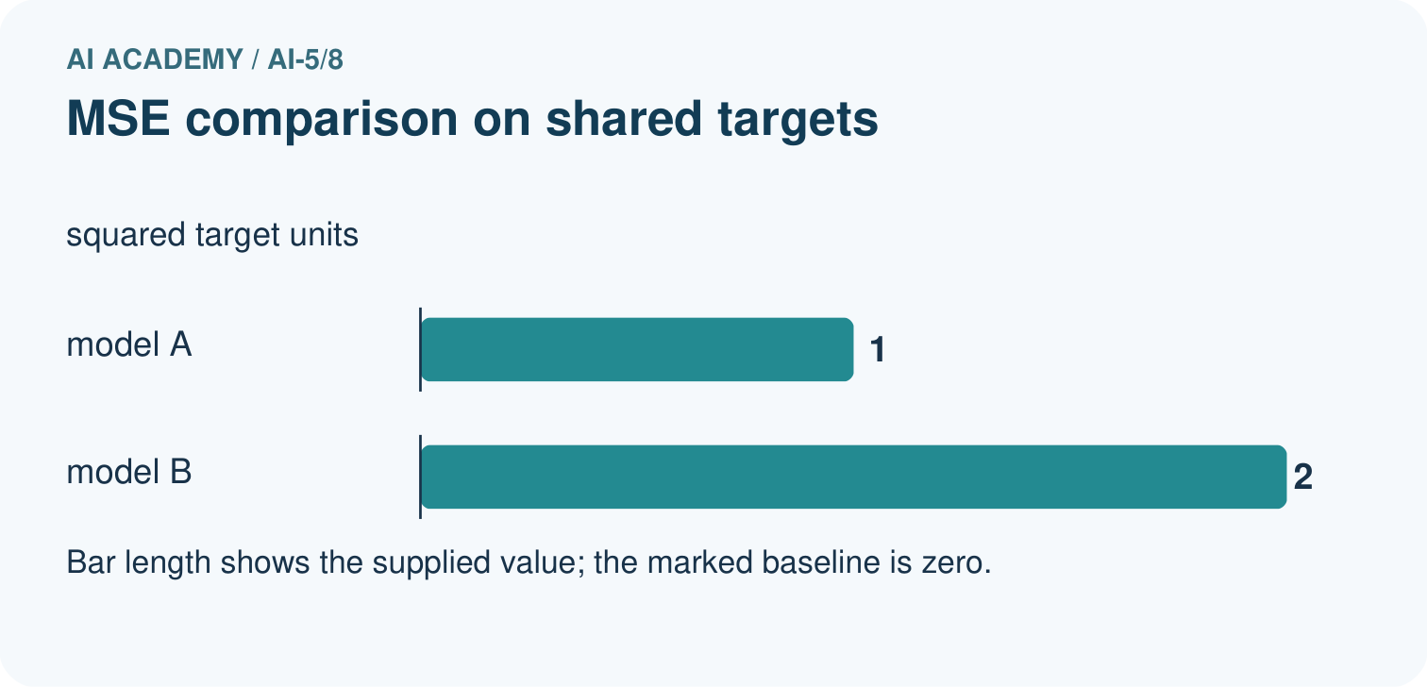
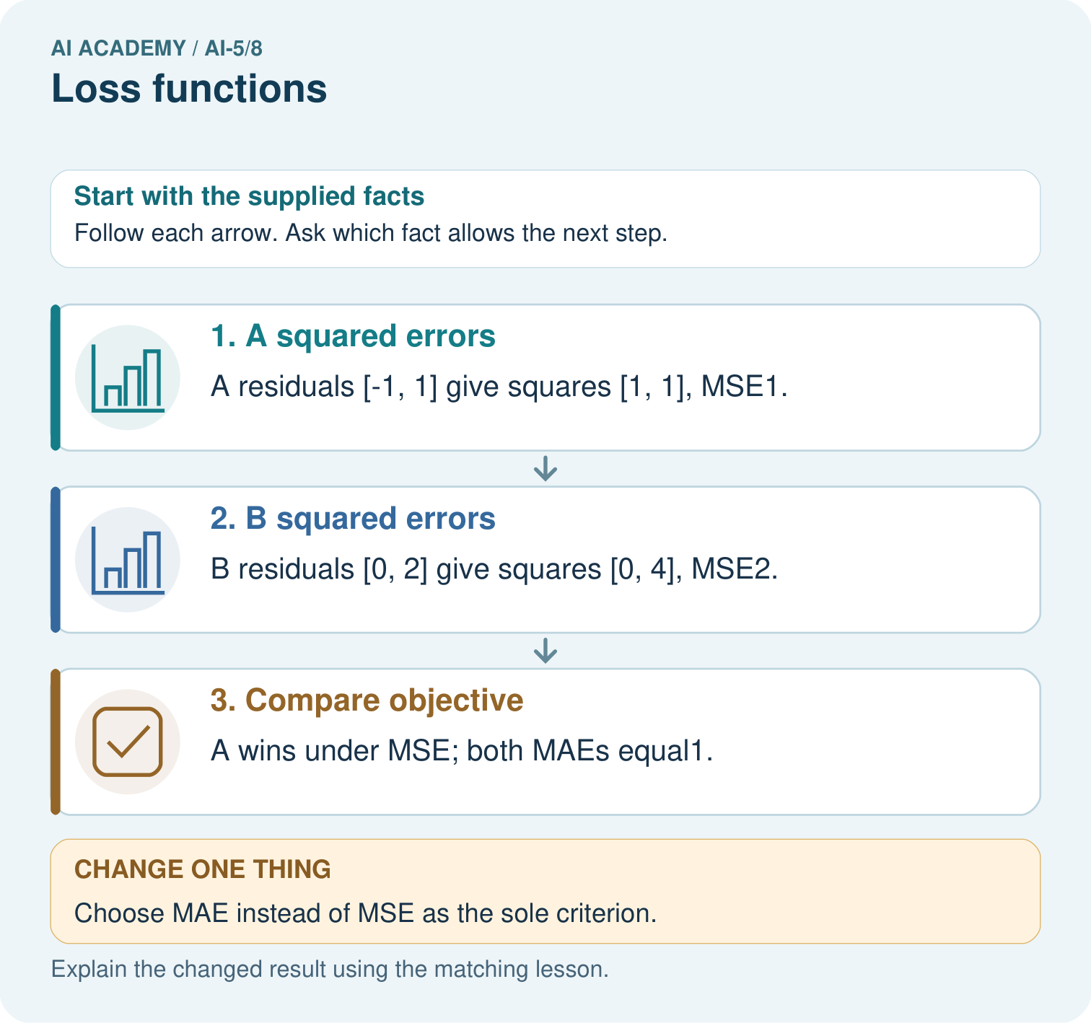

Read the picture one step at a time
Step | What happens and why
1. A squared errors | A residuals [-1, 1] give squares [1, 1], MSE1.
2. B squared errors | B residuals [0, 2] give squares [0, 4], MSE2.
3. Compare objective | A wins under MSE; both MAEs equal1.
Match each pictured step to the supplied facts. This is a worked teaching case, not an independent assessment.

Why this result follows
For this loss calculation, the signed error is prediction minus target. MSE squares each error before averaging; MAE takes its absolute value. A spreads its error equally across both cases, while B concentrates it in one case. Squaring makes the larger individual error count more. State the objective before selecting a model, because these two objectives give different comparisons.

What this example does not establish
Training loss is not automatically a held-out performance estimate or a complete measure of use consequences.

07. Find and repair a mistake
Squaring gives larger residuals more influence: residual 4 contributes 16, four times the penalty of residual 2. This can be useful when large misses matter, but it can also make outliers influential. Mean absolute error uses absolute residuals instead; it can rank candidates differently.
MSE is appropriate here because targets are numerical quantities. A class identifier such as 0, 1 or 2 may merely name a category; its numeric gap does not automatically measure error severity. Later classification models need a loss suited to their outputs and task.

Locate the earliest unsupported step
A learner totals squared errors 1, 0, 9 and divides by 2 because there are two nonzero errors. Correct the MSE.

State one repair and the checks you would rerun.
________________________________________________________________
________________________________________________________________
________________________________________________________________
________________________________________________________________
________________________________________________________________
________________________________________________________________

08. Practise together
For targets [2, 4] and predictions [1, 6], record residuals, squares and MSE.

Candidate R predicts [0, 3, 3] for targets [1, 3, 2]. Calculate residuals, squared errors and MSE. Compare R with the baseline.
________________________________________________________________
________________________________________________________________
________________________________________________________________
________________________________________________________________

Explain your prediction to a partner before comparing results.
________________________________________________________________
________________________________________________________________
________________________________________________________________
________________________________________________________________

Practise with less help: Expose cancellation
Use workbook W2 for the connected example “Loss functions”. First fill the input and rule boxes. Try the middle steps before asking for a hint. After a hint, try the next step yourself.
Plan | Do | Check
What is given? Which rule or procedure applies? | Record each intermediate step. | Does the result follow? What remains unknown?
Explain your trace to a partner. Your partner points to one step to check. Swap roles on the next case. Each person writes their own explanation.

Check your reasoning
Use the worked case for Loss functions. Proposed explanation: “Average residual is the loss”. Decide whether this explanation is supported. Point to the step or supplied fact that decides; explain your repair if needed.
Answer on your own before discussion. If you are unsure, say which step you need help with.

Explain the picture
Why must the report name the chosen loss? Point to the relevant step in the picture, then write the changed result and the rule or evidence that supports it.

My explanation using a pictured step and the given facts
________________________________________________________________
________________________________________________________________
________________________________________________________________
________________________________________________________________
This is supported practice. Keep the separately named independent case for an attempt before feedback.

09. Run the investigation

Predict, investigate and preserve the evidence
Targets [0, 4] have predictions [2, 2]. Compare mean residual and MSE.
def mse(predictions, targets):
if not targets or len(predictions) != len(targets):
raise ValueError("Need equal nonempty sequences")
errors = [(p - t) ** 2
for p, t in zip(predictions, targets)]
return sum(errors) / len(errors)
print(mse([2, 2, 4], [1, 3, 2])) # 2.0
print(mse([2, 2], [1, 3])) # 1.0
Record | Your evidence
Given input and fixed rule
Prediction before checking
Actual result, or “not run”
First mismatch and one explanation
Boundary or missing input and expected response
On paper, trace the supplied procedure. If code is provided, predict before running it in a local practice file. Never write an expected answer as though it were an observed run.

Plan → try → check
Before trying: what do I expect, and why? While trying: which step could first go wrong? Afterwards: what did I actually observe, and what should change? Keep “not run” if you only traced the procedure.

10. Build your understanding

Explain → apply → challenge
For targets [2, 4] and predictions [1, 6], record residuals, squares and MSE.
A learner totals squared errors 1, 0, 9 and divides by 2 because there are two nonzero errors. Correct the MSE.
A team tries ten models and picks the one with the lowest final-test MSE. Can that same result be presented as an untouched final evaluation?

Explain which evidence supports your conclusion and which claim remains unproved.
________________________________________________________________
________________________________________________________________
________________________________________________________________
________________________________________________________________
________________________________________________________________

11. Connect your project
Add a labelled loss functions evidence sheet to Image-pattern Network Investigation. Show how you can calculate per-example squared error and mean squared error. Use the supplied fictional case and keep its inputs, intermediate steps, calculation or prediction, and limitation. Connect this record to last week’s record; a matching answer without a trace is insufficient.
Project evidence | Record
Component and version
Inputs permitted at prediction time
Trace and comparison with earlier work
Failure, limit and human review

Evidence for your project
For your Image-pattern Network Investigation, save the input, procedure, observed result and limitation of this check. Label this worked example as practice; use a different, previously unreviewed case when checking independent understanding.

12. Show what you know
Training loss measures the cases used to adjust parameters. Validation loss can guide choices, so repeated use makes it development evidence. A reserved final test supports a separate evaluation claim only while it remains outside those choices. Always report the split, number of cases and loss definition.

A model reports MSE zero on its training rows. What has this shown, and why is it insufficient to claim perfect future predictions?
________________________________________________________________
________________________________________________________________
________________________________________________________________
________________________________________________________________
Next week studies local changes in a loss, preparing us to choose a direction for a parameter update.
A team tries ten models and picks the one with the lowest final-test MSE. Can that same result be presented as an untouched final evaluation?

My limited claim and a useful next check
________________________________________________________________
________________________________________________________________
________________________________________________________________
________________________________________________________________

13. Study a complete case

Complete evidence record

Use the same targets and denominator
Candidate predictions | Squared errors | MSE
P is [2, 2, 4] | [1, 1, 4] | 6 divided by 3 is 2
Q is [1, 2, 2] | [0, 1, 0] | 1 divided by 3
Baseline is [2, 2, 2] | [1, 1, 0] | 2 divided by 3
Each row evaluates a separate candidate against targets [1, 3, 2]. Q has the lowest MSE on these three cases. The comparison alone does not establish performance on unseen examples.
Follow the input through the stated procedure to its result. Cover the result first, predict it, then explain every intermediate step. The text/table accompanies the figure so the example can be read without colour.

My complete trace of the worked case
________________________________________________________________
________________________________________________________________
________________________________________________________________
________________________________________________________________
________________________________________________________________
________________________________________________________________

14. Try a new case independently

Independent case: Compare an unfamiliar evaluation independently
Targets are [0, 2, 4]. Model A predicts [1, 2, 3]; model B predicts [0, 2, 2]. Calculate both MSEs and identify the better model under MSE on these cases. Calculate mean absolute errors too. State what changes in the conclusion.

My independent explanation, trace and limits
________________________________________________________________
________________________________________________________________
________________________________________________________________
________________________________________________________________
________________________________________________________________
________________________________________________________________
________________________________________________________________
Attempt this case before feedback. Record any help. Earlier examples below are further practice; a case already practised with feedback cannot establish fresh transfer.

Attempt this without hints
Targets are [0, 2, 4]. Model A predicts [1, 2, 3]; model B predicts [0, 2, 2]. Calculate both MSEs and identify the better model under MSE on these cases. Calculate mean absolute errors too. State what changes in the conclusion.

My independent procedure, result and limitation
________________________________________________________________
________________________________________________________________
________________________________________________________________
________________________________________________________________
________________________________________________________________
________________________________________________________________
________________________________________________________________
________________________________________________________________
Record support used: none, hint or teacher explanation. After feedback, a different case is needed to demonstrate independence.

Use feedback to improve
Attempt the independent case before hints. Record whether you worked alone, used a hint or followed a model. After feedback, fix the first unsupported step and explain why it changed. A later check uses a changed case, not a copied answer.

