AI ACADEMY · STUDENT · ai-5/12

Training a small network
Project: Image-pattern Network Investigation

Before you start
Why should all parameters in one simultaneous update use the same saved gradient?

01. Your mission

Your learning target
I can trace repeated forward loss gradient and update steps.
I can keep frozen parameters distinct from the trained parameter.
I can report training results with their evaluation limits.

Remember before reading
Close your notes first. A rough first answer helps us choose the right starting point; it is not a score for your ability.
Without opening the old lesson, explain one key idea from Updating parameters. Give an example and a mistake that the idea helps you avoid.
Without opening the old lesson, explain one key idea from Slopes and local change. Give an example and a mistake that the idea helps you avoid.
Without opening the old lesson, explain one key idea from Forward passes by hand. Give an example and a mistake that the idea helps you avoid.
After trying, check the relevant lesson or ask your teacher. Change the part of your explanation that the evidence shows was wrong.
This week you will practise:
Trace repeated forward loss gradient and update steps
Keep frozen parameters distinct from the trained parameter
Report training results with their evaluation limits

Retrieve what you already know
Why should all parameters in one simultaneous update use the same saved gradient?

My starting explanation
________________________________________________________________
________________________________________________________________
________________________________________________________________

This week’s end goal
By the end, I can explain training a small network using a traced example and a stated limitation.

02. Notice the evidence
Use one hidden ReLU unit h = ReLU(x) and an output y = vh. The hidden input weight is fixed at 1, its bias is fixed at 0, and the output bias is fixed at 0. Only output weight v is trained. This is a restricted two-layer network, not training every parameter of a general network.
Training pairs are (x, target) = (1, 2) and (2, 4). Both x values are positive, so hidden activations are 1 and 2. Define ordinary MSE over both rows. Start at v = 0 and use learning rate 0.1 for exactly four full-data updates. The declared budget prevents stopping only when a preferred result appears.
Update count | v | Training MSE
0 | 0 | 10
1 | 1 | 2.5
2 | 1.5 | 0.625
3 | 1.75 | 0.15625
4 | 1.875 | 0.0390625
Each row evaluates the parameter value after that many updates. Row zero records the starting model. The loss decreases in this specific experiment; that pattern is not a promise for all networks or rates.

List the given facts and one fact that is not supplied.
________________________________________________________________
________________________________________________________________
________________________________________________________________

03. See how it works
Let errors be v - 2 and 2v - 4. MSE is their squared sum divided by 2, which simplifies to 2.5 times (v - 2) squared. Its gradient with respect to v is 5 times (v - 2). At v = 0 the gradient is -10, so the first update gives v = 0 - 0.1 times -10 = 1.
train = [(1.0, 2.0), (2.0, 4.0)]
v = 0.0
rate = 0.1
for step in range(5):
hs = [max(0.0, x) for x, target in train]
errors = [v * h - target
for h, (x, target) in zip(hs, train)]
loss = sum(e * e for e in errors) / len(train)
print(step, v, loss)
if step == 4:
break
gradient = 2 * sum(e * h for e, h in zip(errors, hs)) / len(train)
v = v - rate * gradient
The factor 2 comes from squared error; division by the number of rows makes this the gradient of the mean, not the sum. The code uses every training row for each update. It prints five states but performs only four updates. All data are supplied fictional numbers.

Connect the picture and the explanation
Point to the input, the deciding step and the result in this week’s visual. Explain the same step in ordinary words. A picture helps when you can say what each part represents.

04. Compare the cases

Compare a familiar case with a changed case
At v = 1, the sum of squared errors is 5. A learner uses gradient -10 with rate 0.1. Explain the mismatch with this lesson and give the next v under MSE.

Keep the procedure fixed. Explain what changed in the inputs and result.
________________________________________________________________
________________________________________________________________
________________________________________________________________
________________________________________________________________
________________________________________________________________

Change one thing in the pictured case
Change: Change target from 3 to6 and restart v = 0 with the same rate.
Prediction: First gradient=-36; v becomes2; prediction 6 and loss 0.
Reason: The hidden value remains3, but the target residual and required output weight double.

05. Words that unlock the idea
Word | Meaning
Training loop | A repeated sequence of prediction, loss calculation, gradient calculation and parameter update
Frozen parameter | A model value intentionally held fixed during fitting
Training budget | A declared limit on updates or other training resources
Learning curve | A record of a performance measure across training steps or time

Use two terms to explain a step in this week’s example.
________________________________________________________________
________________________________________________________________
________________________________________________________________

06. Follow a worked example

One full-data update from v is 1
Stage | Compute with current v | Result
Forward and loss | Predictions [1, 2] for targets [2, 4] | Errors [-1, -2], MSE 2.5
Gradient | 2 times (-1 times 1 - 2 times 2) / 2 | Gradient -5
Update with rate 0.1 | 1 - 0.1 times -5 | Next v is 1.5
Each row depends on the preceding calculation. Recompute predictions and loss on the next iteration; do not keep using the first gradient after parameters change.

Starting from v = 1.5, calculate both training predictions, errors, MSE, gradient and the next v.
________________________________________________________________
________________________________________________________________
________________________________________________________________
________________________________________________________________

Learn from the worked case
Cover the result before checking it. Say what is given, choose the procedure, and follow one step at a time. Then uncover the result and explain your first mismatch. Ask why a step is allowed, not only what number it produces.

A pictorial worked case: Training a small network
Train a single output weight while clearly marking the frozen hidden computation.

The facts we will use
Toy h=ReLU(x), y=vh. One training pair x = 3, target 3; start v = 0; squared loss; rate 1/18.
All inputs and outcomes in this worked example are invented classroom data; no real model run is claimed.
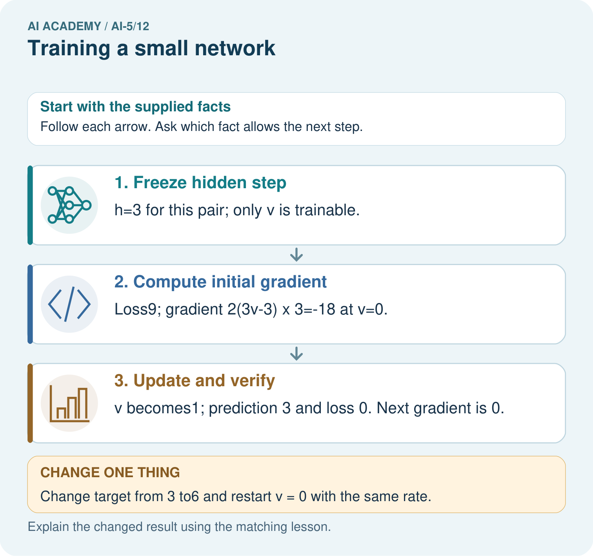

Read the picture one step at a time
Step | What happens and why
1. Freeze hidden step | h=3 for this pair; only v is trainable.
2. Compute initial gradient | Loss9; gradient 2(3v-3)×3=-18 at v=0.
3. Update and verify | v becomes1; prediction 3 and loss 0. Next gradient is 0.
Match each pictured step to the supplied facts. This is a worked teaching case, not an independent assessment.

Why this result follows
Only the output weight v is being fitted in this toy network; the hidden ReLU is fixed. The training input gives hidden value three. Squared-error slope points v from zero towards one, and this specially chosen rate reaches one in a single update. Zero loss on one training pair is exact fitting of that pair, not evidence about other inputs.

What this example does not establish
A zero loss on one example is memorised fit to that example, not proof of a generally useful image classifier.

07. Find and repair a mistake
After four updates, freeze v = 1.875. A reserved demonstration pair (3, 6), not used in the updates, receives prediction 5.625 and squared error 0.140625. Report it separately from training MSE 0.0390625. One synthetic held-out example is a small demonstration, not evidence of broad real-world reliability.
The frozen representation has a limit: for any negative x, ReLU gives h = 0 and the output is always 0. If the intended task were y = 2x for all real inputs, x = -1 would need target -2, so this model would fail there regardless of v. Training cannot recover distinctions that the fixed hidden representation removes.

Locate the earliest unsupported step
At final v = 1.875, calculate the prediction and squared error on reserved pair (3, 6). May its target be included in the four reported training updates?

State one repair and the checks you would rerun.
________________________________________________________________
________________________________________________________________
________________________________________________________________
________________________________________________________________
________________________________________________________________
________________________________________________________________

08. Practise together
At v = 0, calculate both predictions, errors, MSE and gradient, then update at rate 0.1.

Starting from v = 1.5, calculate both training predictions, errors, MSE, gradient and the next v.
________________________________________________________________
________________________________________________________________
________________________________________________________________
________________________________________________________________

Explain your prediction to a partner before comparing results.
________________________________________________________________
________________________________________________________________
________________________________________________________________
________________________________________________________________

Practise with less help: Check the mean convention
Use workbook W2 for the connected example “Training a small network”. First fill the input and rule boxes. Try the middle steps before asking for a hint. After a hint, try the next step yourself.
Plan | Do | Check
What is given? Which rule or procedure applies? | Record each intermediate step. | Does the result follow? What remains unknown?
Explain your trace to a partner. Your partner points to one step to check. Swap roles on the next case. Each person writes their own explanation.

Check your reasoning
Use the worked case for Training a small network. Proposed explanation: “Every parameter was trained”. Decide whether this explanation is supported. Point to the step or supplied fact that decides; explain your repair if needed.
Answer on your own before discussion. If you are unsure, say which step you need help with.

Explain the picture
Which parameter changed, and which part was not trained? Point to the relevant step in the picture, then write the changed result and the rule or evidence that supports it.

My explanation using a pictured step and the given facts
________________________________________________________________
________________________________________________________________
________________________________________________________________
________________________________________________________________
This is supported practice. Keep the separately named independent case for an attempt before feedback.

09. Run the investigation

Predict, investigate and preserve the evidence
At v = 1, the sum of squared errors is 5. A learner uses gradient -10 with rate 0.1. Explain the mismatch with this lesson and give the next v under MSE.
train = [(1.0, 2.0), (2.0, 4.0)]
v = 0.0
rate = 0.1
for step in range(5):
hs = [max(0.0, x) for x, target in train]
errors = [v * h - target
for h, (x, target) in zip(hs, train)]
loss = sum(e * e for e in errors) / len(train)
print(step, v, loss)
if step == 4:
break
gradient = 2 * sum(e * h for e, h in zip(errors, hs)) / len(train)
v = v - rate * gradient
Record | Your evidence
Given input and fixed rule
Prediction before checking
Actual result, or “not run”
First mismatch and one explanation
Boundary or missing input and expected response
On paper, trace the supplied procedure. If code is provided, predict before running it in a local practice file. Never write an expected answer as though it were an observed run.

Plan → try → check
Before trying: what do I expect, and why? While trying: which step could first go wrong? Afterwards: what did I actually observe, and what should change? Keep “not run” if you only traced the procedure.

10. Build your understanding

Explain → apply → challenge
At v = 0, calculate both predictions, errors, MSE and gradient, then update at rate 0.1.
At final v = 1.875, calculate the prediction and squared error on reserved pair (3, 6). May its target be included in the four reported training updates?
For the lesson architecture at x = -1, give h and prediction for any finite v. If target is -2, calculate squared error and explain why changing v cannot fix it.

Explain which evidence supports your conclusion and which claim remains unproved.
________________________________________________________________
________________________________________________________________
________________________________________________________________
________________________________________________________________
________________________________________________________________

11. Connect your project
Add a labelled training a small network evidence sheet to Image-pattern Network Investigation. Show how you can trace repeated forward loss gradient and update steps. Use the supplied fictional case and keep its inputs, intermediate steps, calculation or prediction, and limitation. Connect this record to last week’s record; a matching answer without a trace is insufficient.
Project evidence | Record
Component and version
Inputs permitted at prediction time
Trace and comparison with earlier work
Failure, limit and human review

Evidence for your project
For your Image-pattern Network Investigation, save the input, procedure, observed result and limitation of this check. Label this worked example as practice; use a different, previously unreviewed case when checking independent understanding.

12. Show what you know
Save the model formulas, frozen values, trained parameter, initial value, data pairs, loss definition, learning rate, update budget and the printed trace. State that these numbers are a classroom experiment. Changing a setting after seeing reserved outcomes makes those outcomes development evidence for that revision.

A team reports that its training MSE fell each step and concludes the network learned y = 2x for every real x. Give one numerical counterexample and a more accurate conclusion.
________________________________________________________________
________________________________________________________________
________________________________________________________________
________________________________________________________________
Next week separates an update, a batch and an epoch when training uses more than one group of examples.
For the lesson architecture at x = -1, give h and prediction for any finite v. If target is -2, calculate squared error and explain why changing v cannot fix it.

My limited claim and a useful next check
________________________________________________________________
________________________________________________________________
________________________________________________________________
________________________________________________________________

13. Study a complete case

Complete evidence record

One full-data update from v is 1
Stage | Compute with current v | Result
Forward and loss | Predictions [1, 2] for targets [2, 4] | Errors [-1, -2], MSE 2.5
Gradient | 2 times (-1 times 1 - 2 times 2) / 2 | Gradient -5
Update with rate 0.1 | 1 - 0.1 times -5 | Next v is 1.5
Each row depends on the preceding calculation. Recompute predictions and loss on the next iteration; do not keep using the first gradient after parameters change.
Follow the input through the stated procedure to its result. Cover the result first, predict it, then explain every intermediate step. The text/table accompanies the figure so the example can be read without colour.

My complete trace of the worked case
________________________________________________________________
________________________________________________________________
________________________________________________________________
________________________________________________________________
________________________________________________________________
________________________________________________________________

14. Try a new case independently

Independent case: Run a new training case independently
Keep h = ReLU(x), train only v, and use one pair (2, 2), v = 0 and rate 0.125. Use squared error and gradient 2 times (2v - 2) times 2. Perform two updates, reporting each new v and loss. Explain why the second update changes nothing.

My independent explanation, trace and limits
________________________________________________________________
________________________________________________________________
________________________________________________________________
________________________________________________________________
________________________________________________________________
________________________________________________________________
________________________________________________________________
Attempt this case before feedback. Record any help. Earlier examples below are further practice; a case already practised with feedback cannot establish fresh transfer.

Attempt this without hints
Keep h = ReLU(x), train only v, and use one pair (2, 2), v = 0 and rate 0.125. Use squared error and gradient 2 times (2v - 2) times 2. Perform two updates, reporting each new v and loss. Explain why the second update changes nothing.

My independent procedure, result and limitation
________________________________________________________________
________________________________________________________________
________________________________________________________________
________________________________________________________________
________________________________________________________________
________________________________________________________________
________________________________________________________________
________________________________________________________________
Record support used: none, hint or teacher explanation. After feedback, a different case is needed to demonstrate independence.

Use feedback to improve
Attempt the independent case before hints. Record whether you worked alone, used a hint or followed a model. After feedback, fix the first unsupported step and explain why it changed. A later check uses a changed case, not a copied answer.

