AI ACADEMY · STUDENT · ai-5/14

Learning rate experiments
Project: Image-pattern Network Investigation

Before you start
Why can equal epochs give different update counts when batch size changes?

01. Your mission

Your learning target
I can run a controlled comparison of learning rates.
I can explain slow progress oscillation and increasing loss in a toy model.
I can report the limits of a training experiment.

Remember before reading
Close your notes first. A rough first answer helps us choose the right starting point; it is not a score for your ability.
Without opening the old lesson, explain one key idea from Batching and epochs. Give an example and a mistake that the idea helps you avoid.
Without opening the old lesson, explain one key idea from Updating parameters. Give an example and a mistake that the idea helps you avoid.
Without opening the old lesson, explain one key idea from Loss functions. Give an example and a mistake that the idea helps you avoid.
After trying, check the relevant lesson or ask your teacher. Change the part of your explanation that the evidence shows was wrong.
This week you will practise:
Run a controlled comparison of learning rates
Explain slow progress oscillation and increasing loss in a toy model
Report the limits of a training experiment

Retrieve what you already know
Why can equal epochs give different update counts when batch size changes?

My starting explanation
________________________________________________________________
________________________________________________________________
________________________________________________________________

This week’s end goal
By the end, I can explain learning rate experiments using a traced example and a stated limitation.

02. Notice the evidence
Use the same restricted network h = ReLU(x), y = vh, with only v trained. Keep the fictional training pairs (1, 2) and (2, 4), start v = 0, and use one full-data batch per update. Compare rates 0.05, 0.2, 0.3, 0.4 and 0.5 for exactly four updates each. Restart at zero for every run.
The training objective is ordinary MSE: L(v) = 2.5 times (v - 2) squared. Its gradient is 5 times (v - 2). A step is new v = v - rate times 5 times (v - 2). This small quadratic lets us explain each result rather than treating the rate as a magic setting.
Rate | v after first update | First training MSE | v after four updates
0.05 | 0.5 | 5.625 | 1.3671875
0.2 | 2 | 0 | 2
0.3 | 3 | 2.5 | 1.875
0.4 | 4 | 10 | 0
0.5 | 5 | 22.5 | -8.125
The same rate need not behave this way for another model, input scale, loss convention or batch rule. Rate 0.2 is an exact one-step solution here because of this particular gradient formula.

List the given facts and one fact that is not supplied.
________________________________________________________________
________________________________________________________________
________________________________________________________________

03. See how it works
Write d = v - 2, the signed distance from this objective minimum. Substituting the update gives new d = (1 - 5 times rate) times old d. At rate 0.05 the factor is 0.75: distance shrinks without changing sign. At rate 0.3 it is -0.5: distance changes sign and halves. Both can reduce loss.
def run(rate, updates=4):
v = 0.0
history = [v]
for _ in range(updates):
gradient = 5 * (v - 2)
v = v - rate * gradient
history.append(v)
losses = [2.5 * (value - 2) ** 2 for value in history]
return history, losses
for rate in [0.05, 0.2, 0.3, 0.4, 0.5]:
values, losses = run(rate)
print(rate, values, losses)
The helper assumes a finite rate and nonnegative integer update count. Its five logged states include the initial value. At 0.3 the parameter sequence is [0, 3, 1.5, 2.25, 1.875] and loss is [10, 2.5, 0.625, 0.15625, 0.0390625]. Crossing the minimum does not itself mean training failed.

Connect the picture and the explanation
Point to the input, the deciding step and the result in this week’s visual. Explain the same step in ordinary words. A picture helps when you can say what each part represents.

04. Compare the cases

Compare a familiar case with a changed case
At rate 0.3 the first update gives v = 3, past the minimum at 2. Calculate the next v and loss. Has the first crossing proved divergence?

Keep the procedure fixed. Explain what changed in the inputs and result.
________________________________________________________________
________________________________________________________________
________________________________________________________________
________________________________________________________________
________________________________________________________________

Change one thing in the pictured case
Change: Add a rate 1 run from a = 0.
Prediction: Its path is 8 then 0, with loss 16 at both steps.
Reason: The update alternates across4 without reducing the initial loss.

05. Words that unlock the idea
Word | Meaning
Learning rate | The multiplier controlling the size of a gradient update
Controlled comparison | An experiment changing a named factor while holding other stated conditions fixed
Oscillation | Repeated movement from one side of a value to the other
Divergence | Movement away from a target solution with growing error in this experiment

Use two terms to explain a step in this week’s example.
________________________________________________________________
________________________________________________________________
________________________________________________________________

06. Follow a worked example

The update factor explains three behaviours
Rate and factor | Signed distance behaviour | Training loss behaviour
0.05 gives 0.75 | Same side and shrinking | Multiplied by 0.5625
0.3 gives -0.5 | Alternating and shrinking | Multiplied by 0.25
0.5 gives -1.5 | Alternating and growing | Multiplied by 2.25
For this objective, loss is 2.5 times squared distance. Therefore the loss multiplier is the square of the distance multiplier.

For rate 0.4, calculate its distance multiplier, the first two new v values and both losses. Does a changing parameter guarantee progress?
________________________________________________________________
________________________________________________________________
________________________________________________________________
________________________________________________________________

Learn from the worked case
Cover the result before checking it. Say what is given, choose the procedure, and follow one step at a time. Then uncover the result and explain your first mismatch. Ask why a step is allowed, not only what number it produces.

A pictorial worked case: Learning rate experiments
Compare learning rates with identical starting loss and update counts.

The facts we will use
Loss J(a)=(a-4)²; gradient 2(a-4); start a = = 0. Compare two updates at rates0.25 and 0.75.
All inputs and outcomes in this worked example are invented classroom data; no real model run is claimed.
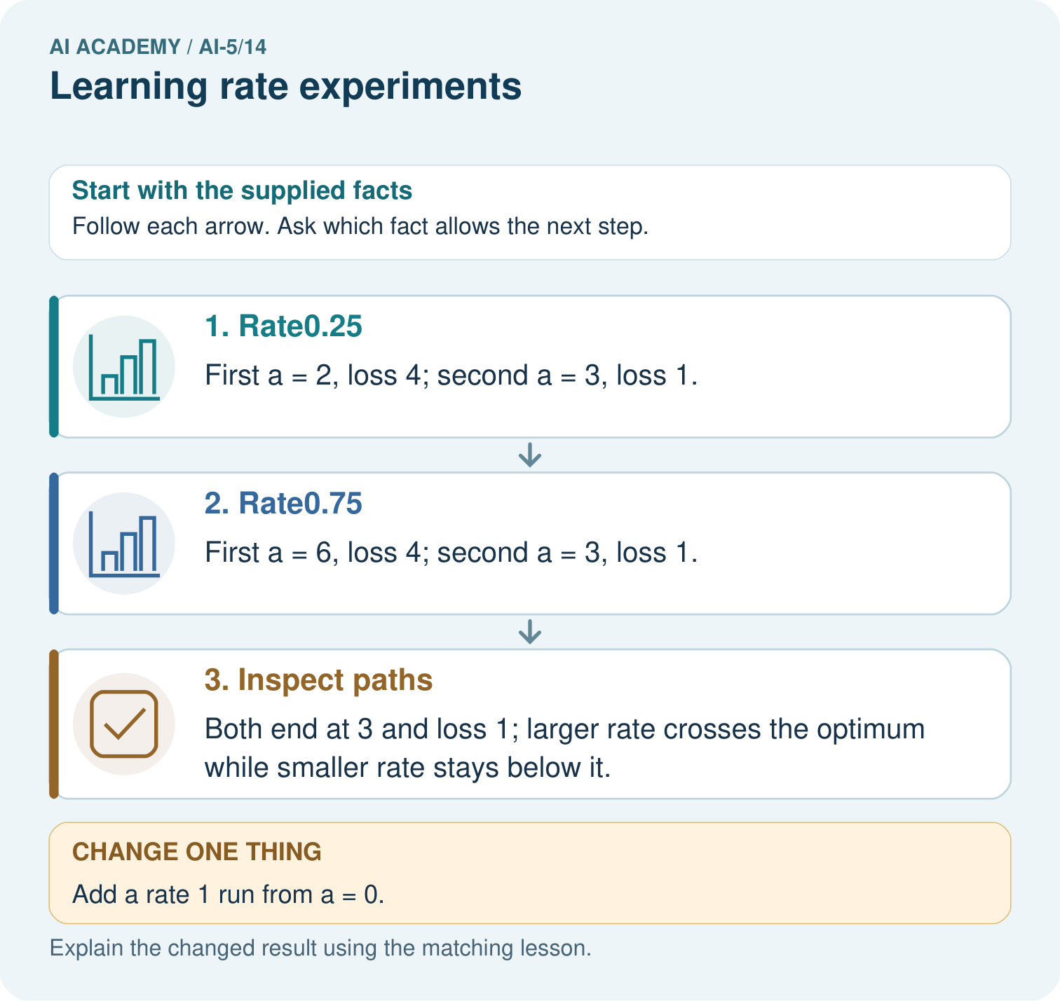

Read the picture one step at a time
Step | What happens and why
1. Rate0.25 | First a = 2, loss 4; second a = 3, loss 1.
2. Rate0.75 | First a = 6, loss 4; second a = 3, loss 1.
3. Inspect paths | Both end at 3 and loss 1; larger rate crosses the optimum while smaller rate stays below it.
Match each pictured step to the supplied facts. This is a worked teaching case, not an independent assessment.

Why this result follows
Keep the starting parameter and update budget identical to compare rates fairly. Rate one-quarter approaches the optimum from below; rate three-quarters crosses it and comes back. Their final losses happen to match after two updates, despite different paths. Rate one repeatedly overshoots by the same distance, so using the correct gradient alone does not ensure improvement.

What this example does not establish
These quadratic paths explain step size. Real nonconvex networks can have more complicated rate behaviour.

07. Find and repair a mistake
For a nonzero starting distance, loss strictly decreases on each step of this quadratic when the absolute value of 1 - 5 times rate is below 1. For positive rates this means 0 < rate < 0.4. At 0 the model does not move. At 0.4 it oscillates with unchanged loss. Above 0.4 its distance grows. These bounds belong to this model and objective, not to neural networks generally.
If we switch from mean squared error to the sum over the same two examples, the gradient doubles from 5(v - 2) to 10(v - 2). Keeping the old rate changes the update. To reproduce the original steps, halve the rate. Likewise, rescaling features can change gradient magnitudes. Record the loss and units alongside the rate.

Locate the earliest unsupported step
Replace MSE by the sum of squared errors on the two training pairs. Which rate reproduces the MSE run at rate 0.3? Explain using gradients.

State one repair and the checks you would rerun.
________________________________________________________________
________________________________________________________________
________________________________________________________________
________________________________________________________________
________________________________________________________________
________________________________________________________________

08. Practise together
For rate 0.05, start v = 0 and compute two updates and their training MSE values using the lesson objective.

For rate 0.4, calculate its distance multiplier, the first two new v values and both losses. Does a changing parameter guarantee progress?
________________________________________________________________
________________________________________________________________
________________________________________________________________
________________________________________________________________

Explain your prediction to a partner before comparing results.
________________________________________________________________
________________________________________________________________
________________________________________________________________
________________________________________________________________

Practise with less help: Explain a crossing
Use workbook W2 for the connected example “Learning rate experiments”. First fill the input and rule boxes. Try the middle steps before asking for a hint. After a hint, try the next step yourself.
Plan | Do | Check
What is given? Which rule or procedure applies? | Record each intermediate step. | Does the result follow? What remains unknown?
Explain your trace to a partner. Your partner points to one step to check. Swap roles on the next case. Each person writes their own explanation.

Check your reasoning
Use the worked case for Learning rate experiments. Proposed explanation: “Crossing the minimum means divergence”. Decide whether this explanation is supported. Point to the step or supplied fact that decides; explain your repair if needed.
Answer on your own before discussion. If you are unsure, say which step you need help with.

Explain the picture
What should a fair rate comparison hold fixed? Point to the relevant step in the picture, then write the changed result and the rule or evidence that supports it.

My explanation using a pictured step and the given facts
________________________________________________________________
________________________________________________________________
________________________________________________________________
________________________________________________________________
This is supported practice. Keep the separately named independent case for an attempt before feedback.

09. Run the investigation

Predict, investigate and preserve the evidence
At rate 0.3 the first update gives v = 3, past the minimum at 2. Calculate the next v and loss. Has the first crossing proved divergence?
def run(rate, updates=4):
v = 0.0
history = [v]
for _ in range(updates):
gradient = 5 * (v - 2)
v = v - rate * gradient
history.append(v)
losses = [2.5 * (value - 2) ** 2 for value in history]
return history, losses
for rate in [0.05, 0.2, 0.3, 0.4, 0.5]:
values, losses = run(rate)
print(rate, values, losses)
Record | Your evidence
Given input and fixed rule
Prediction before checking
Actual result, or “not run”
First mismatch and one explanation
Boundary or missing input and expected response
On paper, trace the supplied procedure. If code is provided, predict before running it in a local practice file. Never write an expected answer as though it were an observed run.

Plan → try → check
Before trying: what do I expect, and why? While trying: which step could first go wrong? Afterwards: what did I actually observe, and what should change? Keep “not run” if you only traced the procedure.

10. Build your understanding

Explain → apply → challenge
For rate 0.05, start v = 0 and compute two updates and their training MSE values using the lesson objective.
Replace MSE by the sum of squared errors on the two training pairs. Which rate reproduces the MSE run at rate 0.3? Explain using gradients.
Run A starts v = 0 with full-data batches for four updates. Run B starts at the final A value, changes both rate and batch size, then compares final training losses. Can the difference be attributed only to rate? Propose a repair.

Explain which evidence supports your conclusion and which claim remains unproved.
________________________________________________________________
________________________________________________________________
________________________________________________________________
________________________________________________________________
________________________________________________________________

11. Connect your project
Add a labelled learning rate experiments evidence sheet to Image-pattern Network Investigation. Show how you can run a controlled comparison of learning rates. Use the supplied fictional case and keep its inputs, intermediate steps, calculation or prediction, and limitation. Connect this record to last week’s record; a matching answer without a trace is insufficient.
Project evidence | Record
Component and version
Inputs permitted at prediction time
Trace and comparison with earlier work
Failure, limit and human review

Evidence for your project
For your Image-pattern Network Investigation, save the input, procedure, observed result and limitation of this check. Label this worked example as practice; use a different, previously unreviewed case when checking independent understanding.

12. Show what you know
Record the initial state, data, frozen values, objective, batch rule, update budget, candidate rates, parameter traces and loss traces. These runs compare training behaviour on two examples. They do not establish which setting performs best on independent data. Keep the final test set out of rate selection; later lessons use validation curves to make development choices.

A team says rate 0.2 is the best rate for every neural network because it reached zero training loss here. Replace this claim with a precise experimental conclusion and one limitation.
________________________________________________________________
________________________________________________________________
________________________________________________________________
________________________________________________________________
Next week compares training and validation curves, including when their trends disagree.
Run A starts v = 0 with full-data batches for four updates. Run B starts at the final A value, changes both rate and batch size, then compares final training losses. Can the difference be attributed only to rate? Propose a repair.

My limited claim and a useful next check
________________________________________________________________
________________________________________________________________
________________________________________________________________
________________________________________________________________

13. Study a complete case

Complete evidence record

The update factor explains three behaviours
Rate and factor | Signed distance behaviour | Training loss behaviour
0.05 gives 0.75 | Same side and shrinking | Multiplied by 0.5625
0.3 gives -0.5 | Alternating and shrinking | Multiplied by 0.25
0.5 gives -1.5 | Alternating and growing | Multiplied by 2.25
For this objective, loss is 2.5 times squared distance. Therefore the loss multiplier is the square of the distance multiplier.
Follow the input through the stated procedure to its result. Cover the result first, predict it, then explain every intermediate step. The text/table accompanies the figure so the example can be read without colour.

My complete trace of the worked case
________________________________________________________________
________________________________________________________________
________________________________________________________________
________________________________________________________________
________________________________________________________________
________________________________________________________________

14. Try a new case independently

Independent case: Compare a new objective independently
Use J(a) = (a - 1) squared with gradient 2(a - 1), start a = 0 and two updates. Restart for each rate 0.25, 0.5 and 1. Compute the two new a values and losses for each run. Identify the result supported after two updates.

My independent explanation, trace and limits
________________________________________________________________
________________________________________________________________
________________________________________________________________
________________________________________________________________
________________________________________________________________
________________________________________________________________
________________________________________________________________
Attempt this case before feedback. Record any help. Earlier examples below are further practice; a case already practised with feedback cannot establish fresh transfer.

Attempt this without hints
Use J(a) = (a - 1) squared with gradient 2(a - 1), start a = 0 and two updates. Restart for each rate 0.25, 0.5 and 1. Compute the two new a values and losses for each run. Identify the result supported after two updates.

My independent procedure, result and limitation
________________________________________________________________
________________________________________________________________
________________________________________________________________
________________________________________________________________
________________________________________________________________
________________________________________________________________
________________________________________________________________
________________________________________________________________
Record support used: none, hint or teacher explanation. After feedback, a different case is needed to demonstrate independence.

Use feedback to improve
Attempt the independent case before hints. Record whether you worked alone, used a hint or followed a model. After feedback, fix the first unsupported step and explain why it changed. A later check uses a changed case, not a copied answer.

