AI ACADEMY · STUDENT · ai-5/25

Sequence representations
Project: Image-pattern Network Investigation

Before you start
Why can two different image regions have the same pooled maximum?

01. Your mission

Your learning target
I can encode an ordered sequence with an explicit vocabulary.
I can use padding and a mask without inventing real events.
I can identify information lost by counts unknown symbols and truncation.

Remember before reading
Close your notes first. A rough first answer helps us choose the right starting point; it is not a score for your ability.
Without opening the old lesson, explain one key idea from Augmentation and leakage. Give an example and a mistake that the idea helps you avoid.
Without opening the old lesson, explain one key idea from Pooling and spatial information. Give an example and a mistake that the idea helps you avoid.
Without opening the old lesson, explain one key idea from Learned representations. Give an example and a mistake that the idea helps you avoid.
After trying, check the relevant lesson or ask your teacher. Change the part of your explanation that the evidence shows was wrong.
This week you will practise:
Encode an ordered sequence with an explicit vocabulary
Use padding and a mask without inventing real events
Identify information lost by counts unknown symbols and truncation

Retrieve what you already know
Why can two different image regions have the same pooled maximum?

My starting explanation
________________________________________________________________
________________________________________________________________
________________________________________________________________

This week’s end goal
By the end, I can explain sequence representations using a traced example and a stated limitation.

02. Notice the evidence
Use fictional robot event logs whose symbols are GO, TURN and STOP. The task asks whether the final real event is STOP. This is a representation exercise, not a claim that an event log proves a robot is safe. GO then STOP and STOP then GO contain the same symbols but have different final events.
Log | Counts in GO TURN STOP order | Final event | Task answer
GO STOP | [1, 0, 1] | STOP | Yes
STOP GO | [1, 0, 1] | GO | No
GO TURN STOP | [1, 1, 1] | STOP | Yes
A count vector discards order, so no deterministic rule using only the first two count vectors can distinguish their answers. A sequence of IDs preserves order if we retain each position. Declare the vocabulary: PAD = 0, UNK = 1, GO = 2, TURN = 3 and STOP = 4. PAD is reserved for added storage positions; UNK represents a real but unrecognised symbol.
IDs are names, not measured amounts. STOP having ID 4 does not make it twice as much as GO with ID 2. Changing the vocabulary requires changing every consumer consistently. Do not interpret numerical distance between IDs as semantic similarity.

List the given facts and one fact that is not supplied.
________________________________________________________________
________________________________________________________________
________________________________________________________________

03. See how it works
Store each log in four positions, padding on the right. A mask value 1 marks a real position and 0 marks padding. The encoder rejects empty logs, logs longer than four, and literal reserved markers. Other unrecognised symbols become UNK and still receive mask 1.
VOCAB = {"GO": 2, "TURN": 3, "STOP": 4}
def encode(events):
if not 1 <= len(events) <= 4:
raise ValueError("Need one to four real events")
if any(e in ("PAD", "UNK") for e in events):
raise ValueError("Reserved markers are not events")
ids = [VOCAB.get(e, 1) for e in events]
n = len(ids)
return ids + [0] * (4 - n), [1] * n + [0] * (4 - n)
assert encode(["GO", "STOP"]) == ([2, 4, 0, 0], [1, 1, 0, 0])
assert encode(["WAIT", "STOP"]) == ([1, 4, 0, 0], [1, 1, 0, 0])
assert encode(["STOP", "GO"]) == ([4, 2, 0, 0], [1, 1, 0, 0])
The code assumes a list of symbol strings and uses exact spelling. It does not fit a vocabulary from data. If a future project fits vocabulary choices or frequency cutoffs, derive those choices from training data and apply the saved encoding consistently to validation and final cases.

Connect the picture and the explanation
Point to the input, the deciding step and the result in this week’s visual. Explain the same step in ordinary words. A picture helps when you can say what each part represents.

04. Compare the cases

Compare a familiar case with a changed case
Give two logs made of exactly GO, TURN and STOP once each that have equal count vectors but different answers to whether the final event is STOP.

Keep the procedure fixed. Explain what changed in the inputs and result.
________________________________________________________________
________________________________________________________________
________________________________________________________________
________________________________________________________________
________________________________________________________________

Change one thing in the pictured case
Change: A missing sequence length causes every numeric0 to be treated as padding in the sensor example.
Prediction: The first real sensor reading is incorrectly discarded.
Reason: Its numeric value is 0, but its position is real according to the declared length.

05. Words that unlock the idea
Word | Meaning
Sequence | An ordered list of elements in which positions can matter
Token ID | A numerical identifier assigned to a symbol by a vocabulary
Padding | Placeholder positions added to make stored sequences the same length
Mask | A list marking which stored positions are real inputs and which are placeholders

Use two terms to explain a step in this week’s example.
________________________________________________________________
________________________________________________________________
________________________________________________________________

06. Follow a worked example

A padded log still has two real events
Stored position | Token ID | Mask
0 | 2 meaning GO | 1 real
1 | 4 meaning STOP | 1 real
2 | 0 meaning PAD | 0 placeholder
3 | 0 meaning PAD | 0 placeholder
The final stored slot is padding. For this right-padded contiguous mask, the real length is the mask sum, and the final real event is at length minus one. A different masking layout would need a different indexing rule.

Encode TURN STOP, give its mask and real length, then identify the final real position and its ID. Why would reading stored position 3 give the wrong event?
________________________________________________________________
________________________________________________________________
________________________________________________________________
________________________________________________________________

Learn from the worked case
Cover the result before checking it. Say what is given, choose the procedure, and follow one step at a time. Then uncover the result and explain your first mismatch. Ask why a step is allowed, not only what number it produces.

A pictorial worked case: Sequence representations
Distinguish padding positions from meaningful zero sensor readings.

The facts we will use
Toy tokensPAD0, UNK1, LEFT2, RIGHT3; stored length4. SequenceLEFT RIGHT encodes [2, 3, 0, 0], mask [1, 1, 0, 0].
All inputs and outcomes in this worked example are invented classroom data; no real model run is claimed.
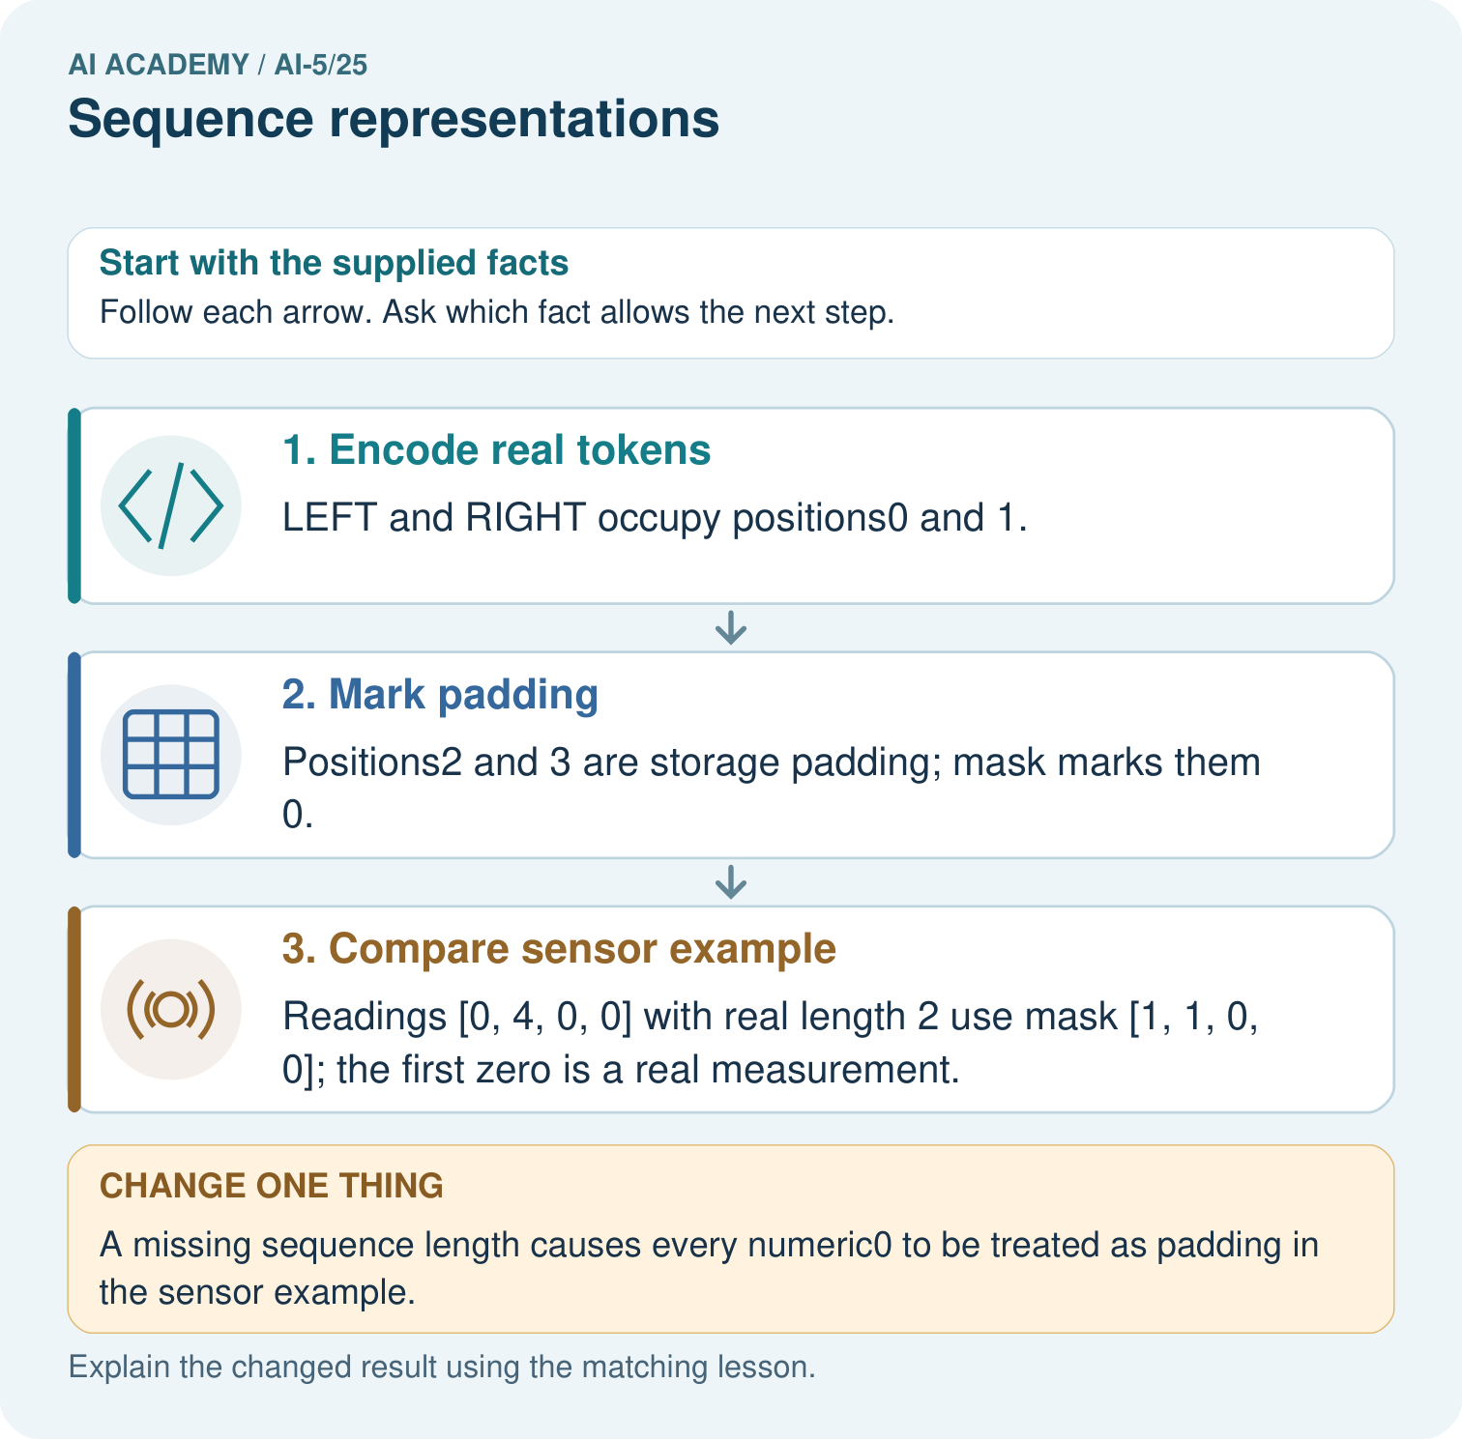

Read the picture one step at a time
Step | What happens and why
1. Encode real tokens | LEFT and RIGHT occupy positions0 and 1.
2. Mark padding | Positions2 and 3 are storage padding; mask marks them 0.
3. Compare sensor example | Readings [0, 4, 0, 0] with real length 2 use mask [1, 1, 0, 0]; the first zero is a real measurement.
Match each pictured step to the supplied facts. This is a worked teaching case, not an independent assessment.

Why this result follows
Sequence values and sequence length are separate information. Padding fills unused storage positions so arrays can share a size; a mask marks which positions are real. A real sensor reading can be zero, just like a padding value. Keep the length or mask rather than inferring presence from the number alone. Token IDs are identifiers, not measured magnitudes.

What this example does not establish
Token padding rules need not apply to sensor values. Document sequence lengths, vocabulary and unknown-token handling.

07. Find and repair a mistake
A mask must affect a calculation to protect it from padding. Suppose real sensor values are [2, 4], stored as [2, 4, 0, 0] with mask [1, 1, 0, 0]. The masked mean is (2 + 4) / 2 = 3. Averaging all four slots gives 1.5. Unlike arbitrary token IDs, these sensor values are measurements for which a mean is meaningful.
Measured zero must remain real: values [0, 4, 0, 0] with mask [1, 1, 0, 0] have mean 2. Removing every zero would incorrectly give 4. The mask distinguishes a measured zero from a storage placeholder. An all-zero mask has no real values; reject it or follow an explicitly defined empty-input policy instead of dividing by zero.
Storing ordered IDs makes order available but does not guarantee a later model uses it. A computation that sums token counts or averages position-independent vectors can lose order again. Trace what the whole procedure reads, not just what the input format could preserve.

Locate the earliest unsupported step
Encode WAIT GO. Which positions are real? Compare it with PAUSE GO, and state what information the encoding loses.

State one repair and the checks you would rerun.
________________________________________________________________
________________________________________________________________
________________________________________________________________
________________________________________________________________
________________________________________________________________
________________________________________________________________

08. Practise together
Encode GO TURN STOP using the lesson vocabulary and four positions. Give its mask, real length and final real event.

Encode TURN STOP, give its mask and real length, then identify the final real position and its ID. Why would reading stored position 3 give the wrong event?
________________________________________________________________
________________________________________________________________
________________________________________________________________
________________________________________________________________

Explain your prediction to a partner before comparing results.
________________________________________________________________
________________________________________________________________
________________________________________________________________
________________________________________________________________

Practise with less help: Expose an order collision
Use workbook W2 for the connected example “Sequence representations”. First fill the input and rule boxes. Try the middle steps before asking for a hint. After a hint, try the next step yourself.
Plan | Do | Check
What is given? Which rule or procedure applies? | Record each intermediate step. | Does the result follow? What remains unknown?
Explain your trace to a partner. Your partner points to one step to check. Swap roles on the next case. Each person writes their own explanation.

Check your reasoning
Use the worked case for Sequence representations. Proposed explanation: “Larger token IDs mean more of a concept”. Decide whether this explanation is supported. Point to the step or supplied fact that decides; explain your repair if needed.
Answer on your own before discussion. If you are unsure, say which step you need help with.

Explain the picture
Which record lets the program distinguish the first and last zeros? Point to the relevant step in the picture, then write the changed result and the rule or evidence that supports it.

My explanation using a pictured step and the given facts
________________________________________________________________
________________________________________________________________
________________________________________________________________
________________________________________________________________
This is supported practice. Keep the separately named independent case for an attempt before feedback.

09. Run the investigation

Predict, investigate and preserve the evidence
Give two logs made of exactly GO, TURN and STOP once each that have equal count vectors but different answers to whether the final event is STOP.
VOCAB = {"GO": 2, "TURN": 3, "STOP": 4}
def encode(events):
if not 1 <= len(events) <= 4:
raise ValueError("Need one to four real events")
if any(e in ("PAD", "UNK") for e in events):
raise ValueError("Reserved markers are not events")
ids = [VOCAB.get(e, 1) for e in events]
n = len(ids)
return ids + [0] * (4 - n), [1] * n + [0] * (4 - n)
assert encode(["GO", "STOP"]) == ([2, 4, 0, 0], [1, 1, 0, 0])
assert encode(["WAIT", "STOP"]) == ([1, 4, 0, 0], [1, 1, 0, 0])
assert encode(["STOP", "GO"]) == ([4, 2, 0, 0], [1, 1, 0, 0])
Record | Your evidence
Given input and fixed rule
Prediction before checking
Actual result, or “not run”
First mismatch and one explanation
Boundary or missing input and expected response
On paper, trace the supplied procedure. If code is provided, predict before running it in a local practice file. Never write an expected answer as though it were an observed run.

Plan → try → check
Before trying: what do I expect, and why? While trying: which step could first go wrong? Afterwards: what did I actually observe, and what should change? Keep “not run” if you only traced the procedure.

10. Build your understanding

Explain → apply → challenge
Encode GO TURN STOP using the lesson vocabulary and four positions. Give its mask, real length and final real event.
Encode WAIT GO. Which positions are real? Compare it with PAUSE GO, and state what information the encoding loses.
The encoder receives five events ending in STOP, then an empty log. What should it do under the lesson contract? Why should a program not simply crop the first and assume a final event for the second?

Explain which evidence supports your conclusion and which claim remains unproved.
________________________________________________________________
________________________________________________________________
________________________________________________________________
________________________________________________________________
________________________________________________________________

11. Connect your project
Add a labelled sequence representations evidence sheet to Image-pattern Network Investigation. Show how you can encode an ordered sequence with an explicit vocabulary. Use the supplied fictional case and keep its inputs, intermediate steps, calculation or prediction, and limitation. Connect this record to last week’s record; a matching answer without a trace is insufficient.
Project evidence | Record
Component and version
Inputs permitted at prediction time
Trace and comparison with earlier work
Failure, limit and human review

Evidence for your project
For your Image-pattern Network Investigation, save the input, procedure, observed result and limitation of this check. Label this worked example as practice; use a different, previously unreviewed case when checking independent understanding.

12. Show what you know
WAIT STOP and PAUSE STOP both become [1, 4, 0, 0] with the same mask. UNK retains a real position but loses the identity of the unrecognised symbol. The final-event task can still answer Yes for both because the last real ID is STOP. A final real UNK would require an unknown result or another documented policy when the intended event cannot be determined.

A log GO TURN GO TURN STOP is cut to its first four events before encoding. What happens to the final-event answer? Explain why the lesson encoder rejects the original log instead of silently truncating it.
________________________________________________________________
________________________________________________________________
________________________________________________________________
________________________________________________________________
The full log ends in STOP, while the retained prefix ends in TURN. Truncation changes the evidence needed for this task. Save the original length and any truncation policy in a real experiment, and test the consequences. Next week introduces embeddings while preserving the distinction between identifiers and learned vectors.
The encoder receives five events ending in STOP, then an empty log. What should it do under the lesson contract? Why should a program not simply crop the first and assume a final event for the second?

My limited claim and a useful next check
________________________________________________________________
________________________________________________________________
________________________________________________________________
________________________________________________________________

13. Study a complete case

Complete evidence record

A padded log still has two real events
Stored position | Token ID | Mask
0 | 2 meaning GO | 1 real
1 | 4 meaning STOP | 1 real
2 | 0 meaning PAD | 0 placeholder
3 | 0 meaning PAD | 0 placeholder
The final stored slot is padding. For this right-padded contiguous mask, the real length is the mask sum, and the final real event is at length minus one. A different masking layout would need a different indexing rule.
Follow the input through the stated procedure to its result. Cover the result first, predict it, then explain every intermediate step. The text/table accompanies the figure so the example can be read without colour.

My complete trace of the worked case
________________________________________________________________
________________________________________________________________
________________________________________________________________
________________________________________________________________
________________________________________________________________
________________________________________________________________

14. Try a new case independently

Independent case: Apply a fresh schema independently
Use PAD = 0, UNK = 1, OPEN = 2, CLOSE = 3, CHECK = 4 and five stored positions. Encode OPEN CHECK CLOSE and give its mask and final real position. Separately, sensor values [0, 6, 3, 0, 0] have that same mask. Calculate their masked mean and the incorrect mean over all five slots.

My independent explanation, trace and limits
________________________________________________________________
________________________________________________________________
________________________________________________________________
________________________________________________________________
________________________________________________________________
________________________________________________________________
________________________________________________________________
Attempt this case before feedback. Record any help. Earlier examples below are further practice; a case already practised with feedback cannot establish fresh transfer.

Attempt this without hints
Use PAD = 0, UNK = 1, OPEN = 2, CLOSE = 3, CHECK = 4 and five stored positions. Encode OPEN CHECK CLOSE and give its mask and final real position. Separately, sensor values [0, 6, 3, 0, 0] have that same mask. Calculate their masked mean and the incorrect mean over all five slots.

My independent procedure, result and limitation
________________________________________________________________
________________________________________________________________
________________________________________________________________
________________________________________________________________
________________________________________________________________
________________________________________________________________
________________________________________________________________
________________________________________________________________
Record support used: none, hint or teacher explanation. After feedback, a different case is needed to demonstrate independence.

Use feedback to improve
Attempt the independent case before hints. Record whether you worked alone, used a hint or followed a model. After feedback, fix the first unsupported step and explain why it changed. A later check uses a changed case, not a copied answer.

