AI ACADEMY · STUDENT · ai-5/28

Transfer learning
Project: Image-pattern Network Investigation

Before you start
If two different records become the same feature vector, can a deterministic output head receiving only that vector distinguish them?

01. Your mission

Your learning target
I can trace a reused feature extractor and a newly fitted output head.
I can fit a small target-task head using training data and compare a baseline.
I can identify when a frozen representation cannot support a new task.

Remember before reading
Close your notes first. A rough first answer helps us choose the right starting point; it is not a score for your ability.
Without opening the old lesson, explain one key idea from Similarity and normalisation. Give an example and a mistake that the idea helps you avoid.
Without opening the old lesson, explain one key idea from Sequence representations. Give an example and a mistake that the idea helps you avoid.
Without opening the old lesson, explain one key idea from Pooling and spatial information. Give an example and a mistake that the idea helps you avoid.
After trying, check the relevant lesson or ask your teacher. Change the part of your explanation that the evidence shows was wrong.
This week you will practise:
Trace a reused feature extractor and a newly fitted output head
Fit a small target-task head using training data and compare a baseline
Identify when a frozen representation cannot support a new task

Retrieve what you already know
If two different records become the same feature vector, can a deterministic output head receiving only that vector distinguish them?

My starting explanation
________________________________________________________________
________________________________________________________________
________________________________________________________________

This week’s end goal
By the end, I can explain transfer learning using a traced example and a stated limitation.

02. Notice the evidence
A source model may learn useful features before we have many labels for a new target task. Transfer learning reuses those learned features or parameters. One approach freezes the feature extractor and fits a new output head. Fine tuning instead updates some or all of the reused parameters, usually together with the head.
Use a transparent stand-in for a source-trained extractor: f(x) = ReLU(x1 + x2), with supplied weights [1, 1] and bias 0. ReLU keeps a positive value and replaces a negative value with zero. Here x1 and x2 are nonnegative fictional event counts, so f(x) is their sum. We did not train this extractor on a source dataset; this exercise demonstrates the mechanics of reuse, not measured transfer benefits.
Part | Operation | During this exercise
Input | [count of type 1, count of type 2] | Keep order and units
Extractor | h = max(0, x1 + x2) | Freeze weights and bias
New head | Predict 1 if h >= threshold | Fit the threshold on target training data
The target is a high-activity label. The extractor returns a single number h, not a class label or probability. A new head converts h into the target prediction.

List the given facts and one fact that is not supplied.
________________________________________________________________
________________________________________________________________
________________________________________________________________

03. See how it works
Use target training records T1 [1, 1] with label 0, T2 [1, 3] with label 0, T3 [4, 2] with label 1 and T4 [5, 3] with label 1. Their extracted values are 2, 4, 6 and 8. Fit the head by trying thresholds 3, 5 and 7 and counting training mistakes. Fitting can use a small search; it need not use gradients.
train = [([1, 1], 0), ([1, 3], 0),
([4, 2], 1), ([5, 3], 1)]
def feature(x):
if len(x) != 2 or any(v < 0 for v in x):
raise ValueError("Need two nonnegative counts")
return max(0, x[0] + x[1])
def predict(x, threshold):
return int(feature(x) >= threshold)
def mistakes(threshold):
return sum(predict(x, threshold) != y
for x, y in train)
candidates = [3, 5, 7]
best = min(candidates, key=lambda t: (mistakes(t), t))
assert best == 5
print([mistakes(t) for t in candidates]) # [1, 0, 1]
The tie rule prefers the smaller threshold if training mistake counts match; there is no tie here. The extractor remains unchanged. The code assumes finite numeric counts and valid binary labels. A constant baseline predicts the most frequent training label; with two of each, our declared tie rule chooses 0.

Connect the picture and the explanation
Point to the input, the deciding step and the result in this week’s visual. Explain the same step in ordinary words. A picture helps when you can say what each part represents.

04. Compare the cases

Compare a familiar case with a changed case
For the four target training records, give the number of mistakes at thresholds 3, 5 and 7 and choose the fitted threshold. Then score that head and the declared constant baseline on V1 and V2. Explain which data fitted the head.

Keep the procedure fixed. Explain what changed in the inputs and result.
________________________________________________________________
________________________________________________________________
________________________________________________________________
________________________________________________________________
________________________________________________________________

Change one thing in the pictured case
Change: Query changes to [2, 1].
Prediction: Its h becomes4 and the fitted head predicts class 0.
Reason: Extractor stays fixed; the changed input crosses the chosen head’s boundary.

05. Words that unlock the idea
Word | Meaning
Transfer learning | Reusing knowledge learned on a source task or dataset to help a target task
Feature extractor | The part of a model that maps an input to a representation
Output head | The part that maps a representation to the current task’s output
Fine tuning | Training some or all previously learned parameters on the target task

Use two terms to explain a step in this week’s example.
________________________________________________________________
________________________________________________________________
________________________________________________________________

06. Follow a worked example

Freeze the fitted head before validation
Validation input | Frozen feature | Head at threshold 5
V1 [2, 1], label 0 | h = 3 | Predict 0, correct
V2 [3, 4], label 1 | h = 7 | Predict 1, correct
The fitted head is correct on 2 of 2 validation records; the constant-0 baseline is correct on 1 of 2. This tiny constructed comparison is not evidence of general transfer performance.
Use the same validation records for both methods. These records were not used to fit the threshold. If validation guides later choices, reserve separate untouched final evaluation data. We have not compared with a full model trained from scratch or measured training time, so this result cannot establish either advantage.

A new input [2, 3] uses the fitted threshold 5. Give h and the predicted class, including the equality rule. Which parameters changed during fitting?
________________________________________________________________
________________________________________________________________
________________________________________________________________
________________________________________________________________

Learn from the worked case
Cover the result before checking it. Say what is given, choose the procedure, and follow one step at a time. Then uncover the result and explain your first mismatch. Ask why a step is allowed, not only what number it produces.

A pictorial worked case: Transfer learning
Transfer a fixed feature extractor while identifying what is actually refitted.

The facts we will use
Frozen extractorh=left+2right. New-task training inputs [1, 0]label0,[2, 1]label0,[1, 3]label1. Class1 whenh>=threshold; candidates3 or5.
All inputs and outcomes in this worked example are invented classroom data; no real model run is claimed.
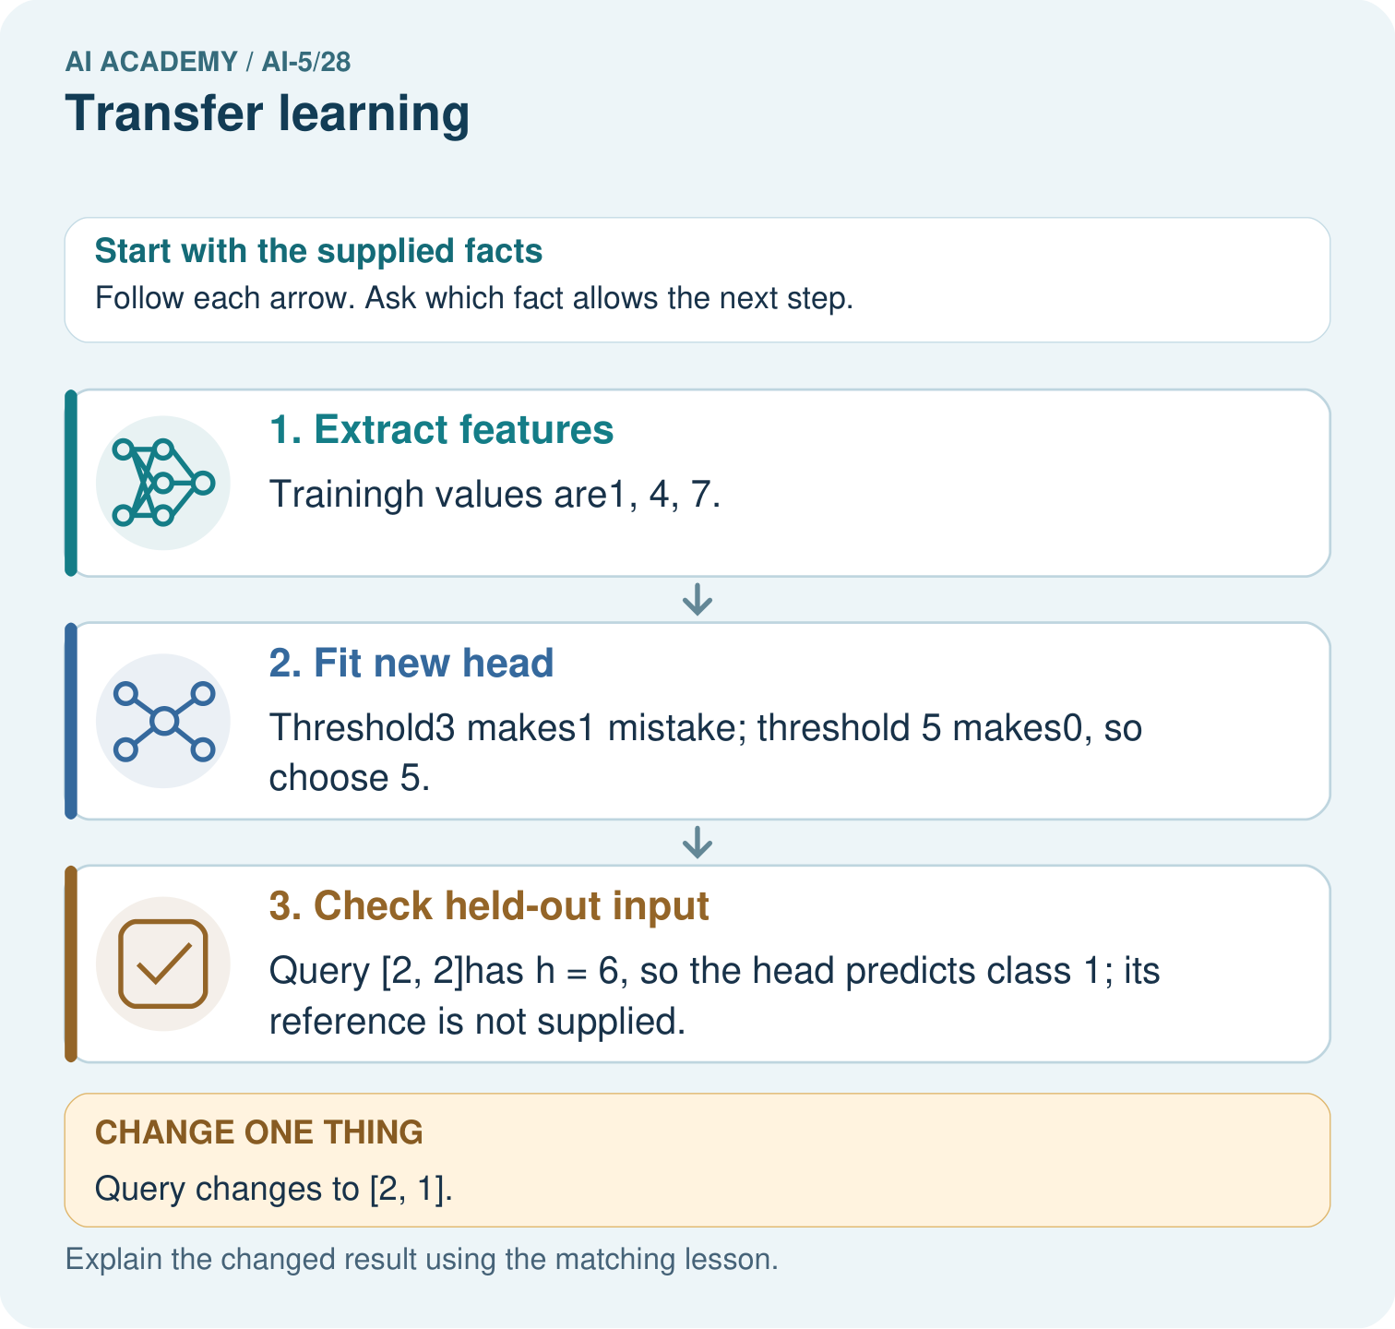

Read the picture one step at a time
Step | What happens and why
1. Extract features | Trainingh values are1, 4, 7.
2. Fit new head | Threshold3 makes1 mistake; threshold 5 makes0, so choose 5.
3. Check held-out input | Query [2, 2]has h = 6, so the head predicts class 1; its reference is not supplied.
Match each pictured step to the supplied facts. This is a worked teaching case, not an independent assessment.

Why this result follows
Transfer learning can keep a representation fixed while fitting a smaller output head for a new task. Here the extractor always applies the same weights, while new labels choose the head’s threshold. Applying the chosen head to a query is inference. State which part was frozen and which was fitted; this arithmetic does not establish the extractor is useful for every task.

What this example does not establish
A frozen extractor can miss task-specific distinctions; transfer is a strategy requiring validation, not a guarantee of useful features.

07. Find and repair a mistake
Now change the target: predict 1 when the first count is greater than the second, otherwise 0. U [1, 3] has label 0 and V [3, 1] has label 1, but both become h = 4. Every fixed deterministic head receiving only this h must give both the same prediction. At least one of the two will be wrong, regardless of how many extra head parameters we add.
Fine tuning could change the extractor to retain relevant distinctions; it does not guarantee success. To see a possible change, hand-set the weights to [1, -1], keep bias 0 and use threshold 1. U then gives ReLU(-2) = 0 and predicts 0; V gives ReLU(2) = 2 and predicts 1. This hand-chosen repair is not a trained result or an independent evaluation.
Keeping the original input alongside h is another possible representation change. Any such change needs a new training and evaluation plan. Normalising the inputs also changes the pipeline; last week showed why that can remove useful magnitude information.

Locate the earliest unsupported step
For the first-count-greater target, explain why the original extractor cannot distinguish U [1, 3] from V [3, 1]. Trace the hand-chosen [1, -1] extractor and threshold 1. Does this show that fine tuning has been trained and independently validated?

State one repair and the checks you would rerun.
________________________________________________________________
________________________________________________________________
________________________________________________________________
________________________________________________________________
________________________________________________________________
________________________________________________________________

08. Practise together
For input [4, 2], compute h using the original extractor and the class at threshold 5. Identify the frozen weights and bias, the fitted quantity, and why h is not a probability.

A new input [2, 3] uses the fitted threshold 5. Give h and the predicted class, including the equality rule. Which parameters changed during fitting?
________________________________________________________________
________________________________________________________________
________________________________________________________________
________________________________________________________________

Explain your prediction to a partner before comparing results.
________________________________________________________________
________________________________________________________________
________________________________________________________________
________________________________________________________________

Practise with less help: Fit and compare
Use workbook W2 for the connected example “Transfer learning”. First fill the input and rule boxes. Try the middle steps before asking for a hint. After a hint, try the next step yourself.
Plan | Do | Check
What is given? Which rule or procedure applies? | Record each intermediate step. | Does the result follow? What remains unknown?
Explain your trace to a partner. Your partner points to one step to check. Swap roles on the next case. Each person writes their own explanation.

Check your reasoning
Use the worked case for Transfer learning. Proposed explanation: “Frozen means the whole model cannot learn”. Decide whether this explanation is supported. Point to the step or supplied fact that decides; explain your repair if needed.
Answer on your own before discussion. If you are unsure, say which step you need help with.

Explain the picture
Which part was trained for the new task? Point to the relevant step in the picture, then write the changed result and the rule or evidence that supports it.

My explanation using a pictured step and the given facts
________________________________________________________________
________________________________________________________________
________________________________________________________________
________________________________________________________________
This is supported practice. Keep the separately named independent case for an attempt before feedback.

09. Run the investigation

Predict, investigate and preserve the evidence
For the four target training records, give the number of mistakes at thresholds 3, 5 and 7 and choose the fitted threshold. Then score that head and the declared constant baseline on V1 and V2. Explain which data fitted the head.
train = [([1, 1], 0), ([1, 3], 0),
([4, 2], 1), ([5, 3], 1)]
def feature(x):
if len(x) != 2 or any(v < 0 for v in x):
raise ValueError("Need two nonnegative counts")
return max(0, x[0] + x[1])
def predict(x, threshold):
return int(feature(x) >= threshold)
def mistakes(threshold):
return sum(predict(x, threshold) != y
for x, y in train)
candidates = [3, 5, 7]
best = min(candidates, key=lambda t: (mistakes(t), t))
assert best == 5
print([mistakes(t) for t in candidates]) # [1, 0, 1]
Record | Your evidence
Given input and fixed rule
Prediction before checking
Actual result, or “not run”
First mismatch and one explanation
Boundary or missing input and expected response
On paper, trace the supplied procedure. If code is provided, predict before running it in a local practice file. Never write an expected answer as though it were an observed run.

Plan → try → check
Before trying: what do I expect, and why? While trying: which step could first go wrong? Afterwards: what did I actually observe, and what should change? Keep “not run” if you only traced the procedure.

10. Build your understanding

Explain → apply → challenge
For input [4, 2], compute h using the original extractor and the class at threshold 5. Identify the frozen weights and bias, the fitted quantity, and why h is not a probability.
For the first-count-greater target, explain why the original extractor cannot distinguish U [1, 3] from V [3, 1]. Trace the hand-chosen [1, -1] extractor and threshold 1. Does this show that fine tuning has been trained and independently validated?
A report omits the source checkpoint and preprocessing, claims faster learning without timing, and repeatedly chooses settings using the final evaluation set. Name the missing records and propose a fair comparison with a model trained from scratch.

Explain which evidence supports your conclusion and which claim remains unproved.
________________________________________________________________
________________________________________________________________
________________________________________________________________
________________________________________________________________
________________________________________________________________

11. Connect your project
Add a labelled transfer learning evidence sheet to Image-pattern Network Investigation. Show how you can trace a reused feature extractor and a newly fitted output head. Use the supplied fictional case and keep its inputs, intermediate steps, calculation or prediction, and limitation. Connect this record to last week’s record; a matching answer without a trace is insufficient.
Project evidence | Record
Component and version
Inputs permitted at prediction time
Trace and comparison with earlier work
Failure, limit and human review

Evidence for your project
For your Image-pattern Network Investigation, save the input, procedure, observed result and limitation of this check. Label this worked example as practice; use a different, previously unreviewed case when checking independent understanding.

12. Show what you know
For a real source-trained model, record the checkpoint version, source task and data provenance, permitted use, input order and preprocessing, frozen and trainable parts, target splits, baseline and resource budget. Check for source-data overlap with target evaluation records; a different filename is not proof of independence. If source history is unknown, report that limitation.

A team says its reused extractor must outperform training from scratch because it scored 2 of 2 here. Give two reasons this conclusion is unsupported and propose a fair next comparison.
________________________________________________________________
________________________________________________________________
________________________________________________________________
________________________________________________________________
Evaluate methods on the same target examples under a declared training budget, with choices made before final evaluation. Record errors as well as totals. Next week examines uncertainty and failure analysis, including confident predictions that can still be wrong.
A report omits the source checkpoint and preprocessing, claims faster learning without timing, and repeatedly chooses settings using the final evaluation set. Name the missing records and propose a fair comparison with a model trained from scratch.

My limited claim and a useful next check
________________________________________________________________
________________________________________________________________
________________________________________________________________
________________________________________________________________

13. Study a complete case

Complete evidence record

Freeze the fitted head before validation
Validation input | Frozen feature | Head at threshold 5
V1 [2, 1], label 0 | h = 3 | Predict 0, correct
V2 [3, 4], label 1 | h = 7 | Predict 1, correct
The fitted head is correct on 2 of 2 validation records; the constant-0 baseline is correct on 1 of 2. This tiny constructed comparison is not evidence of general transfer performance.
Follow the input through the stated procedure to its result. Cover the result first, predict it, then explain every intermediate step. The text/table accompanies the figure so the example can be read without colour.

My complete trace of the worked case
________________________________________________________________
________________________________________________________________
________________________________________________________________
________________________________________________________________
________________________________________________________________
________________________________________________________________

14. Try a new case independently

Independent case: Fit a new head independently
A separate frozen extractor is h = 2*x1 + x2. Training inputs [1, 0], [1, 2], [2, 1], [3, 1] have labels 0, 0, 1, 1. Compare thresholds 2, 4 and 6 using prediction 1 when h >= threshold; choose the fewest mistakes, breaking ties toward the smaller threshold. Score it on validation [2, 0] with label 1 and [0, 2] with label 0. Compare with the training-majority baseline, whose tie rule chooses 0.

My independent explanation, trace and limits
________________________________________________________________
________________________________________________________________
________________________________________________________________
________________________________________________________________
________________________________________________________________
________________________________________________________________
________________________________________________________________
Attempt this case before feedback. Record any help. Earlier examples below are further practice; a case already practised with feedback cannot establish fresh transfer.

Attempt this without hints
A separate frozen extractor is h = 2*x1 + x2. Training inputs [1, 0], [1, 2], [2, 1], [3, 1] have labels 0, 0, 1, 1. Compare thresholds 2, 4 and 6 using prediction 1 when h >= threshold; choose the fewest mistakes, breaking ties toward the smaller threshold. Score it on validation [2, 0] with label 1 and [0, 2] with label 0. Compare with the training-majority baseline, whose tie rule chooses 0.

My independent procedure, result and limitation
________________________________________________________________
________________________________________________________________
________________________________________________________________
________________________________________________________________
________________________________________________________________
________________________________________________________________
________________________________________________________________
________________________________________________________________
Record support used: none, hint or teacher explanation. After feedback, a different case is needed to demonstrate independence.

Use feedback to improve
Attempt the independent case before hints. Record whether you worked alone, used a hint or followed a model. After feedback, fix the first unsupported step and explain why it changed. A later check uses a changed case, not a copied answer.

