AI ACADEMY · STUDENT · ai-6/25

Monitoring quality drift
Project: Grounded Learning Service

Before you start
Recall Release and rollback. Explain why a recorded result needs its input conditions and evidence source before it can support a claim.

01. Your mission

Your learning target
I can explain the mechanism and terminology of monitoring quality drift.
I can apply the stated procedure to a new case with a traceable result.
I can identify an assumption or limitation and design a revealing follow-up.

Remember before reading
Close your notes first. A rough first answer helps us choose the right starting point; it is not a score for your ability.
Without opening the old lesson, explain one key idea from Release and rollback. Give an example and a mistake that the idea helps you avoid.
Without opening the old lesson, explain one key idea from Queues and asynchronous work. Give an example and a mistake that the idea helps you avoid.
Without opening the old lesson, explain one key idea from Sandboxing and resource limits. Give an example and a mistake that the idea helps you avoid.
After trying, check the relevant lesson or ask your teacher. Change the part of your explanation that the evidence shows was wrong.
This week you will practise:
Explain the mechanism and terminology of monitoring quality drift
Apply the stated procedure to a new case with a traceable result
Identify an assumption or limitation and design a revealing follow-up

Retrieve what you already know
Recall Release and rollback. Explain why a recorded result needs its input conditions and evidence source before it can support a claim.

My starting explanation
________________________________________________________________
________________________________________________________________
________________________________________________________________

This week’s end goal
Explain monitoring quality drift using the deciding step in this fictional service.

02. Notice the evidence
Monitoring compares current outcomes with a declared reference and sampling protocol. A change in observed quality may reflect case mix or instrumentation.
Begin by writing the question the procedure is intended to answer. Identify the information already supplied, the information it will produce and the information still missing. These are constructed classroom examples; they do not require live accounts, private records or an external service. Do not treat a plausible explanation as a measured outcome.

List the given facts and one fact that is not supplied.
________________________________________________________________
________________________________________________________________
________________________________________________________________

03. See how it works
For each window report eligible counts, passes, missing outcomes and condition mix. Alert when success falls below the toy80% threshold; investigate before attributing cause.

Monitoring quality drift — evidence trace
Input and scope | Check or calculation | Conclusion and limit
Reference window passes18/20; new window14/20. | For each window report eligible counts, passes, missing outcomes and condition mix. Alert when success falls below the toy80% threshold; investigate before attributing cause. | 90% versus70%, drop20 percentage points; new window breaches80%. Check case mix, data versions and logs before asserting model drift as the cause.
The figure connects this chapter's worked input, declared procedure and result. Read the complete worked reasoning for qualifiers and intermediate steps; the abbreviated labels do not replace that reasoning.
Before applying the procedure, write its units, denominator or decision boundary where relevant. A partner should be able to repeat each step using the same inputs. If a required input is absent or violates the stated contract, record that condition explicitly instead of quietly replacing it with a convenient value.

Connect the picture and the explanation
Point to the input, the deciding step and the result in this week’s visual. Explain the same step in ordinary words. A picture helps when you can say what each part represents.

04. Compare the cases

Compare a familiar case with a changed case
Reference window passes18/20; new window14/20. Show the intermediate steps and give the conclusion with its scope.

Keep the procedure fixed. Explain what changed in the inputs and result.
________________________________________________________________
________________________________________________________________
________________________________________________________________
________________________________________________________________
________________________________________________________________

Change one thing in the pictured case
Change: Week B has no ambiguous questions.
Prediction: That slice is unmeasured, not perfectly correct.
Reason: No observations means no rate can be calculated for it.

05. Words that unlock the idea
Word | Meaning
Monitoring window | The declared interval or batch for measurement
Drift | A change in data or behaviour relative to a reference
Alert threshold | A condition triggering investigation

Use two terms to explain a step in this week’s example.
________________________________________________________________
________________________________________________________________
________________________________________________________________

06. Follow a worked example
Reference window passes18/20; new window14/20.
90% versus70%, drop20 percentage points; new window breaches80%. Check case mix, data versions and logs before asserting model drift as the cause.
Compare the intermediate evidence with the final statement. Explain why each number or decision follows from the stated inputs. The conclusion belongs to this scenario and procedure; changing the inputs, evaluation population or authority can change what it establishes. Retain the raw record so a later revision can be compared honestly.

Learn from the worked case
Cover the result before checking it. Say what is given, choose the procedure, and follow one step at a time. Then uncover the result and explain your first mismatch. Ask why a step is allowed, not only what number it produces.

A pictorial worked case: Monitoring quality drift
Monitor separate question slices. A service uses the same rubric on clear and ambiguous questions in two recorded weeks.

The facts we will use
A: clear 18/20, ambiguous 8/10. B: clear 19/20, ambiguous 4/10.
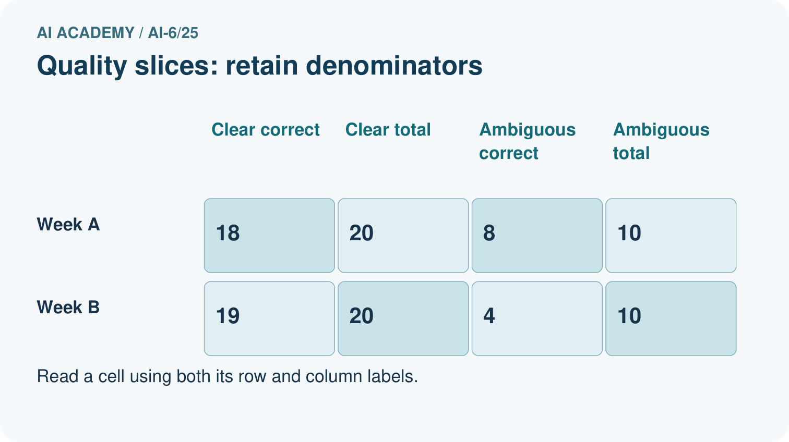
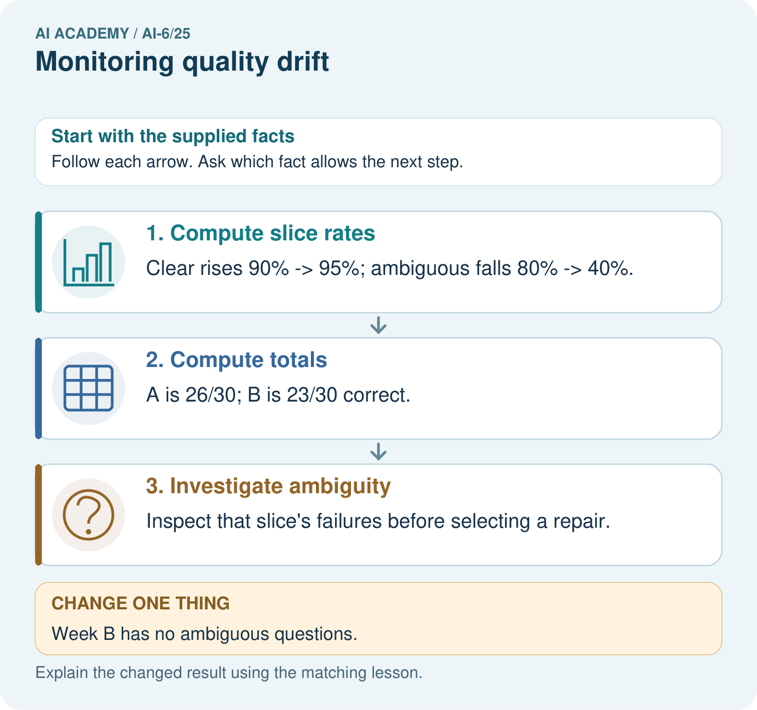

Read the picture one step at a time
Step | What happens and why
1. Compute slice rates | Clear rises 90%→95%; ambiguous falls 80%→40%.
2. Compute totals | A is 26/30; B is 23/30 correct.
3. Investigate ambiguity | Inspect that slice’s failures before selecting a repair.
Match each pictured step to the supplied facts. This is a worked teaching case, not an independent assessment.

Why this result follows
Slice monitoring exposes changes hidden by common easy questions. Retain each denominator and compare the measurement conditions.

What this example does not establish
Small samples do not establish a stable trend or cause; retain uncertainty and compare conditions.

07. Find and repair a mistake
An alert identifies a condition for investigation, not a complete causal explanation.
A useful check asks what would make the reasoning fail. Distinguish a failure to execute the declared procedure from a weakness in the procedure itself. The first may require a correction; the second requires an explicitly revised method and new evidence. Preserve unsuccessful cases so an improved result cannot hide the original problem.

Guided: restate the worked result, then name the assumption or limitation that prevents a broader conclusion.
________________________________________________________________
________________________________________________________________
________________________________________________________________
________________________________________________________________
________________________________________________________________

Locate the earliest unsupported step
A report omits this qualification: An alert identifies a condition for investigation, not a complete causal explanation. Explain how omitting it could change a reader's interpretation, and write an accurate replacement.

State one repair and the checks you would rerun.
________________________________________________________________
________________________________________________________________
________________________________________________________________
________________________________________________________________
________________________________________________________________
________________________________________________________________

08. Practise together
Explain the weekly mechanism in your own words. Use the worked scenario to name its input, decision rule and output.

Guided: restate the worked result, then name the assumption or limitation that prevents a broader conclusion.
________________________________________________________________
________________________________________________________________
________________________________________________________________
________________________________________________________________
________________________________________________________________

Explain your prediction to a partner before comparing results.
________________________________________________________________
________________________________________________________________
________________________________________________________________
________________________________________________________________

Practise with less help: Trace the worked case
Use workbook W2 for the connected example “Monitoring quality drift”. First fill the input and rule boxes. Try the middle steps before asking for a hint. After a hint, try the next step yourself.
Plan | Do | Check
What is given? Which rule or procedure applies? | Record each intermediate step. | Does the result follow? What remains unknown?
Explain your trace to a partner. Your partner points to one step to check. Swap roles on the next case. Each person writes their own explanation.

Check your reasoning
Use the worked case for Monitoring quality drift. Proposed explanation: “The worked result establishes every future case”. Decide whether this explanation is supported. Point to the step or supplied fact that decides; explain your repair if needed.
Answer on your own before discussion. If you are unsure, say which step you need help with.

Explain the picture
Compute both clear and ambiguous slice rates for A and B. Which slice weakens, and how should that slice be reported when no ambiguous questions are observed?

My explanation using a pictured step and the given facts
________________________________________________________________
________________________________________________________________
________________________________________________________________
________________________________________________________________
This is supported practice. Keep the separately named independent case for an attempt before feedback.

09. Run the investigation

Predict, investigate and preserve the evidence
Reference window passes18/20; new window14/20. Show the intermediate steps and give the conclusion with its scope.
Record | Your evidence
Given input and fixed rule
Prediction before checking
Actual result, or “not run”
First mismatch and one explanation
Boundary or missing input and expected response
On paper, trace the supplied procedure. If code is provided, predict before running it in a local practice file. Never write an expected answer as though it were an observed run.

Plan → try → check
Before trying: what do I expect, and why? While trying: which step could first go wrong? Afterwards: what did I actually observe, and what should change? Keep “not run” if you only traced the procedure.

10. Build your understanding

Explain → apply → challenge
Explain the weekly mechanism in your own words. Use the worked scenario to name its input, decision rule and output.
A report omits this qualification: An alert identifies a condition for investigation, not a complete causal explanation. Explain how omitting it could change a reader's interpretation, and write an accurate replacement.
For the worked scenario, propose one additional case that could reveal a failure, describe its expected outcome before running it, and explain what would need to remain fixed for a fair comparison. Do not reuse W4 as a new final test after receiving feedback.

Explain which evidence supports your conclusion and which claim remains unproved.
________________________________________________________________
________________________________________________________________
________________________________________________________________
________________________________________________________________
________________________________________________________________

11. Connect your project
Add a labelled monitoring quality drift evidence sheet to Grounded Learning Service. Show how you can explain the mechanism and terminology of monitoring quality drift. Use the supplied fictional case and keep its inputs, intermediate steps, calculation or prediction, and limitation. Connect this record to last week’s record; a matching answer without a trace is insufficient.
Project evidence | Record
Component and version
Inputs permitted at prediction time
Trace and comparison with earlier work
Failure, limit and human review

Evidence for your project
For the Grounded Learning Service, retain an annotated trace and the changed-case result. Name the contract or evidence that makes the deciding step valid, so another team can review it.

12. Show what you know
Complete the supported workbook tasks before attempting W4 independently. Record any hints or help used. After feedback, use the teacher's fresh retry rather than copying the earlier answer. For a project, select a relevant new case, predict the outcome from the declared rule and preserve the result alongside any revision.

Exit: propose one revealing change to the worked scenario. State the expected outcome and the evidence that would make you revise your explanation.
________________________________________________________________
________________________________________________________________
________________________________________________________________
________________________________________________________________
________________________________________________________________
For the worked scenario, propose one additional case that could reveal a failure, describe its expected outcome before running it, and explain what would need to remain fixed for a fair comparison. Do not reuse W4 as a new final test after receiving feedback.

My limited claim and a useful next check
________________________________________________________________
________________________________________________________________
________________________________________________________________
________________________________________________________________

13. Study a complete case

Complete evidence record

Monitoring quality drift — evidence trace
Input and scope | Check or calculation | Conclusion and limit
Reference window passes18/20; new window14/20. | For each window report eligible counts, passes, missing outcomes and condition mix. Alert when success falls below the toy80% threshold; investigate before attributing cause. | 90% versus70%, drop20 percentage points; new window breaches80%. Check case mix, data versions and logs before asserting model drift as the cause.
The figure connects this chapter's worked input, declared procedure and result. Read the complete worked reasoning for qualifiers and intermediate steps; the abbreviated labels do not replace that reasoning.
Follow the input through the stated procedure to its result. Cover the result first, predict it, then explain every intermediate step. The text/table accompanies the figure so the example can be read without colour.

My complete trace of the worked case
________________________________________________________________
________________________________________________________________
________________________________________________________________
________________________________________________________________
________________________________________________________________
________________________________________________________________

14. Try a new case independently

Independent case: Apply a new case independently
Window A passes8/10; B passes12/20. Threshold70%. Compare.

My independent explanation, trace and limits
________________________________________________________________
________________________________________________________________
________________________________________________________________
________________________________________________________________
________________________________________________________________
________________________________________________________________
________________________________________________________________
Attempt this case before feedback. Record any help. Earlier examples below are further practice; a case already practised with feedback cannot establish fresh transfer.

Attempt this without hints
Window A passes8/10; B passes12/20. Threshold70%. Compare.

My independent procedure, result and limitation
________________________________________________________________
________________________________________________________________
________________________________________________________________
________________________________________________________________
________________________________________________________________
________________________________________________________________
________________________________________________________________
________________________________________________________________
Record support used: none, hint or teacher explanation. After feedback, a different case is needed to demonstrate independence.

Use feedback to improve
Attempt the independent case before hints. Record whether you worked alone, used a hint or followed a model. After feedback, fix the first unsupported step and explain why it changed. A later check uses a changed case, not a copied answer.

