AI ACADEMY · STUDENT · python-bridge/2

Values variables and types
Project: Python readiness portfolio

Before you start
What does print(total) do after total = 24?

01. Your mission

Your learning target
I can distinguish integer, floating-point, text and Boolean values.
I can trace reassignment without treating a name as a live formula.
I can choose a suitable representation for a count and an identifier.

Remember before reading
Close your notes first. A rough first answer helps us choose the right starting point; it is not a score for your ability.
Without opening the old lesson, explain one key idea from From a paper algorithm to Python. Give an example and a mistake that the idea helps you avoid.
After trying, check the relevant lesson or ask your teacher. Change the part of your explanation that the evidence shows was wrong.
This week you will practise:
Distinguish integer, floating-point, text and Boolean values
Trace reassignment without treating a name as a live formula
Choose a suitable representation for a count and an identifier

Retrieve what you already know
What does print(total) do after total = 24?

My starting explanation
________________________________________________________________
________________________________________________________________
________________________________________________________________

This week’s end goal
Trace values variables and types and explain the changed program before running it.

02. Notice the evidence
A count and a shelf label can look similar while needing different operations. The integer 8 is a number; "08" is text that preserves a leading zero. You can count eight objects, but adding two shelf labels is usually meaningless. This week you will examine values, trace changes to names and explain which representation a task needs.
Use the saved Python 3 script workflow from Week 1. Make a new file values.py, predict before running and keep actual output separately. Use fictional labels only. Four useful types are int for whole numbers, float for floating-point numbers, str for text, and bool for True or False. A type describes a value, not whether its meaning is sensible for the task.

List the given facts and one fact that is not supplied.
________________________________________________________________
________________________________________________________________
________________________________________________________________

03. See how it works
Literal in code | Type | Possible meaning
8 | int | Number of counters
2.5 | float | Length in metres
"08" | str | Shelf identifier
True | bool | A yes-or-no condition
count = 8
shelf = "08"
print(type(count))
print(type(shelf))
type(count) produces the type of the value bound to count. These print lines display <class 'int'> and <class 'str'>. The quotes in "08" mark text; they are not displayed by print(shelf). True and False have capital initials and no quotes. "False" is text, not a Boolean.

Connect the picture and the explanation
Point to the input, the deciding step and the result in this week’s visual. Explain the same step in ordinary words. A picture helps when you can say what each part represents.

04. Compare the cases

Compare a familiar case with a changed case
Trace the five-line count and saved program. Record both printed outputs, then predict the result of assigning saved = count after the change. Check with a run or label a paper trace.

Keep the procedure fixed. Explain what changed in the inputs and result.
________________________________________________________________
________________________________________________________________
________________________________________________________________
________________________________________________________________
________________________________________________________________

Change one thing in the pictured case
Change: Change count to 10, leaving tag unchanged.
Prediction: The two valid outputs become 12 and 82.
Reason: Only the integer variable changes; the string still contains the character 8.

05. Words that unlock the idea
Word | Meaning
Value | A piece of data such as 8 or a text label
Variable | A name bound to a value during execution
Type | A category of value that determines available operations
String | A sequence of text characters
Reassignment | Binding an existing name to a new value

Use two terms to explain a step in this week’s example.
________________________________________________________________
________________________________________________________________
________________________________________________________________

06. Follow a worked example

A saved value is not a live link
Instruction | count now | saved now
count = 8 | 8 | Not assigned
saved = count | 8 | 8
count = count + 2 | 10 | 8
Evaluate the right side using the current value, then bind the left-hand name. The saved integer does not update when count is reassigned.
count = 8
saved = count
count = count + 2
print(count)
print(saved)
The outputs are 10 and 8 on separate lines. saved = count uses the value available at that moment. It does not store a formula that keeps following count. count = count + 2 is valid assignment: read the old 8, calculate 10, then rebind count. It is not a claim that 8 equals 10.

After count becomes 10, add saved = count and print(saved). Predict the new output and explain why this is different from expecting saved to change automatically.
________________________________________________________________
________________________________________________________________
________________________________________________________________
________________________________________________________________
________________________________________________________________

Learn from the worked case
Cover the result before checking it. Say what is given, choose the procedure, and follow one step at a time. Then uncover the result and explain your first mismatch. Ask why a step is allowed, not only what number it produces.

A pictorial worked case: Values variables and types
A number and its printed-looking text. A program stores a numeric badge count and a string that looks like that count.

The facts we will use
Python 3: count=8; tag="8"; print(count+2); print(tag+"2").
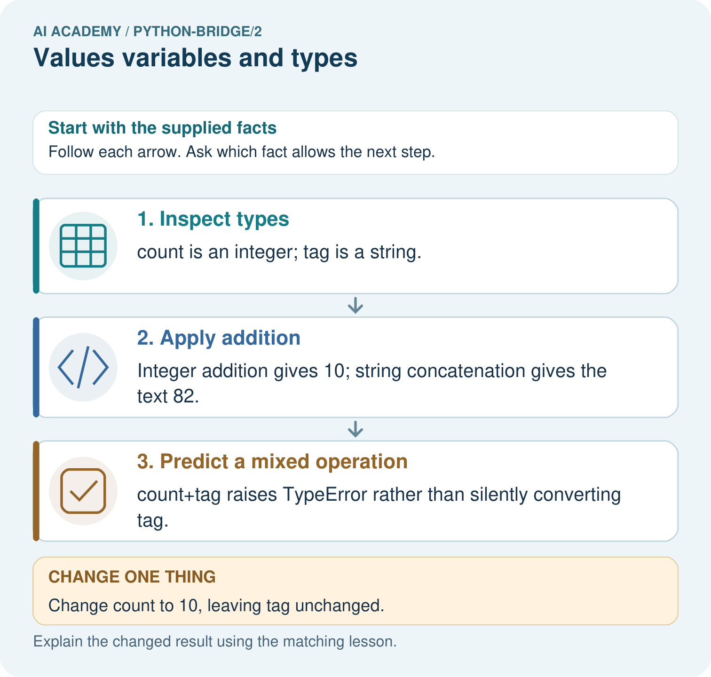

Read the picture one step at a time
Step | What happens and why
1. Inspect types | count is an integer; tag is a string.
2. Apply addition | Integer addition gives 10; string concatenation gives the text 82.
3. Predict a mixed operation | count+tag raises TypeError rather than silently converting tag.
Match each pictured step to the supplied facts. This is a worked teaching case, not an independent assessment.

Why this result follows
Values carry types, not merely appearances. The plus operator performs numeric addition for these integers and concatenation for these strings; the mixed operation is invalid here.

What this example does not establish
These examples use built-in integers and strings; operator behaviour depends on types and is not proof of general model reasoning.

07. Find and repair a mistake
print(8 + 2)
print("8" + "2")
print("8" * 2)
These lines display 10, 82 and 88. Number addition calculates a sum. String addition joins text; string multiplication by a whole number repeats it. Python does not infer from the digits that you wanted a number. Trying "8" + 2 instead raises TypeError because this addition mixes text and an integer.
For a supplied count, use a numeric literal such as 8. For a shelf ID, preserve text such as "08". Later weeks will parse and validate data read from files; changing a type alone will not prove that a value is valid. Use descriptive names with underscores, such as shelf_id. Names are case-sensitive: count and Count are different names.

Locate the earliest unsupported step
Predict 6 + 3, "6" + "3" and "6" * 3. Explain what happens for "6" + 3. Which expression counts six groups of three?

State one repair and the checks you would rerun.
________________________________________________________________
________________________________________________________________
________________________________________________________________
________________________________________________________________
________________________________________________________________
________________________________________________________________

08. Practise together
Classify 12, 1.5, "12", False and "False". Explain why the last two are different.

After count becomes 10, add saved = count and print(saved). Predict the new output and explain why this is different from expecting saved to change automatically.
________________________________________________________________
________________________________________________________________
________________________________________________________________
________________________________________________________________
________________________________________________________________

Explain your prediction to a partner before comparing results.
________________________________________________________________
________________________________________________________________
________________________________________________________________
________________________________________________________________

Practise with less help: Trace a saved value
Use workbook W2 for the connected example “Values variables and types”. First fill the input and rule boxes. Try the middle steps before asking for a hint. After a hint, try the next step yourself.
Plan | Do | Check
What is given? Which rule or procedure applies? | Record each intermediate step. | Does the result follow? What remains unknown?
Explain your trace to a partner. Your partner points to one step to check. Swap roles on the next case. Each person writes their own explanation.

Check your reasoning
Use the worked case for Values variables and types. Proposed explanation: “Digits always mean a number”. Decide whether this explanation is supported. Point to the step or supplied fact that decides; explain your repair if needed.
Answer on your own before discussion. If you are unsure, say which step you need help with.

Explain the picture
Predict both print outputs and explain why they differ. Does count+tag work, and what happens to each valid output after count becomes ten?

My explanation using a pictured step and the given facts
________________________________________________________________
________________________________________________________________
________________________________________________________________
________________________________________________________________
This is supported practice. Keep the separately named independent case for an attempt before feedback.

09. Run the investigation

Predict, investigate and preserve the evidence
Trace the five-line count and saved program. Record both printed outputs, then predict the result of assigning saved = count after the change. Check with a run or label a paper trace.
count = 8
shelf = "08"
print(type(count))
print(type(shelf))
count = 8
saved = count
count = count + 2
print(count)
print(saved)
print(8 + 2)
print("8" + "2")
print("8" * 2)
Record | Your evidence
Given input and fixed rule
Prediction before checking
Actual result, or “not run”
First mismatch and one explanation
Boundary or missing input and expected response
On paper, trace the supplied procedure. If code is provided, predict before running it in a local practice file. Never write an expected answer as though it were an observed run.

Plan → try → check
Before trying: what do I expect, and why? While trying: which step could first go wrong? Afterwards: what did I actually observe, and what should change? Keep “not run” if you only traced the procedure.

10. Build your understanding

Explain → apply → challenge
Classify 12, 1.5, "12", False and "False". Explain why the last two are different.
Predict 6 + 3, "6" + "3" and "6" * 3. Explain what happens for "6" + 3. Which expression counts six groups of three?
Give a suitable type for a counter count, a length of 2.5 metres, a shelf ID with a leading zero, and a yes-or-no availability flag. Give a count value with the right type that should still be rejected.

Explain which evidence supports your conclusion and which claim remains unproved.
________________________________________________________________
________________________________________________________________
________________________________________________________________
________________________________________________________________
________________________________________________________________

11. Connect your project
Add a labelled values variables and types evidence sheet to Python readiness portfolio. Show how you can distinguish integer, floating-point, text and boolean values. Use the supplied fictional case and keep its inputs, intermediate steps, calculation or prediction, and limitation. Connect this record to last week’s record; a matching answer without a trace is insufficient.
Project evidence | Record
Component and version
Inputs permitted at prediction time
Trace and comparison with earlier work
Failure, limit and human review

Evidence for your project
For Python readiness before the Responsible Plant Classifier, retain a trace of the values, the predicted outputs and the changed-case explanation. Use actual Python 3 results to check the prediction after reasoning first.

12. Show what you know
A negative int is still an integer, but it may be invalid as a count of objects. A correctly typed label can still name the wrong shelf. Keep the task’s meaning separate from the value’s Python type. Week 3 uses arithmetic expressions and grouping to calculate with known numeric values.

A shelf identifier "08" is changed to the number 8 so that it can be added to another identifier. Explain what information is lost and why numeric addition does not solve an identifier task. Give one example of a value with the right type but the wrong meaning.
________________________________________________________________
________________________________________________________________
________________________________________________________________
________________________________________________________________
________________________________________________________________
Give a suitable type for a counter count, a length of 2.5 metres, a shelf ID with a leading zero, and a yes-or-no availability flag. Give a count value with the right type that should still be rejected.

My limited claim and a useful next check
________________________________________________________________
________________________________________________________________
________________________________________________________________
________________________________________________________________

13. Study a complete case

Complete evidence record

A saved value is not a live link
Instruction | count now | saved now
count = 8 | 8 | Not assigned
saved = count | 8 | 8
count = count + 2 | 10 | 8
Evaluate the right side using the current value, then bind the left-hand name. The saved integer does not update when count is reassigned.
Follow the input through the stated procedure to its result. Cover the result first, predict it, then explain every intermediate step. The text/table accompanies the figure so the example can be read without colour.

My complete trace of the worked case
________________________________________________________________
________________________________________________________________
________________________________________________________________
________________________________________________________________
________________________________________________________________
________________________________________________________________

14. Try a new case independently

Independent case: Trace values, types and reassignment
Predict both output lines and explain why estimate stays unchanged when count is reassigned. Repeat the trace with initial count=0. Explain why note is text even though its printed characters look like a number.
count = 4
note = "4"
estimate = count / 2
fits = count <= 5
count = count + 3
print(count, note, estimate, fits)
print(type(count).__name__, type(note).__name__, type(estimate).__name__, type(fits).__name__)

My independent explanation, trace and limits
________________________________________________________________
________________________________________________________________
________________________________________________________________
________________________________________________________________
________________________________________________________________
________________________________________________________________
________________________________________________________________
Attempt this case before feedback. Record any help. Earlier examples below are further practice; a case already practised with feedback cannot establish fresh transfer.

Attempt this without hints
A fresh script runs seats = 12; booked = seats; seats = seats - 5; print(seats); print(booked), with each statement on a separate line. Predict both outputs. Then add booked = seats + 1 and print(booked). Explain the evaluation order and choose a type for a seat label "07".

My independent procedure, result and limitation
________________________________________________________________
________________________________________________________________
________________________________________________________________
________________________________________________________________
________________________________________________________________
________________________________________________________________
________________________________________________________________
________________________________________________________________
Record support used: none, hint or teacher explanation. After feedback, a different case is needed to demonstrate independence.

Use feedback to improve
Attempt the independent case before hints. Record whether you worked alone, used a hint or followed a model. After feedback, fix the first unsupported step and explain why it changed. A later check uses a changed case, not a copied answer.

