AI ACADEMY · TEACHER · ai-1/4

Rules or Learned Patterns?
Project: Helpful Classroom Sorter

01. Rules or Learned Patterns?

Teach the learning cycle
Primary target: Execute a stated rule including its boundary
Session | Sequence and minutes | Resources
Session 1 · Understand · 45 min | 0–7: recall and prerequisite; 7–15: inspect the concrete case and predict; 15–30: teacher models the worked trace; 30–40: learners explain a step using the text and visual; 40–45: check the core idea. | Sections 1–6; record the brief recall in the workbook.
Session 2 · Practise · 45 min | 0–5: retrieve the procedure; 5–15: W2 completion practice; 15–23: explain and check with a partner; 23–30: each learner answers the misconception check; 30–40: targeted reteaching or a harder variation; 40–45: prepare the investigation. | Sections 7–10; use the matching workbook W2 and misconception check.
Session 3 · Investigate and transfer · 45 min | 0–5: retrieve the decision rule; 5–20: investigate or trace; 20–30: start the independent case; 30–38: connect the project; 38–43: act on feedback; 43–45: plan the return check. | Sections 9 and 11–14. Give extra time to finish the full task set; use Section 15 when the week includes a coding lab.
This is a starting allocation of 135 minutes, not a validated duration. Preserve all named topics. Schedule extra time for connected examples, the full investigation, independent cases and project building. Repeated copies of a case share one recorded attempt; they are not new evidence.

Retrieval answer guidance

Sensors Are Messengers
Without opening the old lesson, explain one key idea from Sensors Are Messengers. Give an example and a mistake that the idea helps you avoid.
Look for: Describe a measurement using its quantity, value, unit and conditions
Reference example, not the only acceptable wording: Keep the observed value 24 and approximate time lunchtime; mark the unit, exact time if needed, location, exposure and device identity as unknown or to be checked. A suitable completed record needs air temperature, value, unit and relevant conditions. Invented degrees C or shade is not an observation.

AI or Not?
Without opening the old lesson, explain one key idea from AI or Not?. Give an example and a mistake that the idea helps you avoid.
Look for: Distinguish an observed result from an explanation of how it was produced
Reference example, not the only acceptable wording: Observations include that the door opened when the visitor approached and that its label says intelligent entrance. A useful question asks whether a written sensor threshold, a model fitted on examples or a person controls opening. The label is an observed marketing claim, not mechanism evidence.
Use the student module and workbook section with this exact week title. The worked case, independent question and answers below form one aligned lesson sequence.

What the learner must demonstrate
Sorter A follows 'red left, blue right'. Sorter B was trained using labelled red and blue cards. Both send a purple card left. Does their shared output show that they used the same process? What evidence is missing?

Concept to explain
Fixed instructions and learned behavior can look similar but arise differently.
Term | Meaning
fixed rule | instruction written directly in advance
learned pattern | relationship fitted from examples
training | process that adjusts a model from examples
inference | using the finished model on a new input

Prepare the class
Use the supplied scenario, student illustrations and blank paper. For numeric work, offer counters or a calculator after learners show the setup. Fictional records are supplied; personal data and paid accounts are unnecessary.
Allow 80 minutes: recall 8; explanation 12; worked demonstration 15; guided practice 20; independent assessment 15; project and reflection 10. Extend the lab into a second session when needed.

Preparation for the connected explanation
This is a genuine small fitting procedure: choose among candidate thresholds by empirical disagreement count. It is intentionally executable on paper. Do not equate all AI with machine learning or all handwritten rules with non-AI; the lesson isolates fitting versus execution. The fictional label convention avoids implying that size words have universal numerical definitions.

Readiness answer
The warning stays off at exactly 28. Check that the reading is the intended quantity in degrees C and is relevant to the time and conditions.
Width and length cards with labels on a separate sheet
Two candidate-threshold cards for each exercise
A trace-table frame with input, prediction, supplied label and disagreement columns

End goal for the pictorial case
By the end, I can distinguish choosing a rule from applying an already chosen rule.
This added worked case illustrates the week’s main idea. Retain all original and connected topics; schedule its practice within the teaching cycle.

02. Explain the mechanism

Explain the mechanism
Follow the information instead of imagining magic inside the machine.
INPUT a motion value or image values
PROCESS run an explicit if/then rule or a learned classifier
OUTPUT turn on a light or predict an animal label
CORE IDEA Fixed instructions and learned behavior can look similar but arise differently.
UNDER THE HOOD A fixed program's decision logic is specified directly by people. A learned model's parameters are fitted from examples. Both are software, both may be complex, and both can fail; the distinction is how the decision behavior was produced.
Draw a fresh example with all three stages:
Every step connects a claim to observable evidence.
CASE A motion light and an animal recognizer both react to input, but one checks a written condition while the other uses patterns learned from examples.
STEP 1 — OBSERVE a motion value or image values
STEP 2 — TRACE run an explicit if/then rule or a learned classifier
STEP 3 — CONCLUDE turn on a light or predict an animal label
MODEL REASONING The motion light follows a directly written sensor condition. The animal recogniser uses a model fitted on labelled examples. Observing that both react to input does not tell us how their decisions were produced.
DO NOT OVERCLAIM Do not use complicated versus simple as a substitute for fixed versus learned.
What new evidence could change this answer?

Teacher precision note
This course concentrates on modern machine learning. AI also includes symbolic and rule-based approaches. A simple automatic switch or robot body is not, by itself, evidence of AI. Discuss how the system reasons or learns, rather than judging appearance.

Concrete teaching case
Sorter A follows a written red-card-left rule. Sorter B is fitted using labelled leaves.
How were their decision processes obtained? Where should A send blue cards?

Exact explanation to model
A was explicitly programmed; B learned parameters from examples. Blue-card handling is unspecified, so request a rule. Both systems can fail.

Explain the added worked example
A paper sorting task describes imaginary cards. Each card has a width in centimetres and a recorded label, narrow or wide. One person writes a rule from a design requirement: label a card wide when its width is at least 5 cm. Another person compares several candidate thresholds with labelled examples and chooses the one with fewest disagreements. Both may end up using the same threshold, but they selected it in different ways.
Executing a rule means applying it to an input. Fitting means using examples to select or adjust the rule or model. A fitted model can be very simple. We do not need a brain-like picture or a complicated computer to study the difference between selecting a rule and using it.
In this exercise the labels are supplied by the task designer. They are not a universal definition of wide, and a centimetre value alone would not determine every possible meaning of that word. State what the recorded labels mean in the task before counting disagreements.
For threshold t, our rule predicts wide when width is at least t and narrow otherwise. At least includes equality: with t=5, width 5 is wide. Changing at least to greater than changes the rule and may change the error count.
A fitting procedure also contains choices people made: the feature, candidate thresholds, label definition and way of counting errors. Calling a threshold learned does not remove human responsibility for those choices.

Key terms
Term | Meaning
Feature | A recorded property used as an input to a decision or model
Label | A recorded category or target associated with an example
Threshold | A boundary value used in a comparison
Fitting | Choosing or adjusting a model using examples
Error count | The number of predictions that disagree with the comparison labels

Model the reasoning aloud
Use the complete worked example below before asking learners to complete W2. Reveal a small part, invite a prediction, then explain the deciding step. These teacher notes contain solutions; do not reveal the independent case answer during modelling.
2 | narrow | narrow | narrow
4 | narrow | wide | narrow
6 | wide | wide | wide
8 | wide | wide | wide
Apply threshold 3 to each width before checking the label. Only width 4 disagrees, so its error count is 1. Threshold 5 agrees on all four examples, so its error count is 0. Of these two candidates, this procedure selects 5. Zero disagreements here means it fits these four labels; it is not a guarantee about all future cards.
There can be ties. Threshold 6 also agrees on these four examples because 6 is included by at least. Thresholds 5 and 6 predict differently for width 5, which is absent from the fitting set. The available examples therefore do not uniquely determine how that width should be labelled. A procedure needs an explicit tie rule, and we should record the unresolved case.
Thinking move | Teacher prompt
Plan | What is given? What is the question? Which procedure fits these facts?
Do | Point to each input and intermediate step in the worked trace. Name the rule that allows the next step.
Check | Does the output answer the question? Which assumption or limitation prevents a larger claim?
Use the diagram and verbal explanation together. Ask learners to match a sentence to a specific visual step; do not assign learners fixed visual or auditory learning styles.

A pictorial worked case: Rules or Learned Patterns?
A fictional paper sorter learns a size boundary for toy pebbles.

The facts we will use
Training diameters are 1,3,5,7 cm with labels small,small,large,large.
Compare large-at-least-3 with large-at-least-5; choose fewer errors.
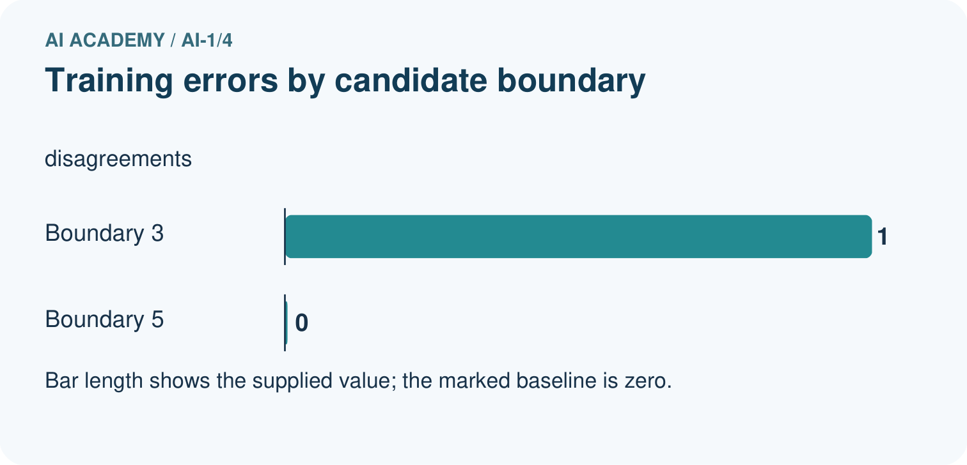
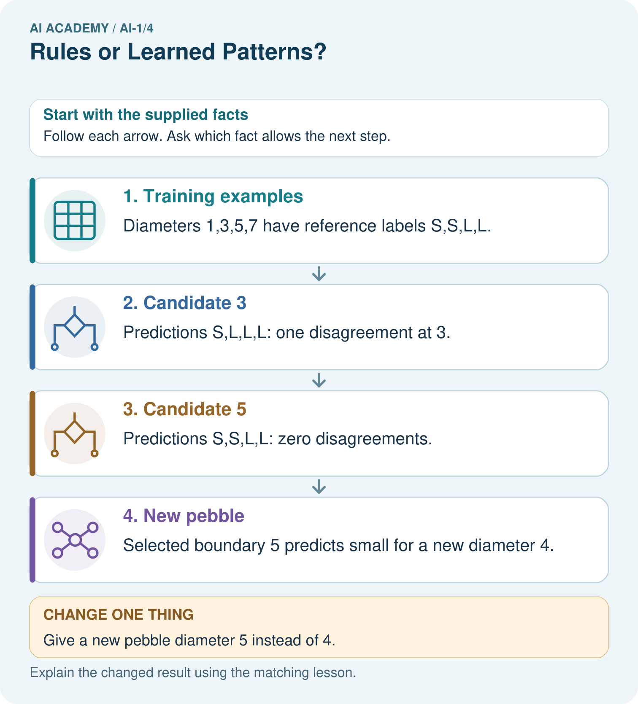

Read the picture one step at a time
Step | What happens and why
1. Training examples | Diameters 1,3,5,7 have reference labels S,S,L,L.
2. Candidate 3 | Predictions S,L,L,L: one disagreement at 3.
3. Candidate 5 | Predictions S,S,L,L: zero disagreements.
4. New pebble | Selected boundary 5 predicts small for a new diameter 4.
Match each pictured step to the supplied facts. This is a worked teaching case, not an independent assessment.

Why this result follows
The learning procedure compares candidate rules against supplied examples and selects boundary 5. Applying that boundary to diameter 4 is a later prediction step. An explicit threshold can be selected from data; being easy to write does not make its origin unknowable.

What this example does not establish
Zero training disagreements do not prove every future pebble receives the correct label.

Change one thing in the pictured case
Change: Give a new pebble diameter 5 instead of 4.
Prediction: The selected rule predicts large.
Reason: At least includes equality, so 5 meets the boundary.

Ask while showing the picture
Cover the result. Ask learners to name the inputs and predict the next step. Uncover one step, connect the icon to the actual procedure, and explain its evidence. Then change the supplied condition and compare. The picture is a representation; it does not document execution of a real AI model.

03. Demonstrate and guide practice

Demonstrate and guide practice

Board sequence
Write the given facts: Sorter A follows a written red-card-left rule. Sorter B is fitted using labelled leaves.
Write the question to explain: How were their decision processes obtained? Where should A send blue cards?
Reveal after predictions: A was explicitly programmed; B learned parameters from examples. Blue-card handling is unspecified, so request a rule. Both systems can fail.
Keep for an independent attempt: System A uses the written rule green means go. System B learns fruit labels from example photographs. Who supplies A's rule? What changes when B is trained on different examples?

Classroom dialogue
Ask: Which facts are given, and which would we have to assume? Learners mark relevant details before discussing answers.
Say: Predict first. Show the rule, information path or calculation that would produce the result. A correct guess is not yet an explanation.
Reveal reasoning one step at a time. Explain why a tempting alternative fails. Write units and denominators for arithmetic, trace conditions for decisions, and identify supporting sources for claims.
In pairs, one learner solves while the other checks evidence; exchange roles. Remove the worked answer before independent assessment.

Model these guided questions
For widths 1,3,5,7, threshold 3 predicts narrow,wide,wide,wide and has one error; threshold 5 predicts narrow,narrow,wide,wide and has zero. The choice establishes a lower fitting error among these candidates on these examples. The exit distinction is selecting a parameter using labelled examples versus keeping the parameter fixed while making a prediction on a new input.

Case-specific teaching sequence
Stage | Teacher action
Session 1 start 0 to 7 minutes | Retrieve the equality boundary from the temperature rule. Compare greater than with at least.
7 to 20 minutes | Contrast a requirement-selected threshold with an example-selected threshold. Read the fitting and use diagram.
20 to 33 minutes | Work through all rows for candidates 3 and 5. Count errors only after writing predictions.
33 to 45 minutes | Pairs complete W1 and W2. Ask each learner to explain where the fitting decision occurs.
Session 2 start 0 to 8 minutes | Show the tie between 5 and 6. Ask for an input that makes them disagree.
8 to 23 minutes | Complete W3 and discuss what the fitting data does not determine.
23 to 38 minutes | Collect W4 independently with comparison labels for the new case hidden.
38 to 45 minutes | Discuss W5 and the exit explanation. Save the selected rule and its known limitations.

Reduce help deliberately
Completion task: Widths 1, 3, 5, 7 have labels narrow, narrow, wide, wide. For candidates 3 and 5, list all predictions using wide when width is at least the candidate. Count disagreements and select the lower-error candidate.
Teacher check: Threshold 3: narrow, wide, wide, wide; one disagreement at 3. Threshold 5: narrow, narrow, wide, wide; zero disagreements. Select 5 among these candidates based on these examples only.
Start by identifying the given inputs together. Leave the intermediate steps blank. If needed, model one step, then withdraw that help on the next step. Move to a full trace only when the partial trace is understood. For partners, alternate explainer and checker; collect a response from every learner before discussion.

Individual reasoning check
Use the worked case for Rules and learned patterns. Proposed explanation: “A learned rule cannot be written simply”. Decide whether this explanation is supported. Point to the step or supplied fact that decides; explain your repair if needed.
Expected correction: The selection procedure can fit a single threshold. Complexity is not the definition of fitting.
Collect explanations, not only yes/no votes. If a misunderstanding is common, re-model the relevant step for the class. If it affects a few learners, give a short targeted group explanation while others solve a more demanding variation.

Pictorial practice question
Show which stage used labels and which stage used only the new measurement.

Reasoned teacher answer
Selection used all four training labels. The new prediction compares diameter with 5 without seeing its reference label.
Changed-case reasoning: The selected rule predicts large. At least includes equality, so 5 meets the boundary.
Collect each learner’s explanation before discussion. Use the first missing connection between input, deciding step and result to choose support. This question is worked-case practice, not fresh mastery evidence.

04. Run the weekly evidence lab

Run the weekly evidence lab
Predict first, test honestly, and explain what the evidence means.
State your prediction before the result is known.
Complete the task: Compare a motion light with an animal recognizer.
Keep a normal case and an edge case clearly separated.
Record what happened—even when it does not match your prediction.
Explain the result, one limitation, and the next useful test.
INDEPENDENCE After support is removed, repeat the proof with a fresh case.

Make the lab runnable
Use the concrete case as the shared normal case and the independent question as a second case. Each pair creates a boundary or missing-information case and predicts its result before testing. Keep the expected result separate from an observed mistake.
Record | What to capture
Input or evidence | Exact data, instruction or claim
Expected result | Answer or safe fallback declared before the run
Observed result | Actual result, including errors
Explanation | Rule, calculation or evidence explaining the outcome
Next test | One justified change and a new prediction

Diagnose and reteach
CLAIM TO REPAIR Every rule must have been learned from data.
For guessing, return to given facts and request a trace. For vocabulary without application, use one example and one non-example. For arithmetic errors, check the setup before the calculation. Finish with a different uncoached case before recording mastery.

Address these additional misconceptions
A learned rule cannot be written simply: The selection procedure can fit a single threshold. Complexity is not the definition of fitting.
Zero fitting errors means the model is correct everywhere: Use thresholds 5 and 6, then input 5. Identical fitting scores leave different unseen predictions.
The label is available when predicting: Cover the new case's label until the prediction is recorded. Separate information available at fitting time from prediction time.

Match the support to the first error
What the response shows | Next teaching action
Missing or misread facts | Read the case aloud, mark supplied versus unknown facts, and let the learner restate it.
Wrong procedure | Return to the deciding step in the worked case. Contrast it with the proposed incorrect explanation.
Arithmetic or implementation error | Trace intermediate values or lines; preserve the first mismatch and retry that step.
Correct result without a reason | Ask for a trace and a changed case before marking independent understanding.
An unsupported wider claim | Ask which supplied evidence supports the claim and which further observation would be needed.
Offer an oral explanation, drawing, enlarged visual or fewer examples when that removes a reading/writing barrier. Keep the same reasoning goal. Stretch secure learners by changing a boundary or assumption and asking them to defend the effect, not simply by assigning more of the same questions.

05. Assess and explain the answers

Assess and explain the answers

Worked case answer
A was explicitly programmed; B learned parameters from examples. Blue-card handling is unspecified, so request a rule. Both systems can fail.

Independent question
System A uses the written rule green means go. System B learns fruit labels from example photographs. Who supplies A's rule? What changes when B is trained on different examples?

Expected independent answer
A's designer writes the rule. Training examples can change B's learned behaviour. A new set of examples does not automatically improve B; test it on separate examples.

What counts as evidence
Criterion | 0 points | 1 point | 2 points
Result | Incorrect or absent | Partly correct | Correct with necessary conditions
Reasoning | No supporting trace | Some steps | Clear mechanism, calculation or source support
Limit | Overclaims certainty | Vague limitation | Relevant uncertainty or missing fact
Transfer | Copies without adapting | Adapts with prompts | Solves a changed case independently
Use 6/8 as a classroom checkpoint, with 2 required for both Result and Reasoning. This is a proposed teaching rule, not a validated certification threshold. Do not count a coached answer as independent mastery; correct unsafe or unsupported claims regardless of total.

Feedback
Ask the learner to find the evidence that challenges this claim: “Every rule must have been learned from data.” Keep the first attempt and an uncoached retry separate.

Original transfer answer
No. A follows supplied instructions but purple handling is unspecified; B applies a learned pattern. Inspect A's complete rule and B's training and prediction process. The same output can arise from different mechanisms and neither result establishes correctness without a purple-card policy.

Explanations for the additional workbook examples

W1 Execute before fitting
Use wide when width is at least 5 cm. Predict the label for widths 4, 5 and 6. Then state what changes if the rule uses greater than 5 instead.
At least 5 gives narrow, wide, wide. Greater than 5 gives narrow, narrow, wide. Only the equality case changes among these inputs.

W2 Complete the supported comparison
Widths 1, 3, 5, 7 have labels narrow, narrow, wide, wide. For candidates 3 and 5, list all predictions using wide when width is at least the candidate. Count disagreements and select the lower-error candidate.
Threshold 3: narrow, wide, wide, wide; one disagreement at 3. Threshold 5: narrow, narrow, wide, wide; zero disagreements. Select 5 among these candidates based on these examples only.

W3 Make a tie visible
For the worked widths 2, 4, 6, 8 with labels narrow, narrow, wide, wide, compare thresholds 5 and 6. Give a width where they predict differently. Explain why the four fitting examples cannot decide that case.
Both thresholds have zero disagreements. At width 5, threshold 5 predicts wide while threshold 6 predicts narrow. No fitting example is width 5 or otherwise distinguishes these thresholds; their equal fitting score does not establish a unique answer there.

W4 Fit a new paper classifier
A fictional sorting task has lengths 2, 5, 7, 9 cm with labels short, short, long, long. Candidate rules predict long when length is at least 5 or at least 7. List predictions and errors for both, choose one, and predict a new length of 6 before any label is revealed. State one limit of your conclusion.
Threshold 5 predicts short, long, long, long: one error at 5. Threshold 7 predicts short, short, long, long: zero errors. Choose 7 and predict short for 6. This fits these supplied labels among these two candidates; the new label, labels at other lengths and general performance are not established.

W5 Keep the check honest
A learner sees that their final-check card was predicted incorrectly, changes the threshold to match it and reports the same card as an unseen test. Explain the problem and propose a valid next check.
The revealed check label influenced the revised threshold, so it became part of development. Record the revision and use a different, unrevealed set after fixing the rule. Do not report the adapted-to case as an independent final test.

Assess independent transfer
Selected case: A fictional sorting task has lengths 2, 5, 7, 9 cm with labels short, short, long, long. Candidate rules predict long when length is at least 5 or at least 7. List predictions and errors for both, choose one, and predict a new length of 6 before any label is revealed. State one limit of your conclusion.

Selected case answer
Threshold 5 predicts short, long, long, long: one error at 5. Threshold 7 predicts short, short, long, long: zero errors. Choose 7 and predict short for 6. This fits these supplied labels among these two candidates; the new label, labels at other lengths and general performance are not established.
Dimension | Evidence required
Explanation | Names the applicable idea or procedure and ties it to the supplied facts.
Trace and result | Preserves the given inputs and shows the relevant intermediate steps; distinguishes a prediction from an observed execution.
Limits | States the assumptions, missing evidence or conditions under which the result would change.
Record each dimension as not yet, with support, or independent. Accept a valid alternative procedure with a defensible trace. Do not penalise an honestly recorded model failure if the learner correctly explains its evidence and limits.

Feedback that the learner uses
Name the earliest unsupported step and give one action to repair it. Have the learner make that repair now and explain why. Then assess the relevant skill on a fresh, fully specified case. Confirm it was not previously practised with feedback; solve and check the new case before assigning it. A follow-up design prompt is a starting brief, not automatically an equivalent test.

06. Connect and extend learning

Connect and extend learning

Helpful Classroom Sorter
Draw a fixed-rule version and a learned-pattern version of the Classroom Sorter; state what evidence would justify the learned version.
Keep the decision, input, result, explanation and remaining limitation in the project evidence record. Retrieve this record next week rather than restarting the project.

Support and stretch
Use physical cards, spoken explanations and a three-stage drawing. Read aloud without giving the answer. Stretch: compare two mechanisms with the same visible output and explain what evidence distinguishes them.

Exit reflection
Ask for one decision the learner can now justify and one situation requiring more evidence or human review. Confidence ratings are separate from correct independent performance.

Bridge to the next week
Next: Week 5: Pictures Become Numbers. Retrieve today’s evidence and identify what carries forward and what is new.

Support and fresh reassessment
Use a number line with a closed dot at the threshold and arrows to the long or wide region. Permit oral explanation with a completed prediction table. Extension: ask learners to find every whole-number threshold tied for zero errors in the worked example and explain what a tie-breaking rule does.
W4 is secure when both prediction lists and counts are correct, threshold 7 is selected, length 6 is predicted short and the learner limits the claim to available evidence. An arithmetic correction alone is insufficient if the fitting versus prediction distinction is missing. Retest with different lengths and thresholds after reteaching.
Week 5 asks how an image becomes numerical input and what spatial information must be preserved before a model can use it.

Plan the delayed return
Suggested return points in this level: ai-1/5, ai-1/7, ai-1/10. Use actual classroom dates, adjusting for holidays and gaps. One, three and six teaching weeks are scheduling choices, not a claimed optimal spacing.
At a delayed check, ask for the idea from memory and a changed application. Compare with the earlier independent response and record support used. For a new level, revisit the previous capstone before checking the new prerequisites.
Record | Teacher evidence
Learner code and date
Concept and case used; prior exposure
Explanation / trace / limits
Support and first repair
Changed case and delayed outcome
Next teaching action
Use the evidence to choose reteaching or the next step. A completed page, confidence rating or attractive project does not by itself demonstrate understanding.

Project evidence from this case
Document whether the sorter’s rules were teacher-written or chosen from examples, retaining candidate errors.

