AI ACADEMY · TEACHER · ai-1/10

If/Then Decisions
Project: Helpful Classroom Sorter

01. If/Then Decisions

Teach the learning cycle
Primary target: Evaluate a condition using the current state and trace only the selected branch
Session | Sequence and minutes | Resources
Session 1 · Understand · 45 min | 0–7: recall and prerequisite; 7–15: inspect the concrete case and predict; 15–30: teacher models the worked trace; 30–40: learners explain a step using the text and visual; 40–45: check the core idea. | Sections 1–6; record the brief recall in the workbook.
Session 2 · Practise · 45 min | 0–5: retrieve the procedure; 5–15: W2 completion practice; 15–23: explain and check with a partner; 23–30: each learner answers the misconception check; 30–40: targeted reteaching or a harder variation; 40–45: prepare the investigation. | Sections 7–10; use the matching workbook W2 and misconception check.
Session 3 · Investigate and transfer · 45 min | 0–5: retrieve the decision rule; 5–20: investigate or trace; 20–30: start the independent case; 30–38: connect the project; 38–43: act on feedback; 43–45: plan the return check. | Sections 9 and 11–14. Give extra time to finish the full task set; use Section 15 when the week includes a coding lab.
This is a starting allocation of 135 minutes, not a validated duration. Preserve all named topics. Schedule extra time for connected examples, the full investigation, independent cases and project building. Repeated copies of a case share one recorded attempt; they are not new evidence.

Retrieval answer guidance

Algorithms as Recipes
Without opening the old lesson, explain one key idea from Algorithms as Recipes. Give an example and a mistake that the idea helps you avoid.
Look for: Trace an ordered algorithm using the current value after every instruction
Reference example, not the only acceptable wording: The trace is 3, 7, 14, 9. The doubling step uses 7, the current value after adding 4 to 3. It must not double the initial 3. Accept a table, arrows or clearly labelled sentences that preserve the order.

Categories and Labels
Without opening the old lesson, explain one key idea from Categories and Labels. Give an example and a mistake that the idea helps you avoid.
Look for: Apply a category definition using explicit evidence and boundary rules
Reference example, not the only acceptable wording: In order: ready because both known fields pass; revise because 31 exceeds 30; review because the known day passes but the room is unknown; revise because the known day failure has priority over the unknown room. Equality at 30 is accepted.

Rules or Learned Patterns?
Without opening the old lesson, explain one key idea from Rules or Learned Patterns?. Give an example and a mistake that the idea helps you avoid.
Look for: Execute a stated rule including its boundary
Reference example, not the only acceptable wording: At least 5 gives narrow, wide, wide. Greater than 5 gives narrow, narrow, wide. Only the equality case changes among these inputs.
Use the student module and workbook section with this exact week title. The worked case, independent question and answers below form one aligned lesson sequence.

What the learner must demonstrate
A club admits a visitor if they have a ticket AND an accompanying adult. Test all four yes/no combinations. A student changes AND to OR. Which outcomes change?

Concept to explain
Conditions make an algorithm branch when information changes.
Term | Meaning
condition | question evaluated as true or false
branch | path selected by a condition
threshold | value where a decision changes
else | path used when earlier conditions are false

Prepare the class
Use the supplied scenario, student illustrations and blank paper. For numeric work, offer counters or a calculator after learners show the setup. Fictional records are supplied; personal data and paid accounts are unnecessary.
Allow 80 minutes: recall 8; explanation 12; worked demonstration 15; guided practice 20; independent assessment 15; project and reflection 10. Extend the lab into a second session when needed.

Preparation for the connected explanation
This week combines current-state tracing with a single if/else decision. Use known whole-number scores first, then explicitly introduce missing input. Separate testing a condition from updating a value. At least and at most include equality; above and below exclude it. Exactly one branch runs for each decision reached. A changed value does not cause the decision to repeat unless another test is explicitly specified. All game and brightness examples are paper simulations.

Readiness answer
The addition changes score to 6, so the next instruction doubles 6 and produces 12. Each instruction reads the current state.
A score box, an add-2 card, and a paired if/otherwise instruction card with report and stop beneath it
A three-column trace headed Current value, Test result and Chosen update, plus cards 5, 6 and 7
The brightness-display task from W4 for independent work, and one unreadable-value card

End goal for the pictorial case
By the end, I can trace exactly one branch and test an including equality boundary.
This added worked case illustrates the week’s main idea. Retain all original and connected topics; schedule its practice within the teaching cycle.

02. Explain the mechanism

Explain the mechanism
Follow the information instead of imagining magic inside the machine.
PROCESS check ordered if/then conditions
OUTPUT clothing suggestion and reason
CORE IDEA Conditions make an algorithm branch when information changes.
UNDER THE HOOD A conditional evaluates a Boolean expression and selects a branch. Order matters when conditions overlap. Complete decision logic needs explicit handling for boundary values and an else path.
Draw a fresh example with all three stages:
Every step connects a claim to observable evidence.
CASE A clothing helper follows different paths depending on temperature, rain, and wind conditions.
STEP 1 — OBSERVE weather values
STEP 2 — TRACE check ordered if/then conditions
STEP 3 — CONCLUDE clothing suggestion and reason
MODEL REASONING Each test follows the stated condition order. The exactly-at-threshold case reveals whether the rule uses less than or less-than-or-equal. Rain-plus-cold needs combined outputs or a clear priority.
DO NOT OVERCLAIM Never hide an unhandled case between two thresholds.
What new evidence could change this answer?

Concrete teaching case
If a card has a star, send it to A; otherwise send it to B.
Sort a star, a circle, and a card with both shapes.

Exact explanation to model
Star and mixed cards go to A because both have a star. The circle goes to B. The test is has a star, not has only a star.

Explain the added worked example
A paper game updates a score with this procedure: add 2 to score; if score is at least 6, subtract 3 from score; otherwise add 4 to score; report score and stop. The if and otherwise instructions form one if/else decision. Exactly one of those branches runs each time this decision is reached.
A condition asks whether a statement is true for the current state. At least 6 means 6 or any larger number. If score is 6, the condition is true. If score is 5, it is false. The condition itself does not change score; the chosen branch performs the update.
Start score at 4. First add 2, giving 6. Now test the current 6: the condition is true, so subtract 3 and report 3. Testing the original 4 would choose the wrong branch. Write the state immediately before the condition so the evidence for the choice is visible.
Compare the three values immediately around the threshold. These are the values when the condition is reached, after the initial add-2 instruction. Testing only a value far above 6 would not show whether equality was handled correctly.
Above 6 is different: it means strictly greater than 6, so 6 itself does not pass. At most 6 means 6 or smaller. Below 6 means strictly smaller, so it excludes 6. Say the equality case aloud before using one of these phrases.
A condition can be true even when its chosen action makes the number smaller. True describes the test result; it does not mean good, bigger, or a successful game. The written instructions define the action.

Key terms
Term | Meaning
Condition | A test whose result is true or false when the required information is known
Branch | The instruction or group of instructions selected by a condition
Threshold | The value used as a comparison boundary
Inclusive boundary | A boundary whose equality case is included
Boundary test | A test using a value at or close to a point where behaviour can change

Model the reasoning aloud
Use the complete worked example below before asking learners to complete W2. Reveal a small part, invite a prediction, then explain the deciding step. These teacher notes contain solutions; do not reveal the independent case answer during modelling.
3 | 5 is not at least 6 | Add 4 and report 9
4 | 6 is at least 6 | Subtract 3 and report 3
5 | 7 is at least 6 | Subtract 3 and report 4
In the first run, the false branch increases 5 to 9. That does not make the earlier decision run again. The procedure has already chosen and carried out the otherwise branch, so it moves on to report and stop. Subtracting 3 afterward would incorrectly run both branches and report 6.
This rule applies to one if/else decision. A later, separate condition would be a new test of the state at that later point. Do not invent an extra test or loop because the value crossed the threshold. Follow only the instructions in the procedure.
Thinking move | Teacher prompt
Plan | What is given? What is the question? Which procedure fits these facts?
Do | Point to each input and intermediate step in the worked trace. Name the rule that allows the next step.
Check | Does the output answer the question? Which assumption or limitation prevents a larger claim?
Use the diagram and verbal explanation together. Ask learners to match a sentence to a specific visual step; do not assign learners fixed visual or auditory learning styles.

A pictorial worked case: If/Then Decisions
A fictional counter begins with a number, adds 2, then chooses one branch.

The facts we will use
If the updated value is at least 6, subtract 1; otherwise double it.
Report once and stop. Use separate starting values 3,4,5.
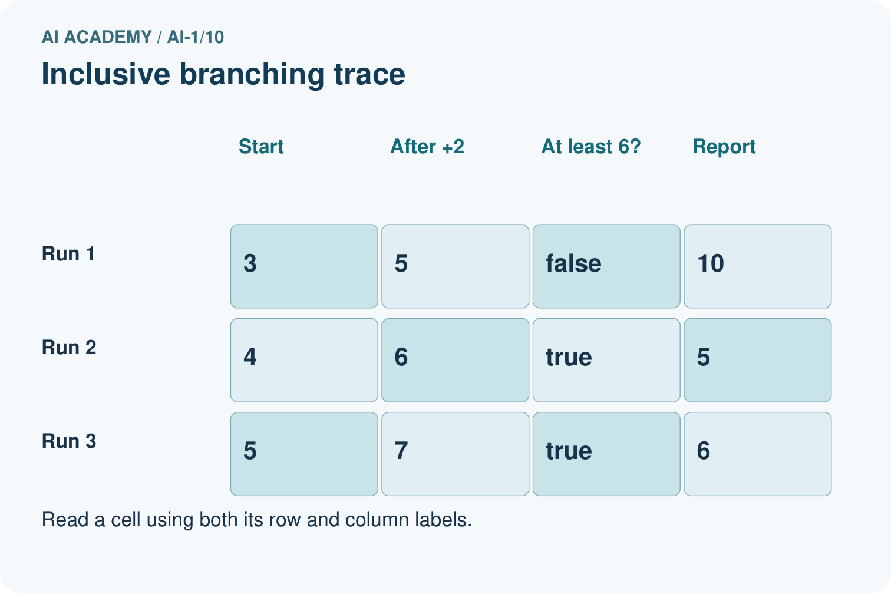
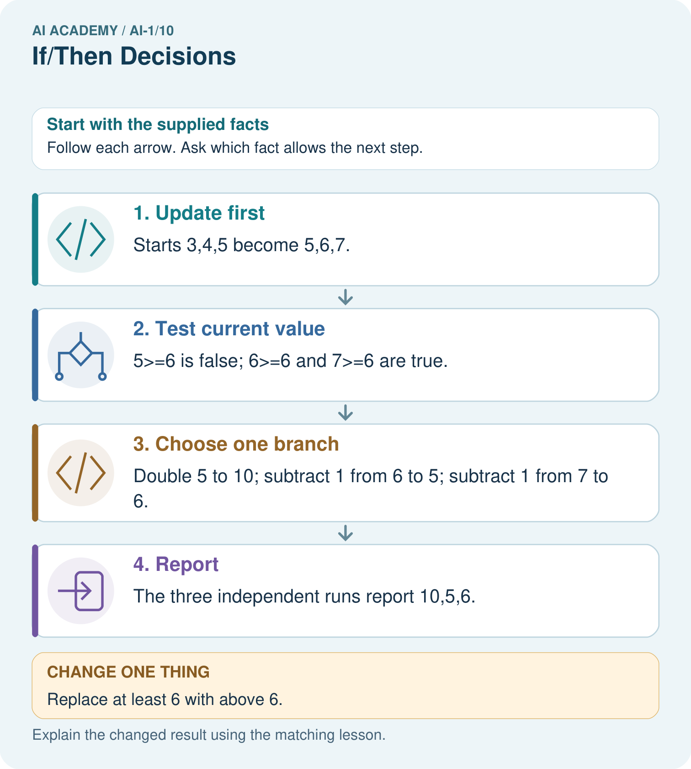

Read the picture one step at a time
Step | What happens and why
1. Update first | Starts 3,4,5 become 5,6,7.
2. Test current value | 5≥6 is false; 6≥6 and 7≥6 are true.
3. Choose one branch | Double 5 to 10; subtract 1 from 6 to 5; subtract 1 from 7 to 6.
4. Report | The three independent runs report 10,5,6.
Match each pictured step to the supplied facts. This is a worked teaching case, not an independent assessment.

Why this result follows
The condition is evaluated after adding 2. Equality belongs to the at-least branch, so starting at 4 checks the boundary. Once a branch finishes, the program reports; it does not reconsider the condition just because doubling 5 produced 10.

What this example does not establish
A large reported value need not mean the true branch ran; branch choice depends on the earlier value.

Change one thing in the pictured case
Change: Replace at least 6 with above 6.
Prediction: Only the run starting at 4 changes: it reports 12.
Reason: Updated value 6 fails a strict above comparison and is doubled.

Ask while showing the picture
Cover the result. Ask learners to name the inputs and predict the next step. Uncover one step, connect the icon to the actual procedure, and explain its evidence. Then change the supplied condition and compare. The picture is a representation; it does not document execution of a real AI model.

03. Demonstrate and guide practice

Demonstrate and guide practice

Board sequence
Write the given facts: If a card has a star, send it to A; otherwise send it to B.
Write the question to explain: Sort a star, a circle, and a card with both shapes.
Reveal after predictions: Star and mixed cards go to A because both have a star. The circle goes to B. The test is has a star, not has only a star.
Keep for an independent attempt: Use this exact rule: if a card has more than three dots, place it in tray A; otherwise use tray B. Trace cards with 2, 3 and 4 dots.

Classroom dialogue
Ask: Which facts are given, and which would we have to assume? Learners mark relevant details before discussing answers.
Say: Predict first. Show the rule, information path or calculation that would produce the result. A correct guess is not yet an explanation.
Reveal reasoning one step at a time. Explain why a tempting alternative fails. Write units and denominators for arithmetic, trace conditions for decisions, and identify supporting sources for claims.
In pairs, one learner solves while the other checks evidence; exchange roles. Remove the worked answer before independent assessment.

Model these guided questions
Choose initial score 4: add 2 to reach 6. Under at least 6, the test is true and subtracting 3 gives 3. Under above 6, it is false and adding 4 gives 10. Equality distinguishes the versions; test values 5 and 7 do not. The exit answer is 6 at the condition, since it is included by at least but excluded by above. If testing from the start of the whole procedure, use initial 4 to reach that value.

Case-specific teaching sequence
Stage | Teacher action
Session 1 start 0 to 7 minutes | Retrieve the current-state rule from Week 9 using start 4, add 2, double. Record 4,6,12 before introducing a condition.
7 to 20 minutes | Model the paper-game procedure from initial score 4. Mark the value 6 at the test and show that the test itself changes no value.
20 to 33 minutes | Compare values 5,6,7 at the condition. Say equality aloud for at least, above, at most and below. Keep separate runs visually separate.
33 to 45 minutes | Complete W1 and W2 in pairs. Require a true/false result and chosen branch alongside each final value.
Session 2 start 0 to 8 minutes | Trace initial score 3 to current 5, then false branch to 9. Point to report and stop so crossing the threshold does not trigger another branch.
8 to 23 minutes | Use W3 to diagnose running both branches. Complete the guided equality test and compare expected versus copied instructions.
23 to 38 minutes | Collect W4 independently. Check whether students evaluate at most on 6,7,8 rather than on the starting 3,4,5.
38 to 45 minutes | Use W5 to distinguish unknown from false. Discuss the exit test and preview explicitly repeated tests in loops.

Reduce help deliberately
Completion task: The known value at a condition is exactly 6. Decide whether each test is true or false: at least 6; above 6; at most 6; below 6. Explain which phrases include equality. Then name one value below and one value above 6 for neighbouring tests.
Teacher check: At least 6 is true, above 6 is false, at most 6 is true, and below 6 is false. At least and at most include equality; above and below are strict. The nearest whole-number neighbours are 5 and 7; other correctly identified lower and higher values are valid but are less close to the boundary.
Start by identifying the given inputs together. Leave the intermediate steps blank. If needed, model one step, then withdraw that help on the next step. Move to a full trace only when the partial trace is understood. For partners, alternate explainer and checker; collect a response from every learner before discussion.

Individual reasoning check
Use the worked case for Conditions and boundary cases. Proposed explanation: “The condition reads the starting value”. Decide whether this explanation is supported. Point to the step or supplied fact that decides; explain your repair if needed.
Expected correction: Trace the initial add-2 instruction first and circle its result before evaluating the comparison.
Collect explanations, not only yes/no votes. If a misunderstanding is common, re-model the relevant step for the class. If it affects a few learners, give a short targeted group explanation while others solve a more demanding variation.

Pictorial practice question
Which input detects the difference between the two written conditions? Explain its entire run.

Reasoned teacher answer
Start 4: add 2 gives 6. The including equality rule subtracts 1 to report 5; the strict rule doubles to report 12.
Changed-case reasoning: Only the run starting at 4 changes: it reports 12. Updated value 6 fails a strict above comparison and is doubled.
Collect each learner’s explanation before discussion. Use the first missing connection between input, deciding step and result to choose support. This question is worked-case practice, not fresh mastery evidence.

04. Run the weekly evidence lab

Run the weekly evidence lab
Predict first, test honestly, and explain what the evidence means.
State your prediction before the result is known.
Complete the task: Build a weather-clothing rule and test four cases.
Keep a normal case and an edge case clearly separated.
Record what happened—even when it does not match your prediction.
Explain the result, one limitation, and the next useful test.
INDEPENDENCE After support is removed, repeat the proof with a fresh case.

Make the lab runnable
Use the concrete case as the shared normal case and the independent question as a second case. Each pair creates a boundary or missing-information case and predicts its result before testing. Keep the expected result separate from an observed mistake.
Record | What to capture
Input or evidence | Exact data, instruction or claim
Expected result | Answer or safe fallback declared before the run
Observed result | Actual result, including errors
Explanation | Rule, calculation or evidence explaining the outcome
Next test | One justified change and a new prediction

Diagnose and reteach
CLAIM TO REPAIR More than three includes three.
For guessing, return to given facts and request a trace. For vocabulary without application, use one example and one non-example. For arithmetic errors, check the setup before the calculation. Finish with a different uncoached case before recording mastery.

Address these additional misconceptions
The condition reads the starting value: Trace the initial add-2 instruction first and circle its result before evaluating the comparison.
At least means strictly above: Put 6 on the boundary and read at least as 6 or more. Compare its true result with above 6, which is false.
Crossing the threshold runs the other branch: Follow the chosen branch to report and stop. A second test must be explicitly written; it is not implied by the new value.
An unknown value makes the test false: Show that the unreadable value could be 5 or 6. Different possibilities select different branches, so the exercise requires a pause and clarification.

Match the support to the first error
What the response shows | Next teaching action
Missing or misread facts | Read the case aloud, mark supplied versus unknown facts, and let the learner restate it.
Wrong procedure | Return to the deciding step in the worked case. Contrast it with the proposed incorrect explanation.
Arithmetic or implementation error | Trace intermediate values or lines; preserve the first mismatch and retry that step.
Correct result without a reason | Ask for a trace and a changed case before marking independent understanding.
An unsupported wider claim | Ask which supplied evidence supports the claim and which further observation would be needed.
Offer an oral explanation, drawing, enlarged visual or fewer examples when that removes a reading/writing barrier. Keep the same reasoning goal. Stretch secure learners by changing a boundary or assumption and asking them to defend the effect, not simply by assigning more of the same questions.

05. Assess and explain the answers

Assess and explain the answers

Worked case answer
Star and mixed cards go to A because both have a star. The circle goes to B. The test is has a star, not has only a star.

Independent question
Use this exact rule: if a card has more than three dots, place it in tray A; otherwise use tray B. Trace cards with 2, 3 and 4 dots.

Expected independent answer
Two and three dots go to B; four goes to A. More than three excludes three. The boundary case reveals whether the condition was read precisely.

What counts as evidence
Criterion | 0 points | 1 point | 2 points
Result | Incorrect or absent | Partly correct | Correct with necessary conditions
Reasoning | No supporting trace | Some steps | Clear mechanism, calculation or source support
Limit | Overclaims certainty | Vague limitation | Relevant uncertainty or missing fact
Transfer | Copies without adapting | Adapts with prompts | Solves a changed case independently
Use 6/8 as a classroom checkpoint, with 2 required for both Result and Reasoning. This is a proposed teaching rule, not a validated certification threshold. Do not count a coached answer as independent mastery; correct unsafe or unsupported claims regardless of total.

Feedback
Ask the learner to find the evidence that challenges this claim: “More than three includes three.” Keep the first attempt and an uncoached retry separate.

Original transfer answer
With AND only ticket=yes/adult=yes is admitted. With OR the two mixed cases are also admitted; no/no is still refused. AND requires both conditions, whereas OR requires at least one. The policy must be chosen before judging the code.

Explanations for the additional workbook examples

W1 Trace a decision from the current score
Use the paper-game procedure: add 2 to score; if score is at least 6 subtract 3, otherwise add 4; report and stop. Start at 2, then make a separate run starting at 5. For each run record the value at the condition, its true or false result, the branch and the final score.
Start 2: after adding 2 score is 4; at least 6 is false; add 4 and report 8. Start 5: after adding 2 score is 7; at least 6 is true; subtract 3 and report 4. Each run starts fresh and executes only its selected branch.

W2 Read four boundary phrases
The known value at a condition is exactly 6. Decide whether each test is true or false: at least 6; above 6; at most 6; below 6. Explain which phrases include equality. Then name one value below and one value above 6 for neighbouring tests.
At least 6 is true, above 6 is false, at most 6 is true, and below 6 is false. At least and at most include equality; above and below are strict. The nearest whole-number neighbours are 5 and 7; other correctly identified lower and higher values are valid but are less close to the boundary.

W3 Stop after the selected branch
In a separate decision the current score is 4. If score is at least 5 subtract 2; otherwise add 3; report and stop. A learner adds 3 to get 7, then subtracts 2 because 7 is now at least 5, and reports 5. Identify the extra action and give the correct trace and result.
The condition at score 4 is false, so only the otherwise branch runs. Add 3 to get 7, then report 7 and stop. The extra subtraction incorrectly runs the other branch after the decision. Crossing the threshold does not repeat the test in this if/else procedure.

W4 Transfer the method to a new display
A paper brightness display adds 3 to its starting number. If the current brightness is at most 7, subtract 2; otherwise add 1. Report and stop. Trace separate runs from starting values 3, 4 and 5. Identify the run that tests equality. Then show how its result changes if at most 7 is accidentally written as below 7.
Start 3: 6 at the test, true, subtract 2, report 4. Start 4: 7 at the test, true, subtract 2, report 5. Start 5: 8 at the test, false, add 1, report 9. Starting at 4 tests equality. With below 7, the current 7 fails, so add 1 and report 8 instead of 5. All three runs use current values after adding 3.

W5 Handle an unknown input explicitly
The score is unreadable at the at-least-6 test. A helper says the test must be false and takes the otherwise branch. Explain what is unknown and why that choice is unjustified. State the next step required by this paper exercise and give two possible scores that would select different branches.
The score value, and therefore the truth of the comparison, is unknown. It could be 5, which selects otherwise, or 6, which selects the true branch. Neither is established by an unreadable value. Pause and request the missing score as specified; do not silently replace it with zero or treat the test as false.

Assess independent transfer
Selected case: A paper brightness display adds 3 to its starting number. If the current brightness is at most 7, subtract 2; otherwise add 1. Report and stop. Trace separate runs from starting values 3, 4 and 5. Identify the run that tests equality. Then show how its result changes if at most 7 is accidentally written as below 7.

Selected case answer
Start 3: 6 at the test, true, subtract 2, report 4. Start 4: 7 at the test, true, subtract 2, report 5. Start 5: 8 at the test, false, add 1, report 9. Starting at 4 tests equality. With below 7, the current 7 fails, so add 1 and report 8 instead of 5. All three runs use current values after adding 3.
Dimension | Evidence required
Explanation | Names the applicable idea or procedure and ties it to the supplied facts.
Trace and result | Preserves the given inputs and shows the relevant intermediate steps; distinguishes a prediction from an observed execution.
Limits | States the assumptions, missing evidence or conditions under which the result would change.
Record each dimension as not yet, with support, or independent. Accept a valid alternative procedure with a defensible trace. Do not penalise an honestly recorded model failure if the learner correctly explains its evidence and limits.

Feedback that the learner uses
Name the earliest unsupported step and give one action to repair it. Have the learner make that repair now and explain why. Then assess the relevant skill on a fresh, fully specified case. Confirm it was not previously practised with feedback; solve and check the new case before assigning it. A follow-up design prompt is a starting brief, not automatically an equivalent test.

06. Connect and extend learning

Connect and extend learning

Helpful Classroom Sorter
Add one transparent if/then branch and one else path to the Classroom Sorter.
Keep the decision, input, result, explanation and remaining limitation in the project evidence record. Retrieve this record next week rather than restarting the project.

Support and stretch
Use physical cards, spoken explanations and a three-stage drawing. Read aloud without giving the answer. Stretch: compare two mechanisms with the same visible output and explain what evidence distinguishes them.

Exit reflection
Ask for one decision the learner can now justify and one situation requiring more evidence or human review. Confidence ratings are separate from correct independent performance.

Bridge to the next week
Next: Week 11: Repeating Efficiently. Retrieve today’s evidence and identify what carries forward and what is new.

Support and fresh reassessment
Provide a number line with the boundary labelled and let students read each comparison in words. Use text labels True branch and Otherwise branch in addition to colour. Supply a blank trace with the comparison row highlighted. Extension: explain why checking 5,6,7 is useful but does not prove a program correct for every possible input or every unrelated implementation error.
W4 is secure when the learner traces all three runs, applies the test to the updated value, includes equality for at most, and explains the changed output under below. A final answer without a branch reason is partial evidence. After support, retry with add 2 followed by if current value is at most 5 subtract 1, otherwise add 2. From starts 2,3,4, the correct final values are 3,4,8 respectively.
Week 11 introduces loops and stopping rules. Students will distinguish one decision from an explicitly repeated test and trace when a loop stops.

Plan the delayed return
Suggested return points in this level: ai-1/11, ai-1/13, ai-1/16. Use actual classroom dates, adjusting for holidays and gaps. One, three and six teaching weeks are scheduling choices, not a claimed optimal spacing.
At a delayed check, ask for the idea from memory and a changed application. Compare with the earlier independent response and record support used. For a new level, revisit the previous capstone before checking the new prerequisites.
Record | Teacher evidence
Learner code and date
Concept and case used; prior exposure
Explanation / trace / limits
Support and first repair
Changed case and delayed outcome
Next teaching action
Use the evidence to choose reteaching or the next step. A completed page, confidence rating or attractive project does not by itself demonstrate understanding.

Project evidence from this case
Include equality examples when reviewing sorter conditions, and trace from original input through output.

