AI ACADEMY · TEACHER · ai-1/16

Boundaries and 'Not Sure'
Project: Helpful Classroom Sorter

01. Boundaries and 'Not Sure'

Teach the learning cycle
Primary target: Identify a specific source of uncertainty and explain how it affects a prediction
Session | Sequence and minutes | Resources
Session 1 · Understand · 45 min | 0–7: recall and prerequisite; 7–15: inspect the concrete case and predict; 15–30: teacher models the worked trace; 30–40: learners explain a step using the text and visual; 40–45: check the core idea. | Sections 1–6; record the brief recall in the workbook.
Session 2 · Practise · 45 min | 0–5: retrieve the procedure; 5–15: W2 completion practice; 15–23: explain and check with a partner; 23–30: each learner answers the misconception check; 30–40: targeted reteaching or a harder variation; 40–45: prepare the investigation. | Sections 7–10; use the matching workbook W2 and misconception check.
Session 3 · Investigate and transfer · 45 min | 0–5: retrieve the decision rule; 5–20: investigate or trace; 20–30: start the independent case; 30–38: connect the project; 38–43: act on feedback; 43–45: plan the return check. | Sections 9 and 11–14. Give extra time to finish the full task set; use Section 15 when the week includes a coding lab.
This is a starting allocation of 135 minutes, not a validated duration. Preserve all named topics. Schedule extra time for connected examples, the full investigation, independent cases and project building. Repeated copies of a case share one recorded attempt; they are not new evidence.

Retrieval answer guidance

Save New Examples for Testing
Without opening the old lesson, explain one key idea from Save New Examples for Testing. Give an example and a mistake that the idea helps you avoid.
Look for: Separate examples used to choose a model from examples reserved for its final evaluation
Reference example, not the only acceptable wording: Comparing candidates is development. Scoring a frozen model on previously reserved examples is evaluation, provided they did not influence its development. Changing a threshold after reading the test score uses that test information for development of the revision; the same set is no longer independent of that revision.

Learning from Examples
Without opening the old lesson, explain one key idea from Learning from Examples. Give an example and a mistake that the idea helps you avoid.
Look for: Fit a threshold by tracing predictions and counting disagreements for every candidate
Reference example, not the only acceptable wording: Threshold 3 predicts short, tall, tall, tall, disagreeing only at 4 cm: count 1. Threshold 7 predicts short, short, short, tall, disagreeing only at 6 cm: count 1. Reset the tally for each candidate.

If/Then Decisions
Without opening the old lesson, explain one key idea from If/Then Decisions. Give an example and a mistake that the idea helps you avoid.
Look for: Evaluate a condition using the current state and trace only the selected branch
Reference example, not the only acceptable wording: Start 2: after adding 2 score is 4; at least 6 is false; add 4 and report 8. Start 5: after adding 2 score is 7; at least 6 is true; subtract 3 and report 4. Each run starts fresh and executes only its selected branch.
Use the student module and workbook section with this exact week title. The worked case, independent question and answers below form one aligned lesson sequence.

What the learner must demonstrate
A sorter receives a clear purple card, a red card hidden by a sleeve and a card labelled both red and blue by two reviewers. Give a different reason for uncertainty in each case and a suitable next action.

Concept to explain
Overlapping categories create uncertainty; abstaining can be responsible.
Term | Meaning
boundary case | example near competing category rules
uncertainty | limited support for one conclusion
abstain | decline to choose a category
escalation | send the case for added information or review

Prepare the class
Use the supplied scenario, student illustrations and blank paper. For numeric work, offer counters or a calculator after learners show the setup. Fictional records are supplied; personal data and paid accounts are unnecessary.
Allow 80 minutes: recall 8; explanation 12; worked demonstration 15; guided practice 20; independent assessment 15; project and reflection 10. Extend the lab into a second session when needed.

Preparation for the connected explanation
Develop uncertainty as a specific evidence gap with a matching review path. The possible-input comparison is a reasoning exercise, not a probability calculation. Assume the listed possibilities are complete for the paper tasks; do not imply that a model normally knows all possible inputs or that shared predictions verify correctness.

Readiness answer
At 5 it predicts short; at 6 it predicts tall. The unclear input leaves two different possible predictions. A previous test result does not tell us which height this record contains.
Tower cards labelled either 5 or 6 cm, either 8 or 9 cm, and height missing
A review record with original input, model version, issue, requested evidence and outcome
Distance possibility cards from W4; use fictional measurements and no personal data

End goal for the pictorial case
By the end, I can use uncertainty to request a specific review when possible inputs lead to different decisions.
This added worked case illustrates the week’s main idea. Retain all original and connected topics; schedule its practice within the teaching cycle.

02. Explain the mechanism

Explain the mechanism
Follow the information instead of imagining magic inside the machine.
INPUT features with incomplete or conflicting clues
PROCESS compare evidence with category boundaries
OUTPUT category, not sure, or request more information
CORE IDEA Overlapping categories create uncertainty; abstaining can be responsible.
UNDER THE HOOD Abstention is a decision policy: when confidence or evidence fails a threshold, the system defers. Good thresholds balance coverage against error cost and specify what additional information or human review follows.
Draw a fresh example with all three stages:
Every step connects a claim to observable evidence.
CASE A soft toy shaped like a ball may fit toy, sports, or comfort-item bins depending on the sorter's purpose.
STEP 1 — OBSERVE features with incomplete or conflicting clues
STEP 2 — TRACE compare evidence with category boundaries
STEP 3 — CONCLUDE category, not sure, or request more information
MODEL REASONING A useful not-sure result is specific: it states which categories compete, what evidence is missing, and who or what should supply it. Abstention reduces forced errors but should not become an excuse to avoid all decisions.
DO NOT OVERCLAIM Responsible uncertainty is informative and actionable, not a blank refusal.
What new evidence could change this answer?

Concrete teaching case
A sorter handles clearly red and clearly blue cards. Purple and very dark cards arrive.
How should it handle each uncertain case?

Exact explanation to model
Use a review tray. Purple is outside the clear categories; darkness prevents observation. These are different uncertainty causes.

Explain the added worked example
An unclear measurement, a missing feature and a weakly tested model create different problems. Saying the AI is unsure does not identify which one matters. Write what is known, what remains unknown and how the unknown could change the result. Then choose a check that addresses that specific gap.
Use the familiar tower model: tall at a height of at least 6 cm, short otherwise, for whole-number heights from 1 through 10. A smudged card could read 5 cm or 6 cm. The threshold is known; the input is unclear. Repeating the same calculation cannot recover the missing digit.
For this paper investigation, treat the listed possibilities as the complete set allowed by the exercise. In real use, that assumption would itself need evidence. We will compare the model’s predictions under each possibility; we are not changing Tower1 to accept an invented exact measurement.
At either 5 or 6 cm, one possibility predicts short and the other tall. Record no single category yet and ask for the original record or a new measurement. Do not select the more convenient digit. Averaging the two readings would introduce a different input that neither possibility stated.
At either 8 or 9 cm, the model predicts tall in both cases. You can state that the prediction stays tall under these two possibilities. Keep the exact-height uncertainty visible. This agreement does not check the model against a correct task label or establish that the list of possible heights is complete.

Key terms
Term | Meaning
Uncertainty | Something relevant that the available evidence does not settle
Possible input | An input still compatible with the stated information
Review trigger | A stated condition that sends a case for an additional check
Review evidence | Information gathered to investigate the reason a case was referred
Unresolved | Still not settled after the available checks

Model the reasoning aloud
Use the complete worked example below before asking learners to complete W2. Reveal a small part, invite a prediction, then explain the deciding step. These teacher notes contain solutions; do not reveal the independent case answer during modelling.
Smudged height | Read the original or remeasure | Whether the model is accurate
Unit missing | Check how the record was made | The unit from digits alone
Two labels for one record | Check the label policy and sources | Truth by majority vote
Poorly tested new use | Evaluate relevant reserved cases | Every future outcome
A review request should carry the original input, model version, unresolved issue and any predictions already made. Name the evidence to seek and the person responsible for checking it. A reviewer needs access to relevant evidence and a clear task; being human does not make an unsupported guess correct.
After review, record what was checked and what changed. If a reliable new reading establishes 6 cm, the model predicts tall. If the record is still unreadable, keep no prediction with reason unresolved height. Do not replace the original record without retaining the reason for the correction.
Thinking move | Teacher prompt
Plan | What is given? What is the question? Which procedure fits these facts?
Do | Point to each input and intermediate step in the worked trace. Name the rule that allows the next step.
Check | Does the output answer the question? Which assumption or limitation prevents a larger claim?
Use the diagram and verbal explanation together. Ask learners to match a sentence to a specific visual step; do not assign learners fixed visual or auditory learning styles.

A pictorial worked case: Boundaries and 'Not Sure'
A fictional cubby selector accepts a block if width is at most 5 cm.

The facts we will use
An unclear measurement means Block A is either 4 or 5 cm; Block B is either 5 or 6 cm.
These complete possibility sets contain all widths under consideration. Other dimensions are known to fit.
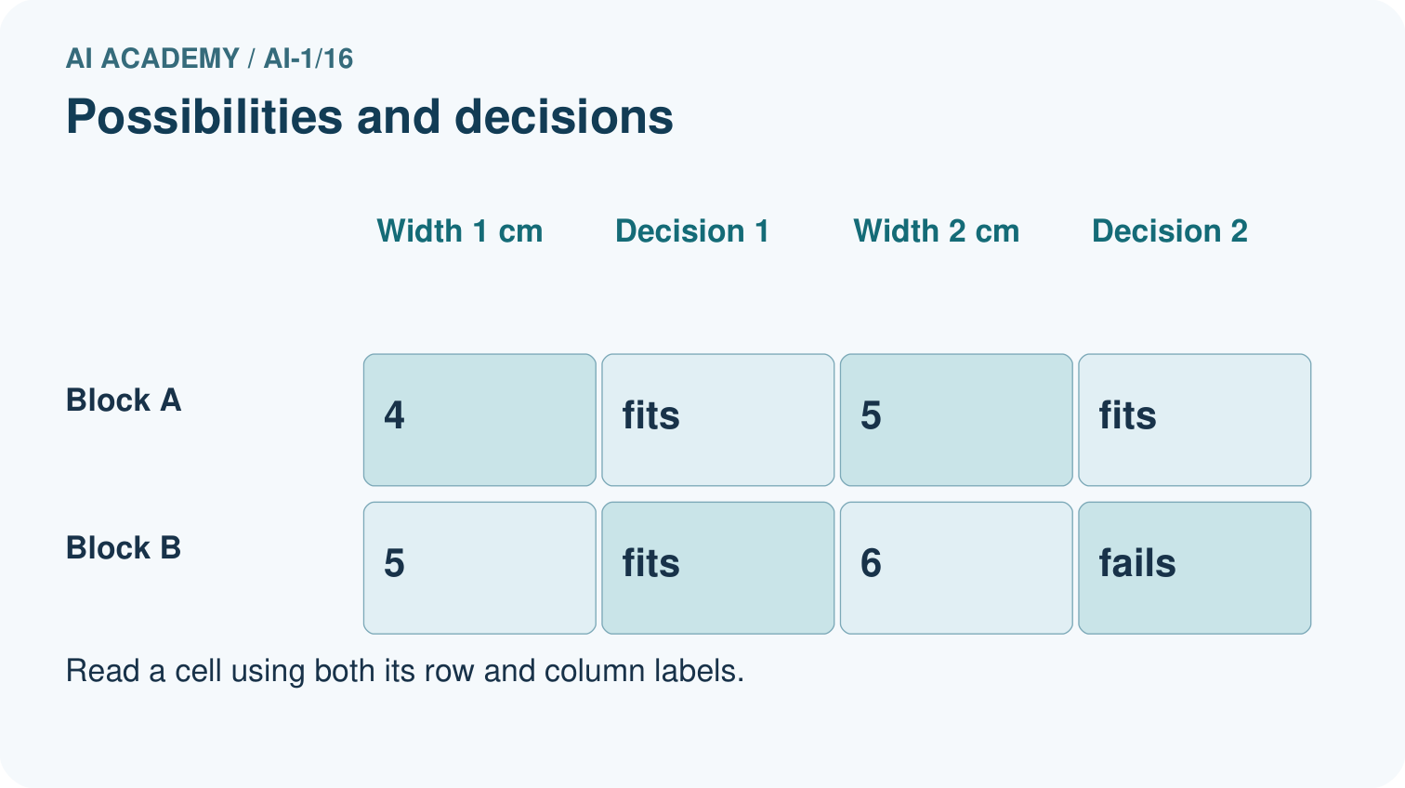
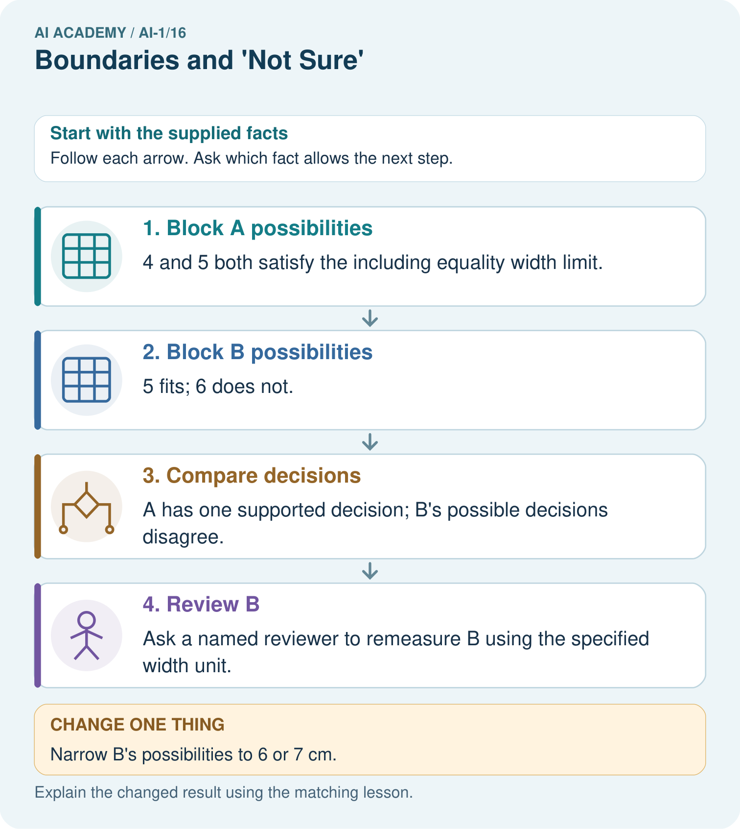

Read the picture one step at a time
Step | What happens and why
1. Block A possibilities | 4 and 5 both satisfy the including equality width limit.
2. Block B possibilities | 5 fits; 6 does not.
3. Compare decisions | A has one supported decision; B’s possible decisions disagree.
4. Review B | Ask a named reviewer to remeasure B using the specified width unit.
Match each pictured step to the supplied facts. This is a worked teaching case, not an independent assessment.

Why this result follows
Uncertainty about a number need not always create uncertainty about the decision. Every allowed width for A fits, so its width uncertainty does not affect acceptance. B straddles the boundary. Record both possibilities and request a better measurement instead of selecting the one that makes a preferred outcome.

What this example does not establish
A review path is not automatically accurate; its conclusion depends on relevant, better evidence.

Change one thing in the pictured case
Change: Narrow B’s possibilities to 6 or 7 cm.
Prediction: Both fail the width limit; rejection no longer depends on resolving their difference.
Reason: All remaining possibilities lead to the same decision.

Ask while showing the picture
Cover the result. Ask learners to name the inputs and predict the next step. Uncover one step, connect the icon to the actual procedure, and explain its evidence. Then change the supplied condition and compare. The picture is a representation; it does not document execution of a real AI model.

03. Demonstrate and guide practice

Demonstrate and guide practice

Board sequence
Write the given facts: A sorter handles clearly red and clearly blue cards. Purple and very dark cards arrive.
Write the question to explain: How should it handle each uncertain case?
Reveal after predictions: Use a review tray. Purple is outside the clear categories; darkness prevents observation. These are different uncertainty causes.
Keep for an independent attempt: A sorter knows pencils and books. You show a lunch box. Should it force a known label or ask for help? State a useful fallback.

Classroom dialogue
Ask: Which facts are given, and which would we have to assume? Learners mark relevant details before discussing answers.
Say: Predict first. Show the rule, information path or calculation that would produce the result. A correct guess is not yet an explanation.
Reveal reasoning one step at a time. Explain why a tempting alternative fails. Write units and denominators for arithmetic, trace conditions for decisions, and identify supporting sources for claims.
In pairs, one learner solves while the other checks evidence; exchange roles. Remove the worked answer before independent assessment.

Model these guided questions
Record the original 5-or-6 cm card, threshold-6 model version, possible predictions short and tall, and unresolved height. Request a reliable original reading or remeasurement. A supported 6 cm reading permits a tall prediction, with the correction documented. If no reliable value is obtained, retain no prediction and hold sorting under the policy. Exit: repeated runs show consistent computation on the guessed input; a reliable height is still needed.

Case-specific teaching sequence
Stage | Teacher action
Session 1 start 0 to 7 minutes | Retrieve the two threshold outcomes for 5 and 6. Distinguish an unclear input from a known model rule.
7 to 20 minutes | Trace every diagram row. State the complete-possibilities assumption and retain exact-height uncertainty even when predictions agree.
20 to 33 minutes | Complete W1 and W2. Ask students to identify which claim follows from both possible inputs and which claims still lack evidence.
33 to 45 minutes | Use W3 and the review table to match each missing fact to a useful source. Reject an assumed unit as a repair.
Session 2 start 0 to 8 minutes | Retrieve the difference between a new measurement and another run on an unchanged input.
8 to 23 minutes | Construct the guided review record and both endings. Require the unresolved path to stop without inventing a height.
23 to 38 minutes | Collect W4 independently. Look for all three possibility comparisons, an appropriate measurement check and limited claims.
38 to 45 minutes | Discuss W5 and the exit. A reviewer can preserve an unknown; human involvement alone is not correctness evidence.

Reduce help deliberately
Completion task: Assume the only possible heights are 8 and 9 cm. Apply tall at least 6 to each. Write a justified result statement and two things it does not establish. Do not invent a confidence percentage.
Teacher check: Both inputs predict tall, so the prediction is tall under both listed possibilities. This does not identify whether the exact height is 8 or 9 and does not establish agreement with the correct task label. Outside the exercise, completeness of the possibilities also needs evidence.
Start by identifying the given inputs together. Leave the intermediate steps blank. If needed, model one step, then withdraw that help on the next step. Move to a full trace only when the partial trace is understood. For partners, alternate explainer and checker; collect a response from every learner before discussion.

Individual reasoning check
Use the worked case for Uncertainty and review. Proposed explanation: “Two possible values imply equal probabilities”. Decide whether this explanation is supported. Point to the step or supplied fact that decides; explain your repair if needed.
Expected correction: A list of possibilities supplies no probabilities unless further evidence states them.
Collect explanations, not only yes/no votes. If a misunderstanding is common, re-model the relevant step for the class. If it affects a few learners, give a short targeted group explanation while others solve a more demanding variation.

Pictorial practice question
Which original block needs a better width before accepting or rejecting it? What should the reviewer do?

Reasoned teacher answer
B needs review because 5 fits and 6 fails. The reviewer should remeasure width in cm and retain the evidence.
Changed-case reasoning: Both fail the width limit; rejection no longer depends on resolving their difference. All remaining possibilities lead to the same decision.
Collect each learner’s explanation before discussion. Use the first missing connection between input, deciding step and result to choose support. This question is worked-case practice, not fresh mastery evidence.

04. Run the weekly evidence lab

Run the weekly evidence lab
Predict first, test honestly, and explain what the evidence means.
State your prediction before the result is known.
Complete the task: Find three boundary cases and design a 'need more info' output.
Keep a normal case and an edge case clearly separated.
Record what happened—even when it does not match your prediction.
Explain the result, one limitation, and the next useful test.
INDEPENDENCE After support is removed, repeat the proof with a fresh case.

Make the lab runnable
Use the concrete case as the shared normal case and the independent question as a second case. Each pair creates a boundary or missing-information case and predicts its result before testing. Keep the expected result separate from an observed mistake.
Record | What to capture
Input or evidence | Exact data, instruction or claim
Expected result | Answer or safe fallback declared before the run
Observed result | Actual result, including errors
Explanation | Rule, calculation or evidence explaining the outcome
Next test | One justified change and a new prediction

Diagnose and reteach
CLAIM TO REPAIR Not sure always means the system has failed.
For guessing, return to given facts and request a trace. For vocabulary without application, use one example and one non-example. For arithmetic errors, check the setup before the calculation. Finish with a different uncoached case before recording mastery.

Address these additional misconceptions
Two possible values imply equal probabilities: A list of possibilities supplies no probabilities unless further evidence states them.
Averaging guesses recovers the missing input: A calculated average is a new assumption, not an observed measurement.
Repeated identical outputs remove input uncertainty: Re-running unchanged information does not reveal a missing digit or unit.
A human reviewer can always settle the case: Require relevant evidence and allow an explicit unresolved outcome.

Match the support to the first error
What the response shows | Next teaching action
Missing or misread facts | Read the case aloud, mark supplied versus unknown facts, and let the learner restate it.
Wrong procedure | Return to the deciding step in the worked case. Contrast it with the proposed incorrect explanation.
Arithmetic or implementation error | Trace intermediate values or lines; preserve the first mismatch and retry that step.
Correct result without a reason | Ask for a trace and a changed case before marking independent understanding.
An unsupported wider claim | Ask which supplied evidence supports the claim and which further observation would be needed.
Offer an oral explanation, drawing, enlarged visual or fewer examples when that removes a reading/writing barrier. Keep the same reasoning goal. Stretch secure learners by changing a boundary or assumption and asking them to defend the effect, not simply by assigning more of the same questions.

05. Assess and explain the answers

Assess and explain the answers

Worked case answer
Use a review tray. Purple is outside the clear categories; darkness prevents observation. These are different uncertainty causes.

Independent question
A sorter knows pencils and books. You show a lunch box. Should it force a known label or ask for help? State a useful fallback.

Expected independent answer
It should flag an unfamiliar item and ask a person. A useful fallback is not sure, please review. A known label would overstate the available evidence.

What counts as evidence
Criterion | 0 points | 1 point | 2 points
Result | Incorrect or absent | Partly correct | Correct with necessary conditions
Reasoning | No supporting trace | Some steps | Clear mechanism, calculation or source support
Limit | Overclaims certainty | Vague limitation | Relevant uncertainty or missing fact
Transfer | Copies without adapting | Adapts with prompts | Solves a changed case independently
Use 6/8 as a classroom checkpoint, with 2 required for both Result and Reasoning. This is a proposed teaching rule, not a validated certification threshold. Do not count a coached answer as independent mastery; correct unsafe or unsupported claims regardless of total.

Feedback
Ask the learner to find the evidence that challenges this claim: “Not sure always means the system has failed.” Keep the first attempt and an uncoached retry separate.

Original transfer answer
Purple needs a policy for an uncovered or boundary category; remove the sleeve or obtain a usable observation for the hidden card; inspect definitions and adjudicate disagreement for conflicting labels. A review outcome is useful only when it leads to an appropriate action.

Explanations for the additional workbook examples

W1 Describe the uncertainty precisely
For a smudged height that could be 5 or 6 cm, state what is known, what is unknown and the two predictions under tall at least 6. Choose a check that could distinguish the heights. Explain why rerunning the threshold comparison cannot do that.
The rule and two stated possibilities are known; the actual height is unresolved. At 5 predict short, at 6 predict tall. Inspect the original readable record or remeasure. Repeating a calculation supplies no new information about which height was recorded.

W2 Keep a stable prediction within its limits
Assume the only possible heights are 8 and 9 cm. Apply tall at least 6 to each. Write a justified result statement and two things it does not establish. Do not invent a confidence percentage.
Both inputs predict tall, so the prediction is tall under both listed possibilities. This does not identify whether the exact height is 8 or 9 and does not establish agreement with the correct task label. Outside the exercise, completeness of the possibilities also needs evidence.

W3 Choose useful review evidence
A record says 60 but omits the unit. A reviewer suggests reading it as 60 cm because the model needs cm. Explain the problem, name the evidence to request and state the outcome if the unit cannot be established.
The required input format does not prove the original measurement’s unit. Ask for the original measurement record, instrument scale or recording instructions. If the unit cannot be established, retain no prediction with reason unresolved unit; do not silently assume cm or convert from an assumed unit.

W4 Transfer the method to distance
A paper model predicts far at a distance of at least 4 units, otherwise near, for whole-number distances 1 through 8. For each complete possibility set, compare predictions: 2 or 3; 3 or 4; 4 or 5. Identify the set requiring review before a single category can be stated. Design a relevant check and an unresolved ending. Limit the claims for the other two sets.
At 2 or 3 both predict near. At 3 predict near and at 4 far, so that set leaves the category unresolved. At 4 or 5 both predict far. Request a reliable distance reading in the stated units for the disputed set; if unavailable retain no single category and reason unresolved distance. The other two predictions are stable only across their listed possibilities, not verified as correct labels or exact distances.

W5 Review the reviewer’s conclusion
A reviewer cannot read the original tower card but chooses 6 cm because two models both predict tall when given 6. Explain why this fails to resolve the input. Write a more defensible review record and a next step.
Both models were given the same guessed input, so their agreement does not establish the actual measurement. Record that the original remains unreadable, the height is unresolved and no supported single-category output is available. Request a reliable new measurement or keep the sorting decision on hold under the stated policy.

Assess independent transfer
Selected case: A paper model predicts far at a distance of at least 4 units, otherwise near, for whole-number distances 1 through 8. For each complete possibility set, compare predictions: 2 or 3; 3 or 4; 4 or 5. Identify the set requiring review before a single category can be stated. Design a relevant check and an unresolved ending. Limit the claims for the other two sets.

Selected case answer
At 2 or 3 both predict near. At 3 predict near and at 4 far, so that set leaves the category unresolved. At 4 or 5 both predict far. Request a reliable distance reading in the stated units for the disputed set; if unavailable retain no single category and reason unresolved distance. The other two predictions are stable only across their listed possibilities, not verified as correct labels or exact distances.
Dimension | Evidence required
Explanation | Names the applicable idea or procedure and ties it to the supplied facts.
Trace and result | Preserves the given inputs and shows the relevant intermediate steps; distinguishes a prediction from an observed execution.
Limits | States the assumptions, missing evidence or conditions under which the result would change.
Record each dimension as not yet, with support, or independent. Accept a valid alternative procedure with a defensible trace. Do not penalise an honestly recorded model failure if the learner correctly explains its evidence and limits.

Feedback that the learner uses
Name the earliest unsupported step and give one action to repair it. Have the learner make that repair now and explain why. Then assess the relevant skill on a fresh, fully specified case. Confirm it was not previously practised with feedback; solve and check the new case before assigning it. A follow-up design prompt is a starting brief, not automatically an equivalent test.

06. Connect and extend learning

Connect and extend learning

Helpful Classroom Sorter
Add a not-sure branch, missing-information prompt, and human review destination to the sorter.
Keep the decision, input, result, explanation and remaining limitation in the project evidence record. Retrieve this record next week rather than restarting the project.

Support and stretch
Use physical cards, spoken explanations and a three-stage drawing. Read aloud without giving the answer. Stretch: compare two mechanisms with the same visible output and explain what evidence distinguishes them.

Exit reflection
Ask for one decision the learner can now justify and one situation requiring more evidence or human review. Confidence ratings are separate from correct independent performance.

Bridge to the next week
Next: Week 17: Prediction Is Not Fact. Retrieve today’s evidence and identify what carries forward and what is new.

Support and fresh reassessment
Use a number line and a separate card for each possibility. Keep known, unknown and requested evidence in three columns. Extension: add a third possibility that changes an apparently stable result and explain why completeness of the possibility list matters.
W4 is secure with near/near, near/far and far/far comparisons, review of the middle set, useful evidence and an unresolved ending. After support retry long at least 7 for whole cm lengths 1 through 10 using 4 or 5, 6 or 7, and 8 or 9: short/short, short/long, long/long. Require limits as well as labels.
Week 17 separates a prediction from the later observation or comparison evidence used to judge it, preserving both records.

Plan the delayed return
Suggested return points in this level: ai-1/17, ai-1/19, ai-1/22. Use actual classroom dates, adjusting for holidays and gaps. One, three and six teaching weeks are scheduling choices, not a claimed optimal spacing.
At a delayed check, ask for the idea from memory and a changed application. Compare with the earlier independent response and record support used. For a new level, revisit the previous capstone before checking the new prerequisites.
Record | Teacher evidence
Learner code and date
Concept and case used; prior exposure
Explanation / trace / limits
Support and first repair
Changed case and delayed outcome
Next teaching action
Use the evidence to choose reteaching or the next step. A completed page, confidence rating or attractive project does not by itself demonstrate understanding.

Project evidence from this case
Add explicit review paths to the sorter, including unresolved input, responsible person and evidence needed.

