AI ACADEMY · TEACHER · ai-1/19

Similarity
Project: Helpful Classroom Sorter

01. Similarity

Teach the learning cycle
Primary target: Calculate similarity using explicitly selected features and a stated scoring rule
Session | Sequence and minutes | Resources
Session 1 · Understand · 45 min | 0–7: recall and prerequisite; 7–15: inspect the concrete case and predict; 15–30: teacher models the worked trace; 30–40: learners explain a step using the text and visual; 40–45: check the core idea. | Sections 1–6; record the brief recall in the workbook.
Session 2 · Practise · 45 min | 0–5: retrieve the procedure; 5–15: W2 completion practice; 15–23: explain and check with a partner; 23–30: each learner answers the misconception check; 30–40: targeted reteaching or a harder variation; 40–45: prepare the investigation. | Sections 7–10; use the matching workbook W2 and misconception check.
Session 3 · Investigate and transfer · 45 min | 0–5: retrieve the decision rule; 5–20: investigate or trace; 20–30: start the independent case; 30–38: connect the project; 38–43: act on feedback; 43–45: plan the return check. | Sections 9 and 11–14. Give extra time to finish the full task set; use Section 15 when the week includes a coding lab.
This is a starting allocation of 135 minutes, not a validated duration. Preserve all named topics. Schedule extra time for connected examples, the full investigation, independent cases and project building. Repeated copies of a case share one recorded attempt; they are not new evidence.

Retrieval answer guidance

Confidence Is Not Correctness
Without opening the old lesson, explain one key idea from Confidence Is Not Correctness. Give an example and a mistake that the idea helps you avoid.
Look for: Distinguish a confidence claim from evidence that a prediction was correct
Reference example, not the only acceptable wording: The learner replaced the documented score meaning with a probability interpretation. Report 80 of 100 feature-match points. To claim a chance of correctness, a defined probability method and relevant outcome evaluation would be needed.

Boundaries and 'Not Sure'
Without opening the old lesson, explain one key idea from Boundaries and 'Not Sure'. Give an example and a mistake that the idea helps you avoid.
Look for: Identify a specific source of uncertainty and explain how it affects a prediction
Reference example, not the only acceptable wording: The rule and two stated possibilities are known; the actual height is unresolved. At 5 predict short, at 6 predict tall. Inspect the original readable record or remeasure. Repeating a calculation supplies no new information about which height was recorded.

Learning from Examples
Without opening the old lesson, explain one key idea from Learning from Examples. Give an example and a mistake that the idea helps you avoid.
Look for: Fit a threshold by tracing predictions and counting disagreements for every candidate
Reference example, not the only acceptable wording: Threshold 3 predicts short, tall, tall, tall, disagreeing only at 4 cm: count 1. Threshold 7 predicts short, short, short, tall, disagreeing only at 6 cm: count 1. Reset the tally for each candidate.
Use the student module and workbook section with this exact week title. The worked case, independent question and answers below form one aligned lesson sequence.

What the learner must demonstrate
A reader wants mystery and short books. A has both traits, B only mystery, C only short. Score one point per matching trait. The reader now says short is essential. Explain how the decision should change.

Concept to explain
Recommendations often begin by comparing selected traits, not whole objects.
Term | Meaning
similarity | degree of likeness under chosen traits
distance | numeric or ordered difference between representations
weight | importance assigned to a feature
nearest neighbor | item with smallest chosen distance

Prepare the class
Use the supplied scenario, student illustrations and blank paper. For numeric work, offer counters or a calculator after learners show the setup. Fictional records are supplied; personal data and paid accounts are unnecessary.
Allow 80 minutes: recall 8; explanation 12; worked demonstration 15; guided practice 20; independent assessment 15; project and reflection 10. Extend the lab into a second session when needed.

Preparation for the connected explanation
Treat similarity as a defined computation with a purpose. This week uses exact category matching and whole-number weights, avoiding formal distance geometry. Keep ranking, probability and eligibility distinct. Students should be able to explain changes in results from the feature contributions rather than memorise a winning item.

Readiness answer
No. Read the score definition and selected features. Matching-feature points describe a comparison rule, not a probability of suitability.
Target and candidate card records from the lesson, with D and incomplete E added later
Counters for colour, shape and texture contributions
Book records J, K and L from W4 with feature headings

End goal for the pictorial case
By the end, I can calculate similarity under a declared feature rule and explain a changed ranking.
This added worked case illustrates the week’s main idea. Retain all original and connected topics; schedule its practice within the teaching cycle.

02. Explain the mechanism

Explain the mechanism
Follow the information instead of imagining magic inside the machine.
INPUT represented traits for candidate items
PROCESS compare distances using selected features
OUTPUT nearest or most similar items
CORE IDEA Recommendations often begin by comparing selected traits, not whole objects.
UNDER THE HOOD Similarity is a designed measure over represented features. Distance changes with feature selection, scaling, weighting, and missing values. Nearest does not mean identical, best, or fair.
Draw a fresh example with all three stages:
Every step connects a claim to observable evidence.
CASE A book can be nearest to another by reading level, topic, length, or mood; the chosen features and scales determine the neighbor.
STEP 1 — OBSERVE represented traits for candidate items
STEP 2 — TRACE compare distances using selected features
STEP 3 — CONCLUDE nearest or most similar items
MODEL REASONING Plot items consistently, define how each axis is measured, and compare distances. A different axis or weight can change the nearest item without any item moving in the real world.
DO NOT OVERCLAIM Similarity is a tool designed for a purpose, not a universal property.
What new evidence could change this answer?

Concrete teaching case
Book A has animals and adventure; B has animals only; C has neither. A reader wants both traits.
Rank by number of matching traits.

Exact explanation to model
A scores 2, B 1, C 0. Ranking depends on the chosen traits; it is not a universal measure of book quality.

Explain the added worked example
Two objects can be alike in colour and different in shape. A computer comparison needs a precise answer to similar in what way. Select features, state how their values are compared, and define what a larger score means. The result belongs to that rule; it is not a universal judgment about the objects.
Our target card is red, round and smooth. Three candidate cards are A: red, round, rough; B: blue, square, smooth; C: red, square, rough. First give one point for each feature that exactly matches the target and zero for each known mismatch. Add the points. Colour, shape and texture are the only selected features.
This paper exercise uses complete category values with agreed spelling. Real records can be missing or uncertain. Do not silently treat an unknown texture as a known mismatch or copy a value from the target. First identify whether the information supports the comparison.
A receives 1 for colour, 1 for shape and 0 for texture: total 2. B receives 0, 0 and 1: total 1. C receives 1, 0 and 0: total 1. Record the contributions, not just the totals, so another learner can check the computation.
A is most similar among these three candidates under this rule. That sentence names the candidate set and the rule. It does not say A is identical to the target, has the right texture or will be the best choice for a task that needs smooth material.

Key terms
Term | Meaning
Similarity | Closeness under a stated choice of features and comparison rule
Feature match | Agreement between two recorded values for a selected feature
Weight | The number of points assigned to a feature match in this scoring rule
Tie | Two or more candidates sharing the same score
Candidate | An item being considered in a comparison

Model the reasoning aloud
Use the complete worked example below before asking learners to complete W2. Reveal a small part, invite a prediction, then explain the deciding step. These teacher notes contain solutions; do not reveal the independent case answer during modelling.
A | 1 + 1 | 0 | 2
B | 0 + 0 | 3 | 3
C | 1 + 0 | 0 | 1
Suppose texture matters more for the stated comparison. Keep colour and shape worth one point each, but give three points for a texture match. B now scores 3 and becomes the unique highest scoring candidate. No card changed; the rule changed. Record both versions rather than overwriting the first result.
Weights express priorities in this designed rule. They need a reason connected to the task and should be set before inspecting the final evaluation results. A convenient winner does not justify a weight. If smooth texture is required without exception, use a requirement check rather than hoping a weighted score will always enforce it.
Thinking move | Teacher prompt
Plan | What is given? What is the question? Which procedure fits these facts?
Do | Point to each input and intermediate step in the worked trace. Name the rule that allows the next step.
Check | Does the output answer the question? Which assumption or limitation prevents a larger claim?
Use the diagram and verbal explanation together. Ask learners to match a sentence to a specific visual step; do not assign learners fixed visual or auditory learning styles.

A pictorial worked case: Similarity
A fictional craft-card matcher compares each candidate with a target.

The facts we will use
Target: red, round, smooth. A: red,square,smooth. B: blue,round,smooth. C: red,round,rough.
Initially each exact feature match scores 1; return all highest scorers.
For the second comparison only, colour and shape matches score 1 each and a texture match scores 3.
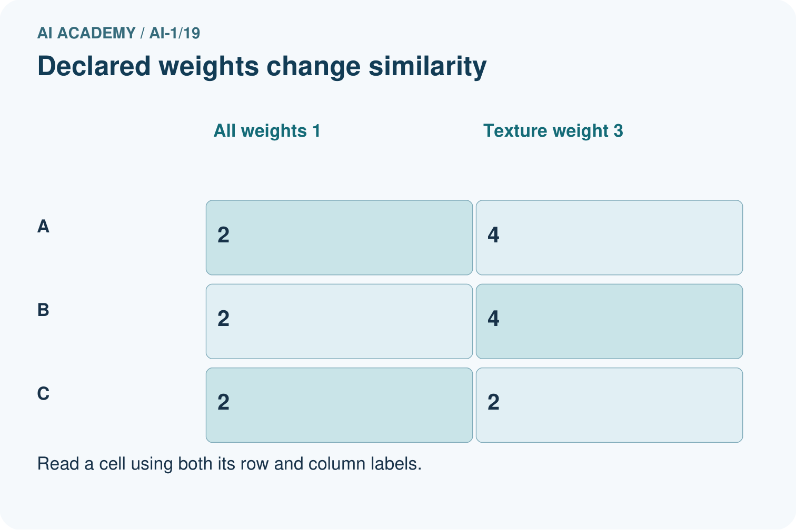
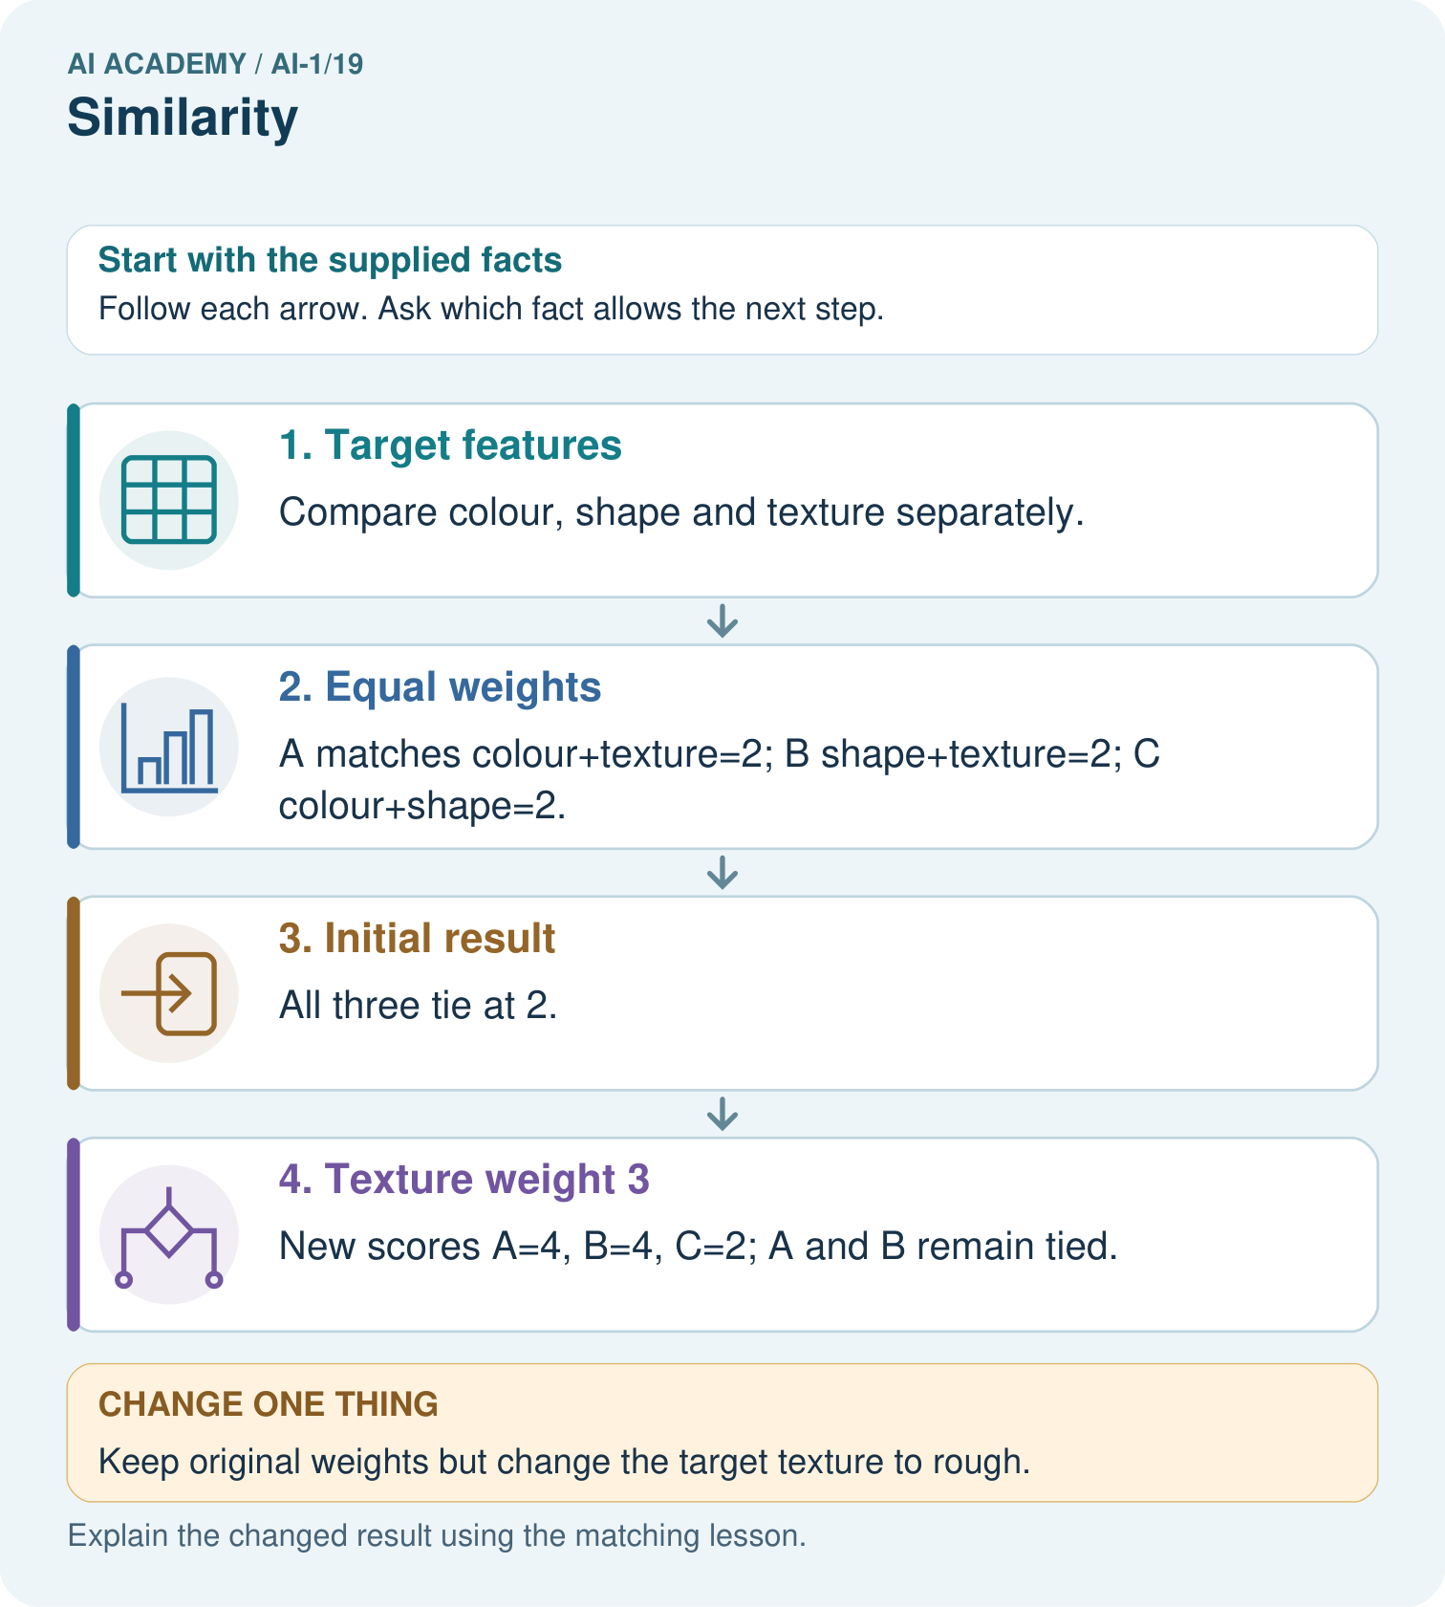

Read the picture one step at a time
Step | What happens and why
1. Target features | Compare colour, shape and texture separately.
2. Equal weights | A matches colour+texture=2; B shape+texture=2; C colour+shape=2.
3. Initial result | All three tie at 2.
4. Texture weight 3 | New scores A=4, B=4, C=2; A and B remain tied.
Match each pictured step to the supplied facts. This is a worked teaching case, not an independent assessment.

Why this result follows
Similarity is defined by the chosen representation and weights. The cards did not change when texture gained weight; the comparison rule did. Two high scores need not mean two identical cards. A complete rule also says what to do with tied scores, rather than choosing whichever appears first by accident.

What this example does not establish
A high feature-match score does not establish usefulness or suitability beyond the features represented.

Change one thing in the pictured case
Change: Keep original weights but change the target texture to rough.
Prediction: C scores 3; A and B each score 1.
Reason: C now matches all three target features; the others lose their smooth-texture match.

Ask while showing the picture
Cover the result. Ask learners to name the inputs and predict the next step. Uncover one step, connect the icon to the actual procedure, and explain its evidence. Then change the supplied condition and compare. The picture is a representation; it does not document execution of a real AI model.

03. Demonstrate and guide practice

Demonstrate and guide practice

Board sequence
Write the given facts: Book A has animals and adventure; B has animals only; C has neither. A reader wants both traits.
Write the question to explain: Rank by number of matching traits.
Reveal after predictions: A scores 2, B 1, C 0. Ranking depends on the chosen traits; it is not a universal measure of book quality.
Keep for an independent attempt: Compare books using topic only. Book A is about space with a red cover; B is about space with a blue cover; C is about dogs with a red cover. Which matches A best?

Classroom dialogue
Ask: Which facts are given, and which would we have to assume? Learners mark relevant details before discussing answers.
Say: Predict first. Show the rule, information path or calculation that would produce the result. A correct guess is not yet an explanation.
Reveal reasoning one step at a time. Explain why a tempting alternative fails. Write units and denominators for arithmetic, trace conditions for decisions, and identify supporting sources for claims.
In pairs, one learner solves while the other checks evidence; exchange roles. Remove the worked answer before independent assessment.

Model these guided questions
Original totals A 2, B 1, C 1, D 2, so return A and D. With texture worth 3: A 2, B 3, C 1, D 4, so return D. D combines shape and texture. Scores count weighted matches, not observed chances of suitability. Exit: the winner depends on weights and candidate set; A’s first result is not a universal fact.

Case-specific teaching sequence
Stage | Teacher action
Session 1 start 0 to 7 minutes | Retrieve why a point score is not automatically a probability.
7 to 20 minutes | Trace the three diagram rows with one counter per match. State the target and candidates aloud.
20 to 33 minutes | Complete W1 and W2. Change only the texture weight and compare the two recorded results.
33 to 45 minutes | Use W3 to distinguish a missing value from a known mismatch. Require a recorded pause under the classroom policy.
Session 2 start 0 to 8 minutes | Retrieve the scoring rule and why it depends on selected features.
8 to 23 minutes | Introduce D and complete the guided task. Return all tied maximum scores and explain the weighted result.
23 to 38 minutes | Collect W4 independently. Look for all ties and the distinction between similarity and a required language.
38 to 45 minutes | Discuss W5 and the exit. End with the need to document feature choices and effective weights.

Reduce help deliberately
Completion task: Keep the same target and candidates but make texture worth 3 points, with colour and shape worth 1 each. Recalculate A, B and C. Explain what changed and what stayed the same.
Teacher check: A stays at 2, B becomes 3 and C stays at 1, so B wins. Only the texture weight changed; candidate values, target and other weights stayed the same. The result is specific to this new comparison rule.
Start by identifying the given inputs together. Leave the intermediate steps blank. If needed, model one step, then withdraw that help on the next step. Move to a full trace only when the partial trace is understood. For partners, alternate explainer and checker; collect a response from every learner before discussion.

Individual reasoning check
Use the worked case for Similarity and selected features. Proposed explanation: “Similar has one objective meaning for every task”. Decide whether this explanation is supported. Point to the step or supplied fact that decides; explain your repair if needed.
Expected correction: Name the features, comparison rule and purpose.
Collect explanations, not only yes/no votes. If a misunderstanding is common, re-model the relevant step for the class. If it affects a few learners, give a short targeted group explanation while others solve a more demanding variation.

Pictorial practice question
Point to the matches supporting C’s new score and explain why there is no tie.

Reasoned teacher answer
C matches red, round and rough: 3. A matches only red and B only round: 1 each.
Changed-case reasoning: C scores 3; A and B each score 1. C now matches all three target features; the others lose their smooth-texture match.
Collect each learner’s explanation before discussion. Use the first missing connection between input, deciding step and result to choose support. This question is worked-case practice, not fresh mastery evidence.

04. Run the weekly evidence lab

Run the weekly evidence lab
Predict first, test honestly, and explain what the evidence means.
State your prediction before the result is known.
Complete the task: Create a trait map and find two different 'nearest' items.
Keep a normal case and an edge case clearly separated.
Record what happened—even when it does not match your prediction.
Explain the result, one limitation, and the next useful test.
INDEPENDENCE After support is removed, repeat the proof with a fresh case.

Make the lab runnable
Use the concrete case as the shared normal case and the independent question as a second case. Each pair creates a boundary or missing-information case and predicts its result before testing. Keep the expected result separate from an observed mistake.
Record | What to capture
Input or evidence | Exact data, instruction or claim
Expected result | Answer or safe fallback declared before the run
Observed result | Actual result, including errors
Explanation | Rule, calculation or evidence explaining the outcome
Next test | One justified change and a new prediction

Diagnose and reteach
CLAIM TO REPAIR Two objects have one universal similarity score.
For guessing, return to given facts and request a trace. For vocabulary without application, use one example and one non-example. For arithmetic errors, check the setup before the calculation. Finish with a different uncoached case before recording mastery.

Address these additional misconceptions
Similar has one objective meaning for every task: Name the features, comparison rule and purpose.
The highest score proves all requirements are met: Check mandatory requirements separately.
Equal scores can be resolved by whichever row appears first: Use the stated tie policy; here return all highest scorers.
Missing texture deserves zero as if it were rough: Retain an unknown and apply the stated missing-value policy.

Match the support to the first error
What the response shows | Next teaching action
Missing or misread facts | Read the case aloud, mark supplied versus unknown facts, and let the learner restate it.
Wrong procedure | Return to the deciding step in the worked case. Contrast it with the proposed incorrect explanation.
Arithmetic or implementation error | Trace intermediate values or lines; preserve the first mismatch and retry that step.
Correct result without a reason | Ask for a trace and a changed case before marking independent understanding.
An unsupported wider claim | Ask which supplied evidence supports the claim and which further observation would be needed.
Offer an oral explanation, drawing, enlarged visual or fewer examples when that removes a reading/writing barrier. Keep the same reasoning goal. Stretch secure learners by changing a boundary or assumption and asking them to defend the effect, not simply by assigning more of the same questions.

05. Assess and explain the answers

Assess and explain the answers

Worked case answer
A scores 2, B 1, C 0. Ranking depends on the chosen traits; it is not a universal measure of book quality.

Independent question
Compare books using topic only. Book A is about space with a red cover; B is about space with a blue cover; C is about dogs with a red cover. Which matches A best?

Expected independent answer
B matches A by topic. C shares cover colour, but colour was not the chosen comparison trait. Similarity depends on what we choose to compare.

What counts as evidence
Criterion | 0 points | 1 point | 2 points
Result | Incorrect or absent | Partly correct | Correct with necessary conditions
Reasoning | No supporting trace | Some steps | Clear mechanism, calculation or source support
Limit | Overclaims certainty | Vague limitation | Relevant uncertainty or missing fact
Transfer | Copies without adapting | Adapts with prompts | Solves a changed case independently
Use 6/8 as a classroom checkpoint, with 2 required for both Result and Reasoning. This is a proposed teaching rule, not a validated certification threshold. Do not count a coached answer as independent mastery; correct unsafe or unsupported claims regardless of total.

Feedback
Ask the learner to find the evidence that challenges this claim: “Two objects have one universal similarity score.” Keep the first attempt and an uncoached retry separate.

Original transfer answer
Initial scores are A=2, B=1, C=1. With short essential, exclude B; A remains preferred to C if mystery still matters. Similarity scores encode selected preferences; they do not establish universal quality or guarantee enjoyment.

Explanations for the additional workbook examples

W1 Show the contributions before the total
For the red round smooth target and candidates A, B and C in the lesson, record the colour, shape and texture contributions under one point per match. Give each total and identify every highest scoring candidate.
A: 1, 1, 0 gives 2. B: 0, 0, 1 gives 1. C: 1, 0, 0 gives 1. A is the only highest scoring candidate among A, B and C under equal weights.

W2 Explain a changed winner
Keep the same target and candidates but make texture worth 3 points, with colour and shape worth 1 each. Recalculate A, B and C. Explain what changed and what stayed the same.
A stays at 2, B becomes 3 and C stays at 1, so B wins. Only the texture weight changed; candidate values, target and other weights stayed the same. The result is specific to this new comparison rule.

W3 Keep unknown separate from different
Candidate E is red and round but its texture is missing. A learner assigns zero for texture and declares E fully scored. Apply our classroom policy. State the known contributions, the missing information and what must happen before a final ranking.
Colour and shape contribute 1 each, giving a known subtotal of 2 under the original rule. Texture is unknown, not a known mismatch. Pause the final ranking, request E’s texture, and record the unresolved feature if it cannot be obtained.

W4 Transfer the comparison to books
A target book has topic space, format comic and language English. Candidates are J: space, prose, English; K: animals, comic, English; L: space, comic, Spanish. Give 1 point per exact match and return all tied highest scorers. Then make topic worth 3 points while keeping the other weights at 1. Report both sets of totals and winners. Explain why a winner may still fail a requirement to read English.
Equal weights: J 2, K 2, L 2; all three tie. Topic weighted 3: J 4, K 2, L 4; J and L tie. L remains a highest scorer despite Spanish language, so weighted similarity does not enforce the English requirement. Check language eligibility separately if English is required.

W5 Notice an accidental extra weight
A designer adds a second colour column that copies the first and gives both columns one point. They say no feature has been given extra importance because every column has equal weight. Explain the problem and propose a clearer rule.
Colour now contributes twice for one underlying match, so it has effective weight 2 while other features have weight 1. Remove the duplicate or state and justify colour’s weight explicitly. Equal column weights do not guarantee equal importance for the underlying features.

Assess independent transfer
Selected case: A target book has topic space, format comic and language English. Candidates are J: space, prose, English; K: animals, comic, English; L: space, comic, Spanish. Give 1 point per exact match and return all tied highest scorers. Then make topic worth 3 points while keeping the other weights at 1. Report both sets of totals and winners. Explain why a winner may still fail a requirement to read English.

Selected case answer
Equal weights: J 2, K 2, L 2; all three tie. Topic weighted 3: J 4, K 2, L 4; J and L tie. L remains a highest scorer despite Spanish language, so weighted similarity does not enforce the English requirement. Check language eligibility separately if English is required.
Dimension | Evidence required
Explanation | Names the applicable idea or procedure and ties it to the supplied facts.
Trace and result | Preserves the given inputs and shows the relevant intermediate steps; distinguishes a prediction from an observed execution.
Limits | States the assumptions, missing evidence or conditions under which the result would change.
Record each dimension as not yet, with support, or independent. Accept a valid alternative procedure with a defensible trace. Do not penalise an honestly recorded model failure if the learner correctly explains its evidence and limits.

Feedback that the learner uses
Name the earliest unsupported step and give one action to repair it. Have the learner make that repair now and explain why. Then assess the relevant skill on a fresh, fully specified case. Confirm it was not previously practised with feedback; solve and check the new case before assigning it. A follow-up design prompt is a starting brief, not automatically an equivalent test.

06. Connect and extend learning

Connect and extend learning

Helpful Classroom Sorter
Choose two useful item traits for similarity-based sorting and explain why each deserves its weight.
Keep the decision, input, result, explanation and remaining limitation in the project evidence record. Retrieve this record next week rather than restarting the project.

Support and stretch
Use physical cards, spoken explanations and a three-stage drawing. Read aloud without giving the answer. Stretch: compare two mechanisms with the same visible output and explain what evidence distinguishes them.

Exit reflection
Ask for one decision the learner can now justify and one situation requiring more evidence or human review. Confidence ratings are separate from correct independent performance.

Bridge to the next week
Next: Week 20: Recommendations. Retrieve today’s evidence and identify what carries forward and what is new.

Support and fresh reassessment
Place one row of counters under each feature heading. Keep the target visible while checking candidates. Extension: add a feature that is irrelevant to the stated purpose and show how it could change the winner without improving usefulness.
W4 is secure with 2/2/2 then 4/2/4, all candidates then J and L as winners, and a separate English eligibility check. After support retry topic weight 2: totals 3/2/3, J and L still tie. Require contribution explanations, not only totals.
Week 20 uses explicit scores and requirements to form recommendations, then examines what feedback can and cannot establish.

Plan the delayed return
Suggested return points in this level: ai-1/20, ai-1/22, ai-1/25. Use actual classroom dates, adjusting for holidays and gaps. One, three and six teaching weeks are scheduling choices, not a claimed optimal spacing.
At a delayed check, ask for the idea from memory and a changed application. Compare with the earlier independent response and record support used. For a new level, revisit the previous capstone before checking the new prerequisites.
Record | Teacher evidence
Learner code and date
Concept and case used; prior exposure
Explanation / trace / limits
Support and first repair
Changed case and delayed outcome
Next teaching action
Use the evidence to choose reteaching or the next step. A completed page, confidence rating or attractive project does not by itself demonstrate understanding.

Project evidence from this case
Declare sorter similarity features, weights and tie behavior before using scores to explain recommendations.

