AI ACADEMY · TEACHER · ai-1/20

Recommendations
Project: Helpful Classroom Sorter

01. Recommendations

Teach the learning cycle
Primary target: Apply eligibility requirements before ranking candidates by preferences
Session | Sequence and minutes | Resources
Session 1 · Understand · 45 min | 0–7: recall and prerequisite; 7–15: inspect the concrete case and predict; 15–30: teacher models the worked trace; 30–40: learners explain a step using the text and visual; 40–45: check the core idea. | Sections 1–6; record the brief recall in the workbook.
Session 2 · Practise · 45 min | 0–5: retrieve the procedure; 5–15: W2 completion practice; 15–23: explain and check with a partner; 23–30: each learner answers the misconception check; 30–40: targeted reteaching or a harder variation; 40–45: prepare the investigation. | Sections 7–10; use the matching workbook W2 and misconception check.
Session 3 · Investigate and transfer · 45 min | 0–5: retrieve the decision rule; 5–20: investigate or trace; 20–30: start the independent case; 30–38: connect the project; 38–43: act on feedback; 43–45: plan the return check. | Sections 9 and 11–14. Give extra time to finish the full task set; use Section 15 when the week includes a coding lab.
This is a starting allocation of 135 minutes, not a validated duration. Preserve all named topics. Schedule extra time for connected examples, the full investigation, independent cases and project building. Repeated copies of a case share one recorded attempt; they are not new evidence.

Retrieval answer guidance

Similarity
Without opening the old lesson, explain one key idea from Similarity. Give an example and a mistake that the idea helps you avoid.
Look for: Calculate similarity using explicitly selected features and a stated scoring rule
Reference example, not the only acceptable wording: A: 1, 1, 0 gives 2. B: 0, 0, 1 gives 1. C: 1, 0, 0 gives 1. A is the only highest scoring candidate among A, B and C under equal weights.

Prediction Is Not Fact
Without opening the old lesson, explain one key idea from Prediction Is Not Fact. Give an example and a mistake that the idea helps you avoid.
Look for: Separate a recorded prediction from the observation used to check it
Reference example, not the only acceptable wording: Input height 6 cm; prediction far because 6 is at least 6; observed distance 3 units; observed category near because 3 is below 4; mismatch. Height is available to the model before the trial, while travel distance is measured afterward to check its prediction.

Build a Human Classifier
Without opening the old lesson, explain one key idea from Build a Human Classifier. Give an example and a mistake that the idea helps you avoid.
Look for: Construct a classifier with a stated input format, selected rule and recorded output
Reference example, not the only acceptable wording: Require a present height, unit cm, a whole number and range 1 through 10 inclusive. For example, 7 cm is accepted; blank is missing, 60 mm has the wrong unit and 11 cm is outside the range. Fractional values such as 4.5 cm also fail. The contract defines accepted inputs; it does not list only the fitting records or establish prediction correctness.
Use the student module and workbook section with this exact week title. The worked case, independent question and answers below form one aligned lesson sequence.

What the learner must demonstrate
A system shows only adventure books and records only adventure clicks. It concludes the reader dislikes poetry. Explain the missing evidence and propose a small test.

Concept to explain
A recommender ranks possibilities using goals, information, and tradeoffs.
Term | Meaning
ranking | ordered list from higher to lower priority
objective | goal the scoring process tries to satisfy
tradeoff | gain in one goal that may reduce another
diversity | meaningful variety among recommended options

Prepare the class
Use the supplied scenario, student illustrations and blank paper. For numeric work, offer counters or a calculator after learners show the setup. Fictional records are supplied; personal data and paid accounts are unnecessary.
Allow 80 minutes: recall 8; explanation 12; worked demonstration 15; guided practice 20; independent assessment 15; project and reflection 10. Extend the lab into a second session when needed.

Preparation for the connected explanation
This is an explicit paper recommender, not a claim that all recommenders use the same algorithm. Separate eligibility, scoring, exposure and feedback meaning. The feedback-loop concept is supported by the primary research Degenerate Feedback Loops in Recommender Systems, https://arxiv.org/abs/1902.10730. All task records are fictional.

Readiness answer
No. Eligibility requirements must be checked separately. A high preference score does not make an ineligible item suitable.
Book records J through M and requirement and preference cards
A feedback log with item, exposure, event and optional stated reason
Activity records A through D for the independent task

End goal for the pictorial case
By the end, I can filter requirements before ranking preferences and avoid overinterpreting clicks.
This added worked case illustrates the week’s main idea. Retain all original and connected topics; schedule its practice within the teaching cycle.

02. Explain the mechanism

Explain the mechanism
Follow the information instead of imagining magic inside the machine.
INPUT reader goals and candidate-book traits
PROCESS score and rank candidates with chosen tradeoffs
OUTPUT ordered recommendations plus reasons
CORE IDEA A recommender ranks possibilities using goals, information, and tradeoffs.
UNDER THE HOOD Recommendation is ranking, not merely classification. An objective combines relevance signals and constraints; tradeoffs may include familiarity, diversity, novelty, safety, and availability. The top score reflects the objective, not universal quality.
Draw a fresh example with all three stages:
Every step connects a claim to observable evidence.
CASE Two readers can receive different book rankings because their goals, reading level, interests, and novelty preferences differ.
STEP 1 — OBSERVE reader goals and candidate-book traits
STEP 2 — TRACE score and rank candidates with chosen tradeoffs
STEP 3 — CONCLUDE ordered recommendations plus reasons
MODEL REASONING Use the same transparent scoring method with each reader's stated preferences. Different inputs create different totals. Report tradeoffs, ties, and one option outside the top rank to preserve choice.
DO NOT OVERCLAIM A recommendation optimizes chosen goals and data; it does not discover what a person truly wants.
What new evidence could change this answer?

Concrete teaching case
A recommender suggests adventure books after one adventure-book choice.
Explain its evidence and limitation.

Exact explanation to model
The past choice supports considering adventure, but does not capture every interest. Ask for feedback and offer variety.

Explain the added worked example
A recommendation suggests an option for a particular purpose. Start with requirements: conditions every suggested item must meet. Then use preferences to rank the eligible options. An item that fails a requirement cannot make up for it by collecting more preference points.
A fictional reader needs an available English book. The reader prefers topic space and format comic. BookRec1 gives eligible books 2 points for space and 1 for comic; a known mismatch gives 0. It returns every eligible book tied for the highest score. If none are eligible, it reports no eligible option rather than ignoring a requirement.
The candidates are J: space, prose, English, available; K: animals, comic, English, available; L: space, comic, Spanish, available; M: space, comic, English, unavailable. These are invented records. The purpose is to trace a recommendation, not to infer anything about real students or collect their personal preferences.
J passes both requirements and scores 2. K passes and scores 1. L fails the English requirement; M fails availability. Do not place L or M above J because they would earn 3 preference points. They are excluded before the eligible scores are compared.
A faithful explanation says J is available in English and has the highest eligible score because its space topic matches the stated preference. It should also mention that J is prose, not comic. Claiming that the system knows the reader will love J would go beyond the computation and the evidence.

Key terms
Term | Meaning
Eligibility | Whether an item meets the requirements for consideration
Preference | A desired feature used to rank eligible choices
Recommendation | A suggested option produced under a stated process
Exposure | An opportunity for a person to see an item
Feedback loop | A process in which earlier recommendations influence the feedback used for later recommendations

Model the reasoning aloud
Use the complete worked example below before asking learners to complete W2. Reveal a small part, invite a prediction, then explain the deciding step. These teacher notes contain solutions; do not reveal the independent case answer during modelling.
J was shown | There was a recorded exposure | The reader noticed or liked it
J was clicked | A recorded interaction occurred | The reader enjoyed the book
Reader said J was too long | A stated reason in this context | All space books are unwanted
K was never shown | No exposure recorded for K | The reader rejected K
A click can reflect interest, curiosity or a mistaken tap. No click can reflect a missed display, lack of time or a decision not to choose it. Preserve the observed event separately from any interpretation. More direct feedback may clarify a reason, but one response still describes one person and occasion.
Useful feedback records name the item, what was shown, the system version, the event and any stated reason. Use only information needed for the task. Our paper exercises use invented feedback; they do not require accounts or recording classmates’ browsing behaviour.
Thinking move | Teacher prompt
Plan | What is given? What is the question? Which procedure fits these facts?
Do | Point to each input and intermediate step in the worked trace. Name the rule that allows the next step.
Check | Does the output answer the question? Which assumption or limitation prevents a larger claim?
Use the diagram and verbal explanation together. Ask learners to match a sentence to a specific visual step; do not assign learners fixed visual or auditory learning styles.

A pictorial worked case: Recommendations
A fictional classroom break chooser recommends a suitable paper activity.

The facts we will use
Must be quiet and take at most 12 minutes. Score 2 for puzzles and 1 for solo.
A puzzle,solo,noisy,8 min; B puzzle,group,quiet,12 min; C drawing,solo,quiet,10 min.
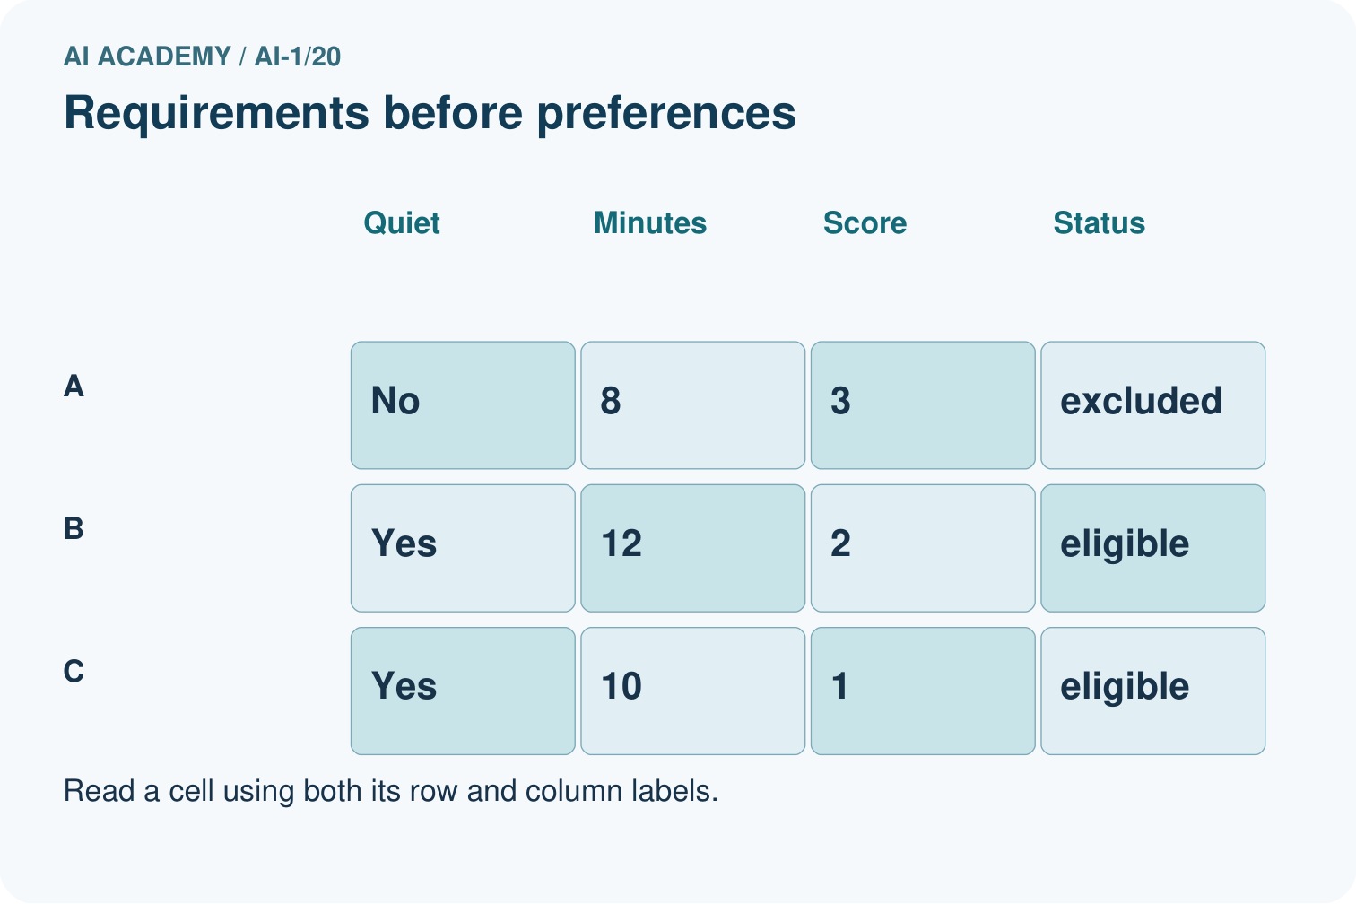
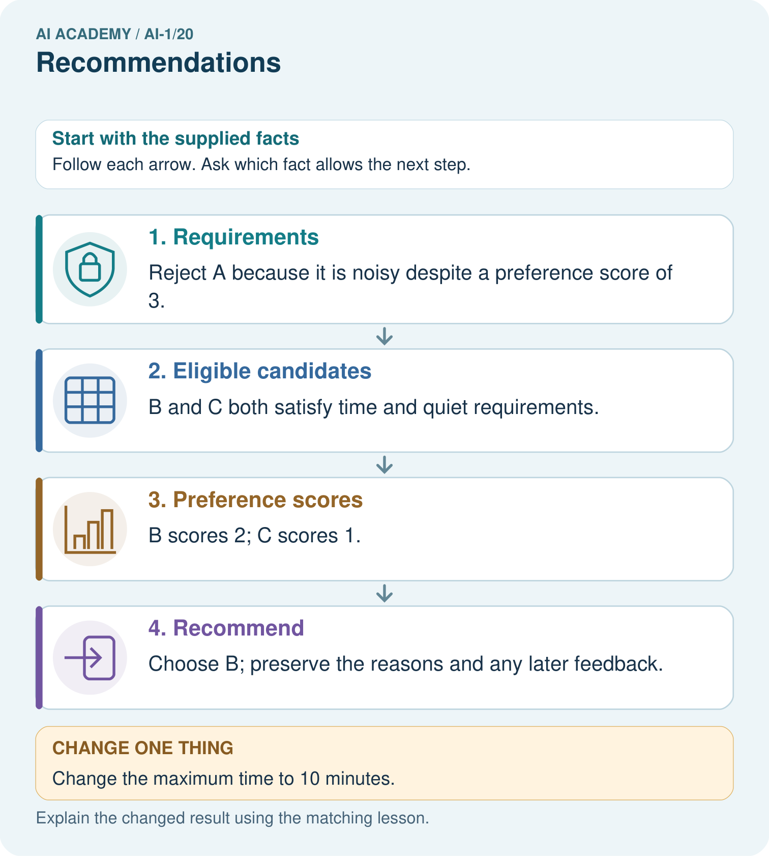

Read the picture one step at a time
Step | What happens and why
1. Requirements | Reject A because it is noisy despite a preference score of 3.
2. Eligible candidates | B and C both satisfy time and quiet requirements.
3. Preference scores | B scores 2; C scores 1.
4. Recommend | Choose B; preserve the reasons and any later feedback.
Match each pictured step to the supplied facts. This is a worked teaching case, not an independent assessment.

Why this result follows
A hard requirement determines whether an option can be chosen at all. Preferences rank the eligible options. The apparent best preference match, A, is not suitable under the quiet requirement. If a learner clicks C instead, the event alone does not tell us whether they disliked B, misclicked or wanted variety.

What this example does not establish
One click is an observed event, not proof of satisfaction or a stable personal preference.

Change one thing in the pictured case
Change: Change the maximum time to 10 minutes.
Prediction: Only C remains eligible and is recommended.
Reason: B takes 12 minutes; A is still noisy.

Ask while showing the picture
Cover the result. Ask learners to name the inputs and predict the next step. Uncover one step, connect the icon to the actual procedure, and explain its evidence. Then change the supplied condition and compare. The picture is a representation; it does not document execution of a real AI model.

03. Demonstrate and guide practice

Demonstrate and guide practice

Board sequence
Write the given facts: A recommender suggests adventure books after one adventure-book choice.
Write the question to explain: Explain its evidence and limitation.
Reveal after predictions: The past choice supports considering adventure, but does not capture every interest. Ask for feedback and offer variety.
Keep for an independent attempt: A recommender suggests a space book because you liked two space books. Does the suggestion prove you will enjoy it? What feedback could help next time?

Classroom dialogue
Ask: Which facts are given, and which would we have to assume? Learners mark relevant details before discussing answers.
Say: Predict first. Show the rule, information path or calculation that would produce the result. A correct guess is not yet an explanation.
Reveal reasoning one step at a time. Explain why a tempting alternative fails. Write units and denominators for arithmetic, trace conditions for decisions, and identify supporting sources for claims.
In pairs, one learner solves while the other checks evidence; exchange roles. Remove the worked answer before independent assessment.

Model these guided questions
J: shown and clicked; enjoyment not established. K: never shown; dislike not established. Ask an optional neutral question about suitability and reason, or offer eligible alternatives and record exposure and response. Exit: only showing prior clicked items restricts opportunities for other feedback; include eligible alternatives and preserve which options were actually shown.

Case-specific teaching sequence
Stage | Teacher action
Session 1 start 0 to 7 minutes | Retrieve why a similarity score cannot override a requirement.
7 to 20 minutes | Trace BookRec1 eligibility and scoring. Ask why L and M never enter the eligible ranking.
20 to 33 minutes | Complete W1 and W2. Compare a faithful explanation with a claim of guaranteed enjoyment.
33 to 45 minutes | Read the feedback table and complete W3. Preserve what was observed without guessing motives.
Session 2 start 0 to 8 minutes | Retrieve the difference between an unseen item and a rejected item.
8 to 23 minutes | Complete the guided feedback record and trace the space-only display loop. Discuss an optional, neutral feedback question.
23 to 38 minutes | Collect W4 independently. Require the tie, the 20-minute boundary and limits on the selection log.
38 to 45 minutes | Discuss W5 and the exit. Test no eligible option and unknown availability without relaxing requirements silently.

Reduce help deliberately
Completion task: Write an explanation of why J was recommended that mentions one preference it does not match. A marketer adds guaranteed enjoyment. Explain why that phrase is unsupported.
Teacher check: J is available in English and its space topic earns 2, the highest score among eligible choices; it is prose rather than the preferred comic. The rule supplies a ranking, not evidence guaranteeing enjoyment.
Start by identifying the given inputs together. Leave the intermediate steps blank. If needed, model one step, then withdraw that help on the next step. Move to a full trace only when the partial trace is understood. For partners, alternate explainer and checker; collect a response from every learner before discussion.

Individual reasoning check
Use the worked case for Recommendations and feedback. Proposed explanation: “A high score can cancel a failed requirement”. Decide whether this explanation is supported. Point to the step or supplied fact that decides; explain your repair if needed.
Expected correction: Filter on requirements before ranking preferences.
Collect explanations, not only yes/no votes. If a misunderstanding is common, re-model the relevant step for the class. If it affects a few learners, give a short targeted group explanation while others solve a more demanding variation.

Pictorial practice question
Why does the recommendation change without changing anyone’s preferences?

Reasoned teacher answer
The requirement changes eligibility. C becomes the only eligible choice even though B would still score more preference points.
Changed-case reasoning: Only C remains eligible and is recommended. B takes 12 minutes; A is still noisy.
Collect each learner’s explanation before discussion. Use the first missing connection between input, deciding step and result to choose support. This question is worked-case practice, not fresh mastery evidence.

04. Run the weekly evidence lab

Run the weekly evidence lab
Predict first, test honestly, and explain what the evidence means.
State your prediction before the result is known.
Complete the task: Score books for two readers; explain why rankings differ.
Keep a normal case and an edge case clearly separated.
Record what happened—even when it does not match your prediction.
Explain the result, one limitation, and the next useful test.
INDEPENDENCE After support is removed, repeat the proof with a fresh case.

Make the lab runnable
Use the concrete case as the shared normal case and the independent question as a second case. Each pair creates a boundary or missing-information case and predicts its result before testing. Keep the expected result separate from an observed mistake.
Record | What to capture
Input or evidence | Exact data, instruction or claim
Expected result | Answer or safe fallback declared before the run
Observed result | Actual result, including errors
Explanation | Rule, calculation or evidence explaining the outcome
Next test | One justified change and a new prediction

Diagnose and reteach
CLAIM TO REPAIR A recommendation decides what a person must choose.
For guessing, return to given facts and request a trace. For vocabulary without application, use one example and one non-example. For arithmetic errors, check the setup before the calculation. Finish with a different uncoached case before recording mastery.

Address these additional misconceptions
A high score can cancel a failed requirement: Filter on requirements before ranking preferences.
A click proves enjoyment: It is an interaction; motive and satisfaction need further evidence.
No clicks means dislike even without exposure: An unseen option has not received a meaningful opportunity for a response.
No eligible result means the system must choose anyway: Return no verified eligible option and explain exclusions or missing facts.

Match the support to the first error
What the response shows | Next teaching action
Missing or misread facts | Read the case aloud, mark supplied versus unknown facts, and let the learner restate it.
Wrong procedure | Return to the deciding step in the worked case. Contrast it with the proposed incorrect explanation.
Arithmetic or implementation error | Trace intermediate values or lines; preserve the first mismatch and retry that step.
Correct result without a reason | Ask for a trace and a changed case before marking independent understanding.
An unsupported wider claim | Ask which supplied evidence supports the claim and which further observation would be needed.
Offer an oral explanation, drawing, enlarged visual or fewer examples when that removes a reading/writing barrier. Keep the same reasoning goal. Stretch secure learners by changing a boundary or assumption and asking them to defend the effect, not simply by assigning more of the same questions.

05. Assess and explain the answers

Assess and explain the answers

Worked case answer
The past choice supports considering adventure, but does not capture every interest. Ask for feedback and offer variety.

Independent question
A recommender suggests a space book because you liked two space books. Does the suggestion prove you will enjoy it? What feedback could help next time?

Expected independent answer
No; shared topic supports a suggestion, not a guarantee. Feedback about what you liked or disliked can guide later recommendations, while other interests should remain possible.

What counts as evidence
Criterion | 0 points | 1 point | 2 points
Result | Incorrect or absent | Partly correct | Correct with necessary conditions
Reasoning | No supporting trace | Some steps | Clear mechanism, calculation or source support
Limit | Overclaims certainty | Vague limitation | Relevant uncertainty or missing fact
Transfer | Copies without adapting | Adapts with prompts | Solves a changed case independently
Use 6/8 as a classroom checkpoint, with 2 required for both Result and Reasoning. This is a proposed teaching rule, not a validated certification threshold. Do not count a coached answer as independent mastery; correct unsafe or unsupported claims regardless of total.

Feedback
Ask the learner to find the evidence that challenges this claim: “A recommendation decides what a person must choose.” Keep the first attempt and an uncoached retry separate.

Original transfer answer
The user never saw poetry, so clicks cannot establish rejection of it. Offer a balanced small choice including poetry, record what was shown as well as chosen, and ask for feedback. One choice remains limited evidence of a person's interests.

Explanations for the additional workbook examples

W1 Filter before scoring
Apply BookRec1 to J, K, L and M from the lesson. State eligibility or exclusion reason for each, the scores of eligible books and the recommendation. Explain why L’s two preference matches do not make it the winner.
J eligible scores 2; K eligible scores 1; L excluded for Spanish; M excluded because unavailable. Recommend J. Preference matches cannot compensate for failing the English requirement.

W2 Explain a recommendation honestly
Write an explanation of why J was recommended that mentions one preference it does not match. A marketer adds guaranteed enjoyment. Explain why that phrase is unsupported.
J is available in English and its space topic earns 2, the highest score among eligible choices; it is prose rather than the preferred comic. The rule supplies a ranking, not evidence guaranteeing enjoyment.

W3 Do not label an unseen item rejected
J was shown and clicked. K was never shown. Separate the observed records from the labels enjoyed and disliked. Write a question that could gather a stated reason while allowing no answer.
Record J shown and clicked; K not shown. Enjoyment of J and dislike of K remain unsupported. An optional question such as Did this suggestion suit what you wanted, and why or why not? seeks a reason without presuming satisfaction. No answer remains missing feedback.

W4 Transfer the process to activities
A fictional learner needs an indoor activity lasting at most 20 minutes. Preferences score 2 for drawing and 1 for solo. Candidates: A drawing, solo, outdoor, 10 minutes; B drawing, group, indoor, 20 minutes; C music, solo, indoor, 15 minutes; D drawing, group, indoor, 18 minutes. Filter, score and return all highest scorers. Only B is then shown and selected; C and D are not shown. State what the feedback establishes and what remains unknown.
A excluded because outdoor. B eligible scores 2; C eligible scores 1; D eligible scores 2. Return B and D. Exactly 20 minutes passes at most 20. The log establishes B shown and selected, not enjoyment. Preferences about unshown C and D are unknown; selecting B does not prove rejection of D or validate the choice to hide it.

W5 Handle an empty eligible set
Return to BookRec1. J and K become unavailable, L remains Spanish, and M’s availability becomes unknown. A designer proposes recommending M anyway because it matches both preferences. Apply the requirements and propose an honest response.
J and K are excluded as unavailable, L for language. M is pending availability verification and cannot yet count as eligible. Report no verified eligible option, identify the missing availability fact, and request confirmation or let the reader revise requirements explicitly.

Assess independent transfer
Selected case: A fictional learner needs an indoor activity lasting at most 20 minutes. Preferences score 2 for drawing and 1 for solo. Candidates: A drawing, solo, outdoor, 10 minutes; B drawing, group, indoor, 20 minutes; C music, solo, indoor, 15 minutes; D drawing, group, indoor, 18 minutes. Filter, score and return all highest scorers. Only B is then shown and selected; C and D are not shown. State what the feedback establishes and what remains unknown.

Selected case answer
A excluded because outdoor. B eligible scores 2; C eligible scores 1; D eligible scores 2. Return B and D. Exactly 20 minutes passes at most 20. The log establishes B shown and selected, not enjoyment. Preferences about unshown C and D are unknown; selecting B does not prove rejection of D or validate the choice to hide it.
Dimension | Evidence required
Explanation | Names the applicable idea or procedure and ties it to the supplied facts.
Trace and result | Preserves the given inputs and shows the relevant intermediate steps; distinguishes a prediction from an observed execution.
Limits | States the assumptions, missing evidence or conditions under which the result would change.
Record each dimension as not yet, with support, or independent. Accept a valid alternative procedure with a defensible trace. Do not penalise an honestly recorded model failure if the learner correctly explains its evidence and limits.

Feedback that the learner uses
Name the earliest unsupported step and give one action to repair it. Have the learner make that repair now and explain why. Then assess the relevant skill on a fresh, fully specified case. Confirm it was not previously practised with feedback; solve and check the new case before assigning it. A follow-up design prompt is a starting brief, not automatically an equivalent test.

06. Connect and extend learning

Connect and extend learning

Helpful Classroom Sorter
If the sorter ranks bins, state the objective and show why the top suggestion is not a command.
Keep the decision, input, result, explanation and remaining limitation in the project evidence record. Retrieve this record next week rather than restarting the project.

Support and stretch
Use physical cards, spoken explanations and a three-stage drawing. Read aloud without giving the answer. Stretch: compare two mechanisms with the same visible output and explain what evidence distinguishes them.

Exit reflection
Ask for one decision the learner can now justify and one situation requiring more evidence or human review. Confidence ratings are separate from correct independent performance.

Bridge to the next week
Next: Week 21: Good Data, Bad Data. Retrieve today’s evidence and identify what carries forward and what is new.

Support and fresh reassessment
Use separate trays for excluded, pending and eligible items. Score only the eligible tray. Extension: change the display order while keeping scores fixed and explain why different clicks would not automatically show changed preferences.
W4 requires excluding A, scores B 2 C 1 D 2, both B and D returned, and no inferred enjoyment or rejection from unshown items. After support change the time limit to at most 18: B becomes excluded, D wins with 2 over C’s 1. Keep feedback limits unchanged.
Week 21 investigates data quality and how to repair a record with evidence while preserving its history.

Plan the delayed return
Suggested return points in this level: ai-1/21, ai-1/23, ai-1/26. Use actual classroom dates, adjusting for holidays and gaps. One, three and six teaching weeks are scheduling choices, not a claimed optimal spacing.
At a delayed check, ask for the idea from memory and a changed application. Compare with the earlier independent response and record support used. For a new level, revisit the previous capstone before checking the new prerequisites.
Record | Teacher evidence
Learner code and date
Concept and case used; prior exposure
Explanation / trace / limits
Support and first repair
Changed case and delayed outcome
Next teaching action
Use the evidence to choose reteaching or the next step. A completed page, confidence rating or attractive project does not by itself demonstrate understanding.

Project evidence from this case
Separate sorter requirements, preferences and observed feedback; document why a suggestion was eligible.

