AI ACADEMY · TEACHER · ai-1/22

Missing and Unbalanced Examples
Project: Helpful Classroom Sorter

01. Missing and Unbalanced Examples

Teach the learning cycle
Primary target: Name the target collection, selection list and cases actually assessed
Session | Sequence and minutes | Resources
Session 1 · Understand · 45 min | 0–7: recall and prerequisite; 7–15: inspect the concrete case and predict; 15–30: teacher models the worked trace; 30–40: learners explain a step using the text and visual; 40–45: check the core idea. | Sections 1–6; record the brief recall in the workbook.
Session 2 · Practise · 45 min | 0–5: retrieve the procedure; 5–15: W2 completion practice; 15–23: explain and check with a partner; 23–30: each learner answers the misconception check; 30–40: targeted reteaching or a harder variation; 40–45: prepare the investigation. | Sections 7–10; use the matching workbook W2 and misconception check.
Session 3 · Investigate and transfer · 45 min | 0–5: retrieve the decision rule; 5–20: investigate or trace; 20–30: start the independent case; 30–38: connect the project; 38–43: act on feedback; 43–45: plan the return check. | Sections 9 and 11–14. Give extra time to finish the full task set; use Section 15 when the week includes a coding lab.
This is a starting allocation of 135 minutes, not a validated duration. Preserve all named topics. Schedule extra time for connected examples, the full investigation, independent cases and project building. Repeated copies of a case share one recorded attempt; they are not new evidence.

Retrieval answer guidance

Good Data, Bad Data
Without opening the old lesson, explain one key idea from Good Data, Bad Data. Give an example and a mistake that the idea helps you avoid.
Look for: Check records against a stated format, unit and meaning before using them
Reference example, not the only acceptable wording: Height 60 fails the whole-number range 1 through 10. Travel blank is missing; its value cannot be inferred. Travel 0 is valid in the whole-number range 0 through 10 and can represent observed no travel. Zero is a measurement, not a replacement for a blank.

Similarity
Without opening the old lesson, explain one key idea from Similarity. Give an example and a mistake that the idea helps you avoid.
Look for: Calculate similarity using explicitly selected features and a stated scoring rule
Reference example, not the only acceptable wording: A: 1, 1, 0 gives 2. B: 0, 0, 1 gives 1. C: 1, 0, 0 gives 1. A is the only highest scoring candidate among A, B and C under equal weights.

Boundaries and 'Not Sure'
Without opening the old lesson, explain one key idea from Boundaries and 'Not Sure'. Give an example and a mistake that the idea helps you avoid.
Look for: Identify a specific source of uncertainty and explain how it affects a prediction
Reference example, not the only acceptable wording: The rule and two stated possibilities are known; the actual height is unresolved. At 5 predict short, at 6 predict tall. Inspect the original readable record or remeasure. Repeating a calculation supplies no new information about which height was recorded.
Use the student module and workbook section with this exact week title. The worked case, independent question and answers below form one aligned lesson sequence.

What the learner must demonstrate
A training set has 18 daylight photos and two dark photos of one object. Copying the dark photos eight times balances the counts. Does it balance the variety? Design a better collection step.

Concept to explain
What is absent can shape a system's failures.
Term | Meaning
missing example | needed condition absent from data
imbalance | some groups appear much more than others
subgroup | defined part of the intended population
coverage gap | important situation poorly represented

Prepare the class
Use the supplied scenario, student illustrations and blank paper. For numeric work, offer counters or a calculator after learners show the setup. Fictional records are supplied; personal data and paid accounts are unnecessary.
Allow 80 minutes: recall 8; explanation 12; worked demonstration 15; guided practice 20; independent assessment 15; project and reflection 10. Extend the lab into a second session when needed.

Preparation for the connected explanation
Teach the difference between accurate records and adequate coverage. The populations here are finite invented card and clip collections, so students can account for every selected and unselected case. Avoid presenting equal group counts as a universal sampling rule: this target has equal groups, and the proposed balanced plan investigates condition coverage. It does not guarantee an unbiased estimate in every application.

Readiness answer
No. Correct records can still describe only a narrow set of conditions. Source checking does not establish coverage of unrecorded cases.
A paper inventory with 6 IDs for each of the four picture-card conditions
A four-row coverage table with target, selected, assessed and missing columns
Twenty paper clip IDs grouped into the four fictional sound conditions; no audio recording needed

End goal for the pictorial case
By the end, I can identify missing conditions and design a targeted coverage check.
This added worked case illustrates the week’s main idea. Retain all original and connected topics; schedule its practice within the teaching cycle.

02. Explain the mechanism

Explain the mechanism
Follow the information instead of imagining magic inside the machine.
INPUT example set with represented and absent conditions
PROCESS learn patterns from available coverage
OUTPUT uneven performance across conditions
CORE IDEA What is absent can shape a system's failures.
UNDER THE HOOD Sampling imbalance changes the empirical distribution seen during training. Missing subgroups or conditions cannot contribute error signals, so average success may hide systematic failure. Rebalancing requires relevant examples, not arbitrary duplication alone.
Draw a fresh example with all three stages:
Every step connects a claim to observable evidence.
CASE An animal recognizer trained only on bright daytime photos may fail on the same animals at night.
STEP 1 — OBSERVE example set with represented and absent conditions
STEP 2 — TRACE learn patterns from available coverage
STEP 3 — CONCLUDE uneven performance across conditions
MODEL REASONING The model may rely on bright backgrounds or fail to detect shapes in low light. Collect varied night examples for every relevant animal and preserve a separate night test set to evaluate the repair.
DO NOT OVERCLAIM Balance is about useful representation, not forcing every count to be identical without reason.
What new evidence could change this answer?

Concrete teaching case
Training includes nine daylight leaf photos and one low-light photo.
What intended-use gap is present?

Exact explanation to model
Low light is poorly represented. Add varied, correctly labelled low-light examples if that use is intended. Copies of one photo do not add equivalent variety.

Explain the added worked example
Suppose a shape recogniser will be evaluated on a fixed collection of 24 invented picture cards. This target population has 6 bright circles, 6 dim circles, 6 bright squares and 6 dim squares. Each card has its own ID and an independently checked circle or square label. We want to know how often the recogniser gives the correct label across these 24 cards.
A tester takes the 6 bright-circle cards nearest the front of the box. Those 6 cards form the sample; the other 18 have not been assessed. The recogniser is correct on 5 of the 6 sampled cards. That is a result for these assessed bright circles. It does not establish correctness on the squares or dim cards.
A sampling frame is the list or source available for selection. A complete list of all 24 IDs could give every card a chance of selection. A list containing only bright-circle IDs cannot select dim cards or squares, even if the choice from that list is random. These fictional picture cards do not contain personal information.
The target has 24 distinct cards, but the sample covers only the 6 bright circles. Photographing each sampled card twice would create 12 image records without adding a new card or covering a missing condition. Record the identity of the underlying case as well as the number of files.
Both shape and lighting matter to this question. A sample with bright circles and dim squares includes each shape and each lighting label, yet still misses dim circles and bright squares. Check combinations when the interaction could matter, not just whether each individual label appears somewhere.

Key terms
Term | Meaning
Target population | The whole collection of cases a question is about
Sample | The selected cases used to investigate a larger collection
Sampling frame | The list or source from which cases can be selected
Coverage | Which relevant kinds of cases the list or sample includes
Selection bias | Systematic distortion caused by how cases enter an investigation

Model the reasoning aloud
Use the complete worked example below before asking learners to complete W2. Reveal a small part, invite a prediction, then explain the deciding step. These teacher notes contain solutions; do not reveal the independent case answer during modelling.
Take cards at the front | Quick initial check | Front position may restrict conditions
Draw from all 24 IDs by chance | Every listed card can be selected | A small draw need not balance conditions
Choose 2 distinct cards per condition | Includes all four conditions | 8 cards do not establish all 24 outcomes
Assess all 24 distinct cards | Covers this entire fixed collection | Does not prove performance on future images
For a broad estimate, a chance-based plan should start from a suitable complete list and use a documented selection procedure. For investigating missing conditions, deliberately selecting cases from each condition can be useful. State which purpose you chose. A set built to expose problems is not automatically a faithful miniature of everyday use.
Selection bias is about a systematic feature of the selection process, not whether a person had bad intentions. Choosing only easy-to-reach, bright cards can leave harder conditions out. More cases from the same narrow source may repeat that gap. A larger sample cannot by itself repair a frame that excludes relevant cases.
Thinking move | Teacher prompt
Plan | What is given? What is the question? Which procedure fits these facts?
Do | Point to each input and intermediate step in the worked trace. Name the rule that allows the next step.
Check | Does the output answer the question? Which assumption or limitation prevents a larger claim?
Use the diagram and verbal explanation together. Ask learners to match a sentence to a specific visual step; do not assign learners fixed visual or auditory learning styles.

A pictorial worked case: Missing and Unbalanced Examples
A fictional badge reader will be used in both bright and dim rooms.

The facts we will use
Intended target has 8 bright plain,8 bright patterned,8 dim plain,8 dim patterned cards.
A development sample contains 6 bright plain cards and 2 bright patterned cards; no dim cards.
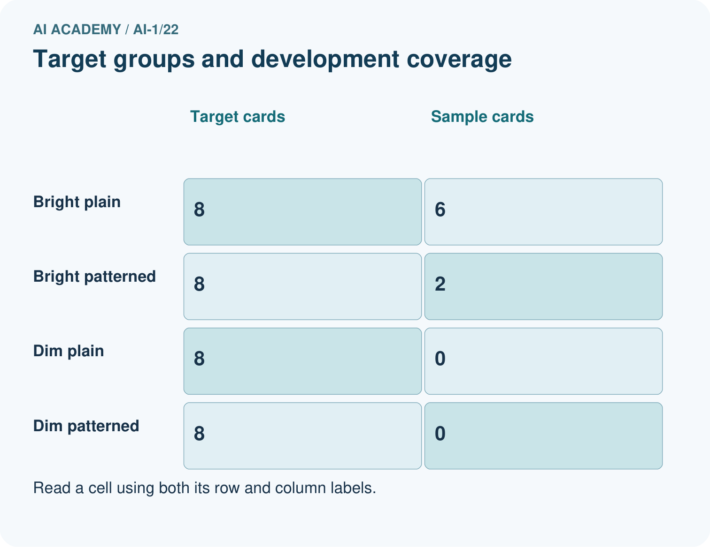
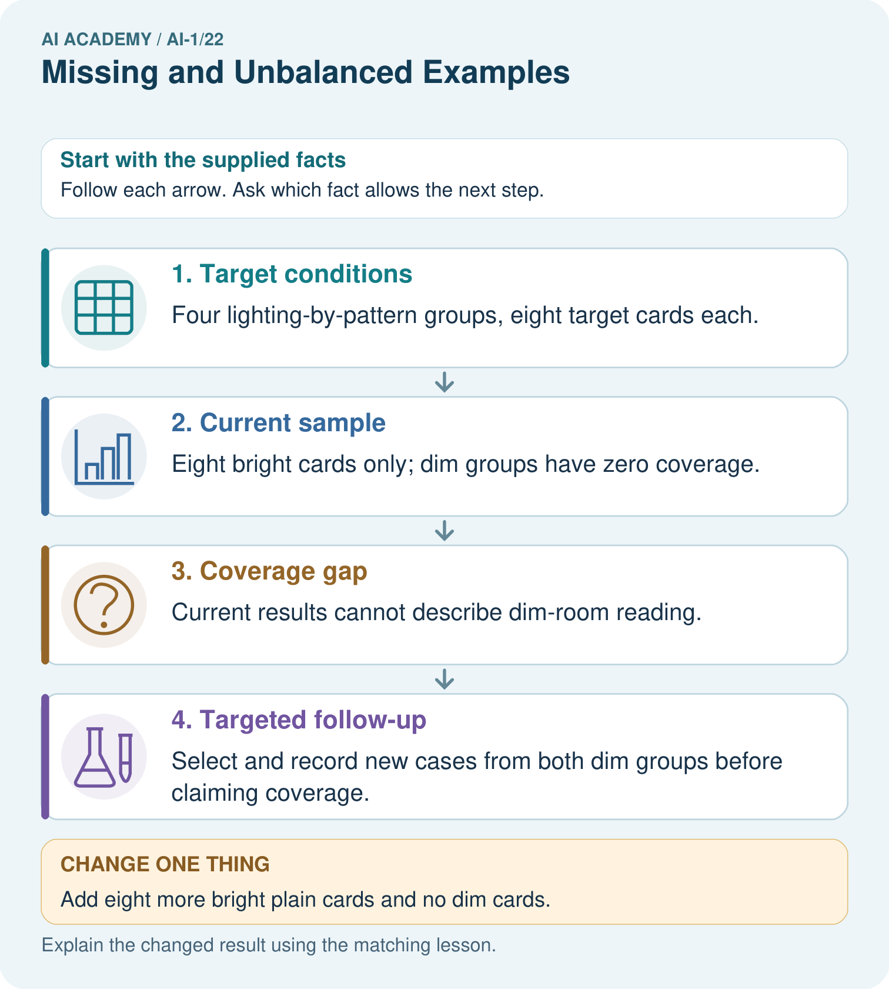

Read the picture one step at a time
Step | What happens and why
1. Target conditions | Four lighting-by-pattern groups, eight target cards each.
2. Current sample | Eight bright cards only; dim groups have zero coverage.
3. Coverage gap | Current results cannot describe dim-room reading.
4. Targeted follow-up | Select and record new cases from both dim groups before claiming coverage.
Match each pictured step to the supplied facts. This is a worked teaching case, not an independent assessment.

Why this result follows
Adding more bright cards can increase sample size without addressing the missing condition. A coverage check asks which relevant situations are absent, not merely how many rows exist. Deliberately selecting dim cases helps investigate those conditions, but the resulting test should not be advertised as a random survey unless its selection really was random.

What this example does not establish
Coverage does not guarantee accuracy, and targeted cases alone do not supply a population-wide success estimate.

Change one thing in the pictured case
Change: Add eight more bright plain cards and no dim cards.
Prediction: The sample becomes larger but still has no dim coverage.
Reason: The missing lighting condition remains untested.

Ask while showing the picture
Cover the result. Ask learners to name the inputs and predict the next step. Uncover one step, connect the icon to the actual procedure, and explain its evidence. Then change the supplied condition and compare. The picture is a representation; it does not document execution of a real AI model.

03. Demonstrate and guide practice

Demonstrate and guide practice

Board sequence
Write the given facts: Training includes nine daylight leaf photos and one low-light photo.
Write the question to explain: What intended-use gap is present?
Reveal after predictions: Low light is poorly represented. Add varied, correctly labelled low-light examples if that use is intended. Copies of one photo do not add equivalent variety.
Keep for an independent attempt: A photo sorter trains on ten bright photos and no dim photos. What group of examples is missing? Design a test that reveals the gap.

Classroom dialogue
Ask: Which facts are given, and which would we have to assume? Learners mark relevant details before discussing answers.
Say: Predict first. Show the rule, information path or calculation that would produce the result. A correct guess is not yet an explanation.
Reveal reasoning one step at a time. Explain why a tempting alternative fails. Write units and denominators for arithmetic, trace conditions for decisions, and identify supporting sources for claims.
In pairs, one learner solves while the other checks evidence; exchange roles. Remove the worked answer before independent assessment.

Model these guided questions
The original recogniser correctly labelled 5 of 6 assessed bright-circle cards. Dim circles, bright squares and dim squares were not assessed. A documented plan selecting 2 distinct cards per condition from all 24 IDs would include each condition without claiming to establish every outcome. Exit: the image count grew, but the absence of dim-square tests remains; more bright-circle data cannot supply dim-square evidence.

Case-specific teaching sequence
Stage | Teacher action
Session 1 start 0 to 7 minutes | Retrieve why source-checked data can still omit relevant conditions.
7 to 20 minutes | Model target, frame and sample using the picture-card inventory. Complete W1.
20 to 33 minutes | Read the coverage diagram. Complete W2 and distinguish file count from distinct cases.
33 to 45 minutes | Complete W3 and compare individual features with their combinations.
Session 2 start 0 to 8 minutes | Retrieve the three absent conditions in the original investigation.
8 to 23 minutes | Compare selection plans and complete the guided claim rewrite. Use shuffled paper IDs to show that a small chance draw need not balance conditions.
23 to 38 minutes | Collect W4 independently. Require a bounded result and a feasible plan with distinct clips.
38 to 45 minutes | Discuss W5 and the exit. Keep selected, assessed and unavailable counts separate.

Reduce help deliberately
Completion task: Each of the six original sampled cards is photographed twice. State the number of image files and distinct cards. Has this covered a new shape or lighting condition? Explain why the counts need different labels.
Teacher check: There are 12 image files but still 6 distinct cards, all bright circles. No new shape or lighting condition has been covered. Multiple records of the same cases are not 12 distinct sampled cards and do not resolve the missing conditions.
Start by identifying the given inputs together. Leave the intermediate steps blank. If needed, model one step, then withdraw that help on the next step. Move to a full trace only when the partial trace is understood. For partners, alternate explainer and checker; collect a response from every learner before discussion.

Individual reasoning check
Use the worked case for Sampling and coverage. Proposed explanation: “More records always remove bias”. Decide whether this explanation is supported. Point to the step or supplied fact that decides; explain your repair if needed.
Expected correction: A restricted source can keep excluding the same conditions as its record count grows.
Collect explanations, not only yes/no votes. If a misunderstanding is common, re-model the relevant step for the class. If it affects a few learners, give a short targeted group explanation while others solve a more demanding variation.

Pictorial practice question
Would testing only dim plain cards close every current gap? Point to the target groups.

Reasoned teacher answer
No. Dim patterned cards would still be absent; both dim groups need planned coverage.
Changed-case reasoning: The sample becomes larger but still has no dim coverage. The missing lighting condition remains untested.
Collect each learner’s explanation before discussion. Use the first missing connection between input, deciding step and result to choose support. This question is worked-case practice, not fresh mastery evidence.

04. Run the weekly evidence lab

Run the weekly evidence lab
Predict first, test honestly, and explain what the evidence means.
State your prediction before the result is known.
Complete the task: Predict failures in an animal set missing night photos.
Keep a normal case and an edge case clearly separated.
Record what happened—even when it does not match your prediction.
Explain the result, one limitation, and the next useful test.
INDEPENDENCE After support is removed, repeat the proof with a fresh case.

Make the lab runnable
Use the concrete case as the shared normal case and the independent question as a second case. Each pair creates a boundary or missing-information case and predicts its result before testing. Keep the expected result separate from an observed mistake.
Record | What to capture
Input or evidence | Exact data, instruction or claim
Expected result | Answer or safe fallback declared before the run
Observed result | Actual result, including errors
Explanation | Rule, calculation or evidence explaining the outcome
Next test | One justified change and a new prediction

Diagnose and reteach
CLAIM TO REPAIR Ten examples cover every condition.
For guessing, return to given facts and request a trace. For vocabulary without application, use one example and one non-example. For arithmetic errors, check the setup before the calculation. Finish with a different uncoached case before recording mastery.

Address these additional misconceptions
More records always remove bias: A restricted source can keep excluding the same conditions as its record count grows.
Random selection repairs an incomplete list: Excluded cases cannot be selected from a list that does not contain them.
Every feature value appears, so every combination appears: Bright circles and dim squares still omit dim circles and bright squares.
Zero assessed means every case failed: Zero assessed means no observed recognition outcomes for that group.

Match the support to the first error
What the response shows | Next teaching action
Missing or misread facts | Read the case aloud, mark supplied versus unknown facts, and let the learner restate it.
Wrong procedure | Return to the deciding step in the worked case. Contrast it with the proposed incorrect explanation.
Arithmetic or implementation error | Trace intermediate values or lines; preserve the first mismatch and retry that step.
Correct result without a reason | Ask for a trace and a changed case before marking independent understanding.
An unsupported wider claim | Ask which supplied evidence supports the claim and which further observation would be needed.
Offer an oral explanation, drawing, enlarged visual or fewer examples when that removes a reading/writing barrier. Keep the same reasoning goal. Stretch secure learners by changing a boundary or assumption and asking them to defend the effect, not simply by assigning more of the same questions.

05. Assess and explain the answers

Assess and explain the answers

Worked case answer
Low light is poorly represented. Add varied, correctly labelled low-light examples if that use is intended. Copies of one photo do not add equivalent variety.

Independent question
A photo sorter trains on ten bright photos and no dim photos. What group of examples is missing? Design a test that reveals the gap.

Expected independent answer
Dim photos are missing. Test on separately collected, correctly labelled dim photos and compare errors with bright photos. Success in bright light does not establish performance in dim light.

What counts as evidence
Criterion | 0 points | 1 point | 2 points
Result | Incorrect or absent | Partly correct | Correct with necessary conditions
Reasoning | No supporting trace | Some steps | Clear mechanism, calculation or source support
Limit | Overclaims certainty | Vague limitation | Relevant uncertainty or missing fact
Transfer | Copies without adapting | Adapts with prompts | Solves a changed case independently
Use 6/8 as a classroom checkpoint, with 2 required for both Result and Reasoning. This is a proposed teaching rule, not a validated certification threshold. Do not count a coached answer as independent mastery; correct unsafe or unsupported claims regardless of total.

Feedback
Ask the learner to find the evidence that challenges this claim: “Ten examples cover every condition.” Keep the first attempt and an uncoached retry separate.

Original transfer answer
No. Copies add no new dark situations. Collect permitted photos of several distinct objects under relevant low-light conditions, with reliable labels. Keep related views together when separating evaluation examples so familiar objects do not inflate results.

Explanations for the additional workbook examples

W1 Name target, frame and sample
Use the 24-card investigation. State the target collection, the original six-card sample and the three absent conditions. If the selection list contains only bright-circle IDs, explain why random selection from that list cannot reach every target condition.
The target is all 24 specified cards across four conditions. The sample is the 6 bright-circle cards. Dim circles, bright squares and dim squares are absent. A frame containing only bright-circle IDs excludes every other condition, regardless of how randomly IDs are drawn from it.

W2 Separate files from distinct cases
Each of the six original sampled cards is photographed twice. State the number of image files and distinct cards. Has this covered a new shape or lighting condition? Explain why the counts need different labels.
There are 12 image files but still 6 distinct cards, all bright circles. No new shape or lighting condition has been covered. Multiple records of the same cases are not 12 distinct sampled cards and do not resolve the missing conditions.

W3 Read a coverage table in combinations
A different test includes 3 bright circles and 3 dim squares. A designer says it covers both shapes and both lighting conditions, so no combinations are missing. Identify the missing combinations and propose six additional distinct cards to investigate them.
Dim circles and bright squares are missing, even though circle, square, bright and dim each occur somewhere. Add 3 distinct dim circles and 3 distinct bright squares from the target collection. This addresses those combination gaps but does not establish every unassessed card outcome.

W4 Audit a new sound-recognition claim
A fixed target has 20 invented clips: 5 quiet bells, 5 noisy bells, 5 quiet claps and 5 noisy claps. A tester selects 4 distinct quiet bells from a quiet-bell-only list; 3 are correctly labelled and 1 is wrong. Write a supported result, name missing conditions and explain why the result is not established for all 20 clips. Propose an 8-clip plan that includes every condition, with no clip selected twice.
The recogniser is correct on 3 of 4 assessed quiet-bell clips. No noisy bells, quiet claps or noisy claps were assessed; even one quiet-bell clip remains unassessed. The restricted frame and sample cannot establish the all-20 result. Select 2 distinct clips from each of the four conditions using the complete target list, document selection before outcomes and report remaining limits. Eight clips improve condition coverage but are not all 20.

W5 Report a selected case without an outcome
An 8-clip plan selects 2 from each sound condition. One selected noisy-clap file cannot be opened. The task measures recognition correctness only. State selected and assessed counts and the assessed count for each condition. Explain why a report of all 8 checked is wrong, and how to handle the missing file transparently.
Eight clips were selected; seven were assessed. Quiet bells, noisy bells and quiet claps each have 2 assessed; noisy claps have 1 assessed and 1 unassessed file. No recognition outcome is available for the unopened file. Log its ID and reason, recover it if possible, and document any replacement rule without choosing on outcomes. Do not label its recognition result correct or wrong or hide its absence.

Assess independent transfer
Selected case: A fixed target has 20 invented clips: 5 quiet bells, 5 noisy bells, 5 quiet claps and 5 noisy claps. A tester selects 4 distinct quiet bells from a quiet-bell-only list; 3 are correctly labelled and 1 is wrong. Write a supported result, name missing conditions and explain why the result is not established for all 20 clips. Propose an 8-clip plan that includes every condition, with no clip selected twice.

Selected case answer
The recogniser is correct on 3 of 4 assessed quiet-bell clips. No noisy bells, quiet claps or noisy claps were assessed; even one quiet-bell clip remains unassessed. The restricted frame and sample cannot establish the all-20 result. Select 2 distinct clips from each of the four conditions using the complete target list, document selection before outcomes and report remaining limits. Eight clips improve condition coverage but are not all 20.
Dimension | Evidence required
Explanation | Names the applicable idea or procedure and ties it to the supplied facts.
Trace and result | Preserves the given inputs and shows the relevant intermediate steps; distinguishes a prediction from an observed execution.
Limits | States the assumptions, missing evidence or conditions under which the result would change.
Record each dimension as not yet, with support, or independent. Accept a valid alternative procedure with a defensible trace. Do not penalise an honestly recorded model failure if the learner correctly explains its evidence and limits.

Feedback that the learner uses
Name the earliest unsupported step and give one action to repair it. Have the learner make that repair now and explain why. Then assess the relevant skill on a fresh, fully specified case. Confirm it was not previously practised with feedback; solve and check the new case before assigning it. A follow-up design prompt is a starting brief, not automatically an equivalent test.

06. Connect and extend learning

Connect and extend learning

Helpful Classroom Sorter
List normal, low-light, partly hidden, worn, and unusual items; mark which conditions are missing from the sorter data.
Keep the decision, input, result, explanation and remaining limitation in the project evidence record. Retrieve this record next week rather than restarting the project.

Support and stretch
Use physical cards, spoken explanations and a three-stage drawing. Read aloud without giving the answer. Stretch: compare two mechanisms with the same visible output and explain what evidence distinguishes them.

Exit reflection
Ask for one decision the learner can now justify and one situation requiring more evidence or human review. Confidence ratings are separate from correct independent performance.

Bridge to the next week
Next: Week 23: Fair for Whom?. Retrieve today’s evidence and identify what carries forward and what is new.

Support and fresh reassessment
Place paper IDs in four labelled boxes and physically mark selected and assessed cards. Provide the column headings while students fill the counts. Extension: explain why a full assessment of this fixed 24-card population still would not prove correctness on every future photograph.
W4 requires 3 of 4 quiet bells, all three missing conditions, recognition that the all-20 result is unestablished, and an 8-clip plan with distinct cases from all four conditions; 2 per condition is one valid plan. After support use a sample of 4 noisy claps with 2 correct: the supported result is 2 of 4 noisy claps, and quiet bells, noisy bells and quiet claps are absent. Require a fresh explanation, not a copied list.
Week 23 compares performance fractions while keeping denominators, missing outcomes and evaluation conditions explicit.

Plan the delayed return
Suggested return points in this level: ai-1/23, ai-1/25, ai-1/28. Use actual classroom dates, adjusting for holidays and gaps. One, three and six teaching weeks are scheduling choices, not a claimed optimal spacing.
At a delayed check, ask for the idea from memory and a changed application. Compare with the earlier independent response and record support used. For a new level, revisit the previous capstone before checking the new prerequisites.
Record | Teacher evidence
Learner code and date
Concept and case used; prior exposure
Explanation / trace / limits
Support and first repair
Changed case and delayed outcome
Next teaching action
Use the evidence to choose reteaching or the next step. A completed page, confidence rating or attractive project does not by itself demonstrate understanding.

Project evidence from this case
Create a sorter coverage table crossing important classroom conditions, then state which groups each test actually represents.

