AI ACADEMY · TEACHER · ai-1/30

Choose Inputs and Outputs
Project: Helpful Classroom Sorter

01. Choose Inputs and Outputs

Teach the learning cycle
Primary target: Turn the project outcome into precise input and output requirements
Session | Sequence and minutes | Resources
Session 1 · Understand · 45 min | 0–7: recall and prerequisite; 7–15: inspect the concrete case and predict; 15–30: teacher models the worked trace; 30–40: learners explain a step using the text and visual; 40–45: check the core idea. | Sections 1–6; record the brief recall in the workbook.
Session 2 · Practise · 45 min | 0–5: retrieve the procedure; 5–15: W2 completion practice; 15–23: explain and check with a partner; 23–30: each learner answers the misconception check; 30–40: targeted reteaching or a harder variation; 40–45: prepare the investigation. | Sections 7–10; use the matching workbook W2 and misconception check.
Session 3 · Investigate and transfer · 45 min | 0–5: retrieve the decision rule; 5–20: investigate or trace; 20–30: start the independent case; 30–38: connect the project; 38–43: act on feedback; 43–45: plan the return check. | Sections 9 and 11–14. Give extra time to finish the full task set; use Section 15 when the week includes a coding lab.
This is a starting allocation of 135 minutes, not a validated duration. Preserve all named topics. Schedule extra time for connected examples, the full investigation, independent cases and project building. Repeated copies of a case share one recorded attempt; they are not new evidence.

Retrieval answer guidance

Find a Real Problem
Without opening the old lesson, explain one key idea from Find a Real Problem. Give an example and a mistake that the idea helps you avoid.
Look for: Describe a specific user difficulty using supplied evidence without inventing its cause
Reference example, not the only acceptable wording: For example: fictional pupils choosing activities in the supplied classroom exercise had to choose again in four of ten requests because the first choice did not fit the time or room conditions. Build an AI app names a solution or construction task without specifying a user difficulty or evidence of need.

Verify Important Outputs
Without opening the old lesson, explain one key idea from Verify Important Outputs. Give an example and a mistake that the idea helps you avoid.
Look for: Separate an answer into claims and connect each claim to relevant evidence
Reference example, not the only acceptable wording: A directly stated fact is four rolls, 2 m per roll or twelve 50 cm pieces. A derived quantity is 8 m starting length, 6 m used or 2 m remaining, supported by the relevant calculation from R. R contains no enjoyment evidence, so citing it does not support everyone enjoying the activity.

Privacy by Choosing Less
Without opening the old lesson, explain one key idea from Privacy by Choosing Less. Give an example and a mistake that the idea helps you avoid.
Look for: Justify which information a stated task needs and remove unnecessary fields
Reference example, not the only acceptable wording: Keep topic choice; remove name, full date of birth, address and photograph. The totals do not require identity or contact details. Collecting extra fields creates copies and exposure to manage even if those fields are later ignored or deleted.
Use the student module and workbook section with this exact week title. The worked case, independent question and answers below form one aligned lesson sequence.

What the learner must demonstrate
Design a paper/plastic sorter that receives an object description. Include a mixed paper-and-plastic cup. Specify inputs, outputs and the uncertain-case action. Is the owner's name useful?

Concept to explain
A useful design makes required information and promised result explicit.
Term | Meaning
required input | information necessary for the process
optional input | information that may help but is not required
output contract | specific result the system promises to produce
missing-data behavior | what happens when an input is absent

Prepare the class
Use the supplied scenario, student illustrations and blank paper. For numeric work, offer counters or a calculator after learners show the setup. Fictional records are supplied; personal data and paid accounts are unnecessary.
Allow 80 minutes: recall 8; explanation 12; worked demonstration 15; guided practice 20; independent assessment 15; project and reflection 10. Extend the lab into a second session when needed.

Preparation for the connected explanation
Use this catalogue and task contract unchanged through the shared project unless a later activity explicitly introduces a versioned change. The baseline is deliberately complete and credible: careful manual checking can satisfy the specification. The educational aim is a traceable, tested recommender and a defensible comparison, not a compulsory claim that automation wins. Minutes are exact paper-model values and resources are assumed available.

Readiness answer
It may miss compatible options on every request where one exists. Check useful suggestions and whether no-match results are justified, as well as incompatible suggestions.
The four-row B1 to B4 catalogue and fictional request cards
A baseline sheet with input, output, reason and pass or fail columns
Separate storage for teacher-reserved final cases, kept out of development work

End goal for the pictorial case
By the end, I can specify valid inputs, exact outputs and a manual baseline.
This added worked case illustrates the week’s main idea. Retain all original and connected topics; schedule its practice within the teaching cycle.

02. Explain the mechanism

Explain the mechanism
Follow the information instead of imagining magic inside the machine.
INPUT minimal required information
PROCESS candidate decision process
OUTPUT specific promised result and uncertainty path
CORE IDEA A useful design makes required information and promised result explicit.
UNDER THE HOOD Interface contracts define inputs, outputs, types, allowed values, missing-data behavior, and guarantees. Good design avoids collecting data that cannot improve the promised result and avoids promising outcomes the process cannot support.
Draw a fresh example with all three stages:
Every step connects a claim to observable evidence.
CASE A sorter can use item type and location found to suggest a bin without collecting a student's name or face.
STEP 1 — OBSERVE minimal required information
STEP 2 — TRACE candidate decision process
STEP 3 — CONCLUDE specific promised result and uncertainty path
MODEL REASONING Prefer the design that meets the measurable need with fewer, clearer inputs and an honest output. State how missing values and ambiguous cases are handled before building.
DO NOT OVERCLAIM Every collected field creates cost and risk; every promised output needs evidence.
What new evidence could change this answer?

Concrete teaching case
A sorter suggests paper or plastic trays using material observations.
Name an input, output and unnecessary input.

Exact explanation to model
Input: material or a suitable image. Output: tray suggestion. Home address is unnecessary. Uncertain material needs review.

Explain the added worked example
Last week we identified a difficulty: some fictional activity choices did not fit the available time or room conditions. Now define the task precisely enough that two reviewers can agree whether an output is correct. A requirement such as “suggest a good activity” is too vague. State which inputs are accepted, what counts as compatible and what to do when no option fits.
For this paper project, a valid request contains an available time from 0 to 30 whole minutes and a quiet-room requirement written Yes or No. Yes means the activity must be marked quiet. No means either quiet or non-quiet activities are permitted; it does not mean noise is required. A missing or invalid value needs clarification, not a guessed value or a no-match claim.
A compatible activity takes no more than the available minutes and meets the quiet-room condition. If several activities fit, suggest the first in catalogue order. If none fits a valid request, report no match. Give a brief reason. This is a suggestion only: it does not book resources, tell anyone to begin or guarantee enjoyment.
These four rows are the complete approved catalogue for the paper model. Treat their times as fixed task values, not measured guarantees about real pupils. All required materials are assumed available. The catalogue order B1, B2, B3, B4 is the tie rule; it is not a claim that B1 is everyone’s favourite.
For 10 minutes with quiet required, B1 fits because 10 is no more than 10 and B1 is quiet. B2 fails the quiet requirement. B3 and B4 take too long. For 8 minutes with quiet not required, B2 fits; B1 takes too long. A request for 7 minutes has no compatible activity in this catalogue, even when quiet is not required.
Check each condition. A fast activity can still fail the quiet requirement. A quiet activity can still take too long. Exact equality is allowed: an activity listed as 10 minutes fits 10 available minutes. A blank time is different from a valid time of zero.

Key terms
Term | Meaning
Requirement | A precise condition that the solution must satisfy
Baseline | A defined starting method used for comparison
Compatible | Meeting all the stated conditions of the request
Tie rule | A stated way to choose when several options qualify
Acceptance check | A check of whether a result satisfies a requirement

Model the reasoning aloud
Use the complete worked example below before asking learners to complete W2. Reveal a small part, invite a prediction, then explain the deciding step. These teacher notes contain solutions; do not reveal the independent case answer during modelling.

The manual checklist baseline
Stage | Manual action | Recorded result
Validate the request | Check minutes and Yes or No | Clarify invalid input
Inspect catalogue in order | Check time and quiet for each | Mark compatible rows
Choose or explain absence | First compatible row or none | Suggestion or no match
Keep the evidence | Record input, result, reason | Comparable baseline record
The baseline is a complete manual method. A prototype must be compared with this defined procedure, not an invented weak opponent.
Write the request at the top of a sheet. If it is invalid, record what needs clarification and stop. Otherwise mark each catalogue row as compatible or incompatible using both conditions. Circle the first compatible row in order, or write no match if every row fails. Record the output and its reason. This checklist is our baseline.
The baseline can be correct on all cases when applied carefully. A prototype that matches it has not demonstrated better compatibility. It may still be easier to use or faster to trace, but those are separate claims that need their own measures. Do not make the baseline skip a condition just to make the prototype look better.
Thinking move | Teacher prompt
Plan | What is given? What is the question? Which procedure fits these facts?
Do | Point to each input and intermediate step in the worked trace. Name the rule that allows the next step.
Check | Does the output answer the question? Which assumption or limitation prevents a larger claim?
Use the diagram and verbal explanation together. Ask learners to match a sentence to a specific visual step; do not assign learners fixed visual or auditory learning styles.

A pictorial worked case: Choose Inputs and Outputs
A fictional classroom chooses a storage bin for model parts.

The facts we will use
Catalogue order: B1 capacity 5, B2 capacity 9. Valid request is a whole part count 1–12.
Return first bin with capacity at least the count; none if neither fits; clarify invalid input.
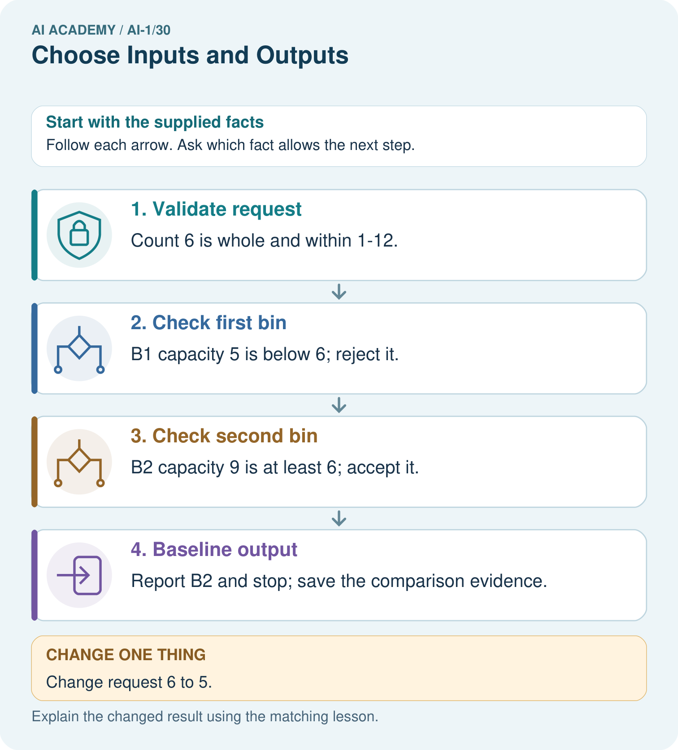

Read the picture one step at a time
Step | What happens and why
1. Validate request | Count 6 is whole and within 1–12.
2. Check first bin | B1 capacity 5 is below 6; reject it.
3. Check second bin | B2 capacity 9 is at least 6; accept it.
4. Baseline output | Report B2 and stop; save the comparison evidence.
Match each pictured step to the supplied facts. This is a worked teaching case, not an independent assessment.

Why this result follows
The baseline is an ordered catalogue scan, not a preference ranking. It makes expectations testable before a prototype is built. Count 10 is valid but has no matching bin; that differs from a blank count, which fails the input contract. Both situations need explicit output behavior.

What this example does not establish
Bin capacity is the only supplied fitting criterion; weight or shape suitability cannot be inferred.

Change one thing in the pictured case
Change: Change request 6 to 5.
Prediction: The baseline returns B1.
Reason: Its capacity equals the request, and at least includes equality.

Ask while showing the picture
Cover the result. Ask learners to name the inputs and predict the next step. Uncover one step, connect the icon to the actual procedure, and explain its evidence. Then change the supplied condition and compare. The picture is a representation; it does not document execution of a real AI model.

03. Demonstrate and guide practice

Demonstrate and guide practice

Board sequence
Write the given facts: A sorter suggests paper or plastic trays using material observations.
Write the question to explain: Name an input, output and unnecessary input.
Reveal after predictions: Input: material or a suitable image. Output: tray suggestion. Home address is unnecessary. Uncertain material needs review.
Keep for an independent attempt: A paper sorter must suggest pencil tray or book shelf. Choose one needed input and state the output. What should happen if the picture is blocked?

Classroom dialogue
Ask: Which facts are given, and which would we have to assume? Learners mark relevant details before discussing answers.
Say: Predict first. Show the rule, information path or calculation that would produce the result. A correct guess is not yet an explanation.
Reveal reasoning one step at a time. Explain why a tempting alternative fails. Write units and denominators for arithmetic, trace conditions for decisions, and identify supporting sources for claims.
In pairs, one learner solves while the other checks evidence; exchange roles. Remove the worked answer before independent assessment.

Model these guided questions
12 Yes: B1 and B3 fit; B2 and B4 are non-quiet, and B4 is also too long. Choose B1 because it is first in catalogue order. 8 Yes: B1 and B3 are too long; B2 is not quiet; B4 fails both. Report no match. Blank time requires clarification, not a guessed number. Exit: equal successful outputs on five cases do not show better accuracy for the app. A separate claim such as faster completion needs recorded times under comparable conditions, with errors and help also recorded.

Case-specific teaching sequence
Stage | Teacher action
Session 1 start 0 to 7 minutes | Retrieve why zero incompatible suggestions is not sufficient evidence of help.
7 to 20 minutes | Define valid input and both compatibility conditions; complete W1.
20 to 33 minutes | Read the complete catalogue and run W2 by hand.
33 to 45 minutes | Complete W3 and distinguish blank input from a valid zero.
Session 2 start 0 to 8 minutes | Retrieve the tie rule and the meaning of Quiet required No.
8 to 23 minutes | Complete the guided baseline and discuss a fair comparison plan.
23 to 38 minutes | Collect W4 independently, requiring reasons for each room result.
38 to 45 minutes | Complete W5 and the exit; save the contract and baseline for Week 31.

Reduce help deliberately
Completion task: Using the catalogue, record the baseline output and reason for 10 minutes with quiet required, 8 minutes with quiet not required, and 7 minutes with quiet not required. Identify which no-match result is justified and why.
Teacher check: 10 Yes gives B1: 10 fits exactly and it is quiet. 8 No gives B2: B1 is too long, B2 fits and non-quiet is permitted. 7 No gives no match: even the shortest activity requires 8 minutes. That no-match result is justified by the complete catalogue.
Start by identifying the given inputs together. Leave the intermediate steps blank. If needed, model one step, then withdraw that help on the next step. Move to a full trace only when the partial trace is understood. For partners, alternate explainer and checker; collect a response from every learner before discussion.

Individual reasoning check
Use the worked case for Requirements and a simple baseline. Proposed explanation: “Quiet required No excludes quiet activities”. Decide whether this explanation is supported. Point to the step or supplied fact that decides; explain your repair if needed.
Expected correction: No removes the quiet restriction; it does not reverse it.
Collect explanations, not only yes/no votes. If a misunderstanding is common, re-model the relevant step for the class. If it affects a few learners, give a short targeted group explanation while others solve a more demanding variation.

Pictorial practice question
Trace requests 10 and blank. Why should they not receive the same explanation?

Reasoned teacher answer
10 is valid but neither bin fits: no match. Blank is missing input: request clarification before searching.
Changed-case reasoning: The baseline returns B1. Its capacity equals the request, and at least includes equality.
Collect each learner’s explanation before discussion. Use the first missing connection between input, deciding step and result to choose support. This question is worked-case practice, not fresh mastery evidence.

04. Run the weekly evidence lab

Run the weekly evidence lab
Predict first, test honestly, and explain what the evidence means.
State your prediction before the result is known.
Complete the task: Sketch two designs and remove an unnecessary input.
Keep a normal case and an edge case clearly separated.
Record what happened—even when it does not match your prediction.
Explain the result, one limitation, and the next useful test.
INDEPENDENCE After support is removed, repeat the proof with a fresh case.

Make the lab runnable
Use the concrete case as the shared normal case and the independent question as a second case. Each pair creates a boundary or missing-information case and predicts its result before testing. Keep the expected result separate from an observed mistake.
Record | What to capture
Input or evidence | Exact data, instruction or claim
Expected result | Answer or safe fallback declared before the run
Observed result | Actual result, including errors
Explanation | Rule, calculation or evidence explaining the outcome
Next test | One justified change and a new prediction

Diagnose and reteach
CLAIM TO REPAIR A system can safely infer every missing input.
For guessing, return to given facts and request a trace. For vocabulary without application, use one example and one non-example. For arithmetic errors, check the setup before the calculation. Finish with a different uncoached case before recording mastery.

Address these additional misconceptions
Quiet required No excludes quiet activities: No removes the quiet restriction; it does not reverse it.
Ten minutes does not fit a ten-minute limit: No more than includes equality.
Blank time means zero: Blank is missing; zero is a valid input with no matching activity here.
A baseline must be bad to make a comparison useful: Use a credible simple method and accept a tie or a baseline win.

Match the support to the first error
What the response shows | Next teaching action
Missing or misread facts | Read the case aloud, mark supplied versus unknown facts, and let the learner restate it.
Wrong procedure | Return to the deciding step in the worked case. Contrast it with the proposed incorrect explanation.
Arithmetic or implementation error | Trace intermediate values or lines; preserve the first mismatch and retry that step.
Correct result without a reason | Ask for a trace and a changed case before marking independent understanding.
An unsupported wider claim | Ask which supplied evidence supports the claim and which further observation would be needed.
Offer an oral explanation, drawing, enlarged visual or fewer examples when that removes a reading/writing barrier. Keep the same reasoning goal. Stretch secure learners by changing a boundary or assumption and asking them to defend the effect, not simply by assigning more of the same questions.

05. Assess and explain the answers

Assess and explain the answers

Worked case answer
Input: material or a suitable image. Output: tray suggestion. Home address is unnecessary. Uncertain material needs review.

Independent question
A paper sorter must suggest pencil tray or book shelf. Choose one needed input and state the output. What should happen if the picture is blocked?

Expected independent answer
A clear object picture or relevant shape description can be an input; the suggested location is the output. A blocked picture should trigger a request for a clearer view or review.

What counts as evidence
Criterion | 0 points | 1 point | 2 points
Result | Incorrect or absent | Partly correct | Correct with necessary conditions
Reasoning | No supporting trace | Some steps | Clear mechanism, calculation or source support
Limit | Overclaims certainty | Vague limitation | Relevant uncertainty or missing fact
Transfer | Copies without adapting | Adapts with prompts | Solves a changed case independently
Use 6/8 as a classroom checkpoint, with 2 required for both Result and Reasoning. This is a proposed teaching rule, not a validated certification threshold. Do not count a coached answer as independent mastery; correct unsafe or unsupported claims regardless of total.

Feedback
Ask the learner to find the evidence that challenges this claim: “A system can safely infer every missing input.” Keep the first attempt and an uncoached retry separate.

Original transfer answer
Use material evidence as input; outputs are paper, plastic or review. Send the mixed cup to review under a predefined local rule. Owner name does not determine material. A description may be incomplete, so the sorter should not claim it has directly inspected the object.

Explanations for the additional workbook examples

W1 Make a requirement checkable
Replace “suggest a good activity” with the time condition, quiet condition and tie rule used in this project. Explain why Quiet required No permits B1 as well as non-quiet activities when their times fit.
Time required must be no more than available time; when quiet is required the activity must be quiet. Choose the first compatible activity in B1 to B4 order. No means quiet is not required, not forbidden, so quiet B1 is permitted if 10 minutes fits.

W2 Run the baseline on three requests
Using the catalogue, record the baseline output and reason for 10 minutes with quiet required, 8 minutes with quiet not required, and 7 minutes with quiet not required. Identify which no-match result is justified and why.
10 Yes gives B1: 10 fits exactly and it is quiet. 8 No gives B2: B1 is too long, B2 fits and non-quiet is permitted. 7 No gives no match: even the shortest activity requires 8 minutes. That no-match result is justified by the complete catalogue.

W3 Separate invalid input from no matching option
Compare a request with blank minutes and Quiet required Yes to a request with 0 minutes and Quiet required Yes. What should the baseline record for each? Explain why these are different outcomes even though neither produces an activity suggestion.
Blank minutes is invalid and requires clarification of the missing time. Zero is a valid whole number within 0 to 30; no activity takes 0 minutes or less, so no match is justified. The first lacks a usable input; the second has a usable input but no compatible option.

W4 Build a baseline for a different catalogue
A paper room recommender uses R1 first, capacity 6, quiet Yes; then R2, capacity 10, quiet No. Valid requests give a whole group size from 1 to 12 and Quiet required Yes or No. A room fits when capacity is at least group size and the quiet condition is met; choose the first fitting room. Record outputs and reasons for 6 people Yes, 8 people No and 8 people Yes. Explain how a manual baseline can be compared fairly with a prototype. No real booking is allowed.
6 Yes gives R1: equality fits and it is quiet. 8 No gives R2: R1 is too small and R2 meets capacity with quiet not required. 8 Yes gives no match: R1 is too small, R2 is not quiet. Use the same room catalogue, request set and requirements for both methods and keep all results. Compare suggestions only; do not make bookings.

W5 Challenge an unfair comparison
Team A tests a prototype on five easy requests and the manual baseline on five different requests, then reports only the prototype’s successful outputs. Identify two changes needed for a fair comparison. If both methods then meet all requirements, what can and cannot be concluded about compatibility?
Use the same requests and catalogue for both with the same judging rules, and retain all outputs including failures and no-match or clarification results. If both meet the requirements on those cases, both pass those checks; the results do not demonstrate the prototype has better compatibility or prove either works on every possible case.

Assess independent transfer
Selected case: A paper room recommender uses R1 first, capacity 6, quiet Yes; then R2, capacity 10, quiet No. Valid requests give a whole group size from 1 to 12 and Quiet required Yes or No. A room fits when capacity is at least group size and the quiet condition is met; choose the first fitting room. Record outputs and reasons for 6 people Yes, 8 people No and 8 people Yes. Explain how a manual baseline can be compared fairly with a prototype. No real booking is allowed.

Selected case answer
6 Yes gives R1: equality fits and it is quiet. 8 No gives R2: R1 is too small and R2 meets capacity with quiet not required. 8 Yes gives no match: R1 is too small, R2 is not quiet. Use the same room catalogue, request set and requirements for both methods and keep all results. Compare suggestions only; do not make bookings.
Dimension | Evidence required
Explanation | Names the applicable idea or procedure and ties it to the supplied facts.
Trace and result | Preserves the given inputs and shows the relevant intermediate steps; distinguishes a prediction from an observed execution.
Limits | States the assumptions, missing evidence or conditions under which the result would change.
Record each dimension as not yet, with support, or independent. Accept a valid alternative procedure with a defensible trace. Do not penalise an honestly recorded model failure if the learner correctly explains its evidence and limits.

Feedback that the learner uses
Name the earliest unsupported step and give one action to repair it. Have the learner make that repair now and explain why. Then assess the relevant skill on a fresh, fully specified case. Confirm it was not previously practised with feedback; solve and check the new case before assigning it. A follow-up design prompt is a starting brief, not automatically an equivalent test.

06. Connect and extend learning

Connect and extend learning

Helpful Classroom Sorter
Freeze the sorter's v1 input list, output contract, and not-sure behavior.
Keep the decision, input, result, explanation and remaining limitation in the project evidence record. Retrieve this record next week rather than restarting the project.

Support and stretch
Use physical cards, spoken explanations and a three-stage drawing. Read aloud without giving the answer. Stretch: compare two mechanisms with the same visible output and explain what evidence distinguishes them.

Exit reflection
Ask for one decision the learner can now justify and one situation requiring more evidence or human review. Confidence ratings are separate from correct independent performance.

Bridge to the next week
Next: Week 31: Design the Decision Process. Retrieve today’s evidence and identify what carries forward and what is new.

Support and fresh reassessment
Give one tick column for time or capacity and another for quiet. Require both ticks before circling a suggestion. Use a number line to distinguish equal to from greater than. Extension: explain why a fixed tie rule helps reproducibility but does not prove a preference ranking.
W4 requires R1, R2 and no match with capacity and quiet reasons, plus matching inputs, catalogue and judging rules in the comparison. After support change R2 to quiet Yes and repeat 8 Yes: expected R2. Ask whether this revises a requirement or a catalogue value; it revises the catalogue, so record a new catalogue version and rerun affected checks.
Week 31 designs the complete decision process using the same requirements and catalogue.

Plan the delayed return
Suggested return points in this level: ai-1/31, ai-1/33, ai-1/36. Use actual classroom dates, adjusting for holidays and gaps. One, three and six teaching weeks are scheduling choices, not a claimed optimal spacing.
At a delayed check, ask for the idea from memory and a changed application. Compare with the earlier independent response and record support used. For a new level, revisit the previous capstone before checking the new prerequisites.
Record | Teacher evidence
Learner code and date
Concept and case used; prior exposure
Explanation / trace / limits
Support and first repair
Changed case and delayed outcome
Next teaching action
Use the evidence to choose reteaching or the next step. A completed page, confidence rating or attractive project does not by itself demonstrate understanding.

Project evidence from this case
Document sorter schema, catalogue order, acceptance rule and all output types; use a manual trace as the comparison baseline.

