AI ACADEMY · TEACHER · ai-2/4

Trace Tables
Project: Transparent Book Recommender

01. Trace Tables

Teach the learning cycle
Primary target: Trace variable values before and after each loop iteration
Session | Sequence and minutes | Resources
Session 1 · Understand · 45 min | 0–7: recall and prerequisite; 7–15: inspect the concrete case and predict; 15–30: teacher models the worked trace; 30–40: learners explain a step using the text and visual; 40–45: check the core idea. | Sections 1–6; record the brief recall in the workbook.
Session 2 · Practise · 45 min | 0–5: retrieve the procedure; 5–15: W2 completion practice; 15–23: explain and check with a partner; 23–30: each learner answers the misconception check; 30–40: targeted reteaching or a harder variation; 40–45: prepare the investigation. | Sections 7–10; use the matching workbook W2 and misconception check.
Session 3 · Investigate and transfer · 45 min | 0–5: retrieve the decision rule; 5–20: investigate or trace; 20–30: start the independent case; 30–38: connect the project; 38–43: act on feedback; 43–45: plan the return check. | Sections 9 and 11–14. Give extra time to finish the full task set; use Section 15 when the week includes a coding lab.
This is a starting allocation of 135 minutes, not a validated duration. Preserve all named topics. Schedule extra time for connected examples, the full investigation, independent cases and project building. Repeated copies of a case share one recorded attempt; they are not new evidence.
Case exposure check: this source example appears in ai-2/4, ai-2/5, python-bridge/6. Reuse a familiar case for recall or modelling; verify that the case used to assess transfer has not already received feedback.

Retrieval answer guidance

Branching Logic
Without opening the old lesson, explain one key idea from Branching Logic. Give an example and a mistake that the idea helps you avoid.
Look for: Trace the selected branch in an if elif else chain
Reference example, not the only acceptable wording: if tests negative first; elif checks <= 12 only after that fails; else handles the rest. Unindented print runs after any selected branch, whose assignment gives label a value.

Precision in Algorithms
Without opening the old lesson, explain one key idea from Precision in Algorithms. Give an example and a mistake that the idea helps you avoid.
Look for: Translate a short paper calculation into a Python script
Reference example, not the only acceptable wording: packs = 4; per_pack = 6; total = packs * per_pack; print(total), each on its own line. The first two bind quantities, the third computes 24 and the fourth displays 24. Assignment alone produces no displayed output in this script.
Use the student module and workbook section with this exact week title. The worked case, independent question and answers below form one aligned lesson sequence.

What the learner must demonstrate
Start score=1; add 4; if score>3 subtract 2; double score. Record score after every operation. A student evaluates the condition using the initial value. Locate the divergence.

Concept to explain
A trace table records changing state and reveals reasoning errors.
Term | Meaning
variable | A named reference to a value that can be used or changed in a program.
state | The current values and information that determine what a process does next.
trace | A record of the successive states, decisions or information transformations in a process.
iteration | One repeat of a process, often followed by inspection and revision.

Prepare the class
Use the supplied scenario, student illustrations and blank paper. For numeric work, offer counters or a calculator after learners show the setup. Fictional records are supplied; personal data and paid accounts are unnecessary.
Allow 80 minutes: recall 8; explanation 12; worked demonstration 15; guided practice 20; independent assessment 15; project and reflection 10. Extend the lab into a second session when needed.

Preparation for the connected explanation
Teach for loops with finite integer ranges before adding more loop forms. Keep range values, body executions and output events separate. Reference: https://docs.python.org/3/tutorial/controlflow.html#the-range-function. The examples use a positive default step and do not require lists or while loops.

Readiness answer
It reads the old 2, adds 3 and stores 5. Assignment updates a value; it is not an algebraic equality.
Python 3 editor and loops.py
Counters or numbered paper cards
Blank trace table with turn total before and total after columns

End goal for the pictorial case
By the end, I can make a trace table for a for-loop, including zero iterations.
This added worked case illustrates the week’s main idea. Retain all original and connected topics; schedule its practice within the teaching cycle.

02. Explain the mechanism

Explain the mechanism
Input → Process → Output
Trace the information. At each stage, ask what changed and how you could test it.
Which stage could fail even when the other two are correct? Explain:
Predict first. Then check each step. A correct answer without visible reasoning is incomplete evidence.
2. Correct answer: score = score + 3 → 5.
3. Hint used: score = score − 1 → 4.
4. A table shows exactly where an unexpected value first appears.
Recalculate, retrace, or restate the reasoning in your own representation:
CHECK Did the evidence answer the exact question? Did the total, path, or source record stay consistent?

Concrete teaching case
Set score=2; add 3; if score>4 subtract 1; double score.
Trace every value.

Exact explanation to model
2,5,4,8. The comparison is evaluated at 5 before subtraction.

Explain the added worked example
Imagine adding numbered counters: first 1, then 2, then 3. A loop can repeat the same addition with a different number each time. This week you will predict each change before running a short Python script. Tracing repeated calculations prepares you to inspect the data processing used in larger AI applications.
In for turn in range(1, 4), Python supplies 1, 2 and 3 in order. The start is included and the stop is excluded. The indented body runs once for each supplied value. The colon and four-space indentation mark that body. This lesson uses integer range values with the default positive step of 1.
The output is 6. Before the first iteration, total is 0. Each assignment reads the previous total and adds the current turn. After turn 3, the range is exhausted, so execution continues after the loop. The table records state; it does not create extra instructions.

Key terms
Term | Meaning
Loop | A block of instructions that can run repeatedly
Iteration | One execution of a loop body
Accumulator | A variable that keeps a running result
Initialization | Giving a variable its starting value
Trace table | A record of variable values as instructions execute

Model the reasoning aloud
Use the complete worked example below before asking learners to complete W2. Reveal a small part, invite a prediction, then explain the deciding step. These teacher notes contain solutions; do not reveal the independent case answer during modelling.
range(1, 4) | 1, 2, 3 | 3
range(1, 2) | 1 | 1
range(1, 1) | No values | 0
range(4) | 0, 1, 2, 3 | 4
With one argument, range starts at zero. range(4) supplies four values but none is 4. If the worked script uses range(1, 1), the body never runs and the initialized total remains 0. Do not rely on a variable first assigned inside a loop: a zero-iteration run might never assign it.

Replace range(1, 4) with range(1, 3) in the worked script. Predict the supplied values and final total. What stop value is needed to include 3?
________________________________________________________________
________________________________________________________________
________________________________________________________________
________________________________________________________________
________________________________________________________________
Thinking move | Teacher prompt
Plan | What is given? What is the question? Which procedure fits these facts?
Do | Point to each input and intermediate step in the worked trace. Name the rule that allows the next step.
Check | Does the output answer the question? Which assumption or limitation prevents a larger claim?
Use the diagram and verbal explanation together. Ask learners to match a sentence to a specific visual step; do not assign learners fixed visual or auditory learning styles.

A pictorial worked case: Trace Tables
A fictional reading-token jar starts with one token and gains three per round.

The facts we will use
Python: total=1; for turn in range(4): total=total+3; after the loop print(total).
The update is inside the loop; print is outside.
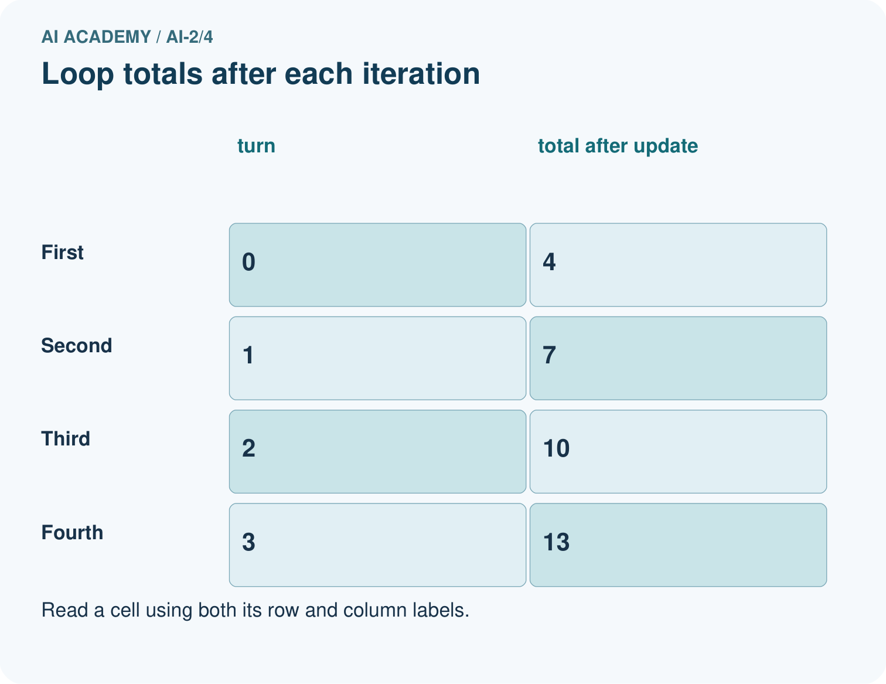
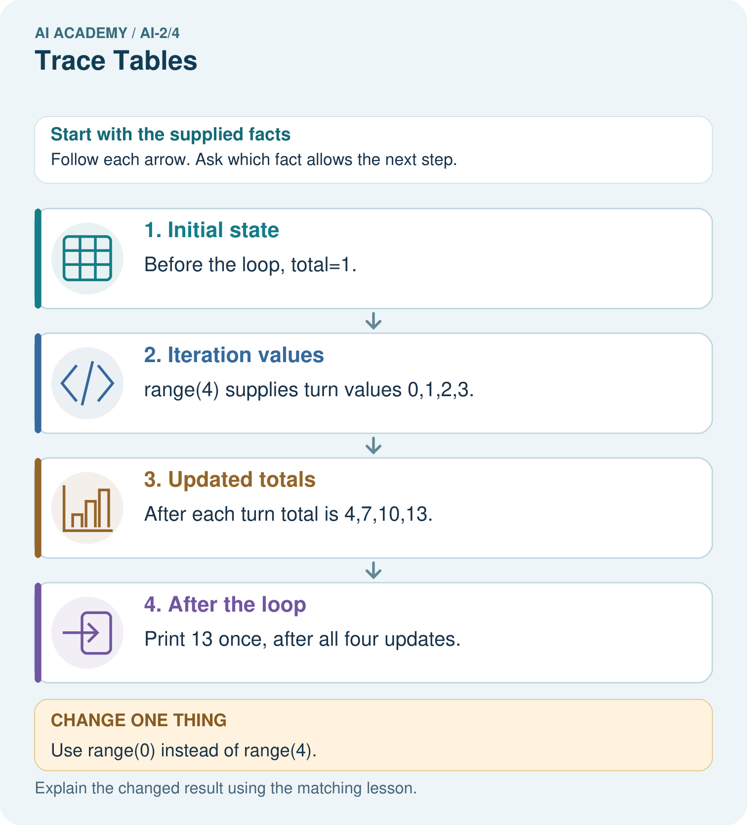

Read the picture one step at a time
Step | What happens and why
1. Initial state | Before the loop, total=1.
2. Iteration values | range(4) supplies turn values 0,1,2,3.
3. Updated totals | After each turn total is 4,7,10,13.
4. After the loop | Print 13 once, after all four updates.
Match each pictured step to the supplied facts. This is a worked teaching case, not an independent assessment.

Why this result follows
The turn value labels an iteration; it is not the number added. The fixed update adds three each time. Four iterations take the total from 1 to 13. Keeping print outside the loop produces one final display rather than four intermediate displays. Initialise total before the loop so a zero-iteration run still has a defined value.

What this example does not establish
This finite loop does not establish behavior of a while-loop with a different update or stopping condition.

Change one thing in the pictured case
Change: Use range(0) instead of range(4).
Prediction: The loop body never runs and the printed total is 1.
Reason: The iterable contains no turn values; the initial assignment still happened.

Ask while showing the picture
Cover the result. Ask learners to name the inputs and predict the next step. Uncover one step, connect the icon to the actual procedure, and explain its evidence. Then change the supplied condition and compare. The picture is a representation; it does not document execution of a real AI model.

03. Demonstrate and guide practice

Demonstrate and guide practice

Board sequence
Write the given facts: Set score=2; add 3; if score>4 subtract 1; double score.
Write the question to explain: Trace every value.
Reveal after predictions: 2,5,4,8. The comparison is evaluated at 5 before subtraction.
Keep for an independent attempt: Set score to 2. Add 3, then double the result. Record the score after each operation. What changes if you double before adding?

Classroom dialogue
Ask: Which facts are given, and which would we have to assume? Learners mark relevant details before discussing answers.
Say: Predict first. Show the rule, information path or calculation that would produce the result. A correct guess is not yet an explanation.
Reveal reasoning one step at a time. Explain why a tempting alternative fails. Write units and denominators for arithmetic, trace conditions for decisions, and identify supporting sources for claims.
In pairs, one learner solves while the other checks evidence; exchange roles. Remove the worked answer before independent assessment.

Model these guided questions
range(1, 3) supplies 1 and 2, giving total 3. Stop 4 includes 3. Exit: the reset bug agrees for one iteration because there are no earlier additions to lose. range(1, 4) should give 6; the faulty version gives 3.

Case-specific teaching sequence
Stage | Teacher action
Session 1 start to 7 minutes | Retrieve assignment using the prerequisite.
7 to 20 minutes | Model range with numbered cards and complete W1.
20 to 33 minutes | Trace each row of the worked addition and predict output.
33 to 45 minutes | Complete W2 and compare predicted and observed values.
Session 2 start to 8 minutes | Retrieve included start and excluded stop.
8 to 20 minutes | Trace the reset bug, complete W3 and discuss the guided response.
20 to 35 minutes | Collect independent W4 code and zero one and several iteration traces.
35 to 45 minutes | Use W5 and the exit to examine assumptions and revealing tests.

Reduce help deliberately
Completion task: Copy the worked script. Change the range to range(2, 5). Record turn, total before and total after each iteration. Predict the single output, then run and compare.
Teacher check: Rows are 2 / 0 / 2, 3 / 2 / 5, 4 / 5 / 9. Final output 9. Keep the observed result distinct from the prediction.
Start by identifying the given inputs together. Leave the intermediate steps blank. If needed, model one step, then withdraw that help on the next step. Move to a full trace only when the partial trace is understood. For partners, alternate explainer and checker; collect a response from every learner before discussion.

Individual reasoning check
Use the worked case for Loops and trace tables. Proposed explanation: “The stop value is included”. Decide whether this explanation is supported. Point to the step or supplied fact that decides; explain your repair if needed.
Expected correction: List the supplied values before tracing; range(1, 4) excludes 4.
Collect explanations, not only yes/no votes. If a misunderstanding is common, re-model the relevant step for the class. If it affects a few learners, give a short targeted group explanation while others solve a more demanding variation.

Pictorial practice question
Move print inside the original loop. What sequence is displayed?

Reasoned teacher answer
4,7,10,13 on separate lines, because each print follows one update.
Changed-case reasoning: The loop body never runs and the printed total is 1. The iterable contains no turn values; the initial assignment still happened.
Collect each learner’s explanation before discussion. Use the first missing connection between input, deciding step and result to choose support. This question is worked-case practice, not fresh mastery evidence.

04. Run the weekly evidence lab

Run the weekly evidence lab
Words You Can Use to Reason
A definition matters when you can recognize the idea, use it, and contrast it with a near-miss.
Predict → Test → Record → Explain
Keep expected and actual results separate. Surprises are useful data when recorded honestly.
Use columns for step, event, old score, new score, and branch. Trace once by hand, predict the next row, then compare.
What did the hardest test teach you that the normal test did not?

Make the lab runnable
Use the concrete case as the shared normal case and the independent question as a second case. Each pair creates a boundary or missing-information case and predicts its result before testing. Keep the expected result separate from an observed mistake.
Record | What to capture
Input or evidence | Exact data, instruction or claim
Expected result | Answer or safe fallback declared before the run
Observed result | Actual result, including errors
Explanation | Rule, calculation or evidence explaining the outcome
Next test | One justified change and a new prediction

Diagnose and reteach
For guessing, return to given facts and request a trace. For vocabulary without application, use one example and one non-example. For arithmetic errors, check the setup before the calculation. Finish with a different uncoached case before recording mastery.

Address these additional misconceptions
The stop value is included: List the supplied values before tracing; range(1, 4) excludes 4.
Initialization belongs inside every iteration: Resetting the accumulator loses earlier work.
An unindented print repeats with the body: Indentation determines which statements repeat.
Zero iterations mean the entire program does nothing: Initialization and statements after the loop still execute.

Match the support to the first error
What the response shows | Next teaching action
Missing or misread facts | Read the case aloud, mark supplied versus unknown facts, and let the learner restate it.
Wrong procedure | Return to the deciding step in the worked case. Contrast it with the proposed incorrect explanation.
Arithmetic or implementation error | Trace intermediate values or lines; preserve the first mismatch and retry that step.
Correct result without a reason | Ask for a trace and a changed case before marking independent understanding.
An unsupported wider claim | Ask which supplied evidence supports the claim and which further observation would be needed.
Offer an oral explanation, drawing, enlarged visual or fewer examples when that removes a reading/writing barrier. Keep the same reasoning goal. Stretch secure learners by changing a boundary or assumption and asking them to defend the effect, not simply by assigning more of the same questions.

05. Assess and explain the answers

Assess and explain the answers

Worked case answer
2,5,4,8. The comparison is evaluated at 5 before subtraction.

Independent question
Set score to 2. Add 3, then double the result. Record the score after each operation. What changes if you double before adding?

Expected independent answer
The trace is 2, 5, 10. Doubling first gives 2, 4, 7. Operation order changes the result.

What counts as evidence
Criterion | 0 points | 1 point | 2 points
Result | Incorrect or absent | Partly correct | Correct with necessary conditions
Reasoning | No supporting trace | Some steps | Clear mechanism, calculation or source support
Limit | Overclaims certainty | Vague limitation | Relevant uncertainty or missing fact
Transfer | Copies without adapting | Adapts with prompts | Solves a changed case independently
Use 6/8 as a classroom checkpoint, with 2 required for both Result and Reasoning. This is a proposed teaching rule, not a validated certification threshold. Do not count a coached answer as independent mastery; correct unsafe or unsupported claims regardless of total.

Feedback
Ask the learner to find the evidence that challenges this claim: “A trace table records only the final answer.” Keep the first attempt and an uncoached retry separate.

Original transfer answer
Trace is 1,5,3,6. The condition sees 5, so subtraction runs. Using the initial 1 incorrectly skips subtraction and gives 10. A variable's current state, not its first value, determines each operation.

Explanations for the additional workbook examples

W1 Explain the range
List the values supplied by range(2, 5) and explain why 5 is absent. How many times does its body run?
2, 3 and 4; the stop value is excluded. The body runs three times.

W2 Trace before running
Copy the worked script. Change the range to range(2, 5). Record turn, total before and total after each iteration. Predict the single output, then run and compare.
Rows are 2 / 0 / 2, 3 / 2 / 5, 4 / 5 / 9. Final output 9. Keep the observed result distinct from the prediction.

W3 Repair the reset
For the faulty script with range(1, 4), record total after each addition. Explain the wrong final output and remove only the faulty reset.
Faulty after-addition values are 1, 2, 3 because each starts from zero. Remove the indented total = 0. Correct after-addition values are 1, 3, 6; final output 6.

W4 Build a repeated addition independently
A box starts with 5 counters. Each round adds 2 counters. Use rounds = 3, an initialized total and for turn in range(rounds). Print the final total once after the loop. Trace the totals and predict fresh runs with rounds 0, 1 and 3. Assume rounds is a nonnegative integer.
Initialize total = 5 before the loop; add 2 inside it. For three rounds, turn values 0, 1, 2 give totals 7, 9, 11. Final outputs for 0, 1, 3 rounds are 5, 7, 11. Print is unindented.

W5 Check a contract limitation
In your counter script, range(-2) performs no iterations. Does returning the initial 5 make negative rounds valid? Explain what the script checks and what it assumes.
No. The written contract requires a nonnegative integer. The script assumes this and does not reject negative values. Empty range behavior does not validate the input; report the limitation or add an explicit check.

Assess independent transfer
Selected case: A box starts with 5 counters. Each round adds 2 counters. Use rounds = 3, an initialized total and for turn in range(rounds). Print the final total once after the loop. Trace the totals and predict fresh runs with rounds 0, 1 and 3. Assume rounds is a nonnegative integer.

Selected case answer
Initialize total = 5 before the loop; add 2 inside it. For three rounds, turn values 0, 1, 2 give totals 7, 9, 11. Final outputs for 0, 1, 3 rounds are 5, 7, 11. Print is unindented.
Dimension | Evidence required
Explanation | Names the applicable idea or procedure and ties it to the supplied facts.
Trace and result | Preserves the given inputs and shows the relevant intermediate steps; distinguishes a prediction from an observed execution.
Limits | States the assumptions, missing evidence or conditions under which the result would change.
Record each dimension as not yet, with support, or independent. Accept a valid alternative procedure with a defensible trace. Do not penalise an honestly recorded model failure if the learner correctly explains its evidence and limits.

Feedback that the learner uses
Name the earliest unsupported step and give one action to repair it. Have the learner make that repair now and explain why. Then assess the relevant skill on a fresh, fully specified case. Confirm it was not previously practised with feedback; solve and check the new case before assigning it. A follow-up design prompt is a starting brief, not automatically an equivalent test.

06. Connect and extend learning

Connect and extend learning

Transparent Book Recommender
Trace each book’s genre, length, difficulty, and total score before sorting.
Keep the decision, input, result, explanation and remaining limitation in the project evidence record. Retrieve this record next week rather than restarting the project.

Support and stretch
Trace one record or condition at a time with counters and labelled columns. Stretch: introduce a tie, boundary or missing field and declare its handling policy before rerunning.

Exit reflection
Ask for one decision the learner can now justify and one situation requiring more evidence or human review. Confidence ratings are separate from correct independent performance.

Bridge to the next week
Next: Week 5: Loops and Stopping. Retrieve today’s evidence and identify what carries forward and what is new.

Support and fresh reassessment
Use counters and let the learner move a pointer through one instruction at a time. Offer a blank trace grid and permit oral explanation. Extension: put print inside the correct loop and explain why zero rounds produces no output while an outside print still does.
W4 must preserve the initial 5, update by 2, trace three iterations and print once. Require outputs 5, 7, 11 for zero one and three rounds. After support, retry with an initial 4 and additions of 3 for zero one and two rounds: outputs 4, 7, 10. Record assistance before judging independence.
Week 7 stores several values in a list and distinguishes an index from the value at that position.

Plan the delayed return
Suggested return points in this level: ai-2/5, ai-2/7, ai-2/10. Use actual classroom dates, adjusting for holidays and gaps. One, three and six teaching weeks are scheduling choices, not a claimed optimal spacing.
At a delayed check, ask for the idea from memory and a changed application. Compare with the earlier independent response and record support used. For a new level, revisit the previous capstone before checking the new prerequisites.
Record | Teacher evidence
Learner code and date
Concept and case used; prior exposure
Explanation / trace / limits
Support and first repair
Changed case and delayed outcome
Next teaching action
Use the evidence to choose reteaching or the next step. A completed page, confidence rating or attractive project does not by itself demonstrate understanding.

Project evidence from this case
Trace recommender loops with current item, eligibility, score and current best so each update can be explained.

