AI ACADEMY · TEACHER · ai-2/8

Operational Labels
Project: Transparent Book Recommender

01. Operational Labels

Teach the learning cycle
Primary target: Apply a category definition using explicit evidence and boundary rules
Session | Sequence and minutes | Resources
Session 1 · Understand · 45 min | 0–7: recall and prerequisite; 7–15: inspect the concrete case and predict; 15–30: teacher models the worked trace; 30–40: learners explain a step using the text and visual; 40–45: check the core idea. | Sections 1–6; record the brief recall in the workbook.
Session 2 · Practise · 45 min | 0–5: retrieve the procedure; 5–15: W2 completion practice; 15–23: explain and check with a partner; 23–30: each learner answers the misconception check; 30–40: targeted reteaching or a harder variation; 40–45: prepare the investigation. | Sections 7–10; use the matching workbook W2 and misconception check.
Session 3 · Investigate and transfer · 45 min | 0–5: retrieve the decision rule; 5–20: investigate or trace; 20–30: start the independent case; 30–38: connect the project; 38–43: act on feedback; 43–45: plan the return check. | Sections 9 and 11–14. Give extra time to finish the full task set; use Section 15 when the week includes a coding lab.
This is a starting allocation of 135 minutes, not a validated duration. Preserve all named topics. Schedule extra time for connected examples, the full investigation, independent cases and project building. Repeated copies of a case share one recorded attempt; they are not new evidence.
Case exposure check: this source example appears in ai-1/7, ai-2/8. Reuse a familiar case for recall or modelling; verify that the case used to assess transfer has not already received feedback.

Retrieval answer guidance

Rows Columns and Data Types
Without opening the old lesson, explain one key idea from Rows Columns and Data Types. Give an example and a mistake that the idea helps you avoid.
Look for: Specify a table schema
Reference example, not the only acceptable wording: activity: nonempty text; minutes: integer from 0 to 60 inclusive.

Loops and Stopping
Without opening the old lesson, explain one key idea from Loops and Stopping. Give an example and a mistake that the idea helps you avoid.
Look for: Trace variable values before and after each loop iteration
Reference example, not the only acceptable wording: 2, 3 and 4; the stop value is excluded. The body runs three times.

Decompose a Goal
Without opening the old lesson, explain one key idea from Decompose a Goal. Give an example and a mistake that the idea helps you avoid.
Look for: Distinguish a function definition from a function call
Reference example, not the only acceptable wording: Name show_remaining; parameters capacity and used. Arguments 15 and 6 match capacity = 15 and used = 6. Expected printed result 9.
Use the student module and workbook section with this exact week title. The worked case, independent question and answers below form one aligned lesson sequence.

What the learner must demonstrate
Two labelers use 'short' to mean pages<100 and pages<=100. They disagree only on 100-page books. Write a shared definition and explain how to repair the existing labels.

Concept to explain
A label is reliable only when different people can apply its definition consistently.
Term | Meaning
label | The recorded target category or value attached to an example.
operational definition | A precise rule explaining how a concept will be observed, measured or labelled in this activity.
agreement | How often two judgments match; matching judgments can still both be wrong.
ambiguous | Having more than one reasonable interpretation given the available information.

Prepare the class
Use the supplied scenario, student illustrations and blank paper. For numeric work, offer counters or a calculator after learners show the setup. Fictional records are supplied; personal data and paid accounts are unnecessary.
Allow 80 minutes: recall 8; explanation 12; worked demonstration 15; guided practice 20; independent assessment 15; project and reflection 10. Extend the lab into a second session when needed.

Preparation for the connected explanation
This lesson establishes labels as task-dependent records produced under a guide. Use fictional event and equipment forms rather than categories about classmates. The three categories deliberately separate known failures from unknown information, with known failure taking priority. A ready label checks a representation; it does not establish truth, quality, safety or permission. Agreement is useful evidence about consistency, but shared mistakes can produce high agreement.

Readiness answer
The missing word is information the representation does not establish. Filling it without evidence adds an assumption; a later stage should preserve the uncertainty or request a check.
Paper calendar cards with the four worked field combinations and the printed policy
A second set of cards labelled independently by partners before discussion
The equipment-request cases on a separate sheet for independent assessment; no accounts or personal data are required

End goal for the pictorial case
By the end, I can resolve label disagreement by checking an operational definition at equality.
This added worked case illustrates the week’s main idea. Retain all original and connected topics; schedule its practice within the teaching cycle.

02. Explain the mechanism

Explain the mechanism
Input → Process → Output
Trace the information. At each stage, ask what changed and how you could test it.
Which stage could fail even when the other two are correct? Explain:
Predict first. Then check each step. A correct answer without visible reasoning is incomplete evidence.
1. Weak label: ‘easy book.’
2. Operational rule: easy for this reader if difficulty level ≤ 2 and unfamiliar words per page ≤ 3.
3. Two labelers test the same 8 books.
4. Agreement of 7/8 identifies one disagreement to review. Check the source, each annotator’s application and the label rule before choosing a repair.
Recalculate, retrace, or restate the reasoning in your own representation:
CHECK Did the evidence answer the exact question? Did the total, path, or source record stay consistent?

Concrete teaching case
Short means fewer than 100 pages. Two annotators disagree about a 100-page book.
Resolve the label.

Exact explanation to model
It is not Short under the stated definition. Agree operational boundaries before labelling.

Explain the added worked example
Two students are sorting fictional event cards for a classroom calendar. Their first instruction is Put the good cards together. Mina calls a colourful card good. Theo calls a plain card good because its room is easy to read. They disagree even though both followed a reasonable interpretation of the word good.
A category is useful for a task when people can tell what evidence makes an example belong to it. An operational definition states the observations or checks to perform. For this paper exercise, we will check two printed fields: an event day and a room code. The task is to check the record against a classroom policy, not to judge the quality of the event or the person who wrote it.
Labels depend on the definition in use. A model fitted to labels can learn the distinctions those labels encode, including mistakes and inconsistencies. Before asking a model to copy a label, ask whether people have a clear, useful guide for assigning it.
Our fictional calendar accepts a whole-number day from 1 through 30, including both endpoints, and exactly one room code, A or B. The month is already fixed for this exercise. A blank or unreadable field counts as unknown. The categories are revise, review and ready. Use the checks in the order shown.
Known failure and unknown are different. Day 31 is known and outside the accepted range, so the card needs revision. An unreadable day might be valid or invalid; without another known failure, it needs review. Never silently turn a blank into zero just to make a comparison possible.

Key terms
Term | Meaning
Category | A group defined by stated membership criteria
Operational definition | A definition precise enough to tell someone what to observe or do when assigning a category
Label | The category recorded for an example under a particular guide
Annotator | A person who assigns labels to examples
Disagreement | A case where annotators assign different labels to the same example

Model the reasoning aloud
Use the complete worked example below before asking learners to complete W2. Reveal a small part, invite a prediction, then explain the deciding step. These teacher notes contain solutions; do not reveal the independent case answer during modelling.
Day 12 room A | Both values satisfy the criteria | Ready because both checks pass
Day 31 room A | 31 is outside 1 through 30 | Revise because a known value fails
Day 12 room unreadable | No known failure but the room is unknown | Review until the room is checked
Day 31 room unreadable | The day already fails although the room is unknown | Revise because the first check has priority
For the last card, first read only what is known: day 31. Compare it with the allowed range and record a failure. The guide therefore selects revise before the missing-room check. Checking the room later could reveal another problem, but it cannot make day 31 satisfy this policy.
A clear explanation cites the particular criterion. Saying It looks wrong is not enough. Write Day 31 exceeds the accepted maximum of 30 instead. That explanation lets another person reproduce the check and challenge it if the recorded value or policy is different.
Thinking move | Teacher prompt
Plan | What is given? What is the question? Which procedure fits these facts?
Do | Point to each input and intermediate step in the worked trace. Name the rule that allows the next step.
Check | Does the output answer the question? Which assumption or limitation prevents a larger claim?
Use the diagram and verbal explanation together. Ask learners to match a sentence to a specific visual step; do not assign learners fixed visual or auditory learning styles.

A pictorial worked case: Operational Labels
Two fictional catalogue reviewers label books compact or extended.

The facts we will use
Agreed policy: compact means at most 80 pages; extended means more than 80.
Reviewer A uses pages<80; reviewer B uses pages<=80. Inspect books of 79,80,81 pages.
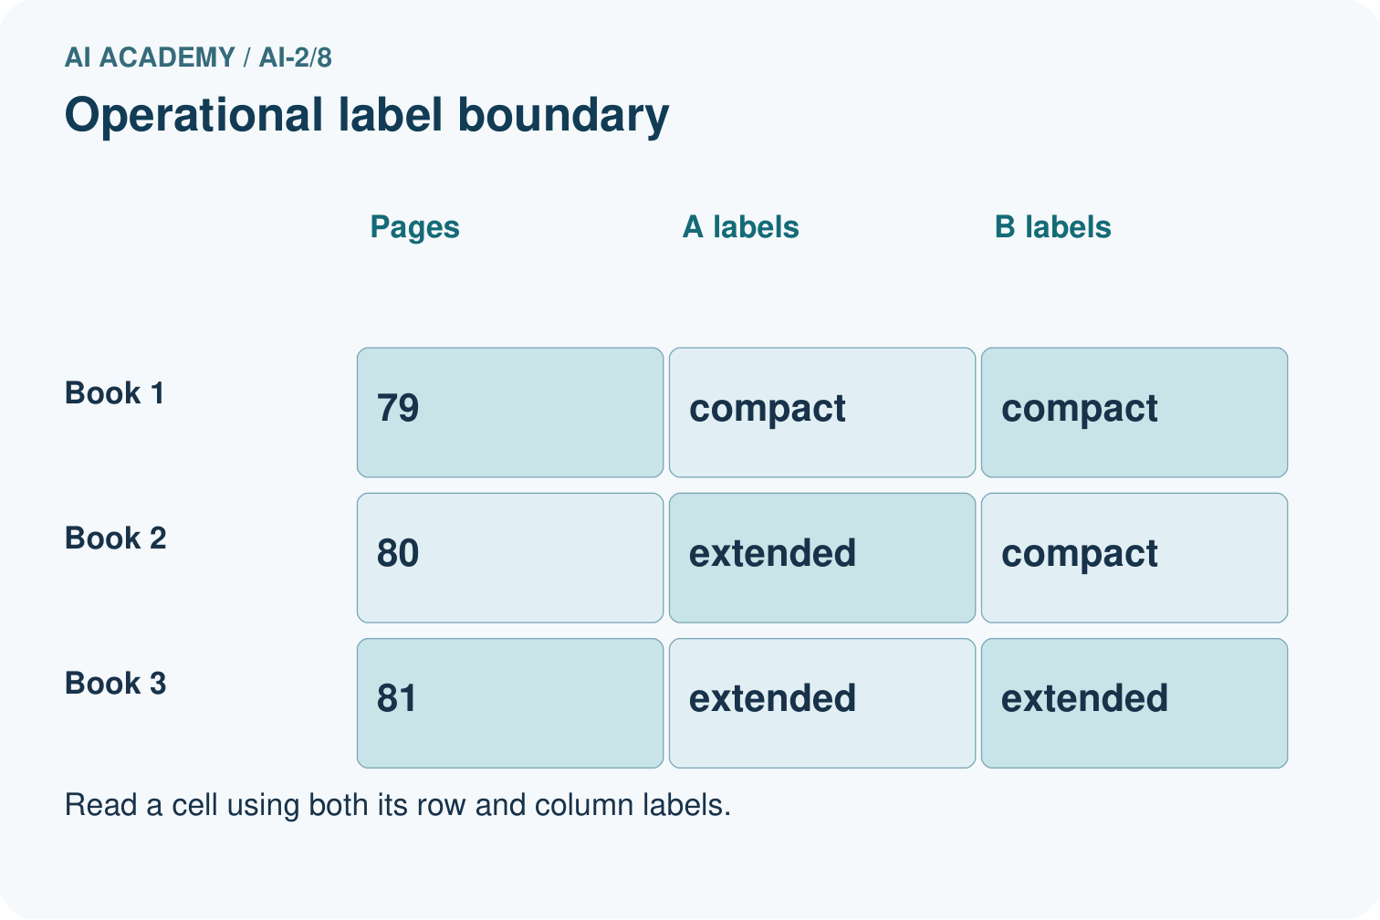
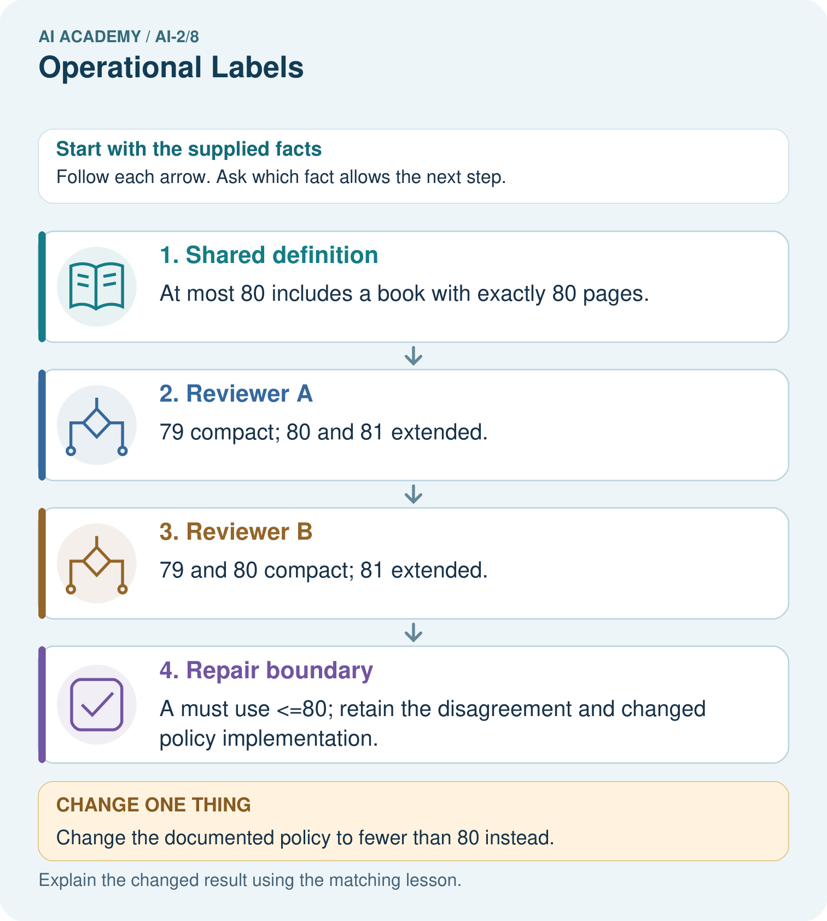

Read the picture one step at a time
Step | What happens and why
1. Shared definition | At most 80 includes a book with exactly 80 pages.
2. Reviewer A | 79 compact; 80 and 81 extended.
3. Reviewer B | 79 and 80 compact; 81 extended.
4. Repair boundary | A must use <=80; retain the disagreement and changed policy implementation.
Match each pictured step to the supplied facts. This is a worked teaching case, not an independent assessment.

Why this result follows
The reviewers agree on two of three examples, but that fraction does not decide which definition to keep. The documented policy decides the equality case. Repairing A’s implementation aligns its labels with the agreed meaning. Rechecking 79 and 81 ensures the boundary fix preserves adjacent decisions.

What this example does not establish
A shared definition improves consistency but does not prove the category captures every learner’s needs.

Change one thing in the pictured case
Change: Change the documented policy to fewer than 80 instead.
Prediction: A’s original labels now match; B must change its equality behavior.
Reason: The authoritative definition changed, not the physical books.

Ask while showing the picture
Cover the result. Ask learners to name the inputs and predict the next step. Uncover one step, connect the icon to the actual procedure, and explain its evidence. Then change the supplied condition and compare. The picture is a representation; it does not document execution of a real AI model.

03. Demonstrate and guide practice

Demonstrate and guide practice

Board sequence
Write the given facts: Short means fewer than 100 pages. Two annotators disagree about a 100-page book.
Write the question to explain: Resolve the label.
Reveal after predictions: It is not Short under the stated definition. Agree operational boundaries before labelling.
Keep for an independent attempt: Use a clear label rule: short means 80 pages or fewer. Two judges label an 80-page book differently. What shared instruction resolves this disagreement?

Classroom dialogue
Ask: Which facts are given, and which would we have to assume? Learners mark relevant details before discussing answers.
Say: Predict first. Show the rule, information path or calculation that would produce the result. A correct guess is not yet an explanation.
Reveal reasoning one step at a time. Explain why a tempting alternative fails. Write units and denominators for arithmetic, trace conditions for decisions, and identify supporting sources for claims.
In pairs, one learner solves while the other checks evidence; exchange roles. Remove the worked answer before independent assessment.

Model these guided questions
Day 0 room A is revise because 0 falls below the accepted minimum of 1; the known day needs correction. Day 18 with a blank room is review because the known day passes and the room is unknown; the missing evidence must be checked. Two people labelling everything ready establishes agreement only. They may share a mistake, ignore the criteria or work from inaccurate records. Correct field checks also do not confirm the event or its permission.

Case-specific teaching sequence
Stage | Teacher action
Session 1 start 0 to 7 minutes | Retrieve the missing-word example from Week 6. Ask what evidence a blank supplies and what it does not.
7 to 20 minutes | Give the vague good-card instruction and collect two different interpretations. Replace it with observable field criteria. Read the ordered checks aloud.
20 to 33 minutes | Trace all four worked cards. Emphasise the inclusive boundary and the priority of a known failure over an unknown field.
33 to 45 minutes | Pairs complete W1 and W2. Ask each learner to cite a criterion rather than a personal impression.
Session 2 start 0 to 8 minutes | Label two fresh calendar cards independently before comparing. Keep original labels visible during discussion.
8 to 23 minutes | Complete W3. Distinguish counting agreement from checking correctness against source fields and policy.
23 to 38 minutes | Collect W4 independently. Require four labels with reasons and a statement about the limit of ready.
38 to 45 minutes | Use W5 to demonstrate a policy-version conflict. Discuss the exit question and preview choosing useful input features.

Reduce help deliberately
Completion task: A helper says Label a card ready if it looks nice. Explain why this can lead to inconsistent labels. Replace it with an instruction that another person can apply using the calendar policy, including what to do about a blank field.
Teacher check: Looks nice has no agreed observable criterion and can invite different preferences. A usable replacement checks for a known day outside whole numbers 1 to 30 or a known room other than A/B and labels revise; otherwise any blank or unreadable required field gives review; otherwise label ready. Accept equivalent wording that preserves all criteria and priority.
Start by identifying the given inputs together. Leave the intermediate steps blank. If needed, model one step, then withdraw that help on the next step. Move to a full trace only when the partial trace is understood. For partners, alternate explainer and checker; collect a response from every learner before discussion.

Individual reasoning check
Use the worked case for Categories and operational labels. Proposed explanation: “A blank is the same as a failing value”. Decide whether this explanation is supported. Point to the step or supplied fact that decides; explain your repair if needed.
Expected correction: Contrast unreadable day with day 0. One is unknown; the other is known to violate the stated range.
Collect explanations, not only yes/no votes. If a misunderstanding is common, re-model the relevant step for the class. If it affects a few learners, give a short targeted group explanation while others solve a more demanding variation.

Pictorial practice question
Why can we not resolve the disagreement merely by taking a majority of reviewers?

Reasoned teacher answer
A vote does not apply the agreed operational definition. The policy includes 80, so the original correct label there is compact.
Changed-case reasoning: A’s original labels now match; B must change its equality behavior. The authoritative definition changed, not the physical books.
Collect each learner’s explanation before discussion. Use the first missing connection between input, deciding step and result to choose support. This question is worked-case practice, not fresh mastery evidence.

04. Run the weekly evidence lab

Run the weekly evidence lab
Words You Can Use to Reason
A definition matters when you can recognize the idea, use it, and contrast it with a near-miss.
Predict → Test → Record → Explain
Keep expected and actual results separate. Surprises are useful data when recorded honestly.
Pairs label the same cards independently, compare, calculate matches/total, discuss disagreements, and revise only the unclear rule.
What did the hardest test teach you that the normal test did not?

Make the lab runnable
Use the concrete case as the shared normal case and the independent question as a second case. Each pair creates a boundary or missing-information case and predicts its result before testing. Keep the expected result separate from an observed mistake.
Record | What to capture
Input or evidence | Exact data, instruction or claim
Expected result | Answer or safe fallback declared before the run
Observed result | Actual result, including errors
Explanation | Rule, calculation or evidence explaining the outcome
Next test | One justified change and a new prediction

Diagnose and reteach
For guessing, return to given facts and request a trace. For vocabulary without application, use one example and one non-example. For arithmetic errors, check the setup before the calculation. Finish with a different uncoached case before recording mastery.

Address these additional misconceptions
A blank is the same as a failing value: Contrast unreadable day with day 0. One is unknown; the other is known to violate the stated range.
Review must win whenever any field is missing: Trace the guide in order for day 31 with a blank room. The known failure already selects revise under this policy.
Agreement proves the labels are true: Give two annotators the same mistaken exclusive-boundary interpretation. Their agreement can coexist with incorrect labels.
A category describes the whole person or event: Return to the task scope. Ready checks two printed fields under one policy, not the worth of a person or the reality of an event.

Match the support to the first error
What the response shows | Next teaching action
Missing or misread facts | Read the case aloud, mark supplied versus unknown facts, and let the learner restate it.
Wrong procedure | Return to the deciding step in the worked case. Contrast it with the proposed incorrect explanation.
Arithmetic or implementation error | Trace intermediate values or lines; preserve the first mismatch and retry that step.
Correct result without a reason | Ask for a trace and a changed case before marking independent understanding.
An unsupported wider claim | Ask which supplied evidence supports the claim and which further observation would be needed.
Offer an oral explanation, drawing, enlarged visual or fewer examples when that removes a reading/writing barrier. Keep the same reasoning goal. Stretch secure learners by changing a boundary or assumption and asking them to defend the effect, not simply by assigning more of the same questions.

05. Assess and explain the answers

Assess and explain the answers

Worked case answer
It is not Short under the stated definition. Agree operational boundaries before labelling.

Independent question
Use a clear label rule: short means 80 pages or fewer. Two judges label an 80-page book differently. What shared instruction resolves this disagreement?

Expected independent answer
Both should label it short because the written definition includes 80. Applying the same operational definition makes the judgement reproducible.

What counts as evidence
Criterion | 0 points | 1 point | 2 points
Result | Incorrect or absent | Partly correct | Correct with necessary conditions
Reasoning | No supporting trace | Some steps | Clear mechanism, calculation or source support
Limit | Overclaims certainty | Vague limitation | Relevant uncertainty or missing fact
Transfer | Copies without adapting | Adapts with prompts | Solves a changed case independently
Use 6/8 as a classroom checkpoint, with 2 required for both Result and Reasoning. This is a proposed teaching rule, not a validated certification threshold. Do not count a coached answer as independent mastery; correct unsafe or unsupported claims regardless of total.

Feedback
Ask the learner to find the evidence that challenges this claim: “A category name alone guarantees consistent labels.” Keep the first attempt and an uncoached retry separate.

Original transfer answer
Choose and document one boundary, such as short means fewer than 100 pages. Review all 100-page records under that rule, preserve old labels and record the correction. Do not average categorical labels or count the disagreement as random noise before inspecting definitions.

Explanations for the additional workbook examples

W1 Apply the calendar guide
The calendar policy accepts whole-number days 1 through 30 inclusive and a room code A or B. Check known failures first, then unknown fields, then readiness. Label these cards and give evidence: day 30 room B; day 31 room A; day 14 room unreadable; day 31 room unreadable.
In order: ready because both known fields pass; revise because 31 exceeds 30; review because the known day passes but the room is unknown; revise because the known day failure has priority over the unknown room. Equality at 30 is accepted.

W2 Replace a vague instruction
A helper says Label a card ready if it looks nice. Explain why this can lead to inconsistent labels. Replace it with an instruction that another person can apply using the calendar policy, including what to do about a blank field.
Looks nice has no agreed observable criterion and can invite different preferences. A usable replacement checks for a known day outside whole numbers 1 to 30 or a known room other than A/B and labels revise; otherwise any blank or unreadable required field gives review; otherwise label ready. Accept equivalent wording that preserves all criteria and priority.

W3 Count and investigate disagreement
For the same four cards, Mina records ready, revise, review, ready. Theo records ready, review, review, revise. How many positions agree? Identify the disagreements. Can you decide which annotator is correct from these label lists alone? Explain what else you need.
Positions 1 and 3 agree, so there are two agreements out of four. Positions 2 and 4 disagree. The lists alone do not show which labels are correct; inspect the corresponding card fields and the guide version, then compare each explanation with the criteria. Agreement at positions 1 and 3 does not itself prove correctness.

W4 Transfer the method to a new record
A fictional equipment-request form accepts a whole-number borrowing duration of 1 through 7 days inclusive and one item code X or Y. Label revise if any known field fails; otherwise label review if a field is blank or unreadable; otherwise label ready. Classify these forms and justify each: 7 days X; 8 days Y; unreadable duration X; 8 days blank code. Explain whether ready alone grants permission to borrow.
7 days X is ready: both pass, including the endpoint. 8 days Y is revise: duration exceeds 7. Unreadable duration X is review: no known failure but duration is unknown. 8 days blank code is revise: the known duration failure has priority. Ready only means the printed fields satisfy this policy; borrowing still requires the actual availability and authorisation process.

W5 Keep a policy change visible
Version 1 accepts calendar days 1 through 30. Version 2 accepts days 1 through 31. A card says day 31 room A. State its label under each version. Explain why mixing the two labels without recording the version could create a misleading training dataset.
Under Version 1 the card is revise; under Version 2 it is ready. Both can be correct relative to their different policies. If the version is omitted, identical printed fields appear to have conflicting targets without explanation. Record which policy produced each label and review or relabel consistently for the intended task; do not erase the history.

Assess independent transfer
Selected case: Two labellers use book-length rules: fewer than 120 pages and at most 120 pages. Label books with 110,120,121 pages. The agreed policy is at most 120. Repair the disagreement.

Selected case answer
Both include 110 and exclude 121; they disagree at 120. Under the supplied common policy, 120 belongs. State the inclusive boundary and check it; disagreement alone does not identify a bad labeller.
Dimension | Evidence required
Explanation | Names the applicable idea or procedure and ties it to the supplied facts.
Trace and result | Preserves the given inputs and shows the relevant intermediate steps; distinguishes a prediction from an observed execution.
Limits | States the assumptions, missing evidence or conditions under which the result would change.
Record each dimension as not yet, with support, or independent. Accept a valid alternative procedure with a defensible trace. Do not penalise an honestly recorded model failure if the learner correctly explains its evidence and limits.

Feedback that the learner uses
Name the earliest unsupported step and give one action to repair it. Have the learner make that repair now and explain why. Then assess the relevant skill on a fresh, fully specified case. Confirm it was not previously practised with feedback; solve and check the new case before assigning it. A follow-up design prompt is a starting brief, not automatically an equivalent test.

06. Connect and extend learning

Connect and extend learning

Transparent Book Recommender
Define ‘good match’ before training or evaluating the recommender.
Keep the decision, input, result, explanation and remaining limitation in the project evidence record. Retrieve this record next week rather than restarting the project.

Support and stretch
Trace one record or condition at a time with counters and labelled columns. Stretch: introduce a tie, boundary or missing field and declare its handling policy before rerunning.

Exit reflection
Ask for one decision the learner can now justify and one situation requiring more evidence or human review. Confidence ratings are separate from correct independent performance.

Bridge to the next week
Next: Week 9: Features and Distractors. Retrieve today’s evidence and identify what carries forward and what is new.

Support and fresh reassessment
Provide a three-step checklist and highlight known versus unreadable fields using words as well as colour. Let learners explain orally while pointing to the criterion. Extension: ask how a different priority policy would label mixed cases, and why that change must be documented rather than silently merged into the old labels.
W4 is secure when all four labels follow the new range and codes, the reasons cite the relevant evidence, the mixed failure/unknown case respects priority, and ready is not treated as authorisation. If only the labels are correct, ask for the reasoning before recording mastery. After support, use new forms with a different maximum and codes for an uncoached retry.
Week 8 examines features: which recorded properties retain the distinctions a task needs, and which attractive-looking inputs add little useful information.

Plan the delayed return
Suggested return points in this level: ai-2/9, ai-2/11, ai-2/14. Use actual classroom dates, adjusting for holidays and gaps. One, three and six teaching weeks are scheduling choices, not a claimed optimal spacing.
At a delayed check, ask for the idea from memory and a changed application. Compare with the earlier independent response and record support used. For a new level, revisit the previous capstone before checking the new prerequisites.
Record | Teacher evidence
Learner code and date
Concept and case used; prior exposure
Explanation / trace / limits
Support and first repair
Changed case and delayed outcome
Next teaching action
Use the evidence to choose reteaching or the next step. A completed page, confidence rating or attractive project does not by itself demonstrate understanding.

Project evidence from this case
Give Transparent Book Recommender metadata labels explicit definitions and boundary examples for reviewers.

