AI ACADEMY · TEACHER · ai-2/28

Prompt Experiments
Project: Transparent Book Recommender

01. Prompt Experiments

Teach the learning cycle
Primary target: Explain the mechanism and terminology of controlled prompt experiments
Session | Sequence and minutes | Resources
Session 1 · Understand · 45 min | 0–7: recall and prerequisite; 7–15: inspect the concrete case and predict; 15–30: teacher models the worked trace; 30–40: learners explain a step using the text and visual; 40–45: check the core idea. | Sections 1–6; record the brief recall in the workbook.
Session 2 · Practise · 45 min | 0–5: retrieve the procedure; 5–15: W2 completion practice; 15–23: explain and check with a partner; 23–30: each learner answers the misconception check; 30–40: targeted reteaching or a harder variation; 40–45: prepare the investigation. | Sections 7–10; use the matching workbook W2 and misconception check.
Session 3 · Investigate and transfer · 45 min | 0–5: retrieve the decision rule; 5–20: investigate or trace; 20–30: start the independent case; 30–38: connect the project; 38–43: act on feedback; 43–45: plan the return check. | Sections 9 and 11–14. Give extra time to finish the full task set; use Section 15 when the week includes a coding lab.
This is a starting allocation of 135 minutes, not a validated duration. Preserve all named topics. Schedule extra time for connected examples, the full investigation, independent cases and project building. Repeated copies of a case share one recorded attempt; they are not new evidence.
Case exposure check: this source example appears in ai-2/28, ai-3/7, ai-3/9. Reuse a familiar case for recall or modelling; verify that the case used to assess transfer has not already received feedback.

Retrieval answer guidance

Predictive vs Generative
Without opening the old lesson, explain one key idea from Predictive vs Generative. Give an example and a mistake that the idea helps you avoid.
Look for: Distinguish discriminative prediction from generation by inspecting the requested output
Reference example, not the only acceptable wording: Teacher explanation: Message labels are discriminative prediction; continuing a sequence is generation; record lookup is retrieval rather than learned generation by itself. One application can route a request, retrieve evidence and generate a response.

Text as Pieces
Without opening the old lesson, explain one key idea from Text as Pieces. Give an example and a mistake that the idea helps you avoid.
Look for: Encode and decode text under an explicit toy vocabulary
Reference example, not the only acceptable wording: Teacher explanation: The rule chooses the longest matching ordinary token; sat has length three and s length one. Vocabulary and matching are case sensitive and contain no uppercase C.

Nearest Neighbor Reasoning
Without opening the old lesson, explain one key idea from Nearest Neighbor Reasoning. Give an example and a mistake that the idea helps you avoid.
Look for: Compute absolute distances and rank training neighbours
Reference example, not the only acceptable wording: Distances to A,B,C,D,E are 1,1,5,7,9 cm. A and B are equally far from 3 on the numeric feature; their labels do not enter the distance calculation.
Use the student module and workbook section with this exact week title. The worked case, independent question and answers below form one aligned lesson sequence.

What the learner must demonstrate
Prompt A is tested on easy requests and B on requests with missing data. B scores lower. Design a fair comparison and specify what to do when outputs vary across runs.

Concept to explain
Prompt quality is evaluated by controlled comparisons and success criteria.
Term | Meaning
prompt | Input instructions and context supplied to a generative system.
constraint | A condition that a valid solution must satisfy.
criterion | One stated standard used to judge a result.
controlled comparison | A comparison designed to keep relevant conditions alike except for the factor being studied.

Prepare the class
Use the supplied scenario, student illustrations and blank paper. For numeric work, offer counters or a calculator after learners show the setup. Fictional records are supplied; personal data and paid accounts are unnecessary.
Allow 80 minutes: recall 8; explanation 12; worked demonstration 15; guided practice 20; independent assessment 15; project and reflection 10. Extend the lab into a second session when needed.

Preparation for the connected explanation
Two 45-minute sessions. A prompt experiment compares complete specifications using the same task cases. Define success before inspecting outputs; change one intended instruction and preserve other settings. Use the supplied constructed scenarios to make the mechanism inspectable. Collect W4 before sharing solutions. Students should name intermediate evidence and limitations; classroom pacing and learning effectiveness remain unvalidated.

Readiness answer
A result depends on the inputs, procedure and conditions that produced it. Preserve data roles and distinguish observed outcomes from predictions or unmeasured conditions. If the prior concept cannot be explained, use a short retrieval activity before this chapter.
Lesson and workbook; paper and pencil
Calculator and optional local Python 3 for arithmetic; no live API or private data
Prepare the fresh retry separately and withhold its solution until after collection

End goal for the pictorial case
By the end, I can compare prompts on paired cases and inspect a subgroup before choosing.
This added worked case illustrates the week’s main idea. Retain all original and connected topics; schedule its practice within the teaching cycle.

02. Explain the mechanism

Explain the mechanism
Input → Process → Output
Trace the information. At each stage, ask what changed and how you could test it.
Which stage could fail even when the other two are correct? Explain:
Predict first. Then check each step. A correct answer without visible reasoning is incomplete evidence.
1. Prompt A meets 3 of 6 rubric checks.
2. Add one constraint: ‘Use 3 sentences and name no ending.’
3. Prompt B meets 5 of 6 checks.
4. Improvement = +2 checks; repeat on more books before claiming it generalizes.
Recalculate, retrace, or restate the reasoning in your own representation:
CHECK Did the evidence answer the exact question? Did the total, path, or source record stay consistent?

Concrete teaching case
Prompt B adds under 100 pages and explain the match to Prompt A. Both use a catalogue.
Design a fair comparison.

Exact explanation to model
Use identical requests, catalogue and scoring criteria. Check constraint compliance and supported explanation; repeat stochastic outputs when relevant.

Explain the added worked example
A prompt experiment compares complete specifications using the same task cases. Define success before inspecting outputs; change one intended instruction and preserve other settings.
Begin by writing the question the procedure is intended to answer. Identify the information already supplied, the information it will produce and the information still missing. These are constructed classroom examples; they do not require live accounts, private records or an external service. Do not treat a plausible explanation as a measured outcome.
Evaluate both prompts on paired cases with fixed model/version, source records, output contract and scoring rubric. Use development results for selection, then reserve new final cases. Score each case rather than counting attractive sentences.
Before applying the procedure, write its units, denominator or decision boundary where relevant. A partner should be able to repeat each step using the same inputs. If a required input is absent or violates the stated contract, record that condition explicitly instead of quietly replacing it with a convenient value.

Key terms
Term | Meaning
Paired case | The same case evaluated under each compared procedure
Rubric | Prespecified criteria for judging an output
Regression | A previously passing condition that fails after a change

Model the reasoning aloud
Use the complete worked example below before asking learners to complete W2. Reveal a small part, invite a prediction, then explain the deciding step. These teacher notes contain solutions; do not reveal the independent case answer during modelling.
On six development cases P passes cases 1, 2, 3, 4; Q passes 1, 2, 3, 5, 6. Missing-approval cases are 4 and 6. Compare totals and condition results.
P passes 4/6 and Q 5/6. P passes one of two missing-approval cases, Q also one of two. Q improves the aggregate while leaving this condition unchanged.
Compare the intermediate evidence with the final statement. Explain why each number or decision follows from the stated inputs. The conclusion belongs to this scenario and procedure; changing the inputs, evaluation population or authority can change what it establishes. Retain the raw record so a later revision can be compared honestly.
Thinking move | Teacher prompt
Plan | What is given? What is the question? Which procedure fits these facts?
Do | Point to each input and intermediate step in the worked trace. Name the rule that allows the next step.
Check | Does the output answer the question? Which assumption or limitation prevents a larger claim?
Use the diagram and verbal explanation together. Ask learners to match a sentence to a specific visual step; do not assign learners fixed visual or auditory learning styles.

A pictorial worked case: Prompt Experiments
A fictional book-help project tests two prompt versions on seven shared development cases.

The facts we will use
P passes cases 1,2,3,4. Q passes 1,2,3,5,6. Cases 4 and 7 involve missing sources.
Same inputs, system configuration and rubric; only the prompt changes. These are invented records.
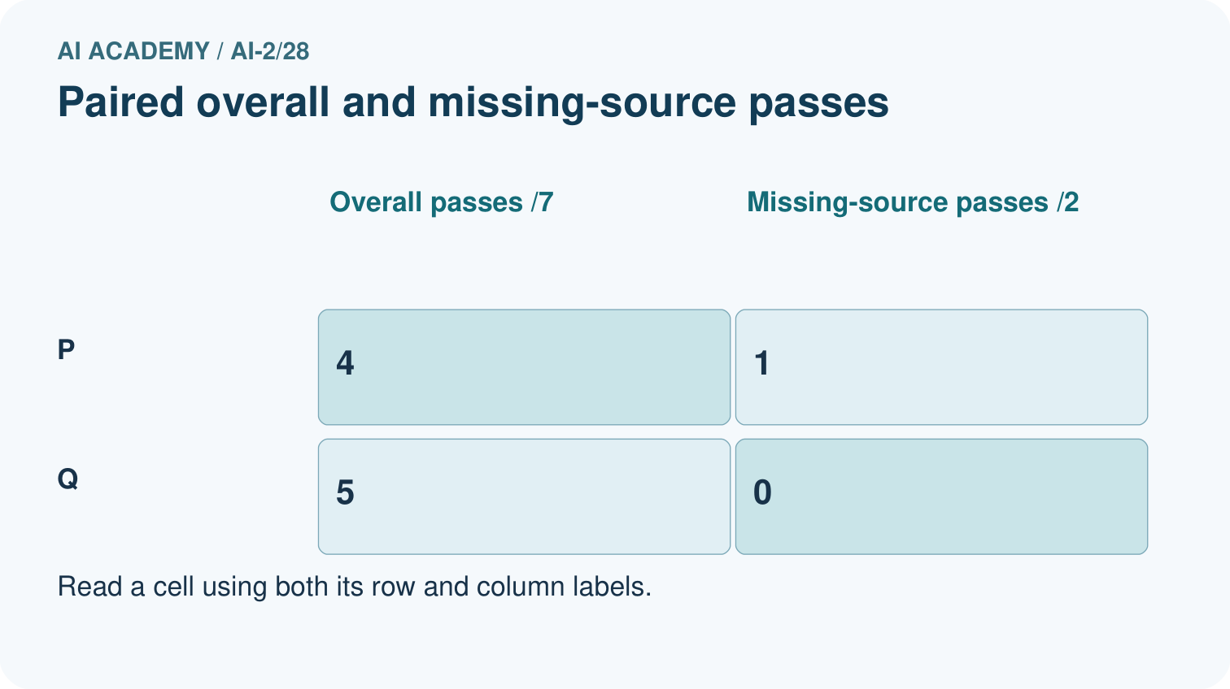
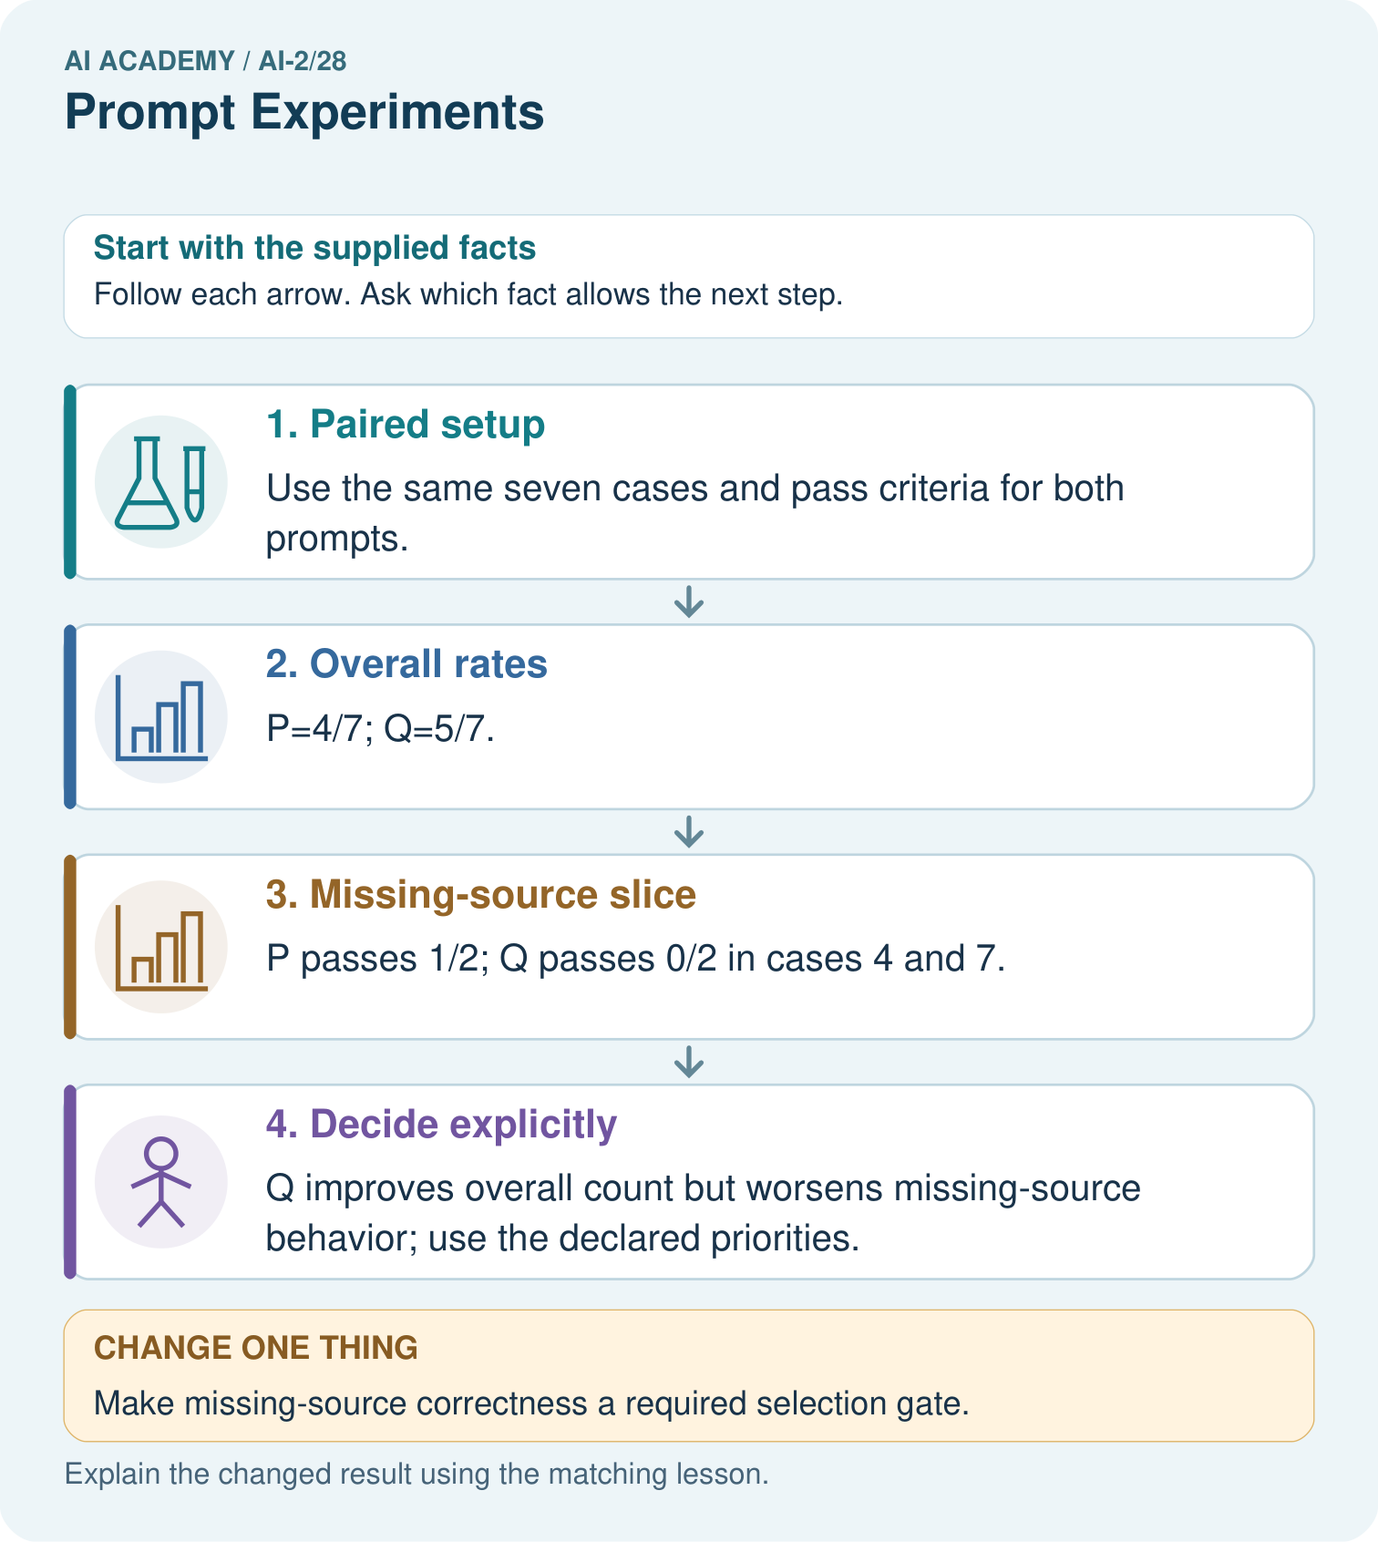

Read the picture one step at a time
Step | What happens and why
1. Paired setup | Use the same seven cases and pass criteria for both prompts.
2. Overall rates | P=4/7; Q=5/7.
3. Missing-source slice | P passes 1/2; Q passes 0/2 in cases 4 and 7.
4. Decide explicitly | Q improves overall count but worsens missing-source behavior; use the declared priorities.
Match each pictured step to the supplied facts. This is a worked teaching case, not an independent assessment.

Why this result follows
A larger total can conceal a more serious failure category. Paired records show which cases changed, not just how many passed. If refusing unsupported claims is mandatory, Q’s overall advantage may not justify selection. Keep the failing examples for development and obtain fresh cases after choosing a final version.

What this example does not establish
Seven development cases cannot establish causal learning benefits or untouched final performance; repeated generation may also vary.

Change one thing in the pictured case
Change: Make missing-source correctness a required selection gate.
Prediction: Neither prompt clears a 2/2 gate on these records.
Reason: P fails 7 and Q fails both 4 and 7; both need revision.

Ask while showing the picture
Cover the result. Ask learners to name the inputs and predict the next step. Uncover one step, connect the icon to the actual procedure, and explain its evidence. Then change the supplied condition and compare. The picture is a representation; it does not document execution of a real AI model.

03. Demonstrate and guide practice

Demonstrate and guide practice

Board sequence
Write the given facts: Prompt B adds under 100 pages and explain the match to Prompt A. Both use a catalogue.
Write the question to explain: Design a fair comparison.
Reveal after predictions: Use identical requests, catalogue and scoring criteria. Check constraint compliance and supported explanation; repeat stochastic outputs when relevant.
Keep for an independent attempt: Prompt A and B are tested on different questions. B scores higher. Can wording alone explain the difference? Design a controlled comparison.

Classroom dialogue
Ask: Which facts are given, and which would we have to assume? Learners mark relevant details before discussing answers.
Say: Predict first. Show the rule, information path or calculation that would produce the result. A correct guess is not yet an explanation.
Reveal reasoning one step at a time. Explain why a tempting alternative fails. Write units and denominators for arithmetic, trace conditions for decisions, and identify supporting sources for claims.
In pairs, one learner solves while the other checks evidence; exchange roles. Remove the worked answer before independent assessment.

Model these guided questions
Guided: P passes 4/6 and Q 5/6. P passes one of two missing-approval cases, Q also one of two. Q improves the aggregate while leaving this condition unchanged. Qualification: Prompt selection on development cases cannot be reported as independent final performance. Exit: accept a concrete variation with its predicted outcome and a stated condition that would challenge the mechanism; reject a claim resting on unmeasured evidence.

Case-specific teaching sequence
Stage | Teacher action
Session 1: 0–7 minutes | Retrieve the prerequisite; identify the input, procedure and evidence source.
7–18 minutes | Explain section 1 and vocabulary. Complete W1 with a mechanism-based explanation.
18–32 minutes | Trace the declared procedure and worked case. Complete W2, recording intermediate steps.
32–45 minutes | Discuss the diagram with the worked input; use W3 to distinguish measured claims and limitations.
Session 2: 0–8 minutes | Retrieve the worked reasoning and collect the guided response before discussing it.
8–20 minutes | Compare a proposed boundary variant with the original case; identify what remains fixed.
20–35 minutes | Collect W4 independently. Require the procedure trace and the bounded conclusion.
35–45 minutes | Use W5 and exit responses for feedback. Administer the fresh retry after feedback and preserve both attempts.

Reduce help deliberately
Completion task: On six development cases P passes cases 1, 2, 3, 4; Q passes 1, 2, 3, 5, 6. Missing-approval cases are 4 and 6. Compare totals and condition results. Show the intermediate steps and give the conclusion with its scope.
Teacher check: Teacher explanation: P passes 4/6 and Q 5/6. P passes one of two missing-approval cases, Q also one of two. Q improves the aggregate while leaving this condition unchanged.
Start by identifying the given inputs together. Leave the intermediate steps blank. If needed, model one step, then withdraw that help on the next step. Move to a full trace only when the partial trace is understood. For partners, alternate explainer and checker; collect a response from every learner before discussion.

Individual reasoning check
Use the worked case for Controlled prompt experiments. Proposed explanation: “The worked result establishes every future case”. Decide whether this explanation is supported. Point to the step or supplied fact that decides; explain your repair if needed.
Expected correction: Prompt selection on development cases cannot be reported as independent final performance.
Collect explanations, not only yes/no votes. If a misunderstanding is common, re-model the relevant step for the class. If it affects a few learners, give a short targeted group explanation while others solve a more demanding variation.

Pictorial practice question
Name the case P passes and Q fails, and explain why it matters.

Reasoned teacher answer
Case 4, a missing-source case. Its regression can matter more than gains on ordinary cases if unsupported answers are unacceptable.
Changed-case reasoning: Neither prompt clears a 2/2 gate on these records. P fails 7 and Q fails both 4 and 7; both need revision.
Collect each learner’s explanation before discussion. Use the first missing connection between input, deciding step and result to choose support. This question is worked-case practice, not fresh mastery evidence.

04. Run the weekly evidence lab

Run the weekly evidence lab
Words You Can Use to Reason
A definition matters when you can recognize the idea, use it, and contrast it with a near-miss.
Predict → Test → Record → Explain
Keep expected and actual results separate. Surprises are useful data when recorded honestly.
Define six rubric checks, keep task and examples fixed, change one prompt element, score both versions across three cases, and explain uncertainty.
What did the hardest test teach you that the normal test did not?

Make the lab runnable
Use the concrete case as the shared normal case and the independent question as a second case. Each pair creates a boundary or missing-information case and predicts its result before testing. Keep the expected result separate from an observed mistake.
Record | What to capture
Input or evidence | Exact data, instruction or claim
Expected result | Answer or safe fallback declared before the run
Observed result | Actual result, including errors
Explanation | Rule, calculation or evidence explaining the outcome
Next test | One justified change and a new prediction

Diagnose and reteach
For guessing, return to given facts and request a trace. For vocabulary without application, use one example and one non-example. For arithmetic errors, check the setup before the calculation. Finish with a different uncoached case before recording mastery.

Address these additional misconceptions
The worked result establishes every future case: Prompt selection on development cases cannot be reported as independent final performance.
A missing input may be replaced without recording the change: A replacement changes the evidence or contract. Record the change and its justification; do not silently turn unknown into a measured value.
Repeating an assessed case is new independent evidence: A replay checks consistency. An example used for feedback or revision cannot later be described as untouched final evaluation.

Match the support to the first error
What the response shows | Next teaching action
Missing or misread facts | Read the case aloud, mark supplied versus unknown facts, and let the learner restate it.
Wrong procedure | Return to the deciding step in the worked case. Contrast it with the proposed incorrect explanation.
Arithmetic or implementation error | Trace intermediate values or lines; preserve the first mismatch and retry that step.
Correct result without a reason | Ask for a trace and a changed case before marking independent understanding.
An unsupported wider claim | Ask which supplied evidence supports the claim and which further observation would be needed.
Offer an oral explanation, drawing, enlarged visual or fewer examples when that removes a reading/writing barrier. Keep the same reasoning goal. Stretch secure learners by changing a boundary or assumption and asking them to defend the effect, not simply by assigning more of the same questions.

05. Assess and explain the answers

Assess and explain the answers

Worked case answer
Use identical requests, catalogue and scoring criteria. Check constraint compliance and supported explanation; repeat stochastic outputs when relevant.

Independent question
Prompt A and B are tested on different questions. B scores higher. Can wording alone explain the difference? Design a controlled comparison.

Expected independent answer
No; question difficulty also changed. Compare both prompts on the same evaluation questions and rubric, with repeated runs when outputs vary.

What counts as evidence
Criterion | 0 points | 1 point | 2 points
Result | Incorrect or absent | Partly correct | Correct with necessary conditions
Reasoning | No supporting trace | Some steps | Clear mechanism, calculation or source support
Limit | Overclaims certainty | Vague limitation | Relevant uncertainty or missing fact
Transfer | Copies without adapting | Adapts with prompts | Solves a changed case independently
Use 6/8 as a classroom checkpoint, with 2 required for both Result and Reasoning. This is a proposed teaching rule, not a validated certification threshold. Do not count a coached answer as independent mastery; correct unsafe or unsupported claims regardless of total.

Feedback
Ask the learner to find the evidence that challenges this claim: “Changing several factors proves which one caused improvement.” Keep the first attempt and an uncoached retry separate.

Original transfer answer
Run both prompts on the same predefined requests and catalogue, with identical criteria for existence, constraints and explanation support. Repeat stochastic runs and retain failures. Separate prompt-development cases from final evaluation and report per-case outcomes, not only the mean.

Explanations for the additional workbook examples

W1 Explain the mechanism
Explain the weekly mechanism in your own words. Use the worked scenario to name its input, decision rule and output.
Teacher explanation: A prompt experiment compares complete specifications using the same task cases. Define success before inspecting outputs; change one intended instruction and preserve other settings. Evaluate both prompts on paired cases with fixed model/version, source records, output contract and scoring rubric. Use development results for selection, then reserve new final cases. Score each case rather than counting attractive sentences.

W2 Trace the worked case
On six development cases P passes cases 1, 2, 3, 4; Q passes 1, 2, 3, 5, 6. Missing-approval cases are 4 and 6. Compare totals and condition results. Show the intermediate steps and give the conclusion with its scope.
Teacher explanation: P passes 4/6 and Q 5/6. P passes one of two missing-approval cases, Q also one of two. Q improves the aggregate while leaving this condition unchanged.

W3 Audit the limit
A report omits this qualification: Prompt selection on development cases cannot be reported as independent final performance. Explain how omitting it could change a reader's interpretation, and write an accurate replacement.
Teacher explanation: Prompt selection on development cases cannot be reported as independent final performance. State the observed result separately from the unverified or out-of-scope claim; preserve the original evidence rather than inventing a missing fact.

W4 Apply a new case independently
On eight paired cases A passes 1–5; B passes 1–4, 6, 7. Special cases are 5 and 8. Compare overall and special-case results; select by total passes.
Teacher explanation: A=5/8, B=6/8, so select B on development. Special-case passes A=1/2, B=0/2; the aggregate selection hides a regression requiring review.

W5 Design a revealing follow-up
For the worked scenario, propose one additional case that could reveal a failure, describe its expected outcome before running it, and explain what would need to remain fixed for a fair comparison. Do not reuse W4 as a new final test after receiving feedback.
Teacher explanation: Accept a concrete variant of the worked input or a missing/conflicting/boundary condition, with an expectation derived from the declared procedure. Require preserved settings, original outputs and data roles. Prompt selection on development cases cannot be reported as independent final performance. The new case should test this particular mechanism rather than merely restate the original result.

Assess independent transfer
Selected case: On eight paired cases A passes 1–5; B passes 1–4, 6, 7. Special cases are 5 and 8. Compare overall and special-case results; select by total passes.

Selected case answer
Teacher explanation: A=5/8, B=6/8, so select B on development. Special-case passes A=1/2, B=0/2; the aggregate selection hides a regression requiring review.
Dimension | Evidence required
Explanation | Names the applicable idea or procedure and ties it to the supplied facts.
Trace and result | Preserves the given inputs and shows the relevant intermediate steps; distinguishes a prediction from an observed execution.
Limits | States the assumptions, missing evidence or conditions under which the result would change.
Record each dimension as not yet, with support, or independent. Accept a valid alternative procedure with a defensible trace. Do not penalise an honestly recorded model failure if the learner correctly explains its evidence and limits.

Feedback that the learner uses
Name the earliest unsupported step and give one action to repair it. Have the learner make that repair now and explain why. Then assess the relevant skill on a fresh, fully specified case. Confirm it was not previously practised with feedback; solve and check the new case before assigning it. A follow-up design prompt is a starting brief, not automatically an equivalent test.

06. Connect and extend learning

Connect and extend learning

Transparent Book Recommender
Test generated book explanations with a fixed rubric and prohibit invented details.
Keep the decision, input, result, explanation and remaining limitation in the project evidence record. Retrieve this record next week rather than restarting the project.

Support and stretch
Trace one record or condition at a time with counters and labelled columns. Stretch: introduce a tie, boundary or missing field and declare its handling policy before rerunning.

Exit reflection
Ask for one decision the learner can now justify and one situation requiring more evidence or human review. Confidence ratings are separate from correct independent performance.

Bridge to the next week
Next: Week 29: Evidence and Sources. Retrieve today’s evidence and identify what carries forward and what is new.

Support and fresh reassessment
Provide an input/procedure/result/limit frame and a calculator when needed. Ask students to identify the first step before completing the whole trace. Extension: compare two concrete variants of this mechanism while holding unrelated conditions fixed; report both successful and unsuccessful outcomes.
W4: A=5/8, B=6/8, so select B on development. Special-case passes A=1/2, B=0/2; the aggregate selection hides a regression requiring review. Require intermediate reasoning and the stated scope. Fresh retry: A passes 1–4 of six; B passes 1, 2, 5. Special cases 4 and 6. Compare. Expected reasoning: A=4/6, B=3/6; special A=1/2, B=0/2. Preserve both outcomes; no final result supplied. If students need support, record it and reassess with another new case rather than awarding independence to a copied answer.
Next connection: Generation failures and verification. Preserve the current case record and retrieve its evidence boundary before moving on.

Plan the delayed return
Suggested return points in this level: ai-2/29, ai-2/31, ai-2/34. Use actual classroom dates, adjusting for holidays and gaps. One, three and six teaching weeks are scheduling choices, not a claimed optimal spacing.
At a delayed check, ask for the idea from memory and a changed application. Compare with the earlier independent response and record support used. For a new level, revisit the previous capstone before checking the new prerequisites.
Record | Teacher evidence
Learner code and date
Concept and case used; prior exposure
Explanation / trace / limits
Support and first repair
Changed case and delayed outcome
Next teaching action
Use the evidence to choose reteaching or the next step. A completed page, confidence rating or attractive project does not by itself demonstrate understanding.

Project evidence from this case
Run controlled recommender explanation experiments with paired cases and report important failure conditions separately.

