AI ACADEMY · TEACHER · ai-2/33

Build the Recommender
Project: Transparent Book Recommender

01. Build the Recommender

Teach the learning cycle
Primary target: Implement a deterministic recommender
Session | Sequence and minutes | Resources
Session 1 · Understand · 45 min | 0–7: recall and prerequisite; 7–15: inspect the concrete case and predict; 15–30: teacher models the worked trace; 30–40: learners explain a step using the text and visual; 40–45: check the core idea. | Sections 1–6; record the brief recall in the workbook.
Session 2 · Practise · 45 min | 0–5: retrieve the procedure; 5–15: W2 completion practice; 15–23: explain and check with a partner; 23–30: each learner answers the misconception check; 30–40: targeted reteaching or a harder variation; 40–45: prepare the investigation. | Sections 7–10; use the matching workbook W2 and misconception check.
Session 3 · Investigate and transfer · 45 min | 0–5: retrieve the decision rule; 5–20: investigate or trace; 20–30: start the independent case; 30–38: connect the project; 38–43: act on feedback; 43–45: plan the return check. | Sections 9 and 11–14. Give extra time to finish the full task set; use Section 15 when the week includes a coding lab.
This is a starting allocation of 135 minutes, not a validated duration. Preserve all named topics. Schedule extra time for connected examples, the full investigation, independent cases and project building. Repeated copies of a case share one recorded attempt; they are not new evidence.
Case exposure check: this source example appears in ai-2/24, ai-2/33. Reuse a familiar case for recall or modelling; verify that the case used to assess transfer has not already received feedback.

Retrieval answer guidance

Project Problem and Success Test
Without opening the old lesson, explain one key idea from Project Problem and Success Test. Give an example and a mistake that the idea helps you avoid.
Look for: Define a small application purpose
Reference example, not the only acceptable wording: Suggest a suitable eligible activity for a teacher-supervised session; the teacher reviews and decides.

Agents and Tools
Without opening the old lesson, explain one key idea from Agents and Tools. Give an example and a mistake that the idea helps you avoid.
Look for: Explain the mechanism and terminology of state machines for bounded agents
Reference example, not the only acceptable wording: Teacher explanation: A bounded agent uses explicit states and finite action limits. A state machine makes invalid transitions visible. States are ready, looking_up, review, done. ready may start lookup; lookup may finish done or request review; review may finish done after authorised evidence. done is terminal. Maximum two lookup attempts.

Predictive vs Generative
Without opening the old lesson, explain one key idea from Predictive vs Generative. Give an example and a mistake that the idea helps you avoid.
Look for: Distinguish discriminative prediction from generation by inspecting the requested output
Reference example, not the only acceptable wording: Teacher explanation: Message labels are discriminative prediction; continuing a sequence is generation; record lookup is retrieval rather than learned generation by itself. One application can route a request, retrieve evidence and generate a response.
Use the student module and workbook section with this exact week title. The worked case, independent question and answers below form one aligned lesson sequence.

What the learner must demonstrate
Catalogue: A mystery/90/illustrated, B mystery/140/not illustrated, C science/80/illustrated. Request mystery, maximum 100 pages. Rank with 2 genre points and 1 illustration point after filtering. Show why other books are excluded.

Concept to explain
A transparent baseline makes later improvements understandable.
Term | Meaning
baseline | A simple reference method used to judge whether a more complex method adds value.
candidate | An item or proposed answer being considered before a final selection.
weighted total | A sum formed after multiplying each contribution by its assigned weight.
explanation | An account connecting a result to the mechanism, calculation or evidence that supports it.

Prepare the class
Use the supplied scenario, student illustrations and blank paper. For numeric work, offer counters or a calculator after learners show the setup. Fictional records are supplied; personal data and paid accounts are unnecessary.
Allow 80 minutes: recall 8; explanation 12; worked demonstration 15; guided practice 20; independent assessment 15; project and reflection 10. Extend the lab into a second session when needed.

Preparation for the connected explanation
Teach Week 24 as a two-session investigation using fictional data. Build a fictional activity recommender using last week's score. Require duration at most a supplied limit. On a tie choose the alphabetically first name. This makes the outcome reproducible rather than dependent on input order. Assume unique names and validated numeric fields. Assess the three stated outcomes through the independent task, not by copying the worked result.

Readiness answer
No. Filter by the hard constraint before ranking.
Python 3 editor with a fresh local practice file
Paper trace table and the student workbook
Fictional input records from this lesson; no real student identifiers

Apply the connected idea: Building the data pipeline
Teach Week 32 as a two-session investigation using fictional data. Build the validation stage of the planned chooser first. A valid record has nonempty text name, integer minutes 0 through 60 and integer fun and learning ratings 0 through 5. The batch stage must separately check name uniqueness. Only accepted records may reach the Week 24 selection function. Assess the three stated outcomes through the independent task, not by copying the worked result.

Readiness answer
Validate, filter eligibility, calculate scores, resolve ties, then report with limits.
Python 3 editor with a fresh local practice file
Paper trace table and the student workbook
Fictional input records from this lesson; no real student identifiers

End goal for the pictorial case
By the end, I can implement deterministic filtering, scoring and ties for a complete catalogue case.
This added worked case illustrates the week’s main idea. Retain all original and connected topics; schedule its practice within the teaching cycle.

02. Explain the mechanism

Explain the mechanism
Input → Process → Output
Trace the information. At each stage, ask what changed and how you could test it.
Which stage could fail even when the other two are correct? Explain:
Predict first. Then check each step. A correct answer without visible reasoning is incomplete evidence.
1. Weights: genre=3, difficulty=2, length=1.
2. Compute every candidate’s terms and total.
3. Filter hard constraints, sort remaining totals high to low.
4. Output top choice, score breakdown, one limitation, and a tie rule.
Recalculate, retrace, or restate the reasoning in your own representation:
CHECK Did the evidence answer the exact question? Did the total, path, or source record stay consistent?

Concrete teaching case
A has flags (1,1), B=(1,0), C=(0,1); score=2g+l.
Compute the winner and evidence to display.

Exact explanation to model
A wins at 3; B=2; C=1. Show flags, formula, scores and explanation; declare tie policy.

Explain the added worked example
Build a fictional activity recommender using last week's score. Require duration at most a supplied limit. On a tie choose the alphabetically first name. This makes the outcome reproducible rather than dependent on input order. Assume unique names and validated numeric fields.
The function prints nothing; the caller prints A. best starts as None to mean no eligible option found. Python short-circuits or: when best is None, later comparisons in that condition need not run. After selecting an item, best_score is numeric. An empty list or no eligible item returns None.

Key terms
Term | Meaning
Recommender | A procedure that suggests options using a stated policy
Tie | Two options have the same comparison score
Deterministic | The same inputs and rules produce the same result
Explanation | Evidence describing how a result was obtained

Apply the connected idea: Building the data pipeline
Build the validation stage of the planned chooser first. A valid record has nonempty text name, integer minutes 0 through 60 and integer fun and learning ratings 0 through 5. The batch stage must separately check name uniqueness. Only accepted records may reach the Week 24 selection function.
The worked calls print True then False. Short-circuit checks keep absent or wrongly typed fields away from later operations. This Boolean helper does not explain the reason; add reason codes in the reporting stage or use a validation result record. Do not describe a range failure as a no-match outcome.
The first passes. Replacing minutes with 61 fails the range. Exit: No. The batch uniqueness contract fails. Block the ambiguous batch and report duplicate names for correction.

Model the reasoning aloud
Use the complete worked example below before asking learners to complete W2. Reveal a small part, invite a prediction, then explain the deciding step. These teacher notes contain solutions; do not reveal the independent case answer during modelling.

Predict the result if the list order is reversed, and if the limit is 8.
________________________________________________________________
________________________________________________________________
________________________________________________________________
________________________________________________________________
________________________________________________________________
________________________________________________________________
Thinking move | Teacher prompt
Plan | What is given? What is the question? Which procedure fits these facts?
Do | Point to each input and intermediate step in the worked trace. Name the rule that allows the next step.
Check | Does the output answer the question? Which assumption or limitation prevents a larger claim?
Use the diagram and verbal explanation together. Ask learners to match a sentence to a specific visual step; do not assign learners fixed visual or auditory learning styles.

A pictorial worked case: Build the Recommender
A fictional book chooser filters a request before comparing preference scores.

The facts we will use
Request: animal subject, at most 90 pages. Score 2 for illustrated and 1 for comic. Tie chooses smaller ID.
A animal90 illustrated prose; B animal70 plain comic; C space60 illustrated comic; D animal80 illustrated comic.
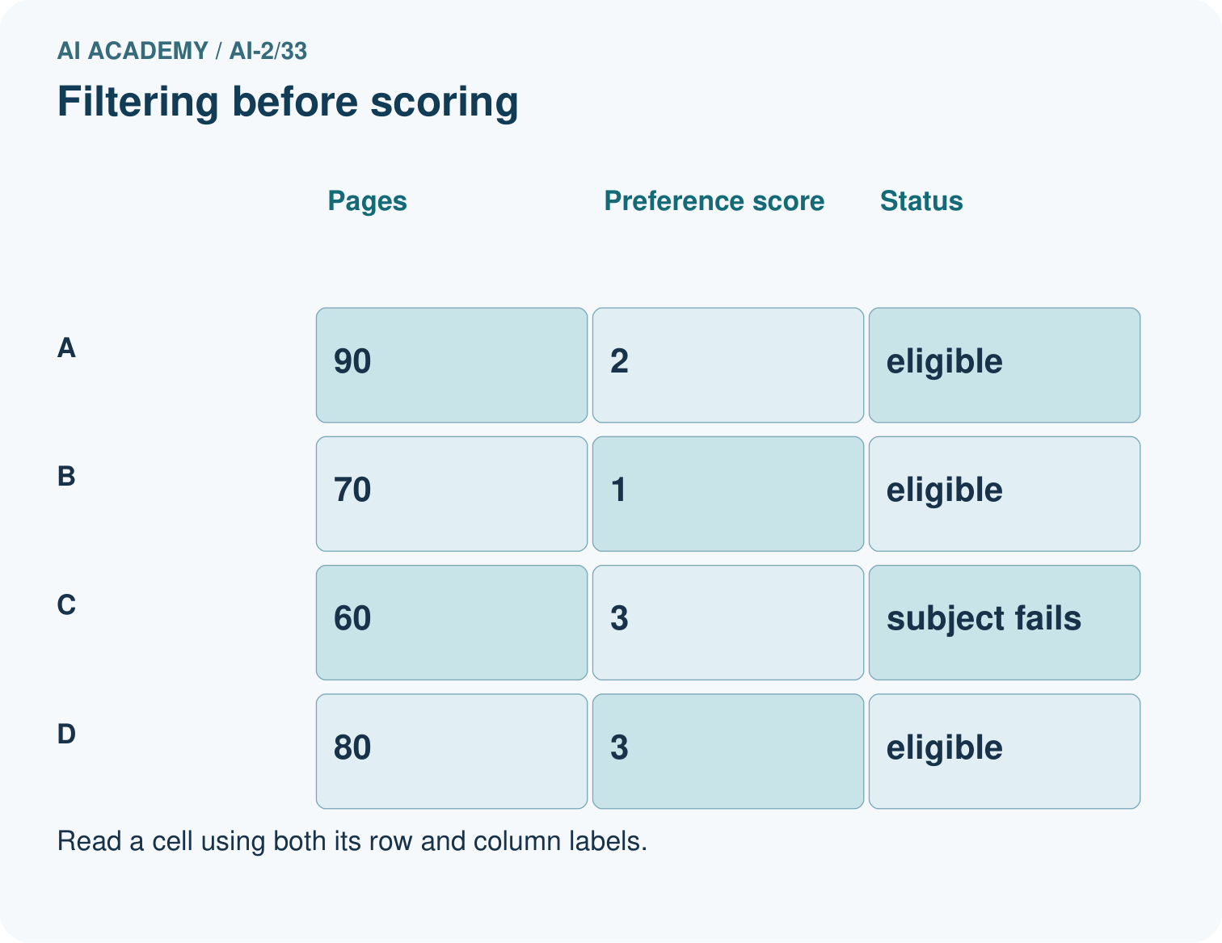
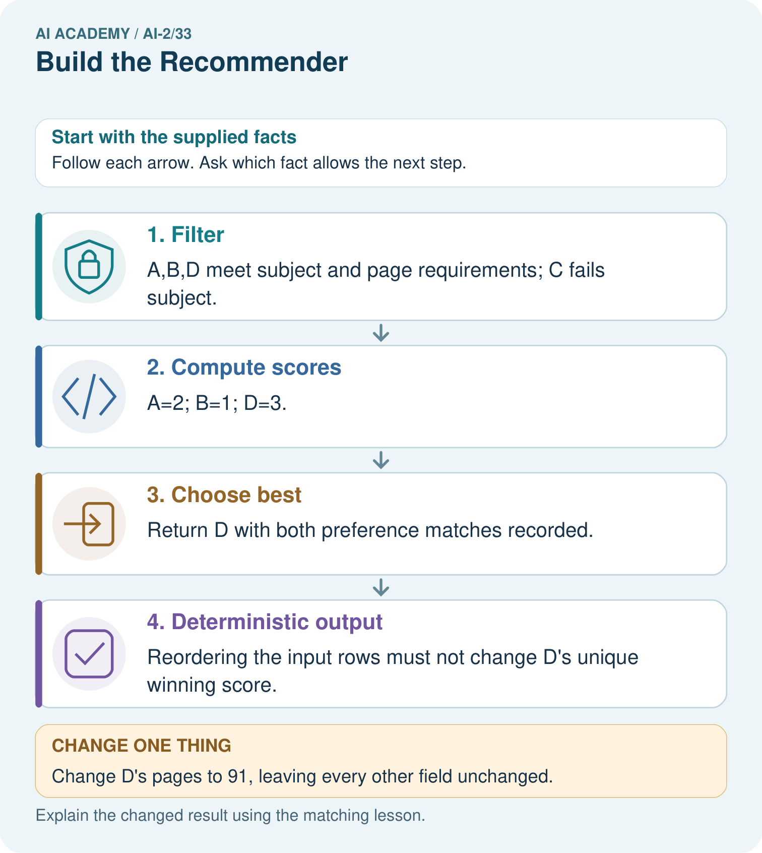

Read the picture one step at a time
Step | What happens and why
1. Filter | A,B,D meet subject and page requirements; C fails subject.
2. Compute scores | A=2; B=1; D=3.
3. Choose best | Return D with both preference matches recorded.
4. Deterministic output | Reordering the input rows must not change D’s unique winning score.
Match each pictured step to the supplied facts. This is a worked teaching case, not an independent assessment.

Why this result follows
Eligibility and ranking answer different questions. C has a high preference score but is not an animal book, so it must stay excluded. The implementation needs a no-match result and explicit tie policy even when this example has a unique winner. Save rejected reasons for an explanation, not just the final ID.

What this example does not establish
Toy preference weights do not imply shorter or illustrated books are universally better for all learners.

Change one thing in the pictured case
Change: Change D’s pages to 91, leaving every other field unchanged.
Prediction: D becomes ineligible, so A wins with score 2.
Reason: The strict excess over the 90-page maximum changes filtering before ranking.

Ask while showing the picture
Cover the result. Ask learners to name the inputs and predict the next step. Uncover one step, connect the icon to the actual procedure, and explain its evidence. Then change the supplied condition and compare. The picture is a representation; it does not document execution of a real AI model.

03. Demonstrate and guide practice

Demonstrate and guide practice

Board sequence
Write the given facts: A has flags (1,1), B=(1,0), C=(0,1); score=2g+l.
Write the question to explain: Compute the winner and evidence to display.
Reveal after predictions: A wins at 3; B=2; C=1. Show flags, formula, scores and explanation; declare tie policy.
Keep for an independent attempt: A reader requests space and at most 60 pages. Book A is space, 90 pages; B is animals, 40 pages. What should the prototype return if both conditions are required?

Classroom dialogue
Ask: Which facts are given, and which would we have to assume? Learners mark relevant details before discussing answers.
Say: Predict first. Show the rule, information path or calculation that would produce the result. A correct guess is not yet an explanation.
Reveal reasoning one step at a time. Explain why a tempting alternative fails. Write units and denominators for arithmetic, trace conditions for decisions, and identify supporting sources for claims.
In pairs, one learner solves while the other checks evidence; exchange roles. Remove the worked answer before independent assessment.

Model these guided questions
Reversing still returns A. Limit 8 leaves no eligible item and returns None. Exit: X meets the 12-minute limit and ties for highest eligible score 9; the alphabetical tie rule selects X.

Case-specific teaching sequence
Stage | Teacher action
Session 1 start to 7 minutes | Retrieve the prerequisite and explain the purpose in the opening section.
7 to 20 minutes | Read the worked example and diagram; ask learners to trace each step aloud.
20 to 33 minutes | Complete W1 and W2, then compare predictions with observed results.
33 to 45 minutes | Collect the guided prediction before running; discuss a mismatch and its cause.
Session 2 start to 8 minutes | Retrieve the main rule without showing the previous answer.
8 to 20 minutes | Use W3 to diagnose and repair the stated failure; rerun an earlier case.
20 to 35 minutes | Collect W4 independently, including code or plan, predictions and explanations, before hints.
35 to 45 minutes | Discuss W5 and the exit; use the fresh retry when support was needed.

Teach the connected idea
Stage | Teacher action
Session 1 start to 7 minutes | Retrieve the prerequisite and explain the purpose in the opening section.
7 to 20 minutes | Read the worked example and diagram; ask learners to trace each step aloud.
20 to 33 minutes | Complete W1 and W2, then compare predictions with observed results.
33 to 45 minutes | Collect the guided prediction before running; discuss a mismatch and its cause.
Session 2 start to 8 minutes | Retrieve the main rule without showing the previous answer.
8 to 20 minutes | Use W3 to diagnose and repair the stated failure; rerun an earlier case.
20 to 35 minutes | Collect W4 independently, including code or plan, predictions and explanations, before hints.
35 to 45 minutes | Discuss W5 and the exit; use the fresh retry when support was needed.

Reduce help deliberately
Completion task: State recommend([], 10) and the worked items with limit 8.
Teacher check: Both return None; the caller should display no eligible option.
Start by identifying the given inputs together. Leave the intermediate steps blank. If needed, model one step, then withdraw that help on the next step. Move to a full trace only when the partial trace is understood. For partners, alternate explainer and checker; collect a response from every learner before discussion.

Individual reasoning check
Use the worked case for Implementing a recommender. Proposed explanation: “A successful run proves the conclusion”. Decide whether this explanation is supported. Point to the step or supplied fact that decides; explain your repair if needed.
Expected correction: The recommendation follows a written scoring policy. It does not learn preferences, prove learning benefit or authorize an action. Display the chosen rule and let a person review whether an option is suitable.
Collect explanations, not only yes/no votes. If a misunderstanding is common, re-model the relevant step for the class. If it affects a few learners, give a short targeted group explanation while others solve a more demanding variation.

Connected teaching cycle: Building the data pipeline
Target: Separate validation selection and reporting
Reserve further sessions for this topic; the 135-minute primary plan does not absorb all added content.
Completion practice: What does valid_item return if learning is absent?
Teacher check: False: get returns None and the exact integer check fails.
Individual check: For Building the data pipeline, use its worked case to evaluate this proposed explanation: “A successful run proves the conclusion”. Explain the deciding step.
Expected correction: Each stage should have a clear input and output contract. A program can be correct at one stage but wrong at their connection, such as passing rejected rows into selection. Keep acceptance and rejection counts in the report.
Apply the same support, independent transfer and delayed-review decisions to the named connected-topic workbook tasks.

Pictorial practice question
Explain why B does not win after D is excluded even though it has fewer pages.

Reasoned teacher answer
Page count is an eligibility limit, not a ranking preference here. A scores 2 and B scores 1.
Changed-case reasoning: D becomes ineligible, so A wins with score 2. The strict excess over the 90-page maximum changes filtering before ranking.
Collect each learner’s explanation before discussion. Use the first missing connection between input, deciding step and result to choose support. This question is worked-case practice, not fresh mastery evidence.

04. Run the weekly evidence lab

Run the weekly evidence lab
Words You Can Use to Reason
A definition matters when you can recognize the idea, use it, and contrast it with a near-miss.
Predict → Test → Record → Explain
Keep expected and actual results separate. Surprises are useful data when recorded honestly.
Build the editable score table, hand-check one row, run two profiles, and compare system ranking with independent recalculation.
What did the hardest test teach you that the normal test did not?

Make the lab runnable
Use the concrete case as the shared normal case and the independent question as a second case. Each pair creates a boundary or missing-information case and predicts its result before testing. Keep the expected result separate from an observed mistake.
Record | What to capture
Input or evidence | Exact data, instruction or claim
Expected result | Answer or safe fallback declared before the run
Observed result | Actual result, including errors
Explanation | Rule, calculation or evidence explaining the outcome
Next test | One justified change and a new prediction

Diagnose and reteach
For guessing, return to given facts and request a trace. For vocabulary without application, use one example and one non-example. For arithmetic errors, check the setup before the calculation. Finish with a different uncoached case before recording mastery.

Address these additional misconceptions
A successful run proves the conclusion: The recommendation follows a written scoring policy. It does not learn preferences, prove learning benefit or authorize an action. Display the chosen rule and let a person review whether an option is suitable.
Matching the example is enough: Require the new W4 case, explicit predictions and an explanation. Fresh retry: B (2,4,8), C (3,2,8), A (5,5,9), limit 8. B/C tie at 8; B wins. Limit 7 returns None.
A convenient shortcut preserves meaning: Updating best on score >= best_score makes the last tied item win, so reordering can change results. Use the explicit name comparison for ties. Test both orders and a no-match case after the repair.

Check these misconceptions
A successful run proves the conclusion: Each stage should have a clear input and output contract. A program can be correct at one stage but wrong at their connection, such as passing rejected rows into selection. Keep acceptance and rejection counts in the report.
Matching the example is enough: Require the new W4 case, explicit predictions and an explanation. Fresh retry: X (minutes 9, fun 2, learning 3), Y (10,3,2), Z (11,6,1), limit 10. Accept X/Y, reject Z rating; select Y score 8 versus X 7.
A convenient shortcut preserves meaning: Calling the selector on raw data can crash or produce a result from invalid ratings. Route data through validation first. Duplicate names require a batch check even when each row individually passes; block the ambiguous batch for review instead of arbitrarily keeping one.

Match the support to the first error
What the response shows | Next teaching action
Missing or misread facts | Read the case aloud, mark supplied versus unknown facts, and let the learner restate it.
Wrong procedure | Return to the deciding step in the worked case. Contrast it with the proposed incorrect explanation.
Arithmetic or implementation error | Trace intermediate values or lines; preserve the first mismatch and retry that step.
Correct result without a reason | Ask for a trace and a changed case before marking independent understanding.
An unsupported wider claim | Ask which supplied evidence supports the claim and which further observation would be needed.
Offer an oral explanation, drawing, enlarged visual or fewer examples when that removes a reading/writing barrier. Keep the same reasoning goal. Stretch secure learners by changing a boundary or assumption and asking them to defend the effect, not simply by assigning more of the same questions.

05. Assess and explain the answers

Assess and explain the answers

Worked case answer
A wins at 3; B=2; C=1. Show flags, formula, scores and explanation; declare tie policy.

Independent question
A reader requests space and at most 60 pages. Book A is space, 90 pages; B is animals, 40 pages. What should the prototype return if both conditions are required?

Expected independent answer
Neither matches both conditions. Return no exact match and ask whether to relax a preference; do not present A or B as a full match.

What counts as evidence
Criterion | 0 points | 1 point | 2 points
Result | Incorrect or absent | Partly correct | Correct with necessary conditions
Reasoning | No supporting trace | Some steps | Clear mechanism, calculation or source support
Limit | Overclaims certainty | Vague limitation | Relevant uncertainty or missing fact
Transfer | Copies without adapting | Adapts with prompts | Solves a changed case independently
Use 6/8 as a classroom checkpoint, with 2 required for both Result and Reasoning. This is a proposed teaching rule, not a validated certification threshold. Do not count a coached answer as independent mastery; correct unsafe or unsupported claims regardless of total.

Feedback
Ask the learner to find the evidence that challenges this claim: “The system must recommend something even when constraints fail.” Keep the first attempt and an uncoached retry separate.

Original transfer answer
Only A meets genre and length constraints; its score is 3. B exceeds the page limit and C fails genre. Do not claim A beat eligible competitors when none existed. Include no-match and missing-field handling in the prototype.

Explanations for the additional workbook examples

W1 Trace selection
Why does A win the worked example even though B is processed first?
Both score 8 and qualify; A is alphabetically first under the tie rule.

W2 Handle no match
State recommend([], 10) and the worked items with limit 8.
Both return None; the caller should display no eligible option.
For the empty list, the loop has no iterations, so best stays None. With the worked durations 10 and 9 under a limit of 8, neither item passes the eligibility check, so best again stays None. The caller must turn this result into a clear no-eligible-option message; it must not treat None as an activity name.

W3 Repair order dependence
A tied selection changes after reversing input order. Identify the likely missing policy and test.
An explicit deterministic tie rule is missing or incorrect. Apply alphabetical name order and rerun both orders.

W4 Implement independently
Use the function with X (fun 4, learning 1, minutes 12), Y (3,3,10), Z (5,5,13), limit 12. Predict the winner, reverse the list and retest. Also test limit 9.
X and Y score 9; Z is excluded. X wins alphabetically in either order. Limit 9 returns None.

W5 Explain the result
Write a one-sentence explanation of X winning without calling it objectively best.
X meets the 12-minute limit and ties for highest eligible score 9; the alphabetical tie rule selects X.

Building the data pipeline — W1 Trace a validation
Explain why a row with fun "4" fails while fun 4 can pass.
The first is text; the schema requires an exact integer rating from 0 to 5.

Building the data pipeline — W2 Check missing fields
What does valid_item return if learning is absent?
False: get returns None and the exact integer check fails.
When learning is absent, row.get("learning") returns None. The condition type(value) is not int is true, so the helper returns False before doing the range comparison. This is a schema rejection; it is different from a valid item that later exceeds the selection time limit.

Building the data pipeline — W3 Repair the connection
A program validates rows but still sends the original raw list to recommend. What should change?
Pass only the accepted, uniqueness-checked list. Preserve rejection information separately for reporting.

Building the data pipeline — W4 Build independently
Combine validation and the Week 24 selector for A (minutes 10, fun 3, learning 2), B (12,4,1), and C (8,"5",5), limit 10. State accepted rows, rejected row, selection and explanation.
A and B validate; C fails fun type. B exceeds the limit. A wins with score 8. Report 2 accepted of 3, one rejection and one eligible item. Verify unique names.

Building the data pipeline — W5 Handle duplicates
Two valid rows have the same name but different ratings. Should individual validation alone permit selection?
No. The batch uniqueness contract fails. Block the ambiguous batch and report duplicate names for correction.

Assess independent transfer
Selected case: Request: mystery, at most 100 pages. Catalogue: D mystery110 illustrated; E mystery80 plain; F science80 illustrated; G mystery95 illustrated; H mystery90 illustrated. Filter first; score 3 for mystery plus 2 for illustrations; break ties by fewer pages.

Selected case answer
D fails length and F fails genre. E scores3, G and H score5. H wins the tie with 90 versus95 pages. Filtering is separate from scoring; this written preference rule is not proof of a trained model.
Dimension | Evidence required
Explanation | Names the applicable idea or procedure and ties it to the supplied facts.
Trace and result | Preserves the given inputs and shows the relevant intermediate steps; distinguishes a prediction from an observed execution.
Limits | States the assumptions, missing evidence or conditions under which the result would change.
Record each dimension as not yet, with support, or independent. Accept a valid alternative procedure with a defensible trace. Do not penalise an honestly recorded model failure if the learner correctly explains its evidence and limits.

Feedback that the learner uses
Name the earliest unsupported step and give one action to repair it. Have the learner make that repair now and explain why. Then assess the relevant skill on a fresh, fully specified case. Confirm it was not previously practised with feedback; solve and check the new case before assigning it. A follow-up design prompt is a starting brief, not automatically an equivalent test.

06. Connect and extend learning

Connect and extend learning

Transparent Book Recommender
This is the complete baseline: inputs, scoring, filter, ranking, explanation, and abstain rule.
Keep the decision, input, result, explanation and remaining limitation in the project evidence record. Retrieve this record next week rather than restarting the project.

Support and stretch
Trace one record or condition at a time with counters and labelled columns. Stretch: introduce a tie, boundary or missing field and declare its handling policy before rerunning.

Exit reflection
Ask for one decision the learner can now justify and one situation requiring more evidence or human review. Confidence ratings are separate from correct independent performance.

Bridge to the next week
Next: Week 34: Test Diverse Users. Retrieve today’s evidence and identify what carries forward and what is new.

Support and fresh reassessment
Trace best and best_score row by row. Extension: return a record with name, score and reason while retaining the same selection policy.
Independent W4 evidence: X and Y score 9; Z is excluded. X wins alphabetically in either order. Limit 9 returns None. Record whether the learner needed no help, a hint or explanation. Fresh retry: B (2,4,8), C (3,2,8), A (5,5,9), limit 8. B/C tie at 8; B wins. Limit 7 returns None.
Next week: File input and output. Reuse this week's explicit contracts and evidence.

Readiness and reassessment for Building the data pipeline
Connect paper stage cards with input/output labels. Extension: return specific reasons for missing, type and range errors without exposing personal data.
Independent W4 evidence: A and B validate; C fails fun type. B exceeds the limit. A wins with score 8. Report 2 accepted of 3, one rejection and one eligible item. Verify unique names. Record whether the learner needed no help, a hint or explanation. Fresh retry: X (minutes 9, fun 2, learning 3), Y (10,3,2), Z (11,6,1), limit 10. Accept X/Y, reject Z rating; select Y score 8 versus X 7.

Plan the delayed return
Suggested return points in this level: ai-2/34, ai-2/36. Use actual classroom dates, adjusting for holidays and gaps. One, three and six teaching weeks are scheduling choices, not a claimed optimal spacing.
At a delayed check, ask for the idea from memory and a changed application. Compare with the earlier independent response and record support used. For a new level, revisit the previous capstone before checking the new prerequisites.
Record | Teacher evidence
Learner code and date
Concept and case used; prior exposure
Explanation / trace / limits
Support and first repair
Changed case and delayed outcome
Next teaching action
Use the evidence to choose reteaching or the next step. A completed page, confidence rating or attractive project does not by itself demonstrate understanding.

Project evidence from this case
Save the recommender code, contract and this full trace; test the same records in different input orders.

