AI ACADEMY · TEACHER · ai-2/36

Capstone Expo
Project: Transparent Book Recommender

01. Capstone Expo

Teach the learning cycle
Primary target: Defend an application using reproducible evidence
Session | Sequence and minutes | Resources
Session 1 · Understand · 45 min | 0–7: recall and prerequisite; 7–15: inspect the concrete case and predict; 15–30: teacher models the worked trace; 30–40: learners explain a step using the text and visual; 40–45: check the core idea. | Sections 1–6; record the brief recall in the workbook.
Session 2 · Practise · 45 min | 0–5: retrieve the procedure; 5–15: W2 completion practice; 15–23: explain and check with a partner; 23–30: each learner answers the misconception check; 30–40: targeted reteaching or a harder variation; 40–45: prepare the investigation. | Sections 7–10; use the matching workbook W2 and misconception check.
Session 3 · Investigate and transfer · 45 min | 0–5: retrieve the decision rule; 5–20: investigate or trace; 20–30: start the independent case; 30–38: connect the project; 38–43: act on feedback; 43–45: plan the return check. | Sections 9 and 11–14. Give extra time to finish the full task set; use Section 15 when the week includes a coding lab.
This is a starting allocation of 135 minutes, not a validated duration. Preserve all named topics. Schedule extra time for connected examples, the full investigation, independent cases and project building. Repeated copies of a case share one recorded attempt; they are not new evidence.

Retrieval answer guidance

Improve and Challenge
Without opening the old lesson, explain one key idea from Improve and Challenge. Give an example and a mistake that the idea helps you avoid.
Look for: Repair a specific observed failure
Reference example, not the only acceptable wording: Strict less-than excludes equality; at most requires <=.

Build the Recommender
Without opening the old lesson, explain one key idea from Build the Recommender. Give an example and a mistake that the idea helps you avoid.
Look for: Implement a deterministic recommender
Reference example, not the only acceptable wording: Both score 8 and qualify; A is alphabetically first under the tie rule.

Agents and Tools
Without opening the old lesson, explain one key idea from Agents and Tools. Give an example and a mistake that the idea helps you avoid.
Look for: Explain the mechanism and terminology of state machines for bounded agents
Reference example, not the only acceptable wording: Teacher explanation: A bounded agent uses explicit states and finite action limits. A state machine makes invalid transitions visible. States are ready, looking_up, review, done. ready may start lookup; lookup may finish done or request review; review may finish done after authorised evidence. done is terminal. Maximum two lookup attempts.
Use the student module and workbook section with this exact week title. The worked case, independent question and answers below form one aligned lesson sequence.

What the learner must demonstrate
Present a recommender that gets 8/10 final requests right. One failure invents a title; another violates a hard page limit. Is '80%, ready for everyone' justified? Propose release criteria.

Concept to explain
Ownership is demonstrated by a fresh recommendation and evidence-based defense.
Term | Meaning
capstone | A final project combining skills and evidence developed across the course.
defense | An explanation of a project decision supported by evidence and an account of its limitations.
transfer | Apply an idea or skill to a new case rather than copy the worked example.
limitation | A condition or missing capability that restricts what a result can establish or a system can safely do.

Prepare the class
Use the supplied scenario, student illustrations and blank paper. For numeric work, offer counters or a calculator after learners show the setup. Fictional records are supplied; personal data and paid accounts are unnecessary.
Allow 80 minutes: recall 8; explanation 12; worked demonstration 15; guided practice 20; independent assessment 15; project and reflection 10. Extend the lab into a second session when needed.

Preparation for the connected explanation
Teach Week 36 as a two-session investigation using fictional data. Finish the fictional activity chooser with a short evidence-based presentation and a reproducible handover. Show the purpose, contract, pipeline, one ordinary trace, one boundary or failure case, improvements and remaining limits. A working demonstration supports a software claim, not a claim of proven learning benefit. Assess the three stated outcomes through the independent task, not by copying the worked result.

Readiness answer
Identified inputs, code/configuration, rules and expected outputs that another person can rerun.
Python 3 editor with a fresh local practice file
Paper trace table and the student workbook
Fictional input records from this lesson; no real student identifiers

End goal for the pictorial case
By the end, I can defend a complete recommendation with validation, eligibility and reproducible ranking.
This added worked case illustrates the week’s main idea. Retain all original and connected topics; schedule its practice within the teaching cycle.

02. Explain the mechanism

Explain the mechanism
Input → Process → Output
Trace the information. At each stage, ask what changed and how you could test it.
Which stage could fail even when the other two are correct? Explain:
Predict first. Then check each step. A correct answer without visible reasoning is incomplete evidence.
1. Demo one known reader profile end to end.
2. Recalculate one book score in front of the audience.
3. Accept an unseen profile and predict before running.
4. State one limitation, one fairness check, and one responsible next improvement.
Recalculate, retrace, or restate the reasoning in your own representation:
CHECK Did the evidence answer the exact question? Did the total, path, or source record stay consistent?

Concrete teaching case
An expo claim says the recommender knows everybody's favourite book after twelve tests.
Rewrite the defence.

Exact explanation to model
Explain trait-based ranking, report the twelve outcomes and limits, and demonstrate no-match handling. It cannot know unstated preferences.

Explain the added worked example
Finish the fictional activity chooser with a short evidence-based presentation and a reproducible handover. Show the purpose, contract, pipeline, one ordinary trace, one boundary or failure case, improvements and remaining limits. A working demonstration supports a software claim, not a claim of proven learning benefit.
The example report prints A 8 and its counts are internally consistent. These checks do not prove A is the correct winner; the input records and scoring trace are also needed. Keep raw fictional data, source code, settings, test results and change log together.

Key terms
Term | Meaning
Defense | An explanation supported by evidence and questions
Evidence bundle | The records needed to check a project claim
Demonstration | Showing the application on specified inputs
Handover | Giving another person enough information to use or check the work

Model the reasoning aloud
Use the complete worked example below before asking learners to complete W2. Reveal a small part, invite a prediction, then explain the deciding step. These teacher notes contain solutions; do not reveal the independent case answer during modelling.

A demonstration shows only the winning name. Name two pieces of evidence needed to explain that choice.
________________________________________________________________
________________________________________________________________
________________________________________________________________
________________________________________________________________
________________________________________________________________
________________________________________________________________
Thinking move | Teacher prompt
Plan | What is given? What is the question? Which procedure fits these facts?
Do | Point to each input and intermediate step in the worked trace. Name the rule that allows the next step.
Check | Does the output answer the question? Which assumption or limitation prevents a larger claim?
Use the diagram and verbal explanation together. Ask learners to match a sentence to a specific visual step; do not assign learners fixed visual or auditory learning styles.

A pictorial worked case: Capstone Expo
A fictional team presents its transparent book recommender on a reserved catalogue.

The facts we will use
Request maximum 120 pages; score=2×interest+illustrated, where illustrated is 1 for True and 0 for False; tie by ID.
A pages120 interest3 True; B pages100 interest4 False; C pages121 interest5 True; D pages90 interest"4" True. Numeric fields require exact integers.
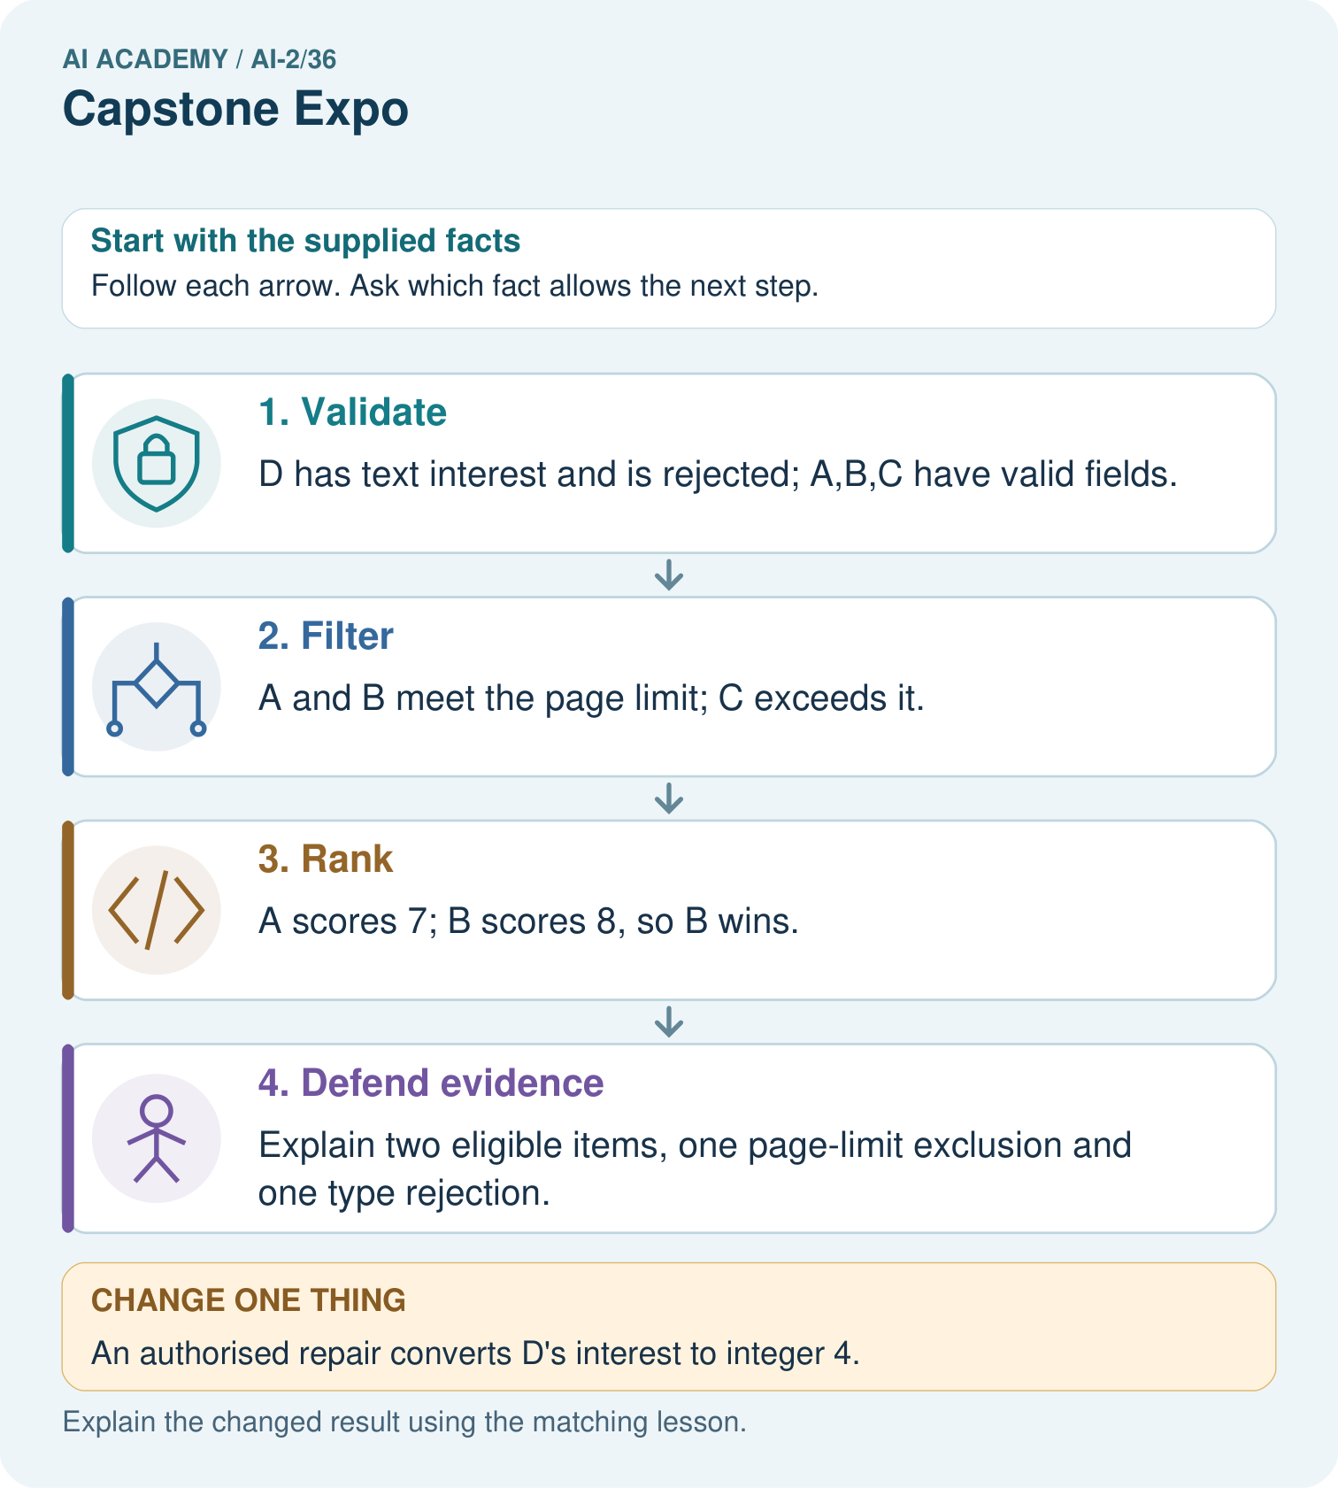

Read the picture one step at a time
Step | What happens and why
1. Validate | D has text interest and is rejected; A,B,C have valid fields.
2. Filter | A and B meet the page limit; C exceeds it.
3. Rank | A scores 7; B scores 8, so B wins.
4. Defend evidence | Explain two eligible items, one page-limit exclusion and one type rejection.
Match each pictured step to the supplied facts. This is a worked teaching case, not an independent assessment.

Why this result follows
A presentation should let someone rebuild the result from the stated contract. A’s equality is accepted; D is not silently converted; C’s high preference score cannot override the page requirement. Reversing rows must preserve B because it has the unique highest eligible score. Keep the reserved case distinct from practice demonstrations.

What this example does not establish
A defensible algorithmic trace does not prove B will be liked or that classroom learning improved.

Change one thing in the pictured case
Change: An authorised repair converts D’s interest to integer 4.
Prediction: D becomes eligible and scores 9, so it wins.
Reason: The evidence-backed input repair changes validation and then ranking; record this as a new case/version.

Ask while showing the picture
Cover the result. Ask learners to name the inputs and predict the next step. Uncover one step, connect the icon to the actual procedure, and explain its evidence. Then change the supplied condition and compare. The picture is a representation; it does not document execution of a real AI model.

03. Demonstrate and guide practice

Demonstrate and guide practice

Board sequence
Write the given facts: An expo claim says the recommender knows everybody's favourite book after twelve tests.
Write the question to explain: Rewrite the defence.
Reveal after predictions: Explain trait-based ranking, report the twelve outcomes and limits, and demonstrate no-match handling. It cannot know unstated preferences.
Keep for an independent attempt: Your demo recommends the right book once. An audience member asks why they should trust it. Name evidence and one limitation you should present.

Classroom dialogue
Ask: Which facts are given, and which would we have to assume? Learners mark relevant details before discussing answers.
Say: Predict first. Show the rule, information path or calculation that would produce the result. A correct guess is not yet an explanation.
Reveal reasoning one step at a time. Explain why a tempting alternative fails. Write units and denominators for arithmetic, trace conditions for decisions, and identify supporting sources for claims.
In pairs, one learner solves while the other checks evidence; exchange roles. Remove the worked answer before independent assessment.

Model these guided questions
The input records and eligibility/scoring/tie trace; also show the policy/version and rejection counts. Exit: All possible input correctness and educational benefit remain unproven. Add varied independent cases or propose a teacher-approved usability pilot with a defined question; do not claim outcomes before collecting evidence.

Case-specific teaching sequence
Stage | Teacher action
Session 1 start to 7 minutes | Retrieve the prerequisite and explain the purpose in the opening section.
7 to 20 minutes | Read the worked example and diagram; ask learners to trace each step aloud.
20 to 33 minutes | Complete W1 and W2, then compare predictions with observed results.
33 to 45 minutes | Collect the guided prediction before running; discuss a mismatch and its cause.
Session 2 start to 8 minutes | Retrieve the main rule without showing the previous answer.
8 to 20 minutes | Use W3 to diagnose and repair the stated failure; rerun an earlier case.
20 to 35 minutes | Collect W4 independently, including code or plan, predictions and explanations, before hints.
35 to 45 minutes | Discuss W5 and the exit; use the fresh retry when support was needed.

Reduce help deliberately
Completion task: A report says supplied 5, accepted 4 and rejected 2. Identify the inconsistency.
Teacher check: Accepted plus rejected is 6, not 5. Investigate double counting or reporting before presenting it.
Start by identifying the given inputs together. Leave the intermediate steps blank. If needed, model one step, then withdraw that help on the next step. Move to a full trace only when the partial trace is understood. For partners, alternate explainer and checker; collect a response from every learner before discussion.

Individual reasoning check
Use the worked case for Defending the data application. Proposed explanation: “A successful run proves the conclusion”. Decide whether this explanation is supported. Point to the step or supplied fact that decides; explain your repair if needed.
Expected correction: The final independent task must be attempted before hints. Record support honestly and use a new case after support. Keep teacher answers separate from student materials and do not publish private credentials or real student records in the handover.
Collect explanations, not only yes/no votes. If a misunderstanding is common, re-model the relevant step for the class. If it affects a few learners, give a short targeted group explanation while others solve a more demanding variation.

Pictorial practice question
Give the original winning ID, its score, and counts of eligible, excluded and invalid rows.

Reasoned teacher answer
B wins with 8. Two rows eligible, one valid-but-too-long row excluded, one type-invalid row rejected.
Changed-case reasoning: D becomes eligible and scores 9, so it wins. The evidence-backed input repair changes validation and then ranking; record this as a new case/version.
Collect each learner’s explanation before discussion. Use the first missing connection between input, deciding step and result to choose support. This question is worked-case practice, not fresh mastery evidence.

04. Run the weekly evidence lab

Run the weekly evidence lab
Words You Can Use to Reason
A definition matters when you can recognize the idea, use it, and contrast it with a near-miss.
Predict → Test → Record → Explain
Keep expected and actual results separate. Surprises are useful data when recorded honestly.
Present the working recommender, evidence table, test record, and limitation; answer a fresh calculation and a ‘what could fail?’ question.
What did the hardest test teach you that the normal test did not?

Make the lab runnable
Use the concrete case as the shared normal case and the independent question as a second case. Each pair creates a boundary or missing-information case and predicts its result before testing. Keep the expected result separate from an observed mistake.
Record | What to capture
Input or evidence | Exact data, instruction or claim
Expected result | Answer or safe fallback declared before the run
Observed result | Actual result, including errors
Explanation | Rule, calculation or evidence explaining the outcome
Next test | One justified change and a new prediction

Diagnose and reteach
For guessing, return to given facts and request a trace. For vocabulary without application, use one example and one non-example. For arithmetic errors, check the setup before the calculation. Finish with a different uncoached case before recording mastery.

Address these additional misconceptions
A successful run proves the conclusion: The final independent task must be attempted before hints. Record support honestly and use a new case after support. Keep teacher answers separate from student materials and do not publish private credentials or real student records in the handover.
Matching the example is enough: Require the new W4 case, explicit predictions and an explanation. Fresh retry after support: limit 12; M (minutes 12, fun 3, learning 3), N (11,4,1), O (13,5,5), P (10,-1,2). Counts 4 supplied,3 accepted,1 rejected,2 eligible. M/N tie at 9; M wins in either order.
A convenient shortcut preserves meaning: A polished presentation can conceal missing evidence. Replace claims such as works for everyone with the exact requirements met, cases executed and known limitations. Show one prior failure and its repair rather than deleting it from the story.

Match the support to the first error
What the response shows | Next teaching action
Missing or misread facts | Read the case aloud, mark supplied versus unknown facts, and let the learner restate it.
Wrong procedure | Return to the deciding step in the worked case. Contrast it with the proposed incorrect explanation.
Arithmetic or implementation error | Trace intermediate values or lines; preserve the first mismatch and retry that step.
Correct result without a reason | Ask for a trace and a changed case before marking independent understanding.
An unsupported wider claim | Ask which supplied evidence supports the claim and which further observation would be needed.
Offer an oral explanation, drawing, enlarged visual or fewer examples when that removes a reading/writing barrier. Keep the same reasoning goal. Stretch secure learners by changing a boundary or assumption and asking them to defend the effect, not simply by assigning more of the same questions.

05. Assess and explain the answers

Assess and explain the answers

Worked case answer
Explain trait-based ranking, report the twelve outcomes and limits, and demonstrate no-match handling. It cannot know unstated preferences.

Independent question
Your demo recommends the right book once. An audience member asks why they should trust it. Name evidence and one limitation you should present.

Expected independent answer
Show the scoring rule, test preferences, expected and observed outputs, failures and revisions. Explain the limited test coverage and when no match or human review is needed.

What counts as evidence
Criterion | 0 points | 1 point | 2 points
Result | Incorrect or absent | Partly correct | Correct with necessary conditions
Reasoning | No supporting trace | Some steps | Clear mechanism, calculation or source support
Limit | Overclaims certainty | Vague limitation | Relevant uncertainty or missing fact
Transfer | Copies without adapting | Adapts with prompts | Solves a changed case independently
Use 6/8 as a classroom checkpoint, with 2 required for both Result and Reasoning. This is a proposed teaching rule, not a validated certification threshold. Do not count a coached answer as independent mastery; correct unsafe or unsupported claims regardless of total.

Feedback
Ask the learner to find the evidence that challenges this claim: “A successful live example replaces an evaluation record.” Keep the first attempt and an uncoached retry separate.

Original transfer answer
No. Report 8/10 on the specified set, but invented titles and constraint violations fail essential criteria. Repair and retest those behaviours, preserve a no-match path and gather broader evidence. The system ranks declared traits; it does not know unstated preferences.

Explanations for the additional workbook examples

W1 Assemble evidence
List the files or records a peer needs to reproduce the chooser result.
Fictional raw dataset, schema, code version, settings, run instructions, tests with expected/actual results, rejection reasons and change log.

W2 Check report consistency
A report says supplied 5, accepted 4 and rejected 2. Identify the inconsistency.
Accepted plus rejected is 6, not 5. Investigate double counting or reporting before presenting it.

W3 Repair a claim
A presentation says the project proves students learn better. What claim does a successful rule-based demo support instead?
It supports that the tested version follows specified selection rules on the tested cases. Learning benefit needs separate classroom evidence.

W4 Defend a new case independently
Limit is 10. A has minutes 10, fun 2, learning 4; B has 9,3,2; C has 11,5,5; D has 8,"4",2. Validate, rank, give counts, explain the winner, then reverse the input order. Present without hints.
4 supplied, 3 accepted, 1 rejected D for rating type, 2 eligible A/B. Both score 8; A wins alphabetically. C is valid but over-limit. Reversal preserves counts and A. Explain the policy and its limits.

W5 State the next evidence need
After passing the new case, what remains unproven and what is a reasonable next step?
All possible input correctness and educational benefit remain unproven. Add varied independent cases or propose a teacher-approved usability pilot with a defined question; do not claim outcomes before collecting evidence.

Assess independent transfer
Selected case: Limit is 10. A has minutes 10, fun 2, learning 4; B has 9,3,2; C has 11,5,5; D has 8,"4",2. Validate, rank, give counts, explain the winner, then reverse the input order. Present without hints.

Selected case answer
4 supplied, 3 accepted, 1 rejected D for rating type, 2 eligible A/B. Both score 8; A wins alphabetically. C is valid but over-limit. Reversal preserves counts and A. Explain the policy and its limits.
Dimension | Evidence required
Explanation | Names the applicable idea or procedure and ties it to the supplied facts.
Trace and result | Preserves the given inputs and shows the relevant intermediate steps; distinguishes a prediction from an observed execution.
Limits | States the assumptions, missing evidence or conditions under which the result would change.
Record each dimension as not yet, with support, or independent. Accept a valid alternative procedure with a defensible trace. Do not penalise an honestly recorded model failure if the learner correctly explains its evidence and limits.

Feedback that the learner uses
Name the earliest unsupported step and give one action to repair it. Have the learner make that repair now and explain why. Then assess the relevant skill on a fresh, fully specified case. Confirm it was not previously practised with feedback; solve and check the new case before assigning it. A follow-up design prompt is a starting brief, not automatically an equivalent test.

06. Connect and extend learning

Connect and extend learning

Transparent Book Recommender
Final evidence bundle: brief, data, scoring logic, tests, improvement record, and product card.
Keep the decision, input, result, explanation and remaining limitation in the project evidence record. Retrieve this record next week rather than restarting the project.

Support and stretch
Trace one record or condition at a time with counters and labelled columns. Stretch: introduce a tie, boundary or missing field and declare its handling policy before rerunning.

Exit reflection
Ask for one decision the learner can now justify and one situation requiring more evidence or human review. Confidence ratings are separate from correct independent performance.

Bridge to the next week
Review the full project evidence and choose concepts needing another independent attempt before the next level. One expo is not proof of mastery of all AI.

Support and fresh reassessment
Offer a presentation outline only after the initial independent attempt and record support. Extension: let a peer supply a new valid case and require a prediction before running. Assess explanation, not decorative slide polish.
Independent W4 evidence: 4 supplied, 3 accepted, 1 rejected D for rating type, 2 eligible A/B. Both score 8; A wins alphabetically. C is valid but over-limit. Reversal preserves counts and A. Explain the policy and its limits. Record whether the learner needed no help, a hint or explanation. Fresh retry after support: limit 12; M (minutes 12, fun 3, learning 3), N (11,4,1), O (13,5,5), P (10,-1,2). Counts 4 supplied,3 accepted,1 rejected,2 eligible. M/N tie at 9; M wins in either order.
Grade 7 is complete when the learner can independently explain and defend the application. Use readiness evidence and recorded support to plan the next level.

Plan the delayed return
Suggested return points in this level: plan a review after the level ends. Use actual classroom dates, adjusting for holidays and gaps. One, three and six teaching weeks are scheduling choices, not a claimed optimal spacing.
At a delayed check, ask for the idea from memory and a changed application. Compare with the earlier independent response and record support used. For a new level, revisit the previous capstone before checking the new prerequisites.
Record | Teacher evidence
Learner code and date
Concept and case used; prior exposure
Explanation / trace / limits
Support and first repair
Changed case and delayed outcome
Next teaching action
Use the evidence to choose reteaching or the next step. A completed page, confidence rating or attractive project does not by itself demonstrate understanding.

Project evidence from this case
Present the Transparent Book Recommender’s code, baseline, full-case traces, reserved results and limitations, without claiming fictional results as pupil work.

