AI ACADEMY · TEACHER · ai-3/8

Structured Output and Schemas
Project: Verified Study Buddy

01. Structured Output and Schemas

Teach the learning cycle
Primary target: Separate JSON parsing, schema validation and source support checks
Session | Sequence and minutes | Resources
Session 1 · Understand · 45 min | 0–7: recall and prerequisite; 7–15: inspect the concrete case and predict; 15–30: teacher models the worked trace; 30–40: learners explain a step using the text and visual; 40–45: check the core idea. | Sections 1–6; record the brief recall in the workbook.
Session 2 · Practise · 45 min | 0–5: retrieve the procedure; 5–15: W2 completion practice; 15–23: explain and check with a partner; 23–30: each learner answers the misconception check; 30–40: targeted reteaching or a harder variation; 40–45: prepare the investigation. | Sections 7–10; use the matching workbook W2 and misconception check.
Session 3 · Investigate and transfer · 45 min | 0–5: retrieve the decision rule; 5–20: investigate or trace; 20–30: start the independent case; 30–38: connect the project; 38–43: act on feedback; 43–45: plan the return check. | Sections 9 and 11–14. Give extra time to finish the full task set; use Section 15 when the week includes a coding lab.
This is a starting allocation of 135 minutes, not a validated duration. Preserve all named topics. Schedule extra time for connected examples, the full investigation, independent cases and project building. Repeated copies of a case share one recorded attempt; they are not new evidence.

Retrieval answer guidance

Iterative Prompting
Without opening the old lesson, explain one key idea from Iterative Prompting. Give an example and a mistake that the idea helps you avoid.
Look for: Explain the mechanism and terminology of controlled prompt experiments
Reference example, not the only acceptable wording: Teacher explanation: A prompt experiment compares complete specifications using the same task cases. Define success before inspecting outputs; change one intended instruction and preserve other settings. Evaluate both prompts on paired cases with fixed model/version, source records, output contract and scoring rubric. Use development results for selection, then reserve new final cases. Score each case rather than counting attractive sentences.

Prompt as a Contract
Without opening the old lesson, explain one key idea from Prompt as a Contract. Give an example and a mistake that the idea helps you avoid.
Look for: Write a prompt specification with observable response criteria
Reference example, not the only acceptable wording: Teacher explanation: Fields status,room,capacity,source_ids. Status supported or needs_review. supported requires matching current approval and current capacity for the same room; no unresolved conflict.

A Distribution of Possibilities
Without opening the old lesson, explain one key idea from A Distribution of Possibilities. Give an example and a mistake that the idea helps you avoid.
Look for: Check whether a next-token table is a valid probability distribution
Reference example, not the only acceptable wording: Teacher explanation: Entries are nonnegative and sum to 1. Not ready has mass 0.3+0.2 = 0.5, including busy and unknown.
Use the student module and workbook section with this exact week title. The worked case, independent question and answers below form one aligned lesson sequence.

What the learner must demonstrate
Schema requires title:text and pages:number. Output is {"title":"Cloud","pages":"80"}. Fix its structural error. Would the repaired object prove the book really has 80 pages?

Concept to explain
Week 8: Structured Output and Schemas
Term | Meaning
schema | A specification of required fields, types and structural rules for data.
field | A named item of information in a record or structured message.
type | The category of a value, such as text, number or Boolean.
validation | Checking data or behaviour against rules; in ML, validation data is used to choose settings or models, separately from final testing.

Prepare the class
Use the supplied scenario, student illustrations and blank paper. For numeric work, offer counters or a calculator after learners show the setup. Fictional records are supplied; personal data and paid accounts are unnecessary.
Allow 80 minutes: recall 8; explanation 12; worked demonstration 15; guided practice 20; independent assessment 15; project and reflection 10. Extend the lab into a second session when needed.

Preparation for the connected explanation
Use two 45-minute sessions. All model outputs and probability tables are constructed classroom examples. No hosted AI service, external API or student account is needed. Distinguish a model objective from factual support and system permissions. Collect independent work before discussing its solutions.

Readiness answer
No. Parse and validate the returned value, then check its claims and permitted actions against the evidence and contract.
Printed lesson and workbook; paper and pencil
Calculator; optional local Python 3 interpreter
Prepare the independent task and fresh retry without displaying solutions

End goal for the pictorial case
By the end, I can validate structured output in layers: syntax, schema and source meaning.
This added worked case illustrates the week’s main idea. Retain all original and connected topics; schedule its practice within the teaching cycle.

02. Explain the mechanism

Explain the mechanism
Input → Process → Output
Trace the information. At each stage, ask what changed and how you could test it.
Which stage could fail even when the other two are correct? Explain:
Predict first. Then check each step. A correct answer without visible reasoning is incomplete evidence.
1. Schema fields: answer=text; evidence=list; confidence=low/medium/high.
2. Output omits evidence: validation fails.
3. Confidence=97 is the wrong type and allowed-value set.
4. Reject, repair, or request again before downstream use.
Recalculate, retrace, or restate the reasoning in your own representation:
CHECK Did the evidence answer the exact question? Did the total, path, or source record stay consistent?

Concrete teaching case
Schema requires title text and pages number. Output is {"title":"River","pages":"80"}.
Diagnose the shape error.

Exact explanation to model
Pages is a string, not a number. Use numeric 80. Structure validation does not verify the real page count.

Explain the added worked example
A response may be valid JSON and still violate the schema or sources. First parse the text. Then check the exact object fields and types. Finally check source support and domain meaning. These checks answer different questions. Do not call a successful parser a complete validator.
Use the Week 11 closed object: exactly status,room,capacity,source_ids. status is supported or needs_review. source_ids is a list of distinct known source-ID strings. For supported, room is a nonempty string and capacity a nonnegative integer. For needs_review, room and capacity are null. Boolean values are not capacities under this contract.
These fragments illustrate failures, not complete candidate objects. A real check receives the whole object and verifies every required field. Do not repair a string capacity automatically unless a separate documented conversion policy permits it; otherwise report validation failure. A null value differs from missing a field.

Key terms
Term | Meaning
Syntax validation | Checking whether text can be parsed under the format grammar
Schema validation | Checking fields, types and allowed combinations in a parsed value
Semantic validation | Checking meaning and consistency with sources or domain rules
Closed schema | A contract rejecting fields beyond the stated set

Model the reasoning aloud
Use the complete worked example below before asking learners to complete W2. Reveal a small part, invite a prediction, then explain the deciding step. These teacher notes contain solutions; do not reveal the independent case answer during modelling.
Suppose sources P and Q approve room B and give capacity 12. The complete object {"status":"supported","room":"B","capacity":99,"source_ids":["P","Q"]} parses and satisfies the stated field types, but its capacity is unsupported by Q. Reject it at semantic validation. Listing a real source ID does not prove that source supports the associated claim.
An object with needs_review and room B violates the conditional schema rule even if its source IDs are real. An object with supported, room B and capacity 12 but source ID Z fails the known-source rule. Require the linked current approval and capacity records to support the same room.
Thinking move | Teacher prompt
Plan | What is given? What is the question? Which procedure fits these facts?
Do | Point to each input and intermediate step in the worked trace. Name the rule that allows the next step.
Check | Does the output answer the question? Which assumption or limitation prevents a larger claim?
Use the diagram and verbal explanation together. Ask learners to match a sentence to a specific visual step; do not assign learners fixed visual or auditory learning styles.

A pictorial worked case: Structured Output and Schemas
A fictional Study Buddy returns a machine-readable book fact.

The facts we will use
Schema: exactly title text, pages integer, source_id text. Approved record R: River Notes, 64 pages.
X={"title":"River Notes","pages":64,"source_id":"R"}; Y uses pages:"64"; Z uses pages:46 with otherwise identical fields.
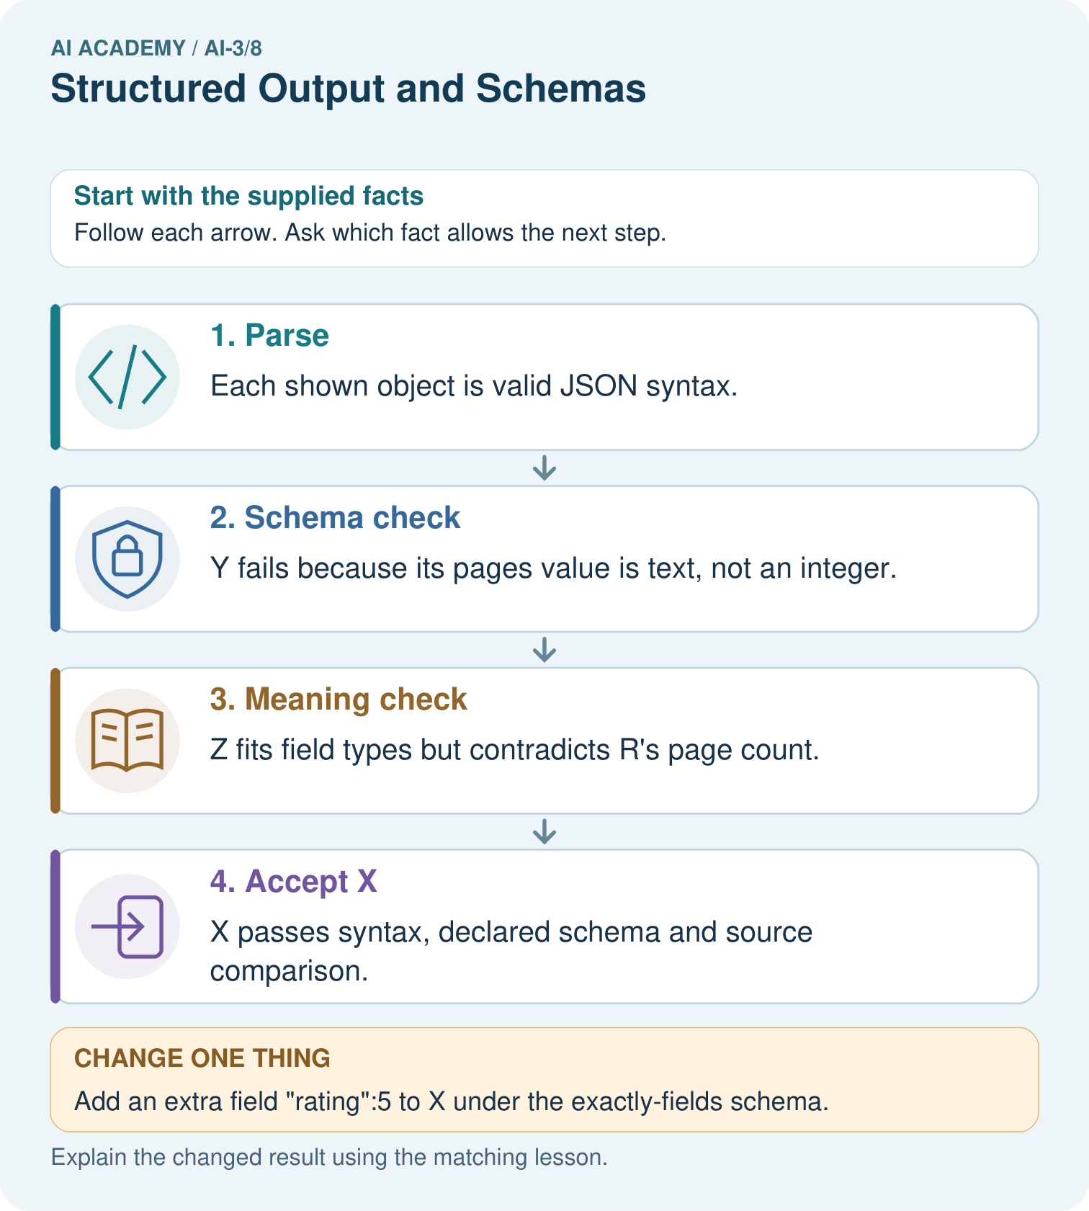

Read the picture one step at a time
Step | What happens and why
1. Parse | Each shown object is valid JSON syntax.
2. Schema check | Y fails because its pages value is text, not an integer.
3. Meaning check | Z fits field types but contradicts R’s page count.
4. Accept X | X passes syntax, declared schema and source comparison.
Match each pictured step to the supplied facts. This is a worked teaching case, not an independent assessment.

Why this result follows
Parsing establishes that text forms a structured object. Schema checks establish required fields and types. Semantic validation compares their meaning with the approved source. These are different layers: a parseable, well-shaped object can still contain a false fact. Report the first failing layer without treating format success as factual success.

What this example does not establish
Source agreement does not establish that the approved catalogue itself is correct or complete.

Change one thing in the pictured case
Change: Add an extra field "rating":5 to X under the exactly-fields schema.
Prediction: The changed object fails schema despite keeping the correct page count.
Reason: Exactly means additional fields are not allowed in this contract.

Ask while showing the picture
Cover the result. Ask learners to name the inputs and predict the next step. Uncover one step, connect the icon to the actual procedure, and explain its evidence. Then change the supplied condition and compare. The picture is a representation; it does not document execution of a real AI model.

03. Demonstrate and guide practice

Demonstrate and guide practice

Board sequence
Write the given facts: Schema requires title text and pages number. Output is {"title":"River","pages":"80"}.
Write the question to explain: Diagnose the shape error.
Reveal after predictions: Pages is a string, not a number. Use numeric 80. Structure validation does not verify the real page count.
Keep for an independent attempt: A required schema has title as text and count as an integer. The output is {"title":"Seeds","count":"three"}. Identify the error and give a valid replacement.

Classroom dialogue
Ask: Which facts are given, and which would we have to assume? Learners mark relevant details before discussing answers.
Say: Predict first. Show the rule, information path or calculation that would produce the result. A correct guess is not yet an explanation.
Reveal reasoning one step at a time. Explain why a tempting alternative fails. Write units and denominators for arithmetic, trace conditions for decisions, and identify supporting sources for claims.
In pairs, one learner solves while the other checks evidence; exchange roles. Remove the worked answer before independent assessment.

Model these guided questions
Guided: D/8 with P/Q passes syntax, schema and source consistency. Zero is a permitted integer but is supported only if Q says zero. Exit: schema must reject Boolean capacity and extra fields; no action authority exists.

Case-specific teaching sequence
Stage | Teacher action
Session 1 start to 7 minutes | Retrieve the prerequisite and distinguish a numerical claim from its interpretation.
7 to 18 minutes | Read section 1 and complete W1; ask for a reason alongside each answer.
18 to 32 minutes | Trace the worked case in section 2 and complete W2.
32 to 45 minutes | Discuss the diagram and complete W3 in pairs; record support.
Session 2 start to 8 minutes | Complete the guided response before sharing the answer.
8 to 20 minutes | Read the remaining sections and trace another constructed case.
20 to 35 minutes | Collect W4 independently, requiring calculations and a bounded conclusion.
35 to 45 minutes | Discuss W5 and the exit response. Provide feedback and a fresh retry.

Reduce help deliberately
Completion task: Why do string "12",boolean true,missing capacity and an extra action field violate this contract?
Teacher check: Teacher explanation: Capacity must be an integer for supported and null for needs_review, with the field present. A Boolean is explicitly excluded. Extra fields violate the closed schema; string values are not silently converted.
Start by identifying the given inputs together. Leave the intermediate steps blank. If needed, model one step, then withdraw that help on the next step. Move to a full trace only when the partial trace is understood. For partners, alternate explainer and checker; collect a response from every learner before discussion.

Individual reasoning check
Use the worked case for Structured outputs and validation. Proposed explanation: “Valid JSON means correct answer”. Decide whether this explanation is supported. Point to the step or supplied fact that decides; explain your repair if needed.
Expected correction: JSON syntax says nothing about schema or source truth.
Collect explanations, not only yes/no votes. If a misunderstanding is common, re-model the relevant step for the class. If it affects a few learners, give a short targeted group explanation while others solve a more demanding variation.

Pictorial practice question
Which object demonstrates that valid JSON and valid types are insufficient for truth?

Reasoned teacher answer
Z: its pages is an integer and syntax is valid, but 46 contradicts approved 64.
Changed-case reasoning: The changed object fails schema despite keeping the correct page count. Exactly means additional fields are not allowed in this contract.
Collect each learner’s explanation before discussion. Use the first missing connection between input, deciding step and result to choose support. This question is worked-case practice, not fresh mastery evidence.

04. Run the weekly evidence lab

Run the weekly evidence lab
Words You Can Use to Reason
A definition matters when you can recognize the idea, use it, and contrast it with a near-miss.
Predict → Test → Record → Explain
Keep expected and actual results separate. Surprises are useful data when recorded honestly.
Validate six output cards for required fields, types, allowed values, and evidence support; explain each rejection.
What did the hardest test teach you that the normal test did not?

Make the lab runnable
Use the concrete case as the shared normal case and the independent question as a second case. Each pair creates a boundary or missing-information case and predicts its result before testing. Keep the expected result separate from an observed mistake.
Record | What to capture
Input or evidence | Exact data, instruction or claim
Expected result | Answer or safe fallback declared before the run
Observed result | Actual result, including errors
Explanation | Rule, calculation or evidence explaining the outcome
Next test | One justified change and a new prediction

Diagnose and reteach
For guessing, return to given facts and request a trace. For vocabulary without application, use one example and one non-example. For arithmetic errors, check the setup before the calculation. Finish with a different uncoached case before recording mastery.

Address these additional misconceptions
Valid JSON means correct answer: JSON syntax says nothing about schema or source truth.
Python treats bool as int, so it is acceptable: The contract explicitly excludes Booleans; an implementation must check accordingly.
A valid report authorises a side effect: Reporting and booking have different permissions.

Match the support to the first error
What the response shows | Next teaching action
Missing or misread facts | Read the case aloud, mark supplied versus unknown facts, and let the learner restate it.
Wrong procedure | Return to the deciding step in the worked case. Contrast it with the proposed incorrect explanation.
Arithmetic or implementation error | Trace intermediate values or lines; preserve the first mismatch and retry that step.
Correct result without a reason | Ask for a trace and a changed case before marking independent understanding.
An unsupported wider claim | Ask which supplied evidence supports the claim and which further observation would be needed.
Offer an oral explanation, drawing, enlarged visual or fewer examples when that removes a reading/writing barrier. Keep the same reasoning goal. Stretch secure learners by changing a boundary or assumption and asking them to defend the effect, not simply by assigning more of the same questions.

05. Assess and explain the answers

Assess and explain the answers

Worked case answer
Pages is a string, not a number. Use numeric 80. Structure validation does not verify the real page count.

Independent question
A required schema has title as text and count as an integer. The output is {"title":"Seeds","count":"three"}. Identify the error and give a valid replacement.

Expected independent answer
The count value is text instead of an integer. A valid replacement is {"title":"Seeds","count":3}. Valid structure still does not prove factual correctness.

What counts as evidence
Criterion | 0 points | 1 point | 2 points
Result | Incorrect or absent | Partly correct | Correct with necessary conditions
Reasoning | No supporting trace | Some steps | Clear mechanism, calculation or source support
Limit | Overclaims certainty | Vague limitation | Relevant uncertainty or missing fact
Transfer | Copies without adapting | Adapts with prompts | Solves a changed case independently
Use 6/8 as a classroom checkpoint, with 2 required for both Result and Reasoning. This is a proposed teaching rule, not a validated certification threshold. Do not count a coached answer as independent mastery; correct unsafe or unsupported claims regardless of total.

Feedback
Ask the learner to find the evidence that challenges this claim: “JSON that looks tidy necessarily satisfies the schema.” Keep the first attempt and an uncoached retry separate.

Original transfer answer
Use {"title":"Cloud","pages":80}. This satisfies the stated types but the page count still needs a reliable edition-specific source. Reject malformed or missing fields explicitly rather than assuming a successful-looking response is valid.

Explanations for the additional workbook examples

W1 Distinguish the layers
Explain what parsing, schema checks and source support each establish.
Teacher explanation: Parsing establishes grammatical JSON; schema checks enforce fields/types/conditional rules; semantic checks match the claims to sources and domain meaning. None alone establishes all three.

W2 Audit types and fields
Why do string "12",boolean true,missing capacity and an extra action field violate this contract?
Teacher explanation: Capacity must be an integer for supported and null for needs_review, with the field present. A Boolean is explicitly excluded. Extra fields violate the closed schema; string values are not silently converted.

W3 Check a citation-like ID
Sources P,Q support B capacity 12. A schema-valid object cites P,Q but gives 99. Which layer rejects it?
Teacher explanation: Semantic/source validation rejects unsupported capacity 99. Existing source IDs do not establish entailment.

W4 Validate new objects independently
Sources A approve room F and B register F capacity 9. Object X has supported,F,9,[A,B] with exactly the required fields. Y replaces 9 with "9". Z keeps integer 9 but names room G. Trace the first failing layer for each and explain the difference.
Teacher explanation: X passes parsing, schema and source validation. Y parses but fails schema because capacity is a string. Z parses and satisfies field types but fails semantic support because sources name F, not G. Assuming these values are encoded as proper JSON, syntax is not the failure.

W5 Keep permissions separate
A fully valid supported reporting object is returned. May the application automatically book the room? Explain.
Teacher explanation: No. The specification is read-only; validation of a report does not grant action permission. Booking requires a separately authorised action contract and application controls.

Assess independent transfer
Selected case: Sources A approve room F and B register F capacity 9. Object X has supported,F,9,[A,B] with exactly the required fields. Y replaces 9 with "9". Z keeps integer 9 but names room G. Trace the first failing layer for each and explain the difference.

Selected case answer
Teacher explanation: X passes parsing, schema and source validation. Y parses but fails schema because capacity is a string. Z parses and satisfies field types but fails semantic support because sources name F, not G. Assuming these values are encoded as proper JSON, syntax is not the failure.
Dimension | Evidence required
Explanation | Names the applicable idea or procedure and ties it to the supplied facts.
Trace and result | Preserves the given inputs and shows the relevant intermediate steps; distinguishes a prediction from an observed execution.
Limits | States the assumptions, missing evidence or conditions under which the result would change.
Record each dimension as not yet, with support, or independent. Accept a valid alternative procedure with a defensible trace. Do not penalise an honestly recorded model failure if the learner correctly explains its evidence and limits.

Feedback that the learner uses
Name the earliest unsupported step and give one action to repair it. Have the learner make that repair now and explain why. Then assess the relevant skill on a fresh, fully specified case. Confirm it was not previously practised with feedback; solve and check the new case before assigning it. A follow-up design prompt is a starting brief, not automatically an equivalent test.

06. Connect and extend learning

Connect and extend learning

Verified Study Buddy
Require answer, source snippet, citation, uncertainty, and next-question fields.
Keep the decision, input, result, explanation and remaining limitation in the project evidence record. Retrieve this record next week rather than restarting the project.

Support and stretch
Provide one short approved passage; separate instruction, input, output and evidence. Stretch: introduce an unsupported claim or conflicting source and validate claim by claim with a fallback.

Exit reflection
Ask for one decision the learner can now justify and one situation requiring more evidence or human review. Confidence ratings are separate from correct independent performance.

Bridge to the next week
Next: Week 9: Prompt Evaluation. Retrieve today’s evidence and identify what carries forward and what is new.

Support and fresh reassessment
Provide labelled intermediate columns and allow a calculator. Ask students to state the meaning and denominator of a value before interpreting it. Extension: implement the classroom calculation locally and test boundary cases without using personal data.
W4 requires X passes all, Y schema failure, Z semantic failure. Fresh retry: sources approve H capacity 0. Object H/0 passes; H/null with supported fails schema; H/1 with integer capacity passes schema but fails semantic support. Preserve legitimate zero.
Week 13 compares prompt specifications using fixed development cases, observable criteria and reserved evaluation.

Plan the delayed return
Suggested return points in this level: ai-3/9, ai-3/11, ai-3/14. Use actual classroom dates, adjusting for holidays and gaps. One, three and six teaching weeks are scheduling choices, not a claimed optimal spacing.
At a delayed check, ask for the idea from memory and a changed application. Compare with the earlier independent response and record support used. For a new level, revisit the previous capstone before checking the new prerequisites.
Record | Teacher evidence
Learner code and date
Concept and case used; prior exposure
Explanation / trace / limits
Support and first repair
Changed case and delayed outcome
Next teaching action
Use the evidence to choose reteaching or the next step. A completed page, confidence rating or attractive project does not by itself demonstrate understanding.

Project evidence from this case
Validate Study Buddy outputs before another program consumes them; retain source IDs and separate syntax/type/support failures.

