AI ACADEMY · TEACHER · ai-3/16

Verify Numbers and Dates
Project: Verified Study Buddy

01. Verify Numbers and Dates

Teach the learning cycle
Primary target: Explain the mechanism and terminology of claim support and citation evaluation
Session | Sequence and minutes | Resources
Session 1 · Understand · 45 min | 0–7: recall and prerequisite; 7–15: inspect the concrete case and predict; 15–30: teacher models the worked trace; 30–40: learners explain a step using the text and visual; 40–45: check the core idea. | Sections 1–6; record the brief recall in the workbook.
Session 2 · Practise · 45 min | 0–5: retrieve the procedure; 5–15: W2 completion practice; 15–23: explain and check with a partner; 23–30: each learner answers the misconception check; 30–40: targeted reteaching or a harder variation; 40–45: prepare the investigation. | Sections 7–10; use the matching workbook W2 and misconception check.
Session 3 · Investigate and transfer · 45 min | 0–5: retrieve the decision rule; 5–20: investigate or trace; 20–30: start the independent case; 30–38: connect the project; 38–43: act on feedback; 43–45: plan the return check. | Sections 9 and 11–14. Give extra time to finish the full task set; use Section 15 when the week includes a coding lab.
This is a starting allocation of 135 minutes, not a validated duration. Preserve all named topics. Schedule extra time for connected examples, the full investigation, independent cases and project building. Repeated copies of a case share one recorded attempt; they are not new evidence.
Case exposure check: this source example appears in ai-2/29, ai-3/16. Reuse a familiar case for recall or modelling; verify that the case used to assess transfer has not already received feedback.

Retrieval answer guidance

Source Quality
Without opening the old lesson, explain one key idea from Source Quality. Give an example and a mistake that the idea helps you avoid.
Look for: Explain the mechanism and terminology of conflicting and time-sensitive sources
Reference example, not the only acceptable wording: Teacher explanation: Changing facts require a stated time and source-version policy. Current-looking records can conflict without enough evidence to choose between them. For this toy task a signed amendment supersedes the referenced original from its effective time. Keep both records. A newer timestamp alone has no authority unless the policy grants it.

Multimodal Evidence
Without opening the old lesson, explain one key idea from Multimodal Evidence. Give an example and a mistake that the idea helps you avoid.
Look for: Explain the mechanism and terminology of speech pipelines and multimodal evidence
Reference example, not the only acceptable wording: Teacher explanation: A multimodal pipeline may transcribe speech, inspect an image and generate a response. Errors at one stage can propagate even when later stages run correctly. Track source modality, segment/time references, transcription, interpretation and final claims separately. Compare conflicting evidence without assuming one modality always wins. Ask for clarification when the task needs unresolved information.

Image Generation Models
Without opening the old lesson, explain one key idea from Image Generation Models. Give an example and a mistake that the idea helps you avoid.
Look for: Explain the mechanism and terminology of image generation and provenance
Reference example, not the only acceptable wording: Teacher explanation: An image generator constructs an output from learned patterns and a specification. A generated picture is not a record that the depicted event occurred. Keep a provenance record containing specification, tool/version when known, generation date, edits, permissions and intended use. Label fictional imagery. Inspect visual requirements and avoid inferring identity or event authenticity from appearance.
Use the student module and workbook section with this exact week title. The worked case, independent question and answers below form one aligned lesson sequence.

What the learner must demonstrate
A report says 21/28=70% and gives February 30 as the deadline. Correct what can be computed and identify what must be checked externally.

Concept to explain
Precise values require direct evidence and recalculation.
Term | Meaning
primary record | An original record directly relevant to a claim, rather than a later summary of it.
recalculate | Compute a quantity again from the original values or corrected inputs.
unit | An agreed amount used to express a measurement, such as centimetres or seconds.
as-of date | The date up to which a claim or record is stated to be current.

Prepare the class
Use the supplied scenario, student illustrations and blank paper. For numeric work, offer counters or a calculator after learners show the setup. Fictional records are supplied; personal data and paid accounts are unnecessary.
Allow 80 minutes: recall 8; explanation 12; worked demonstration 15; guided practice 20; independent assessment 15; project and reflection 10. Extend the lab into a second session when needed.

Preparation for the connected explanation
Two 45-minute sessions. Citation evaluation checks source existence, exact passage support and coverage of answer claims. A real citation can still be irrelevant. Use the supplied constructed scenarios to make the mechanism inspectable. Collect W4 before sharing solutions. Students should name intermediate evidence and limitations; classroom pacing and learning effectiveness remain unvalidated.

Readiness answer
A result depends on the inputs, procedure and conditions that produced it. Preserve data roles and distinguish observed outcomes from predictions or unmeasured conditions. If the prior concept cannot be explained, use a short retrieval activity before this chapter.
Lesson and workbook; paper and pencil
Calculator and optional local Python 3 for arithmetic; no live API or private data
Prepare the fresh retry separately and withhold its solution until after collection

End goal for the pictorial case
By the end, I can verify numbers and dates without inventing the intended correction.
This added worked case illustrates the week’s main idea. Retain all original and connected topics; schedule its practice within the teaching cycle.

02. Explain the mechanism

Explain the mechanism
Input → Process → Output
Trace the information. At each stage, ask what changed and how you could test it.
Which stage could fail even when the other two are correct? Explain:
Predict first. Then check each step. A correct answer without visible reasoning is incomplete evidence.
1. Claim: 18 of 24 tests passed, reported as 80%.
2. Recalculate: 18 ÷ 24 = 0.75 = 75%.
3. Check denominator, unit, rounding, and source date.
4. Correct the claim and preserve the calculation trail.
Recalculate, retrace, or restate the reasoning in your own representation:
CHECK Did the evidence answer the exact question? Did the total, path, or source record stay consistent?

Concrete teaching case
An answer says 15/20=80% and sets a deadline of February 30.
Verify both.

Exact explanation to model
15/20=75%. February 30 is invalid in the Gregorian calendar. Check the intended deadline from its authority rather than guessing.

Explain the added worked example
Citation evaluation checks source existence, exact passage support and coverage of answer claims. A real citation can still be irrelevant.
Begin by writing the question the procedure is intended to answer. Identify the information already supplied, the information it will produce and the information still missing. These are constructed classroom examples; they do not require live accounts, private records or an external service. Do not treat a plausible explanation as a measured outcome.
For this classroom rubric count a claim as supported only when its cited passage entails it. Separately count correct citation links. Use the number of factual claims as the support denominator.
Before applying the procedure, write its units, denominator or decision boundary where relevant. A partner should be able to repeat each step using the same inputs. If a required input is absent or violates the stated contract, record that condition explicitly instead of quietly replacing it with a convenient value.

Key terms
Term | Meaning
Entailment | Whether the cited passage supports the specific claim
Citation coverage | Which claims include source references
Link validity | Whether a source reference resolves to the intended record

Model the reasoning aloud
Use the complete worked example below before asking learners to complete W2. Reveal a small part, invite a prediction, then explain the deciding step. These teacher notes contain solutions; do not reveal the independent case answer during modelling.
An answer has four factual claims. Three have citations, but only two are supported by their cited passages. All links exist.
Claim support is 2/4=50%; citation presence is 3/4=75%; link existence among three citations is 3/3. These measure different failures.
Compare the intermediate evidence with the final statement. Explain why each number or decision follows from the stated inputs. The conclusion belongs to this scenario and procedure; changing the inputs, evaluation population or authority can change what it establishes. Retain the raw record so a later revision can be compared honestly.
Thinking move | Teacher prompt
Plan | What is given? What is the question? Which procedure fits these facts?
Do | Point to each input and intermediate step in the worked trace. Name the rule that allows the next step.
Check | Does the output answer the question? Which assumption or limitation prevents a larger claim?
Use the diagram and verbal explanation together. Ask learners to match a sentence to a specific visual step; do not assign learners fixed visual or auditory learning styles.

A pictorial worked case: Verify Numbers and Dates
A fictional Study Buddy checks a science-club summary against supplied counts and calendar facts.

The facts we will use
Record: 15 of 20 fictional model trials passed. Draft: “70% passed; the meeting is on June 31.”
June has 30 days. No authoritative record gives the intended meeting date.
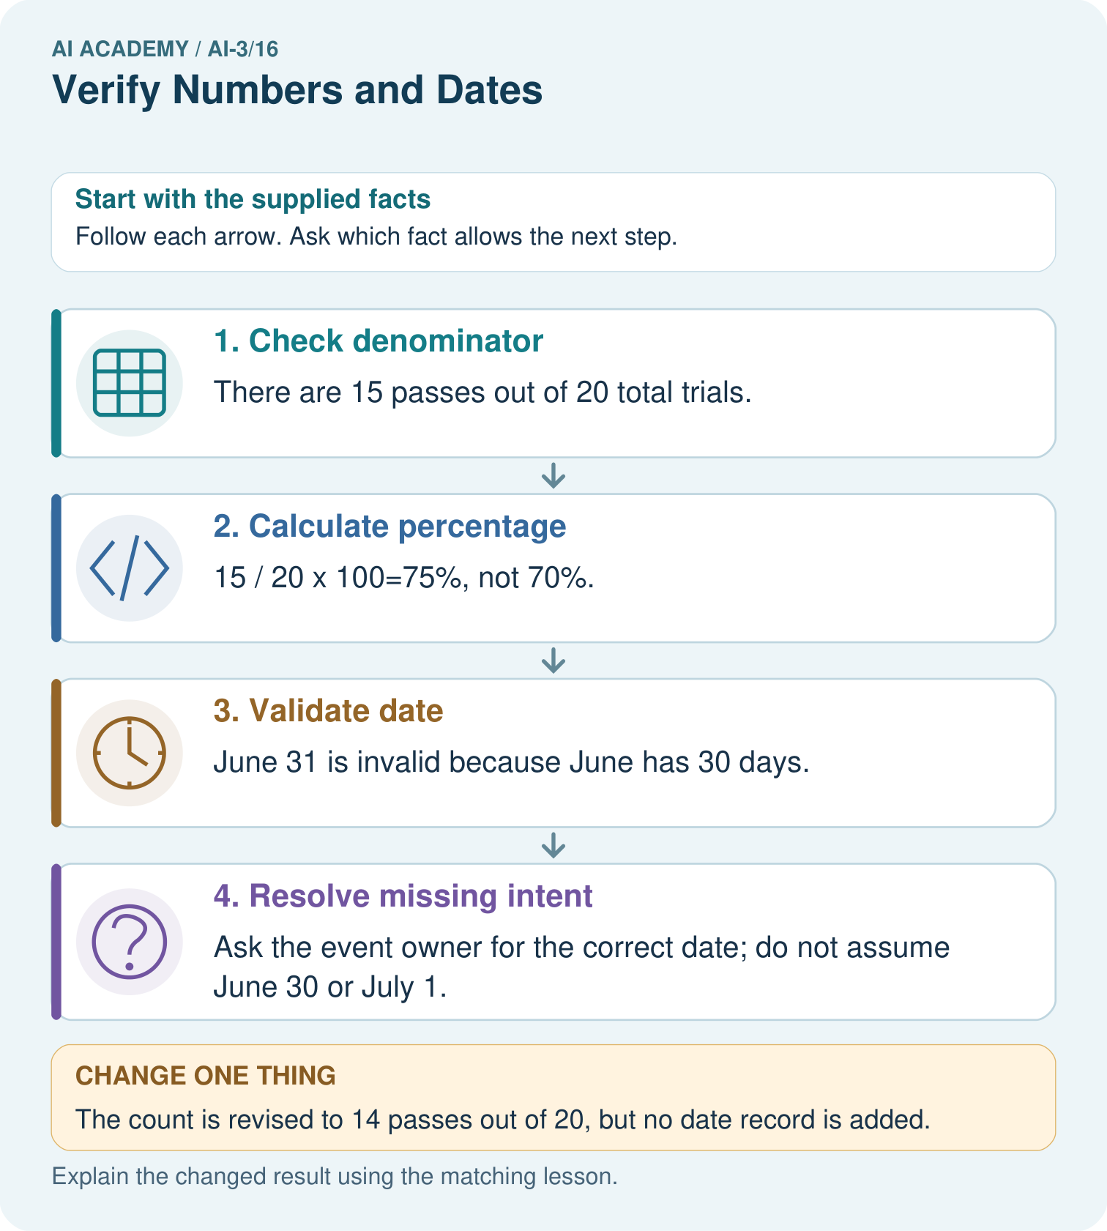

Read the picture one step at a time
Step | What happens and why
1. Check denominator | There are 15 passes out of 20 total trials.
2. Calculate percentage | 15÷20×100=75%, not 70%.
3. Validate date | June 31 is invalid because June has 30 days.
4. Resolve missing intent | Ask the event owner for the correct date; do not assume June 30 or July 1.
Match each pictured step to the supplied facts. This is a worked teaching case, not an independent assessment.

Why this result follows
A percentage requires the correct numerator and denominator. Calendar validation identifies an impossible date, but it cannot discover what date the author intended. These checks use different evidence: arithmetic repairs the percentage from the supplied counts, while the date needs another authoritative source before publication.

What this example does not establish
This check confirms internal arithmetic and date validity, not whether the fictional trial measurements themselves were reliable.

Change one thing in the pictured case
Change: The count is revised to 14 passes out of 20, but no date record is added.
Prediction: 70% now matches the count; June 31 remains invalid and unresolved.
Reason: 14÷20×100=70%; changing a count provides no new calendar evidence.

Ask while showing the picture
Cover the result. Ask learners to name the inputs and predict the next step. Uncover one step, connect the icon to the actual procedure, and explain its evidence. Then change the supplied condition and compare. The picture is a representation; it does not document execution of a real AI model.

03. Demonstrate and guide practice

Demonstrate and guide practice

Board sequence
Write the given facts: An answer says 15/20=80% and sets a deadline of February 30.
Write the question to explain: Verify both.
Reveal after predictions: 15/20=75%. February 30 is invalid in the Gregorian calendar. Check the intended deadline from its authority rather than guessing.
Keep for an independent attempt: A report says 12 of 40 responses is 40%. Recalculate and state the correction with the denominator.

Classroom dialogue
Ask: Which facts are given, and which would we have to assume? Learners mark relevant details before discussing answers.
Say: Predict first. Show the rule, information path or calculation that would produce the result. A correct guess is not yet an explanation.
Reveal reasoning one step at a time. Explain why a tempting alternative fails. Write units and denominators for arithmetic, trace conditions for decisions, and identify supporting sources for claims.
In pairs, one learner solves while the other checks evidence; exchange roles. Remove the worked answer before independent assessment.

Model these guided questions
Guided: Claim support is 2/4=50%; citation presence is 3/4=75%; link existence among three citations is 3/3. These measure different failures. Qualification: Citation counts do not establish truth beyond the supplied sources or the correctness of uncited claims. Exit: accept a concrete variation with its predicted outcome and a stated condition that would challenge the mechanism; reject a claim resting on unmeasured evidence.

Case-specific teaching sequence
Stage | Teacher action
Session 1: 0–7 minutes | Retrieve the prerequisite; identify the input, procedure and evidence source.
7–18 minutes | Explain section 1 and vocabulary. Complete W1 with a mechanism-based explanation.
18–32 minutes | Trace the declared procedure and worked case. Complete W2, recording intermediate steps.
32–45 minutes | Discuss the diagram with the worked input; use W3 to distinguish measured claims and limitations.
Session 2: 0–8 minutes | Retrieve the worked reasoning and collect the guided response before discussing it.
8–20 minutes | Compare a proposed boundary variant with the original case; identify what remains fixed.
20–35 minutes | Collect W4 independently. Require the procedure trace and the bounded conclusion.
35–45 minutes | Use W5 and exit responses for feedback. Administer the fresh retry after feedback and preserve both attempts.

Reduce help deliberately
Completion task: An answer has four factual claims. Three have citations, but only two are supported by their cited passages. All links exist. Show the intermediate steps and give the conclusion with its scope.
Teacher check: Teacher explanation: Claim support is 2/4=50%; citation presence is 3/4=75%; link existence among three citations is 3/3. These measure different failures.
Start by identifying the given inputs together. Leave the intermediate steps blank. If needed, model one step, then withdraw that help on the next step. Move to a full trace only when the partial trace is understood. For partners, alternate explainer and checker; collect a response from every learner before discussion.

Individual reasoning check
Use the worked case for Claim support and citation evaluation. Proposed explanation: “The worked result establishes every future case”. Decide whether this explanation is supported. Point to the step or supplied fact that decides; explain your repair if needed.
Expected correction: Citation counts do not establish truth beyond the supplied sources or the correctness of uncited claims.
Collect explanations, not only yes/no votes. If a misunderstanding is common, re-model the relevant step for the class. If it affects a few learners, give a short targeted group explanation while others solve a more demanding variation.

Pictorial practice question
Which part can be corrected immediately from existing evidence, and which needs follow-up?

Reasoned teacher answer
Correct percentage to 75% in the original case. The intended date needs confirmation from the responsible event source.
Changed-case reasoning: 70% now matches the count; June 31 remains invalid and unresolved. 14÷20×100=70%; changing a count provides no new calendar evidence.
Collect each learner’s explanation before discussion. Use the first missing connection between input, deciding step and result to choose support. This question is worked-case practice, not fresh mastery evidence.

04. Run the weekly evidence lab

Run the weekly evidence lab
Words You Can Use to Reason
A definition matters when you can recognize the idea, use it, and contrast it with a near-miss.
Predict → Test → Record → Explain
Keep expected and actual results separate. Surprises are useful data when recorded honestly.
Audit six claims for source, date, unit, denominator, and arithmetic; mark verified, corrected, or unresolved.
What did the hardest test teach you that the normal test did not?

Make the lab runnable
Use the concrete case as the shared normal case and the independent question as a second case. Each pair creates a boundary or missing-information case and predicts its result before testing. Keep the expected result separate from an observed mistake.
Record | What to capture
Input or evidence | Exact data, instruction or claim
Expected result | Answer or safe fallback declared before the run
Observed result | Actual result, including errors
Explanation | Rule, calculation or evidence explaining the outcome
Next test | One justified change and a new prediction

Diagnose and reteach
For guessing, return to given facts and request a trace. For vocabulary without application, use one example and one non-example. For arithmetic errors, check the setup before the calculation. Finish with a different uncoached case before recording mastery.

Address these additional misconceptions
The worked result establishes every future case: Citation counts do not establish truth beyond the supplied sources or the correctness of uncited claims.
A missing input may be replaced without recording the change: A replacement changes the evidence or contract. Record the change and its justification; do not silently turn unknown into a measured value.
Repeating an assessed case is new independent evidence: A replay checks consistency. An example used for feedback or revision cannot later be described as untouched final evaluation.

Match the support to the first error
What the response shows | Next teaching action
Missing or misread facts | Read the case aloud, mark supplied versus unknown facts, and let the learner restate it.
Wrong procedure | Return to the deciding step in the worked case. Contrast it with the proposed incorrect explanation.
Arithmetic or implementation error | Trace intermediate values or lines; preserve the first mismatch and retry that step.
Correct result without a reason | Ask for a trace and a changed case before marking independent understanding.
An unsupported wider claim | Ask which supplied evidence supports the claim and which further observation would be needed.
Offer an oral explanation, drawing, enlarged visual or fewer examples when that removes a reading/writing barrier. Keep the same reasoning goal. Stretch secure learners by changing a boundary or assumption and asking them to defend the effect, not simply by assigning more of the same questions.

05. Assess and explain the answers

Assess and explain the answers

Worked case answer
15/20=75%. February 30 is invalid in the Gregorian calendar. Check the intended deadline from its authority rather than guessing.

Independent question
A report says 12 of 40 responses is 40%. Recalculate and state the correction with the denominator.

Expected independent answer
12 divided by 40 equals 0.30, or 30%. The correct statement is 12 of 40 responses, 30%.

What counts as evidence
Criterion | 0 points | 1 point | 2 points
Result | Incorrect or absent | Partly correct | Correct with necessary conditions
Reasoning | No supporting trace | Some steps | Clear mechanism, calculation or source support
Limit | Overclaims certainty | Vague limitation | Relevant uncertainty or missing fact
Transfer | Copies without adapting | Adapts with prompts | Solves a changed case independently
Use 6/8 as a classroom checkpoint, with 2 required for both Result and Reasoning. This is a proposed teaching rule, not a validated certification threshold. Do not count a coached answer as independent mastery; correct unsafe or unsupported claims regardless of total.

Feedback
Ask the learner to find the evidence that challenges this claim: “A precise-looking percentage should be accepted without calculation.” Keep the first attempt and an uncoached retry separate.

Original transfer answer
21/28=3/4=75%. February 30 is not a valid Gregorian date, but the intended deadline must be checked in the responsible source. Do not guess February 28 or March 2 merely because the supplied date is invalid.

Explanations for the additional workbook examples

W1 Explain the mechanism
Explain the weekly mechanism in your own words. Use the worked scenario to name its input, decision rule and output.
Teacher explanation: Citation evaluation checks source existence, exact passage support and coverage of answer claims. A real citation can still be irrelevant. For this classroom rubric count a claim as supported only when its cited passage entails it. Separately count correct citation links. Use the number of factual claims as the support denominator.

W2 Trace the worked case
An answer has four factual claims. Three have citations, but only two are supported by their cited passages. All links exist. Show the intermediate steps and give the conclusion with its scope.
Teacher explanation: Claim support is 2/4=50%; citation presence is 3/4=75%; link existence among three citations is 3/3. These measure different failures.

W3 Audit the limit
A report omits this qualification: Citation counts do not establish truth beyond the supplied sources or the correctness of uncited claims. Explain how omitting it could change a reader's interpretation, and write an accurate replacement.
Teacher explanation: Citation counts do not establish truth beyond the supplied sources or the correctness of uncited claims. State the observed result separately from the unverified or out-of-scope claim; preserve the original evidence rather than inventing a missing fact.

W4 Apply a new case independently
Five claims; four cited; three supported by cited passages; one cited ID is nonexistent. Compute support and citation presence and explain link limits.
Teacher explanation: Support=3/5=60%; citation presence=4/5=80%. Link checks reject the nonexistent ID; remaining real links still need entailment checks.

W5 Design a revealing follow-up
For the worked scenario, propose one additional case that could reveal a failure, describe its expected outcome before running it, and explain what would need to remain fixed for a fair comparison. Do not reuse W4 as a new final test after receiving feedback.
Teacher explanation: Accept a concrete variant of the worked input or a missing/conflicting/boundary condition, with an expectation derived from the declared procedure. Require preserved settings, original outputs and data roles. Citation counts do not establish truth beyond the supplied sources or the correctness of uncited claims. The new case should test this particular mechanism rather than merely restate the original result.

Assess independent transfer
Selected case: A draft claims18 of24 learners is60%, and gives an April31 deadline. Check both statements without inventing a deadline.

Selected case answer
18/24=75%. April has30 days, so April31 is invalid. Verify the intended date with an authoritative source rather than substituting April30 or May1.
Dimension | Evidence required
Explanation | Names the applicable idea or procedure and ties it to the supplied facts.
Trace and result | Preserves the given inputs and shows the relevant intermediate steps; distinguishes a prediction from an observed execution.
Limits | States the assumptions, missing evidence or conditions under which the result would change.
Record each dimension as not yet, with support, or independent. Accept a valid alternative procedure with a defensible trace. Do not penalise an honestly recorded model failure if the learner correctly explains its evidence and limits.

Feedback that the learner uses
Name the earliest unsupported step and give one action to repair it. Have the learner make that repair now and explain why. Then assess the relevant skill on a fresh, fully specified case. Confirm it was not previously practised with feedback; solve and check the new case before assigning it. A follow-up design prompt is a starting brief, not automatically an equivalent test.

06. Connect and extend learning

Connect and extend learning

Verified Study Buddy
Route arithmetic to a calculator and dates to direct sources before presenting them.
Keep the decision, input, result, explanation and remaining limitation in the project evidence record. Retrieve this record next week rather than restarting the project.

Support and stretch
Provide one short approved passage; separate instruction, input, output and evidence. Stretch: introduce an unsupported claim or conflicting source and validate claim by claim with a fallback.

Exit reflection
Ask for one decision the learner can now justify and one situation requiring more evidence or human review. Confidence ratings are separate from correct independent performance.

Bridge to the next week
Next: Week 17: Model Memory vs Retrieval. Retrieve today’s evidence and identify what carries forward and what is new.

Support and fresh reassessment
Provide an input/procedure/result/limit frame and a calculator when needed. Ask students to identify the first step before completing the whole trace. Extension: compare two concrete variants of this mechanism while holding unrelated conditions fixed; report both successful and unsuccessful outcomes.
W4: Support=3/5=60%; citation presence=4/5=80%. Link checks reject the nonexistent ID; remaining real links still need entailment checks. Require intermediate reasoning and the stated scope. Fresh retry: Six claims, five cited, four supported; all five links real. Expected reasoning: Support 4/6=2/3; citation presence 5/6; link existence 5/5 does not verify every claim. If students need support, record it and reassess with another new case rather than awarding independence to a copied answer.
Next connection: Abstention and clarification. Preserve the current case record and retrieve its evidence boundary before moving on.

Plan the delayed return
Suggested return points in this level: ai-3/17, ai-3/19, ai-3/22. Use actual classroom dates, adjusting for holidays and gaps. One, three and six teaching weeks are scheduling choices, not a claimed optimal spacing.
At a delayed check, ask for the idea from memory and a changed application. Compare with the earlier independent response and record support used. For a new level, revisit the previous capstone before checking the new prerequisites.
Record | Teacher evidence
Learner code and date
Concept and case used; prior exposure
Explanation / trace / limits
Support and first repair
Changed case and delayed outcome
Next teaching action
Use the evidence to choose reteaching or the next step. A completed page, confidence rating or attractive project does not by itself demonstrate understanding.

Project evidence from this case
Make Study Buddy check quantities, units, dates and source support separately; record unresolved fields instead of guessing.

