AI ACADEMY · TEACHER · ai-3/29

Copyright and Provenance
Project: Verified Study Buddy

01. Copyright and Provenance

Teach the learning cycle
Primary target: Explain the mechanism and terminology of copyright and permitted sources
Session | Sequence and minutes | Resources
Session 1 · Understand · 45 min | 0–7: recall and prerequisite; 7–15: inspect the concrete case and predict; 15–30: teacher models the worked trace; 30–40: learners explain a step using the text and visual; 40–45: check the core idea. | Sections 1–6; record the brief recall in the workbook.
Session 2 · Practise · 45 min | 0–5: retrieve the procedure; 5–15: W2 completion practice; 15–23: explain and check with a partner; 23–30: each learner answers the misconception check; 30–40: targeted reteaching or a harder variation; 40–45: prepare the investigation. | Sections 7–10; use the matching workbook W2 and misconception check.
Session 3 · Investigate and transfer · 45 min | 0–5: retrieve the decision rule; 5–20: investigate or trace; 20–30: start the independent case; 30–38: connect the project; 38–43: act on feedback; 43–45: plan the return check. | Sections 9 and 11–14. Give extra time to finish the full task set; use Section 15 when the week includes a coding lab.
This is a starting allocation of 135 minutes, not a validated duration. Preserve all named topics. Schedule extra time for connected examples, the full investigation, independent cases and project building. Repeated copies of a case share one recorded attempt; they are not new evidence.

Retrieval answer guidance

Privacy by Design
Without opening the old lesson, explain one key idea from Privacy by Design. Give an example and a mistake that the idea helps you avoid.
Look for: Explain the mechanism and terminology of data retention and deletion
Reference example, not the only acceptable wording: Teacher explanation: Retention and deletion cover all declared stores, including caches and logs. Removing a visible row may leave copies elsewhere. Toy policy retains session content for 7 days and deletes it when age is at least7. Audit metadata may remain for 30 days without content. Track primary storage, cache and backup policy separately.

Evaluation Sets
Without opening the old lesson, explain one key idea from Evaluation Sets. Give an example and a mistake that the idea helps you avoid.
Look for: Explain the mechanism and terminology of system evaluation sets
Reference example, not the only acceptable wording: Teacher explanation: A system evaluation set contains cases with expected behaviour and scoring rules. It should cover retrieval, support, fallback and permissions rather than only easy answerable questions. Record case ID, evidence version, expected claims or fallback, permitted actions and scoring rubric. Separate development from final cases. Aggregate metrics only after checking required conditions individually.

Block to Python Bridge
Without opening the old lesson, explain one key idea from Block to Python Bridge. Give an example and a mistake that the idea helps you avoid.
Look for: Translate a short paper calculation into a Python script
Reference example, not the only acceptable wording: packs = 4; per_pack = 6; total = packs * per_pack; print(total), each on its own line. The first two bind quantities, the third computes 24 and the fourth displays 24. Assignment alone produces no displayed output in this script.
Use the student module and workbook section with this exact week title. The worked case, independent question and answers below form one aligned lesson sequence.

What the learner must demonstrate
A project uses an image found through search. Its author is known but its licence is missing. Is naming the author enough to establish reuse permission? Describe a provenance record and next action.

Concept to explain
Responsible creation distinguishes source material, transformation, attribution, and generated content.
Term | Meaning
copyright | Legal rights concerning original creative expression; the permitted uses depend on the applicable rules and permissions.
provenance | A record of where information or material came from and how it was changed.
attribution | Identifying the source or creator of material; this alone does not establish permission to use it.
license | Terms granting specified permissions to use material or software.

Prepare the class
Use the supplied scenario, student illustrations and blank paper. For numeric work, offer counters or a calculator after learners show the setup. Fictional records are supplied; personal data and paid accounts are unnecessary.
Allow 80 minutes: recall 8; explanation 12; worked demonstration 15; guided practice 20; independent assessment 15; project and reflection 10. Extend the lab into a second session when needed.

Preparation for the connected explanation
Two 45-minute sessions. Permission to access a work and permission to redistribute or modify it are separate. Use a classroom licence ledger instead of assuming all online material is reusable. Use the supplied constructed scenarios to make the mechanism inspectable. Collect W4 before sharing solutions. Students should name intermediate evidence and limitations; classroom pacing and learning effectiveness remain unvalidated.

Readiness answer
A result depends on the inputs, procedure and conditions that produced it. Preserve data roles and distinguish observed outcomes from predictions or unmeasured conditions. If the prior concept cannot be explained, use a short retrieval activity before this chapter.
Lesson and workbook; paper and pencil
Calculator and optional local Python 3 for arithmetic; no live API or private data
Prepare the fresh retry separately and withhold its solution until after collection

End goal for the pictorial case
By the end, I can explain copyright and provenance using a traced example and a stated limitation.
This added worked case illustrates the week’s main idea. Retain all original and connected topics; schedule its practice within the teaching cycle.

02. Explain the mechanism

Explain the mechanism
Input → Process → Output
Trace the information. At each stage, ask what changed and how you could test it.
Which stage could fail even when the other two are correct? Explain:
Predict first. Then check each step. A correct answer without visible reasoning is incomplete evidence.
1. Source paragraph is quoted within allowed classroom use and cited.
2. Student summary is a transformation but still names the source.
3. Generated image is labeled as generated.
4. Provenance record stores creator/source, license or permission, transformation, and use.
Recalculate, retrace, or restate the reasoning in your own representation:
CHECK Did the evidence answer the exact question? Did the total, path, or source record stay consistent?

Concrete teaching case
A slide reuses an online photograph and textbook paragraph.
What provenance and reuse checks are needed?

Exact explanation to model
Record creator, source, licence or permission, attribution requirements and modifications. Attribution alone is not permission; classroom context is not a universal exemption.

Explain the added worked example
Permission to access a work and permission to redistribute or modify it are separate. Use a classroom licence ledger instead of assuming all online material is reusable.
Begin by writing the question the procedure is intended to answer. Identify the information already supplied, the information it will produce and the information still missing. These are constructed classroom examples; they do not require live accounts, private records or an external service. Do not treat a plausible explanation as a measured outcome.
For this fictional policy, licence L permits classroom display with attribution but forbids public redistribution. Licence M permits adaptation and redistribution with attribution. Unknown permission means seek approval or choose a permitted alternative; this exercise is not a legal ruling.
Before applying the procedure, write its units, denominator or decision boundary where relevant. A partner should be able to repeat each step using the same inputs. If a required input is absent or violates the stated contract, record that condition explicitly instead of quietly replacing it with a convenient value.

Key terms
Term | Meaning
Licence | Terms specifying permitted uses
Attribution | Credit required by the applicable use terms
Permission ledger | A record linking each asset to its authorised use

Model the reasoning aloud
Use the complete worked example below before asking learners to complete W2. Reveal a small part, invite a prediction, then explain the deciding step. These teacher notes contain solutions; do not reveal the independent case answer during modelling.
Image A has L; image B has M. The project is a publicly downloadable adapted poster.
A is not permitted for this use under L. B is permitted under the supplied M terms with attribution. Keep licence version and provenance.
Compare the intermediate evidence with the final statement. Explain why each number or decision follows from the stated inputs. The conclusion belongs to this scenario and procedure; changing the inputs, evaluation population or authority can change what it establishes. Retain the raw record so a later revision can be compared honestly.
Thinking move | Teacher prompt
Plan | What is given? What is the question? Which procedure fits these facts?
Do | Point to each input and intermediate step in the worked trace. Name the rule that allows the next step.
Check | Does the output answer the question? Which assumption or limitation prevents a larger claim?
Use the diagram and verbal explanation together. Ask learners to match a sentence to a specific visual step; do not assign learners fixed visual or auditory learning styles.

A pictorial worked case: Copyright and Provenance
Read fictional reuse terms before decorating a public study guide.

The facts we will use
Image Fern allows public redistribution with attribution but no alteration. Image Moss allows alteration and public redistribution with attribution. The plan crops an image.
All inputs and outcomes in this worked example are invented classroom data; no real model run is claimed.
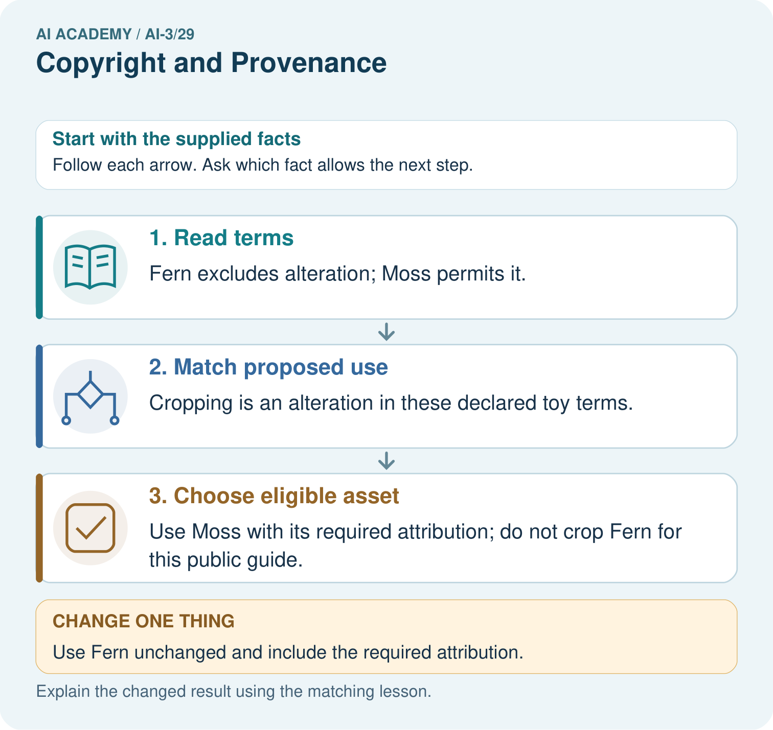

Read the picture one step at a time
Step | What happens and why
1. Read terms | Fern excludes alteration; Moss permits it.
2. Match proposed use | Cropping is an alteration in these declared toy terms.
3. Choose eligible asset | Use Moss with its required attribution; do not crop Fern for this public guide.
Match each pictured step to the supplied facts. This is a worked teaching case, not an independent assessment.

Why this result follows
Read the picture in order. Use Moss with its required attribution; do not crop Fern for this public guide. The arrows show which recorded input or intermediate result each decision uses. Explain the deciding step aloud before checking the changed case; pointing to the final answer alone does not show how it follows.

What this example does not establish
Real permission decisions require the actual licence and use context. These invented terms teach condition matching, not legal advice.

Change one thing in the pictured case
Change: Use Fern unchanged and include the required attribution.
Prediction: That use satisfies the stated fictional permission conditions.
Reason: Its public redistribution is permitted when there is no alteration and attribution is included.

Ask while showing the picture
Cover the result. Ask learners to name the inputs and predict the next step. Uncover one step, connect the icon to the actual procedure, and explain its evidence. Then change the supplied condition and compare. The picture is a representation; it does not document execution of a real AI model.

03. Demonstrate and guide practice

Demonstrate and guide practice

Board sequence
Write the given facts: A slide reuses an online photograph and textbook paragraph.
Write the question to explain: What provenance and reuse checks are needed?
Reveal after predictions: Record creator, source, licence or permission, attribution requirements and modifications. Attribution alone is not permission; classroom context is not a universal exemption.
Keep for an independent attempt: You find an attractive illustration online with no license information. What should you record and check before reusing it in a public project?

Classroom dialogue
Ask: Which facts are given, and which would we have to assume? Learners mark relevant details before discussing answers.
Say: Predict first. Show the rule, information path or calculation that would produce the result. A correct guess is not yet an explanation.
Reveal reasoning one step at a time. Explain why a tempting alternative fails. Write units and denominators for arithmetic, trace conditions for decisions, and identify supporting sources for claims.
In pairs, one learner solves while the other checks evidence; exchange roles. Remove the worked answer before independent assessment.

Model these guided questions
Guided: A is not permitted for this use under L. B is permitted under the supplied M terms with attribution. Keep licence version and provenance. Qualification: Real legal outcomes depend on jurisdiction and facts; supplied licence terms define this classroom exercise, not universal copyright law. Exit: accept a concrete variation with its predicted outcome and a stated condition that would challenge the mechanism; reject a claim resting on unmeasured evidence.

Case-specific teaching sequence
Stage | Teacher action
Session 1: 0–7 minutes | Retrieve the prerequisite; identify the input, procedure and evidence source.
7–18 minutes | Explain section 1 and vocabulary. Complete W1 with a mechanism-based explanation.
18–32 minutes | Trace the declared procedure and worked case. Complete W2, recording intermediate steps.
32–45 minutes | Discuss the diagram with the worked input; use W3 to distinguish measured claims and limitations.
Session 2: 0–8 minutes | Retrieve the worked reasoning and collect the guided response before discussing it.
8–20 minutes | Compare a proposed boundary variant with the original case; identify what remains fixed.
20–35 minutes | Collect W4 independently. Require the procedure trace and the bounded conclusion.
35–45 minutes | Use W5 and exit responses for feedback. Administer the fresh retry after feedback and preserve both attempts.

Reduce help deliberately
Completion task: Image A has L; image B has M. The project is a publicly downloadable adapted poster. Show the intermediate steps and give the conclusion with its scope.
Teacher check: Teacher explanation: A is not permitted for this use under L. B is permitted under the supplied M terms with attribution. Keep licence version and provenance.
Start by identifying the given inputs together. Leave the intermediate steps blank. If needed, model one step, then withdraw that help on the next step. Move to a full trace only when the partial trace is understood. For partners, alternate explainer and checker; collect a response from every learner before discussion.

Individual reasoning check
Use the worked case for Copyright and permitted sources. Proposed explanation: “The worked result establishes every future case”. Decide whether this explanation is supported. Point to the step or supplied fact that decides; explain your repair if needed.
Expected correction: Real legal outcomes depend on jurisdiction and facts; supplied licence terms define this classroom exercise, not universal copyright law.
Collect explanations, not only yes/no votes. If a misunderstanding is common, re-model the relevant step for the class. If it affects a few learners, give a short targeted group explanation while others solve a more demanding variation.

Pictorial practice question
Does acknowledging Fern make a cropped version permitted? Point to the relevant step in the picture, then write the changed result and the rule or evidence that supports it.

Reasoned teacher answer
No. Attribution is one condition; the no-alteration condition still prohibits cropping under these terms. Changed-case check: That use satisfies the stated fictional permission conditions. Its public redistribution is permitted when there is no alteration and attribution is included.
Changed-case reasoning: That use satisfies the stated fictional permission conditions. Its public redistribution is permitted when there is no alteration and attribution is included.
Collect each learner’s explanation before discussion. Use the first missing connection between input, deciding step and result to choose support. This question is worked-case practice, not fresh mastery evidence.

04. Run the weekly evidence lab

Run the weekly evidence lab
Words You Can Use to Reason
A definition matters when you can recognize the idea, use it, and contrast it with a near-miss.
Predict → Test → Record → Explain
Keep expected and actual results separate. Surprises are useful data when recorded honestly.
Inspect a mixed project, classify original/quoted/transformed/generated parts, check permission, and build a complete provenance record.
What did the hardest test teach you that the normal test did not?

Make the lab runnable
Use the concrete case as the shared normal case and the independent question as a second case. Each pair creates a boundary or missing-information case and predicts its result before testing. Keep the expected result separate from an observed mistake.
Record | What to capture
Input or evidence | Exact data, instruction or claim
Expected result | Answer or safe fallback declared before the run
Observed result | Actual result, including errors
Explanation | Rule, calculation or evidence explaining the outcome
Next test | One justified change and a new prediction

Diagnose and reteach
For guessing, return to given facts and request a trace. For vocabulary without application, use one example and one non-example. For arithmetic errors, check the setup before the calculation. Finish with a different uncoached case before recording mastery.

Address these additional misconceptions
The worked result establishes every future case: Real legal outcomes depend on jurisdiction and facts; supplied licence terms define this classroom exercise, not universal copyright law.
A missing input may be replaced without recording the change: A replacement changes the evidence or contract. Record the change and its justification; do not silently turn unknown into a measured value.
Repeating an assessed case is new independent evidence: A replay checks consistency. An example used for feedback or revision cannot later be described as untouched final evaluation.

Match the support to the first error
What the response shows | Next teaching action
Missing or misread facts | Read the case aloud, mark supplied versus unknown facts, and let the learner restate it.
Wrong procedure | Return to the deciding step in the worked case. Contrast it with the proposed incorrect explanation.
Arithmetic or implementation error | Trace intermediate values or lines; preserve the first mismatch and retry that step.
Correct result without a reason | Ask for a trace and a changed case before marking independent understanding.
An unsupported wider claim | Ask which supplied evidence supports the claim and which further observation would be needed.
Offer an oral explanation, drawing, enlarged visual or fewer examples when that removes a reading/writing barrier. Keep the same reasoning goal. Stretch secure learners by changing a boundary or assumption and asking them to defend the effect, not simply by assigning more of the same questions.

05. Assess and explain the answers

Assess and explain the answers

Worked case answer
Record creator, source, licence or permission, attribution requirements and modifications. Attribution alone is not permission; classroom context is not a universal exemption.

Independent question
You find an attractive illustration online with no license information. What should you record and check before reusing it in a public project?

Expected independent answer
Record its source and creator if known, check permission or license terms for the intended reuse, and choose an appropriately licensed alternative if rights remain unclear.

What counts as evidence
Criterion | 0 points | 1 point | 2 points
Result | Incorrect or absent | Partly correct | Correct with necessary conditions
Reasoning | No supporting trace | Some steps | Clear mechanism, calculation or source support
Limit | Overclaims certainty | Vague limitation | Relevant uncertainty or missing fact
Transfer | Copies without adapting | Adapts with prompts | Solves a changed case independently
Use 6/8 as a classroom checkpoint, with 2 required for both Result and Reasoning. This is a proposed teaching rule, not a validated certification threshold. Do not count a coached answer as independent mastery; correct unsafe or unsupported claims regardless of total.

Feedback
Ask the learner to find the evidence that challenges this claim: “Being visible online grants permission for any reuse.” Keep the first attempt and an uncoached retry separate.

Original transfer answer
No. Record creator, source URL, licence or permission evidence, required attribution and modifications. If permission is unclear, use an appropriately licensed alternative or seek guidance from the teacher. Do not assume search visibility or classroom use provides universal permission.

Explanations for the additional workbook examples

W1 Explain the mechanism
Explain the weekly mechanism in your own words. Use the worked scenario to name its input, decision rule and output.
Teacher explanation: Permission to access a work and permission to redistribute or modify it are separate. Use a classroom licence ledger instead of assuming all online material is reusable. For this fictional policy, licence L permits classroom display with attribution but forbids public redistribution. Licence M permits adaptation and redistribution with attribution. Unknown permission means seek approval or choose a permitted alternative; this exercise is not a legal ruling.

W2 Trace the worked case
Image A has L; image B has M. The project is a publicly downloadable adapted poster. Show the intermediate steps and give the conclusion with its scope.
Teacher explanation: A is not permitted for this use under L. B is permitted under the supplied M terms with attribution. Keep licence version and provenance.

W3 Audit the limit
A report omits this qualification: Real legal outcomes depend on jurisdiction and facts; supplied licence terms define this classroom exercise, not universal copyright law. Explain how omitting it could change a reader's interpretation, and write an accurate replacement.
Teacher explanation: Real legal outcomes depend on jurisdiction and facts; supplied licence terms define this classroom exercise, not universal copyright law. State the observed result separately from the unverified or out-of-scope claim; preserve the original evidence rather than inventing a missing fact.

W4 Apply a new case independently
Text C permits internal reading only; D permits public quotation up to 30 words with attribution. Proposed public handout reproduces 40 words. Apply the fictional terms.
Teacher explanation: C lacks public-use permission; 40 exceeds D limit. Revise D quotation to at most 30 words with attribution or obtain permission. Do not infer legal exceptions from this fictional policy.

W5 Design a revealing follow-up
For the worked scenario, propose one additional case that could reveal a failure, describe its expected outcome before running it, and explain what would need to remain fixed for a fair comparison. Do not reuse W4 as a new final test after receiving feedback.
Teacher explanation: Accept a concrete variant of the worked input or a missing/conflicting/boundary condition, with an expectation derived from the declared procedure. Require preserved settings, original outputs and data roles. Real legal outcomes depend on jurisdiction and facts; supplied licence terms define this classroom exercise, not universal copyright law. The new case should test this particular mechanism rather than merely restate the original result.

Assess independent transfer
Selected case: Text C permits internal reading only; D permits public quotation up to 30 words with attribution. Proposed public handout reproduces 40 words. Apply the fictional terms.

Selected case answer
Teacher explanation: C lacks public-use permission; 40 exceeds D limit. Revise D quotation to at most 30 words with attribution or obtain permission. Do not infer legal exceptions from this fictional policy.
Dimension | Evidence required
Explanation | Names the applicable idea or procedure and ties it to the supplied facts.
Trace and result | Preserves the given inputs and shows the relevant intermediate steps; distinguishes a prediction from an observed execution.
Limits | States the assumptions, missing evidence or conditions under which the result would change.
Record each dimension as not yet, with support, or independent. Accept a valid alternative procedure with a defensible trace. Do not penalise an honestly recorded model failure if the learner correctly explains its evidence and limits.

Feedback that the learner uses
Name the earliest unsupported step and give one action to repair it. Have the learner make that repair now and explain why. Then assess the relevant skill on a fresh, fully specified case. Confirm it was not previously practised with feedback; solve and check the new case before assigning it. A follow-up design prompt is a starting brief, not automatically an equivalent test.

06. Connect and extend learning

Connect and extend learning

Verified Study Buddy
Attach citations and provenance metadata to every Study Buddy learning asset.
Keep the decision, input, result, explanation and remaining limitation in the project evidence record. Retrieve this record next week rather than restarting the project.

Support and stretch
Provide one short approved passage; separate instruction, input, output and evidence. Stretch: introduce an unsupported claim or conflicting source and validate claim by claim with a fallback.

Exit reflection
Ask for one decision the learner can now justify and one situation requiring more evidence or human review. Confidence ratings are separate from correct independent performance.

Bridge to the next week
Next: Week 30: Bias and Representation. Retrieve today’s evidence and identify what carries forward and what is new.

Support and fresh reassessment
Provide an input/procedure/result/limit frame and a calculator when needed. Ask students to identify the first step before completing the whole trace. Extension: compare two concrete variants of this mechanism while holding unrelated conditions fixed; report both successful and unsuccessful outcomes.
W4: C lacks public-use permission; 40 exceeds D limit. Revise D quotation to at most 30 words with attribution or obtain permission. Do not infer legal exceptions from this fictional policy. Require intermediate reasoning and the stated scope. Fresh retry: Licence permits 20 attributed words; handout includes 25. Expected reasoning: Reduce to at most 20 or obtain permission under this policy; unknown rights are not assumed granted. If students need support, record it and reassess with another new case rather than awarding independence to a copied answer.
Next connection: Representation and bias evaluation. Preserve the current case record and retrieve its evidence boundary before moving on.

Plan the delayed return
Suggested return points in this level: ai-3/30, ai-3/32, ai-3/35. Use actual classroom dates, adjusting for holidays and gaps. One, three and six teaching weeks are scheduling choices, not a claimed optimal spacing.
At a delayed check, ask for the idea from memory and a changed application. Compare with the earlier independent response and record support used. For a new level, revisit the previous capstone before checking the new prerequisites.
Record | Teacher evidence
Learner code and date
Concept and case used; prior exposure
Explanation / trace / limits
Support and first repair
Changed case and delayed outcome
Next teaching action
Use the evidence to choose reteaching or the next step. A completed page, confidence rating or attractive project does not by itself demonstrate understanding.

Project evidence from this case
For your Verified Study Buddy, save the input, procedure, observed result and limitation of this check. Label this worked example as practice; use a different, previously unreviewed case when checking independent understanding.

