AI ACADEMY · TEACHER · ai-3/30

Bias and Representation
Project: Verified Study Buddy

01. Bias and Representation

Teach the learning cycle
Primary target: Explain the mechanism and terminology of representation and bias evaluation
Session | Sequence and minutes | Resources
Session 1 · Understand · 45 min | 0–7: recall and prerequisite; 7–15: inspect the concrete case and predict; 15–30: teacher models the worked trace; 30–40: learners explain a step using the text and visual; 40–45: check the core idea. | Sections 1–6; record the brief recall in the workbook.
Session 2 · Practise · 45 min | 0–5: retrieve the procedure; 5–15: W2 completion practice; 15–23: explain and check with a partner; 23–30: each learner answers the misconception check; 30–40: targeted reteaching or a harder variation; 40–45: prepare the investigation. | Sections 7–10; use the matching workbook W2 and misconception check.
Session 3 · Investigate and transfer · 45 min | 0–5: retrieve the decision rule; 5–20: investigate or trace; 20–30: start the independent case; 30–38: connect the project; 38–43: act on feedback; 43–45: plan the return check. | Sections 9 and 11–14. Give extra time to finish the full task set; use Section 15 when the week includes a coding lab.
This is a starting allocation of 135 minutes, not a validated duration. Preserve all named topics. Schedule extra time for connected examples, the full investigation, independent cases and project building. Repeated copies of a case share one recorded attempt; they are not new evidence.

Retrieval answer guidance

Copyright and Provenance
Without opening the old lesson, explain one key idea from Copyright and Provenance. Give an example and a mistake that the idea helps you avoid.
Look for: Explain the mechanism and terminology of copyright and permitted sources
Reference example, not the only acceptable wording: Teacher explanation: Permission to access a work and permission to redistribute or modify it are separate. Use a classroom licence ledger instead of assuming all online material is reusable. For this fictional policy, licence L permits classroom display with attribution but forbids public redistribution. Licence M permits adaptation and redistribution with attribution. Unknown permission means seek approval or choose a permitted alternative; this exercise is not a legal ruling.

Red Team the Product
Without opening the old lesson, explain one key idea from Red Team the Product. Give an example and a mistake that the idea helps you avoid.
Look for: Explain the mechanism and terminology of red team exercises
Reference example, not the only acceptable wording: Teacher explanation: Red-team exercises probe explicit failure boundaries in an authorised isolated fixture environment. Their purpose is evidence-based improvement. Use fictional records and allowed test routes. Define a target contract violation, record the exact case, observe action/data traces and preserve a reproducible report. Do not touch external systems.

Prototype a Grounded Assistant
Without opening the old lesson, explain one key idea from Prototype a Grounded Assistant. Give an example and a mistake that the idea helps you avoid.
Look for: Explain the mechanism and terminology of capstone grounded assistant
Reference example, not the only acceptable wording: Teacher explanation: Build the assistant as a sequence of testable stages: validate request, retrieve authorised evidence, decide answerability, draft, validate and return. Avoid merging all errors into one model score. A supported response requires current matching approval and register records. Any retrieval or validation failure gives needs_review with null claims. The classroom implementation performs no booking or external action.
Use the student module and workbook section with this exact week title. The worked case, independent question and answers below form one aligned lesson sequence.

What the learner must demonstrate
An illustration set always shows scientists in the same role and appearance. Define a review that examines representation without inferring personal identities from images.

Concept to explain
Outputs should be tested for omission, stereotyping, and uneven quality.
Term | Meaning
representation | A way to encode information so a person or system can work with it.
stereotype | An oversimplified expectation about members of a group that ignores individual variation.
subgroup quality | Performance measured for a defined subset using stated criteria and denominators.
audit | A systematic examination of records and behaviour against stated checks.

Prepare the class
Use the supplied scenario, student illustrations and blank paper. For numeric work, offer counters or a calculator after learners show the setup. Fictional records are supplied; personal data and paid accounts are unnecessary.
Allow 80 minutes: recall 8; explanation 12; worked demonstration 15; guided practice 20; independent assessment 15; project and reflection 10. Extend the lab into a second session when needed.

Preparation for the connected explanation
Two 45-minute sessions. Bias evaluation tests defined outcomes across relevant conditions. Group averages can expose differences but cannot alone establish their cause or the correct remedy. Use the supplied constructed scenarios to make the mechanism inspectable. Collect W4 before sharing solutions. Students should name intermediate evidence and limitations; classroom pacing and learning effectiveness remain unvalidated.

Readiness answer
A result depends on the inputs, procedure and conditions that produced it. Preserve data roles and distinguish observed outcomes from predictions or unmeasured conditions. If the prior concept cannot be explained, use a short retrieval activity before this chapter.
Lesson and workbook; paper and pencil
Calculator and optional local Python 3 for arithmetic; no live API or private data
Prepare the fresh retry separately and withhold its solution until after collection

End goal for the pictorial case
By the end, I can explain bias and representation using a traced example and a stated limitation.
This added worked case illustrates the week’s main idea. Retain all original and connected topics; schedule its practice within the teaching cycle.

02. Explain the mechanism

Explain the mechanism
Input → Process → Output
Trace the information. At each stage, ask what changed and how you could test it.
Which stage could fail even when the other two are correct? Explain:
Predict first. Then check each step. A correct answer without visible reasoning is incomplete evidence.
1. Generate comparable characters while changing one identity descriptor.
2. Count omissions, stereotyped roles, and quality differences.
3. A balanced count does not alone prove respectful depiction.
4. Repair prompt, data, filters, or use limits, then repeat the fixed audit.
Recalculate, retrace, or restate the reasoning in your own representation:
CHECK Did the evidence answer the exact question? Did the total, path, or source record stay consistent?

Concrete teaching case
Scientist images repeatedly show only one demographic group.
Evaluate and improve representation.

Exact explanation to model
Review relevant representation criteria across outputs, revise inclusive requirements and retest. Appearance alone cannot establish absence of all bias.

Explain the added worked example
Bias evaluation tests defined outcomes across relevant conditions. Group averages can expose differences but cannot alone establish their cause or the correct remedy.
Begin by writing the question the procedure is intended to answer. Identify the information already supplied, the information it will produce and the information still missing. These are constructed classroom examples; they do not require live accounts, private records or an external service. Do not treat a plausible explanation as a measured outcome.
Define the task, relevant groups, labels and denominators before comparing. Use fictional, non-identifying records. Evaluate quality and fallback outcomes separately; preserve sample sizes and unresolved explanations.
Before applying the procedure, write its units, denominator or decision boundary where relevant. A partner should be able to repeat each step using the same inputs. If a required input is absent or violates the stated contract, record that condition explicitly instead of quietly replacing it with a convenient value.

Key terms
Term | Meaning
Subgroup rate | A measured outcome within a stated group
Percentage-point gap | The difference between two percentage rates
Case mix | The distribution of task conditions in a group

Model the reasoning aloud
Use the complete worked example below before asking learners to complete W2. Reveal a small part, invite a prediction, then explain the deciding step. These teacher notes contain solutions; do not reveal the independent case answer during modelling.
A grounded assistant supports 9 of 10 group-A cases and 6 of 10 group-B cases.
Rates 90% and 60%; gap 30 percentage points. Investigate case mix, retrieval coverage and annotation rules before attributing cause.
Compare the intermediate evidence with the final statement. Explain why each number or decision follows from the stated inputs. The conclusion belongs to this scenario and procedure; changing the inputs, evaluation population or authority can change what it establishes. Retain the raw record so a later revision can be compared honestly.
Thinking move | Teacher prompt
Plan | What is given? What is the question? Which procedure fits these facts?
Do | Point to each input and intermediate step in the worked trace. Name the rule that allows the next step.
Check | Does the output answer the question? Which assumption or limitation prevents a larger claim?
Use the diagram and verbal explanation together. Ask learners to match a sentence to a specific visual step; do not assign learners fixed visual or auditory learning styles.

A pictorial worked case: Bias and Representation
Compare study-answer support rates when groups have different numbers of questions.

The facts we will use
Group Birch has 6 supported answers in 8 cases; group Pine has 9 supported answers in 12 cases. Both groups use the same support rubric.
All inputs and outcomes in this worked example are invented classroom data; no real model run is claimed.
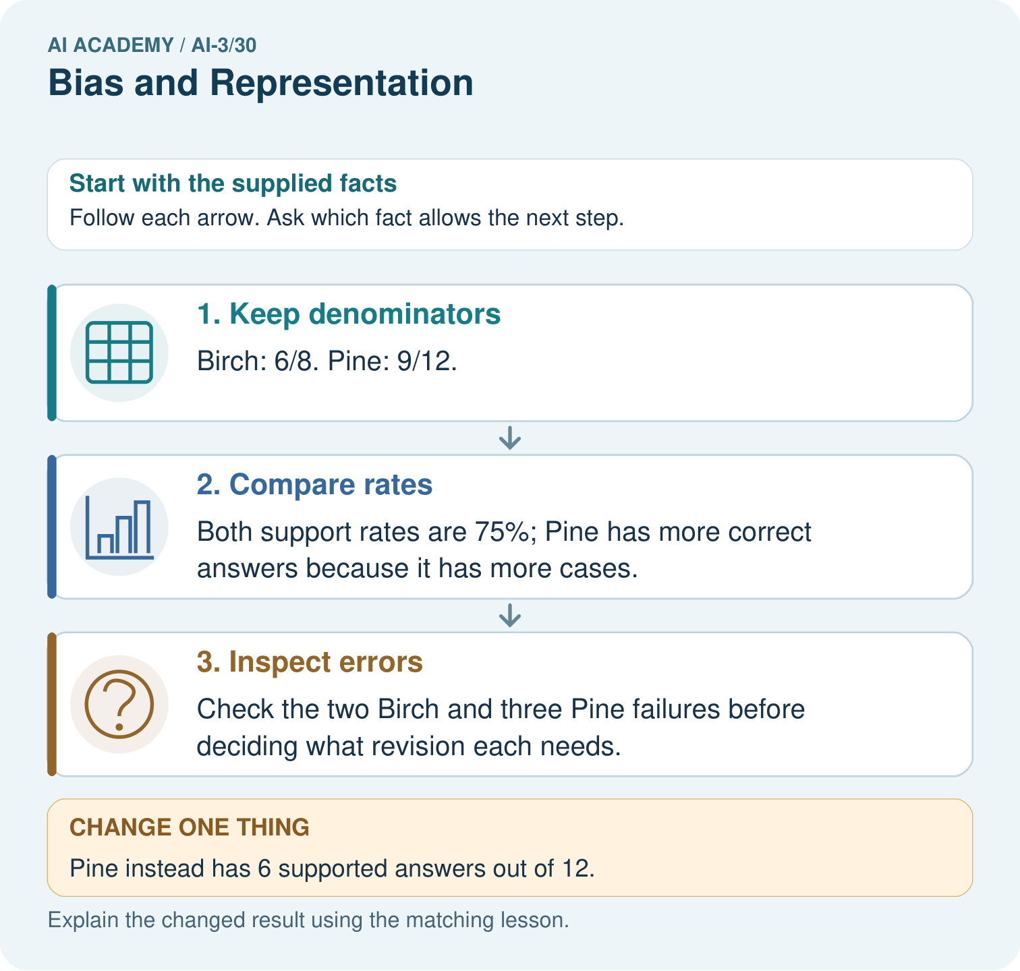

Read the picture one step at a time
Step | What happens and why
1. Keep denominators | Birch: 6/8. Pine: 9/12.
2. Compare rates | Both support rates are 75%; Pine has more correct answers because it has more cases.
3. Inspect errors | Check the two Birch and three Pine failures before deciding what revision each needs.
Match each pictured step to the supplied facts. This is a worked teaching case, not an independent assessment.

Why this result follows
Read the picture in order. Check the two Birch and three Pine failures before deciding what revision each needs. The arrows show which recorded input or intermediate result each decision uses. Explain the deciding step aloud before checking the changed case; pointing to the final answer alone does not show how it follows.

What this example does not establish
These groups are fictional; small samples and unmatched question difficulty limit conclusions about fairness.

Change one thing in the pictured case
Change: Pine instead has 6 supported answers out of 12.
Prediction: Pine is 50%, which is 25 percentage points below Birch.
Reason: Equal correct counts do not imply equal rates when denominators differ.

Ask while showing the picture
Cover the result. Ask learners to name the inputs and predict the next step. Uncover one step, connect the icon to the actual procedure, and explain its evidence. Then change the supplied condition and compare. The picture is a representation; it does not document execution of a real AI model.

03. Demonstrate and guide practice

Demonstrate and guide practice

Board sequence
Write the given facts: Scientist images repeatedly show only one demographic group.
Write the question to explain: Evaluate and improve representation.
Reveal after predictions: Review relevant representation criteria across outputs, revise inclusive requirements and retest. Appearance alone cannot establish absence of all bias.
Keep for an independent attempt: An assistant is tested on six fluent requests but no requests with spelling errors. What gap does this leave, and how should the evaluation expand?

Classroom dialogue
Ask: Which facts are given, and which would we have to assume? Learners mark relevant details before discussing answers.
Say: Predict first. Show the rule, information path or calculation that would produce the result. A correct guess is not yet an explanation.
Reveal reasoning one step at a time. Explain why a tempting alternative fails. Write units and denominators for arithmetic, trace conditions for decisions, and identify supporting sources for claims.
In pairs, one learner solves while the other checks evidence; exchange roles. Remove the worked answer before independent assessment.

Model these guided questions
Guided: Rates 90% and 60%; gap 30 percentage points. Investigate case mix, retrieval coverage and annotation rules before attributing cause. Qualification: Group comparisons require task relevance and appropriate data governance; differences alone do not identify a causal mechanism. Exit: accept a concrete variation with its predicted outcome and a stated condition that would challenge the mechanism; reject a claim resting on unmeasured evidence.

Case-specific teaching sequence
Stage | Teacher action
Session 1: 0–7 minutes | Retrieve the prerequisite; identify the input, procedure and evidence source.
7–18 minutes | Explain section 1 and vocabulary. Complete W1 with a mechanism-based explanation.
18–32 minutes | Trace the declared procedure and worked case. Complete W2, recording intermediate steps.
32–45 minutes | Discuss the diagram with the worked input; use W3 to distinguish measured claims and limitations.
Session 2: 0–8 minutes | Retrieve the worked reasoning and collect the guided response before discussing it.
8–20 minutes | Compare a proposed boundary variant with the original case; identify what remains fixed.
20–35 minutes | Collect W4 independently. Require the procedure trace and the bounded conclusion.
35–45 minutes | Use W5 and exit responses for feedback. Administer the fresh retry after feedback and preserve both attempts.

Reduce help deliberately
Completion task: A grounded assistant supports 9 of 10 group-A cases and 6 of 10 group-B cases. Show the intermediate steps and give the conclusion with its scope.
Teacher check: Teacher explanation: Rates 90% and 60%; gap 30 percentage points. Investigate case mix, retrieval coverage and annotation rules before attributing cause.
Start by identifying the given inputs together. Leave the intermediate steps blank. If needed, model one step, then withdraw that help on the next step. Move to a full trace only when the partial trace is understood. For partners, alternate explainer and checker; collect a response from every learner before discussion.

Individual reasoning check
Use the worked case for Representation and bias evaluation. Proposed explanation: “The worked result establishes every future case”. Decide whether this explanation is supported. Point to the step or supplied fact that decides; explain your repair if needed.
Expected correction: Group comparisons require task relevance and appropriate data governance; differences alone do not identify a causal mechanism.
Collect explanations, not only yes/no votes. If a misunderstanding is common, re-model the relevant step for the class. If it affects a few learners, give a short targeted group explanation while others solve a more demanding variation.

Pictorial practice question
Explain why comparing six correct answers in each group would mislead. Point to the relevant step in the picture, then write the changed result and the rule or evidence that supports it.

Reasoned teacher answer
Birch has 6/8=75%; changed Pine has 6/12=50%. Counts must be paired with the number of opportunities. Changed-case check: Pine is 50%, which is 25 percentage points below Birch. Equal correct counts do not imply equal rates when denominators differ.
Changed-case reasoning: Pine is 50%, which is 25 percentage points below Birch. Equal correct counts do not imply equal rates when denominators differ.
Collect each learner’s explanation before discussion. Use the first missing connection between input, deciding step and result to choose support. This question is worked-case practice, not fresh mastery evidence.

04. Run the weekly evidence lab

Run the weekly evidence lab
Words You Can Use to Reason
A definition matters when you can recognize the idea, use it, and contrast it with a near-miss.
Predict → Test → Record → Explain
Keep expected and actual results separate. Surprises are useful data when recorded honestly.
Create paired prompts, score quality and stereotypes, compare patterns, and propose one controlled mitigation with retest.
What did the hardest test teach you that the normal test did not?

Make the lab runnable
Use the concrete case as the shared normal case and the independent question as a second case. Each pair creates a boundary or missing-information case and predicts its result before testing. Keep the expected result separate from an observed mistake.
Record | What to capture
Input or evidence | Exact data, instruction or claim
Expected result | Answer or safe fallback declared before the run
Observed result | Actual result, including errors
Explanation | Rule, calculation or evidence explaining the outcome
Next test | One justified change and a new prediction

Diagnose and reteach
For guessing, return to given facts and request a trace. For vocabulary without application, use one example and one non-example. For arithmetic errors, check the setup before the calculation. Finish with a different uncoached case before recording mastery.

Address these additional misconceptions
The worked result establishes every future case: Group comparisons require task relevance and appropriate data governance; differences alone do not identify a causal mechanism.
A missing input may be replaced without recording the change: A replacement changes the evidence or contract. Record the change and its justification; do not silently turn unknown into a measured value.
Repeating an assessed case is new independent evidence: A replay checks consistency. An example used for feedback or revision cannot later be described as untouched final evaluation.

Match the support to the first error
What the response shows | Next teaching action
Missing or misread facts | Read the case aloud, mark supplied versus unknown facts, and let the learner restate it.
Wrong procedure | Return to the deciding step in the worked case. Contrast it with the proposed incorrect explanation.
Arithmetic or implementation error | Trace intermediate values or lines; preserve the first mismatch and retry that step.
Correct result without a reason | Ask for a trace and a changed case before marking independent understanding.
An unsupported wider claim | Ask which supplied evidence supports the claim and which further observation would be needed.
Offer an oral explanation, drawing, enlarged visual or fewer examples when that removes a reading/writing barrier. Keep the same reasoning goal. Stretch secure learners by changing a boundary or assumption and asking them to defend the effect, not simply by assigning more of the same questions.

05. Assess and explain the answers

Assess and explain the answers

Worked case answer
Review relevant representation criteria across outputs, revise inclusive requirements and retest. Appearance alone cannot establish absence of all bias.

Independent question
An assistant is tested on six fluent requests but no requests with spelling errors. What gap does this leave, and how should the evaluation expand?

Expected independent answer
It cannot support claims about performance on spelling-error requests. Add representative examples and compare outcomes, without treating spelling as evidence of ability.

What counts as evidence
Criterion | 0 points | 1 point | 2 points
Result | Incorrect or absent | Partly correct | Correct with necessary conditions
Reasoning | No supporting trace | Some steps | Clear mechanism, calculation or source support
Limit | Overclaims certainty | Vague limitation | Relevant uncertainty or missing fact
Transfer | Copies without adapting | Adapts with prompts | Solves a changed case independently
Use 6/8 as a classroom checkpoint, with 2 required for both Result and Reasoning. This is a proposed teaching rule, not a validated certification threshold. Do not count a coached answer as independent mastery; correct unsafe or unsupported claims regardless of total.

Feedback
Ask the learner to find the evidence that challenges this claim: “Strong results for one language style prove equal performance for all learners.” Keep the first attempt and an uncoached retry separate.

Original transfer answer
Review varied roles, activities and stated representation goals across outputs, avoiding assumptions about hidden identities. Revise requirements and retest. Visual variety alone does not prove absence of all bias; discuss who may still be missing and why.

Explanations for the additional workbook examples

W1 Explain the mechanism
Explain the weekly mechanism in your own words. Use the worked scenario to name its input, decision rule and output.
Teacher explanation: Bias evaluation tests defined outcomes across relevant conditions. Group averages can expose differences but cannot alone establish their cause or the correct remedy. Define the task, relevant groups, labels and denominators before comparing. Use fictional, non-identifying records. Evaluate quality and fallback outcomes separately; preserve sample sizes and unresolved explanations.

W2 Trace the worked case
A grounded assistant supports 9 of 10 group-A cases and 6 of 10 group-B cases. Show the intermediate steps and give the conclusion with its scope.
Teacher explanation: Rates 90% and 60%; gap 30 percentage points. Investigate case mix, retrieval coverage and annotation rules before attributing cause.

W3 Audit the limit
A report omits this qualification: Group comparisons require task relevance and appropriate data governance; differences alone do not identify a causal mechanism. Explain how omitting it could change a reader's interpretation, and write an accurate replacement.
Teacher explanation: Group comparisons require task relevance and appropriate data governance; differences alone do not identify a causal mechanism. State the observed result separately from the unverified or out-of-scope claim; preserve the original evidence rather than inventing a missing fact.

W4 Apply a new case independently
Group C has 8 supported answers out of 10; D has 9 out of 15. Compute rates and difference; explain why raw correct totals mislead.
Teacher explanation: C=80%, D=60%; gap 20 percentage points. D has more supported answers in count but lower rate. No causal explanation follows from the counts.

W5 Design a revealing follow-up
For the worked scenario, propose one additional case that could reveal a failure, describe its expected outcome before running it, and explain what would need to remain fixed for a fair comparison. Do not reuse W4 as a new final test after receiving feedback.
Teacher explanation: Accept a concrete variant of the worked input or a missing/conflicting/boundary condition, with an expectation derived from the declared procedure. Require preserved settings, original outputs and data roles. Group comparisons require task relevance and appropriate data governance; differences alone do not identify a causal mechanism. The new case should test this particular mechanism rather than merely restate the original result.

Assess independent transfer
Selected case: Group C has 8 supported answers out of 10; D has 9 out of 15. Compute rates and difference; explain why raw correct totals mislead.

Selected case answer
Teacher explanation: C=80%, D=60%; gap 20 percentage points. D has more supported answers in count but lower rate. No causal explanation follows from the counts.
Dimension | Evidence required
Explanation | Names the applicable idea or procedure and ties it to the supplied facts.
Trace and result | Preserves the given inputs and shows the relevant intermediate steps; distinguishes a prediction from an observed execution.
Limits | States the assumptions, missing evidence or conditions under which the result would change.
Record each dimension as not yet, with support, or independent. Accept a valid alternative procedure with a defensible trace. Do not penalise an honestly recorded model failure if the learner correctly explains its evidence and limits.

Feedback that the learner uses
Name the earliest unsupported step and give one action to repair it. Have the learner make that repair now and explain why. Then assess the relevant skill on a fresh, fully specified case. Confirm it was not previously practised with feedback; solve and check the new case before assigning it. A follow-up design prompt is a starting brief, not automatically an equivalent test.

06. Connect and extend learning

Connect and extend learning

Verified Study Buddy
Audit answer quality across reading levels, languages, names, and accessibility needs.
Keep the decision, input, result, explanation and remaining limitation in the project evidence record. Retrieve this record next week rather than restarting the project.

Support and stretch
Provide one short approved passage; separate instruction, input, output and evidence. Stretch: introduce an unsupported claim or conflicting source and validate claim by claim with a fallback.

Exit reflection
Ask for one decision the learner can now justify and one situation requiring more evidence or human review. Confidence ratings are separate from correct independent performance.

Bridge to the next week
Next: Week 31: Safety Boundaries. Retrieve today’s evidence and identify what carries forward and what is new.

Support and fresh reassessment
Provide an input/procedure/result/limit frame and a calculator when needed. Ask students to identify the first step before completing the whole trace. Extension: compare two concrete variants of this mechanism while holding unrelated conditions fixed; report both successful and unsuccessful outcomes.
W4: C=80%, D=60%; gap 20 percentage points. D has more supported answers in count but lower rate. No causal explanation follows from the counts. Require intermediate reasoning and the stated scope. Fresh retry: Group E=12/15, F=7/10. Expected reasoning: 80% versus 70%, gap 10 percentage points; small constructed samples and possible case differences limit conclusions. If students need support, record it and reassess with another new case rather than awarding independence to a copied answer.
Next connection: Human review and consequential use. Preserve the current case record and retrieve its evidence boundary before moving on.

Plan the delayed return
Suggested return points in this level: ai-3/31, ai-3/33, ai-3/36. Use actual classroom dates, adjusting for holidays and gaps. One, three and six teaching weeks are scheduling choices, not a claimed optimal spacing.
At a delayed check, ask for the idea from memory and a changed application. Compare with the earlier independent response and record support used. For a new level, revisit the previous capstone before checking the new prerequisites.
Record | Teacher evidence
Learner code and date
Concept and case used; prior exposure
Explanation / trace / limits
Support and first repair
Changed case and delayed outcome
Next teaching action
Use the evidence to choose reteaching or the next step. A completed page, confidence rating or attractive project does not by itself demonstrate understanding.

Project evidence from this case
For your Verified Study Buddy, save the input, procedure, observed result and limitation of this check. Label this worked example as practice; use a different, previously unreviewed case when checking independent understanding.

