AI ACADEMY · TEACHER · ai-3/36

Creator Defense
Project: Verified Study Buddy

01. Creator Defense

Teach the learning cycle
Primary target: Explain the mechanism and terminology of generative systems defense
Session | Sequence and minutes | Resources
Session 1 · Understand · 45 min | 0–7: recall and prerequisite; 7–15: inspect the concrete case and predict; 15–30: teacher models the worked trace; 30–40: learners explain a step using the text and visual; 40–45: check the core idea. | Sections 1–6; record the brief recall in the workbook.
Session 2 · Practise · 45 min | 0–5: retrieve the procedure; 5–15: W2 completion practice; 15–23: explain and check with a partner; 23–30: each learner answers the misconception check; 30–40: targeted reteaching or a harder variation; 40–45: prepare the investigation. | Sections 7–10; use the matching workbook W2 and misconception check.
Session 3 · Investigate and transfer · 45 min | 0–5: retrieve the decision rule; 5–20: investigate or trace; 20–30: start the independent case; 30–38: connect the project; 38–43: act on feedback; 43–45: plan the return check. | Sections 9 and 11–14. Give extra time to finish the full task set; use Section 15 when the week includes a coding lab.
This is a starting allocation of 135 minutes, not a validated duration. Preserve all named topics. Schedule extra time for connected examples, the full investigation, independent cases and project building. Repeated copies of a case share one recorded attempt; they are not new evidence.

Retrieval answer guidance

Capstone Evaluate and Improve
Without opening the old lesson, explain one key idea from Capstone Evaluate and Improve. Give an example and a mistake that the idea helps you avoid.
Look for: Explain the mechanism and terminology of capstone evaluation and revision
Reference example, not the only acceptable wording: Teacher explanation: Capstone evaluation compares the frozen assistant with a baseline on reserved cases and preserves failures. Revision uses observed errors but needs fresh evidence for new final claims. Report paired case outcomes, condition rates and permission violations separately. A critical access failure can block release even when overall pass rate rises. Never overwrite the original final run.

Capstone Design
Without opening the old lesson, explain one key idea from Capstone Design. Give an example and a mistake that the idea helps you avoid.
Look for: Explain the mechanism and terminology of capstone requirements and corpus
Reference example, not the only acceptable wording: Teacher explanation: A grounded-assistant capstone begins with bounded requirements and a versioned permitted corpus. A baseline can be a manual lookup process using the same evidence. Specify the user question, source authority, access, output/fallback contract and evaluation plan. Freeze corpus IDs and split cases before implementation. Keep teacher material out of student retrieval.

Bias and Representation
Without opening the old lesson, explain one key idea from Bias and Representation. Give an example and a mistake that the idea helps you avoid.
Look for: Explain the mechanism and terminology of representation and bias evaluation
Reference example, not the only acceptable wording: Teacher explanation: Bias evaluation tests defined outcomes across relevant conditions. Group averages can expose differences but cannot alone establish their cause or the correct remedy. Define the task, relevant groups, labels and denominators before comparing. Use fictional, non-identifying records. Evaluate quality and fallback outcomes separately; preserve sample sizes and unresolved explanations.
Use the student module and workbook section with this exact week title. The worked case, independent question and answers below form one aligned lesson sequence.

What the learner must demonstrate
Your assistant passes 9/12 final questions, including all six direct facts but only 3/6 ambiguous or absent-evidence cases. Report results and argue for a focused next step.

Concept to explain
A creator explains architecture, evidence, limitations, provenance, and responsible use.
Term | Meaning
defense | An explanation of a project decision supported by evidence and an account of its limitations.
architecture | The arrangement of a system's parts and the connections between them.
limitation | A condition or missing capability that restricts what a result can establish or a system can safely do.
transfer test | A fresh task that checks whether learning can be applied without the original supports.

Prepare the class
Use the supplied scenario, student illustrations and blank paper. For numeric work, offer counters or a calculator after learners show the setup. Fictional records are supplied; personal data and paid accounts are unnecessary.
Allow 80 minutes: recall 8; explanation 12; worked demonstration 15; guided practice 20; independent assessment 15; project and reflection 10. Extend the lab into a second session when needed.

Preparation for the connected explanation
Two 45-minute sessions. A generative-system defense presents the question, architecture, corpus, permissions, baseline, evaluation and unresolved failures. Demonstration fluency is only one observable property. Use the supplied constructed scenarios to make the mechanism inspectable. Collect W4 before sharing solutions. Students should name intermediate evidence and limitations; classroom pacing and learning effectiveness remain unvalidated.

Readiness answer
A result depends on the inputs, procedure and conditions that produced it. Preserve data roles and distinguish observed outcomes from predictions or unmeasured conditions. If the prior concept cannot be explained, use a short retrieval activity before this chapter.
Lesson and workbook; paper and pencil
Calculator and optional local Python 3 for arithmetic; no live API or private data
Prepare the fresh retry separately and withhold its solution until after collection

End goal for the pictorial case
By the end, I can explain creator defense using a traced example and a stated limitation.
This added worked case illustrates the week’s main idea. Retain all original and connected topics; schedule its practice within the teaching cycle.

02. Explain the mechanism

Explain the mechanism
Input → Process → Output
Trace the information. At each stage, ask what changed and how you could test it.
Which stage could fail even when the other two are correct? Explain:
Predict first. Then check each step. A correct answer without visible reasoning is incomplete evidence.
1. Trace one question through retrieval, generation, validation, and citation.
2. Recompute one evaluation score and show source support.
3. Run an unseen missing-source or conflicting-source case.
4. State intended use, do-not-use case, privacy/provenance controls, and human responsibility.
Recalculate, retrace, or restate the reasoning in your own representation:
CHECK Did the evidence answer the exact question? Did the total, path, or source record stay consistent?

Concrete teaching case
Ten successful demos lead to a never hallucinates claim.
Write a defensible conclusion.

Exact explanation to model
Report those ten specified passes, show evidence and fallback, and state untested conditions. Demonstrate an unanswerable question.

Explain the added worked example
A generative-system defense presents the question, architecture, corpus, permissions, baseline, evaluation and unresolved failures. Demonstration fluency is only one observable property.
Begin by writing the question the procedure is intended to answer. Identify the information already supplied, the information it will produce and the information still missing. These are constructed classroom examples; they do not require live accounts, private records or an external service. Do not treat a plausible explanation as a measured outcome.
Link each claim to a recorded result. State the distinction between retrieval relevance, claim support, fallback and permissions. Give a reproduction packet and answer challenges without inventing missing measurements.
Before applying the procedure, write its units, denominator or decision boundary where relevant. A partner should be able to repeat each step using the same inputs. If a required input is absent or violates the stated contract, record that condition explicitly instead of quietly replacing it with a convenient value.

Key terms
Term | Meaning
Defense claim | A statement tied to inspectable project evidence
Reproduction packet | Artifacts needed to repeat a reported procedure
Unmeasured outcome | A property for which the experiment supplies no observation

Model the reasoning aloud
Use the complete worked example below before asking learners to complete W2. Reveal a small part, invite a prediction, then explain the deciding step. These teacher notes contain solutions; do not reveal the independent case answer during modelling.
System reports 9/10 retrieved relevant records, 7/10 supported answers and zero actions in a read-only run. Presenter claims 90% fully correct and faster than baseline.
Retrieval rate 90% and support rate 70% differ. Action trace supports zero actions in that run; no timing evidence supports speed. Correct the full-correctness and speed claims.
Compare the intermediate evidence with the final statement. Explain why each number or decision follows from the stated inputs. The conclusion belongs to this scenario and procedure; changing the inputs, evaluation population or authority can change what it establishes. Retain the raw record so a later revision can be compared honestly.
Thinking move | Teacher prompt
Plan | What is given? What is the question? Which procedure fits these facts?
Do | Point to each input and intermediate step in the worked trace. Name the rule that allows the next step.
Check | Does the output answer the question? Which assumption or limitation prevents a larger claim?
Use the diagram and verbal explanation together. Ask learners to match a sentence to a specific visual step; do not assign learners fixed visual or auditory learning styles.

A pictorial worked case: Creator Defense
Defend a study-buddy project using separate claims and matching evidence.

The facts we will use
Set A: 15 answerable questions, with 12 relevant retrievals and 9 supported answers. Separate set B: 5 missing-source questions, with 4 appropriate fallbacks. No speed measurements exist.
All inputs and outcomes in this worked example are invented classroom data; no real model run is claimed.
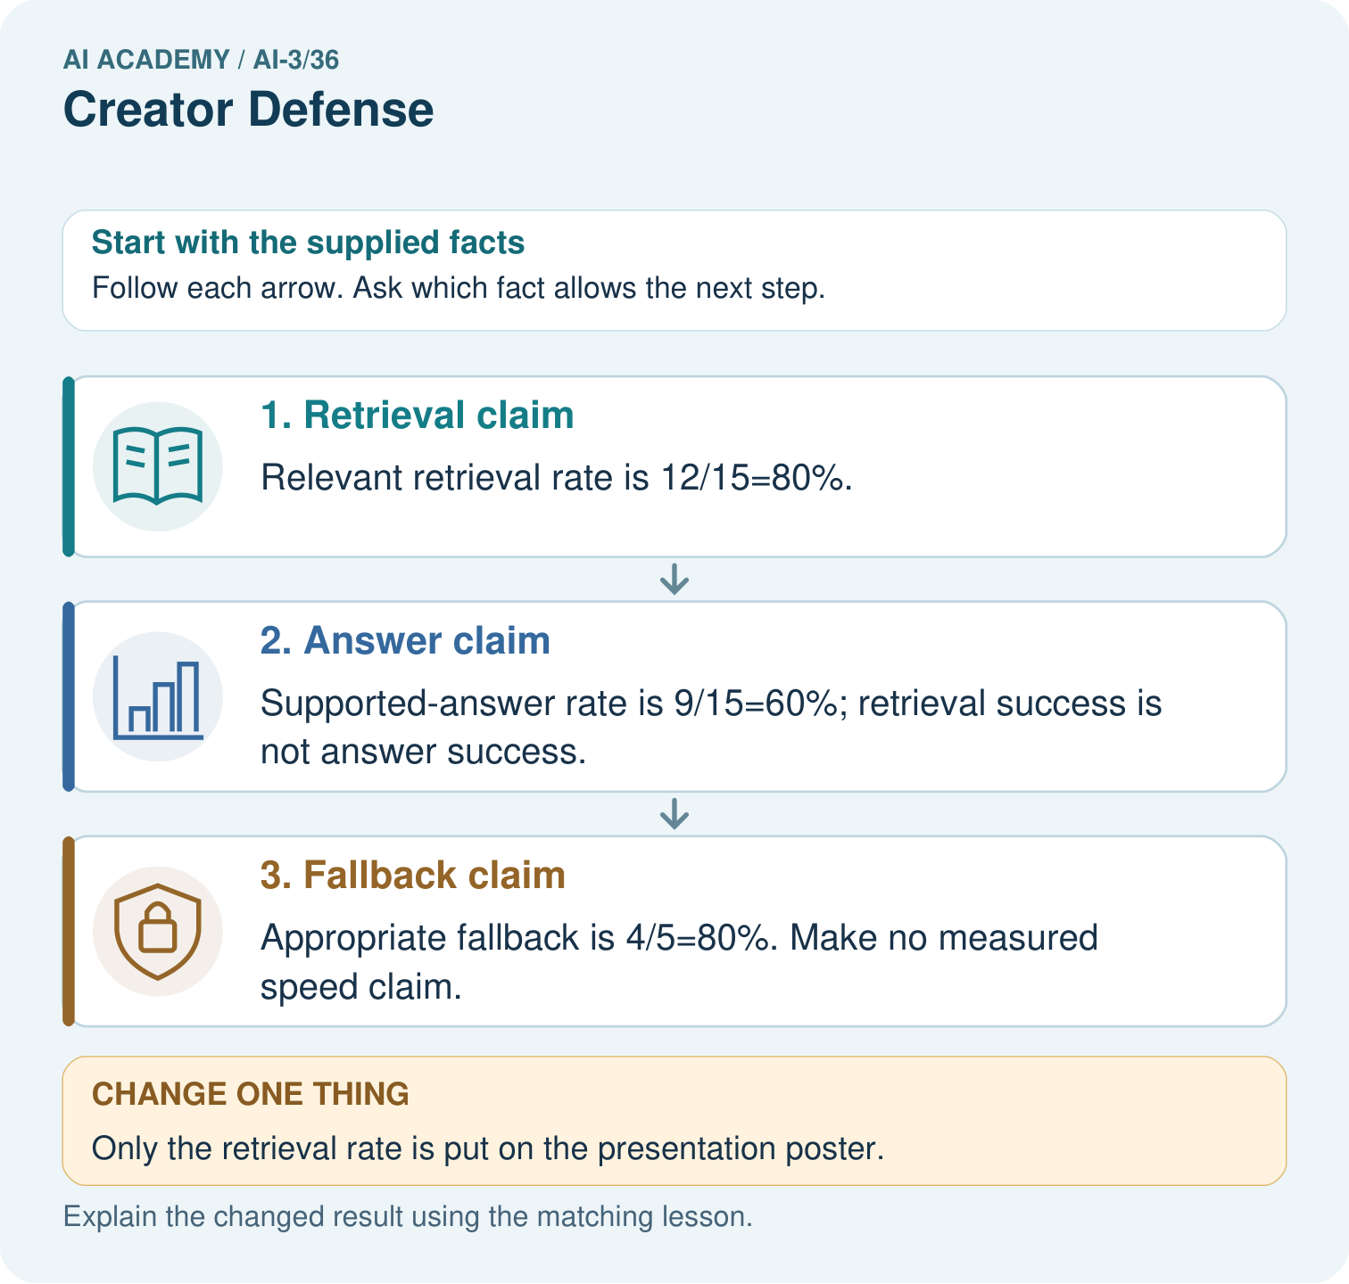

Read the picture one step at a time
Step | What happens and why
1. Retrieval claim | Relevant retrieval rate is 12/15=80%.
2. Answer claim | Supported-answer rate is 9/15=60%; retrieval success is not answer success.
3. Fallback claim | Appropriate fallback is 4/5=80%. Make no measured speed claim.
Match each pictured step to the supplied facts. This is a worked teaching case, not an independent assessment.

Why this result follows
Read the picture in order. Appropriate fallback is 4/5=80%. Make no measured speed claim. The arrows show which recorded input or intermediate result each decision uses. Explain the deciding step aloud before checking the changed case; pointing to the final answer alone does not show how it follows.

What this example does not establish
These invented counts illustrate defense structure; the class must replace them with its own documented evidence.

Change one thing in the pictured case
Change: Only the retrieval rate is put on the presentation poster.
Prediction: The poster omits the lower supported-answer rate and cannot imply 80% fully correct answers.
Reason: Retrieving useful evidence is an intermediate step, not proof that the final answer uses it correctly.

Ask while showing the picture
Cover the result. Ask learners to name the inputs and predict the next step. Uncover one step, connect the icon to the actual procedure, and explain its evidence. Then change the supplied condition and compare. The picture is a representation; it does not document execution of a real AI model.

03. Demonstrate and guide practice

Demonstrate and guide practice

Board sequence
Write the given facts: Ten successful demos lead to a never hallucinates claim.
Write the question to explain: Write a defensible conclusion.
Reveal after predictions: Report those ten specified passes, show evidence and fallback, and state untested conditions. Demonstrate an unanswerable question.
Keep for an independent attempt: An audience asks whether your assistant is always correct. Give an evidence-based defense using results and a limit.

Classroom dialogue
Ask: Which facts are given, and which would we have to assume? Learners mark relevant details before discussing answers.
Say: Predict first. Show the rule, information path or calculation that would produce the result. A correct guess is not yet an explanation.
Reveal reasoning one step at a time. Explain why a tempting alternative fails. Write units and denominators for arithmetic, trace conditions for decisions, and identify supporting sources for claims.
In pairs, one learner solves while the other checks evidence; exchange roles. Remove the worked answer before independent assessment.

Model these guided questions
Guided: Retrieval rate 90% and support rate 70% differ. Action trace supports zero actions in that run; no timing evidence supports speed. Correct the full-correctness and speed claims. Qualification: A defense should preserve negative evidence and uncertainty rather than treating polished presentation as proof. Exit: accept a concrete variation with its predicted outcome and a stated condition that would challenge the mechanism; reject a claim resting on unmeasured evidence.

Case-specific teaching sequence
Stage | Teacher action
Session 1: 0–7 minutes | Retrieve the prerequisite; identify the input, procedure and evidence source.
7–18 minutes | Explain section 1 and vocabulary. Complete W1 with a mechanism-based explanation.
18–32 minutes | Trace the declared procedure and worked case. Complete W2, recording intermediate steps.
32–45 minutes | Discuss the diagram with the worked input; use W3 to distinguish measured claims and limitations.
Session 2: 0–8 minutes | Retrieve the worked reasoning and collect the guided response before discussing it.
8–20 minutes | Compare a proposed boundary variant with the original case; identify what remains fixed.
20–35 minutes | Collect W4 independently. Require the procedure trace and the bounded conclusion.
35–45 minutes | Use W5 and exit responses for feedback. Administer the fresh retry after feedback and preserve both attempts.

Reduce help deliberately
Completion task: System reports 9/10 retrieved relevant records, 7/10 supported answers and zero actions in a read-only run. Presenter claims 90% fully correct and faster than baseline. Show the intermediate steps and give the conclusion with its scope.
Teacher check: Teacher explanation: Retrieval rate 90% and support rate 70% differ. Action trace supports zero actions in that run; no timing evidence supports speed. Correct the full-correctness and speed claims.
Start by identifying the given inputs together. Leave the intermediate steps blank. If needed, model one step, then withdraw that help on the next step. Move to a full trace only when the partial trace is understood. For partners, alternate explainer and checker; collect a response from every learner before discussion.

Individual reasoning check
Use the worked case for Generative systems defense. Proposed explanation: “The worked result establishes every future case”. Decide whether this explanation is supported. Point to the step or supplied fact that decides; explain your repair if needed.
Expected correction: A defense should preserve negative evidence and uncertainty rather than treating polished presentation as proof.
Collect explanations, not only yes/no votes. If a misunderstanding is common, re-model the relevant step for the class. If it affects a few learners, give a short targeted group explanation while others solve a more demanding variation.

Pictorial practice question
Which numbers would you display to make the defense honest? Point to the relevant step in the picture, then write the changed result and the rule or evidence that supports it.

Reasoned teacher answer
Display 12/15 retrieval, 9/15 support and 4/5 fallback with separate set A and set B definitions; say speed was not measured. Changed-case check: The poster omits the lower supported-answer rate and cannot imply 80% fully correct answers. Retrieving useful evidence is an intermediate step, not proof that the final answer uses it correctly.
Changed-case reasoning: The poster omits the lower supported-answer rate and cannot imply 80% fully correct answers. Retrieving useful evidence is an intermediate step, not proof that the final answer uses it correctly.
Collect each learner’s explanation before discussion. Use the first missing connection between input, deciding step and result to choose support. This question is worked-case practice, not fresh mastery evidence.

04. Run the weekly evidence lab

Run the weekly evidence lab
Words You Can Use to Reason
A definition matters when you can recognize the idea, use it, and contrast it with a near-miss.
Predict → Test → Record → Explain
Keep expected and actual results separate. Surprises are useful data when recorded honestly.
Present architecture and evidence bundle, accept a fresh case, explain a failure without hiding it, and defend one tradeoff.
What did the hardest test teach you that the normal test did not?

Make the lab runnable
Use the concrete case as the shared normal case and the independent question as a second case. Each pair creates a boundary or missing-information case and predicts its result before testing. Keep the expected result separate from an observed mistake.
Record | What to capture
Input or evidence | Exact data, instruction or claim
Expected result | Answer or safe fallback declared before the run
Observed result | Actual result, including errors
Explanation | Rule, calculation or evidence explaining the outcome
Next test | One justified change and a new prediction

Diagnose and reteach
For guessing, return to given facts and request a trace. For vocabulary without application, use one example and one non-example. For arithmetic errors, check the setup before the calculation. Finish with a different uncoached case before recording mastery.

Address these additional misconceptions
The worked result establishes every future case: A defense should preserve negative evidence and uncertainty rather than treating polished presentation as proof.
A missing input may be replaced without recording the change: A replacement changes the evidence or contract. Record the change and its justification; do not silently turn unknown into a measured value.
Repeating an assessed case is new independent evidence: A replay checks consistency. An example used for feedback or revision cannot later be described as untouched final evaluation.

Match the support to the first error
What the response shows | Next teaching action
Missing or misread facts | Read the case aloud, mark supplied versus unknown facts, and let the learner restate it.
Wrong procedure | Return to the deciding step in the worked case. Contrast it with the proposed incorrect explanation.
Arithmetic or implementation error | Trace intermediate values or lines; preserve the first mismatch and retry that step.
Correct result without a reason | Ask for a trace and a changed case before marking independent understanding.
An unsupported wider claim | Ask which supplied evidence supports the claim and which further observation would be needed.
Offer an oral explanation, drawing, enlarged visual or fewer examples when that removes a reading/writing barrier. Keep the same reasoning goal. Stretch secure learners by changing a boundary or assumption and asking them to defend the effect, not simply by assigning more of the same questions.

05. Assess and explain the answers

Assess and explain the answers

Worked case answer
Report those ten specified passes, show evidence and fallback, and state untested conditions. Demonstrate an unanswerable question.

Independent question
An audience asks whether your assistant is always correct. Give an evidence-based defense using results and a limit.

Expected independent answer
Describe the evaluation tasks, results, failures and revisions; explain the source boundary and remaining uncertainty. Do not claim universal correctness from a limited test.

What counts as evidence
Criterion | 0 points | 1 point | 2 points
Result | Incorrect or absent | Partly correct | Correct with necessary conditions
Reasoning | No supporting trace | Some steps | Clear mechanism, calculation or source support
Limit | Overclaims certainty | Vague limitation | Relevant uncertainty or missing fact
Transfer | Copies without adapting | Adapts with prompts | Solves a changed case independently
Use 6/8 as a classroom checkpoint, with 2 required for both Result and Reasoning. This is a proposed teaching rule, not a validated certification threshold. Do not count a coached answer as independent mastery; correct unsafe or unsupported claims regardless of total.

Feedback
Ask the learner to find the evidence that challenges this claim: “A successful capstone demonstration proves universal reliability.” Keep the first attempt and an uncoached retry separate.

Original transfer answer
Overall is 75%; direct facts 100%; difficult cases 50%. Prioritise clarification and abstention, retaining each failure record. Twelve questions do not establish broad reliability. Demonstrate a correct unsupported-question response during the defense.

Explanations for the additional workbook examples

W1 Explain the mechanism
Explain the weekly mechanism in your own words. Use the worked scenario to name its input, decision rule and output.
Teacher explanation: A generative-system defense presents the question, architecture, corpus, permissions, baseline, evaluation and unresolved failures. Demonstration fluency is only one observable property. Link each claim to a recorded result. State the distinction between retrieval relevance, claim support, fallback and permissions. Give a reproduction packet and answer challenges without inventing missing measurements.

W2 Trace the worked case
System reports 9/10 retrieved relevant records, 7/10 supported answers and zero actions in a read-only run. Presenter claims 90% fully correct and faster than baseline. Show the intermediate steps and give the conclusion with its scope.
Teacher explanation: Retrieval rate 90% and support rate 70% differ. Action trace supports zero actions in that run; no timing evidence supports speed. Correct the full-correctness and speed claims.

W3 Audit the limit
A report omits this qualification: A defense should preserve negative evidence and uncertainty rather than treating polished presentation as proof. Explain how omitting it could change a reader's interpretation, and write an accurate replacement.
Teacher explanation: A defense should preserve negative evidence and uncertainty rather than treating polished presentation as proof. State the observed result separately from the unverified or out-of-scope claim; preserve the original evidence rather than inventing a missing fact.

W4 Apply a new case independently
A defense has retrieval 8/10, support 6/10, fallback 3/4 and no measured latency. State the three rates and reject one unsupported claim.
Teacher explanation: 80% retrieval, 60% support, 75% appropriate fallback; denominators differ. Speed and universal correctness are unmeasured; present limitations and source versions.

W5 Design a revealing follow-up
For the worked scenario, propose one additional case that could reveal a failure, describe its expected outcome before running it, and explain what would need to remain fixed for a fair comparison. Do not reuse W4 as a new final test after receiving feedback.
Teacher explanation: Accept a concrete variant of the worked input or a missing/conflicting/boundary condition, with an expectation derived from the declared procedure. Require preserved settings, original outputs and data roles. A defense should preserve negative evidence and uncertainty rather than treating polished presentation as proof. The new case should test this particular mechanism rather than merely restate the original result.

Assess independent transfer
Selected case: A defense has retrieval 8/10, support 6/10, fallback 3/4 and no measured latency. State the three rates and reject one unsupported claim.

Selected case answer
Teacher explanation: 80% retrieval, 60% support, 75% appropriate fallback; denominators differ. Speed and universal correctness are unmeasured; present limitations and source versions.
Dimension | Evidence required
Explanation | Names the applicable idea or procedure and ties it to the supplied facts.
Trace and result | Preserves the given inputs and shows the relevant intermediate steps; distinguishes a prediction from an observed execution.
Limits | States the assumptions, missing evidence or conditions under which the result would change.
Record each dimension as not yet, with support, or independent. Accept a valid alternative procedure with a defensible trace. Do not penalise an honestly recorded model failure if the learner correctly explains its evidence and limits.

Feedback that the learner uses
Name the earliest unsupported step and give one action to repair it. Have the learner make that repair now and explain why. Then assess the relevant skill on a fresh, fully specified case. Confirm it was not previously practised with feedback; solve and check the new case before assigning it. A follow-up design prompt is a starting brief, not automatically an equivalent test.

06. Connect and extend learning

Connect and extend learning

Verified Study Buddy
Final product card documents purpose, system map, sources, evals, limits, risks, and human oversight.
Keep the decision, input, result, explanation and remaining limitation in the project evidence record. Retrieve this record next week rather than restarting the project.

Support and stretch
Provide one short approved passage; separate instruction, input, output and evidence. Stretch: introduce an unsupported claim or conflicting source and validate claim by claim with a fallback.

Exit reflection
Ask for one decision the learner can now justify and one situation requiring more evidence or human review. Confidence ratings are separate from correct independent performance.

Bridge to the next week
Review the full project evidence and choose concepts needing another independent attempt before the next level. One expo is not proof of mastery of all AI.

Support and fresh reassessment
Provide an input/procedure/result/limit frame and a calculator when needed. Ask students to identify the first step before completing the whole trace. Extension: compare two concrete variants of this mechanism while holding unrelated conditions fixed; report both successful and unsuccessful outcomes.
W4: 80% retrieval, 60% support, 75% appropriate fallback; denominators differ. Speed and universal correctness are unmeasured; present limitations and source versions. Require intermediate reasoning and the stated scope. Fresh retry: Retrieval 6/8, support 5/8, fallback 2/3; no energy measurement. Expected reasoning: 75%, 62.5%, 66.667% with stated denominators; energy efficiency cannot be claimed. If students need support, record it and reassess with another new case rather than awarding independence to a copied answer.
Next connection: Explain token generation and attention at an appropriate level, build a grounded assistant and evaluate retrieval, claim support, fallback and permissions separately.. Preserve the current case record and retrieve its evidence boundary before moving on.

Plan the delayed return
Suggested return points in this level: plan a review after the level ends. Use actual classroom dates, adjusting for holidays and gaps. One, three and six teaching weeks are scheduling choices, not a claimed optimal spacing.
At a delayed check, ask for the idea from memory and a changed application. Compare with the earlier independent response and record support used. For a new level, revisit the previous capstone before checking the new prerequisites.
Record | Teacher evidence
Learner code and date
Concept and case used; prior exposure
Explanation / trace / limits
Support and first repair
Changed case and delayed outcome
Next teaching action
Use the evidence to choose reteaching or the next step. A completed page, confidence rating or attractive project does not by itself demonstrate understanding.

Project evidence from this case
For your Verified Study Buddy, save the input, procedure, observed result and limitation of this check. Label this worked example as practice; use a different, previously unreviewed case when checking independent understanding.

