AI ACADEMY · TEACHER · ai-4/9

Dataset Cards
Project: Responsible Plant Classifier

01. Dataset Cards

Teach the learning cycle
Primary target: Inspect row meaning missing values and repeated records
Session | Sequence and minutes | Resources
Session 1 · Understand · 45 min | 0–7: recall and prerequisite; 7–15: inspect the concrete case and predict; 15–30: teacher models the worked trace; 30–40: learners explain a step using the text and visual; 40–45: check the core idea. | Sections 1–6; record the brief recall in the workbook.
Session 2 · Practise · 45 min | 0–5: retrieve the procedure; 5–15: W2 completion practice; 15–23: explain and check with a partner; 23–30: each learner answers the misconception check; 30–40: targeted reteaching or a harder variation; 40–45: prepare the investigation. | Sections 7–10; use the matching workbook W2 and misconception check.
Session 3 · Investigate and transfer · 45 min | 0–5: retrieve the decision rule; 5–20: investigate or trace; 20–30: start the independent case; 30–38: connect the project; 38–43: act on feedback; 43–45: plan the return check. | Sections 9 and 11–14. Give extra time to finish the full task set; use Section 15 when the week includes a coding lab.
This is a starting allocation of 135 minutes, not a validated duration. Preserve all named topics. Schedule extra time for connected examples, the full investigation, independent cases and project building. Repeated copies of a case share one recorded attempt; they are not new evidence.
Case exposure check: this source example appears in ai-4/5, ai-4/7, ai-4/9. Reuse a familiar case for recall or modelling; verify that the case used to assess transfer has not already received feedback.

Retrieval answer guidance

Leakage
Without opening the old lesson, explain one key idea from Leakage. Give an example and a mistake that the idea helps you avoid.
Look for: Choose a split unit that matches the intended prediction claim
Reference example, not the only acceptable wording: Training fits the model; validation compares development choices; test evaluates after choices are fixed. Repeatedly selecting by the test score uses that set for development, so it is no longer an untouched final evaluation.

Label Quality
Without opening the old lesson, explain one key idea from Label Quality. Give an example and a mistake that the idea helps you avoid.
Look for: Write an observable label rule with boundaries and a review option
Reference example, not the only acceptable wording: Touching is blocked. An object entirely outside is clear only when all objects are outside and the entire lane is visible. A partly hidden lane requires review because clear cannot be established from the available description.

Classification or Regression?
Without opening the old lesson, explain one key idea from Classification or Regression?. Give an example and a mistake that the idea helps you avoid.
Look for: Identify a task from the meaning of its target
Reference example, not the only acceptable wording: Route type is classification because 1 and 2 encode categories. Whole-minute duration is regression because numerical differences measure time. Exceeding 10 minutes is binary classification because the target is yes or no.
Use the student module and workbook section with this exact week title. The worked case, independent question and answers below form one aligned lesson sequence.

What the learner must demonstrate
Write five dataset-card fields for a leaf dataset and explain why '1000 images' alone is insufficient.

Concept to explain
A dataset card records where data came from, why it exists, its fields, collection process, known gaps, risks, and prohibited uses.
Term | Meaning
dataset card | structured documentation for a dataset
provenance | where data originated and changed
limitation | condition weakening valid use
prohibited use | use outside evidence or permission

Prepare the class
Use the supplied scenario, student illustrations and blank paper. For numeric work, offer counters or a calculator after learners show the setup. Fictional records are supplied; personal data and paid accounts are unnecessary.
Allow 80 minutes: recall 8; explanation 12; worked demonstration 15; guided practice 20; independent assessment 15; project and reflection 10. Extend the lab into a second session when needed.

Preparation for the connected explanation
Teach inspection before modelling in two 45-minute sessions. Use fictional data only. Emphasize the unit of observation, provenance, units, unknown values and overlapping audit flags. The dataset card is a concise classroom documentation exercise inspired by datasheets for datasets, not a claim to implement every part of a research framework. Students must distinguish observations from unsupported repairs and from evidence of model fitness.

Readiness answer
It is a numerical quantity whose differences measure time. Whole-number formatting does not turn it into a category.
Printed lesson and workbook
Cards for the five raw rows including both B rows
Optional Python 3 editor; no packages required
Blank card headings: purpose source row schema findings changes limits version owner

End goal for the pictorial case
By the end, I can explain dataset cards using a traced example and a stated limitation.
This added worked case illustrates the week’s main idea. Retain all original and connected topics; schedule its practice within the teaching cycle.

02. Explain the mechanism

Explain the mechanism
Trace the information, fitted behavior, and evaluation proof separately.
QUESTION Complete a dataset card and identify two uses the data cannot support.
MODEL IDEA A dataset card records where data came from, why it exists, its fields, collection process, known gaps, risks, and prohibited uses.
PROOF NEEDED Use an unseen case, visible calculation, error analysis, and a stated limitation.
UNDER THE HOOD Source: student-collected classroom plant photos with permission. Purpose: teach a low-stakes healthy-versus-spotted classifier.
Draw a fresh data → model → prediction → evaluation trace:
Predict first. Then check each step. A correct answer without visible evidence cannot be audited.
STEP 1 Source: student-collected classroom plant photos with permission.
STEP 2 Purpose: teach a low-stakes healthy-versus-spotted classifier.
STEP 3 Gap: few evening-light photos and no outdoor disease diagnosis evidence.
STEP 4 Prohibit medical, agricultural, or pesticide decisions; require teacher review.
CHECK Verify the denominator, unit, split, class definition, and data version before interpreting a score.
Recalculate, retrace, or restate the evidence independently:

Concrete teaching case
A dataset card lists fields but omits source and intended use.
Add information needed to assess suitability.

Exact explanation to model
Provenance, permissions, collection method/time/conditions, label definitions, coverage, exclusions, missingness, use and limitations. Fields alone are insufficient.

Explain the added worked example
A dataset can look like a neat table and still contain missing outcomes, repeated records or impossible values. Before fitting a model, inspect what one row represents and document where the table came from. A dataset card is a short record of its purpose, contents, collection, changes and limits. It helps another person decide whether the data suits a proposed use.
Our source is a teacher-authored fictional export called Robot practice v1, created for this lesson. Each row is intended to describe one trip, with one unique trip ID and elapsed duration in minutes. Durations may be zero or positive; None means unknown. All trips are described as indoor practice trips. No real robot measurements or personal records were collected, and there is no evidence about outdoor performance.
Keep this raw version unchanged. At this stage a flag means investigate, not automatically delete or replace. A repeated ID might be a copied row or a problem with the supposed one-row-per-trip definition. We need evidence before deciding what happened.
A set stores each distinct ID once. The output is 5 4 2 1: five rows, four distinct IDs, two rows with unknown duration and one row with a negative duration. There is one extra occurrence beyond the four distinct IDs. This is not a count of all rows in repeated-ID groups: both B rows belong to that group.
The code assumes every row is a pair and each duration is a number or None. It is a small audit, not full schema validation. It does not check text values, units, source truth or whether IDs refer to real unique events. A successful run does not certify data quality.

Key terms
Term | Meaning
Provenance | Where data came from and how it was created
Schema | The stated meaning types units and rules for fields
Missing value | An unknown or unavailable value rather than a measured zero
Dataset card | A concise record of dataset contents creation intended use and limitations

Model the reasoning aloud
Use the complete worked example below before asking learners to complete W2. Reveal a small part, invite a prediction, then explain the deciding step. These teacher notes contain solutions; do not reveal the independent case answer during modelling.
For Robot practice v1, record the purpose as practising inspection, the source as teacher-authored fictional data, and the row meaning as an intended single indoor trip. Record the five-row count, the ID field, minutes as the duration unit and None as unknown. List the duplicate-ID and invalid-duration findings. State that no cleaning has occurred, no train/test split is assigned, and no model has been evaluated.
Add intended use, excluded uses, known gaps, version and a contact or owner. Here the lesson teacher maintains the practice copy; its allowed classroom purpose is inspection practice. Do not describe it as validated navigation data. For a real external dataset, also verify its actual permission or licence and collection context; an absent field in the documentation is an unanswered question, not permission to invent a value.

What fraction of the five raw rows has unknown duration? Can you subtract two missing rows, one negative row and one extra ID occurrence from five to count distinct usable trips? Explain using the B rows.
________________________________________________________________
________________________________________________________________
________________________________________________________________
________________________________________________________________
________________________________________________________________
Thinking move | Teacher prompt
Plan | What is given? What is the question? Which procedure fits these facts?
Do | Point to each input and intermediate step in the worked trace. Name the rule that allows the next step.
Check | Does the output answer the question? Which assumption or limitation prevents a larger claim?
Use the diagram and verbal explanation together. Ask learners to match a sentence to a specific visual step; do not assign learners fixed visual or auditory learning styles.

A pictorial worked case: Dataset Cards
Build a dataset card that reveals what the photo count hides.

The facts we will use
Teacher-created dataset: 18 photos of 6 fictional plants, 3 views each, one tablet, indoor fluorescent light. Label rule is visible spot/no visible spot/review.
All inputs and outcomes in this worked example are invented classroom data; no real model run is claimed.
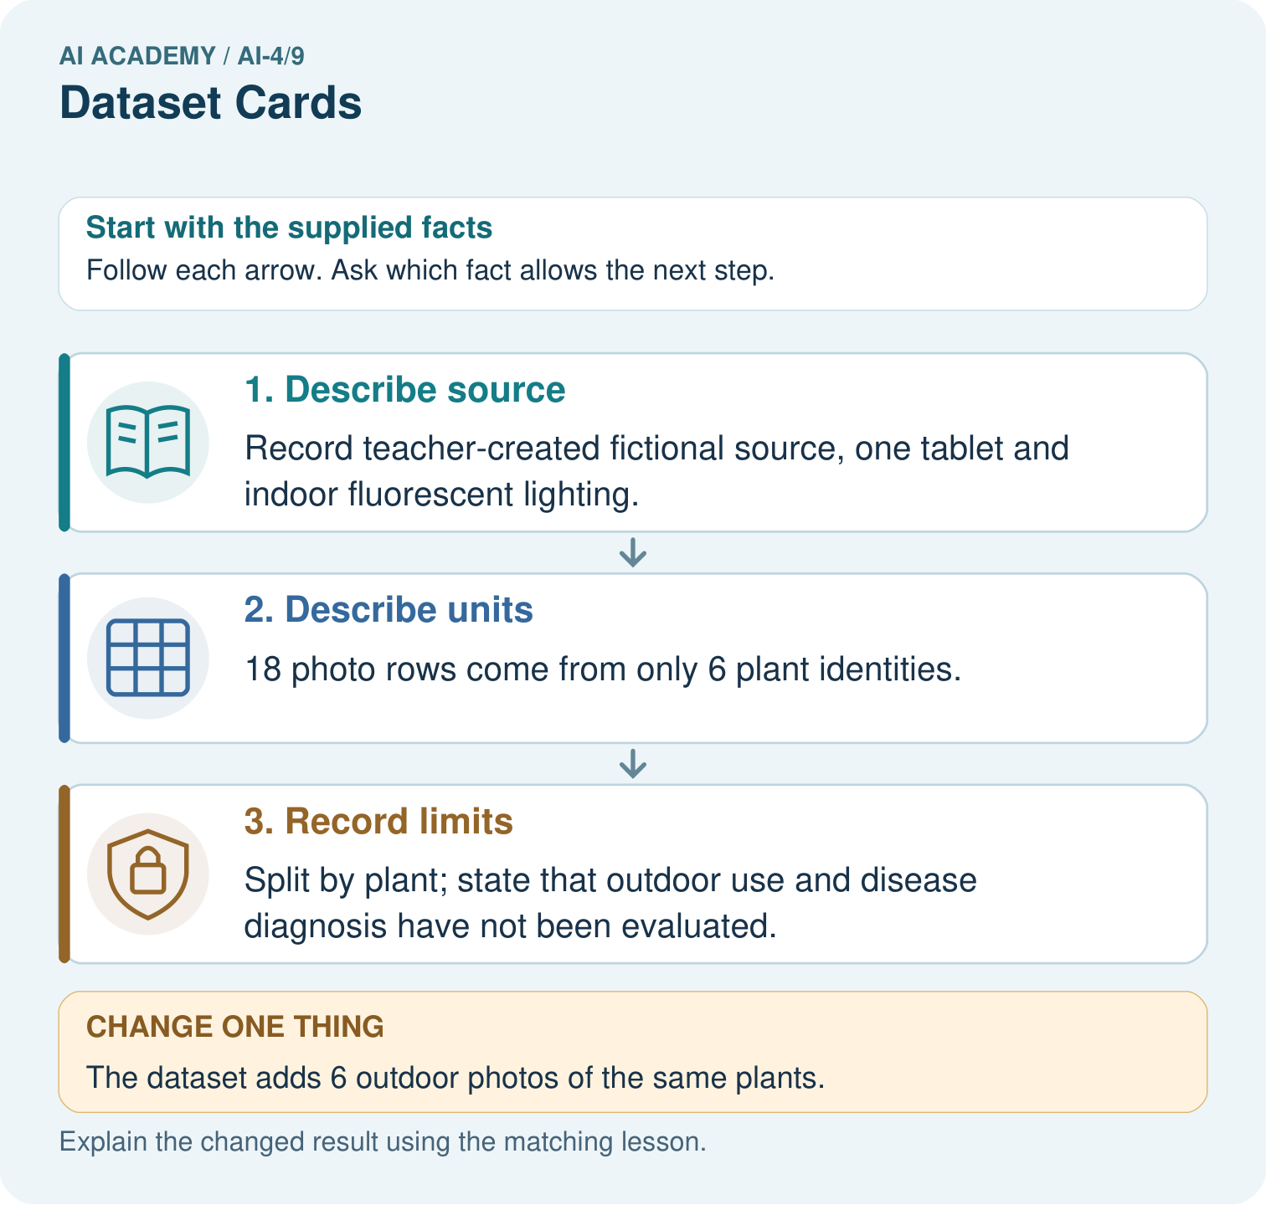

Read the picture one step at a time
Step | What happens and why
1. Describe source | Record teacher-created fictional source, one tablet and indoor fluorescent lighting.
2. Describe units | 18 photo rows come from only 6 plant identities.
3. Record limits | Split by plant; state that outdoor use and disease diagnosis have not been evaluated.
Match each pictured step to the supplied facts. This is a worked teaching case, not an independent assessment.

Why this result follows
Read the picture in order. Split by plant; state that outdoor use and disease diagnosis have not been evaluated. The arrows show which recorded input or intermediate result each decision uses. Explain the deciding step aloud before checking the changed case; pointing to the final answer alone does not show how it follows.

What this example does not establish
A dataset card documents evidence and gaps; writing one does not fix biased sampling or inaccurate labels.

Change one thing in the pictured case
Change: The dataset adds 6 outdoor photos of the same plants.
Prediction: Photo count becomes 24, plant count remains 6; lighting coverage changes.
Reason: Additional views broaden conditions without creating new independent plant identities.

Ask while showing the picture
Cover the result. Ask learners to name the inputs and predict the next step. Uncover one step, connect the icon to the actual procedure, and explain its evidence. Then change the supplied condition and compare. The picture is a representation; it does not document execution of a real AI model.

03. Demonstrate and guide practice

Demonstrate and guide practice

Board sequence
Write the given facts: A dataset card lists fields but omits source and intended use.
Write the question to explain: Add information needed to assess suitability.
Reveal after predictions: Provenance, permissions, collection method/time/conditions, label definitions, coverage, exclusions, missingness, use and limitations. Fields alone are insufficient.
Keep for an independent attempt: A dataset card lists 500 images but omits collection conditions and intended use. Add two essential entries and explain their value.

Classroom dialogue
Ask: Which facts are given, and which would we have to assume? Learners mark relevant details before discussing answers.
Say: Predict first. Show the rule, information path or calculation that would produce the result. A correct guess is not yet an explanation.
Reveal reasoning one step at a time. Explain why a tempting alternative fails. Write units and denominators for arithmetic, trace conditions for decisions, and identify supporting sources for claims.
In pairs, one learner solves while the other checks evidence; exchange roles. Remove the worked answer before independent assessment.

Model these guided questions
Guided: 2 of 5 raw rows have unknown duration, or 40 percent. No: the extra B occurrence is already among the missing rows, so subtracting all three flag counts double-counts it. A distinct usable-trip count requires a stated resolution policy and source review. Exit examples include duplicate IDs, impossible values, units, provenance and coverage. A defensible statement is that this five-row fictional export has documented quality flags and is suitable for inspection practice, with no model-readiness claim.

Case-specific teaching sequence
Stage | Teacher action
Session 1 start to 7 minutes | Retrieve regression target meaning and why later outcomes are separate from prediction inputs. Establish that this week inspects data before fitting.
7 to 18 minutes | Read the source description and schema. Count physical rows and distinct trip IDs separately. Ask whether a repeated ID proves the reason for duplication.
18 to 32 minutes | Trace the code with row cards. Explain set, None and negative checks. Complete W1 and W2 with named denominators.
32 to 45 minutes | Use the guided question to show overlap: place both B cards in missing and repeated-ID groups. Do not subtract all flag counts independently.
Session 2 start to 8 minutes | Retrieve raw version versus corrected version. Ask what evidence could justify changing a recorded value.
8 to 20 minutes | Read the card example and complete W3. Distinguish a documented fact, an unknown and an assumption.
20 to 35 minutes | Collect W4 independently. Require counts, overlap and a concise card with source and limitations before offering hints.
35 to 45 minutes | Discuss W5 and the exit claim. Use the fresh retry after support and record the support given.

Reduce help deliberately
Completion task: Explain each number in 5 4 2 1. How many extra ID occurrences are there, and how many rows belong to a repeated-ID group?
Teacher check: The numbers mean 5 raw rows, 4 distinct IDs, 2 missing durations and 1 negative duration. There is 1 extra ID occurrence; 2 rows belong to the repeated-ID group B. These are different counts.
Start by identifying the given inputs together. Leave the intermediate steps blank. If needed, model one step, then withdraw that help on the next step. Move to a full trace only when the partial trace is understood. For partners, alternate explainer and checker; collect a response from every learner before discussion.

Individual reasoning check
Use the worked case for Dataset inspection and cards. Proposed explanation: “A complete card certifies data quality”. Decide whether this explanation is supported. Point to the step or supplied fact that decides; explain your repair if needed.
Expected correction: The card records evidence and gaps; its claims still need checking. Documentation does not prove suitability.
Collect explanations, not only yes/no votes. If a misunderstanding is common, re-model the relevant step for the class. If it affects a few learners, give a short targeted group explanation while others solve a more demanding variation.

Pictorial practice question
What two counts should the revised card show? Point to the relevant step in the picture, then write the changed result and the rule or evidence that supports it.

Reasoned teacher answer
24 photos and 6 plants, with view relationships, source and indoor/outdoor conditions documented. Changed-case check: Photo count becomes 24, plant count remains 6; lighting coverage changes. Additional views broaden conditions without creating new independent plant identities.
Changed-case reasoning: Photo count becomes 24, plant count remains 6; lighting coverage changes. Additional views broaden conditions without creating new independent plant identities.
Collect each learner’s explanation before discussion. Use the first missing connection between input, deciding step and result to choose support. This question is worked-case practice, not fresh mastery evidence.

04. Run the weekly evidence lab

Run the weekly evidence lab
Keep the test conditions fixed, record every result, and change only one planned factor.
1. Write the hypothesis and expected evidence before running.
2. Dataset Card Review: inspect two incomplete cards, find missing provenance or risks, and write a defensible replacement.
3. Run one normal, one boundary, one missing, and one shifted case.
4. Calculate the metric from raw counts or row-level errors.
5. Interpret what changed, what did not, and what remains unsafe or unknown.

Make the lab runnable
Use the concrete case as the shared normal case and the independent question as a second case. Each pair creates a boundary or missing-information case and predicts its result before testing. Keep the expected result separate from an observed mistake.
Record | What to capture
Input or evidence | Exact data, instruction or claim
Expected result | Answer or safe fallback declared before the run
Observed result | Actual result, including errors
Explanation | Rule, calculation or evidence explaining the outcome
Next test | One justified change and a new prediction

Diagnose and reteach
MISCONCEPTION TO REPAIR A file name and list of columns are enough documentation for responsible reuse.
For guessing, return to given facts and request a trace. For vocabulary without application, use one example and one non-example. For arithmetic errors, check the setup before the calculation. Finish with a different uncoached case before recording mastery.

Address these additional misconceptions
A complete card certifies data quality: The card records evidence and gaps; its claims still need checking. Documentation does not prove suitability.
Missing means zero: None is unknown; zero is a specific allowed value in this exercise. Substitution without evidence changes the meaning.
Flag counts can always be added: The same row can have multiple flags. Count rows or unique events under an explicit policy and retain the raw denominator.

Match the support to the first error
What the response shows | Next teaching action
Missing or misread facts | Read the case aloud, mark supplied versus unknown facts, and let the learner restate it.
Wrong procedure | Return to the deciding step in the worked case. Contrast it with the proposed incorrect explanation.
Arithmetic or implementation error | Trace intermediate values or lines; preserve the first mismatch and retry that step.
Correct result without a reason | Ask for a trace and a changed case before marking independent understanding.
An unsupported wider claim | Ask which supplied evidence supports the claim and which further observation would be needed.
Offer an oral explanation, drawing, enlarged visual or fewer examples when that removes a reading/writing barrier. Keep the same reasoning goal. Stretch secure learners by changing a boundary or assumption and asking them to defend the effect, not simply by assigning more of the same questions.

05. Assess and explain the answers

Assess and explain the answers

Worked case answer
Provenance, permissions, collection method/time/conditions, label definitions, coverage, exclusions, missingness, use and limitations. Fields alone are insufficient.

Independent question
A dataset card lists 500 images but omits collection conditions and intended use. Add two essential entries and explain their value.

Expected independent answer
Document where and how images were collected and the intended or excluded uses. These help readers judge suitability, coverage and limits beyond row count.

What counts as evidence
Criterion | 0 points | 1 point | 2 points
Result | Incorrect or absent | Partly correct | Correct with necessary conditions
Reasoning | No supporting trace | Some steps | Clear mechanism, calculation or source support
Limit | Overclaims certainty | Vague limitation | Relevant uncertainty or missing fact
Transfer | Copies without adapting | Adapts with prompts | Solves a changed case independently
Use 6/8 as a classroom checkpoint, with 2 required for both Result and Reasoning. This is a proposed teaching rule, not a validated certification threshold. Do not count a coached answer as independent mastery; correct unsafe or unsupported claims regardless of total.

Feedback
Ask the learner to find the evidence that challenges this claim: “The number of rows alone adequately describes a dataset.” Keep the first attempt and an uncoached retry separate.

Original transfer answer
Include provenance/permission, collection conditions and dates, leaf identity groups, operational label definitions and class/condition coverage, plus missingness, intended use and exclusions. A large count can consist of duplicates or narrow conditions.

Explanations for the additional workbook examples

W1 Define the row and source
For Robot practice v1, state what one row is intended to represent, the source, the unit and the meaning of None.
One row is intended to represent one indoor practice trip. The source is a teacher-authored fictional export for this lesson, duration uses minutes, and None means unknown rather than zero.

W2 Interpret the audit counts
Explain each number in 5 4 2 1. How many extra ID occurrences are there, and how many rows belong to a repeated-ID group?
The numbers mean 5 raw rows, 4 distinct IDs, 2 missing durations and 1 negative duration. There is 1 extra ID occurrence; 2 rows belong to the repeated-ID group B. These are different counts.

W3 Reject an unsupported correction
A learner changes None to 0 and -2 to 2, then reports a clean dataset. Explain why this is not a justified repair and what record should be kept.
Those edits invent outcomes without source evidence. Preserve the raw version, flag the affected rows and investigate. Record any supported correction with old value, new value, reason and version; unresolved values remain uncertain.

W4 Inspect and document independently
A new fictional indoor trip export has (P,4), (Q,None), (Q,None), (R,-1), (S,6), (T,0), with durations in minutes and the same schema. Count raw rows, distinct IDs, missing durations, negative durations and extra ID occurrences. Identify overlap. Draft a short dataset card stating source, row meaning, unit, findings, unchanged version and one excluded use.
There are 6 rows, 5 distinct IDs, 2 missing durations, 1 negative duration and 1 extra ID occurrence. Both Q rows are missing, so the duplicate and missing flags overlap. Zero for T is allowed by the stated schema. The card should identify the supplied fictional indoor export, one intended row per trip, minutes, all findings, raw unchanged version and no evidence for real or outdoor navigation use.

W5 State an evidence gap
Someone duplicates each row ten times and claims the export now covers more kinds of trips. Explain what changed and what did not.
The row count increased but no new trip conditions or independent observations were added. Coverage remains limited to the same supplied fictional indoor cases; the larger count does not establish broader usefulness.

Assess independent transfer
Selected case: Write key dataset-card entries for20 photos: five plants, four views each, one phone, one indoor setting. Growth labels have not been supplied.

Selected case answer
Record collection source,20 images and five plant groups, view/device/setting coverage, missing label definitions, intended use and limitations. Specify a plant-group split and obtain a defensible label rule. Twenty images are not20 independent plants; no accuracy claim is supported without labels and evaluation.
Dimension | Evidence required
Explanation | Names the applicable idea or procedure and ties it to the supplied facts.
Trace and result | Preserves the given inputs and shows the relevant intermediate steps; distinguishes a prediction from an observed execution.
Limits | States the assumptions, missing evidence or conditions under which the result would change.
Record each dimension as not yet, with support, or independent. Accept a valid alternative procedure with a defensible trace. Do not penalise an honestly recorded model failure if the learner correctly explains its evidence and limits.

Feedback that the learner uses
Name the earliest unsupported step and give one action to repair it. Have the learner make that repair now and explain why. Then assess the relevant skill on a fresh, fully specified case. Confirm it was not previously practised with feedback; solve and check the new case before assigning it. A follow-up design prompt is a starting brief, not automatically an equivalent test.

06. Connect and extend learning

Connect and extend learning

Responsible Plant Classifier
Publish the Plant Classifier dataset card before model experiments begin; update it when data changes.
Keep the decision, input, result, explanation and remaining limitation in the project evidence record. Retrieve this record next week rather than restarting the project.

Support and stretch
Use a tiny labelled dataset, explicit units and a named positive class. Stretch: require a baseline, held-out evaluation and subgroup or shifted-condition analysis with denominators.

Exit reflection
Ask for one decision the learner can now justify and one situation requiring more evidence or human review. Confidence ratings are separate from correct independent performance.

Bridge to the next week
Next: Week 10: Baselines First. Retrieve today’s evidence and identify what carries forward and what is new.

Support and fresh reassessment
Use physical row cards and overlapping circles for flags. Supply blank card headings but no completed findings. Extension: explain how to record an evidenced seconds-to-minutes conversion while preserving the raw value, unit and version, and why a unit guess is not enough.
Require W4 counts 6,5,2,1,1 in the stated order, the Q overlap, acceptance of zero under this schema, and a card with source, unit, raw version and excluded use. Fresh retry: rows (L,3), (M,None), (N,-2), (N,-2), (O,0). Counts are 5 raw, 4 IDs, 1 missing, 2 negative and 1 extra ID occurrence. The negative and repeated-ID flags overlap on N. Do not infer whether the two N rows describe one event without checking the source.
Week 5 examines label definitions and disagreement. Carry forward the dataset card, source questions and explicit distinction between unknown and observed values. Teacher reference: https://arxiv.org/abs/1803.09010 (Datasheets for Datasets; reviewed 2026-09-26).

Plan the delayed return
Suggested return points in this level: ai-4/10, ai-4/12, ai-4/15. Use actual classroom dates, adjusting for holidays and gaps. One, three and six teaching weeks are scheduling choices, not a claimed optimal spacing.
At a delayed check, ask for the idea from memory and a changed application. Compare with the earlier independent response and record support used. For a new level, revisit the previous capstone before checking the new prerequisites.
Record | Teacher evidence
Learner code and date
Concept and case used; prior exposure
Explanation / trace / limits
Support and first repair
Changed case and delayed outcome
Next teaching action
Use the evidence to choose reteaching or the next step. A completed page, confidence rating or attractive project does not by itself demonstrate understanding.

Project evidence from this case
For your Responsible Plant Classifier, save the input, procedure, observed result and limitation of this check. Label this worked example as practice; use a different, previously unreviewed case when checking independent understanding.

