AI ACADEMY · TEACHER · ai-4/10

Baselines First
Project: Responsible Plant Classifier

01. Baselines First

Teach the learning cycle
Primary target: Fit a majority label baseline using training labels only
Session | Sequence and minutes | Resources
Session 1 · Understand · 45 min | 0–7: recall and prerequisite; 7–15: inspect the concrete case and predict; 15–30: teacher models the worked trace; 30–40: learners explain a step using the text and visual; 40–45: check the core idea. | Sections 1–6; record the brief recall in the workbook.
Session 2 · Practise · 45 min | 0–5: retrieve the procedure; 5–15: W2 completion practice; 15–23: explain and check with a partner; 23–30: each learner answers the misconception check; 30–40: targeted reteaching or a harder variation; 40–45: prepare the investigation. | Sections 7–10; use the matching workbook W2 and misconception check.
Session 3 · Investigate and transfer · 45 min | 0–5: retrieve the decision rule; 5–20: investigate or trace; 20–30: start the independent case; 30–38: connect the project; 38–43: act on feedback; 43–45: plan the return check. | Sections 9 and 11–14. Give extra time to finish the full task set; use Section 15 when the week includes a coding lab.
This is a starting allocation of 135 minutes, not a validated duration. Preserve all named topics. Schedule extra time for connected examples, the full investigation, independent cases and project building. Repeated copies of a case share one recorded attempt; they are not new evidence.

Retrieval answer guidance

Dataset Cards
Without opening the old lesson, explain one key idea from Dataset Cards. Give an example and a mistake that the idea helps you avoid.
Look for: Inspect row meaning missing values and repeated records
Reference example, not the only acceptable wording: One row is intended to represent one indoor practice trip. The source is a teacher-authored fictional export for this lesson, duration uses minutes, and None means unknown rather than zero.

Sampling and Intended Use
Without opening the old lesson, explain one key idea from Sampling and Intended Use. Give an example and a mistake that the idea helps you avoid.
Look for: Inspect row meaning missing values and repeated records
Reference example, not the only acceptable wording: One row is intended to represent one indoor practice trip. The source is a teacher-authored fictional export for this lesson, duration uses minutes, and None means unknown rather than zero.

Python and Table Readiness
Without opening the old lesson, explain one key idea from Python and Table Readiness. Give an example and a mistake that the idea helps you avoid.
Look for: Specify a table schema
Reference example, not the only acceptable wording: activity: nonempty text; minutes: integer from 0 to 60 inclusive.
Use the student module and workbook section with this exact week title. The worked case, independent question and answers below form one aligned lesson sequence.

What the learner must demonstrate
A dataset contains 27 healthy and 3 spotted leaves. An always-healthy baseline gets what accuracy and spotted recall? What must a new model improve upon?

Concept to explain
A model must be compared with a simple transparent strategy on the same untouched examples.
Term | Meaning
baseline | simple comparison method
majority class | most frequent training label
rule baseline | transparent fixed decision rule
incremental value | measured gain beyond baseline

Prepare the class
Use the supplied scenario, student illustrations and blank paper. For numeric work, offer counters or a calculator after learners show the setup. Fictional records are supplied; personal data and paid accounts are unnecessary.
Allow 80 minutes: recall 8; explanation 12; worked demonstration 15; guided practice 20; independent assessment 15; project and reflection 10. Extend the lab into a second session when needed.

Preparation for the connected explanation
Teach two 45-minute sessions. Fit a binary majority-label baseline from training labels and freeze its prediction before scoring. The invented set uses one frame per distinct trip; it is separate from Week 6 data. Supplied candidate predictions are comparison examples, not an implemented fitted model. Treat this as a first benchmark and evidence lesson, not a readiness test.

Readiness answer
Related frames can share conditions and objects. Keeping the trip together prevents that trip from appearing in both development and evaluation sets.
Printed lesson and workbook
Six training label cards and four validation cards kept in order
Optional Python 3 editor with no extra packages
Blank comparison table with row reference baseline candidate and matches

End goal for the pictorial case
By the end, I can explain baselines first using a traced example and a stated limitation.
This added worked case illustrates the week’s main idea. Retain all original and connected topics; schedule its practice within the teaching cycle.

02. Explain the mechanism

Explain the mechanism
Trace the information, fitted behavior, and evaluation proof separately.
QUESTION Build majority-class and one-rule baselines, then calculate their results.
MODEL IDEA A model must be compared with a simple transparent strategy on the same untouched examples.
PROOF NEEDED Use an unseen case, visible calculation, error analysis, and a stated limitation.
UNDER THE HOOD Test set has 12 healthy and 8 spotted leaves. Always-healthy baseline gets 12 ÷ 20 = 60% accuracy but 0% spotted recall.
Draw a fresh data → model → prediction → evaluation trace:
Predict first. Then check each step. A correct answer without visible evidence cannot be audited.
STEP 1 Test set has 12 healthy and 8 spotted leaves.
STEP 2 Always-healthy baseline gets 12 ÷ 20 = 60% accuracy but 0% spotted recall.
STEP 3 On the same 20 leaves, the visible-spot rule correctly labels 5 spotted leaves, misses 3 spotted leaves, correctly labels 10 healthy leaves and falsely marks 2 healthy leaves as spotted. Accuracy=(5+10)/20=75%; spotted recall=5/8=62.5%.
STEP 4 A learned model must beat relevant baseline metrics—not only one convenient total.
CHECK Verify the denominator, unit, split, class definition, and data version before interpreting a score.
Recalculate, retrace, or restate the evidence independently:

Concrete teaching case
A test set has eighteen healthy and two spotted leaves. Baseline always predicts healthy.
Calculate and critique accuracy.

Exact explanation to model
18/20=90%, but spotted recall is 0/2=0%. Compare with task-relevant metrics and the trained model.

Explain the added worked example
A learner reports that a classifier gets 80 percent correct. Is that useful? We need to know the task, the examples and what a simple method achieves on those same examples. A baseline is a reference method. This week our baseline ignores each scene and always predicts the label that is most common in the training set.
Use a new teacher-authored fictional dataset for predicting clear or blocked lanes. Each listed row describes one frame from a different trip on a familiar route; training and validation trips do not overlap. This is a new practice set, not the twelve-frame table from Week 6. All supplied labels have been resolved under the classroom rule. There are no review cases in this exercise, and no real navigation claim is made.
The training counts are four clear and two blocked. Our stated method therefore predicts clear for every new example. A baseline can still learn a value from training data; simple does not mean it uses no data. If the two training counts tie, our rule chooses clear, declared before scoring.
The output is clear 2 4. The fixed prediction matches two of the four validation labels, so accuracy is 2/4 or 50 percent. The training majority share, 4/6, is not the validation accuracy. The baseline does not inspect the validation labels to decide which constant to predict.
The code assumes nonempty training data with only clear and blocked labels. It counts matches on the supplied validation list; a percentage also requires a nonempty validation set. Do not run it on empty training data and describe the default clear value as learned evidence. Other labels and unresolved review statuses need an explicit policy.

Key terms
Term | Meaning
Baseline | A simple reference method used to judge a more complex approach
Majority label | The label with more examples than the other label in this binary task
Accuracy | Correct predictions divided by the number of scored examples
Percentage point | A unit for the difference between two percentages

Model the reasoning aloud
Use the complete worked example below before asking learners to complete W2. Reveal a small part, invite a prediction, then explain the deciding step. These teacher notes contain solutions; do not reveal the independent case answer during modelling.
Suppose a candidate method supplies blocked, clear, clear, clear for the four validation rows in the table. These are supplied predictions for a comparison exercise; we have not fitted that candidate. It gets three of four correct, or 75 percent. The baseline gets two of four, or 50 percent. The candidate is ahead by one correct example and 25 percentage points on this set.
Use identical row IDs, reference labels, exclusions and metric for both methods. Match predictions to their rows even if files are reordered. A score on easier examples is not a fair comparison. Neither this four-row result nor beating one baseline proves that the candidate will perform well on future trips.

The candidate misses the third validation row. Which rows does the baseline miss? Explain how the candidate changes the number correct. Why is the improvement 25 percentage points rather than a claim of 25 percent relative improvement?
________________________________________________________________
________________________________________________________________
________________________________________________________________
________________________________________________________________
________________________________________________________________
Record training counts, the fixed prediction and tie rule, validation IDs and labels, prediction lists and correct/total counts. Keep the final test separate from development decisions. Next week we will search candidate rules using training evidence, then compare choices carefully.
Thinking move | Teacher prompt
Plan | What is given? What is the question? Which procedure fits these facts?
Do | Point to each input and intermediate step in the worked trace. Name the rule that allows the next step.
Check | Does the output answer the question? Which assumption or limitation prevents a larger claim?
Use the diagram and verbal explanation together. Ask learners to match a sentence to a specific visual step; do not assign learners fixed visual or auditory learning styles.

A pictorial worked case: Baselines First
Make a simple baseline earn its place before claiming a better classifier.

The facts we will use
Training labels: healthy, healthy, spotted. Majority baseline predicts healthy. Validation references: healthy, spotted, healthy, spotted.
All inputs and outcomes in this worked example are invented classroom data; no real model run is claimed.
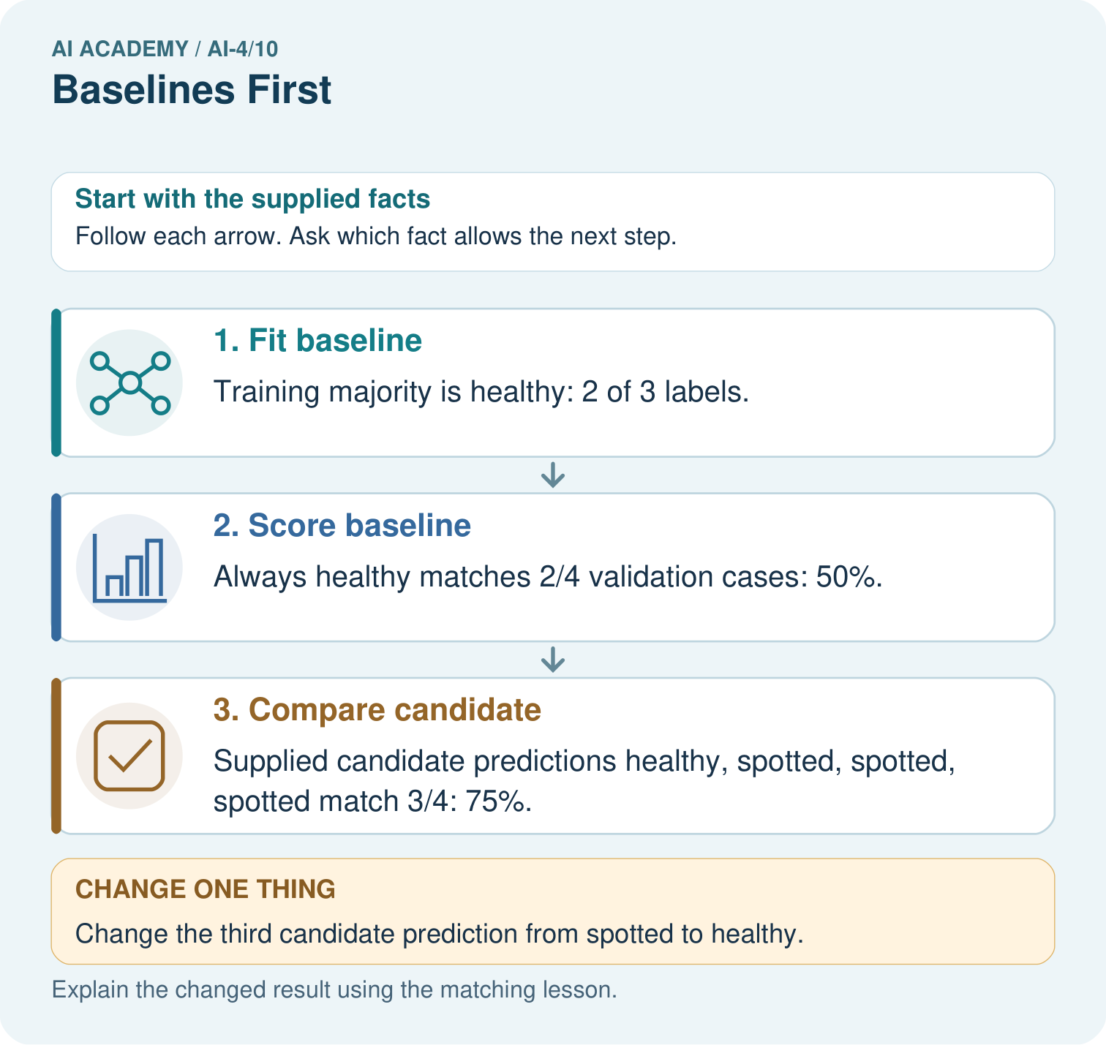

Read the picture one step at a time
Step | What happens and why
1. Fit baseline | Training majority is healthy: 2 of 3 labels.
2. Score baseline | Always healthy matches 2/4 validation cases: 50%.
3. Compare candidate | Supplied candidate predictions healthy, spotted, spotted, spotted match 3/4: 75%.
Match each pictured step to the supplied facts. This is a worked teaching case, not an independent assessment.

Why this result follows
Read the picture in order. Supplied candidate predictions healthy, spotted, spotted, spotted match 3/4: 75%. The arrows show which recorded input or intermediate result each decision uses. Explain the deciding step aloud before checking the changed case; pointing to the final answer alone does not show how it follows.

What this example does not establish
These supplied predictions illustrate comparison. No actual model was trained, and four cases are limited evidence.

Change one thing in the pictured case
Change: Change the third candidate prediction from spotted to healthy.
Prediction: Candidate becomes correct on all 4 validation cases.
Reason: Only the previously wrong third decision changes; baseline stays fixed at 2/4.

Ask while showing the picture
Cover the result. Ask learners to name the inputs and predict the next step. Uncover one step, connect the icon to the actual procedure, and explain its evidence. Then change the supplied condition and compare. The picture is a representation; it does not document execution of a real AI model.

03. Demonstrate and guide practice

Demonstrate and guide practice

Board sequence
Write the given facts: A test set has eighteen healthy and two spotted leaves. Baseline always predicts healthy.
Write the question to explain: Calculate and critique accuracy.
Reveal after predictions: 18/20=90%, but spotted recall is 0/2=0%. Compare with task-relevant metrics and the trained model.
Keep for an independent attempt: A dataset has 18 grass and 2 fern examples. A baseline always predicts grass. Compute accuracy and name a serious limitation.

Classroom dialogue
Ask: Which facts are given, and which would we have to assume? Learners mark relevant details before discussing answers.
Say: Predict first. Show the rule, information path or calculation that would produce the result. A correct guess is not yet an explanation.
Reveal reasoning one step at a time. Explain why a tempting alternative fails. Write units and denominators for arithmetic, trace conditions for decisions, and identify supporting sources for claims.
In pairs, one learner solves while the other checks evidence; exchange roles. Remove the worked answer before independent assessment.

Model these guided questions
Guided: the baseline misses rows 1 and 3; the candidate misses only row 3, adding one correct example. The difference is 75 minus 50 = 25 percentage points. Relative improvement in accuracy would be (75 minus 50)/50 = 50 percent; keep the measure explicit. Exit: equal accuracy does not establish identical mistakes or suitability. Inspect predictions by row, missed blocked cases, false blocked predictions, sample coverage and consequences, then evaluate using an appropriate held out process.

Case-specific teaching sequence
Stage | Teacher action
Session 1 start to 7 minutes | Retrieve the split roles and related-trip issue. Ask what a score means without a reference method.
7 to 18 minutes | Count training labels and write the constant before revealing validation labels. State the tie rule before any comparison.
18 to 32 minutes | Trace the code. Complete W1 and W2, separating training share from validation accuracy.
32 to 45 minutes | Build a row-by-row comparison for the supplied candidate. Complete the guided percentage-point question.
Session 2 start to 8 minutes | Retrieve what changes if the baseline constant is chosen using validation labels.
8 to 20 minutes | Discuss the two unfair comparisons and complete W3. Require common rows, labels and scoring policy.
20 to 35 minutes | Collect W4 independently before hints. Require the training counts, both prediction lists, scores and restrained claim.
35 to 45 minutes | Use W5 and the exit question to compare error patterns. Give the fresh retry after feedback and record support.

Reduce help deliberately
Completion task: List the four baseline predictions and mark which validation rows are correct. Give correct/total and accuracy. Explain why 4/6 is not the answer.
Teacher check: Predictions are clear, clear, clear, clear. Rows 2 and 4 match, giving 2/4 or 50 percent. The fraction 4/6 describes clear labels in training, not correct predictions on the four validation rows.
Start by identifying the given inputs together. Leave the intermediate steps blank. If needed, model one step, then withdraw that help on the next step. Move to a full trace only when the partial trace is understood. For partners, alternate explainer and checker; collect a response from every learner before discussion.

Individual reasoning check
Use the worked case for A baseline before a model. Proposed explanation: “A simple baseline does not need training data”. Decide whether this explanation is supported. Point to the step or supplied fact that decides; explain your repair if needed.
Expected correction: This method learns its constant from training label counts, although it ignores input features.
Collect explanations, not only yes/no votes. If a misunderstanding is common, re-model the relevant step for the class. If it affects a few learners, give a short targeted group explanation while others solve a more demanding variation.

Pictorial practice question
Can the candidate’s training accuracy replace this validation comparison? Point to the relevant step in the picture, then write the changed result and the rule or evidence that supports it.

Reasoned teacher answer
No. Compare candidate and baseline on the same held-out cases and references; training fit answers a different question. Changed-case check: Candidate becomes correct on all 4 validation cases. Only the previously wrong third decision changes; baseline stays fixed at 2/4.
Changed-case reasoning: Candidate becomes correct on all 4 validation cases. Only the previously wrong third decision changes; baseline stays fixed at 2/4.
Collect each learner’s explanation before discussion. Use the first missing connection between input, deciding step and result to choose support. This question is worked-case practice, not fresh mastery evidence.

04. Run the weekly evidence lab

Run the weekly evidence lab
Keep the test conditions fixed, record every result, and change only one planned factor.
1. Write the hypothesis and expected evidence before running.
2. Baseline Challenge: calculate two baselines on one fixed set, compare class-specific errors, and choose the honest benchmark.
3. Run one normal, one boundary, one missing, and one shifted case.
4. Calculate the metric from raw counts or row-level errors.
5. Interpret what changed, what did not, and what remains unsafe or unknown.

Make the lab runnable
Use the concrete case as the shared normal case and the independent question as a second case. Each pair creates a boundary or missing-information case and predicts its result before testing. Keep the expected result separate from an observed mistake.
Record | What to capture
Input or evidence | Exact data, instruction or claim
Expected result | Answer or safe fallback declared before the run
Observed result | Actual result, including errors
Explanation | Rule, calculation or evidence explaining the outcome
Next test | One justified change and a new prediction

Diagnose and reteach
MISCONCEPTION TO REPAIR Any trained model is more intelligent and therefore better than a simple rule.
For guessing, return to given facts and request a trace. For vocabulary without application, use one example and one non-example. For arithmetic errors, check the setup before the calculation. Finish with a different uncoached case before recording mastery.

Address these additional misconceptions
A simple baseline does not need training data: This method learns its constant from training label counts, although it ignores input features.
Training majority share is validation accuracy: Fit using training labels, then count matches separately on validation rows. Their label proportions can differ.
Beating a baseline proves the system is ready: It is one comparison on specified examples. Error types, coverage, uncertainty and final evaluation remain relevant.

Match the support to the first error
What the response shows | Next teaching action
Missing or misread facts | Read the case aloud, mark supplied versus unknown facts, and let the learner restate it.
Wrong procedure | Return to the deciding step in the worked case. Contrast it with the proposed incorrect explanation.
Arithmetic or implementation error | Trace intermediate values or lines; preserve the first mismatch and retry that step.
Correct result without a reason | Ask for a trace and a changed case before marking independent understanding.
An unsupported wider claim | Ask which supplied evidence supports the claim and which further observation would be needed.
Offer an oral explanation, drawing, enlarged visual or fewer examples when that removes a reading/writing barrier. Keep the same reasoning goal. Stretch secure learners by changing a boundary or assumption and asking them to defend the effect, not simply by assigning more of the same questions.

05. Assess and explain the answers

Assess and explain the answers

Worked case answer
18/20=90%, but spotted recall is 0/2=0%. Compare with task-relevant metrics and the trained model.

Independent question
A dataset has 18 grass and 2 fern examples. A baseline always predicts grass. Compute accuracy and name a serious limitation.

Expected independent answer
Accuracy is 18/20 = 90%, but fern recall is 0/2. The high total hides complete failure on the minority class.

What counts as evidence
Criterion | 0 points | 1 point | 2 points
Result | Incorrect or absent | Partly correct | Correct with necessary conditions
Reasoning | No supporting trace | Some steps | Clear mechanism, calculation or source support
Limit | Overclaims certainty | Vague limitation | Relevant uncertainty or missing fact
Transfer | Copies without adapting | Adapts with prompts | Solves a changed case independently
Use 6/8 as a classroom checkpoint, with 2 required for both Result and Reasoning. This is a proposed teaching rule, not a validated certification threshold. Do not count a coached answer as independent mastery; correct unsafe or unsupported claims regardless of total.

Feedback
Ask the learner to find the evidence that challenges this claim: “A 90% baseline necessarily serves both classes well.” Keep the first attempt and an uncoached retry separate.

Original transfer answer
Accuracy=27/30=90%; spotted recall=0/3=0%. A new model should be compared on task-relevant metrics and error consequences, not only accuracy. Fit a majority baseline using training labels, without using final labels to choose the class.

Explanations for the additional workbook examples

W1 Choose from training evidence
Count clear and blocked in the worked training list. State the constant prediction and the declared tie rule. Explain why the validation majority does not choose this baseline.
Training has four clear and two blocked, so the constant is clear. A tie chooses clear under the declared classroom rule. Validation labels score the stored prediction; using their majority to choose it would change the fitting procedure.

W2 Calculate the validation score
List the four baseline predictions and mark which validation rows are correct. Give correct/total and accuracy. Explain why 4/6 is not the answer.
Predictions are clear, clear, clear, clear. Rows 2 and 4 match, giving 2/4 or 50 percent. The fraction 4/6 describes clear labels in training, not correct predictions on the four validation rows.

W3 Make the comparison fair
A candidate is scored on ten easy rows and the baseline on four difficult rows. Describe a fair comparison and two details you must record.
Score both methods on the same intended validation examples with matched IDs, reference labels, metric and exclusion policy. Record predictions, correct/total counts and the training-derived baseline rule. Different example sets do not isolate a method difference.

W4 Fit and compare independently
New training labels are blocked, clear, blocked, blocked, clear. New validation labels are clear, blocked, clear, blocked. Fit the same baseline rule and list its four predictions. A supplied candidate predicts clear, blocked, blocked, blocked. Score both on these rows and state the difference in correct examples and percentage points. What claim remains unsupported?
Training counts are three blocked and two clear, so predict blocked four times. The baseline matches rows 2 and 4: 2/4 or 50 percent. The candidate matches rows 1,2,4: 3/4 or 75 percent. It gains one correct example and 25 percentage points. This tiny validation comparison does not prove future performance or readiness for use.

W5 Explain the hidden error
A training-derived clear baseline gets nine of ten validation cases correct; the labels are nine clear and one blocked. State its accuracy and missed case. If a candidate also gets nine correct, must it miss the same case? Explain.
Accuracy is 90 percent, and the baseline misses the sole blocked case. A candidate could also score 90 percent by correctly identifying blocked but missing one clear case. Equal totals do not imply identical errors; inspect predictions by row and error type.

Assess independent transfer
Selected case: New training labels are blocked, clear, blocked, blocked, clear. New validation labels are clear, blocked, clear, blocked. Fit the same baseline rule and list its four predictions. A supplied candidate predicts clear, blocked, blocked, blocked. Score both on these rows and state the difference in correct examples and percentage points. What claim remains unsupported?

Selected case answer
Training counts are three blocked and two clear, so predict blocked four times. The baseline matches rows 2 and 4: 2/4 or 50 percent. The candidate matches rows 1,2,4: 3/4 or 75 percent. It gains one correct example and 25 percentage points. This tiny validation comparison does not prove future performance or readiness for use.
Dimension | Evidence required
Explanation | Names the applicable idea or procedure and ties it to the supplied facts.
Trace and result | Preserves the given inputs and shows the relevant intermediate steps; distinguishes a prediction from an observed execution.
Limits | States the assumptions, missing evidence or conditions under which the result would change.
Record each dimension as not yet, with support, or independent. Accept a valid alternative procedure with a defensible trace. Do not penalise an honestly recorded model failure if the learner correctly explains its evidence and limits.

Feedback that the learner uses
Name the earliest unsupported step and give one action to repair it. Have the learner make that repair now and explain why. Then assess the relevant skill on a fresh, fully specified case. Confirm it was not previously practised with feedback; solve and check the new case before assigning it. A follow-up design prompt is a starting brief, not automatically an equivalent test.

06. Connect and extend learning

Connect and extend learning

Responsible Plant Classifier
Record majority and transparent-rule baselines for the Plant Classifier using the frozen test plan.
Keep the decision, input, result, explanation and remaining limitation in the project evidence record. Retrieve this record next week rather than restarting the project.

Support and stretch
Use a tiny labelled dataset, explicit units and a named positive class. Stretch: require a baseline, held-out evaluation and subgroup or shifted-condition analysis with denominators.

Exit reflection
Ask for one decision the learner can now justify and one situation requiring more evidence or human review. Confidence ratings are separate from correct independent performance.

Bridge to the next week
Next: Week 11: Decision Trees. Retrieve today’s evidence and identify what carries forward and what is new.

Support and fresh reassessment
Use labelled cards and matching ticks before fractions. Supply a blank row-aligned comparison table without predictions. Extension: construct two different prediction lists with identical accuracy but different missed rows, and explain how to report both.
Require W4 blocked from counts 3 versus 2, baseline 2/4, candidate 3/4, one extra correct and 25 percentage points. Fresh retry: training clear, blocked, blocked, clear is tied, so choose clear by the declared rule. Validation blocked, clear, blocked, blocked gives baseline 1/4 or 25 percent. Candidate blocked, clear, clear, blocked gives 3/4 or 75 percent: two extra correct and 50 percentage points. Require the tie rule and explain why validation majority blocked cannot replace the stored constant.
Week 8 searches candidate rules. Carry forward a frozen training-derived baseline and a fair comparison record. Teacher reference: scikit-learn DummyClassifier documentation, most_frequent strategy, https://scikit-learn.org/dev/modules/generated/sklearn.dummy.DummyClassifier.html (reviewed 2026-09-27).

Plan the delayed return
Suggested return points in this level: ai-4/11, ai-4/13, ai-4/16. Use actual classroom dates, adjusting for holidays and gaps. One, three and six teaching weeks are scheduling choices, not a claimed optimal spacing.
At a delayed check, ask for the idea from memory and a changed application. Compare with the earlier independent response and record support used. For a new level, revisit the previous capstone before checking the new prerequisites.
Record | Teacher evidence
Learner code and date
Concept and case used; prior exposure
Explanation / trace / limits
Support and first repair
Changed case and delayed outcome
Next teaching action
Use the evidence to choose reteaching or the next step. A completed page, confidence rating or attractive project does not by itself demonstrate understanding.

Project evidence from this case
For your Responsible Plant Classifier, save the input, procedure, observed result and limitation of this check. Label this worked example as practice; use a different, previously unreviewed case when checking independent understanding.

