AI ACADEMY · TEACHER · ai-4/16

Accuracy and Imbalance
Project: Responsible Plant Classifier

01. Accuracy and Imbalance

Teach the learning cycle
Primary target: Explain why overall accuracy can hide failure on a less common class
Session | Sequence and minutes | Resources
Session 1 · Understand · 45 min | 0–7: recall and prerequisite; 7–15: inspect the concrete case and predict; 15–30: teacher models the worked trace; 30–40: learners explain a step using the text and visual; 40–45: check the core idea. | Sections 1–6; record the brief recall in the workbook.
Session 2 · Practise · 45 min | 0–5: retrieve the procedure; 5–15: W2 completion practice; 15–23: explain and check with a partner; 23–30: each learner answers the misconception check; 30–40: targeted reteaching or a harder variation; 40–45: prepare the investigation. | Sections 7–10; use the matching workbook W2 and misconception check.
Session 3 · Investigate and transfer · 45 min | 0–5: retrieve the decision rule; 5–20: investigate or trace; 20–30: start the independent case; 30–38: connect the project; 38–43: act on feedback; 43–45: plan the return check. | Sections 9 and 11–14. Give extra time to finish the full task set; use Section 15 when the week includes a coding lab.
This is a starting allocation of 135 minutes, not a validated duration. Preserve all named topics. Schedule extra time for connected examples, the full investigation, independent cases and project building. Repeated copies of a case share one recorded attempt; they are not new evidence.
Case exposure check: this source example appears in ai-2/12, ai-4/16. Reuse a familiar case for recall or modelling; verify that the case used to assess transfer has not already received feedback.

Retrieval answer guidance

Confusion Matrix
Without opening the old lesson, explain one key idea from Confusion Matrix. Give an example and a mistake that the idea helps you avoid.
Look for: Build a labelled confusion matrix from matched reference and prediction pairs
Reference example, not the only acceptable wording: Reference clear/predicted clear contains V1,V2: 2. Clear/blocked contains V3: 1. Blocked/clear contains V4,V5: 2. Blocked/blocked contains V6,V7,V8: 3. Matrix [[2,1],[2,3]].

Train a Classifier
Without opening the old lesson, explain one key idea from Train a Classifier. Give an example and a mistake that the idea helps you avoid.
Look for: Connect training-only scaling and neighbour prediction in one pipeline
Reference example, not the only acceptable wording: fit learns training minima and ranges and stores scaled training rows with IDs and labels. predict takes a raw feature pair and the fitted state. Evaluation compares a prediction with its reference label afterward. Validation references belong only in evaluation, not in fitting or the neighbour pool.

Baselines First
Without opening the old lesson, explain one key idea from Baselines First. Give an example and a mistake that the idea helps you avoid.
Look for: Fit a majority label baseline using training labels only
Reference example, not the only acceptable wording: Training has four clear and two blocked, so the constant is clear. A tie chooses clear under the declared classroom rule. Validation labels score the stored prediction; using their majority to choose it would change the fitting procedure.
Use the student module and workbook section with this exact week title. The worked case, independent question and answers below form one aligned lesson sequence.

What the learner must demonstrate
Model A is always healthy on 96 healthy and 4 spotted leaves. Model B finds 3 spotted but falsely flags 5 healthy. Compare accuracy and spotted detection.

Concept to explain
Accuracy can be dominated by a common class and hide failure on a rare but important class.
Term | Meaning
accuracy | correct predictions divided by all predictions
class imbalance | classes occur in very different amounts
minority class | less frequent target class
recall | fraction of actual positives found

Prepare the class
Use the supplied scenario, student illustrations and blank paper. For numeric work, offer counters or a calculator after learners show the setup. Fictional records are supplied; personal data and paid accounts are unnecessary.
Allow 80 minutes: recall 8; explanation 12; worked demonstration 15; guided practice 20; independent assessment 15; project and reflection 10. Extend the lab into a second session when needed.

Preparation for the connected explanation
Teach two 45-minute sessions. Begin with a majority guess that looks successful under overall accuracy, then keep both class denominators visible. Introduce balanced accuracy as an equal average of two correct fractions, without treating it as a universal replacement for task-specific evaluation.

Readiness answer
They are in the blocked-reference row and clear-prediction column: the lower-left cell. These are missed blocked cases.
Printed lesson and workbook
Twenty counters with sixteen labelled clear and four blocked
Blank confusion matrices and fraction strips
Optional Python 3 editor with no packages required

End goal for the pictorial case
By the end, I can explain accuracy and imbalance using a traced example and a stated limitation.
This added worked case illustrates the week’s main idea. Retain all original and connected topics; schedule its practice within the teaching cycle.

02. Explain the mechanism

Explain the mechanism
Trace the information, fitted behavior, and evaluation proof separately.
QUESTION Compare trivial accuracy with minority-class recall.
MODEL IDEA Accuracy can be dominated by a common class and hide failure on a rare but important class.
PROOF NEEDED Use an unseen case, visible calculation, error analysis, and a stated limitation.
UNDER THE HOOD Test set has 95 healthy and 5 diseased leaves. Always predicting healthy gives 95 ÷ 100 = 95% accuracy.
Draw a fresh data → model → prediction → evaluation trace:
Predict first. Then check each step. A correct answer without visible evidence cannot be audited.
STEP 1 Test set has 95 healthy and 5 diseased leaves.
STEP 2 Always predicting healthy gives 95 ÷ 100 = 95% accuracy.
STEP 3 It finds 0 of 5 diseased leaves, so diseased recall = 0%.
STEP 4 Report class counts and recall; redesign data or use only where misses are acceptable.
CHECK Verify the denominator, unit, split, class definition, and data version before interpreting a score.
Recalculate, retrace, or restate the evidence independently:

Concrete teaching case
A dataset has 95 healthy and 5 spotted. Model predicts healthy for all.
Calculate and critique accuracy.

Exact explanation to model
95/100=95%, but spotted recall=0/5=0%. Majority performance hides the detection failure.

Explain the added worked example
Accuracy counts all correct predictions and divides by all evaluated examples. Each example has equal weight, so a common class contributes more to the score. A high result can hide failure on a rare class. This week keeps the confusion matrix visible and checks both classes separately.
New fictional training data has 16 clear and 4 blocked labels. Its majority baseline predicts clear for every query; choose that rule from training, not evaluation labels. A separate evaluation set also contains 16 clear and 4 blocked cases. A frozen candidate and the baseline are evaluated on the same 20 records.
Rows are references and columns are predictions, ordered clear then blocked. Blocked is positive. Both methods get 16/20=80 percent accuracy. The baseline misses all four blocked cases. The candidate finds all four but falsely flags four clear cases. The same score conceals a different tradeoff.
The output is baseline 80.0 50.0, then candidate 80.0 87.5. In each output line the first percentage is ordinary accuracy and the second is balanced accuracy. For the candidate, the clear-class correct fraction is 12/16=75 percent and the blocked-class fraction is 4/4=100 percent. Their equal average is 87.5 percent.
For the baseline, those fractions are 16/16=100 percent and 0/4=0 percent, averaging 50 percent. The code assumes a two-by-two table of nonnegative integer counts in the stated order. It stops when either reference class is absent. Then report the observed counts and the unavailable class result; do not invent a denominator or silently substitute zero.

Key terms
Term | Meaning
Class imbalance | Unequal numbers of examples in different classes
Majority baseline | A rule that always predicts the most common training label
Class-specific correct fraction | Correct predictions for one reference class divided by the number of examples of that class
Balanced accuracy | The average of the class-specific correct fractions with equal weight for each class

Model the reasoning aloud
Use the complete worked example below before asking learners to complete W2. Reveal a small part, invite a prediction, then explain the deciding step. These teacher notes contain solutions; do not reveal the independent case answer during modelling.

Same overall score different class results
Summary | Always clear baseline | Frozen candidate
Overall correct | 16 of 20 is 80 percent | 16 of 20 is 80 percent
Reference clear correct | 16 of 16 is 100 percent | 12 of 16 is 75 percent
Reference blocked correct | 0 of 4 is 0 percent | 4 of 4 is 100 percent
Overall accuracy weights classes by their number of evaluation examples. Balanced accuracy gives the two class-specific fractions equal weight.

Both methods score 80 percent. Explain which cases the baseline fails, how the candidate changes the errors, and why their balanced accuracies differ.
________________________________________________________________
________________________________________________________________
________________________________________________________________
________________________________________________________________
Balanced accuracy is a metric choice, not a repair to the classifier or a guarantee of safety. It gives classes equal influence in this summary; it does not encode the actual consequences of false alarms and missed cases. Four blocked evaluation examples are also too few for a strong general claim.
Thinking move | Teacher prompt
Plan | What is given? What is the question? Which procedure fits these facts?
Do | Point to each input and intermediate step in the worked trace. Name the rule that allows the next step.
Check | Does the output answer the question? Which assumption or limitation prevents a larger claim?
Use the diagram and verbal explanation together. Ask learners to match a sentence to a specific visual step; do not assign learners fixed visual or auditory learning styles.

A pictorial worked case: Accuracy and Imbalance
Show how a common healthy class can hide complete failure to detect spotted leaves.

The facts we will use
Toy evaluation has 18 healthy and 2 spotted leaves. Always-healthy predicts all healthy. A candidate hasTP2, FN 0, FP 3, TN 15.
All inputs and outcomes in this worked example are invented classroom data; no real model run is claimed.
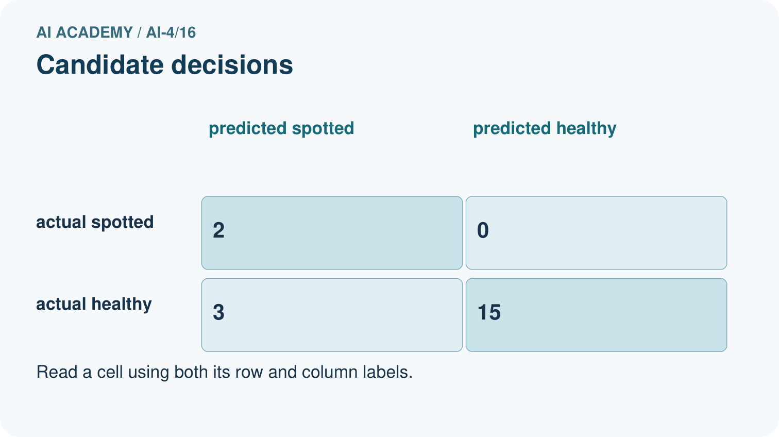
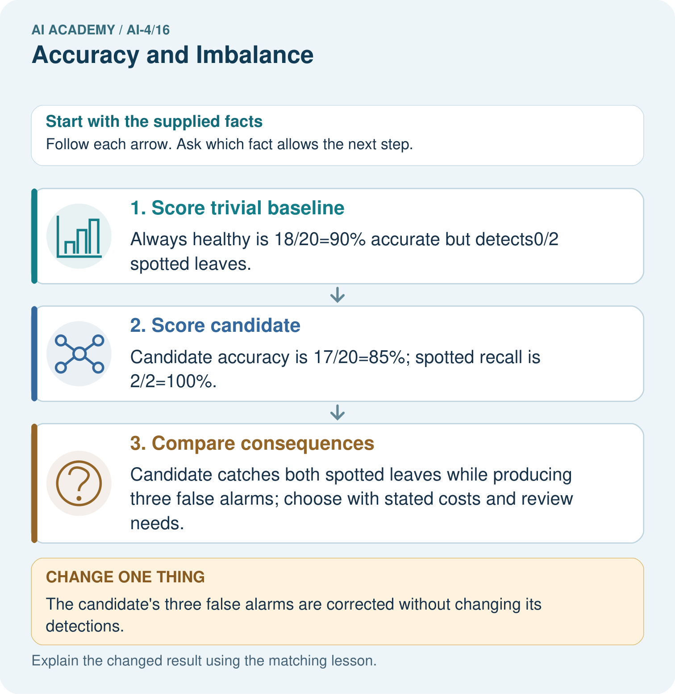

Read the picture one step at a time
Step | What happens and why
1. Score trivial baseline | Always healthy is 18/20=90% accurate but detects0/2 spotted leaves.
2. Score candidate | Candidate accuracy is 17/20=85%; spotted recall is 2/2=100%.
3. Compare consequences | Candidate catches both spotted leaves while producing three false alarms; choose with stated costs and review needs.
Match each pictured step to the supplied facts. This is a worked teaching case, not an independent assessment.

Why this result follows
Read the picture in order. Candidate catches both spotted leaves while producing three false alarms; choose with stated costs and review needs. The arrows show which recorded input or intermediate result each decision uses. Explain the deciding step aloud before checking the changed case; pointing to the final answer alone does not show how it follows.

What this example does not establish
Perfect performance on twenty supplied cases does not demonstrate dependable detection in other plants or settings.

Change one thing in the pictured case
Change: The candidate’s three false alarms are corrected without changing its detections.
Prediction: Candidate accuracy becomes20/20 with spotted recall still100% in this toy set.
Reason: False alarms move from FP to TN; neither TP nor FN changes.

Ask while showing the picture
Cover the result. Ask learners to name the inputs and predict the next step. Uncover one step, connect the icon to the actual procedure, and explain its evidence. Then change the supplied condition and compare. The picture is a representation; it does not document execution of a real AI model.

03. Demonstrate and guide practice

Demonstrate and guide practice

Board sequence
Write the given facts: A dataset has 95 healthy and 5 spotted. Model predicts healthy for all.
Write the question to explain: Calculate and critique accuracy.
Reveal after predictions: 95/100=95%, but spotted recall=0/5=0%. Majority performance hides the detection failure.
Keep for an independent attempt: A classifier predicts healthy for all 100 plants; 95 are healthy and 5 diseased. Compute accuracy and diseased recall.

Classroom dialogue
Ask: Which facts are given, and which would we have to assume? Learners mark relevant details before discussing answers.
Say: Predict first. Show the rule, information path or calculation that would produce the result. A correct guess is not yet an explanation.
Reveal reasoning one step at a time. Explain why a tempting alternative fails. Write units and denominators for arithmetic, trace conditions for decisions, and identify supporting sources for claims.
In pairs, one learner solves while the other checks evidence; exchange roles. Remove the worked answer before independent assessment.

Model these guided questions
Guided: baseline has FP=0,FN=4, finding none of four blocked cases. Candidate has FP=4,FN=0, finding all four but adding four false alarms. Both have sixteen correct predictions. Equal averaging gives baseline (100+0)/2=50 percent and candidate (75+100)/2=87.5 percent. Exit: request the full labelled matrix, class counts, sampling method, training-derived baseline and task consequences. The worked always-clear rule misses all four blocked cases.

Case-specific teaching sequence
Stage | Teacher action
Session 1 start to 7 minutes | Retrieve false negatives and reference-row totals from Week 13.
7 to 18 minutes | Use counters to score the always-clear baseline and complete W1.
18 to 32 minutes | Compare the candidate matrix. Calculate ordinary and class-specific correct fractions in W2.
32 to 45 minutes | Trace the code and read the visual. Answer the guided question and explain equal class weighting.
Session 2 start to 8 minutes | Retrieve each denominator and why a high overall score can hide rare-class failure.
8 to 20 minutes | Complete W3 with a changed class mix. Separate the arithmetic assumption from claims about deployment.
20 to 35 minutes | Collect W4 independently before support. Require fractions before rounded percentages and the error tradeoff.
35 to 45 minutes | Use W5 and the exit question to discuss missing classes. Offer the fresh retry after feedback and record support.

Reduce help deliberately
Completion task: For the worked candidate [[12,4],[0,4]], give ordinary accuracy, both class-specific correct fractions, balanced accuracy, false positives and false negatives. Compare with the baseline.
Teacher check: Accuracy 16/20=80 percent. Clear fraction 12/16=75 percent; blocked fraction 4/4=100 percent; balanced accuracy (75+100)/2=87.5 percent. FP=4,FN=0. Baseline accuracy is also 80 percent but balanced accuracy is 50 percent with FP=0,FN=4.
Start by identifying the given inputs together. Leave the intermediate steps blank. If needed, model one step, then withdraw that help on the next step. Move to a full trace only when the partial trace is understood. For partners, alternate explainer and checker; collect a response from every learner before discussion.

Individual reasoning check
Use the worked case for Accuracy and class imbalance. Proposed explanation: “High accuracy means both classes work well”. Decide whether this explanation is supported. Point to the step or supplied fact that decides; explain your repair if needed.
Expected correction: A common class can dominate the overall count. Inspect each reference-class denominator and its errors.
Collect explanations, not only yes/no votes. If a misunderstanding is common, re-model the relevant step for the class. If it affects a few learners, give a short targeted group explanation while others solve a more demanding variation.

Pictorial practice question
Why can the 90% baseline still be unsuitable for a detection task? Point to the relevant step in the picture, then write the changed result and the rule or evidence that supports it.

Reasoned teacher answer
It misses every spotted leaf. Accuracy is dominated by18 healthy cases; report class-specific errors and the intended-use consequences. Changed-case check: Candidate accuracy becomes20/20 with spotted recall still100% in this toy set. False alarms move from FP to TN; neither TP nor FN changes.
Changed-case reasoning: Candidate accuracy becomes20/20 with spotted recall still100% in this toy set. False alarms move from FP to TN; neither TP nor FN changes.
Collect each learner’s explanation before discussion. Use the first missing connection between input, deciding step and result to choose support. This question is worked-case practice, not fresh mastery evidence.

04. Run the weekly evidence lab

Run the weekly evidence lab
Keep the test conditions fixed, record every result, and change only one planned factor.
1. Write the hypothesis and expected evidence before running.
2. Imbalance Simulation: compare majority prediction with a model using accuracy, recall, and the actual error costs.
3. Run one normal, one boundary, one missing, and one shifted case.
4. Calculate the metric from raw counts or row-level errors.
5. Interpret what changed, what did not, and what remains unsafe or unknown.

Make the lab runnable
Use the concrete case as the shared normal case and the independent question as a second case. Each pair creates a boundary or missing-information case and predicts its result before testing. Keep the expected result separate from an observed mistake.
Record | What to capture
Input or evidence | Exact data, instruction or claim
Expected result | Answer or safe fallback declared before the run
Observed result | Actual result, including errors
Explanation | Rule, calculation or evidence explaining the outcome
Next test | One justified change and a new prediction

Diagnose and reteach
MISCONCEPTION TO REPAIR A classifier with 95% accuracy is excellent in every practical situation.
For guessing, return to given facts and request a trace. For vocabulary without application, use one example and one non-example. For arithmetic errors, check the setup before the calculation. Finish with a different uncoached case before recording mastery.

Address these additional misconceptions
High accuracy means both classes work well: A common class can dominate the overall count. Inspect each reference-class denominator and its errors.
Balanced accuracy fixes the model: It changes the summary weighting, not any prediction or underlying error.
An absent class has zero measured performance: Its fraction has a zero denominator and is unavailable. Report missing coverage rather than inventing a value.

Match the support to the first error
What the response shows | Next teaching action
Missing or misread facts | Read the case aloud, mark supplied versus unknown facts, and let the learner restate it.
Wrong procedure | Return to the deciding step in the worked case. Contrast it with the proposed incorrect explanation.
Arithmetic or implementation error | Trace intermediate values or lines; preserve the first mismatch and retry that step.
Correct result without a reason | Ask for a trace and a changed case before marking independent understanding.
An unsupported wider claim | Ask which supplied evidence supports the claim and which further observation would be needed.
Offer an oral explanation, drawing, enlarged visual or fewer examples when that removes a reading/writing barrier. Keep the same reasoning goal. Stretch secure learners by changing a boundary or assumption and asking them to defend the effect, not simply by assigning more of the same questions.

05. Assess and explain the answers

Assess and explain the answers

Worked case answer
95/100=95%, but spotted recall=0/5=0%. Majority performance hides the detection failure.

Independent question
A classifier predicts healthy for all 100 plants; 95 are healthy and 5 diseased. Compute accuracy and diseased recall.

Expected independent answer
Accuracy is 95/100 = 95%. Diseased recall is 0/5 = 0%; the model misses every diseased plant.

What counts as evidence
Criterion | 0 points | 1 point | 2 points
Result | Incorrect or absent | Partly correct | Correct with necessary conditions
Reasoning | No supporting trace | Some steps | Clear mechanism, calculation or source support
Limit | Overclaims certainty | Vague limitation | Relevant uncertainty or missing fact
Transfer | Copies without adapting | Adapts with prompts | Solves a changed case independently
Use 6/8 as a classroom checkpoint, with 2 required for both Result and Reasoning. This is a proposed teaching rule, not a validated certification threshold. Do not count a coached answer as independent mastery; correct unsafe or unsupported claims regardless of total.

Feedback
Ask the learner to find the evidence that challenges this claim: “High overall accuracy rules out a serious minority-class failure.” Keep the first attempt and an uncoached retry separate.

Original transfer answer
A accuracy=96%, recall=0%. B has TP=3,FN=1,FP=5,TN=91; accuracy=94%, recall=75%. Higher accuracy alone favours A despite missing all positives. The preferred tradeoff depends on task consequences and review capacity.

Explanations for the additional workbook examples

W1 Score the majority baseline
Training has 16 clear and 4 blocked labels. State the majority rule. On the worked evaluation, give its matrix, accuracy, false positives and false negatives with blocked positive. Explain why 80 percent is incomplete.
The training-majority rule always predicts clear. Matrix [[16,0],[4,0]] gives 16/20=80 percent, FP=0,FN=4. It misses all four blocked cases, so the overall score hides complete failure on that evaluated class.

W2 Compare both class fractions
For the worked candidate [[12,4],[0,4]], give ordinary accuracy, both class-specific correct fractions, balanced accuracy, false positives and false negatives. Compare with the baseline.
Accuracy 16/20=80 percent. Clear fraction 12/16=75 percent; blocked fraction 4/4=100 percent; balanced accuracy (75+100)/2=87.5 percent. FP=4,FN=0. Baseline accuracy is also 80 percent but balanced accuracy is 50 percent with FP=0,FN=4.

W3 Explain a changed class mix
For the illustrative 8-clear 8-blocked set, use baseline [[8,0],[8,0]] and candidate [[6,2],[0,8]]. Calculate ordinary and balanced accuracy for each. Explain what stayed fixed and what this example does not prove.
Baseline ordinary 8/16=50 percent and balanced (100+0)/2=50 percent. Candidate ordinary 14/16=87.5 percent and balanced (75+100)/2=87.5 percent. Within-class fractions stayed fixed while class counts changed. This arithmetic assumption does not prove unchanged real-world behavior on a new population.

W4 Assess a new comparison independently
New training labels have a clear majority. A separate evaluation has 18 clear and 2 blocked records. The always-clear baseline is [[18,0],[2,0]] and candidate is [[15,3],[1,1]], with reference rows and clear then blocked on both axes. Calculate ordinary accuracy, both class fractions and balanced accuracy for each. Give candidate FP and FN, then explain why the metrics do not choose an automatic winner.
Baseline accuracy 18/20=90 percent; class fractions 100 percent and 0 percent; balanced accuracy 50 percent. Candidate accuracy 16/20=80 percent; clear fraction 15/18=5/6 about 83.3 percent, blocked fraction 1/2=50 percent; balanced accuracy (5/6+1/2)/2=2/3 about 66.7 percent. Candidate FP=3,FN=1. It finds one blocked case but adds three false alarms; task consequences and the small sample matter.

W5 Limit claims from missing classes
An evaluation contains ten clear cases and no blocked cases. All predictions are clear. State ordinary accuracy, explain why blocked performance is unavailable, and describe how our code handles the missing class.
Ordinary accuracy is 10/10=100 percent on the observed clear cases. The blocked-class fraction has denominator zero, so it cannot be measured. Our two-class summary function stops with ValueError; report the missing coverage instead of claiming perfect performance on both classes.

Assess independent transfer
Selected case: Validation has90 healthy and10 spotted cases. Always-healthy predicts all healthy. Another model has TP7,FN3,FP8,TN82. Compare accuracy and spotted recall.

Selected case answer
Always-healthy accuracy90% but spotted recall0%. The other model has89% accuracy and70% spotted recall. Its false positives are8. Decide using declared consequences and relevant metrics; accuracy alone hides missed spotted cases.
Dimension | Evidence required
Explanation | Names the applicable idea or procedure and ties it to the supplied facts.
Trace and result | Preserves the given inputs and shows the relevant intermediate steps; distinguishes a prediction from an observed execution.
Limits | States the assumptions, missing evidence or conditions under which the result would change.
Record each dimension as not yet, with support, or independent. Accept a valid alternative procedure with a defensible trace. Do not penalise an honestly recorded model failure if the learner correctly explains its evidence and limits.

Feedback that the learner uses
Name the earliest unsupported step and give one action to repair it. Have the learner make that repair now and explain why. Then assess the relevant skill on a fresh, fully specified case. Confirm it was not previously practised with feedback; solve and check the new case before assigning it. A follow-up design prompt is a starting brief, not automatically an equivalent test.

06. Connect and extend learning

Connect and extend learning

Responsible Plant Classifier
Check Plant Classifier class balance and select metrics that keep the spotted-leaf class visible.
Keep the decision, input, result, explanation and remaining limitation in the project evidence record. Retrieve this record next week rather than restarting the project.

Support and stretch
Use a tiny labelled dataset, explicit units and a named positive class. Stretch: require a baseline, held-out evaluation and subgroup or shifted-condition analysis with denominators.

Exit reflection
Ask for one decision the learner can now justify and one situation requiring more evidence or human review. Confidence ratings are separate from correct independent performance.

Bridge to the next week
Next: Week 17: Precision and Recall. Retrieve today’s evidence and identify what carries forward and what is new.

Support and fresh reassessment
Use counters and write each fraction with its reference-class total before converting to a percentage. Supply blank denominator boxes rather than answers. Extension: express ordinary accuracy as the class-size-weighted average of the two correct fractions; for the candidate use (16/20)(12/16)+(4/20)(4/4)=16/20.
Require W4 baseline ordinary 90 percent and balanced 50 percent; candidate ordinary 80 percent and balanced 2/3 about 66.7 percent, with FP=3,FN=1. Fresh retry: evaluation 12 clear and 4 blocked, baseline [[12,0],[4,0]], candidate [[9,3],[1,3]], training majority clear. Baseline ordinary 75 percent, class fractions 100 and 0 percent, balanced 50 percent. Candidate ordinary 12/16=75 percent, both class fractions 75 percent, balanced 75 percent, FP=3,FN=1. Require both denominators and no automatic-winner claim.
Week 15 covers precision recall and denominators. Carry forward the matrix and the question answered by each fraction. Teacher reference: https://scikit-learn.org/stable/modules/generated/sklearn.metrics.balanced_accuracy_score.html (equal average of class recalls; reviewed 2026-09-28).

Plan the delayed return
Suggested return points in this level: ai-4/17, ai-4/19, ai-4/22. Use actual classroom dates, adjusting for holidays and gaps. One, three and six teaching weeks are scheduling choices, not a claimed optimal spacing.
At a delayed check, ask for the idea from memory and a changed application. Compare with the earlier independent response and record support used. For a new level, revisit the previous capstone before checking the new prerequisites.
Record | Teacher evidence
Learner code and date
Concept and case used; prior exposure
Explanation / trace / limits
Support and first repair
Changed case and delayed outcome
Next teaching action
Use the evidence to choose reteaching or the next step. A completed page, confidence rating or attractive project does not by itself demonstrate understanding.

Project evidence from this case
For your Responsible Plant Classifier, save the input, procedure, observed result and limitation of this check. Label this worked example as practice; use a different, previously unreviewed case when checking independent understanding.

