AI ACADEMY · TEACHER · ai-4/26

Reproducible Experiments
Project: Responsible Plant Classifier

01. Reproducible Experiments

Teach the learning cycle
Primary target: Record enough detail to reproduce a run
Session | Sequence and minutes | Resources
Session 1 · Understand · 45 min | 0–7: recall and prerequisite; 7–15: inspect the concrete case and predict; 15–30: teacher models the worked trace; 30–40: learners explain a step using the text and visual; 40–45: check the core idea. | Sections 1–6; record the brief recall in the workbook.
Session 2 · Practise · 45 min | 0–5: retrieve the procedure; 5–15: W2 completion practice; 15–23: explain and check with a partner; 23–30: each learner answers the misconception check; 30–40: targeted reteaching or a harder variation; 40–45: prepare the investigation. | Sections 7–10; use the matching workbook W2 and misconception check.
Session 3 · Investigate and transfer · 45 min | 0–5: retrieve the decision rule; 5–20: investigate or trace; 20–30: start the independent case; 30–38: connect the project; 38–43: act on feedback; 43–45: plan the return check. | Sections 9 and 11–14. Give extra time to finish the full task set; use Section 15 when the week includes a coding lab.
This is a starting allocation of 135 minutes, not a validated duration. Preserve all named topics. Schedule extra time for connected examples, the full investigation, independent cases and project building. Repeated copies of a case share one recorded attempt; they are not new evidence.

Retrieval answer guidance

Metrics Match Consequences
Without opening the old lesson, explain one key idea from Metrics Match Consequences. Give an example and a mistake that the idea helps you avoid.
Look for: Apply a declared score threshold including equality
Reference example, not the only acceptable wording: Teacher explanation: At .5: A, B, C. At .3: A, B, C, D, E, including equality.

Hold Out Test Data
Without opening the old lesson, explain one key idea from Hold Out Test Data. Give an example and a mistake that the idea helps you avoid.
Look for: Freeze the full evaluation procedure before testing
Reference example, not the only acceptable wording: Teacher explanation: Accuracy 15/20, precision 3/5, recall 3/6. Report TN 12 FP 2 FN 3 TP 3 and blocked positive.

Mean, Median, and Baselines
Without opening the old lesson, explain one key idea from Mean, Median, and Baselines. Give an example and a mistake that the idea helps you avoid.
Look for: Fit mean and median constant baselines on training targets
Reference example, not the only acceptable wording: Teacher explanation: Mean 6; median 5.
Use the student module and workbook section with this exact week title. The worked case, independent question and answers below form one aligned lesson sequence.

What the learner must demonstrate
Two teams use the same random seed but different label files. Their results differ. List the records needed to reproduce the experiment.

Concept to explain
A result is reproducible only when another builder can recreate the data, split, code, settings, seed, and metric calculation.
Term | Meaning
reproducibility | ability to recreate a result
data version | identified dataset state
random seed | value controlling repeatable randomness
experiment record | complete inputs, settings, and outcomes

Prepare the class
Use the supplied scenario, student illustrations and blank paper. For numeric work, offer counters or a calculator after learners show the setup. Fictional records are supplied; personal data and paid accounts are unnecessary.
Allow 80 minutes: recall 8; explanation 12; worked demonstration 15; guided practice 20; independent assessment 15; project and reflection 10. Extend the lab into a second session when needed.

Preparation for the connected explanation
Teach two 45-minute sessions. This week focuses on experimental records and seeds. Model the worked example first, collect the new W 4 case independently before feedback, and use the fresh retry to check transfer. Award credit for traceable reasoning and bounded claims, including justified uncertainty.

Readiness answer
The model version, split, metric, data provenance and development choices.
Printed student lesson and workbook
Paper, pencils and a calculator for fractions
The fictional examples and a blank evidence table
Saved classroom project records for critique; no personal student dataset required

Apply the connected idea: Versioned experiments
Teach Week 28 as a two-session investigation using fictional data. A fictional activity scoring experiment compares two weight settings on the same development records. Save code version, input version, weights, tie rule and outputs. A label such as v2 is useful only when it refers to an identifiable saved state. Assess the three stated outcomes through the independent task, not by copying the worked result.

Readiness answer
To avoid changing expectations simply to match a bug.
Python 3 editor with a fresh local practice file
Paper trace table and the student workbook
Fictional input records from this lesson; no real student identifiers

End goal for the pictorial case
By the end, I can explain reproducible experiments using a traced example and a stated limitation.
This added worked case illustrates the week’s main idea. Retain all original and connected topics; schedule its practice within the teaching cycle.

02. Explain the mechanism

Explain the mechanism
Trace the information, fitted behavior, and evaluation proof separately.
QUESTION Reproduce a peer's run from an experiment card.
MODEL IDEA A result is reproducible only when another builder can recreate the data, split, code, settings, seed, and metric calculation.
PROOF NEEDED Use an unseen case, visible calculation, error analysis, and a stated limitation.
UNDER THE HOOD Record data=v2, split=grouped-s1, code=commit A7, seed=42. Record preprocessing, features, model type, settings, and library versions.
Draw a fresh data → model → prediction → evaluation trace:
Predict first. Then check each step. A correct answer without visible evidence cannot be audited.
STEP 1 Record data=v2, split=grouped-s1, code=commit A7, seed=42.
STEP 2 Record preprocessing, features, model type, settings, and library versions.
STEP 3 Peer reruns and gets 16/20 correct, matching 80% accuracy.
STEP 4 A mismatch triggers environment and data comparison—not silent replacement.
CHECK Verify the denominator, unit, split, class definition, and data version before interpreting a score.
Recalculate, retrace, or restate the evidence independently:

Concrete teaching case
A report says accuracy85% without data split, code version, seed or preprocessing.
Specify reproducibility records.

Exact explanation to model
Record data identity, group/split IDs, code/dependency versions, preprocessing, features, settings, seeds where relevant, metric definition and raw predictions. Seed alone is insufficient.

Explain the added worked example
A seed can help repeat a random split or initialization, but it is not a magic quality stamp. Save data version, split membership, code version, settings, preprocessing, seed and metric definition. Some software operations remain nondeterministic, so document tolerances and environment too.
Use fictional classroom data throughout this investigation. Keep the task, units, reference labels and data split visible as you reason. Earlier weeks supplied the model-building process; this week examines experimental records and seeds.
A team declares seeds 11, 22, 33 before running. Validation accuracies are 14/20, 16/20, 12/20:70, 80, 60 percent. Mean accuracy is 70 percent, with a 20-percentage-point range. Reporting only seed 22 as the model result hides the declared experiment.
Before continuing, underline the decision rule and circle the evidence that supports the conclusion. Explain the example to a partner without replacing the counts or conditions with a stronger claim. Keep the distinction between an observed result and a proposed next step.

Key terms
Term | Meaning
Seed | An initial value controlling a pseudo-random process
Run record | A saved account of inputs, settings and outputs
Reproducibility | Ability to repeat a specified procedure
Cherry-picking | Reporting favorable results while hiding relevant others

Apply the connected idea: Versioned experiments
A fictional activity scoring experiment compares two weight settings on the same development records. Save code version, input version, weights, tie rule and outputs. A label such as v2 is useful only when it refers to an identifiable saved state.
The ranking changes because the preference weights changed. That is a policy comparison, not proof that v2 is more accurate. Keep the same data and constraints when comparing weights, and record why a policy better fits the stated goal.
No. The data change is another possible explanation. Exit: No. They now informed development. Report that use and seek fresh cases for a new independent check.

Model the reasoning aloud
Use the complete worked example below before asking learners to complete W2. Reveal a small part, invite a prediction, then explain the deciding step. These teacher notes contain solutions; do not reveal the independent case answer during modelling.

Experimental records and seeds at a glance
Part | Evidence or action | Interpretation
Before running | Declare 11 22 33 | Save data and settings
Observed results | 70 80 60 percent | Keep all three runs
Summary | Mean 70 percent | Range 20 points
The seed is part of the procedure, not evidence that a split represents the target population. Reproducing leakage perfectly reproduces a mistake. Check group separation and legitimate features before celebrating identical outputs.

A file contains only seed 22 and 80 percent. Name four missing items. Explain the steps or evidence behind your response.
________________________________________________________________
________________________________________________________________
________________________________________________________________
________________________________________________________________
Thinking move | Teacher prompt
Plan | What is given? What is the question? Which procedure fits these facts?
Do | Point to each input and intermediate step in the worked trace. Name the rule that allows the next step.
Check | Does the output answer the question? Which assumption or limitation prevents a larger claim?
Use the diagram and verbal explanation together. Ask learners to match a sentence to a specific visual step; do not assign learners fixed visual or auditory learning styles.

A pictorial worked case: Reproducible Experiments
Record variation across declared seeds instead of selecting the prettiest run.

The facts we will use
Same fixed validation set of10 cases; declared runs seed 4=6 correct, seed 5=8, seed 6=7. All three are reported.
All inputs and outcomes in this worked example are invented classroom data; no real model run is claimed.
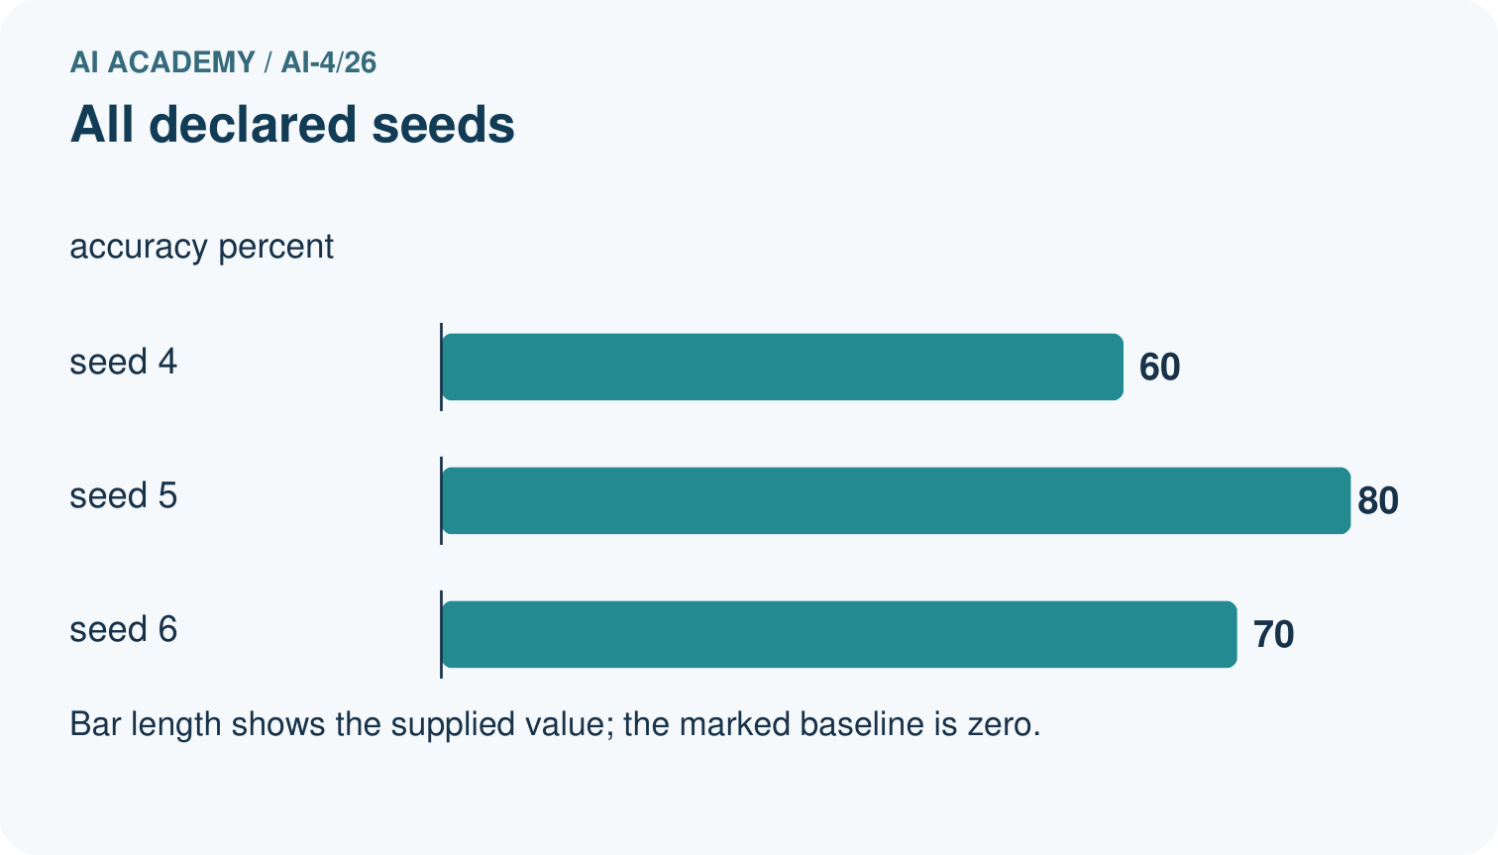
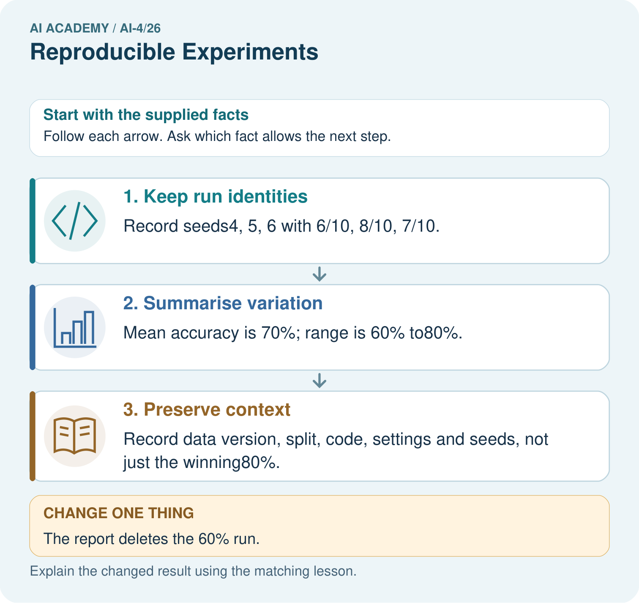

Read the picture one step at a time
Step | What happens and why
1. Keep run identities | Record seeds4, 5, 6 with 6/10, 8/10, 7/10.
2. Summarise variation | Mean accuracy is 70%; range is 60% to80%.
3. Preserve context | Record data version, split, code, settings and seeds, not just the winning80%.
Match each pictured step to the supplied facts. This is a worked teaching case, not an independent assessment.

Why this result follows
Read the picture in order. Record data version, split, code, settings and seeds, not just the winning80%. The arrows show which recorded input or intermediate result each decision uses. Explain the deciding step aloud before checking the changed case; pointing to the final answer alone does not show how it follows.

What this example does not establish
Seeds help reproduction but do not necessarily remove hardware or library nondeterminism; report the actual environment.

Change one thing in the pictured case
Change: The report deletes the 60% run.
Prediction: The remaining mean rises to75%, but the reported comparison becomes selectively incomplete.
Reason: Removing an unfavourable declared run changes the evidence rather than improving the method.

Ask while showing the picture
Cover the result. Ask learners to name the inputs and predict the next step. Uncover one step, connect the icon to the actual procedure, and explain its evidence. Then change the supplied condition and compare. The picture is a representation; it does not document execution of a real AI model.

03. Demonstrate and guide practice

Demonstrate and guide practice

Board sequence
Write the given facts: A report says accuracy85% without data split, code version, seed or preprocessing.
Write the question to explain: Specify reproducibility records.
Reveal after predictions: Record data identity, group/split IDs, code/dependency versions, preprocessing, features, settings, seeds where relevant, metric definition and raw predictions. Seed alone is insufficient.
Keep for an independent attempt: Two runs use different random splits and different feature sets. Their scores differ. What must be recorded, and why is the cause unclear?

Classroom dialogue
Ask: Which facts are given, and which would we have to assume? Learners mark relevant details before discussing answers.
Say: Predict first. Show the rule, information path or calculation that would produce the result. A correct guess is not yet an explanation.
Reveal reasoning one step at a time. Explain why a tempting alternative fails. Write units and denominators for arithmetic, trace conditions for decisions, and identify supporting sources for claims.
In pairs, one learner solves while the other checks evidence; exchange roles. Remove the worked answer before independent assessment.

Model these guided questions
Guided response: Examples: data version, split IDs, model settings, code version, metric denominator and full planned-run results. Exit response: Record the failed run, cause and any retry; disclose which runs contributed to summaries and do not invent its score.

Case-specific teaching sequence
Stage | Teacher action
Session 1 start to 7 minutes | Use the prerequisite question: What must accompany a reported validation score? Check the explanation before proceeding.
7 to 18 minutes | Read the opening and model the worked evidence. Ask students to identify seed in context.
18 to 32 minutes | Complete W 1 and W 2 with support: summarize all runs; improve a record. Require the evidence, not only the final response.
32 to 45 minutes | Read the visual row by row. Collect the guided explanation and compare reasoning in pairs. Connect each conclusion to the stated evidence.
Session 2 start to 8 minutes | Retrieve the distinction between seed and run record. Invite a counterexample to an overconfident claim.
8 to 20 minutes | Discuss the application and complete W 3: Does identical output prove a valid experiment?
20 to 35 minutes | Collect W4 independently before giving hints. Assess these outcomes: Record enough detail to reproduce a run; Distinguish reproducibility from validity. Record any support used.
35 to 45 minutes | Use W 5 and the exit response to assess limits. Give targeted feedback, then the fresh retry. Save evidence of independent understanding.

Teach the connected idea
Stage | Teacher action
Session 1 start to 7 minutes | Retrieve the prerequisite and explain the purpose in the opening section.
7 to 20 minutes | Read the worked example and diagram; ask learners to trace each step aloud.
20 to 33 minutes | Complete W1 and W2, then compare predictions with observed results.
33 to 45 minutes | Collect the guided prediction before running; discuss a mismatch and its cause.
Session 2 start to 8 minutes | Retrieve the main rule without showing the previous answer.
8 to 20 minutes | Use W3 to diagnose and repair the stated failure; rerun an earlier case.
20 to 35 minutes | Collect W4 independently, including code or plan, predictions and explanations, before hints.
35 to 45 minutes | Discuss W5 and the exit; use the fresh retry when support was needed.

Reduce help deliberately
Completion task: A file contains only seed 22 and 80 percent. Name four missing items.
Teacher check: Teacher explanation: Examples: data version, split IDs, model settings, code version, metric denominator and full planned-run results.
Start by identifying the given inputs together. Leave the intermediate steps blank. If needed, model one step, then withdraw that help on the next step. Move to a full trace only when the partial trace is understood. For partners, alternate explainer and checker; collect a response from every learner before discussion.

Individual reasoning check
Use the worked case for Experimental records and seeds. Proposed explanation: “A final answer is enough”. Decide whether this explanation is supported. Point to the step or supplied fact that decides; explain your repair if needed.
Expected correction: Ask for the relevant counts, units, procedure or saved record. For this week: Mean 70 percent; range 80-60=20 percentage points, across the three declared runs.
Collect explanations, not only yes/no votes. If a misunderstanding is common, re-model the relevant step for the class. If it affects a few learners, give a short targeted group explanation while others solve a more demanding variation.

Connected teaching cycle: Versioned experiments
Target: Record a reproducible experiment version
Reserve further sessions for this topic; the 135-minute primary plan does not absorb all added content.
Completion practice: A has fun 3 and learning 2. Score it under weights (2,1) and (1,2).
Teacher check: Scores 8 and 7.
Individual check: For Versioned experiments, use its worked case to evaluate this proposed explanation: “A successful run proves the conclusion”. Explain the deciding step.
Expected correction: Once holdout results guide another change, those cases have become development evidence. A later independent evaluation needs new reserved cases. Small holdouts still provide limited evidence.
Apply the same support, independent transfer and delayed-review decisions to the named connected-topic workbook tasks.

Pictorial practice question
What should accompany the mean 70%? Point to the relevant step in the picture, then write the changed result and the rule or evidence that supports it.

Reasoned teacher answer
The three individual run results, seed list, 60–80% range and shared evaluation conditions, so variability is visible. Changed-case check: The remaining mean rises to75%, but the reported comparison becomes selectively incomplete. Removing an unfavourable declared run changes the evidence rather than improving the method.
Changed-case reasoning: The remaining mean rises to75%, but the reported comparison becomes selectively incomplete. Removing an unfavourable declared run changes the evidence rather than improving the method.
Collect each learner’s explanation before discussion. Use the first missing connection between input, deciding step and result to choose support. This question is worked-case practice, not fresh mastery evidence.

04. Run the weekly evidence lab

Run the weekly evidence lab
Keep the test conditions fixed, record every result, and change only one planned factor.
1. Write the hypothesis and expected evidence before running.
2. Reproduction Swap: exchange incomplete experiment cards, identify missing fields, then reproduce and explain any mismatch.
3. Run one normal, one boundary, one missing, and one shifted case.
4. Calculate the metric from raw counts or row-level errors.
5. Interpret what changed, what did not, and what remains unsafe or unknown.

Make the lab runnable
Use the concrete case as the shared normal case and the independent question as a second case. Each pair creates a boundary or missing-information case and predicts its result before testing. Keep the expected result separate from an observed mistake.
Record | What to capture
Input or evidence | Exact data, instruction or claim
Expected result | Answer or safe fallback declared before the run
Observed result | Actual result, including errors
Explanation | Rule, calculation or evidence explaining the outcome
Next test | One justified change and a new prediction

Diagnose and reteach
MISCONCEPTION TO REPAIR Writing down the final accuracy makes an experiment reproducible.
For guessing, return to given facts and request a trace. For vocabulary without application, use one example and one non-example. For arithmetic errors, check the setup before the calculation. Finish with a different uncoached case before recording mastery.

Address these additional misconceptions
A final answer is enough: Ask for the relevant counts, units, procedure or saved record. For this week: Mean 70 percent; range 80-60=20 percentage points, across the three declared runs.
A stronger claim makes a stronger project: Record the failed run, cause and any retry; disclose which runs contributed to summaries and do not invent its score.
The new case can be copied from the example: The independent task changes the evidence. Require a fresh explanation: Mean 27/36=75 percent; range(10-8)/12=1/6 about 16.7 percentage points. Retain all three runs.

Check these misconceptions
A successful run proves the conclusion: Once holdout results guide another change, those cases have become development evidence. A later independent evaluation needs new reserved cases. Small holdouts still provide limited evidence.
Matching the example is enough: Require the new W4 case, explicit predictions and an explanation. Fresh retry: E (4,2), F (1,5) gives v1 10 versus 7 and v2 8 versus 11. Require a complete run log and a statement of what is held fixed.
A convenient shortcut preserves meaning: Overwriting a file called latest removes the ability to reproduce earlier results unless versions are retained elsewhere. Save identifiable versions and a run log. Avoid editing a reserved final test after seeing its output to make the chosen version look better.

Match the support to the first error
What the response shows | Next teaching action
Missing or misread facts | Read the case aloud, mark supplied versus unknown facts, and let the learner restate it.
Wrong procedure | Return to the deciding step in the worked case. Contrast it with the proposed incorrect explanation.
Arithmetic or implementation error | Trace intermediate values or lines; preserve the first mismatch and retry that step.
Correct result without a reason | Ask for a trace and a changed case before marking independent understanding.
An unsupported wider claim | Ask which supplied evidence supports the claim and which further observation would be needed.
Offer an oral explanation, drawing, enlarged visual or fewer examples when that removes a reading/writing barrier. Keep the same reasoning goal. Stretch secure learners by changing a boundary or assumption and asking them to defend the effect, not simply by assigning more of the same questions.

05. Assess and explain the answers

Assess and explain the answers

Worked case answer
Record data identity, group/split IDs, code/dependency versions, preprocessing, features, settings, seeds where relevant, metric definition and raw predictions. Seed alone is insufficient.

Independent question
Two runs use different random splits and different feature sets. Their scores differ. What must be recorded, and why is the cause unclear?

Expected independent answer
Record data version, split or seed, features, model settings, code version and metric. Since multiple factors changed, the score difference cannot be attributed to one factor.

What counts as evidence
Criterion | 0 points | 1 point | 2 points
Result | Incorrect or absent | Partly correct | Correct with necessary conditions
Reasoning | No supporting trace | Some steps | Clear mechanism, calculation or source support
Limit | Overclaims certainty | Vague limitation | Relevant uncertainty or missing fact
Transfer | Copies without adapting | Adapts with prompts | Solves a changed case independently
Use 6/8 as a classroom checkpoint, with 2 required for both Result and Reasoning. This is a proposed teaching rule, not a validated certification threshold. Do not count a coached answer as independent mastery; correct unsafe or unsupported claims regardless of total.

Feedback
Ask the learner to find the evidence that challenges this claim: “A random seed alone records every source of experimental variation.” Keep the first attempt and an uncoached retry separate.

Original transfer answer
Record dataset and label versions, identity groups and split IDs, code/dependency versions, preprocessing, features, model settings, seeds, metric definitions and raw predictions. Same seed cannot compensate for different data or procedures.

Explanations for the additional workbook examples

W1 Summarize all runs
Calculate the worked mean and range in percentage points.
Teacher explanation: Mean 70 percent; range 80-60=20 percentage points, across the three declared runs.

W2 Improve a record
A file contains only seed 22 and 80 percent. Name four missing items.
Teacher explanation: Examples: data version, split IDs, model settings, code version, metric denominator and full planned-run results.

W3 Separate two ideas
Does identical output prove a valid experiment?
Teacher explanation: No. A deterministic experiment can still contain leakage, invalid labels or an unrepresentative split.

W4 Apply independently
Declared seeds 1, 2, 3 produce 9/12, 8/12, 10/12 correct. Compute the mean accuracy and range.
Teacher explanation: Mean 27/36=75 percent; range(10-8)/12=1/6 about 16.7 percentage points. Retain all three runs.

W5 Handle a failed run
One planned seed fails before prediction. How should it appear in the record?
Teacher explanation: Record the failed run, cause and any retry; disclose which runs contributed to summaries and do not invent its score.

Versioned experiments — W1 Record a run
List five items needed to reproduce a scoring run.
Code version, input version, configuration weights, tie/eligibility rules and outputs; also record date and method as useful context.

Versioned experiments — W2 Compute a comparison
A has fun 3 and learning 2. Score it under weights (2,1) and (1,2).
Scores 8 and 7.
The weight pair is (fun weight, learning weight). Under (2,1), the score is 2*3 + 1*2 = 8. Under (1,2), it is 1*3 + 2*2 = 7. The same ratings were kept fixed; the difference comes from changing the preference policy.

Versioned experiments — W3 Repair an experiment
A learner changes weights, input ratings and the time limit together. Why is attribution difficult?
Multiple factors changed. Compare one deliberate change while holding the others fixed, or explicitly describe a multi-change experiment without attributing it to one cause.

Versioned experiments — W4 Design independently
Plan two versions for C (fun 5, learning 1) and D (fun 2, learning 5), using weights (2,1) and (1,2). Record expected scores, ranks, fixed data and a separate final-case plan.
v1 C 11, D 9 selects C; v2 C 7, D 12 selects D. Preserve the same records and other rules; reserve unseen cases until the policy is fixed.

Versioned experiments — W5 Protect evaluation
You revise the policy after reading final-case failures. Are those cases still untouched holdout evidence?
No. They now informed development. Report that use and seek fresh cases for a new independent check.

Assess independent transfer
Selected case: Declared seeds 1, 2, 3 produce 9/12, 8/12, 10/12 correct. Compute the mean accuracy and range.

Selected case answer
Teacher explanation: Mean 27/36=75 percent; range(10-8)/12=1/6 about 16.7 percentage points. Retain all three runs.
Dimension | Evidence required
Explanation | Names the applicable idea or procedure and ties it to the supplied facts.
Trace and result | Preserves the given inputs and shows the relevant intermediate steps; distinguishes a prediction from an observed execution.
Limits | States the assumptions, missing evidence or conditions under which the result would change.
Record each dimension as not yet, with support, or independent. Accept a valid alternative procedure with a defensible trace. Do not penalise an honestly recorded model failure if the learner correctly explains its evidence and limits.

Feedback that the learner uses
Name the earliest unsupported step and give one action to repair it. Have the learner make that repair now and explain why. Then assess the relevant skill on a fresh, fully specified case. Confirm it was not previously practised with feedback; solve and check the new case before assigning it. A follow-up design prompt is a starting brief, not automatically an equivalent test.

06. Connect and extend learning

Connect and extend learning

Responsible Plant Classifier
Give every Plant Classifier experiment an ID and immutable record linking dataset, split, code, settings, predictions, and metrics.
Keep the decision, input, result, explanation and remaining limitation in the project evidence record. Retrieve this record next week rather than restarting the project.

Support and stretch
Use a tiny labelled dataset, explicit units and a named positive class. Stretch: require a baseline, held-out evaluation and subgroup or shifted-condition analysis with denominators.

Exit reflection
Ask for one decision the learner can now justify and one situation requiring more evidence or human review. Confidence ratings are separate from correct independent performance.

Bridge to the next week
Next: Week 27: Overfitting. Retrieve today’s evidence and identify what carries forward and what is new.

Support and fresh reassessment
Provide a blank evidence table and allow a verbal explanation before writing. Highlight the given conditions without supplying the W 4 conclusion. Use seed and run record in full sentences. Extension: alter one condition in the worked example and explain which conclusion changes and which remains supported.
For independent W 4, require: Mean 27/36=75 percent; range(10-8)/12=1/6 about 16.7 percentage points. Retain all three runs. Fresh retry accuracies 50, 60, 70 percent: mean 60 percent, range 20 percentage points. Require all declared runs and their denominators. Mark each criterion as independent, supported or not yet demonstrated. Reassess the reasoning after feedback; do not replace the first attempt silently.
Next week: Distribution shift. Carry forward the saved evidence and the distinction between development choices and justified claims.

Readiness and reassessment for Versioned experiments
Provide a run-log table. Extension: rerun a saved version in a fresh folder and compare exact output values.
Independent W4 evidence: v1 C 11, D 9 selects C; v2 C 7, D 12 selects D. Preserve the same records and other rules; reserve unseen cases until the policy is fixed. Record whether the learner needed no help, a hint or explanation. Fresh retry: E (4,2), F (1,5) gives v1 10 versus 7 and v2 8 versus 11. Require a complete run log and a statement of what is held fixed.

Plan the delayed return
Suggested return points in this level: ai-4/27, ai-4/29, ai-4/32. Use actual classroom dates, adjusting for holidays and gaps. One, three and six teaching weeks are scheduling choices, not a claimed optimal spacing.
At a delayed check, ask for the idea from memory and a changed application. Compare with the earlier independent response and record support used. For a new level, revisit the previous capstone before checking the new prerequisites.
Record | Teacher evidence
Learner code and date
Concept and case used; prior exposure
Explanation / trace / limits
Support and first repair
Changed case and delayed outcome
Next teaching action
Use the evidence to choose reteaching or the next step. A completed page, confidence rating or attractive project does not by itself demonstrate understanding.

Project evidence from this case
For your Responsible Plant Classifier, save the input, procedure, observed result and limitation of this check. Label this worked example as practice; use a different, previously unreviewed case when checking independent understanding.

