AI ACADEMY · TEACHER · ai-4/28

Learning Curves
Project: Responsible Plant Classifier

01. Learning Curves

Teach the learning cycle
Primary target: Read training-size learning curves
Session | Sequence and minutes | Resources
Session 1 · Understand · 45 min | 0–7: recall and prerequisite; 7–15: inspect the concrete case and predict; 15–30: teacher models the worked trace; 30–40: learners explain a step using the text and visual; 40–45: check the core idea. | Sections 1–6; record the brief recall in the workbook.
Session 2 · Practise · 45 min | 0–5: retrieve the procedure; 5–15: W2 completion practice; 15–23: explain and check with a partner; 23–30: each learner answers the misconception check; 30–40: targeted reteaching or a harder variation; 40–45: prepare the investigation. | Sections 7–10; use the matching workbook W2 and misconception check.
Session 3 · Investigate and transfer · 45 min | 0–5: retrieve the decision rule; 5–20: investigate or trace; 20–30: start the independent case; 30–38: connect the project; 38–43: act on feedback; 43–45: plan the return check. | Sections 9 and 11–14. Give extra time to finish the full task set; use Section 15 when the week includes a coding lab.
This is a starting allocation of 135 minutes, not a validated duration. Preserve all named topics. Schedule extra time for connected examples, the full investigation, independent cases and project building. Repeated copies of a case share one recorded attempt; they are not new evidence.

Retrieval answer guidance

Overfitting
Without opening the old lesson, explain one key idea from Overfitting. Give an example and a mistake that the idea helps you avoid.
Look for: Compare training and validation evidence for model capacity
Reference example, not the only acceptable wording: Teacher explanation: Choose the line with validation MAE 3. The curve training MAE 0 does not compensate for validation MAE 8.

Metrics Match Consequences
Without opening the old lesson, explain one key idea from Metrics Match Consequences. Give an example and a mistake that the idea helps you avoid.
Look for: Apply a declared score threshold including equality
Reference example, not the only acceptable wording: Teacher explanation: At .5: A, B, C. At .3: A, B, C, D, E, including equality.

Train a Regression Model
Without opening the old lesson, explain one key idea from Train a Regression Model. Give an example and a mistake that the idea helps you avoid.
Look for: Fit a line from a declared training candidate set
Reference example, not the only acceptable wording: Teacher explanation: A 5 B 3 C 0; choose m 2 b 1.
Use the student module and workbook section with this exact week title. The worked case, independent question and answers below form one aligned lesson sequence.

What the learner must demonstrate
Training sizes 20,40,80 yield validation accuracies 62%,70%,73%. Is doubling again guaranteed to yield 76%? Describe a defensible next experiment.

Concept to explain
Learning curves plot performance against training size or effort and help distinguish underfitting, overfitting, and data limitation.
Term | Meaning
learning curve | performance across training sizes
bias | systematic underfitting
variance | sensitivity to particular samples
plateau | little improvement from added data

Prepare the class
Use the supplied scenario, student illustrations and blank paper. For numeric work, offer counters or a calculator after learners show the setup. Fictional records are supplied; personal data and paid accounts are unnecessary.
Allow 80 minutes: recall 8; explanation 12; worked demonstration 15; guided practice 20; independent assessment 15; project and reflection 10. Extend the lab into a second session when needed.

Preparation for the connected explanation
Teach two 45-minute sessions. This week focuses on learning curves and variability. Model the worked example first, collect the new W 4 case independently before feedback, and use the fresh retry to check transfer. Award credit for traceable reasoning and bounded claims, including justified uncertainty.

Readiness answer
Evidence about examples that did not fit the model parameters.
Printed student lesson and workbook
Paper, pencils and a calculator for fractions
The fictional examples and a blank evidence table
Saved classroom project records for critique; no personal student dataset required

End goal for the pictorial case
By the end, I can explain learning curves using a traced example and a stated limitation.
This added worked case illustrates the week’s main idea. Retain all original and connected topics; schedule its practice within the teaching cycle.

02. Explain the mechanism

Explain the mechanism
Trace the information, fitted behavior, and evaluation proof separately.
QUESTION Interpret three curve patterns and select a targeted next experiment.
MODEL IDEA Learning curves plot performance against training size or effort and help distinguish underfitting, overfitting, and data limitation.
PROOF NEEDED Use an unseen case, visible calculation, error analysis, and a stated limitation.
UNDER THE HOOD Both train and validation scores are low and close: likely underfitting. Train high, validation much lower: likely high variance or overfitting.
Draw a fresh data → model → prediction → evaluation trace:
Predict first. Then check each step. A correct answer without visible evidence cannot be audited.
STEP 1 Both train and validation scores are low and close: likely underfitting.
STEP 2 Train high, validation much lower: likely high variance or overfitting.
STEP 3 Validation improves as data grows and gap narrows: more representative data may help.
STEP 4 Curves suggest hypotheses; confirm with controlled experiments and error slices.
CHECK Verify the denominator, unit, split, class definition, and data version before interpreting a score.
Recalculate, retrace, or restate the evidence independently:

Concrete teaching case
With20,40,80 training leaves, fixed-set validation accuracy is60%,70%,78%.
Interpret the curve and uncertainty.

Exact explanation to model
These runs improve with more data. Further representative data may help, but gains are not guaranteed. Controlled repeats reveal variability.

Explain the added worked example
A learning curve asks how performance changes as the amount of training evidence grows. Keep the validation protocol, model settings and metric comparable. Use subsets of training only; never add validation rows into the training subsets. Multiple repeats reveal sensitivity to sample selection or model randomness.
Use fictional classroom data throughout this investigation. Keep the task, units, reference labels and data split visible as you reason. Earlier weeks supplied the model-building process; this week examines learning curves and variability.
At training sizes 10, 20, 40, validation MAEs across three declared repeats are [7, 9, 8], [5, 7, 6], [4, 6, 5]. Means are 8, 6, 5 and ranges 2, 2, 2. Mean training MAEs are 1, 2, 3. Validation improves as training grows, while training error rises because fitting more varied examples can be harder.
Before continuing, underline the decision rule and circle the evidence that supports the conclusion. Explain the example to a partner without replacing the counts or conditions with a stronger claim. Keep the distinction between an observed result and a proposed next step.

Key terms
Term | Meaning
Learning curve | Performance plotted against training sample size
Repeat | Another run under a recorded procedure
Variability | How much results differ between runs
Range | Maximum minus minimum of observed values

Model the reasoning aloud
Use the complete worked example below before asking learners to complete W2. Reveal a small part, invite a prediction, then explain the deciding step. These teacher notes contain solutions; do not reveal the independent case answer during modelling.

Learning curves and variability at a glance
Part | Evidence or action | Interpretation
10 training rows | Validation 7 9 8 | Mean 8 range 2
20 training rows | Validation 5 7 6 | Mean 6 range 2
40 training rows | Validation 4 6 5 | Mean 5 range 2
The decreasing gap is encouraging in this experiment. It does not establish that doubling again will halve error. A range from three repeats is a descriptive spread, not a confidence interval or a guarantee that future results fall inside it. Repeated runs can share records and therefore are not independent studies.

Why can training error rise while validation error falls? Explain the steps or evidence behind your response.
________________________________________________________________
________________________________________________________________
________________________________________________________________
________________________________________________________________
Thinking move | Teacher prompt
Plan | What is given? What is the question? Which procedure fits these facts?
Do | Point to each input and intermediate step in the worked trace. Name the rule that allows the next step.
Check | Does the output answer the question? Which assumption or limitation prevents a larger claim?
Use the diagram and verbal explanation together. Ask learners to match a sentence to a specific visual step; do not assign learners fixed visual or auditory learning styles.

A pictorial worked case: Learning Curves
Read a learning curve with repeated-run spread rather than drawing a certainty arrow.

The facts we will use
At 10 training plants validation errors across3 runs are [6, 5, 7]; at 20 plants errors [4, 5, 3], on the same 10-case validation set.
All inputs and outcomes in this worked example are invented classroom data; no real model run is claimed.
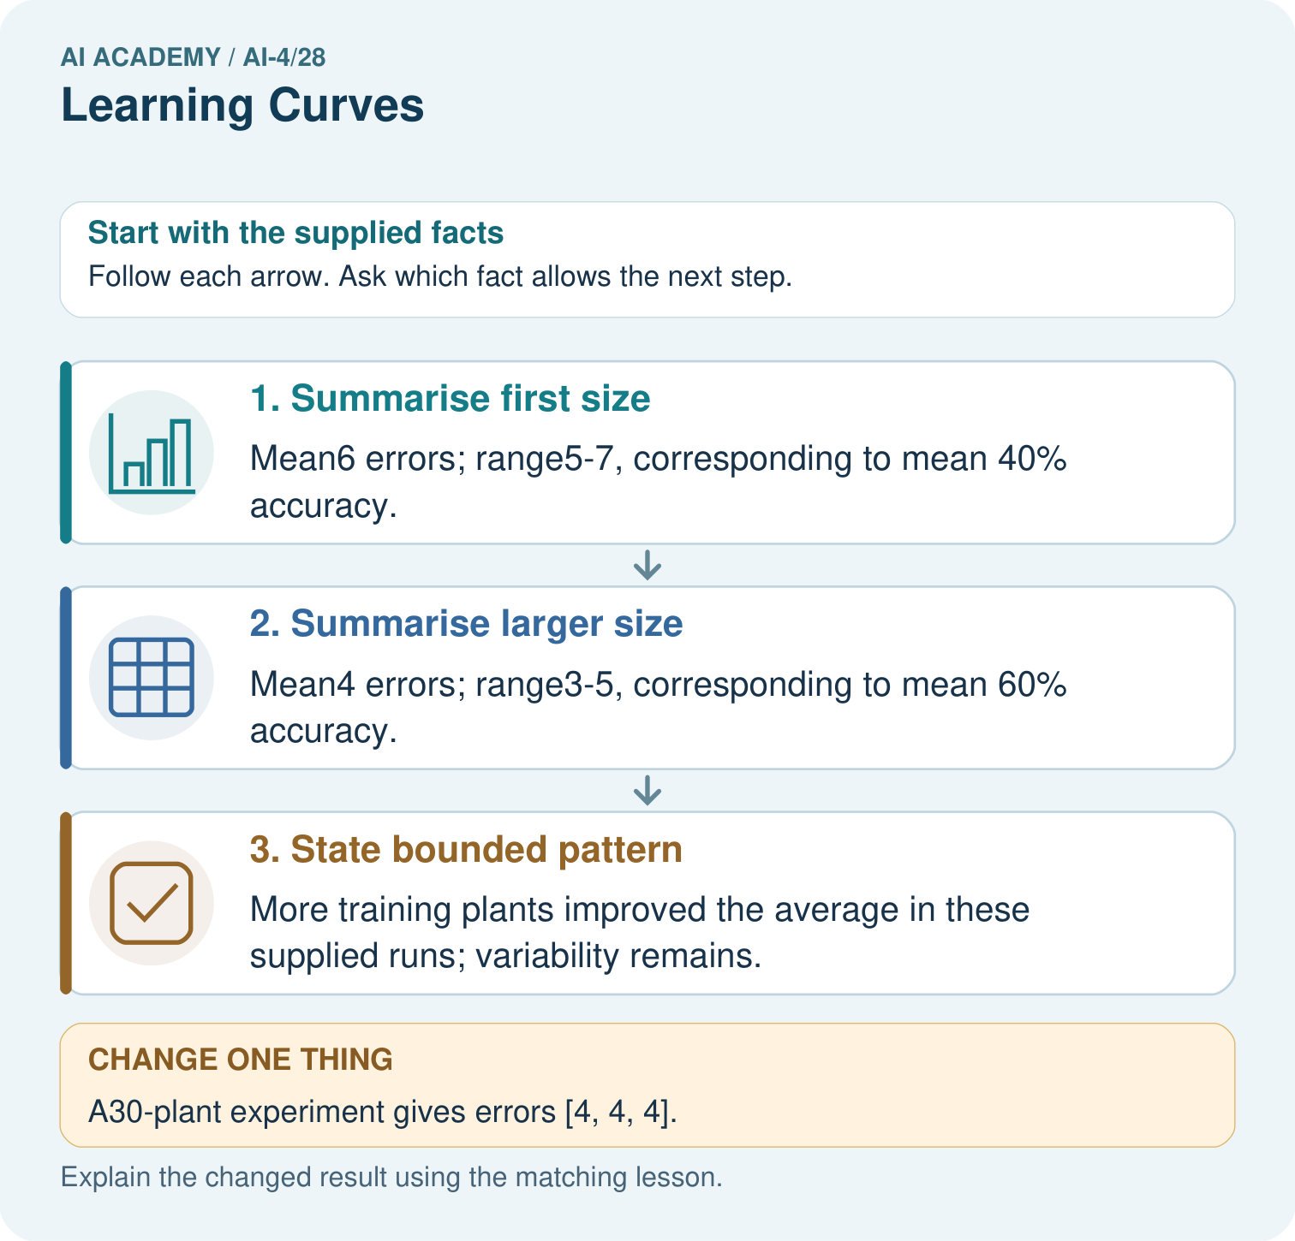

Read the picture one step at a time
Step | What happens and why
1. Summarise first size | Mean6 errors; range5–7, corresponding to mean 40% accuracy.
2. Summarise larger size | Mean4 errors; range3–5, corresponding to mean 60% accuracy.
3. State bounded pattern | More training plants improved the average in these supplied runs; variability remains.
Match each pictured step to the supplied facts. This is a worked teaching case, not an independent assessment.

Why this result follows
Read the picture in order. More training plants improved the average in these supplied runs; variability remains. The arrows show which recorded input or intermediate result each decision uses. Explain the deciding step aloud before checking the changed case; pointing to the final answer alone does not show how it follows.

What this example does not establish
These toy runs do not establish that data quantity alone caused improvement; collection quality and conditions matter.

Change one thing in the pictured case
Change: A30-plant experiment gives errors [4, 4, 4].
Prediction: Mean remains4; this additional size does not improve the observed mean over20 plants.
Reason: Learning curves are measured patterns, not a guarantee of improvement at every data size.

Ask while showing the picture
Cover the result. Ask learners to name the inputs and predict the next step. Uncover one step, connect the icon to the actual procedure, and explain its evidence. Then change the supplied condition and compare. The picture is a representation; it does not document execution of a real AI model.

03. Demonstrate and guide practice

Demonstrate and guide practice

Board sequence
Write the given facts: With20,40,80 training leaves, fixed-set validation accuracy is60%,70%,78%.
Write the question to explain: Interpret the curve and uncertainty.
Reveal after predictions: These runs improve with more data. Further representative data may help, but gains are not guaranteed. Controlled repeats reveal variability.
Keep for an independent attempt: As training examples grow from 50 to 100 to 200, validation accuracy is 60%, 72%, 78%. What does the curve suggest, and what does it not guarantee?

Classroom dialogue
Ask: Which facts are given, and which would we have to assume? Learners mark relevant details before discussing answers.
Say: Predict first. Show the rule, information path or calculation that would produce the result. A correct guess is not yet an explanation.
Reveal reasoning one step at a time. Explain why a tempting alternative fails. Write units and denominators for arithmetic, trace conditions for decisions, and identify supporting sources for claims.
In pairs, one learner solves while the other checks evidence; exchange roles. Remove the worked answer before independent assessment.

Model these guided questions
Guided response: More varied training cases may be harder to fit exactly while giving a pattern that generalizes better. Exit response: It only describes the smallest and largest observed repeats; no coverage-probability calculation or independent-sampling argument was supplied.

Case-specific teaching sequence
Stage | Teacher action
Session 1 start to 7 minutes | Use the prerequisite question: What does validation loss add to training loss? Check the explanation before proceeding.
7 to 18 minutes | Read the opening and model the worked evidence. Ask students to identify learning curve in context.
18 to 32 minutes | Complete W 1 and W 2 with support: summarize repeats; read both curves. Require the evidence, not only the final response.
32 to 45 minutes | Read the visual row by row. Collect the guided explanation and compare reasoning in pairs. Connect each conclusion to the stated evidence.
Session 2 start to 8 minutes | Retrieve the distinction between learning curve and repeat. Invite a counterexample to an overconfident claim.
8 to 20 minutes | Discuss the application and complete W 3: Can the 40-row result guarantee a mean MAE of 2.5 at 80 rows?
20 to 35 minutes | Collect W4 independently before giving hints. Assess these outcomes: Read training-size learning curves; Describe variability across repeated development runs. Record any support used.
35 to 45 minutes | Use W 5 and the exit response to assess limits. Give targeted feedback, then the fresh retry. Save evidence of independent understanding.

Reduce help deliberately
Completion task: Why can training error rise while validation error falls?
Teacher check: Teacher explanation: More varied training cases may be harder to fit exactly while giving a pattern that generalizes better.
Start by identifying the given inputs together. Leave the intermediate steps blank. If needed, model one step, then withdraw that help on the next step. Move to a full trace only when the partial trace is understood. For partners, alternate explainer and checker; collect a response from every learner before discussion.

Individual reasoning check
Use the worked case for Learning curves and variability. Proposed explanation: “A final answer is enough”. Decide whether this explanation is supported. Point to the step or supplied fact that decides; explain your repair if needed.
Expected correction: Ask for the relevant counts, units, procedure or saved record. For this week: Mean(5+7+6)/3=6; range 7-5=2.
Collect explanations, not only yes/no votes. If a misunderstanding is common, re-model the relevant step for the class. If it affects a few learners, give a short targeted group explanation while others solve a more demanding variation.

Pictorial practice question
What comparison is valid if the validation set changes between sizes? Point to the relevant step in the picture, then write the changed result and the rule or evidence that supports it.

Reasoned teacher answer
The raw change is confounded by changed evaluation cases. Prefer a fixed appropriately reserved validation set and record repeated-run variation. Changed-case check: Mean remains4; this additional size does not improve the observed mean over20 plants. Learning curves are measured patterns, not a guarantee of improvement at every data size.
Changed-case reasoning: Mean remains4; this additional size does not improve the observed mean over20 plants. Learning curves are measured patterns, not a guarantee of improvement at every data size.
Collect each learner’s explanation before discussion. Use the first missing connection between input, deciding step and result to choose support. This question is worked-case practice, not fresh mastery evidence.

04. Run the weekly evidence lab

Run the weekly evidence lab
Keep the test conditions fixed, record every result, and change only one planned factor.
1. Write the hypothesis and expected evidence before running.
2. Curve Clinic: match three graphs to diagnoses, challenge each diagnosis, and propose the smallest informative experiment.
3. Run one normal, one boundary, one missing, and one shifted case.
4. Calculate the metric from raw counts or row-level errors.
5. Interpret what changed, what did not, and what remains unsafe or unknown.

Make the lab runnable
Use the concrete case as the shared normal case and the independent question as a second case. Each pair creates a boundary or missing-information case and predicts its result before testing. Keep the expected result separate from an observed mistake.
Record | What to capture
Input or evidence | Exact data, instruction or claim
Expected result | Answer or safe fallback declared before the run
Observed result | Actual result, including errors
Explanation | Rule, calculation or evidence explaining the outcome
Next test | One justified change and a new prediction

Diagnose and reteach
MISCONCEPTION TO REPAIR Every learning curve that rises proves more data will solve the problem.
For guessing, return to given facts and request a trace. For vocabulary without application, use one example and one non-example. For arithmetic errors, check the setup before the calculation. Finish with a different uncoached case before recording mastery.

Address these additional misconceptions
A final answer is enough: Ask for the relevant counts, units, procedure or saved record. For this week: Mean(5+7+6)/3=6; range 7-5=2.
A stronger claim makes a stronger project: It only describes the smallest and largest observed repeats; no coverage-probability calculation or independent-sampling argument was supplied.
The new case can be copied from the example: The independent task changes the evidence. Require a fresh explanation: Means 7 and 6; ranges 2 and 3. The larger condition improves the mean by 1 but has greater observed spread in these three repeats.

Match the support to the first error
What the response shows | Next teaching action
Missing or misread facts | Read the case aloud, mark supplied versus unknown facts, and let the learner restate it.
Wrong procedure | Return to the deciding step in the worked case. Contrast it with the proposed incorrect explanation.
Arithmetic or implementation error | Trace intermediate values or lines; preserve the first mismatch and retry that step.
Correct result without a reason | Ask for a trace and a changed case before marking independent understanding.
An unsupported wider claim | Ask which supplied evidence supports the claim and which further observation would be needed.
Offer an oral explanation, drawing, enlarged visual or fewer examples when that removes a reading/writing barrier. Keep the same reasoning goal. Stretch secure learners by changing a boundary or assumption and asking them to defend the effect, not simply by assigning more of the same questions.

05. Assess and explain the answers

Assess and explain the answers

Worked case answer
These runs improve with more data. Further representative data may help, but gains are not guaranteed. Controlled repeats reveal variability.

Independent question
As training examples grow from 50 to 100 to 200, validation accuracy is 60%, 72%, 78%. What does the curve suggest, and what does it not guarantee?

Expected independent answer
More representative data helped over these measured sizes, with smaller later gains. It does not guarantee continued improvement or performance in untested conditions.

What counts as evidence
Criterion | 0 points | 1 point | 2 points
Result | Incorrect or absent | Partly correct | Correct with necessary conditions
Reasoning | No supporting trace | Some steps | Clear mechanism, calculation or source support
Limit | Overclaims certainty | Vague limitation | Relevant uncertainty or missing fact
Transfer | Copies without adapting | Adapts with prompts | Solves a changed case independently
Use 6/8 as a classroom checkpoint, with 2 required for both Result and Reasoning. This is a proposed teaching rule, not a validated certification threshold. Do not count a coached answer as independent mastery; correct unsafe or unsupported claims regardless of total.

Feedback
Ask the learner to find the evidence that challenges this claim: “An improving learning curve guarantees unlimited future gains.” Keep the first attempt and an uncoached retry separate.

Original transfer answer
No. Gains need not be linear or continue. Keep validation fixed, add representative training examples, record exact subsets and repeat stochastic runs. Compare variation and collection costs; do not imply the line predicts an unmeasured size.

Explanations for the additional workbook examples

W1 Summarize repeats
Calculate the mean and range for the 20-row condition.
Teacher explanation: Mean(5+7+6)/3=6; range 7-5=2.
For the stated 20-row condition, add the run results 5, 7 and 6 to obtain 18 and divide by three to obtain mean 6. Range is largest minus smallest: 7 - 5 = 2. Keep the number of repeated runs distinct from the number of data rows.

W2 Read both curves
Why can training error rise while validation error falls?
Teacher explanation: More varied training cases may be harder to fit exactly while giving a pattern that generalizes better.

W3 Avoid extrapolation
Can the 40-row result guarantee a mean MAE of 2.5 at 80 rows?
Teacher explanation: No. The observed trend does not establish a fixed proportional improvement.

W4 Apply independently
At sizes 12 and 24, validation errors are [6, 8, 7] and [4, 7, 7]. Calculate means/ranges and a careful comparison.
Teacher explanation: Means 7 and 6; ranges 2 and 3. The larger condition improves the mean by 1 but has greater observed spread in these three repeats.

W5 Explain the spread
Why is an observed range not a confidence interval?
Teacher explanation: It only describes the smallest and largest observed repeats; no coverage-probability calculation or independent-sampling argument was supplied.

Assess independent transfer
Selected case: At sizes 12 and 24, validation errors are [6, 8, 7] and [4, 7, 7]. Calculate means/ranges and a careful comparison.

Selected case answer
Teacher explanation: Means 7 and 6; ranges 2 and 3. The larger condition improves the mean by 1 but has greater observed spread in these three repeats.
Dimension | Evidence required
Explanation | Names the applicable idea or procedure and ties it to the supplied facts.
Trace and result | Preserves the given inputs and shows the relevant intermediate steps; distinguishes a prediction from an observed execution.
Limits | States the assumptions, missing evidence or conditions under which the result would change.
Record each dimension as not yet, with support, or independent. Accept a valid alternative procedure with a defensible trace. Do not penalise an honestly recorded model failure if the learner correctly explains its evidence and limits.

Feedback that the learner uses
Name the earliest unsupported step and give one action to repair it. Have the learner make that repair now and explain why. Then assess the relevant skill on a fresh, fully specified case. Confirm it was not previously practised with feedback; solve and check the new case before assigning it. A follow-up design prompt is a starting brief, not automatically an equivalent test.

06. Connect and extend learning

Connect and extend learning

Responsible Plant Classifier
Plot Plant Classifier train/validation performance at several training sizes and document the chosen next action.
Keep the decision, input, result, explanation and remaining limitation in the project evidence record. Retrieve this record next week rather than restarting the project.

Support and stretch
Use a tiny labelled dataset, explicit units and a named positive class. Stretch: require a baseline, held-out evaluation and subgroup or shifted-condition analysis with denominators.

Exit reflection
Ask for one decision the learner can now justify and one situation requiring more evidence or human review. Confidence ratings are separate from correct independent performance.

Bridge to the next week
Next: Week 29: Feature Engineering. Retrieve today’s evidence and identify what carries forward and what is new.

Support and fresh reassessment
Provide a blank evidence table and allow a verbal explanation before writing. Highlight the given conditions without supplying the W 4 conclusion. Use learning curve and repeat in full sentences. Extension: alter one condition in the worked example and explain which conclusion changes and which remains supported.
For independent W 4, require: Means 7 and 6; ranges 2 and 3. The larger condition improves the mean by 1 but has greater observed spread in these three repeats. Fresh retry errors [3, 5, 7]: mean 5, range 4. Require the description to say three observed runs rather than a guaranteed future interval. Mark each criterion as independent, supported or not yet demonstrated. Reassess the reasoning after feedback; do not replace the first attempt silently.
Next week: Feature engineering. Carry forward the saved evidence and the distinction between development choices and justified claims.

Plan the delayed return
Suggested return points in this level: ai-4/29, ai-4/31, ai-4/34. Use actual classroom dates, adjusting for holidays and gaps. One, three and six teaching weeks are scheduling choices, not a claimed optimal spacing.
At a delayed check, ask for the idea from memory and a changed application. Compare with the earlier independent response and record support used. For a new level, revisit the previous capstone before checking the new prerequisites.
Record | Teacher evidence
Learner code and date
Concept and case used; prior exposure
Explanation / trace / limits
Support and first repair
Changed case and delayed outcome
Next teaching action
Use the evidence to choose reteaching or the next step. A completed page, confidence rating or attractive project does not by itself demonstrate understanding.

Project evidence from this case
For your Responsible Plant Classifier, save the input, procedure, observed result and limitation of this check. Label this worked example as practice; use a different, previously unreviewed case when checking independent understanding.

