AI ACADEMY · TEACHER · ai-5/1

Representing inputs as vectors
Project: Image-pattern Network Investigation

01. Prepare the purpose, prerequisites and materials

Teach the learning cycle
Primary target: Encode a record using a fixed feature order and units
Session | Sequence and minutes | Resources
Session 1 · Understand · 45 min | 0–7: recall and prerequisite; 7–15: inspect the concrete case and predict; 15–30: teacher models the worked trace; 30–40: learners explain a step using the text and visual; 40–45: check the core idea. | Sections 1–6; record the brief recall in the workbook.
Session 2 · Practise · 45 min | 0–5: retrieve the procedure; 5–15: W2 completion practice; 15–23: explain and check with a partner; 23–30: each learner answers the misconception check; 30–40: targeted reteaching or a harder variation; 40–45: prepare the investigation. | Sections 7–10; use the matching workbook W2 and misconception check.
Session 3 · Investigate and transfer · 45 min | 0–5: retrieve the decision rule; 5–20: investigate or trace; 20–30: start the independent case; 30–38: connect the project; 38–43: act on feedback; 43–45: plan the return check. | Sections 9 and 11–14. Give extra time to finish the full task set; use Section 15 when the week includes a coding lab.
This is a starting allocation of 135 minutes, not a validated duration. Preserve all named topics. Schedule extra time for connected examples, the full investigation, independent cases and project building. Repeated copies of a case share one recorded attempt; they are not new evidence.

Retrieval answer guidance

ML Builder Expo
Without opening the old lesson, explain one key idea from ML Builder Expo. Give an example and a mistake that the idea helps you avoid.
Look for: Defend the project using traceable evidence
Reference example, not the only acceptable wording: Teacher explanation: A valid response names the fictional task, reports an auditable baseline/candidate comparison with denominator, and restricts the claim to the evaluated setup.
Begin Grade 9 by connecting the Grade 8 feature table to an ordered numerical input. Students should name every component before calculating. Use two 45-minute sessions. Avoid treating a vector as a mysterious neural object: the learning target is a precise data contract, including order, units, missing values and the distinction between inputs and targets.

Outcomes
Encode a record using a fixed feature order and units
Distinguish a vector dimension from the number of examples
Detect missing values and target leakage before computation

Preparation
Printed lesson and workbook; paper and pencil
Calculator and optional local Python 3 editor; no packages or AI accounts needed
Use the fictional examples supplied; prepare the fresh retry before class

Prerequisite answer
The class is the target being predicted. Supplying that answer as an input leaks information that would not be available for a new prediction.

End goal for the pictorial case
By the end, I can explain representing inputs as vectors using a traced example and a stated limitation.
This added worked case illustrates the week’s main idea. Retain all original and connected topics; schedule its practice within the teaching cycle.

02. Explain and model the mechanism
A neural network receives numbers in a specified order. Before learning how it computes, we need to represent one example without losing the meaning of its fields. A vector is an ordered list: [4, 2] can mean width 4 cm and height 2 cm if that is the declared order. Reversing the two numbers describes a different rectangle under the same schema.
For this fictional parcel investigation, use [width in cm, height in cm]. Width and height must both be present and greater than zero. The vector has dimension 2 because it contains two components. Record IDs identify examples; they do not measure the parcel. The target class is stored separately.
There are three examples, each with two features. Stacking their vectors makes a table with three rows and two columns. Do not confuse the number of rows with the dimension of one input.
Read fields by name, convert to the declared units, validate, and only then write the vector. Parcel D has width 50 mm and height 30 mm. Because 10 mm equals 1 cm, its encoded vector is [5, 3]. Writing [50, 30] would preserve the numbers while changing the physical meaning by a factor of ten.
This short function assumes each supplied value is a number in mm or None for missing. It is a classroom example, not a complete input validator. Trace the conversion before running it. The function represents data; it does not fit a model or predict a class.
Term | Meaning
Vector | An ordered list of numerical components
Component | One value at a specified position in a vector
Dimension | The number of components in a vector
Schema | The recorded feature order, units and validity rules

An input vector keeps an agreed order
Source record | Encoding action | Model input
D width 50 mm | Divide width by 10 | First component 5
D height 30 mm | Divide height by 10 | Second component 3
Schema width then height | Keep named positions | Vector [5, 3] in cm
Read each row left to right, then assemble the final ordered pair. The schema explains the numbers; the vector alone does not.
Guided E: [2, 7]. The reversed [7, 2] means width 7 cm and height 2 cm, a different measurement pair. Exit: [4, 2] reveals only width and height under the schema. It cannot reveal the omitted distinction causing different labels; the same deterministic input receives the same output.

Model the reasoning aloud
Use the complete worked example below before asking learners to complete W2. Reveal a small part, invite a prediction, then explain the deciding step. These teacher notes contain solutions; do not reveal the independent case answer during modelling.

An input vector keeps an agreed order
Source record | Encoding action | Model input
D width 50 mm | Divide width by 10 | First component 5
D height 30 mm | Divide height by 10 | Second component 3
Schema width then height | Keep named positions | Vector [5, 3] in cm
Read each row left to right, then assemble the final ordered pair. The schema explains the numbers; the vector alone does not.

Parcel E has width 20 mm and height 70 mm. Encode it and explain why [7, 2] is not the same input under this schema.
________________________________________________________________
________________________________________________________________
________________________________________________________________
________________________________________________________________
Thinking move | Teacher prompt
Plan | What is given? What is the question? Which procedure fits these facts?
Do | Point to each input and intermediate step in the worked trace. Name the rule that allows the next step.
Check | Does the output answer the question? Which assumption or limitation prevents a larger claim?
Use the diagram and verbal explanation together. Ask learners to match a sentence to a specific visual step; do not assign learners fixed visual or auditory learning styles.

A pictorial worked case: Representing inputs as vectors
Encode the same pixel measurements in a fixed vector order.

The facts we will use
Toy image features are [left_brightness, right_brightness], each = 0..10. ImageA has left2, right7; imageB has left7, right2.
All inputs and outcomes in this worked example are invented classroom data; no real model run is claimed.
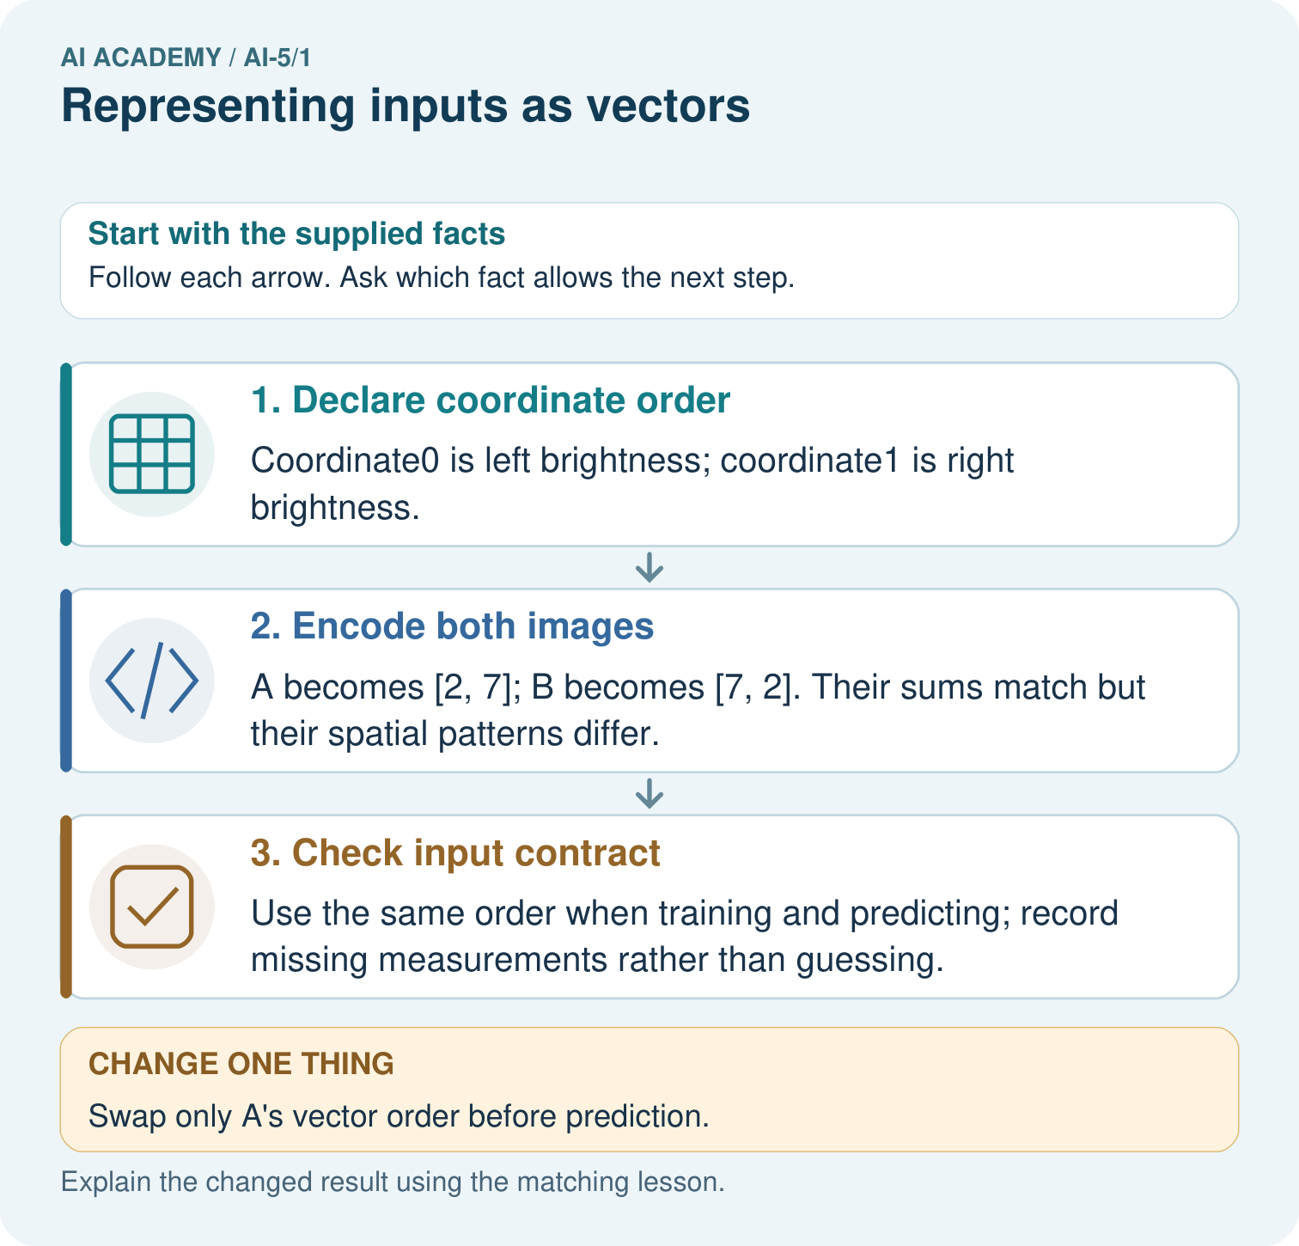

Read the picture one step at a time
Step | What happens and why
1. Declare coordinate order | Coordinate0 is left brightness; coordinate1 is right brightness.
2. Encode both images | A becomes [2, 7]; B becomes [7, 2]. Their sums match but their spatial patterns differ.
3. Check input contract | Use the same order when training and predicting; record missing measurements rather than guessing.
Match each pictured step to the supplied facts. This is a worked teaching case, not an independent assessment.

Why this result follows
A vector is an ordered list, so the position of a number carries meaning. Here the first number always means left brightness. Adding the two measurements keeps total brightness but discards which side is brighter. A network receives the representation we give it; it cannot recover a lost distinction just because it has more layers.

What this example does not establish
These two features are simplified measurements, not a complete image representation or evidence of learned vision.

Change one thing in the pictured case
Change: Swap only A’s vector order before prediction.
Prediction: The encoded input becomes [7, 2], numerically identical to B’s original input.
Reason: Changing coordinate order changes feature meaning even if the numbers are unchanged.

Ask while showing the picture
Cover the result. Ask learners to name the inputs and predict the next step. Uncover one step, connect the icon to the actual procedure, and explain its evidence. Then change the supplied condition and compare. The picture is a representation; it does not document execution of a real AI model.

03. Demonstrate and guide practice
Time or stage | Teacher action
Session 1 start to 7 minutes | Ask the prerequisite question. Retrieve the distinction between a feature and a target; require a prediction-time explanation.
7 to 18 minutes | Place A, B and C on paper. Students label horizontal width and vertical height, then write vectors with the schema above them.
18 to 32 minutes | Complete W1 and W2. Contrast three examples with two components per example. Model the mm-to-cm conversion explicitly.
32 to 45 minutes | Trace the Python function or its paper equivalent. Complete the guided E case and compare the swapped vector.
Session 2 start to 8 minutes | Retrieve the schema without looking. Ask how two correctly sized vectors can have different meanings.
8 to 20 minutes | Use W3 and the identical-input example. Discuss valid zero in another schema without changing the parcel rule.
20 to 35 minutes | Collect W4 independently before giving hints. Check field order, dimensions, valid age zero and the excluded future target.
35 to 45 minutes | Use W5 and the exit response. Give targeted feedback, then administer the fresh retry and retain both attempts.
Use the worked example in Sections 3 and 6. Collect a prediction before revealing its result; ask the learner to point to each intermediate fact.
Provide empty boxes labelled with feature names and units. Accept a correct spoken explanation before written notation. Extension: propose two different real objects that share the same two-feature vector, then identify an additional measurable feature available before prediction.

Reduce help deliberately
Completion task: A new record has width 60 mm and height 10 mm. Give its vector in the agreed cm schema, and name one error in [60, 10].
Teacher check: Teacher explanation: The vector is [6, 1]. [60, 10] uses mm numbers where cm numbers are expected, scaling both measurements tenfold.
Start by identifying the given inputs together. Leave the intermediate steps blank. If needed, model one step, then withdraw that help on the next step. Move to a full trace only when the partial trace is understood. For partners, alternate explainer and checker; collect a response from every learner before discussion.

Individual reasoning check
Use the worked case for Representing inputs as vectors. Proposed explanation: “Order does not matter”. Decide whether this explanation is supported. Point to the step or supplied fact that decides; explain your repair if needed.
Expected correction: A and B use the same numbers but assign them to different features. Read each position by name.
Collect explanations, not only yes/no votes. If a misunderstanding is common, re-model the relevant step for the class. If it affects a few learners, give a short targeted group explanation while others solve a more demanding variation.

Pictorial practice question
Why does equal total brightness not make A and B identical inputs? Point to the relevant step in the picture, then write the changed result and the rule or evidence that supports it.

Reasoned teacher answer
A and B place brightness in different positions. The ordered vectors distinguish left/right structure; their common sum 9 loses that distinction. Changed-case check: The encoded input becomes [7, 2], numerically identical to B’s original input. Changing coordinate order changes feature meaning even if the numbers are unchanged.
Changed-case reasoning: The encoded input becomes [7, 2], numerically identical to B’s original input. Changing coordinate order changes feature meaning even if the numbers are unchanged.
Collect each learner’s explanation before discussion. Use the first missing connection between input, deciding step and result to choose support. This question is worked-case practice, not fresh mastery evidence.

04. Run the investigation and diagnose misconceptions
Order does not matter: A and B use the same numbers but assign them to different features. Read each position by name.
More rows increase vector dimension: Rows count examples; components count features of one example.
A missing value is zero: Whether zero is valid depends on the field. Missing means unknown, and is not interchangeable with a measured zero.
Use Section 9 for the evidence ledger. Add a boundary or missing-input case and record the expected response before checking. More successful repeats of one case do not establish wider coverage.

Match the support to the first error
What the response shows | Next teaching action
Missing or misread facts | Read the case aloud, mark supplied versus unknown facts, and let the learner restate it.
Wrong procedure | Return to the deciding step in the worked case. Contrast it with the proposed incorrect explanation.
Arithmetic or implementation error | Trace intermediate values or lines; preserve the first mismatch and retry that step.
Correct result without a reason | Ask for a trace and a changed case before marking independent understanding.
An unsupported wider claim | Ask which supplied evidence supports the claim and which further observation would be needed.
Offer an oral explanation, drawing, enlarged visual or fewer examples when that removes a reading/writing barrier. Keep the same reasoning goal. Stretch secure learners by changing a boundary or assumption and asking them to defend the effect, not simply by assigning more of the same questions.

05. Assess and explain the answers

Guided and exit questions
Guided E: [2, 7]. The reversed [7, 2] means width 7 cm and height 2 cm, a different measurement pair. Exit: [4, 2] reveals only width and height under the schema. It cannot reveal the omitted distinction causing different labels; the same deterministic input receives the same output.

W1 Encode the records
Write A, B and C as ordered pairs from the lesson. State the dimension of each and the shape of the stacked table.
Teacher explanation: A [4, 2], B [2, 4], C [3, 3]. Each has dimension 2. The table has 3 rows and 2 columns.

W2 Convert before encoding
A new record has width 60 mm and height 10 mm. Give its vector in the agreed cm schema, and name one error in [60, 10].
Teacher explanation: The vector is [6, 1]. [60, 10] uses mm numbers where cm numbers are expected, scaling both measurements tenfold.

W3 Handle missing information
Width is 4 cm and height is missing. A teammate writes [4, 0]. Explain why this is invalid and give the action required by this schema.
Teacher explanation: Missing is not measured zero. Height must be present and positive; reject the record and request a valid measurement before encoding.

W4 Apply a new schema independently
A new toy battery task uses [temperature in degrees C, voltage in V, age in days]. Record K has voltage 5, age 12, temperature 18. Record L has temperature 20, voltage 4, age 0. Encode both; state the vector dimension and table shape. Age zero is valid. The future failure label is also supplied in the data file: should it be appended?
Teacher explanation: K [18, 5, 12], L [20, 4, 0]. Dimension 3, table 2 rows by 3 columns. Age zero is a valid known value. Exclude the future failure target from inputs; it is not available at prediction time.

W5 Explain a collision
Two parcels have the same width and height but different material and target class. Explain why adding more examples alone cannot let this deterministic two-feature model tell these two inputs apart.
Teacher explanation: The two input vectors are identical, so the fixed deterministic computation returns the same output. Additional rows do not create a missing distinction in these two vectors; a relevant available feature or an explicit uncertainty policy may be needed.

Independent assessment and fresh retry
Assess W4 for named order, all values retained, dimension 3, two-row shape and exclusion of the future label. Fresh retry: schema [mass in g, length in cm]; two records (length 4, mass 12) and (mass 9, length 6) encode as [12, 4] and [9, 6], dimension 2, table 2 by 2. Ask why an absent mass must not become zero without a declared policy.

Assess independent transfer
Selected case: A new toy battery task uses [temperature in degrees C, voltage in V, age in days]. Record K has voltage 5, age 12, temperature 18. Record L has temperature 20, voltage 4, age 0. Encode both; state the vector dimension and table shape. Age zero is valid. The future failure label is also supplied in the data file: should it be appended?

Selected case answer
Teacher explanation: K [18, 5, 12], L [20, 4, 0]. Dimension 3, table 2 rows by 3 columns. Age zero is a valid known value. Exclude the future failure target from inputs; it is not available at prediction time.
Dimension | Evidence required
Explanation | Names the applicable idea or procedure and ties it to the supplied facts.
Trace and result | Preserves the given inputs and shows the relevant intermediate steps; distinguishes a prediction from an observed execution.
Limits | States the assumptions, missing evidence or conditions under which the result would change.
Record each dimension as not yet, with support, or independent. Accept a valid alternative procedure with a defensible trace. Do not penalise an honestly recorded model failure if the learner correctly explains its evidence and limits.

Feedback that the learner uses
Name the earliest unsupported step and give one action to repair it. Have the learner make that repair now and explain why. Then assess the relevant skill on a fresh, fully specified case. Confirm it was not previously practised with feedback; solve and check the new case before assigning it. A follow-up design prompt is a starting brief, not automatically an equivalent test.

06. Connect the project, support and next lesson
Add a labelled representing inputs as vectors evidence sheet to Image-pattern Network Investigation. Show how you can encode a record using a fixed feature order and units. Use the supplied fictional case and keep its inputs, intermediate steps, calculation or prediction, and limitation. Connect this record to last week’s record; a matching answer without a trace is insufficient.
Provide empty boxes labelled with feature names and units. Accept a correct spoken explanation before written notation. Extension: propose two different real objects that share the same two-feature vector, then identify an additional measurable feature available before prediction.
Week 2 uses the ordered components in dot products. Revisit order and signed multiplication before introducing weights.
Retain the project ledger and assess a changed case after support. Check the relevant prerequisite before carrying this component forward.

Plan the delayed return
Suggested return points in this level: ai-5/2, ai-5/4, ai-5/7. Use actual classroom dates, adjusting for holidays and gaps. One, three and six teaching weeks are scheduling choices, not a claimed optimal spacing.
At a delayed check, ask for the idea from memory and a changed application. Compare with the earlier independent response and record support used. For a new level, revisit the previous capstone before checking the new prerequisites.
Record | Teacher evidence
Learner code and date
Concept and case used; prior exposure
Explanation / trace / limits
Support and first repair
Changed case and delayed outcome
Next teaching action
Use the evidence to choose reteaching or the next step. A completed page, confidence rating or attractive project does not by itself demonstrate understanding.

Project evidence from this case
For your Image-pattern Network Investigation, save the input, procedure, observed result and limitation of this check. Label this worked example as practice; use a different, previously unreviewed case when checking independent understanding.

