AI ACADEMY · TEACHER · ai-5/13

Batching and epochs
Project: Image-pattern Network Investigation

01. Prepare the purpose, prerequisites and materials

Teach the learning cycle
Primary target: Distinguish an example a batch an update and an epoch
Session | Sequence and minutes | Resources
Session 1 · Understand · 45 min | 0–7: recall and prerequisite; 7–15: inspect the concrete case and predict; 15–30: teacher models the worked trace; 30–40: learners explain a step using the text and visual; 40–45: check the core idea. | Sections 1–6; record the brief recall in the workbook.
Session 2 · Practise · 45 min | 0–5: retrieve the procedure; 5–15: W2 completion practice; 15–23: explain and check with a partner; 23–30: each learner answers the misconception check; 30–40: targeted reteaching or a harder variation; 40–45: prepare the investigation. | Sections 7–10; use the matching workbook W2 and misconception check.
Session 3 · Investigate and transfer · 45 min | 0–5: retrieve the decision rule; 5–20: investigate or trace; 20–30: start the independent case; 30–38: connect the project; 38–43: act on feedback; 43–45: plan the return check. | Sections 9 and 11–14. Give extra time to finish the full task set; use Section 15 when the week includes a coding lab.
This is a starting allocation of 135 minutes, not a validated duration. Preserve all named topics. Schedule extra time for connected examples, the full investigation, independent cases and project building. Repeated copies of a case share one recorded attempt; they are not new evidence.

Retrieval answer guidance

Training a small network
Without opening the old lesson, explain one key idea from Training a small network. Give an example and a mistake that the idea helps you avoid.
Look for: Trace repeated forward loss gradient and update steps
Reference example, not the only acceptable wording: Teacher explanation: Predictions [0, 0], errors [-2, -4], MSE 10, gradient -10 and new v = 1.

Gradients with a numerical check
Without opening the old lesson, explain one key idea from Gradients with a numerical check. Give an example and a mistake that the idea helps you avoid.
Look for: Estimate one partial derivative while other parameters stay fixed
Reference example, not the only acceptable wording: Teacher explanation: Prediction 3, residual 0, loss 0, gradient [0, 0].

Parameters and architecture
Without opening the old lesson, explain one key idea from Parameters and architecture. Give an example and a mistake that the idea helps you avoid.
Look for: Distinguish architectural choices from parameter values
Reference example, not the only acceptable wording: Teacher explanation: There are 8 weights and 2 biases, total 10.
Use two 45-minute sessions to separate counting from numerical training. Keep the frozen hidden layer from Week 12. Have students move paper record cards into batches before doing arithmetic. The coincident final values for the proportional-target example require the independent counterexample; do not teach that ordering is generally irrelevant.

Outcomes
Distinguish an example a batch an update and an epoch
Trace parameter changes across successive batches
Calculate update counts and aggregate unequal batch losses correctly

Preparation
Printed lesson and workbook; paper and pencil
Calculator and optional local Python 3 editor; no packages or AI accounts needed
Use the fictional examples supplied; prepare the fresh retry before class

Prerequisite answer
Four updates occurred. State zero was the initial model before training.

End goal for the pictorial case
By the end, I can explain batching and epochs using a traced example and a stated limitation.
This added worked case illustrates the week’s main idea. Retain all original and connected topics; schedule its practice within the teaching cycle.

02. Explain and model the mechanism
In Week 12 every update used both training examples. We now keep the same network h = ReLU(x), y = vh, with only v trained, and divide the data into batches. In this lesson each nonempty batch produces exactly one update. An epoch visits every training example exactly once, without replacement. These rules make the counts unambiguous.
Imagine five fictional records A through E in fixed order. With batch size 2, the groups are [A, B], [C, D] and [E]. Keep the smaller last batch. One epoch has three batches and three updates; two epochs have six updates and ten example visits.
When the last batch is retained, updates per epoch equal the row count divided by batch size rounded up. A program that drops the final incomplete batch follows a different rule and omits examples in that pass. Record the rule instead of silently changing the denominator.
Use the two fictional pairs A = (1, 2) and B = (2, 4), start v = 0 and rate 0.1. For one pair with hidden value h, squared-error gradient is 2 times (vh - target) times h. For a batch, average these gradients at the same current v. Apply one update, then recompute for the next batch.
Assume finite numeric pairs, integer size and finite rate. With size 1, A gives gradient -4 and new v = 0.4. B then uses 0.4, giving prediction 0.8, residual -3.2 and gradient -12.8, so v becomes 1.68. With size 2, both gradients are evaluated at v = 0; their mean is -10, producing v = 1.
Term | Meaning
Batch | A group of training examples used together to calculate one gradient here
Update | One application of the gradient and learning rate to the current parameters
Epoch | One pass through all training examples under the stated sampling rule
Batch size | The intended number of examples in each batch with a possible smaller final batch

One pass can contain different numbers of updates
Batch rule | Parameter after each batch | Updates
A then B separately | 0 to 0.4 to 1.68 | 2
A and B together | 0 to 1 | 1
B then A separately | 0 to 1.6 to 1.68 | 2
All three passes visit two examples. The reversed order happens to end at the same value for these proportional targets; that coincidence is not a general order-invariance rule.
Guided: B at v = 0 gives gradient -16 and v = 1.6. A then gives residual -0.4, gradient -0.8 and v = 1.68. Two batches each cause one update. Exit: both teams visit ten examples. Size 2 produces six updates; size 5 produces two. Record both budgets and all training settings.

Model the reasoning aloud
Use the complete worked example below before asking learners to complete W2. Reveal a small part, invite a prediction, then explain the deciding step. These teacher notes contain solutions; do not reveal the independent case answer during modelling.

One pass can contain different numbers of updates
Batch rule | Parameter after each batch | Updates
A then B separately | 0 to 0.4 to 1.68 | 2
A and B together | 0 to 1 | 1
B then A separately | 0 to 1.6 to 1.68 | 2
All three passes visit two examples. The reversed order happens to end at the same value for these proportional targets; that coincidence is not a general order-invariance rule.

For B then A separately, show both gradients and new parameter values. Why does one epoch still contain two updates?
________________________________________________________________
________________________________________________________________
________________________________________________________________
________________________________________________________________
Thinking move | Teacher prompt
Plan | What is given? What is the question? Which procedure fits these facts?
Do | Point to each input and intermediate step in the worked trace. Name the rule that allows the next step.
Check | Does the output answer the question? Which assumption or limitation prevents a larger claim?
Use the diagram and verbal explanation together. Ask learners to match a sentence to a specific visual step; do not assign learners fixed visual or auditory learning styles.

A pictorial worked case: Batching and epochs
Show why an epoch’s example order can matter for single-example updates.

The facts we will use
Toy y=wx, rate 0.1, squared loss, start w = 0. Training A=(x = 1, target 2), B=(x = 2, target 0).
All inputs and outcomes in this worked example are invented classroom data; no real model run is claimed.
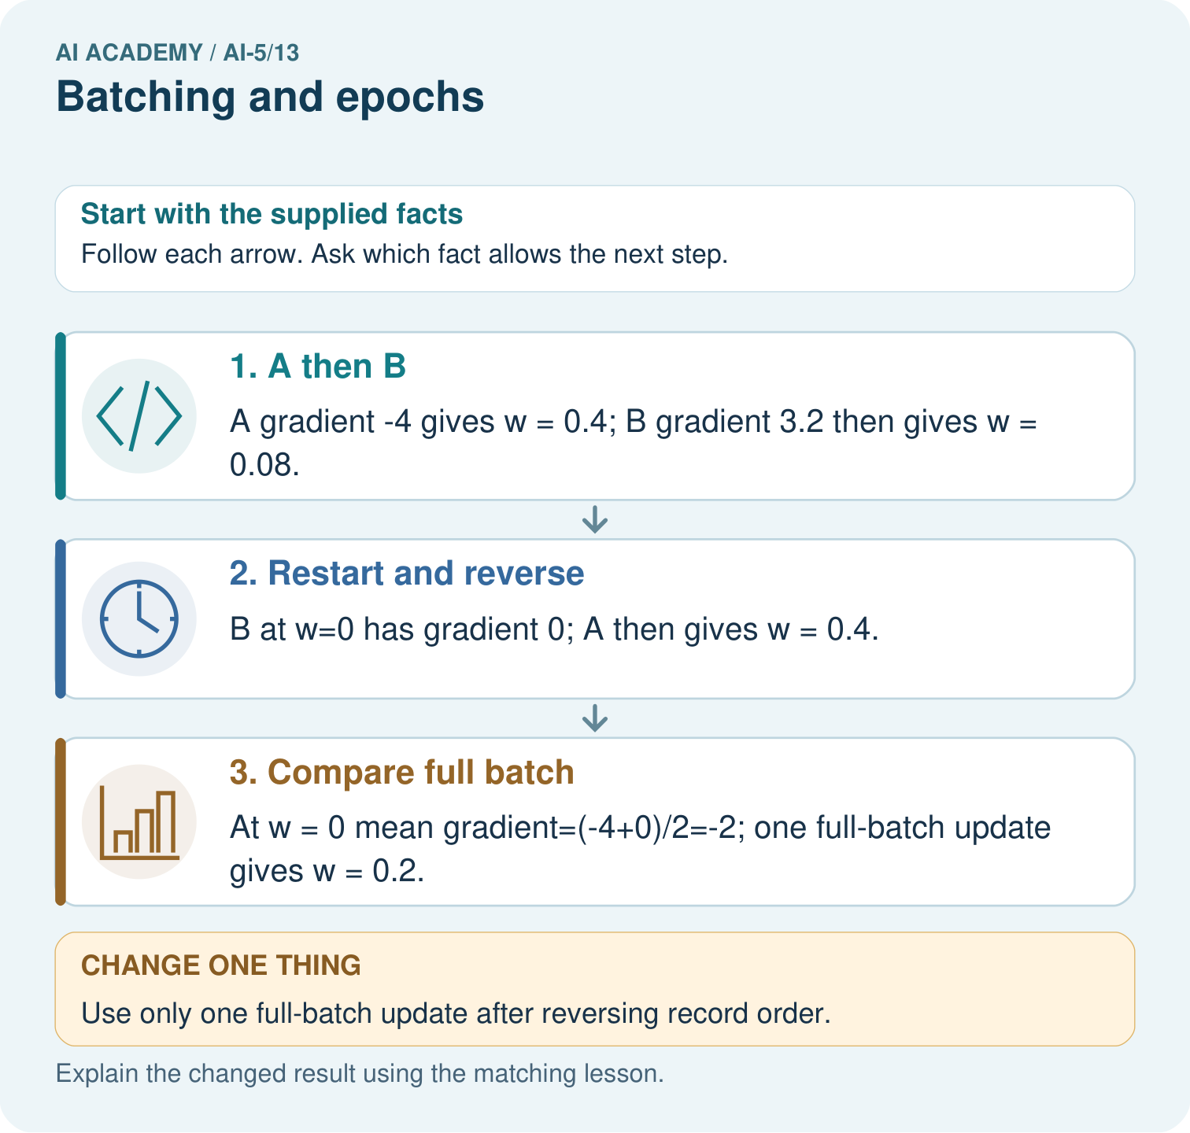

Read the picture one step at a time
Step | What happens and why
1. A then B | A gradient -4 gives w = 0.4; B gradient 3.2 then gives w = 0.08.
2. Restart and reverse | B at w=0 has gradient 0; A then gives w = 0.4.
3. Compare full batch | At w = 0 mean gradient=(-4+0)/2=-2; one full-batch update gives w = 0.2.
Match each pictured step to the supplied facts. This is a worked teaching case, not an independent assessment.

Why this result follows
A single-example update changes the weight before the next example’s gradient is calculated. Reversing the example order can therefore change the path. A full-batch update computes both gradients at the same starting weight and averages them before changing that weight. The distinction is when the update occurs, not whether the examples have different labels.

What this example does not establish
Different order effects do not mean a universally better batching strategy; compare declared schedules and budgets fairly.

Change one thing in the pictured case
Change: Use only one full-batch update after reversing record order.
Prediction: The updated weight remains 0.2.
Reason: The same mean of the two starting gradients is unchanged by their order.

Ask while showing the picture
Cover the result. Ask learners to name the inputs and predict the next step. Uncover one step, connect the icon to the actual procedure, and explain its evidence. Then change the supplied condition and compare. The picture is a representation; it does not document execution of a real AI model.

03. Demonstrate and guide practice
Time or stage | Teacher action
Session 1 start to 7 minutes | Retrieve states versus updates, then arrange five cards into batches of two.
7 to 18 minutes | Count batches, updates and visits for the table and W1; discuss retaining the final group.
18 to 32 minutes | Trace A then B at current v. Complete W2 and identify exactly where the stale gradient arose.
32 to 45 minutes | Run or trace the code and compare the full-batch update with the two singleton updates.
Session 2 start to 8 minutes | Complete the guided reverse-order trace and mark its coincidental equal endpoint.
8 to 20 minutes | Calculate fixed-model loss and use W3 to weight unequal batch means.
20 to 35 minutes | Collect W4 independently, requiring a fresh reset for the reverse-order run.
35 to 45 minutes | Discuss W5 and the exit response, then assess the fresh retry after targeted feedback.
Use the worked example in Sections 3 and 6. Collect a prediction before revealing its result; ask the learner to point to each intermediate fact.
Provide separate boxes for old v, batch gradient and new v; allow calculators. Extension: at a fixed v, prove that the row-count-weighted mean of batch gradients equals the full-data mean gradient. Explain why successive updates with changed v are a different procedure.

Reduce help deliberately
Completion task: For A then B separately in the lesson, a learner computes both gradients at v = 0, then applies them to get v = 2. Explain the error and give the correct final value.
Teacher check: Teacher explanation: The second gradient must use v = 0.4. Using -16 from the old state is stale; the current B gradient is -12.8 and the final v is 1.68.
Start by identifying the given inputs together. Leave the intermediate steps blank. If needed, model one step, then withdraw that help on the next step. Move to a full trace only when the partial trace is understood. For partners, alternate explainer and checker; collect a response from every learner before discussion.

Individual reasoning check
Use the worked case for Batching and epochs. Proposed explanation: “One epoch always means one update”. Decide whether this explanation is supported. Point to the step or supplied fact that decides; explain your repair if needed.
Expected correction: Only a full-data batch gives one update per epoch in this procedure.
Collect explanations, not only yes/no votes. If a misunderstanding is common, re-model the relevant step for the class. If it affects a few learners, give a short targeted group explanation while others solve a more demanding variation.

Pictorial practice question
Why do the single-example orders finish at different weights? Point to the relevant step in the picture, then write the changed result and the rule or evidence that supports it.

Reasoned teacher answer
The second gradient is evaluated at an already updated weight. Full-batch gradients here share the same starting weight before averaging. Changed-case check: The updated weight remains 0.2. The same mean of the two starting gradients is unchanged by their order.
Changed-case reasoning: The updated weight remains 0.2. The same mean of the two starting gradients is unchanged by their order.
Collect each learner’s explanation before discussion. Use the first missing connection between input, deciding step and result to choose support. This question is worked-case practice, not fresh mastery evidence.

04. Run the investigation and diagnose misconceptions
One epoch always means one update: Only a full-data batch gives one update per epoch in this procedure.
Reuse all gradients from the start of an epoch: Recompute at the parameter value before each batch update.
Average batch means equally: At one fixed model, weight each batch mean by the number of examples in that batch.
Use Section 9 for the evidence ledger. Add a boundary or missing-input case and record the expected response before checking. More successful repeats of one case do not establish wider coverage.

Match the support to the first error
What the response shows | Next teaching action
Missing or misread facts | Read the case aloud, mark supplied versus unknown facts, and let the learner restate it.
Wrong procedure | Return to the deciding step in the worked case. Contrast it with the proposed incorrect explanation.
Arithmetic or implementation error | Trace intermediate values or lines; preserve the first mismatch and retry that step.
Correct result without a reason | Ask for a trace and a changed case before marking independent understanding.
An unsupported wider claim | Ask which supplied evidence supports the claim and which further observation would be needed.
Offer an oral explanation, drawing, enlarged visual or fewer examples when that removes a reading/writing barrier. Keep the same reasoning goal. Stretch secure learners by changing a boundary or assumption and asking them to defend the effect, not simply by assigning more of the same questions.

05. Assess and explain the answers

Guided and exit questions
Guided: B at v = 0 gives gradient -16 and v = 1.6. A then gives residual -0.4, gradient -0.8 and v = 1.68. Two batches each cause one update. Exit: both teams visit ten examples. Size 2 produces six updates; size 5 produces two. Record both budgets and all training settings.

W1 Count a partial batch
For 10 rows, batch size 4 and three epochs, retaining the final batch, list batch lengths and count total updates and example visits.
Teacher explanation: Batch lengths 4, 4, 2; three updates per epoch, nine total updates and 30 example visits.

W2 Repair a stale gradient
For A then B separately in the lesson, a learner computes both gradients at v = 0, then applies them to get v = 2. Explain the error and give the correct final value.
Teacher explanation: The second gradient must use v = 0.4. Using -16 from the old state is stale; the current B gradient is -12.8 and the final v is 1.68.

W3 Combine unequal batches
At one frozen model, batches of sizes 3 and 1 have mean squared errors 2 and 10. Find the full MSE and explain why the average of 2 and 10 is wrong.
Teacher explanation: Full MSE is (3 times 2 + 10) / 4 = 4. The unweighted average 6 gives the single-row batch too much weight.

W4 Test order on a new case independently
Use A = (1, 1), B = (2, 0), h = ReLU(x), y = vh, v = 0 and rate 0.1. Train with size 1 for one epoch in A then B order, then restart at 0 and reverse the order. Show gradients and parameter values. Compare the final values.
Teacher explanation: A then B: A gradient -2 gives v = 0.2; B residual 0.4 gives gradient 1.6 and v = 0.04. B then A: B gradient 0 keeps v = 0; A gradient -2 gives v = 0.2. Both see the same rows but finish differently.

W5 Audit an epoch claim
A program processes 11 rows using size 4 and drops the last incomplete batch. How many examples did it visit and how many updates occurred? What must its report disclose?
Teacher explanation: It visits eight rows in two batches and performs two updates. Three rows are omitted; it did not complete a full pass under this lesson definition. Report the drop rule and actual visits.

Independent assessment and fresh retry
W4 requires the two traces and final values 0.04 and 0.2. Fresh retry: A = (1, 2), B = (1, 0), start v = 0, rate 0.25, singleton batches. A then B gives gradients -4 and 2, values 1 and 0.5. Reverse order gives gradients 0 and -4, values 0 and 1. Ask students to name the reset and explain the order effect.

Assess independent transfer
Selected case: Use A = (1, 1), B = (2, 0), h = ReLU(x), y = vh, v = 0 and rate 0.1. Train with size 1 for one epoch in A then B order, then restart at 0 and reverse the order. Show gradients and parameter values. Compare the final values.

Selected case answer
Teacher explanation: A then B: A gradient -2 gives v = 0.2; B residual 0.4 gives gradient 1.6 and v = 0.04. B then A: B gradient 0 keeps v = 0; A gradient -2 gives v = 0.2. Both see the same rows but finish differently.
Dimension | Evidence required
Explanation | Names the applicable idea or procedure and ties it to the supplied facts.
Trace and result | Preserves the given inputs and shows the relevant intermediate steps; distinguishes a prediction from an observed execution.
Limits | States the assumptions, missing evidence or conditions under which the result would change.
Record each dimension as not yet, with support, or independent. Accept a valid alternative procedure with a defensible trace. Do not penalise an honestly recorded model failure if the learner correctly explains its evidence and limits.

Feedback that the learner uses
Name the earliest unsupported step and give one action to repair it. Have the learner make that repair now and explain why. Then assess the relevant skill on a fresh, fully specified case. Confirm it was not previously practised with feedback; solve and check the new case before assigning it. A follow-up design prompt is a starting brief, not automatically an equivalent test.

06. Connect the project, support and next lesson
Add a labelled batching and epochs evidence sheet to Image-pattern Network Investigation. Show how you can distinguish an example a batch an update and an epoch. Use the supplied fictional case and keep its inputs, intermediate steps, calculation or prediction, and limitation. Connect this record to last week’s record; a matching answer without a trace is insufficient.
Provide separate boxes for old v, batch gradient and new v; allow calculators. Extension: at a fixed v, prove that the row-count-weighted mean of batch gradients equals the full-data mean gradient. Explain why successive updates with changed v are a different procedure.
Week 14 compares learning rates under one fixed batch rule.
Retain the project ledger and assess a changed case after support. Check the relevant prerequisite before carrying this component forward.

Plan the delayed return
Suggested return points in this level: ai-5/14, ai-5/16, ai-5/19. Use actual classroom dates, adjusting for holidays and gaps. One, three and six teaching weeks are scheduling choices, not a claimed optimal spacing.
At a delayed check, ask for the idea from memory and a changed application. Compare with the earlier independent response and record support used. For a new level, revisit the previous capstone before checking the new prerequisites.
Record | Teacher evidence
Learner code and date
Concept and case used; prior exposure
Explanation / trace / limits
Support and first repair
Changed case and delayed outcome
Next teaching action
Use the evidence to choose reteaching or the next step. A completed page, confidence rating or attractive project does not by itself demonstrate understanding.

Project evidence from this case
For your Image-pattern Network Investigation, save the input, procedure, observed result and limitation of this check. Label this worked example as practice; use a different, previously unreviewed case when checking independent understanding.

