AI ACADEMY · TEACHER · ai-5/16

Regularisation and early stopping
Project: Image-pattern Network Investigation

01. Prepare the purpose, prerequisites and materials

Teach the learning cycle
Primary target: Separate a weight penalty from prediction error
Session | Sequence and minutes | Resources
Session 1 · Understand · 45 min | 0–7: recall and prerequisite; 7–15: inspect the concrete case and predict; 15–30: teacher models the worked trace; 30–40: learners explain a step using the text and visual; 40–45: check the core idea. | Sections 1–6; record the brief recall in the workbook.
Session 2 · Practise · 45 min | 0–5: retrieve the procedure; 5–15: W2 completion practice; 15–23: explain and check with a partner; 23–30: each learner answers the misconception check; 30–40: targeted reteaching or a harder variation; 40–45: prepare the investigation. | Sections 7–10; use the matching workbook W2 and misconception check.
Session 3 · Investigate and transfer · 45 min | 0–5: retrieve the decision rule; 5–20: investigate or trace; 20–30: start the independent case; 30–38: connect the project; 38–43: act on feedback; 43–45: plan the return check. | Sections 9 and 11–14. Give extra time to finish the full task set; use Section 15 when the week includes a coding lab.
This is a starting allocation of 135 minutes, not a validated duration. Preserve all named topics. Schedule extra time for connected examples, the full investigation, independent cases and project building. Repeated copies of a case share one recorded attempt; they are not new evidence.

Retrieval answer guidance

Training and validation curves
Without opening the old lesson, explain one key idea from Training and validation curves. Give an example and a mistake that the idea helps you avoid.
Look for: Compute comparable training and validation losses at saved checkpoints
Reference example, not the only acceptable wording: Teacher explanation: Predictions [3, 4], residuals [-1.5, -2], squares [2.25, 4], MSE 3.125.

Batching and epochs
Without opening the old lesson, explain one key idea from Batching and epochs. Give an example and a mistake that the idea helps you avoid.
Look for: Distinguish an example a batch an update and an epoch
Reference example, not the only acceptable wording: Teacher explanation: Batch lengths 4, 4, 2; three updates per epoch, nine total updates and 30 example visits.

Gradients with a numerical check
Without opening the old lesson, explain one key idea from Gradients with a numerical check. Give an example and a mistake that the idea helps you avoid.
Look for: Estimate one partial derivative while other parameters stay fixed
Reference example, not the only acceptable wording: Teacher explanation: Prediction 3, residual 0, loss 0, gradient [0, 0].
Use two 45-minute sessions. Keep prediction error, penalty and total objective in separate columns. Teach early stopping as a second mechanism with a precise state machine on paper. Cover future curve values until a decision is made; do not reward retrospective selection as if it were a live stopping rule.

Outcomes
Separate a weight penalty from prediction error
Trace a regularised update under a stated objective
Apply a stopping rule and restore the best observed checkpoint

Preparation
Printed lesson and workbook; paper and pencil
Calculator and optional local Python 3 editor; no packages or AI accounts needed
Use the fictional examples supplied; prepare the fresh retry before class

Prerequisite answer
Restore the parameters saved at the chosen checkpoint. The last parameters produced by training may have a different validation loss.

End goal for the pictorial case
By the end, I can explain regularisation and early stopping using a traced example and a stated limitation.
This added worked case illustrates the week’s main idea. Retain all original and connected topics; schedule its practice within the teaching cycle.

02. Explain and model the mechanism
Keep h = ReLU(x), y = vh, train only v on (1, 2) and (2, 4), and freeze all hidden parameters and the zero output bias. Training MSE is L(v) = 2.5(v - 2) squared. Define J(v) = L(v) + lambda times v squared, with lambda nonnegative. Only this one output weight is penalised here.
For lambda = 0.5, the penalty at v = 1.5 is 0.5 times 2.25 = 1.125. Prediction MSE is 0.625, so total objective J is 1.75. Keep these quantities separate in logs. A smaller total objective does not automatically mean a smaller prediction error.
Among these three candidates, the smallest penalised objective is at v = 1.5, whereas the smallest training MSE is at v = 2. Penalising a weight changes the tradeoff. It does not guarantee better validation performance or fair outcomes.
The data gradient is 5(v - 2). The penalty gradient is 2 times lambda times v, giving total gradient 5(v - 2) + 2 lambda v. At v = 1.5 and lambda = 0.5, these contributions are -2.5 and 1.5, so total gradient is -1. A rate 0.1 step gives v = 1.6.
Assume finite numeric values and nonnegative penalty. At the new v, data loss is 0.4, penalty 1.28 and total 1.68. Choose penalty strength using a declared validation prediction metric, not by comparing total objectives with different lambdas as if they were the same measure.
Term | Meaning
Regularisation | A constraint or training procedure intended to limit fitting choices and improve generalisation
Weight penalty | An added objective term that discourages specified large parameter values
Patience | The allowed run of consecutive non-improving evaluations before stopping under a stated rule
Restore | Reload the parameters saved at the selected checkpoint

Patience two with strict improvement
Epoch | Validation MSE | Decision
0 then 1 then 2 | 4 then 2 then 1.5 | Save each improved state
3 then 4 | 1.6 then 1.4 | Wait once then reset
5 then 6 | 1.45 then 1.46 | Two misses so stop at 6
Initial checkpoint is epoch 0. Evaluate once after each epoch. A strict decrease is improvement; an exact tie is a miss. Reset the miss count after improvement and stop at two consecutive misses. Restore epoch 4, the best observed checkpoint.
Guided: miss counts at epochs 3, 4, 5, 6 are 1, 0, 1, 2. Stop at 6 and restore 4. Exit: using final parameters ignores restoration; selecting patience with test losses uses test data for development. Restore the selected checkpoint, choose policy using validation, then freeze it before evaluating suitable untouched final examples.

Model the reasoning aloud
Use the complete worked example below before asking learners to complete W2. Reveal a small part, invite a prediction, then explain the deciding step. These teacher notes contain solutions; do not reveal the independent case answer during modelling.

Patience two with strict improvement
Epoch | Validation MSE | Decision
0 then 1 then 2 | 4 then 2 then 1.5 | Save each improved state
3 then 4 | 1.6 then 1.4 | Wait once then reset
5 then 6 | 1.45 then 1.46 | Two misses so stop at 6
Initial checkpoint is epoch 0. Evaluate once after each epoch. A strict decrease is improvement; an exact tie is a miss. Reset the miss count after improvement and stop at two consecutive misses. Restore epoch 4, the best observed checkpoint.

At epochs 3, 4, 5 and 6, record the miss count after evaluation. Which epoch stops training, and which epoch supplies the restored parameters?
________________________________________________________________
________________________________________________________________
________________________________________________________________
________________________________________________________________
Thinking move | Teacher prompt
Plan | What is given? What is the question? Which procedure fits these facts?
Do | Point to each input and intermediate step in the worked trace. Name the rule that allows the next step.
Check | Does the output answer the question? Which assumption or limitation prevents a larger claim?
Use the diagram and verbal explanation together. Ask learners to match a sentence to a specific visual step; do not assign learners fixed visual or auditory learning styles.

A pictorial worked case: Regularisation and early stopping
Separate a regularisation penalty from prediction loss and an early-stopping rule.

The facts we will use
Toy objective J(a)=(a-3)²+2a²; start a = 0; gradient 6a-6; rate 1/6. Separate validation losses:[5, 3, 3, 4], patience 1, no ties as improvement.
All inputs and outcomes in this worked example are invented classroom data; no real model run is claimed.
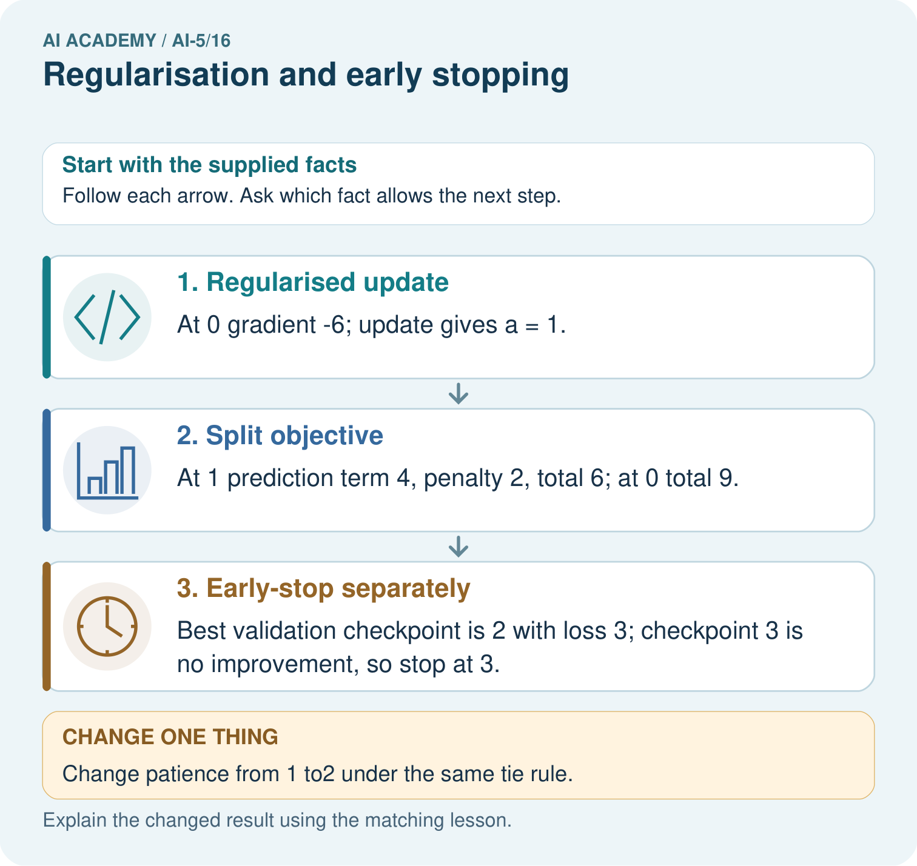

Read the picture one step at a time
Step | What happens and why
1. Regularised update | At 0 gradient -6; update gives a = 1.
2. Split objective | At 1 prediction term 4, penalty 2, total 6; at 0 total 9.
3. Early-stop separately | Best validation checkpoint is 2 with loss 3; checkpoint 3 is no improvement, so stop at 3.
Match each pictured step to the supplied facts. This is a worked teaching case, not an independent assessment.

Why this result follows
Regularisation adds a parameter penalty to the training objective. Here it discourages large a, so the objective balances prediction error against that penalty. Early stopping is a different decision based on the supplied validation sequence. A tied validation loss is not improvement under this policy; stop when the patience allowance is used and restore the best checkpoint.

What this example does not establish
Regularisation and early stopping are different tools; neither guarantees better performance in every dataset.

Change one thing in the pictured case
Change: Change patience from 1 to2 under the same tie rule.
Prediction: Stop at checkpoint 4; still restore checkpoint 2.
Reason: Checkpoints 3 and 4 are two consecutive non-improvements; a later stop does not redefine the best checkpoint.

Ask while showing the picture
Cover the result. Ask learners to name the inputs and predict the next step. Uncover one step, connect the icon to the actual procedure, and explain its evidence. Then change the supplied condition and compare. The picture is a representation; it does not document execution of a real AI model.

03. Demonstrate and guide practice
Time or stage | Teacher action
Session 1 start to 7 minutes | Retrieve checkpoint restoration and introduce the named penalised weight.
7 to 18 minutes | Calculate the objective table and W1, identifying the nonzero penalty gradient at v = 2.
18 to 32 minutes | Trace the worked regularised update and use W2 for the next step.
32 to 45 minutes | Run or trace the code and distinguish objective reduction from validation evidence.
Session 2 start to 8 minutes | Reveal the validation sequence one epoch at a time; complete the guided miss counts.
8 to 20 minutes | Complete W3 before revealing the future value; compare stopping and restored epochs.
20 to 35 minutes | Collect W4 independently, scoring the arithmetic and the tied-loss policy separately.
35 to 45 minutes | Discuss W5 and the exit response, then use the fresh retry and record the complete policy.
Use the worked example in Sections 3 and 6. Collect a prediction before revealing its result; ask the learner to point to each intermediate fact.
Use a ledger with columns epoch, metric, best epoch and miss count; cover future rows. Extension: solve 5(v - 2) + 2 lambda v = 0 to obtain v = 10 / (5 + 2 lambda). For nonnegative lambda, discuss why the optimum moves toward zero without claiming this always improves prediction.

Reduce help deliberately
Completion task: Start v = 1.6 with lambda = 0.5 and rate 0.1. Calculate both gradient contributions, new v and new prediction MSE.
Teacher check: Teacher explanation: Data gradient -2, penalty gradient 1.6, total -0.4. New v = 1.64; prediction MSE is 2.5 times 0.36 squared = 0.324.
Start by identifying the given inputs together. Leave the intermediate steps blank. If needed, model one step, then withdraw that help on the next step. Move to a full trace only when the partial trace is understood. For partners, alternate explainer and checker; collect a response from every learner before discussion.

Individual reasoning check
Use the worked case for Regularisation and early stopping. Proposed explanation: “Zero prediction error means no regularised update”. Decide whether this explanation is supported. Point to the step or supplied fact that decides; explain your repair if needed.
Expected correction: The penalty gradient can remain nonzero.
Collect explanations, not only yes/no votes. If a misunderstanding is common, re-model the relevant step for the class. If it affects a few learners, give a short targeted group explanation while others solve a more demanding variation.

Pictorial practice question
Why should the penalty value not be reported as validation error? Point to the relevant step in the picture, then write the changed result and the rule or evidence that supports it.

Reasoned teacher answer
It is part of the training objective, not the measured validation prediction loss. Report these separate quantities with their definitions. Changed-case check: Stop at checkpoint 4; still restore checkpoint 2. Checkpoints 3 and 4 are two consecutive non-improvements; a later stop does not redefine the best checkpoint.
Changed-case reasoning: Stop at checkpoint 4; still restore checkpoint 2. Checkpoints 3 and 4 are two consecutive non-improvements; a later stop does not redefine the best checkpoint.
Collect each learner’s explanation before discussion. Use the first missing connection between input, deciding step and result to choose support. This question is worked-case practice, not fresh mastery evidence.

04. Run the investigation and diagnose misconceptions
Zero prediction error means no regularised update: The penalty gradient can remain nonzero.
Early stopping adds a weight penalty: It limits training duration using a validation rule; a weight penalty changes the objective.
Restore the epoch where stopping happened: Restore the best observed checkpoint under the declared rule, which can be earlier.
Use Section 9 for the evidence ledger. Add a boundary or missing-input case and record the expected response before checking. More successful repeats of one case do not establish wider coverage.

Match the support to the first error
What the response shows | Next teaching action
Missing or misread facts | Read the case aloud, mark supplied versus unknown facts, and let the learner restate it.
Wrong procedure | Return to the deciding step in the worked case. Contrast it with the proposed incorrect explanation.
Arithmetic or implementation error | Trace intermediate values or lines; preserve the first mismatch and retry that step.
Correct result without a reason | Ask for a trace and a changed case before marking independent understanding.
An unsupported wider claim | Ask which supplied evidence supports the claim and which further observation would be needed.
Offer an oral explanation, drawing, enlarged visual or fewer examples when that removes a reading/writing barrier. Keep the same reasoning goal. Stretch secure learners by changing a boundary or assumption and asking them to defend the effect, not simply by assigning more of the same questions.

05. Assess and explain the answers

Guided and exit questions
Guided: miss counts at epochs 3, 4, 5, 6 are 1, 0, 1, 2. Stop at 6 and restore 4. Exit: using final parameters ignores restoration; selecting patience with test losses uses test data for development. Restore the selected checkpoint, choose policy using validation, then freeze it before evaluating suitable untouched final examples.

W1 Separate the objective terms
At v = 2 and lambda = 0.5 in the lesson, compute prediction MSE, penalty, total objective and total gradient. Does zero training MSE make this gradient zero?
Teacher explanation: MSE 0, penalty 2, total J 2, total gradient 2. Zero data gradient does not remove the penalty gradient.

W2 Trace the next update
Start v = 1.6 with lambda = 0.5 and rate 0.1. Calculate both gradient contributions, new v and new prediction MSE.
Teacher explanation: Data gradient -2, penalty gradient 1.6, total -0.4. New v = 1.64; prediction MSE is 2.5 times 0.36 squared = 0.324.

W3 Apply patience without peeking
Validation MSE at epochs 0 to 7 is [4, 2, 1.5, 1.6, 1.4, 1.45, 1.46, 1.3]. Apply the lesson policy with patience 2. Give the stop epoch, restored epoch and why the listed epoch 7 cannot change this decision.
Teacher explanation: Stop at epoch 6 after misses at 5 and 6; restore epoch 4 with MSE 1.4. A live run has stopped before observing epoch 7; hindsight cannot be included in that policy decision.

W4 Transfer both rules independently
For a new objective J(a) = (a - 2) squared + a squared, gradient 4a - 4, start a = 0 and take one step at rate 0.25. Give new a, prediction error term, penalty and total J. Separately apply patience 2 with strict improvement to validation values [3, 2, 2, 2, 1] at epochs 0 to 4; report the stop and restored epochs.
Teacher explanation: The update gives a = 1. Prediction error 1, penalty 1, total J 2. For the separate curve, epoch 1 is best at 2; ties at 2 and 3 are two misses, so stop at epoch 3 and restore epoch 1. Epoch 4 is not observed by that live policy.

W5 Compare penalties fairly
A team compares lambda 0 and lambda 0.5 by choosing whichever has the smaller penalised training objective. Explain why this does not establish the better prediction model and name a suitable development comparison.
Teacher explanation: The objectives use different penalties, and both are training quantities. Compare the candidates on the same fixed validation examples using the same declared prediction metric, such as ordinary MSE. Reserve final test examples from setting selection.

Independent assessment and fresh retry
W4 requires a = 1 and terms 1, 1, 2 plus stop epoch 3 and restored epoch 1. Fresh retry: J(b) = (b - 3) squared + 0.5b squared, gradient 3b - 6; start b = 0, rate 0.25. New b = 1.5, data term 2.25, penalty 1.125, total 3.375. On validation [5, 3, 3.2, 3.1] with patience 2, stop at 3 and restore 1.

Assess independent transfer
Selected case: For a new objective J(a) = (a - 2) squared + a squared, gradient 4a - 4, start a = 0 and take one step at rate 0.25. Give new a, prediction error term, penalty and total J. Separately apply patience 2 with strict improvement to validation values [3, 2, 2, 2, 1] at epochs 0 to 4; report the stop and restored epochs.

Selected case answer
Teacher explanation: The update gives a = 1. Prediction error 1, penalty 1, total J 2. For the separate curve, epoch 1 is best at 2; ties at 2 and 3 are two misses, so stop at epoch 3 and restore epoch 1. Epoch 4 is not observed by that live policy.
Dimension | Evidence required
Explanation | Names the applicable idea or procedure and ties it to the supplied facts.
Trace and result | Preserves the given inputs and shows the relevant intermediate steps; distinguishes a prediction from an observed execution.
Limits | States the assumptions, missing evidence or conditions under which the result would change.
Record each dimension as not yet, with support, or independent. Accept a valid alternative procedure with a defensible trace. Do not penalise an honestly recorded model failure if the learner correctly explains its evidence and limits.

Feedback that the learner uses
Name the earliest unsupported step and give one action to repair it. Have the learner make that repair now and explain why. Then assess the relevant skill on a fresh, fully specified case. Confirm it was not previously practised with feedback; solve and check the new case before assigning it. A follow-up design prompt is a starting brief, not automatically an equivalent test.

06. Connect the project, support and next lesson
Add a labelled regularisation and early stopping evidence sheet to Image-pattern Network Investigation. Show how you can separate a weight penalty from prediction error. Use the supplied fictional case and keep its inputs, intermediate steps, calculation or prediction, and limitation. Connect this record to last week’s record; a matching answer without a trace is insufficient.
Use a ledger with columns epoch, metric, best epoch and miss count; cover future rows. Extension: solve 5(v - 2) + 2 lambda v = 0 to obtain v = 10 / (5 + 2 lambda). For nonnegative lambda, discuss why the optimum moves toward zero without claiming this always improves prediction.
Week 17 investigates initialisation and reproducibility.
Retain the project ledger and assess a changed case after support. Check the relevant prerequisite before carrying this component forward.

Plan the delayed return
Suggested return points in this level: ai-5/17, ai-5/19, ai-5/22. Use actual classroom dates, adjusting for holidays and gaps. One, three and six teaching weeks are scheduling choices, not a claimed optimal spacing.
At a delayed check, ask for the idea from memory and a changed application. Compare with the earlier independent response and record support used. For a new level, revisit the previous capstone before checking the new prerequisites.
Record | Teacher evidence
Learner code and date
Concept and case used; prior exposure
Explanation / trace / limits
Support and first repair
Changed case and delayed outcome
Next teaching action
Use the evidence to choose reteaching or the next step. A completed page, confidence rating or attractive project does not by itself demonstrate understanding.

Project evidence from this case
For your Image-pattern Network Investigation, save the input, procedure, observed result and limitation of this check. Label this worked example as practice; use a different, previously unreviewed case when checking independent understanding.

