AI ACADEMY · TEACHER · ai-5/18

Debugging shapes and gradients
Project: Image-pattern Network Investigation

01. Prepare the purpose, prerequisites and materials

Teach the learning cycle
Primary target: Check dimension contracts before computing a layer
Session | Sequence and minutes | Resources
Session 1 · Understand · 45 min | 0–7: recall and prerequisite; 7–15: inspect the concrete case and predict; 15–30: teacher models the worked trace; 30–40: learners explain a step using the text and visual; 40–45: check the core idea. | Sections 1–6; record the brief recall in the workbook.
Session 2 · Practise · 45 min | 0–5: retrieve the procedure; 5–15: W2 completion practice; 15–23: explain and check with a partner; 23–30: each learner answers the misconception check; 30–40: targeted reteaching or a harder variation; 40–45: prepare the investigation. | Sections 7–10; use the matching workbook W2 and misconception check.
Session 3 · Investigate and transfer · 45 min | 0–5: retrieve the decision rule; 5–20: investigate or trace; 20–30: start the independent case; 30–38: connect the project; 38–43: act on feedback; 43–45: plan the return check. | Sections 9 and 11–14. Give extra time to finish the full task set; use Section 15 when the week includes a coding lab.
This is a starting allocation of 135 minutes, not a validated duration. Preserve all named topics. Schedule extra time for connected examples, the full investigation, independent cases and project building. Repeated copies of a case share one recorded attempt; they are not new evidence.

Retrieval answer guidance

Initialisation and reproducibility
Without opening the old lesson, explain one key idea from Initialisation and reproducibility. Give an example and a mistake that the idea helps you avoid.
Look for: Trace how starting values affect a fixed training budget
Reference example, not the only acceptable wording: Teacher explanation: States are -2, 0 and 1. Final training MSE is 2.5. Each step halves the signed distance from 2.

Training and validation curves
Without opening the old lesson, explain one key idea from Training and validation curves. Give an example and a mistake that the idea helps you avoid.
Look for: Compute comparable training and validation losses at saved checkpoints
Reference example, not the only acceptable wording: Teacher explanation: Predictions [3, 4], residuals [-1.5, -2], squares [2.25, 4], MSE 3.125.

Training a small network
Without opening the old lesson, explain one key idea from Training a small network. Give an example and a mistake that the idea helps you avoid.
Look for: Trace repeated forward loss gradient and update steps
Reference example, not the only acceptable wording: Teacher explanation: Predictions [0, 0], errors [-2, -4], MSE 10, gradient -10 and new v = 1.
Use two 45-minute sessions. Start with an axis contract and a deliberately wrong intermediate value. Keep the dense-layer example separate from the scalar gradient diagnostic. The central assessment is locating the first error and preserving meaningful regression checks, not merely getting a program to execute.

Outcomes
Check dimension contracts before computing a layer
Locate the first wrong value in a forward or gradient trace
Verify a repair with independent checks and limited claims

Preparation
Printed lesson and workbook; paper and pencil
Calculator and optional local Python 3 editor; no packages or AI accounts needed
Use the fictional examples supplied; prepare the fresh retry before class

Prerequisite answer
A deterministic error can repeat perfectly. Independent expected values and checks of intermediate computations are needed.

End goal for the pictorial case
By the end, I can explain debugging shapes and gradients using a traced example and a stated limitation.
This added worked case illustrates the week’s main idea. Retain all original and connected topics; schedule its practice within the teaching cycle.

02. Explain and model the mechanism
For this lesson, a dense layer stores one output unit per weight-matrix row. If an input has two features and the layer has three units, W has three rows and two columns, b has length 3, and one input x has length 2. Compute z for each unit, then apply ReLU to each component.
Use W rows [1, 0], [0, 1], [1, -1] and b = [0, 0, 1]. For x = [1, 2], the scores are [1, 2, 0] and the activations are [1, 2, 0]. A batch stores examples in rows: inputs [[1, 2], [3, 1]] have shape 2 by 2, and outputs have shape 2 by 3.
Other software may use a transposed weight convention. The key is to record and follow one contract. An array with the right number of values can still be wrong if features or axes are swapped.
Python zip stops when its shortest input ends. Without a length check, a missing feature can silently remove a contribution. Reject malformed dimensions before computing: do not pad, truncate or reshape a mismatched input just to make the calculation run.
The function assumes finite numeric values; it checks dimensions, not every possible input fault. Evaluate the two batch rows independently and stack their outputs. Retain tests that reject a missing input feature, a short weight row and an incorrect bias count.
Term | Meaning
Shape | The sizes of an array along its declared axes
Contract | A stated condition that inputs and outputs must satisfy
Partial gradient | The change rate of a scalar loss with respect to one parameter while others are fixed
Regression check | A saved check rerun after a repair to detect the return of a defect

Repair from the first disagreement
Trace stage for x [1 2] | Expected result | Submitted result
Input and dimensions | x length 2 W 3 by 2 b length 3 | Dimensions match
Scores before ReLU | [1, 2, 0] | [1, 2, -1]
Hidden activations | [1, 2, 0] | [1, 2, 0]
The submitted third score omits bias 1. ReLU hides the error for this input, so matching final activations are not enough. At x = [3, 1], the same omission changes the third activation from 3 to 2.
Guided: correct scores [0, 2, -1], activations [0, 2, 0]. With the third bias omitted, scores become [0, 2, -2], but activations stay [0, 2, 0]. Exit: neither check is sufficient. Verify the intermediate score, coordinate meanings and expected update, use multiple independent inputs and retain malformed-dimension checks.

Model the reasoning aloud
Use the complete worked example below before asking learners to complete W2. Reveal a small part, invite a prediction, then explain the deciding step. These teacher notes contain solutions; do not reveal the independent case answer during modelling.

Repair from the first disagreement
Trace stage for x [1 2] | Expected result | Submitted result
Input and dimensions | x length 2 W 3 by 2 b length 3 | Dimensions match
Scores before ReLU | [1, 2, 0] | [1, 2, -1]
Hidden activations | [1, 2, 0] | [1, 2, 0]
The submitted third score omits bias 1. ReLU hides the error for this input, so matching final activations are not enough. At x = [3, 1], the same omission changes the third activation from 3 to 2.

Trace x = [0, 2] with the correct layer. Then omit the third bias. Which scores differ, and why do the activation vectors still agree?
________________________________________________________________
________________________________________________________________
________________________________________________________________
________________________________________________________________
Thinking move | Teacher prompt
Plan | What is given? What is the question? Which procedure fits these facts?
Do | Point to each input and intermediate step in the worked trace. Name the rule that allows the next step.
Check | Does the output answer the question? Which assumption or limitation prevents a larger claim?
Use the diagram and verbal explanation together. Ask learners to match a sentence to a specific visual step; do not assign learners fixed visual or auditory learning styles.

A pictorial worked case: Debugging shapes and gradients
Catch a gradient -order bug before the optimiser changes parameters.

The facts we will use
Toy y=2a+3c, target 4, start [a, c]=[1, 0]. Loss (y-4)². Program claims gradient [-12,-8] in order [a, c].
All inputs and outcomes in this worked example are invented classroom data; no real model run is claimed.
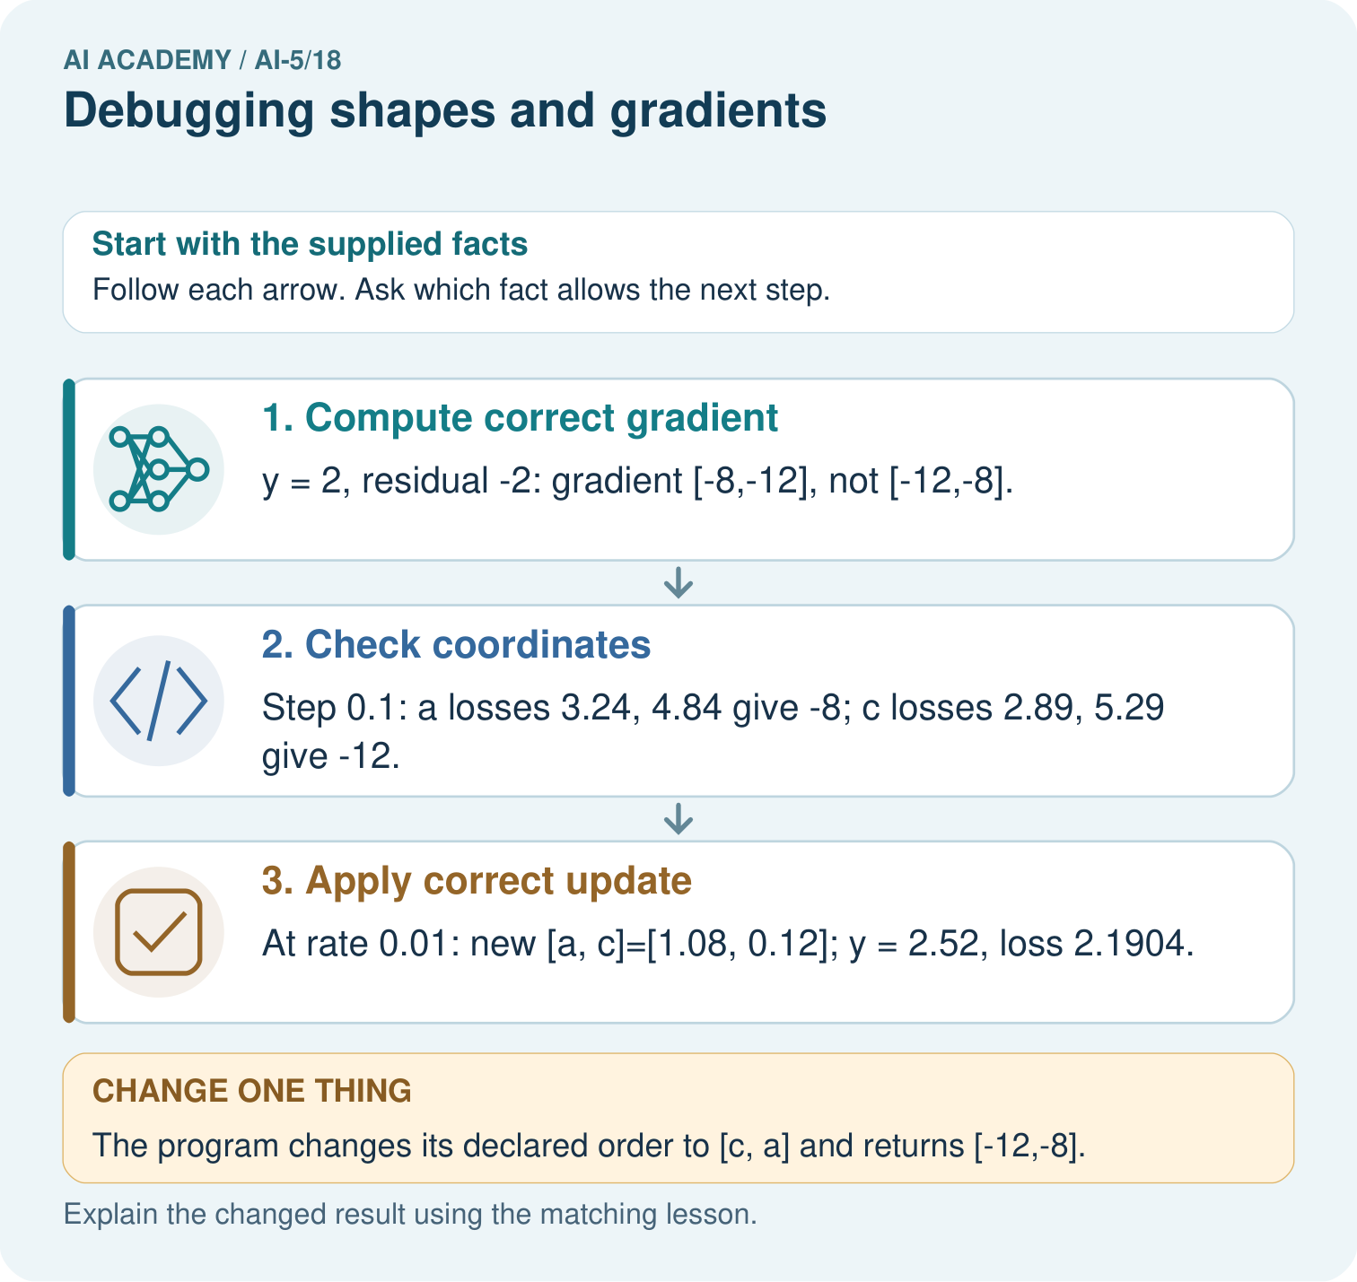

Read the picture one step at a time
Step | What happens and why
1. Compute correct gradient | y = 2, residual -2: gradient [-8,-12], not [-12,-8].
2. Check coordinates | Step 0.1: a losses 3.24, 4.84 give -8; c losses 2.89, 5.29 give -12.
3. Apply correct update | At rate 0.01: new [a, c]=[1.08, 0.12]; y = 2.52, loss 2.1904.
Match each pictured step to the supplied facts. This is a worked teaching case, not an independent assessment.

Why this result follows
Array shape and coordinate meaning both matter. A vector with two entries can have the right length but assign each derivative to the wrong parameter. Label the entries a and c, then perturb one coordinate at a time to check their slopes. Repairing the coordinate mapping is necessary before using the gradient to update the network.

What this example does not establish
A correct gradient at one point does not establish every batch, shape or activation path is implemented correctly.

Change one thing in the pictured case
Change: The program changes its declared order to [c, a] and returns [-12,-8].
Prediction: That vector now matches the declared coordinate order.
Reason: Gradient values are meaningful only when their parameter names and array positions agree.

Ask while showing the picture
Cover the result. Ask learners to name the inputs and predict the next step. Uncover one step, connect the icon to the actual procedure, and explain its evidence. Then change the supplied condition and compare. The picture is a representation; it does not document execution of a real AI model.

03. Demonstrate and guide practice
Time or stage | Teacher action
Session 1 start to 7 minutes | Retrieve the difference between repeated and independently checked results; label all axes.
7 to 18 minutes | Trace both batch examples and use W1 to reject a dimension mismatch.
18 to 32 minutes | Run or trace the guarded dense-layer function and test invalid dimensions.
32 to 45 minutes | Use the visual and W2 to show how ReLU can hide a bias omission on one input.
Session 2 start to 8 minutes | Complete the guided x = [0, 2] trace, comparing scores with activations.
8 to 20 minutes | Probe w and b separately in the scalar diagnostic, then complete W3.
20 to 35 minutes | Collect W4 independently with four probe losses, ordered gradients and the corrected update.
35 to 45 minutes | Use W5 and the exit response to retain a regression checklist; administer the fresh retry.
Use the worked example in Sections 3 and 6. Collect a prediction before revealing its result; ask the learner to point to each intermediate fact.
Provide labelled columns for inputs, scores, activations and parameter coordinates; allow calculators. Extension: test several positive and negative inputs against an independent explicit formula and explain why a test at a ReLU corner needs different reasoning from a smooth gradient check.

Reduce help deliberately
Completion task: Compute scores and activations for x = [3, 1] with the lesson layer, then omit the third bias. Identify the first discrepancy and the resulting activation error.
Teacher check: Teacher explanation: Correct scores and activations are [3, 1, 3]. Omitting the third bias produces [3, 1, 2]. The third score is the first discrepancy and now survives ReLU.
Start by identifying the given inputs together. Leave the intermediate steps blank. If needed, model one step, then withdraw that help on the next step. Move to a full trace only when the partial trace is understood. For partners, alternate explainer and checker; collect a response from every learner before discussion.

Individual reasoning check
Use the worked case for Debugging shapes and gradients. Proposed explanation: “Matching output shape guarantees the computation”. Decide whether this explanation is supported. Point to the step or supplied fact that decides; explain your repair if needed.
Expected correction: Correct dimensions can hide swapped features, missing biases or wrong axis meanings.
Collect explanations, not only yes/no votes. If a misunderstanding is common, re-model the relevant step for the class. If it affects a few learners, give a short targeted group explanation while others solve a more demanding variation.

Pictorial practice question
What should a debugging record pair with every gradient value? Point to the relevant step in the picture, then write the changed result and the rule or evidence that supports it.

Reasoned teacher answer
Parameter name and index, expected shape, analytic derivative and numerical check; correct [a, c] gradient is [-8,-12]. Changed-case check: That vector now matches the declared coordinate order. Gradient values are meaningful only when their parameter names and array positions agree.
Changed-case reasoning: That vector now matches the declared coordinate order. Gradient values are meaningful only when their parameter names and array positions agree.
Collect each learner’s explanation before discussion. Use the first missing connection between input, deciding step and result to choose support. This question is worked-case practice, not fresh mastery evidence.

04. Run the investigation and diagnose misconceptions
Matching output shape guarantees the computation: Correct dimensions can hide swapped features, missing biases or wrong axis meanings.
Matching final activations proves all scores: ReLU can map different negative scores to the same zero.
Decreasing loss proves a correct gradient: An incorrect direction can still improve one case; compare coordinate probes and exact update expectations.
Use Section 9 for the evidence ledger. Add a boundary or missing-input case and record the expected response before checking. More successful repeats of one case do not establish wider coverage.

Match the support to the first error
What the response shows | Next teaching action
Missing or misread facts | Read the case aloud, mark supplied versus unknown facts, and let the learner restate it.
Wrong procedure | Return to the deciding step in the worked case. Contrast it with the proposed incorrect explanation.
Arithmetic or implementation error | Trace intermediate values or lines; preserve the first mismatch and retry that step.
Correct result without a reason | Ask for a trace and a changed case before marking independent understanding.
An unsupported wider claim | Ask which supplied evidence supports the claim and which further observation would be needed.
Offer an oral explanation, drawing, enlarged visual or fewer examples when that removes a reading/writing barrier. Keep the same reasoning goal. Stretch secure learners by changing a boundary or assumption and asking them to defend the effect, not simply by assigning more of the same questions.

05. Assess and explain the answers

Guided and exit questions
Guided: correct scores [0, 2, -1], activations [0, 2, 0]. With the third bias omitted, scores become [0, 2, -2], but activations stay [0, 2, 0]. Exit: neither check is sufficient. Verify the intermediate score, coordinate meanings and expected update, use multiple independent inputs and retain malformed-dimension checks.

W1 Reject a shape mismatch
The layer expects W shape 3 by 2, b length 3 and x length 2. A submitted x has length 3. Should the last feature be silently ignored? State the failed contract and repair process.
Teacher explanation: No. Each weight row must have the same length as x. Confirm the intended feature schema, then supply a valid two-feature input or deliberately redesign and retrain the layer; do not silently discard a value.

W2 Expose a hidden bias error
Compute scores and activations for x = [3, 1] with the lesson layer, then omit the third bias. Identify the first discrepancy and the resulting activation error.
Teacher explanation: Correct scores and activations are [3, 1, 3]. Omitting the third bias produces [3, 1, 2]. The third score is the first discrepancy and now survives ReLU.

W3 Check an update sign
For the diagnostic model at [1, 0], gradient [-4, -2] and rate 0.05, calculate the correct new parameters and loss. Compare with adding the gradient step.
Teacher explanation: Correct subtraction gives [1.2, 0.1], prediction 2.5 and loss 0.25. Addition gives [0.8, -0.1], prediction 1.5 and loss 2.25, compared with starting loss 1.

W4 Debug a new gradient independently
Use y = 3a + c, target 2, loss (y - 2) squared, at [a, c] = [0, 1]. A program returns gradient [-2, -6] in order [a, c]. Use symmetric step 0.1 to check each coordinate, then update both with the corrected gradient and rate 0.05. Report new parameters and loss.
Teacher explanation: For a, losses at -0.1 and 0.1 are 1.69 and 0.49, giving -6. For c, losses at 0.9 and 1.1 are 1.21 and 0.81, giving -2. The entries were swapped. Correct update gives [0.3, 1.1], prediction 2 and loss 0.

W5 Keep independent regression checks
A program passes only the x = [1, 2] final-activation test. Propose one intermediate-value check, one malformed-input check and one additional input that exposes the bias omission.
Teacher explanation: Check scores [1, 2, 0] before ReLU; reject a wrong input length or bias count; test x = [3, 1], whose third activation must be 3. These checks address different defects rather than repeating the same final output.

Independent assessment and fresh retry
W4 requires partials [-6, -2], new parameters [0.3, 1.1] and loss 0. Fresh retry: y = 2p + q, target 4, at [1, 1]. With step 0.1, p losses 1.44 and 0.64 give -4; q losses 1.21 and 0.81 give -2. Rate 0.1 gives [1.4, 1.2], prediction 4 and loss 0. Require parameter ordering to remain explicit.

Assess independent transfer
Selected case: Use y = 3a + c, target 2, loss (y - 2) squared, at [a, c] = [0, 1]. A program returns gradient [-2, -6] in order [a, c]. Use symmetric step 0.1 to check each coordinate, then update both with the corrected gradient and rate 0.05. Report new parameters and loss.

Selected case answer
Teacher explanation: For a, losses at -0.1 and 0.1 are 1.69 and 0.49, giving -6. For c, losses at 0.9 and 1.1 are 1.21 and 0.81, giving -2. The entries were swapped. Correct update gives [0.3, 1.1], prediction 2 and loss 0.
Dimension | Evidence required
Explanation | Names the applicable idea or procedure and ties it to the supplied facts.
Trace and result | Preserves the given inputs and shows the relevant intermediate steps; distinguishes a prediction from an observed execution.
Limits | States the assumptions, missing evidence or conditions under which the result would change.
Record each dimension as not yet, with support, or independent. Accept a valid alternative procedure with a defensible trace. Do not penalise an honestly recorded model failure if the learner correctly explains its evidence and limits.

Feedback that the learner uses
Name the earliest unsupported step and give one action to repair it. Have the learner make that repair now and explain why. Then assess the relevant skill on a fresh, fully specified case. Confirm it was not previously practised with feedback; solve and check the new case before assigning it. A follow-up design prompt is a starting brief, not automatically an equivalent test.

06. Connect the project, support and next lesson
Add a labelled debugging shapes and gradients evidence sheet to Image-pattern Network Investigation. Show how you can check dimension contracts before computing a layer. Use the supplied fictional case and keep its inputs, intermediate steps, calculation or prediction, and limitation. Connect this record to last week’s record; a matching answer without a trace is insufficient.
Provide labelled columns for inputs, scores, activations and parameter coordinates; allow calculators. Extension: test several positive and negative inputs against an independent explicit formula and explain why a test at a ReLU corner needs different reasoning from a smooth gradient check.
Week 19 explores learned representations and the distinctions hidden activations preserve.
Retain the project ledger and assess a changed case after support. Check the relevant prerequisite before carrying this component forward.

Plan the delayed return
Suggested return points in this level: ai-5/19, ai-5/21, ai-5/24. Use actual classroom dates, adjusting for holidays and gaps. One, three and six teaching weeks are scheduling choices, not a claimed optimal spacing.
At a delayed check, ask for the idea from memory and a changed application. Compare with the earlier independent response and record support used. For a new level, revisit the previous capstone before checking the new prerequisites.
Record | Teacher evidence
Learner code and date
Concept and case used; prior exposure
Explanation / trace / limits
Support and first repair
Changed case and delayed outcome
Next teaching action
Use the evidence to choose reteaching or the next step. A completed page, confidence rating or attractive project does not by itself demonstrate understanding.

Project evidence from this case
For your Image-pattern Network Investigation, save the input, procedure, observed result and limitation of this check. Label this worked example as practice; use a different, previously unreviewed case when checking independent understanding.

