AI ACADEMY · TEACHER · ai-5/23

Training a small image model
Project: Image-pattern Network Investigation

01. Prepare the purpose, prerequisites and materials

Teach the learning cycle
Primary target: Trace a complete image model with fixed features and one trained weight
Session | Sequence and minutes | Resources
Session 1 · Understand · 45 min | 0–7: recall and prerequisite; 7–15: inspect the concrete case and predict; 15–30: teacher models the worked trace; 30–40: learners explain a step using the text and visual; 40–45: check the core idea. | Sections 1–6; record the brief recall in the workbook.
Session 2 · Practise · 45 min | 0–5: retrieve the procedure; 5–15: W2 completion practice; 15–23: explain and check with a partner; 23–30: each learner answers the misconception check; 30–40: targeted reteaching or a harder variation; 40–45: prepare the investigation. | Sections 7–10; use the matching workbook W2 and misconception check.
Session 3 · Investigate and transfer · 45 min | 0–5: retrieve the decision rule; 5–20: investigate or trace; 20–30: start the independent case; 30–38: connect the project; 38–43: act on feedback; 43–45: plan the return check. | Sections 9 and 11–14. Give extra time to finish the full task set; use Section 15 when the week includes a coding lab.
This is a starting allocation of 135 minutes, not a validated duration. Preserve all named topics. Schedule extra time for connected examples, the full investigation, independent cases and project building. Repeated copies of a case share one recorded attempt; they are not new evidence.

Retrieval answer guidance

Pooling and spatial information
Without opening the old lesson, explain one key idea from Pooling and spatial information. Give an example and a mistake that the idea helps you avoid.
Look for: Compute max and mean pooling under an explicit window rule
Reference example, not the only acceptable wording: Teacher explanation: Values are 1, 3, 2 and 7. Sum is 13, maximum 7 and mean 3.25. Each pooled output has shape 2 by 2.

Image tensors and channels
Without opening the old lesson, explain one key idea from Image tensors and channels. Give an example and a mistake that the idea helps you avoid.
Look for: Read a pixel using declared row column and channel axes
Reference example, not the only acceptable wording: Teacher explanation: The RGB pixel is [0, 0, 255]; its blue value is 255. Shape is 2 by 2 by 3, with four pixels and twelve channel values.

Initialisation and reproducibility
Without opening the old lesson, explain one key idea from Initialisation and reproducibility. Give an example and a mistake that the idea helps you avoid.
Look for: Trace how starting values affect a fixed training budget
Reference example, not the only acceptable wording: Teacher explanation: States are -2, 0 and 1. Final training MSE is 2.5. Each step halves the signed distance from 2.
Use two 45-minute sessions. The model deliberately trains only one output scalar; do not present the fixed kernels as learned. Keep the final cases below teacher-only until students record the selected checkpoint and threshold. Supply each final image first for prediction, then reveal its label. No image download, account or external training library is needed.

Outcomes
Trace a complete image model with fixed features and one trained weight
Select a checkpoint using a declared validation rule
Evaluate a frozen model against a baseline and limit the conclusion

Preparation
Printed lesson and workbook; paper and pencil
Calculator and optional local Python 3 editor; no packages or AI accounts needed
Use the fictional examples supplied; prepare the fresh retry before class

Prerequisite answer
Moving the same values between left and right can preserve the maximum and mean. A summary of all four positions may discard the distinction the task needs.

End goal for the pictorial case
By the end, I can explain training a small image model using a traced example and a stated limitation.
This added worked case illustrates the week’s main idea. Retain all original and connected topics; schedule its practice within the teaching cycle.

02. Explain and model the mechanism
Use fictional 2 by 2 binary images, stored as two rows. Predict class 1 when the left column sum exceeds the right column sum; otherwise predict class 0. Equal sums belong to class 0. This known arithmetic task makes every step checkable; it does not establish real-world image recognition.
Apply the fixed kernel [[1, -1], [1, -1]] to the entire image to obtain d. Its negative gives -d. ReLU produces h1 = max(0, d) and h2 = max(0, -d). The output score is a(h1 - h2) = ad. Only the shared scalar a is trained; both kernels stay frozen and there is no bias or pooling.
For squared-error training, map class 1 to target t = 1 and class 0 to t = -1. Predict class 1 only when score > 0; otherwise class 0. The score is not a probability. Keep the teacher-held final cases unseen until the checkpoint is selected and recorded.
Start a = 0. Use all four training examples in each update, ordinary mean squared error and learning rate 0.1. Save checkpoints at updates 0, 1 and 2. The training loss is 2.5a squared - 3a + 1, with gradient 5a - 3. Subtract learning rate times gradient; this gives a = 0.3 then a = 0.45.
The code assumes valid 2 by 2 numeric images and nonempty labelled lists. It prints update, weight, training MSE and validation MSE. Validation examples are scored but never used in the gradient. A single-channel filter spanning the whole image produces one value here, so no further spatial pooling is needed.
Term | Meaning
Frozen feature | A feature computation whose parameters are kept unchanged during training
Checkpoint | Saved model parameters at a particular training stage
Selection metric | The quantity used under a declared rule to choose a model
Baseline | A simple comparison method evaluated on the same cases

Compare the saved checkpoints
Update and weight | Training MSE | Validation MSE
0 with a 0 | 1 | 1
1 with a 0.3 | 0.325 | 0.49
2 with a 0.45 | 0.15625 | 0.3025
Before training, declare selection by lowest validation MSE among these three checkpoints, with the earliest checkpoint winning an exact tie. Checkpoint 2 is selected. Training loss alone does not define the selection rule.
Guided: at a = 0.3, E and F score 0.3 and -0.3; at a = 0.45 they score 0.45 and -0.45. Both checkpoints predict classes 1 and 0 correctly, while squared residuals change from 0.49 to 0.3025. Final cases: G rows [1, 1], [1, 0], class 1; H rows [1, 1], [0, 1], class 0; I rows [1, 0], [0, 1], class 0. Differences are 1, -1, 0; scores 0.45, -0.45, 0; predictions 1, 0, 0. Model accuracy is 3 of 3, baseline 2 of 3. Signed-target squared errors are 0.3025, 0.3025, 1, so final MSE is 0.535. The tie case is classified correctly despite nonzero regression error. Exit: only a was learned; using final results to choose a model contaminates final evaluation. Preserve setup, predictions, baseline and limits.

Model the reasoning aloud
Use the complete worked example below before asking learners to complete W2. Reveal a small part, invite a prediction, then explain the deciding step. These teacher notes contain solutions; do not reveal the independent case answer during modelling.

Compare the saved checkpoints
Update and weight | Training MSE | Validation MSE
0 with a 0 | 1 | 1
1 with a 0.3 | 0.325 | 0.49
2 with a 0.45 | 0.15625 | 0.3025
Before training, declare selection by lowest validation MSE among these three checkpoints, with the earliest checkpoint winning an exact tie. Checkpoint 2 is selected. Training loss alone does not define the selection rule.

At a = 0.3 and a = 0.45, compute the validation scores for E and F and their predicted classes. Why can validation accuracy stay the same while validation MSE changes?
________________________________________________________________
________________________________________________________________
________________________________________________________________
________________________________________________________________
Thinking move | Teacher prompt
Plan | What is given? What is the question? Which procedure fits these facts?
Do | Point to each input and intermediate step in the worked trace. Name the rule that allows the next step.
Check | Does the output answer the question? Which assumption or limitation prevents a larger claim?
Use the diagram and verbal explanation together. Ask learners to match a sentence to a specific visual step; do not assign learners fixed visual or auditory learning styles.

A pictorial worked case: Training a small image model
Train one tiny image score with a fixed budget and a separately reserved check.

The facts we will use
Toy brightness difference d=left−right; score=a×d. Training pair d=2, target 2; start a=0; squared loss; learning rate 1/16; two updates.
All inputs and outcomes in this worked example are invented classroom data; no real model run is claimed.
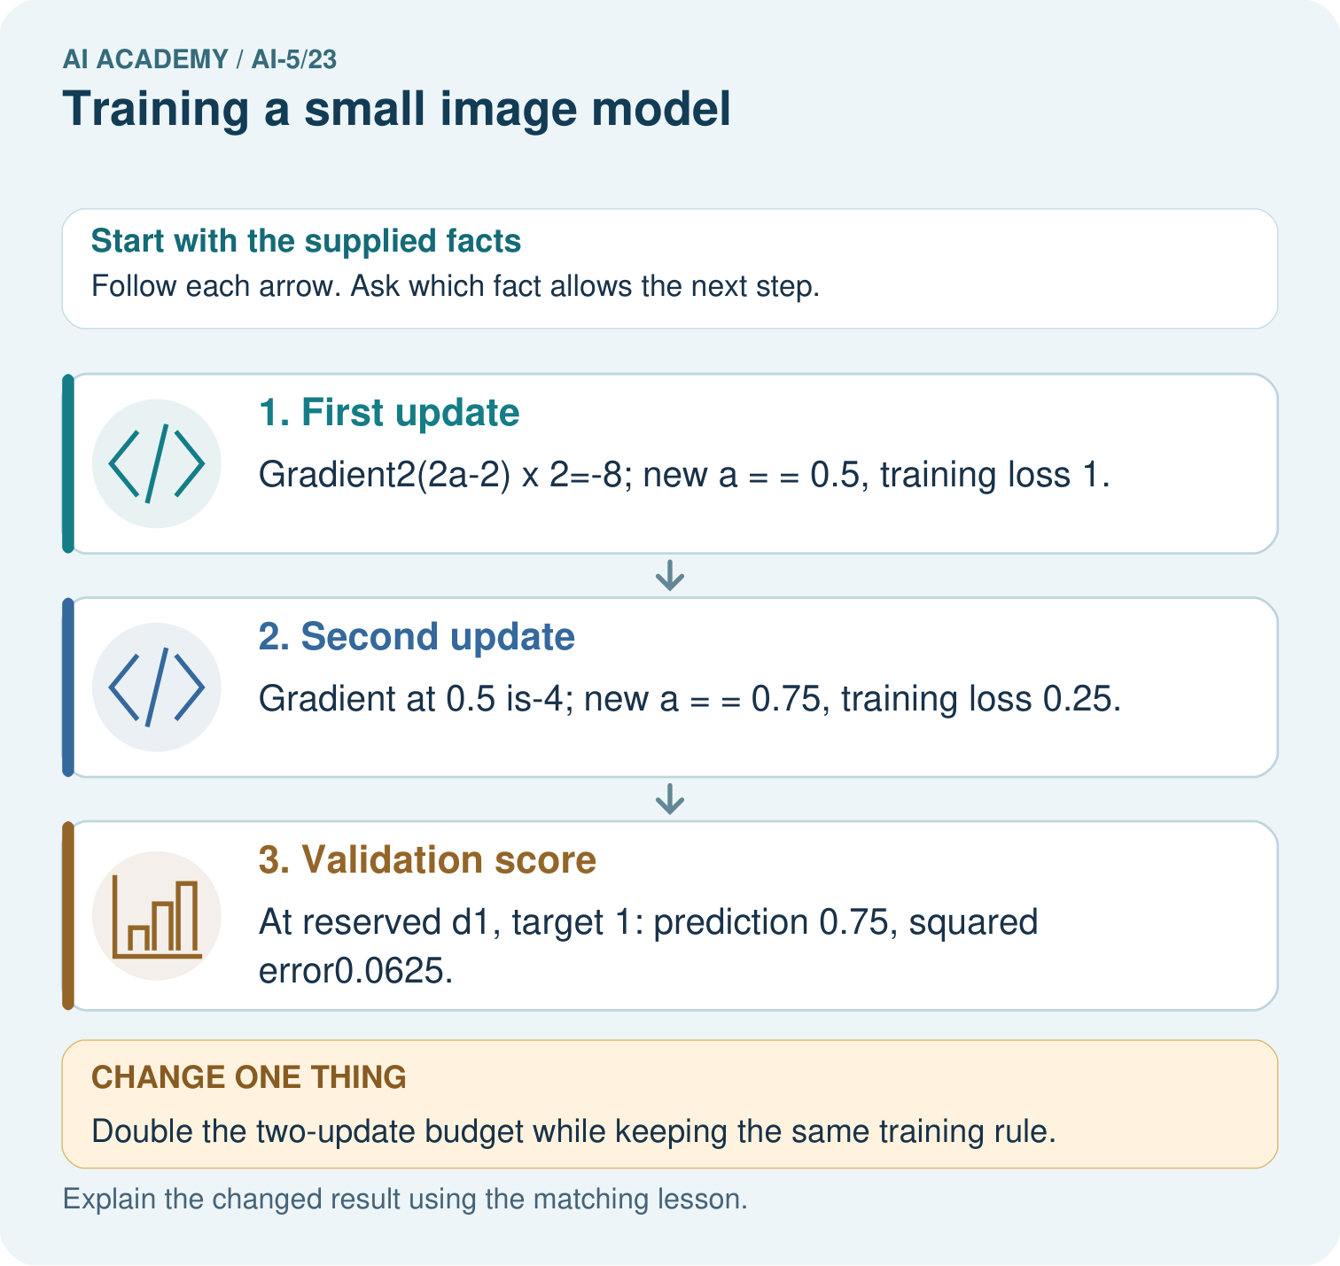

Read the picture one step at a time
Step | What happens and why
1. First update | Gradient2(2a-2)×2=-8; new a = = 0.5, training loss 1.
2. Second update | Gradient at 0.5 is-4; new a = = 0.75, training loss 0.25.
3. Validation score | At reserved d1, target 1: prediction 0.75, squared error0.0625.
Match each pictured step to the supplied facts. This is a worked teaching case, not an independent assessment.

Why this result follows
The image feature is a brightness difference, and training adjusts one output weight multiplying it. Each gradient is computed using the current prediction before the next update. In this example, the rate halves the distance to the training optimum each time. More updates reduce this training loss, but choosing a budget still requires separate validation evidence.

What this example does not establish
This scalar brightness model is a transparent toy image task, not a claim that a full image network was run.

Change one thing in the pictured case
Change: Double the two-update budget while keeping the same training rule.
Prediction: Next a values 0.875 and 0.9375; training loss falls to 0.015625.
Reason: Each update halves the distance to the training optimum1 in this toy system.

Ask while showing the picture
Cover the result. Ask learners to name the inputs and predict the next step. Uncover one step, connect the icon to the actual procedure, and explain its evidence. Then change the supplied condition and compare. The picture is a representation; it does not document execution of a real AI model.

03. Demonstrate and guide practice
Time or stage | Teacher action
Session 1 start to 7 minutes | Retrieve the pooling collision and declare the binary image task, signed targets and separate splits.
7 to 18 minutes | Trace fixed kernels, ReLU features and the scalar head, then complete W1.
18 to 32 minutes | Compute both full-data updates and use W2 to check the loss arithmetic.
32 to 45 minutes | Run or trace the code and use W3 to select a saved checkpoint by validation MSE.
Session 2 start to 8 minutes | Complete the guided validation scores; record the frozen model and constant baseline.
8 to 20 minutes | Reveal final images G, H and I only after the record is complete; collect predictions before labels, then compare both methods.
20 to 35 minutes | Collect W4 independently, requiring validation calculations for every checkpoint.
35 to 45 minutes | Use W5 and the exit response to audit claims and administer the fresh retry.
Use the worked example in Sections 3 and 6. Collect a prediction before revealing its result; ask the learner to point to each intermediate fact.
Provide a ledger for image, difference, signed target, score, residual and class. Allow calculators and distinguish class 0 from signed target -1. Extension: enumerate all sixteen binary 2 by 2 images under the frozen model and exact task rule; label this exhaustive toy-domain audit separately from the three-case held-out evaluation.

Reduce help deliberately
Completion task: Starting at a = 0, use gradient 5a - 3 and rate 0.1 for two updates. Give each gradient, new weight and training MSE.
Teacher check: Teacher explanation: First gradient -3 gives a = 0.3 and MSE 0.325. Second gradient -1.5 gives a = 0.45 and MSE 0.15625. Each gradient is computed at the current weight before the update.
Start by identifying the given inputs together. Leave the intermediate steps blank. If needed, model one step, then withdraw that help on the next step. Move to a full trace only when the partial trace is understood. For partners, alternate explainer and checker; collect a response from every learner before discussion.

Individual reasoning check
Use the worked case for Training a small image model. Proposed explanation: “All parameters in a trained model must have been learned”. Decide whether this explanation is supported. Point to the step or supplied fact that decides; explain your repair if needed.
Expected correction: The declared experiment freezes the feature kernels and adjusts only a.
Collect explanations, not only yes/no votes. If a misunderstanding is common, re-model the relevant step for the class. If it affects a few learners, give a short targeted group explanation while others solve a more demanding variation.

Pictorial practice question
Does lower training loss alone establish that four updates generalise better? Point to the relevant step in the picture, then write the changed result and the rule or evidence that supports it.

Reasoned teacher answer
No. Record the extra budget and score suitable validation evidence; use an untouched final evaluation after selecting a schedule. Changed-case check: Next a values 0.875 and 0.9375; training loss falls to 0.015625. Each update halves the distance to the training optimum1 in this toy system.
Changed-case reasoning: Next a values 0.875 and 0.9375; training loss falls to 0.015625. Each update halves the distance to the training optimum1 in this toy system.
Collect each learner’s explanation before discussion. Use the first missing connection between input, deciding step and result to choose support. This question is worked-case practice, not fresh mastery evidence.

04. Run the investigation and diagnose misconceptions
All parameters in a trained model must have been learned: The declared experiment freezes the feature kernels and adjusts only a.
Perfect accuracy means zero MSE: Thresholded classes can all be correct while continuous scores differ from signed targets.
The last checkpoint must be best: Selection depends on the declared validation rule, not update order or training loss alone.
Use Section 9 for the evidence ledger. Add a boundary or missing-input case and record the expected response before checking. More successful repeats of one case do not establish wider coverage.

Match the support to the first error
What the response shows | Next teaching action
Missing or misread facts | Read the case aloud, mark supplied versus unknown facts, and let the learner restate it.
Wrong procedure | Return to the deciding step in the worked case. Contrast it with the proposed incorrect explanation.
Arithmetic or implementation error | Trace intermediate values or lines; preserve the first mismatch and retry that step.
Correct result without a reason | Ask for a trace and a changed case before marking independent understanding.
An unsupported wider claim | Ask which supplied evidence supports the claim and which further observation would be needed.
Offer an oral explanation, drawing, enlarged visual or fewer examples when that removes a reading/writing barrier. Keep the same reasoning goal. Stretch secure learners by changing a boundary or assumption and asking them to defend the effect, not simply by assigning more of the same questions.

05. Assess and explain the answers

Guided and exit questions
Guided: at a = 0.3, E and F score 0.3 and -0.3; at a = 0.45 they score 0.45 and -0.45. Both checkpoints predict classes 1 and 0 correctly, while squared residuals change from 0.49 to 0.3025. Final cases: G rows [1, 1], [1, 0], class 1; H rows [1, 1], [0, 1], class 0; I rows [1, 0], [0, 1], class 0. Differences are 1, -1, 0; scores 0.45, -0.45, 0; predictions 1, 0, 0. Model accuracy is 3 of 3, baseline 2 of 3. Signed-target squared errors are 0.3025, 0.3025, 1, so final MSE is 0.535. The tie case is classified correctly despite nonzero regression error. Exit: only a was learned; using final results to choose a model contaminates final evaluation. Preserve setup, predictions, baseline and limits.

W1 Trace features and a prediction
For Train B, compute d, h1, h2 and the score at a = 0.45. Give the class prediction and squared error against its signed target.
Teacher explanation: d = 2, h1 = 2 and h2 = 0. Score is 0.9, prediction class 1 and squared error (0.9 - 1) squared = 0.01.

W2 Check both updates
Starting at a = 0, use gradient 5a - 3 and rate 0.1 for two updates. Give each gradient, new weight and training MSE.
Teacher explanation: First gradient -3 gives a = 0.3 and MSE 0.325. Second gradient -1.5 gives a = 0.45 and MSE 0.15625. Each gradient is computed at the current weight before the update.

W3 Apply the selection rule
Select among the three saved lesson checkpoints using validation MSE, with earliest update breaking a tie. Is selecting by training accuracy the same declared procedure?
Teacher explanation: Select update 2 with a = 0.45 and validation MSE 0.3025. Training accuracy is a different selection metric; both trained checkpoints have perfect training accuracy, so it does not establish the same choice.

W4 Choose a checkpoint independently
A separate model scores bd. Its training examples have d = 1 and -1 with signed targets 1 and -1. Start b = 0; gradient is 2(b - 1), rate 0.25 and budget two updates. Validation differences are 2 and -2 with targets 1 and -1. Calculate all three weights and their validation MSEs, then select by lowest validation MSE.
Teacher explanation: Weights are 0, 0.5 and 0.75. Validation scores are [0, 0], [1, -1] and [1.5, -1.5], so validation MSEs are 1, 0 and 0.25. Select update 1 with b = 0.5, even though a later update exists. Training MSE falls from 1 to 0.25 to 0.0625.

W5 Audit a final evaluation
After inspecting the final cases, a team changes the decision threshold and reports the best result as an unseen test score. Explain the problem and list two things the original report should preserve.
Teacher explanation: Final outcomes influenced the revised model, so that set is no longer unseen evidence for the revision. Preserve the original frozen checkpoint and threshold, per-case predictions and errors, baseline results, and split IDs. Evaluate the revision on new reserved cases.

Independent assessment and fresh retry
W4 requires weights 0, 0.5, 0.75 and validation MSEs 1, 0, 0.25; select update 1. Fresh retry: train on d = 2 and -2, signed targets 1 and -1; gradient 8b - 4, rate 0.0625, start 0 and two updates. Weights are 0, 0.25, 0.375. Validate on d = 4 and -4 with targets 1 and -1: MSEs are 1, 0, 0.25. Select update 1 with b = 0.25.

Assess independent transfer
Selected case: A separate model scores bd. Its training examples have d = 1 and -1 with signed targets 1 and -1. Start b = 0; gradient is 2(b - 1), rate 0.25 and budget two updates. Validation differences are 2 and -2 with targets 1 and -1. Calculate all three weights and their validation MSEs, then select by lowest validation MSE.

Selected case answer
Teacher explanation: Weights are 0, 0.5 and 0.75. Validation scores are [0, 0], [1, -1] and [1.5, -1.5], so validation MSEs are 1, 0 and 0.25. Select update 1 with b = 0.5, even though a later update exists. Training MSE falls from 1 to 0.25 to 0.0625.
Dimension | Evidence required
Explanation | Names the applicable idea or procedure and ties it to the supplied facts.
Trace and result | Preserves the given inputs and shows the relevant intermediate steps; distinguishes a prediction from an observed execution.
Limits | States the assumptions, missing evidence or conditions under which the result would change.
Record each dimension as not yet, with support, or independent. Accept a valid alternative procedure with a defensible trace. Do not penalise an honestly recorded model failure if the learner correctly explains its evidence and limits.

Feedback that the learner uses
Name the earliest unsupported step and give one action to repair it. Have the learner make that repair now and explain why. Then assess the relevant skill on a fresh, fully specified case. Confirm it was not previously practised with feedback; solve and check the new case before assigning it. A follow-up design prompt is a starting brief, not automatically an equivalent test.

06. Connect the project, support and next lesson
Add a labelled training a small image model evidence sheet to Image-pattern Network Investigation. Show how you can trace a complete image model with fixed features and one trained weight. Use the supplied fictional case and keep its inputs, intermediate steps, calculation or prediction, and limitation. Connect this record to last week’s record; a matching answer without a trace is insufficient.
Provide a ledger for image, difference, signed target, score, residual and class. Allow calculators and distinguish class 0 from signed target -1. Extension: enumerate all sixteen binary 2 by 2 images under the frozen model and exact task rule; label this exhaustive toy-domain audit separately from the three-case held-out evaluation.
Week 24 examines augmentation and leakage, including how related image variants should remain in the same split.
Retain the project ledger and assess a changed case after support. Check the relevant prerequisite before carrying this component forward.

Plan the delayed return
Suggested return points in this level: ai-5/24, ai-5/26, ai-5/29. Use actual classroom dates, adjusting for holidays and gaps. One, three and six teaching weeks are scheduling choices, not a claimed optimal spacing.
At a delayed check, ask for the idea from memory and a changed application. Compare with the earlier independent response and record support used. For a new level, revisit the previous capstone before checking the new prerequisites.
Record | Teacher evidence
Learner code and date
Concept and case used; prior exposure
Explanation / trace / limits
Support and first repair
Changed case and delayed outcome
Next teaching action
Use the evidence to choose reteaching or the next step. A completed page, confidence rating or attractive project does not by itself demonstrate understanding.

Project evidence from this case
For your Image-pattern Network Investigation, save the input, procedure, observed result and limitation of this check. Label this worked example as practice; use a different, previously unreviewed case when checking independent understanding.

