AI ACADEMY · WORKBOOK · ai-1/5

Pictures Become Numbers
Project: Helpful Classroom Sorter

01. Recall and choose your starting point
Try the recall before opening notes. Then use a different colour or a labelled second line to correct your explanation.

Rules or Learned Patterns?
Without opening the old lesson, explain one key idea from Rules or Learned Patterns?. Give an example and a mistake that the idea helps you avoid.

My remembered idea, example and correction
________________________________________________________________
________________________________________________________________
________________________________________________________________

Input, Process, Output
Without opening the old lesson, explain one key idea from Input, Process, Output. Give an example and a mistake that the idea helps you avoid.

My remembered idea, example and correction
________________________________________________________________
________________________________________________________________
________________________________________________________________

02. Practise with fading help
Use W2: Preserve the missing field for Images as numerical grids. Record the answer once; the lesson and workbook refer to the same attempt.
Given inputs | Procedure I chose | Middle steps | Result and check

The step I completed without help, and the hint I needed
________________________________________________________________
________________________________________________________________
________________________________________________________________

03. Individual reasoning check
Use the worked case for Images as numerical grids. Proposed explanation: “The number one always means black”. Decide whether this explanation is supported. Point to the step or supplied fact that decides; explain your repair if needed.

My explanation before partner discussion
________________________________________________________________
________________________________________________________________
________________________________________________________________
________________________________________________________________

04. Independent transfer case

Independent case: Design a new counterexample
Create two different images of width 4 and height 2, each with exactly three black pixels. Write both complete row encodings. Explain which fact their shared count retains and which difference it discards.

My independent explanation, trace and limits
________________________________________________________________
________________________________________________________________
________________________________________________________________
________________________________________________________________
________________________________________________________________
________________________________________________________________
________________________________________________________________
Attempt this case before feedback. Record any help. Earlier examples below are further practice; a case already practised with feedback cannot establish fresh transfer.

05. Your learning target
Encode a 2×3 monochrome image with top row black–white–black and bottom row white–black–white, using 1 for black. A partner reads columns first. Explain why the image changes although the six values are identical.

06. Solve the given case
A 2 by 2 image has rows [0,1] and [1,0]. Zero means white and one means black.
Draw it, then change the top-left value to 1.
Show your trace, calculation or evidence

Write or draw your reasoning and evidence.
________________________________________________________________
________________________________________________________________
________________________________________________________________
________________________________________________________________
________________________________________________________________

07. Check a changed case
Use 0 for dark and 1 for light. Draw a two-by-two image with rows [1,0] and [0,1]. Then change only the bottom-left pixel to light. Which number changes?
My independent answer and reason

Write or draw your reasoning and evidence.
________________________________________________________________
________________________________________________________________
________________________________________________________________
________________________________________________________________
________________________________________________________________

Week 5 Test and reflect

08. Design a revealing test
Create a changed input, boundary case or missing-information case. Write the expected answer or safe response before testing.
Test record | My evidence
Changed input or condition
Expected answer or fallback
Observed result
Why the result occurred

09. Project checkpoint
Choose which visible item features the Classroom Sorter may represent as image measurements and name one feature that lighting could distort.
The project change and evidence I will keep

Write or draw your reasoning and evidence.
________________________________________________________________
________________________________________________________________
________________________________________________________________
________________________________________________________________
________________________________________________________________

10. Self check
I can explain the mechanism. I can show evidence. I can handle a changed case. I can name a limit. Mark each as not yet, with help or independently, and attach supporting work.
Teacher review ____________________ Next step ____________________

11. Transfer practice from the original programme
Encode a 2×3 monochrome image with top row black–white–black and bottom row white–black–white, using 1 for black. A partner reads columns first. Explain why the image changes although the six values are identical.

My independently reasoned answer
________________________________________________________________
________________________________________________________________
________________________________________________________________
________________________________________________________________
________________________________________________________________
________________________________________________________________
________________________________________________________________
Record support used: none, hint or teacher explanation.

12. W1 Read and reconstruct
Using 1 for black and 0 for white, draw width 3, height 2 with rows 1,0,1 and 0,1,0. Read it back into numbers and count black pixels.

My reasoning and evidence
________________________________________________________________
________________________________________________________________
________________________________________________________________
________________________________________________________________
________________________________________________________________
________________________________________________________________

13. W2 Preserve the missing field
A message contains 1,0,0,1,1,0 but gives no dimensions. Show a one-row arrangement and a two-row arrangement using the same values. Name the extra information that would distinguish them.

My reasoning and evidence
________________________________________________________________
________________________________________________________________
________________________________________________________________
________________________________________________________________
________________________________________________________________
________________________________________________________________

14. W3 Test a count feature
A classifier receives only the number of black pixels. Can it always distinguish the chapter's cross from every other three by three pattern? Construct a different pattern with the same count and explain.

My reasoning and evidence
________________________________________________________________
________________________________________________________________
________________________________________________________________
________________________________________________________________
________________________________________________________________
________________________________________________________________

15. W4 Design a new counterexample
Create two different images of width 4 and height 2, each with exactly three black pixels. Write both complete row encodings. Explain which fact their shared count retains and which difference it discards.

My reasoning and evidence
________________________________________________________________
________________________________________________________________
________________________________________________________________
________________________________________________________________
________________________________________________________________
________________________________________________________________
________________________________________________________________
________________________________________________________________

16. W5 Locate an input problem
A program receives the correct grid but displays black wherever the code says 0 and white wherever it says 1. A student proposes collecting more classifier examples. Identify the earlier mismatch and the first check to perform.

My reasoning and evidence
________________________________________________________________
________________________________________________________________
________________________________________________________________
________________________________________________________________
________________________________________________________________

17. Feedback, return check and learning record
Evidence | My record
Worked alone / hint / model
First step I repaired and why
New case checked later; date and result
What I can now explain without notes
One remaining question
Revisit this idea with your teacher after a delay. Familiarity is different from explaining and using it on a changed case.

18. Pictorial case practice: Pictures Become Numbers
Two fictional 2-by-3 pixel badges contain the same number of dark squares.
Dark=1, light=0; rows are read top to bottom, left to right.
Badge A rows: 1,0,1 / 0,1,0. Badge B: 1,1,1 / 0,0,0.
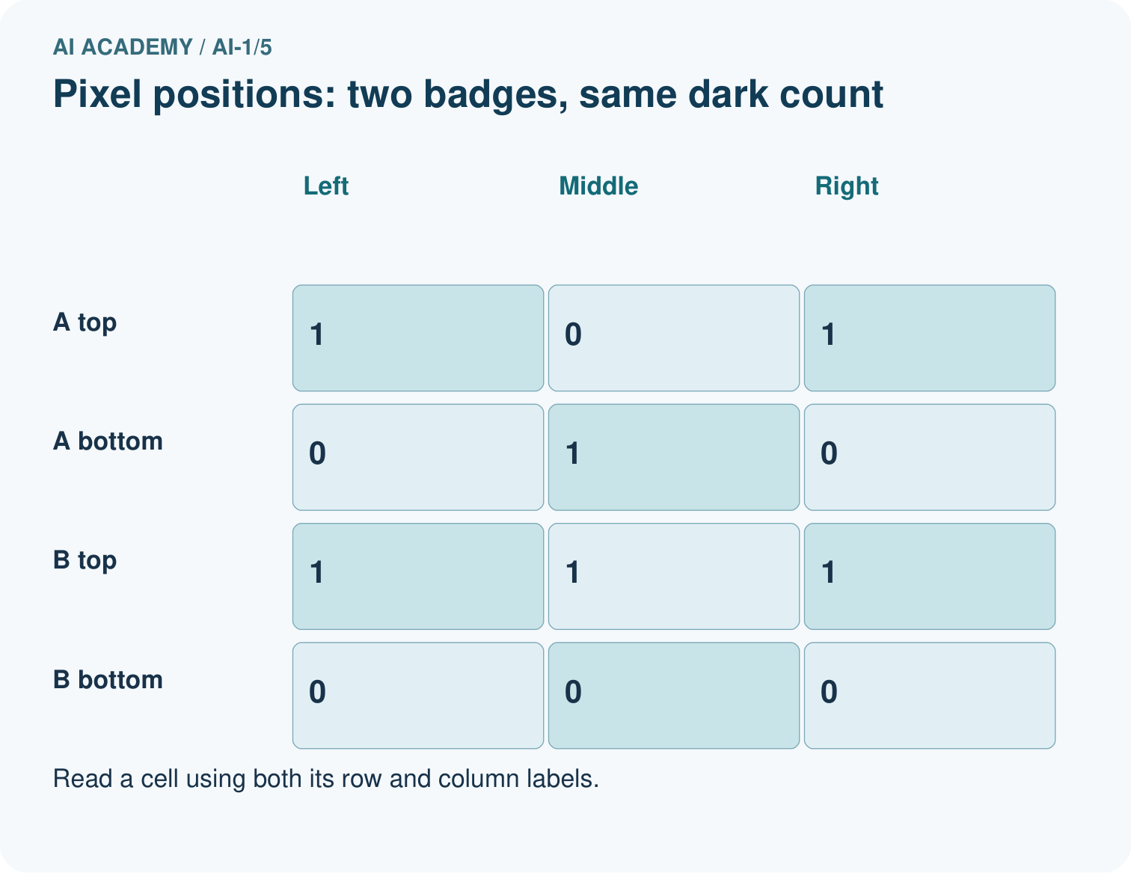
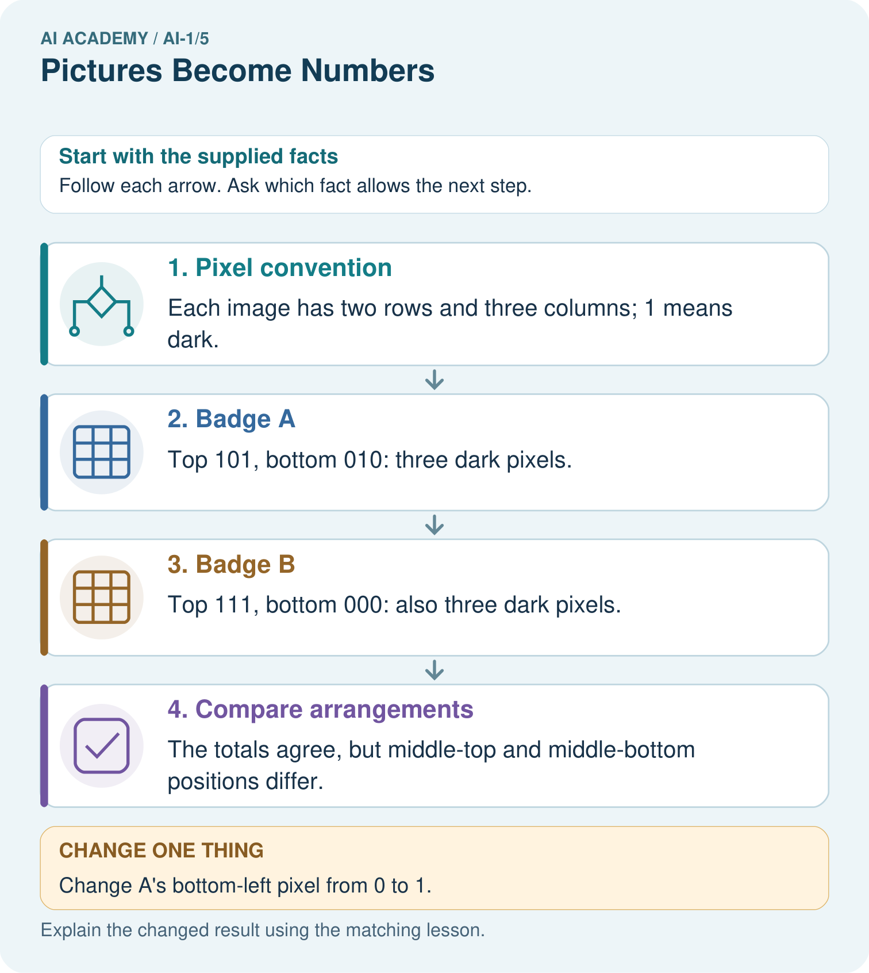
Find a position where the original badges differ, then read the changed A back as a picture.

My picture-based explanation and changed-case prediction
________________________________________________________________
________________________________________________________________
________________________________________________________________
________________________________________________________________
________________________________________________________________
________________________________________________________________
Support used: alone / hint / worked example. This record is practice evidence.
Project connection: If the sorter uses images, retain dimensions and arrangement rather than assuming a dark-pixel count describes shape.

