AI ACADEMY · WORKBOOK · ai-1/7

Categories and Labels
Project: Helpful Classroom Sorter

01. Recall and choose your starting point
Try the recall before opening notes. Then use a different colour or a labelled second line to correct your explanation.

Sound Becomes a Signal
Without opening the old lesson, explain one key idea from Sound Becomes a Signal. Give an example and a mistake that the idea helps you avoid.

My remembered idea, example and correction
________________________________________________________________
________________________________________________________________
________________________________________________________________

Rules or Learned Patterns?
Without opening the old lesson, explain one key idea from Rules or Learned Patterns?. Give an example and a mistake that the idea helps you avoid.

My remembered idea, example and correction
________________________________________________________________
________________________________________________________________
________________________________________________________________

AI or Not?
Without opening the old lesson, explain one key idea from AI or Not?. Give an example and a mistake that the idea helps you avoid.

My remembered idea, example and correction
________________________________________________________________
________________________________________________________________
________________________________________________________________

02. Practise with fading help
Use W2: Replace a vague instruction for Categories and operational labels. Record the answer once; the lesson and workbook refer to the same attempt.
Given inputs | Procedure I chose | Middle steps | Result and check

The step I completed without help, and the hint I needed
________________________________________________________________
________________________________________________________________
________________________________________________________________

03. Individual reasoning check
Use the worked case for Categories and operational labels. Proposed explanation: “A blank is the same as a failing value”. Decide whether this explanation is supported. Point to the step or supplied fact that decides; explain your repair if needed.

My explanation before partner discussion
________________________________________________________________
________________________________________________________________
________________________________________________________________
________________________________________________________________

04. Independent transfer case

Independent case: Transfer the method to a new record
A fictional equipment-request form accepts a whole-number borrowing duration of 1 through 7 days inclusive and one item code X or Y. Label revise if any known field fails; otherwise label review if a field is blank or unreadable; otherwise label ready. Classify these forms and justify each: 7 days X; 8 days Y; unreadable duration X; 8 days blank code. Explain whether ready alone grants permission to borrow.

My independent explanation, trace and limits
________________________________________________________________
________________________________________________________________
________________________________________________________________
________________________________________________________________
________________________________________________________________
________________________________________________________________
________________________________________________________________
Attempt this case before feedback. Record any help. Earlier examples below are further practice; a case already practised with feedback cannot establish fresh transfer.

05. Your learning target
Your dataset labels 'reusable containers'. One team includes a disposable bottle reused once; another excludes it. Give an operational label rule and classify this boundary case under that rule. Explain why a different rule could be defensible.

06. Solve the given case
Six cards show two circles, two triangles and two squares. Sort by shape.
Why can red and blue circles share a label?
Show your trace, calculation or evidence

Write or draw your reasoning and evidence.
________________________________________________________________
________________________________________________________________
________________________________________________________________
________________________________________________________________
________________________________________________________________

07. Check a changed case
The rule is: fruit has seeds; other objects go in other. Sort an apple, a pencil and a sealed mystery box. Which item needs more evidence, and why?
My independent answer and reason

Write or draw your reasoning and evidence.
________________________________________________________________
________________________________________________________________
________________________________________________________________
________________________________________________________________
________________________________________________________________

Week 7 Test and reflect

08. Design a revealing test
Create a changed input, boundary case or missing-information case. Write the expected answer or safe response before testing.
Test record | My evidence
Changed input or condition
Expected answer or fallback
Observed result
Why the result occurred

09. Project checkpoint
Define the Classroom Sorter's bin labels and write how to handle objects that reasonably fit more than one bin.
The project change and evidence I will keep

Write or draw your reasoning and evidence.
________________________________________________________________
________________________________________________________________
________________________________________________________________
________________________________________________________________
________________________________________________________________

10. Self check
I can explain the mechanism. I can show evidence. I can handle a changed case. I can name a limit. Mark each as not yet, with help or independently, and attach supporting work.
Teacher review ____________________ Next step ____________________

11. Transfer practice from the original programme
Your dataset labels 'reusable containers'. One team includes a disposable bottle reused once; another excludes it. Give an operational label rule and classify this boundary case under that rule. Explain why a different rule could be defensible.

My independently reasoned answer
________________________________________________________________
________________________________________________________________
________________________________________________________________
________________________________________________________________
________________________________________________________________
________________________________________________________________
________________________________________________________________
Record support used: none, hint or teacher explanation.

12. W1 Apply the calendar guide
The calendar policy accepts whole-number days 1 through 30 inclusive and a room code A or B. Check known failures first, then unknown fields, then readiness. Label these cards and give evidence: day 30 room B; day 31 room A; day 14 room unreadable; day 31 room unreadable.

My reasoning and evidence
________________________________________________________________
________________________________________________________________
________________________________________________________________
________________________________________________________________
________________________________________________________________
________________________________________________________________
________________________________________________________________

13. W2 Replace a vague instruction
A helper says Label a card ready if it looks nice. Explain why this can lead to inconsistent labels. Replace it with an instruction that another person can apply using the calendar policy, including what to do about a blank field.

My reasoning and evidence
________________________________________________________________
________________________________________________________________
________________________________________________________________
________________________________________________________________
________________________________________________________________
________________________________________________________________

14. W3 Count and investigate disagreement
For the same four cards, Mina records ready, revise, review, ready. Theo records ready, review, review, revise. How many positions agree? Identify the disagreements. Can you decide which annotator is correct from these label lists alone? Explain what else you need.

My reasoning and evidence
________________________________________________________________
________________________________________________________________
________________________________________________________________
________________________________________________________________
________________________________________________________________
________________________________________________________________

15. W4 Transfer the method to a new record
A fictional equipment-request form accepts a whole-number borrowing duration of 1 through 7 days inclusive and one item code X or Y. Label revise if any known field fails; otherwise label review if a field is blank or unreadable; otherwise label ready. Classify these forms and justify each: 7 days X; 8 days Y; unreadable duration X; 8 days blank code. Explain whether ready alone grants permission to borrow.

My reasoning and evidence
________________________________________________________________
________________________________________________________________
________________________________________________________________
________________________________________________________________
________________________________________________________________
________________________________________________________________
________________________________________________________________
________________________________________________________________

16. W5 Keep a policy change visible
Version 1 accepts calendar days 1 through 30. Version 2 accepts days 1 through 31. A card says day 31 room A. State its label under each version. Explain why mixing the two labels without recording the version could create a misleading training dataset.

My reasoning and evidence
________________________________________________________________
________________________________________________________________
________________________________________________________________
________________________________________________________________
________________________________________________________________
________________________________________________________________

17. Feedback, return check and learning record
Evidence | My record
Worked alone / hint / model
First step I repaired and why
New case checked later; date and result
What I can now explain without notes
One remaining question
Revisit this idea with your teacher after a delay. Familiarity is different from explaining and using it on a changed case.

18. Pictorial case practice: Categories and Labels
A fictional craft club labels cardboard-order cards ready, review or revise.
Allowed quantity: whole number 1–4. Required colour: red or blue.
If any known field fails, revise; otherwise if a required field is blank, review; otherwise ready. Cards A=(4,red), B=(5,blank), C=(2,blank).
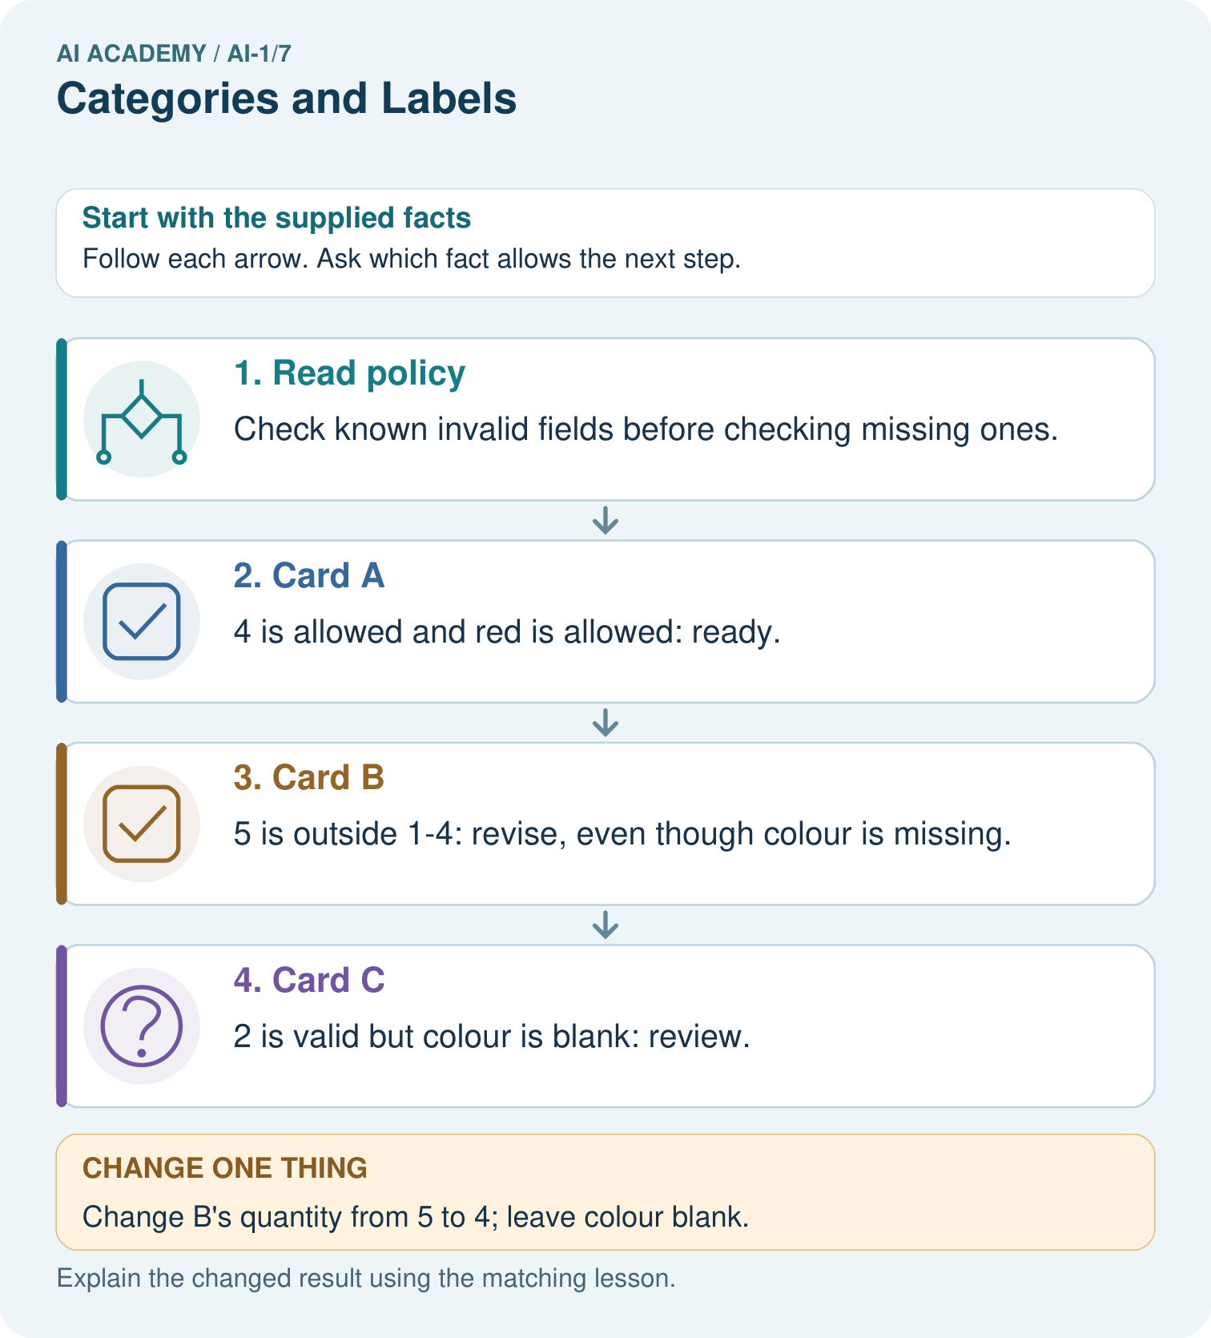
Explain why B originally was revise rather than review, then label its changed version.

My picture-based explanation and changed-case prediction
________________________________________________________________
________________________________________________________________
________________________________________________________________
________________________________________________________________
________________________________________________________________
________________________________________________________________
Support used: alone / hint / worked example. This record is practice evidence.
Project connection: Write a sorter label guide with examples of complete, invalid and unresolved inputs before comparing labels.

