AI ACADEMY · WORKBOOK · ai-1/9

Algorithms as Recipes
Project: Helpful Classroom Sorter

01. Recall and choose your starting point
Try the recall before opening notes. Then use a different colour or a labelled second line to correct your explanation.

Features: Useful Clues
Without opening the old lesson, explain one key idea from Features: Useful Clues. Give an example and a mistake that the idea helps you avoid.

My remembered idea, example and correction
________________________________________________________________
________________________________________________________________
________________________________________________________________

Sound Becomes a Signal
Without opening the old lesson, explain one key idea from Sound Becomes a Signal. Give an example and a mistake that the idea helps you avoid.

My remembered idea, example and correction
________________________________________________________________
________________________________________________________________
________________________________________________________________

Sensors Are Messengers
Without opening the old lesson, explain one key idea from Sensors Are Messengers. Give an example and a mistake that the idea helps you avoid.

My remembered idea, example and correction
________________________________________________________________
________________________________________________________________
________________________________________________________________

02. Practise with fading help
Use W2: Distinguish replacement from addition for Algorithms and changing state. Record the answer once; the lesson and workbook refer to the same attempt.
Given inputs | Procedure I chose | Middle steps | Result and check

The step I completed without help, and the hint I needed
________________________________________________________________
________________________________________________________________
________________________________________________________________

03. Individual reasoning check
Use the worked case for Algorithms and changing state. Proposed explanation: “Every instruction uses the original number”. Decide whether this explanation is supported. Point to the step or supplied fact that decides; explain your repair if needed.

My explanation before partner discussion
________________________________________________________________
________________________________________________________________
________________________________________________________________
________________________________________________________________

04. Independent transfer case

Independent case: Trace two changing number boxes
For a new display, X starts at 4 and Y starts at 1. Copy the current X into Y; add 3 to X; double Y; report both and stop. Record X and Y initially and after each instruction. Explain why Y does not become 7 when X changes. Then swap the first two instructions and trace the new procedure from the same initial state.

My independent explanation, trace and limits
________________________________________________________________
________________________________________________________________
________________________________________________________________
________________________________________________________________
________________________________________________________________
________________________________________________________________
________________________________________________________________
Attempt this case before feedback. Record any help. Earlier examples below are further practice; a case already practised with feedback cannot establish fresh transfer.

05. Your learning target
On numbered squares 0–5, start at 1 facing increasing numbers. Execute FORWARD 2, TURN, FORWARD 1, STOP. Define TURN as reversing direction. Trace position and direction after every instruction. What if TURN were unspecified?

06. Solve the given case
A robot starts on the left of three squares, facing right. It executes MOVE, MOVE, STOP, each MOVE being one square.
Trace the position after each command.
Show your trace, calculation or evidence

Write or draw your reasoning and evidence.
________________________________________________________________
________________________________________________________________
________________________________________________________________
________________________________________________________________
________________________________________________________________

07. Check a changed case
Instructions say pick up a pencil, write your name, then find paper. Find the first ordering problem and rewrite the three steps so another learner can follow them.
My independent answer and reason

Write or draw your reasoning and evidence.
________________________________________________________________
________________________________________________________________
________________________________________________________________
________________________________________________________________
________________________________________________________________

Week 9 Test and reflect

08. Design a revealing test
Create a changed input, boundary case or missing-information case. Write the expected answer or safe response before testing.
Test record | My evidence
Changed input or condition
Expected answer or fallback
Observed result
Why the result occurred

09. Project checkpoint
Write the first executable sorting algorithm for one easy item before adding branches or AI.
The project change and evidence I will keep

Write or draw your reasoning and evidence.
________________________________________________________________
________________________________________________________________
________________________________________________________________
________________________________________________________________
________________________________________________________________

10. Self check
I can explain the mechanism. I can show evidence. I can handle a changed case. I can name a limit. Mark each as not yet, with help or independently, and attach supporting work.
Teacher review ____________________ Next step ____________________

11. Transfer practice from the original programme
On numbered squares 0–5, start at 1 facing increasing numbers. Execute FORWARD 2, TURN, FORWARD 1, STOP. Define TURN as reversing direction. Trace position and direction after every instruction. What if TURN were unspecified?

My independently reasoned answer
________________________________________________________________
________________________________________________________________
________________________________________________________________
________________________________________________________________
________________________________________________________________
________________________________________________________________
________________________________________________________________
Record support used: none, hint or teacher explanation.

12. W1 Trace the current value
Start score at 3. Add 4 to score, double score, then subtract 5. Record the initial state and the state after each instruction. Underline the number used by the doubling step and explain where it came from.

My reasoning and evidence
________________________________________________________________
________________________________________________________________
________________________________________________________________
________________________________________________________________
________________________________________________________________
________________________________________________________________

13. W2 Distinguish replacement from addition
Two procedures start score at 6. Procedure A sets score to 4, then adds 2. Procedure B adds 4 to score, then adds 2. Trace both and explain why the first instructions are different.

My reasoning and evidence
________________________________________________________________
________________________________________________________________
________________________________________________________________
________________________________________________________________
________________________________________________________________
________________________________________________________________

14. W3 Repair the first error
A procedure starts score at 6, adds 2, doubles score, then subtracts 3. A trace says 6, 8, 12, 9. Identify the first wrong transition, explain the likely mistake and write a complete corrected trace. Why is changing only the last value inadequate?

My reasoning and evidence
________________________________________________________________
________________________________________________________________
________________________________________________________________
________________________________________________________________
________________________________________________________________
________________________________________________________________

15. W4 Trace two changing number boxes
For a new display, X starts at 4 and Y starts at 1. Copy the current X into Y; add 3 to X; double Y; report both and stop. Record X and Y initially and after each instruction. Explain why Y does not become 7 when X changes. Then swap the first two instructions and trace the new procedure from the same initial state.

My reasoning and evidence
________________________________________________________________
________________________________________________________________
________________________________________________________________
________________________________________________________________
________________________________________________________________
________________________________________________________________
________________________________________________________________
________________________________________________________________

16. W5 Test what a final answer can prove
The required procedure starts score at 10, adds 2 and subtracts 2. A learner instead adds 4 and subtracts 4. Both report 10. Write both traces and explain whether matching the final result proves that the learner followed the required procedure.

My reasoning and evidence
________________________________________________________________
________________________________________________________________
________________________________________________________________
________________________________________________________________
________________________________________________________________
________________________________________________________________

17. Feedback, return check and learning record
Evidence | My record
Worked alone / hint / model
First step I repaired and why
New case checked later; date and result
What I can now explain without notes
One remaining question
Revisit this idea with your teacher after a delay. Familiarity is different from explaining and using it on a changed case.

18. Pictorial case practice: Algorithms as Recipes
A fictional paper badge machine transforms an initial score using an ordered recipe.
Start score=3. Recipe A: double, add 4, subtract 1, report.
Recipe B swaps the first two operations but keeps the same starting score.
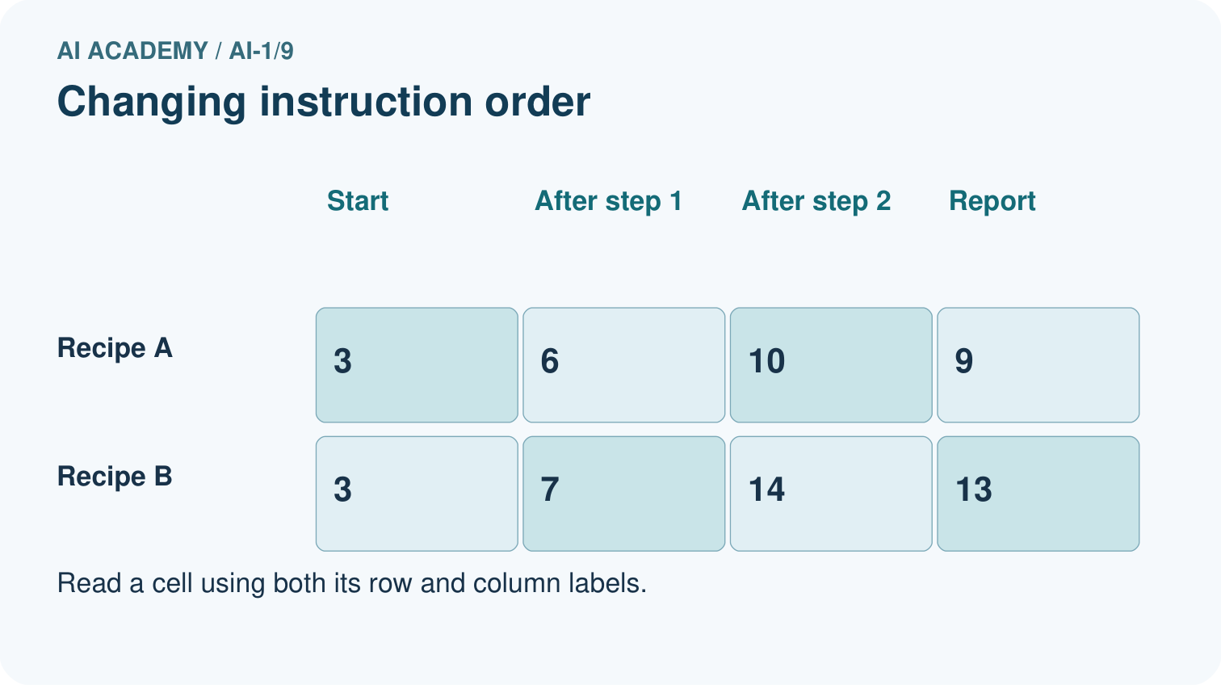
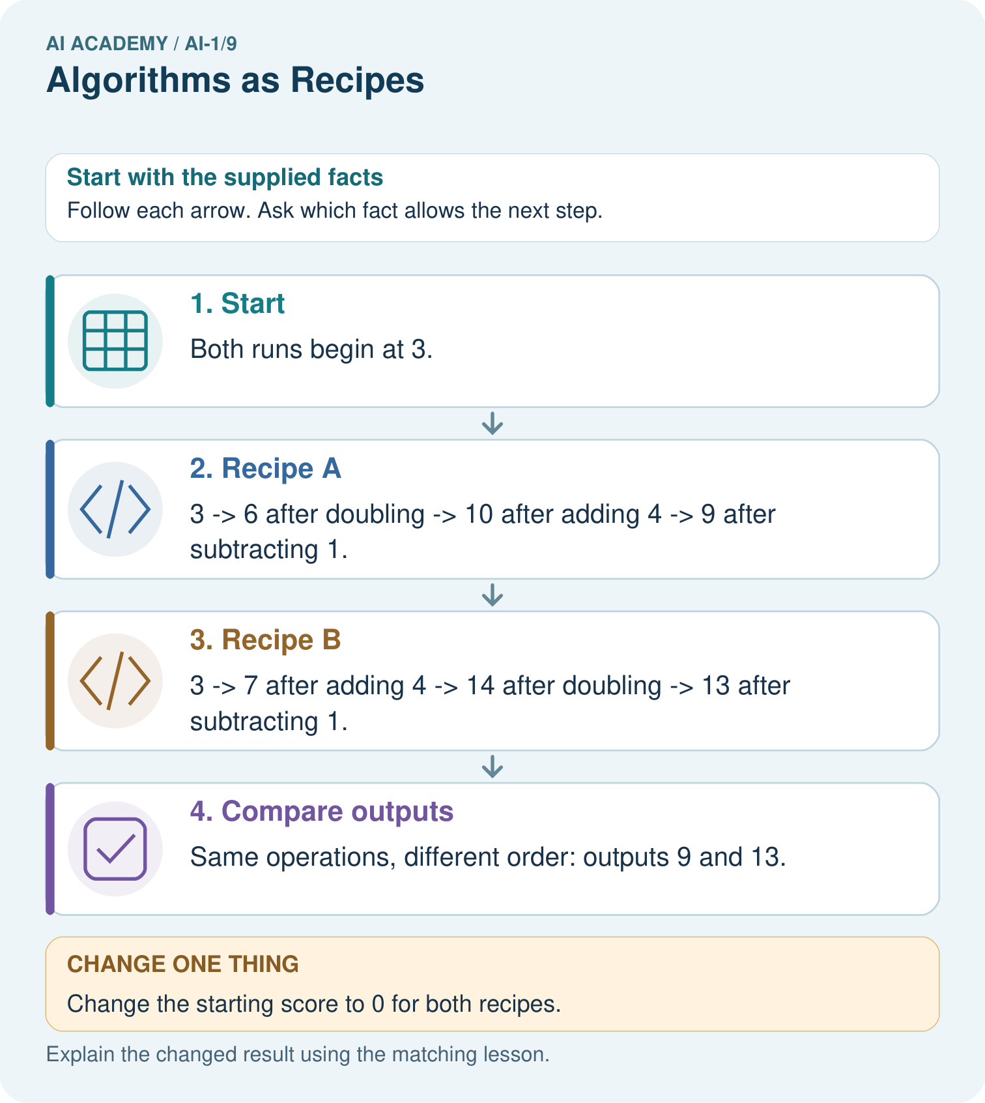
Use the arrows to explain where the two zero-start runs first differ.

My picture-based explanation and changed-case prediction
________________________________________________________________
________________________________________________________________
________________________________________________________________
________________________________________________________________
________________________________________________________________
________________________________________________________________
Support used: alone / hint / worked example. This record is practice evidence.
Project connection: Write the sorter’s steps in order, showing which values each step updates so a partner can reproduce the result.

