AI ACADEMY · WORKBOOK · ai-1/11

Repeating Efficiently
Project: Helpful Classroom Sorter

01. Recall and choose your starting point
Try the recall before opening notes. Then use a different colour or a labelled second line to correct your explanation.

If/Then Decisions
Without opening the old lesson, explain one key idea from If/Then Decisions. Give an example and a mistake that the idea helps you avoid.

My remembered idea, example and correction
________________________________________________________________
________________________________________________________________
________________________________________________________________

Features: Useful Clues
Without opening the old lesson, explain one key idea from Features: Useful Clues. Give an example and a mistake that the idea helps you avoid.

My remembered idea, example and correction
________________________________________________________________
________________________________________________________________
________________________________________________________________

Pictures Become Numbers
Without opening the old lesson, explain one key idea from Pictures Become Numbers. Give an example and a mistake that the idea helps you avoid.

My remembered idea, example and correction
________________________________________________________________
________________________________________________________________
________________________________________________________________

02. Practise with fading help
Use W2: Check the first test for Loops and stopping rules. Record the answer once; the lesson and workbook refer to the same attempt.
Given inputs | Procedure I chose | Middle steps | Result and check

The step I completed without help, and the hint I needed
________________________________________________________________
________________________________________________________________
________________________________________________________________

03. Individual reasoning check
Use the worked case for Loops and stopping rules. Proposed explanation: “Every loop runs at least once”. Decide whether this explanation is supported. Point to the step or supplied fact that decides; explain your repair if needed.

My explanation before partner discussion
________________________________________________________________
________________________________________________________________
________________________________________________________________
________________________________________________________________

04. Independent transfer case

Independent case: Transfer to a countdown
A paper countdown starts at 7. While remaining is above 1, subtract 2. When false, report and stop. Trace the run and count iterations. Repeat from 6 and from 1. Explain why the final value need not equal 1. What happens from 7 if subtract 2 is replaced by subtract 0?

My independent explanation, trace and limits
________________________________________________________________
________________________________________________________________
________________________________________________________________
________________________________________________________________
________________________________________________________________
________________________________________________________________
________________________________________________________________
Attempt this case before feedback. Record any help. Earlier examples below are further practice; a case already practised with feedback cannot establish fresh transfer.

05. Your learning target
A robot stamps the next unstamped card until it has stamped five cards. Only three cards are available. Write a stopping rule that handles both limits and trace the number stamped.

06. Solve the given case
Repeat take the next unstamped card and stamp it four times.
How many cards are stamped? What assumption matters?
Show your trace, calculation or evidence

Write or draw your reasoning and evidence.
________________________________________________________________
________________________________________________________________
________________________________________________________________
________________________________________________________________
________________________________________________________________

07. Check a changed case
Repeat clap then tap three times. Write the complete sequence. How many actions occur? What would happen if the stopping instruction were missing?
My independent answer and reason

Write or draw your reasoning and evidence.
________________________________________________________________
________________________________________________________________
________________________________________________________________
________________________________________________________________
________________________________________________________________

Week 11 Test and reflect

08. Design a revealing test
Create a changed input, boundary case or missing-information case. Write the expected answer or safe response before testing.
Test record | My evidence
Changed input or condition
Expected answer or fallback
Observed result
Why the result occurred

09. Project checkpoint
Use a loop to process each item card in the test pile, with an explicit stop when no cards remain.
The project change and evidence I will keep

Write or draw your reasoning and evidence.
________________________________________________________________
________________________________________________________________
________________________________________________________________
________________________________________________________________
________________________________________________________________

10. Self check
I can explain the mechanism. I can show evidence. I can handle a changed case. I can name a limit. Mark each as not yet, with help or independently, and attach supporting work.
Teacher review ____________________ Next step ____________________

11. Transfer practice from the original programme
A robot stamps the next unstamped card until it has stamped five cards. Only three cards are available. Write a stopping rule that handles both limits and trace the number stamped.

My independently reasoned answer
________________________________________________________________
________________________________________________________________
________________________________________________________________
________________________________________________________________
________________________________________________________________
________________________________________________________________
________________________________________________________________
Record support used: none, hint or teacher explanation.

12. W1 Trace every test
Start counter at 2. While counter is below 8, add 2. When false, report and stop. Record the value and result at every test, including the final false test. State the number of iterations and the reported value.

My reasoning and evidence
________________________________________________________________
________________________________________________________________
________________________________________________________________
________________________________________________________________
________________________________________________________________
________________________________________________________________
________________________________________________________________

13. W2 Check the first test
Use the same below 8 loop with add 2. Make separate runs from 8 and 9. Explain how many times the body runs and what each run reports. Why would adding 2 once be an error?

My reasoning and evidence
________________________________________________________________
________________________________________________________________
________________________________________________________________
________________________________________________________________
________________________________________________________________
________________________________________________________________

14. W3 Find the extra repetition
Start counter at 3. While counter is below 8, add 2. A learner writes values 3, 5, 7, 9, 11 and reports 11. Identify the first unauthorised update. Give the correct final test, reported value and iteration count.

My reasoning and evidence
________________________________________________________________
________________________________________________________________
________________________________________________________________
________________________________________________________________
________________________________________________________________
________________________________________________________________

15. W4 Transfer to a countdown
A paper countdown starts at 7. While remaining is above 1, subtract 2. When false, report and stop. Trace the run and count iterations. Repeat from 6 and from 1. Explain why the final value need not equal 1. What happens from 7 if subtract 2 is replaced by subtract 0?

My reasoning and evidence
________________________________________________________________
________________________________________________________________
________________________________________________________________
________________________________________________________________
________________________________________________________________
________________________________________________________________
________________________________________________________________
________________________________________________________________

16. W5 Test a proposed stopping rule
A procedure says start at 4; while counter is not equal to 9, add 2; report and stop. Write the first four values tested. Explain why the loop will not reach 9 using whole numbers. Suggest a changed condition that would stop once the counter reaches or passes 9, and trace that repaired run.

My reasoning and evidence
________________________________________________________________
________________________________________________________________
________________________________________________________________
________________________________________________________________
________________________________________________________________
________________________________________________________________

17. Feedback, return check and learning record
Evidence | My record
Worked alone / hint / model
First step I repaired and why
New case checked later; date and result
What I can now explain without notes
One remaining question
Revisit this idea with your teacher after a delay. Familiarity is different from explaining and using it on a changed case.

18. Pictorial case practice: Repeating Efficiently
A fictional paper counter advances through a display until its condition becomes false.
Start at 2. While the current counter is below 10, add 3.
Test before each addition; report when the condition is false.
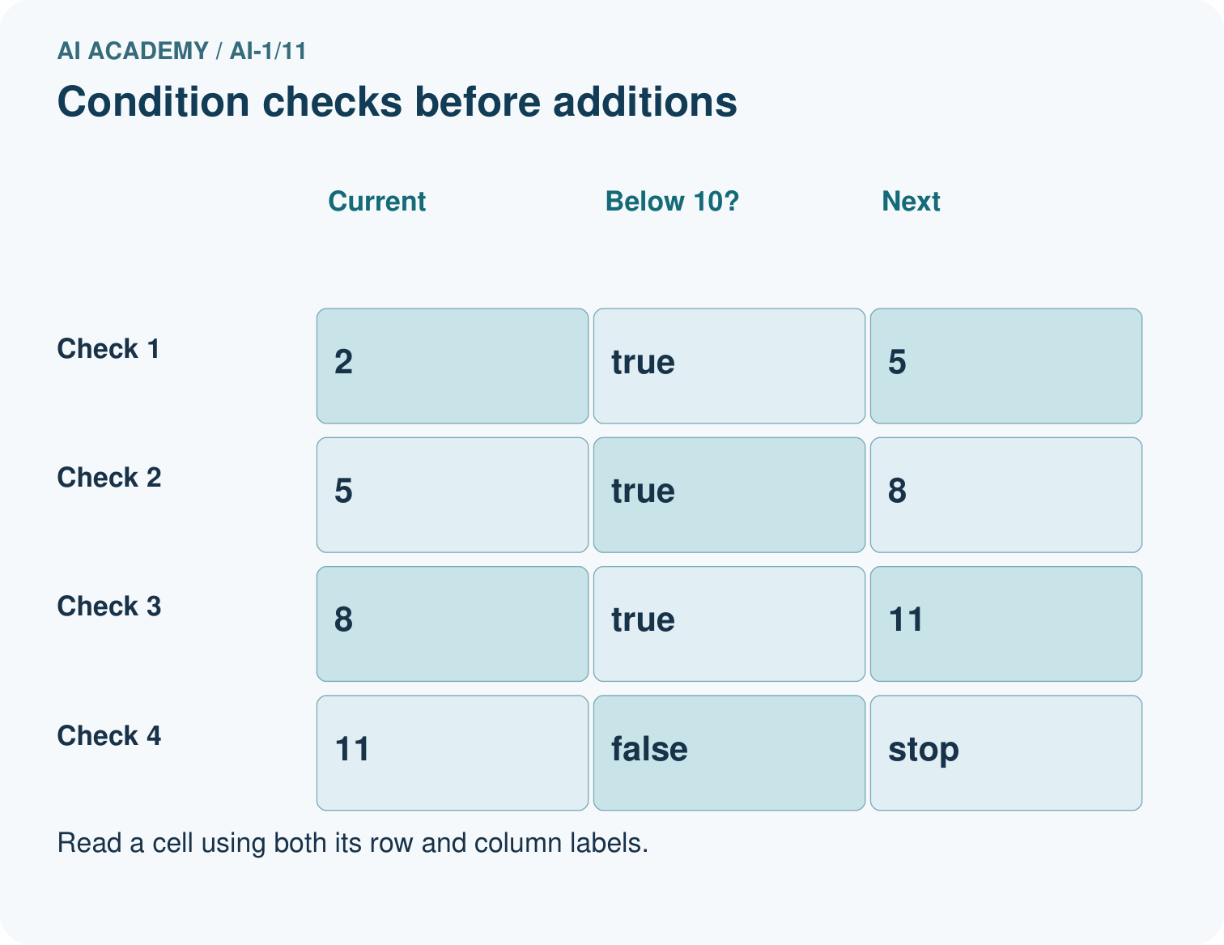
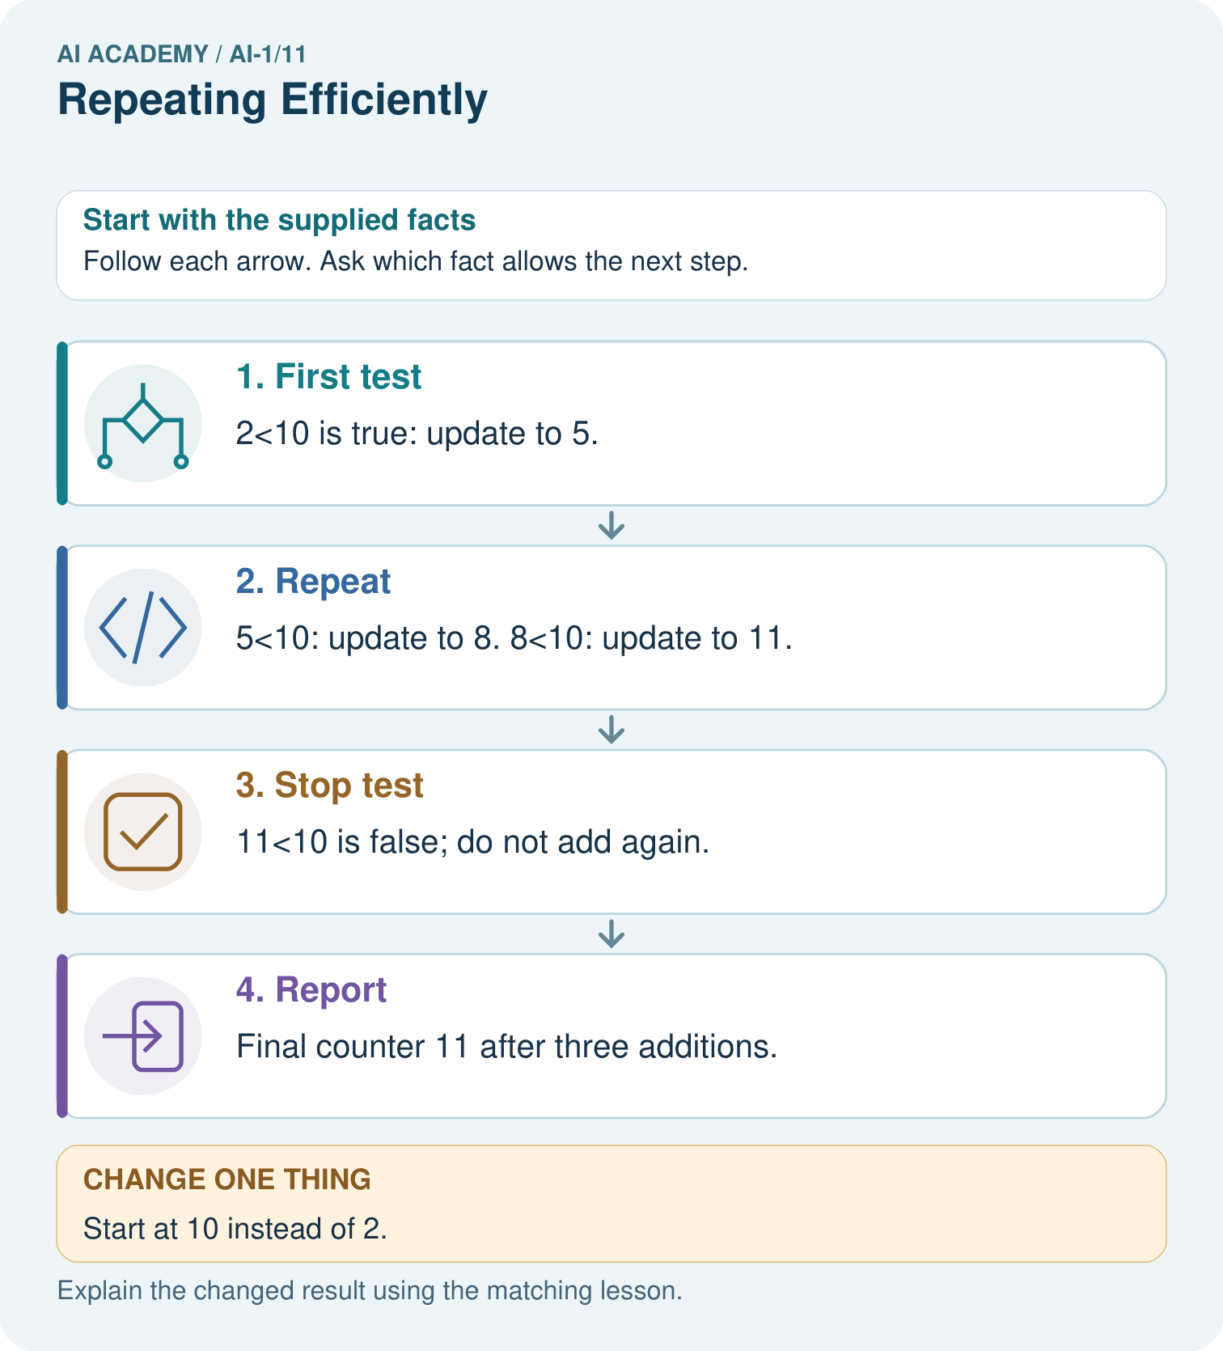
Trace a fresh start of 9. How many additions occur, and must the report equal 10?

My picture-based explanation and changed-case prediction
________________________________________________________________
________________________________________________________________
________________________________________________________________
________________________________________________________________
________________________________________________________________
________________________________________________________________
Support used: alone / hint / worked example. This record is practice evidence.
Project connection: Give any repeated sorter step an explicit stopping condition and trace a zero-iteration example.

