AI ACADEMY · WORKBOOK · ai-1/14

Build a Human Classifier
Project: Helpful Classroom Sorter

01. Recall and choose your starting point
Try the recall before opening notes. Then use a different colour or a labelled second line to correct your explanation.

Learning from Examples
Without opening the old lesson, explain one key idea from Learning from Examples. Give an example and a mistake that the idea helps you avoid.

My remembered idea, example and correction
________________________________________________________________
________________________________________________________________
________________________________________________________________

Repeating Efficiently
Without opening the old lesson, explain one key idea from Repeating Efficiently. Give an example and a mistake that the idea helps you avoid.

My remembered idea, example and correction
________________________________________________________________
________________________________________________________________
________________________________________________________________

Features: Useful Clues
Without opening the old lesson, explain one key idea from Features: Useful Clues. Give an example and a mistake that the idea helps you avoid.

My remembered idea, example and correction
________________________________________________________________
________________________________________________________________
________________________________________________________________

02. Practise with fading help
Use W2: Construct both outcome paths for Constructing a classifier. Record the answer once; the lesson and workbook refer to the same attempt.
Given inputs | Procedure I chose | Middle steps | Result and check

The step I completed without help, and the hint I needed
________________________________________________________________
________________________________________________________________
________________________________________________________________

03. Individual reasoning check
Use the worked case for Constructing a classifier. Proposed explanation: “Any numeric input must receive a category”. Decide whether this explanation is supported. Point to the step or supplied fact that decides; explain your repair if needed.

My explanation before partner discussion
________________________________________________________________
________________________________________________________________
________________________________________________________________
________________________________________________________________

04. Independent transfer case

Independent case: Build an independent ribbon classifier
Design Ribbon1 for ribbon lengths recorded as whole centimetres from 1 through 12 inclusive, with unit cm required. Predict long at 8 cm or more and short otherwise. Write complete instructions and trace 7 cm, 8 cm, a blank length and 13 cm. Include reasons for no prediction and the model version in each record.

My independent explanation, trace and limits
________________________________________________________________
________________________________________________________________
________________________________________________________________
________________________________________________________________
________________________________________________________________
________________________________________________________________
________________________________________________________________
Attempt this case before feedback. Record any help. Earlier examples below are further practice; a case already practised with feedback cannot establish fresh transfer.

05. Your learning target
A classroom rule labels anything with wings as a bird. Test a bat, a penguin and a toy aeroplane. Define the target independently, then propose a next step without pretending one visual clue solves biology.

06. Solve the given case
A human classifier uses has wheels means vehicle on a bicycle, wheelchair, toy car and boat.
Apply the rule and identify a limitation.
Show your trace, calculation or evidence

Write or draw your reasoning and evidence.
________________________________________________________________
________________________________________________________________
________________________________________________________________
________________________________________________________________
________________________________________________________________

07. Check a changed case
Use a human classifier: three sides means triangle; four equal sides means square. Classify a three-sided card and a card whose corner is hidden. When should you pause?
My independent answer and reason

Write or draw your reasoning and evidence.
________________________________________________________________
________________________________________________________________
________________________________________________________________
________________________________________________________________
________________________________________________________________

Week 14 Test and reflect

08. Design a revealing test
Create a changed input, boundary case or missing-information case. Write the expected answer or safe response before testing.
Test record | My evidence
Changed input or condition
Expected answer or fallback
Observed result
Why the result occurred

09. Project checkpoint
Make the sorter's current decision boundary visible as a rule chart or feature map.
The project change and evidence I will keep

Write or draw your reasoning and evidence.
________________________________________________________________
________________________________________________________________
________________________________________________________________
________________________________________________________________
________________________________________________________________

10. Self check
I can explain the mechanism. I can show evidence. I can handle a changed case. I can name a limit. Mark each as not yet, with help or independently, and attach supporting work.
Teacher review ____________________ Next step ____________________

11. Transfer practice from the original programme
A classroom rule labels anything with wings as a bird. Test a bat, a penguin and a toy aeroplane. Define the target independently, then propose a next step without pretending one visual clue solves biology.

My independently reasoned answer
________________________________________________________________
________________________________________________________________
________________________________________________________________
________________________________________________________________
________________________________________________________________
________________________________________________________________
________________________________________________________________
Record support used: none, hint or teacher explanation.

12. W1 Write an input contract
Write the complete Tower1 input contract. Give one accepted example and three different rejected examples, each with its reason. Explain why an accepted input does not have to be one of the examples used to fit the threshold.

My reasoning and evidence
________________________________________________________________
________________________________________________________________
________________________________________________________________
________________________________________________________________
________________________________________________________________
________________________________________________________________
________________________________________________________________

13. W2 Construct both outcome paths
Write numbered instructions for Tower1, including input checks, the stopping path after a failed check, the threshold rule and the record to keep. Your partner must be able to use them without supplying an unstated rule.

My reasoning and evidence
________________________________________________________________
________________________________________________________________
________________________________________________________________
________________________________________________________________
________________________________________________________________
________________________________________________________________
________________________________________________________________
________________________________________________________________

14. W3 Trace boundaries and a broken path
Trace 1 cm, 5 cm, 6 cm, 10 cm and 11 cm using Tower1. A faulty procedure records no prediction for a blank, then continues and treats the blank as zero to report short. Identify the missing instruction and the proper final outcome.

My reasoning and evidence
________________________________________________________________
________________________________________________________________
________________________________________________________________
________________________________________________________________
________________________________________________________________
________________________________________________________________

15. W4 Build an independent ribbon classifier
Design Ribbon1 for ribbon lengths recorded as whole centimetres from 1 through 12 inclusive, with unit cm required. Predict long at 8 cm or more and short otherwise. Write complete instructions and trace 7 cm, 8 cm, a blank length and 13 cm. Include reasons for no prediction and the model version in each record.

My reasoning and evidence
________________________________________________________________
________________________________________________________________
________________________________________________________________
________________________________________________________________
________________________________________________________________
________________________________________________________________
________________________________________________________________
________________________________________________________________

16. W5 Explain what your procedure establishes
Ribbon1 accepts 12 cm and predicts long. No comparison label has been supplied for that record. State what has been checked and what remains unknown. Explain why changing a blank to 1 cm just to produce a category would be a mistake.

My reasoning and evidence
________________________________________________________________
________________________________________________________________
________________________________________________________________
________________________________________________________________
________________________________________________________________
________________________________________________________________

17. Feedback, return check and learning record
Evidence | My record
Worked alone / hint / model
First step I repaired and why
New case checked later; date and result
What I can now explain without notes
One remaining question
Revisit this idea with your teacher after a delay. Familiarity is different from explaining and using it on a changed case.

18. Pictorial case practice: Build a Human Classifier
A fictional ribbon sorter uses a fixed instruction card called RibbonR.
Valid input: whole-number length from 0 to 15 with unit cm.
Predict long at least 9 cm; otherwise short. Missing, wrong-unit or out-of-range values request clarification.
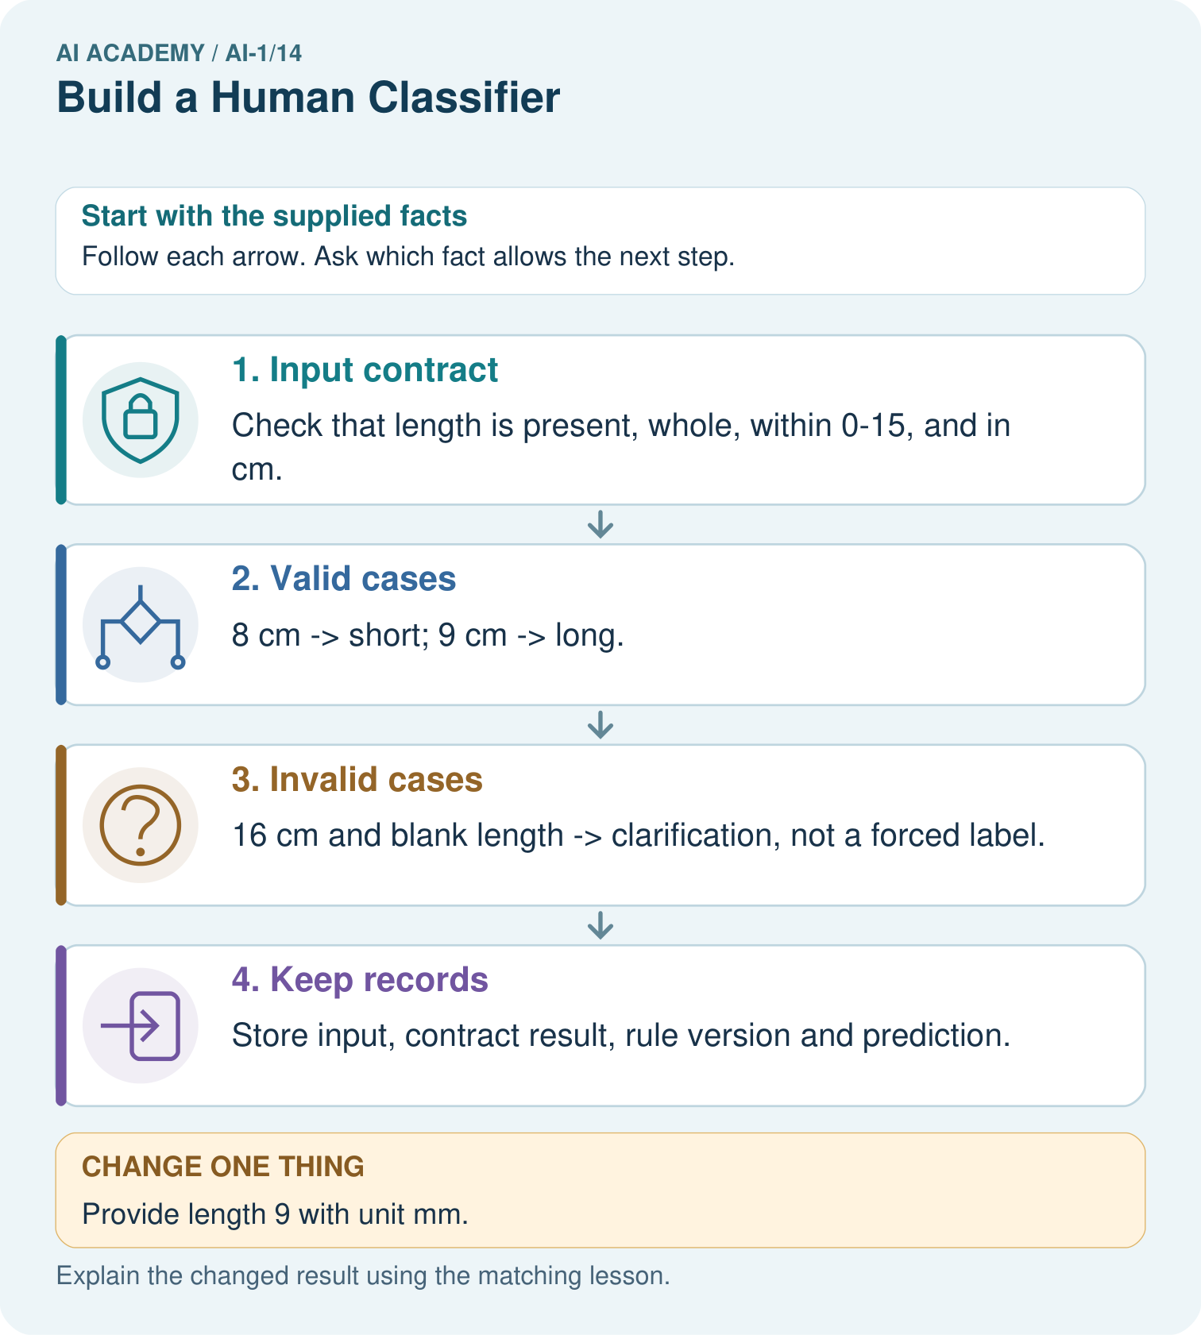
Trace 0 cm and explain why clarification is different from predicting short.

My picture-based explanation and changed-case prediction
________________________________________________________________
________________________________________________________________
________________________________________________________________
________________________________________________________________
________________________________________________________________
________________________________________________________________
Support used: alone / hint / worked example. This record is practice evidence.
Project connection: Create a sorter instruction card covering valid values, equality, missing fields and who can resolve clarification requests.

