AI ACADEMY · WORKBOOK · ai-1/16

Boundaries and 'Not Sure'
Project: Helpful Classroom Sorter

01. Recall and choose your starting point
Try the recall before opening notes. Then use a different colour or a labelled second line to correct your explanation.

Save New Examples for Testing
Without opening the old lesson, explain one key idea from Save New Examples for Testing. Give an example and a mistake that the idea helps you avoid.

My remembered idea, example and correction
________________________________________________________________
________________________________________________________________
________________________________________________________________

Learning from Examples
Without opening the old lesson, explain one key idea from Learning from Examples. Give an example and a mistake that the idea helps you avoid.

My remembered idea, example and correction
________________________________________________________________
________________________________________________________________
________________________________________________________________

If/Then Decisions
Without opening the old lesson, explain one key idea from If/Then Decisions. Give an example and a mistake that the idea helps you avoid.

My remembered idea, example and correction
________________________________________________________________
________________________________________________________________
________________________________________________________________

02. Practise with fading help
Use W2: Keep a stable prediction within its limits for Uncertainty and review. Record the answer once; the lesson and workbook refer to the same attempt.
Given inputs | Procedure I chose | Middle steps | Result and check

The step I completed without help, and the hint I needed
________________________________________________________________
________________________________________________________________
________________________________________________________________

03. Individual reasoning check
Use the worked case for Uncertainty and review. Proposed explanation: “Two possible values imply equal probabilities”. Decide whether this explanation is supported. Point to the step or supplied fact that decides; explain your repair if needed.

My explanation before partner discussion
________________________________________________________________
________________________________________________________________
________________________________________________________________
________________________________________________________________

04. Independent transfer case

Independent case: Transfer the method to distance
A paper model predicts far at a distance of at least 4 units, otherwise near, for whole-number distances 1 through 8. For each complete possibility set, compare predictions: 2 or 3; 3 or 4; 4 or 5. Identify the set requiring review before a single category can be stated. Design a relevant check and an unresolved ending. Limit the claims for the other two sets.

My independent explanation, trace and limits
________________________________________________________________
________________________________________________________________
________________________________________________________________
________________________________________________________________
________________________________________________________________
________________________________________________________________
________________________________________________________________
Attempt this case before feedback. Record any help. Earlier examples below are further practice; a case already practised with feedback cannot establish fresh transfer.

05. Your learning target
A sorter receives a clear purple card, a red card hidden by a sleeve and a card labelled both red and blue by two reviewers. Give a different reason for uncertainty in each case and a suitable next action.

06. Solve the given case
A sorter handles clearly red and clearly blue cards. Purple and very dark cards arrive.
How should it handle each uncertain case?
Show your trace, calculation or evidence

Write or draw your reasoning and evidence.
________________________________________________________________
________________________________________________________________
________________________________________________________________
________________________________________________________________
________________________________________________________________

07. Check a changed case
A sorter knows pencils and books. You show a lunch box. Should it force a known label or ask for help? State a useful fallback.
My independent answer and reason

Write or draw your reasoning and evidence.
________________________________________________________________
________________________________________________________________
________________________________________________________________
________________________________________________________________
________________________________________________________________

Week 16 Test and reflect

08. Design a revealing test
Create a changed input, boundary case or missing-information case. Write the expected answer or safe response before testing.
Test record | My evidence
Changed input or condition
Expected answer or fallback
Observed result
Why the result occurred

09. Project checkpoint
Add a not-sure branch, missing-information prompt, and human review destination to the sorter.
The project change and evidence I will keep

Write or draw your reasoning and evidence.
________________________________________________________________
________________________________________________________________
________________________________________________________________
________________________________________________________________
________________________________________________________________

10. Self check
I can explain the mechanism. I can show evidence. I can handle a changed case. I can name a limit. Mark each as not yet, with help or independently, and attach supporting work.
Teacher review ____________________ Next step ____________________

11. Transfer practice from the original programme
A sorter receives a clear purple card, a red card hidden by a sleeve and a card labelled both red and blue by two reviewers. Give a different reason for uncertainty in each case and a suitable next action.

My independently reasoned answer
________________________________________________________________
________________________________________________________________
________________________________________________________________
________________________________________________________________
________________________________________________________________
________________________________________________________________
________________________________________________________________
Record support used: none, hint or teacher explanation.

12. W1 Describe the uncertainty precisely
For a smudged height that could be 5 or 6 cm, state what is known, what is unknown and the two predictions under tall at least 6. Choose a check that could distinguish the heights. Explain why rerunning the threshold comparison cannot do that.

My reasoning and evidence
________________________________________________________________
________________________________________________________________
________________________________________________________________
________________________________________________________________
________________________________________________________________
________________________________________________________________

13. W2 Keep a stable prediction within its limits
Assume the only possible heights are 8 and 9 cm. Apply tall at least 6 to each. Write a justified result statement and two things it does not establish. Do not invent a confidence percentage.

My reasoning and evidence
________________________________________________________________
________________________________________________________________
________________________________________________________________
________________________________________________________________
________________________________________________________________
________________________________________________________________

14. W3 Choose useful review evidence
A record says 60 but omits the unit. A reviewer suggests reading it as 60 cm because the model needs cm. Explain the problem, name the evidence to request and state the outcome if the unit cannot be established.

My reasoning and evidence
________________________________________________________________
________________________________________________________________
________________________________________________________________
________________________________________________________________
________________________________________________________________
________________________________________________________________

15. W4 Transfer the method to distance
A paper model predicts far at a distance of at least 4 units, otherwise near, for whole-number distances 1 through 8. For each complete possibility set, compare predictions: 2 or 3; 3 or 4; 4 or 5. Identify the set requiring review before a single category can be stated. Design a relevant check and an unresolved ending. Limit the claims for the other two sets.

My reasoning and evidence
________________________________________________________________
________________________________________________________________
________________________________________________________________
________________________________________________________________
________________________________________________________________
________________________________________________________________
________________________________________________________________
________________________________________________________________

16. W5 Review the reviewer’s conclusion
A reviewer cannot read the original tower card but chooses 6 cm because two models both predict tall when given 6. Explain why this fails to resolve the input. Write a more defensible review record and a next step.

My reasoning and evidence
________________________________________________________________
________________________________________________________________
________________________________________________________________
________________________________________________________________
________________________________________________________________
________________________________________________________________

17. Feedback, return check and learning record
Evidence | My record
Worked alone / hint / model
First step I repaired and why
New case checked later; date and result
What I can now explain without notes
One remaining question
Revisit this idea with your teacher after a delay. Familiarity is different from explaining and using it on a changed case.

18. Pictorial case practice: Boundaries and 'Not Sure'
A fictional cubby selector accepts a block if width is at most 5 cm.
An unclear measurement means Block A is either 4 or 5 cm; Block B is either 5 or 6 cm.
These complete possibility sets contain all widths under consideration. Other dimensions are known to fit.
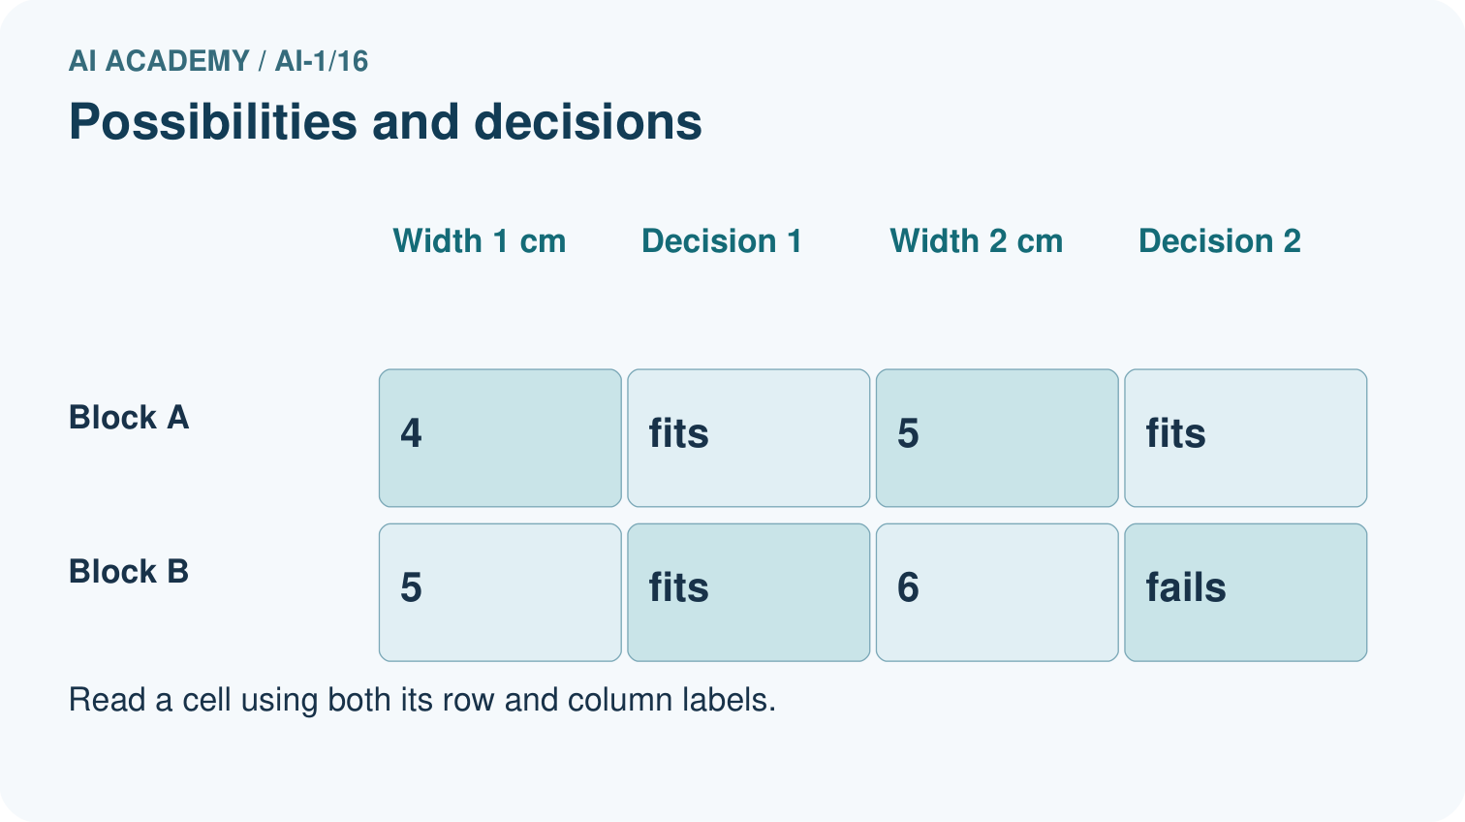
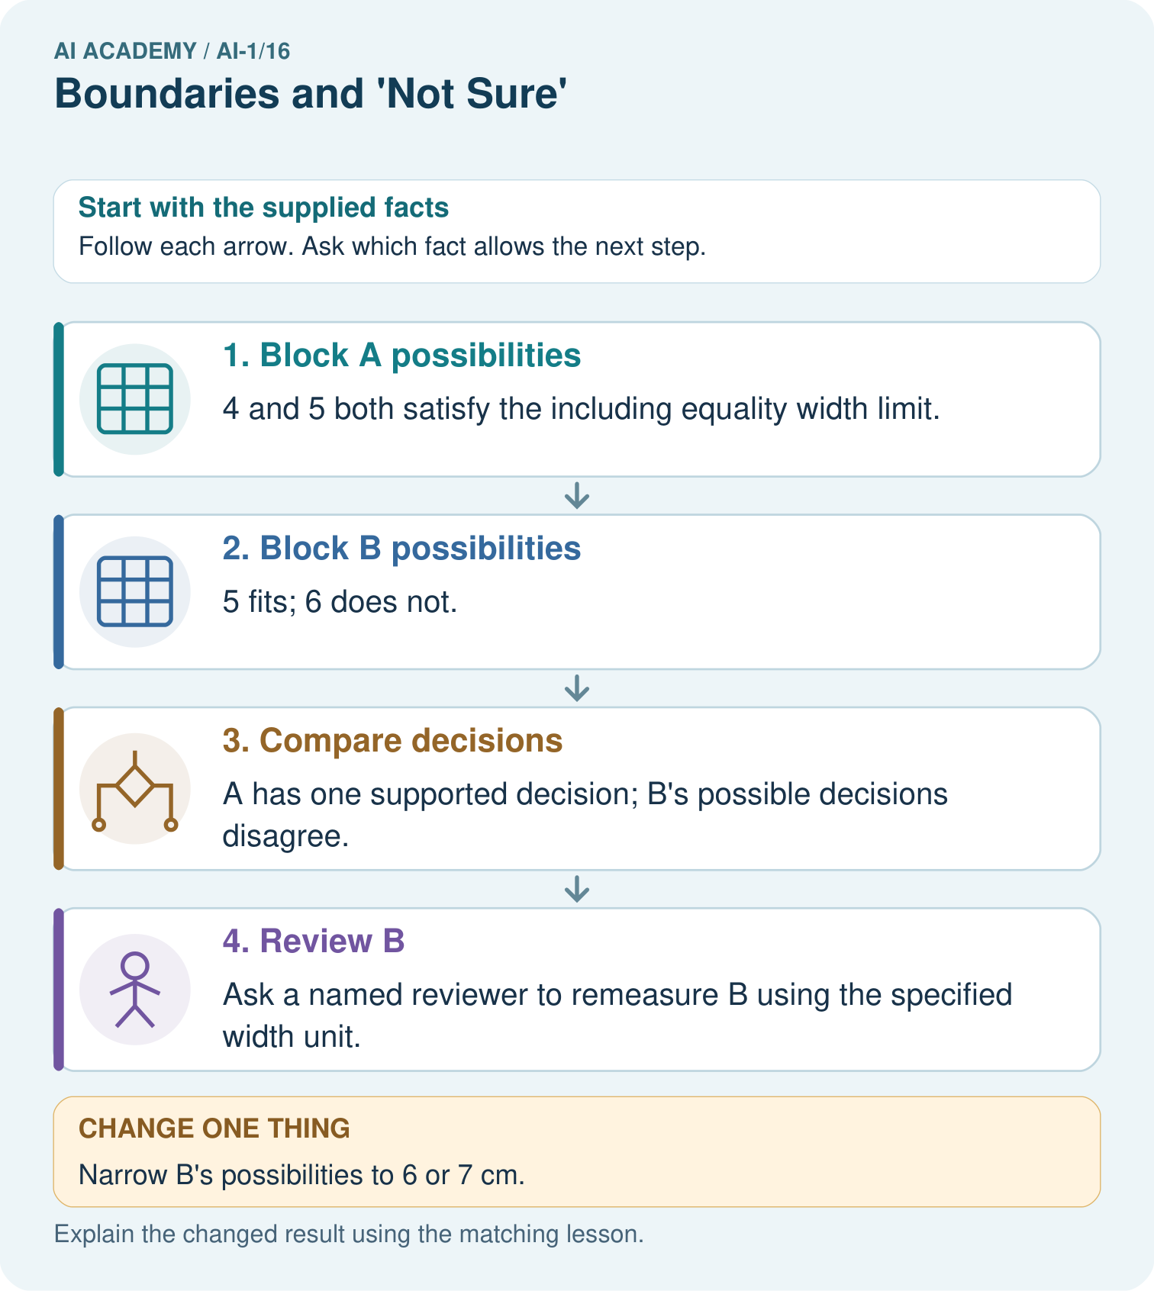
Which original block needs a better width before accepting or rejecting it? What should the reviewer do?

My picture-based explanation and changed-case prediction
________________________________________________________________
________________________________________________________________
________________________________________________________________
________________________________________________________________
________________________________________________________________
________________________________________________________________
Support used: alone / hint / worked example. This record is practice evidence.
Project connection: Add explicit review paths to the sorter, including unresolved input, responsible person and evidence needed.

