AI ACADEMY · WORKBOOK · ai-1/18

Confidence Is Not Correctness
Project: Helpful Classroom Sorter

01. Recall and choose your starting point
Try the recall before opening notes. Then use a different colour or a labelled second line to correct your explanation.

Prediction Is Not Fact
Without opening the old lesson, explain one key idea from Prediction Is Not Fact. Give an example and a mistake that the idea helps you avoid.

My remembered idea, example and correction
________________________________________________________________
________________________________________________________________
________________________________________________________________

Save New Examples for Testing
Without opening the old lesson, explain one key idea from Save New Examples for Testing. Give an example and a mistake that the idea helps you avoid.

My remembered idea, example and correction
________________________________________________________________
________________________________________________________________
________________________________________________________________

Debug the Cause
Without opening the old lesson, explain one key idea from Debug the Cause. Give an example and a mistake that the idea helps you avoid.

My remembered idea, example and correction
________________________________________________________________
________________________________________________________________
________________________________________________________________

02. Practise with fading help
Use W2: Judge cases using outcomes for Confidence and correctness. Record the answer once; the lesson and workbook refer to the same attempt.
Given inputs | Procedure I chose | Middle steps | Result and check

The step I completed without help, and the hint I needed
________________________________________________________________
________________________________________________________________
________________________________________________________________

03. Individual reasoning check
Use the worked case for Confidence and correctness. Proposed explanation: “An 80 point score always means an 80 percent probability”. Decide whether this explanation is supported. Point to the step or supplied fact that decides; explain your repair if needed.

My explanation before partner discussion
________________________________________________________________
________________________________________________________________
________________________________________________________________
________________________________________________________________

04. Independent transfer case

Independent case: Audit a different probability claim
A fictional leaf sorter claims a 75 percent probability of correctness for each of eight chosen labels. Later evidence establishes six correct labels, one incorrect label and one missing outcome. A report says six out of eight proves perfect calibration and guarantees the next label. Repair the report, state the assessed and unassessed counts, and describe a better follow-up check.

My independent explanation, trace and limits
________________________________________________________________
________________________________________________________________
________________________________________________________________
________________________________________________________________
________________________________________________________________
________________________________________________________________
________________________________________________________________
Attempt this case before feedback. Record any help. Earlier examples below are further practice; a case already practised with feedback cannot establish fresh transfer.

05. Your learning target
A helper says 'definitely correct' on four answers; only two match the answer key. A cautious helper gives the same four answers. Which is more accurate? What additional evidence would you need to compare confidence quality?

06. Solve the given case
A helper confidently labels a blurred dog photo as cat; the clear original shows a dog.
What does this show?
Show your trace, calculation or evidence

Write or draw your reasoning and evidence.
________________________________________________________________
________________________________________________________________
________________________________________________________________
________________________________________________________________
________________________________________________________________

07. Check a changed case
A sorter is very confident that a leaf is a coin, but a person checks and sees a leaf. Which determines correctness: confidence or the checked object? Why?
My independent answer and reason

Write or draw your reasoning and evidence.
________________________________________________________________
________________________________________________________________
________________________________________________________________
________________________________________________________________
________________________________________________________________

Week 18 Test and reflect

08. Design a revealing test
Create a changed input, boundary case or missing-information case. Write the expected answer or safe response before testing.
Test record | My evidence
Changed input or condition
Expected answer or fallback
Observed result
Why the result occurred

09. Project checkpoint
Record both the sorter's confidence wording and the human-confirmed outcome; keep them in separate columns.
The project change and evidence I will keep

Write or draw your reasoning and evidence.
________________________________________________________________
________________________________________________________________
________________________________________________________________
________________________________________________________________
________________________________________________________________

10. Self check
I can explain the mechanism. I can show evidence. I can handle a changed case. I can name a limit. Mark each as not yet, with help or independently, and attach supporting work.
Teacher review ____________________ Next step ____________________

11. Transfer practice from the original programme
A helper says 'definitely correct' on four answers; only two match the answer key. A cautious helper gives the same four answers. Which is more accurate? What additional evidence would you need to compare confidence quality?

My independently reasoned answer
________________________________________________________________
________________________________________________________________
________________________________________________________________
________________________________________________________________
________________________________________________________________
________________________________________________________________
________________________________________________________________
Record support used: none, hint or teacher explanation.

12. W1 Read the score definition
A card sorter gives a match score of 80 out of 100 points. Its documentation says the score counts weighted feature matches and is not a probability. A learner calls this an 80 percent chance of correctness. Explain the error and write an accurate description.

My reasoning and evidence
________________________________________________________________
________________________________________________________________
________________________________________________________________
________________________________________________________________
________________________________________________________________
________________________________________________________________

13. W2 Judge cases using outcomes
Use cases A, B and C from the lesson table. State which is correct, incorrect and unassessed. Explain why ordering them by confidence cannot replace checking their outcomes.

My reasoning and evidence
________________________________________________________________
________________________________________________________________
________________________________________________________________
________________________________________________________________
________________________________________________________________
________________________________________________________________

14. W3 Interpret a small group carefully
Ten predictions each claim an 80 percent probability that their chosen category is correct. Five later prove correct and five incorrect. State the claimed probability and observed fraction separately. Does this prove every future prediction will be wrong, or that each next prediction has exactly a 50 percent chance? Explain.

My reasoning and evidence
________________________________________________________________
________________________________________________________________
________________________________________________________________
________________________________________________________________
________________________________________________________________
________________________________________________________________

15. W4 Audit a different probability claim
A fictional leaf sorter claims a 75 percent probability of correctness for each of eight chosen labels. Later evidence establishes six correct labels, one incorrect label and one missing outcome. A report says six out of eight proves perfect calibration and guarantees the next label. Repair the report, state the assessed and unassessed counts, and describe a better follow-up check.

My reasoning and evidence
________________________________________________________________
________________________________________________________________
________________________________________________________________
________________________________________________________________
________________________________________________________________
________________________________________________________________
________________________________________________________________
________________________________________________________________

16. W5 Keep repetition separate from evidence
A learner copies the same 90 percent prediction into ten rows and calls this ten independent tests. No new outcomes were obtained. Explain why the evidence has not grown and propose a useful check.

My reasoning and evidence
________________________________________________________________
________________________________________________________________
________________________________________________________________
________________________________________________________________
________________________________________________________________
________________________________________________________________

17. Feedback, return check and learning record
Evidence | My record
Worked alone / hint / model
First step I repaired and why
New case checked later; date and result
What I can now explain without notes
One remaining question
Revisit this idea with your teacher after a delay. Familiarity is different from explaining and using it on a changed case.

18. Pictorial case practice: Confidence Is Not Correctness
A fictional card classifier reports a claimed 80% chance that each chosen label is correct.
Ten predictions all have score 80%.
Later checks find 7 correct, 2 incorrect and 1 outcome unavailable. The selected cards were not a representative survey.
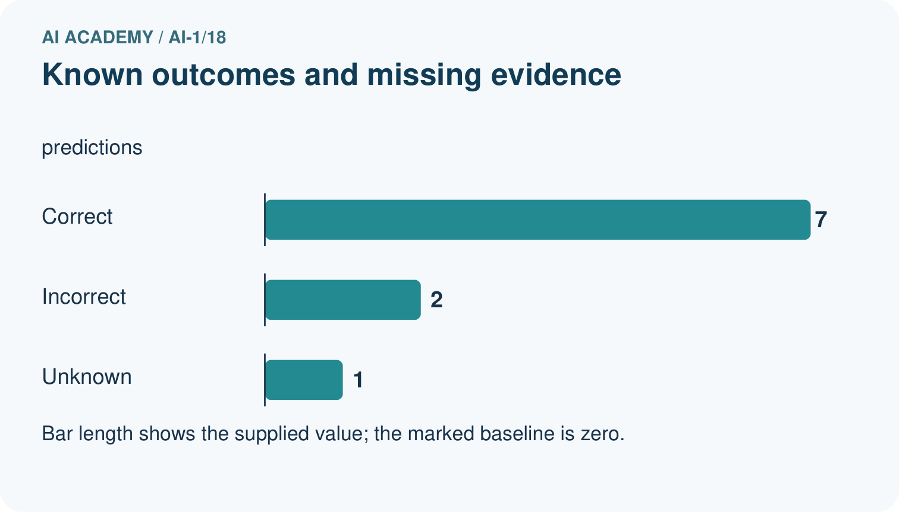
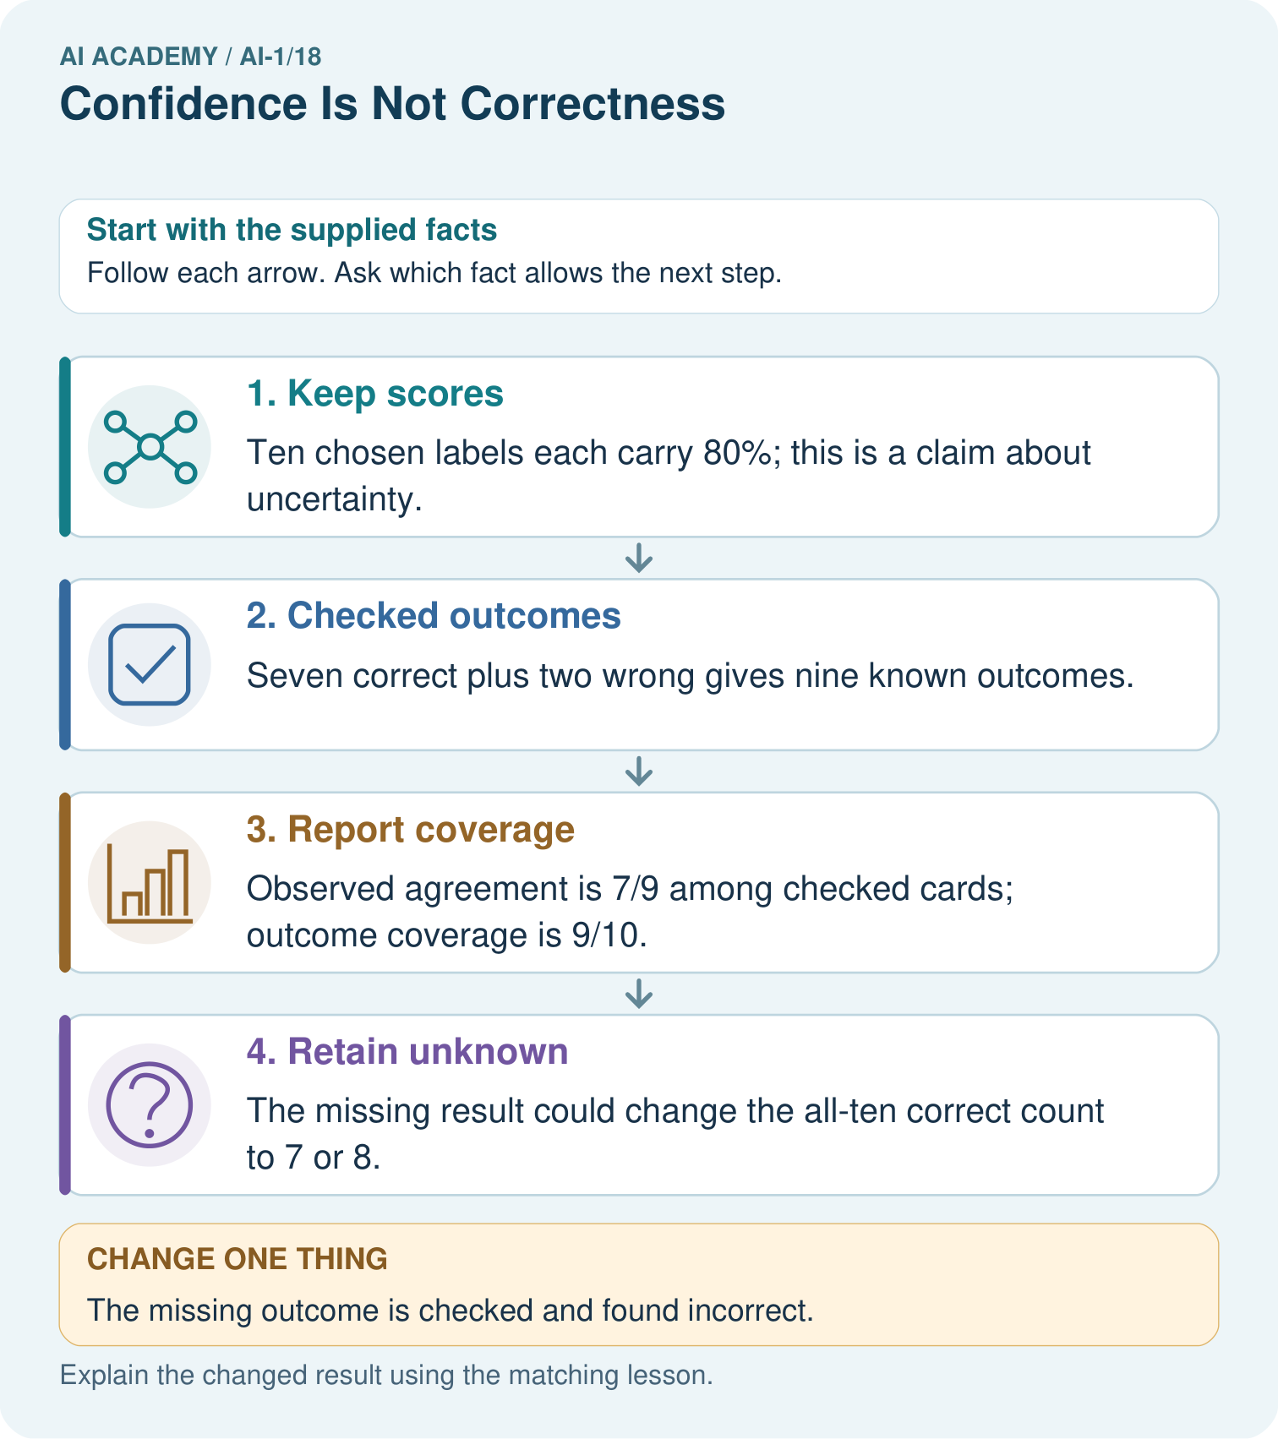
Was the unknown label guaranteed correct because its confidence was 80%?

My picture-based explanation and changed-case prediction
________________________________________________________________
________________________________________________________________
________________________________________________________________
________________________________________________________________
________________________________________________________________
________________________________________________________________
Support used: alone / hint / worked example. This record is practice evidence.
Project connection: Keep sorter scores, reference outcomes and missingness separately; use review policies instead of treating high scores as facts.

