AI ACADEMY · WORKBOOK · ai-1/20

Recommendations
Project: Helpful Classroom Sorter

01. Recall and choose your starting point
Try the recall before opening notes. Then use a different colour or a labelled second line to correct your explanation.

Similarity
Without opening the old lesson, explain one key idea from Similarity. Give an example and a mistake that the idea helps you avoid.

My remembered idea, example and correction
________________________________________________________________
________________________________________________________________
________________________________________________________________

Prediction Is Not Fact
Without opening the old lesson, explain one key idea from Prediction Is Not Fact. Give an example and a mistake that the idea helps you avoid.

My remembered idea, example and correction
________________________________________________________________
________________________________________________________________
________________________________________________________________

Build a Human Classifier
Without opening the old lesson, explain one key idea from Build a Human Classifier. Give an example and a mistake that the idea helps you avoid.

My remembered idea, example and correction
________________________________________________________________
________________________________________________________________
________________________________________________________________

02. Practise with fading help
Use W2: Explain a recommendation honestly for Recommendations and feedback. Record the answer once; the lesson and workbook refer to the same attempt.
Given inputs | Procedure I chose | Middle steps | Result and check

The step I completed without help, and the hint I needed
________________________________________________________________
________________________________________________________________
________________________________________________________________

03. Individual reasoning check
Use the worked case for Recommendations and feedback. Proposed explanation: “A high score can cancel a failed requirement”. Decide whether this explanation is supported. Point to the step or supplied fact that decides; explain your repair if needed.

My explanation before partner discussion
________________________________________________________________
________________________________________________________________
________________________________________________________________
________________________________________________________________

04. Independent transfer case

Independent case: Transfer the process to activities
A fictional learner needs an indoor activity lasting at most 20 minutes. Preferences score 2 for drawing and 1 for solo. Candidates: A drawing, solo, outdoor, 10 minutes; B drawing, group, indoor, 20 minutes; C music, solo, indoor, 15 minutes; D drawing, group, indoor, 18 minutes. Filter, score and return all highest scorers. Only B is then shown and selected; C and D are not shown. State what the feedback establishes and what remains unknown.

My independent explanation, trace and limits
________________________________________________________________
________________________________________________________________
________________________________________________________________
________________________________________________________________
________________________________________________________________
________________________________________________________________
________________________________________________________________
Attempt this case before feedback. Record any help. Earlier examples below are further practice; a case already practised with feedback cannot establish fresh transfer.

05. Your learning target
A system shows only adventure books and records only adventure clicks. It concludes the reader dislikes poetry. Explain the missing evidence and propose a small test.

06. Solve the given case
A recommender suggests adventure books after one adventure-book choice.
Explain its evidence and limitation.
Show your trace, calculation or evidence

Write or draw your reasoning and evidence.
________________________________________________________________
________________________________________________________________
________________________________________________________________
________________________________________________________________
________________________________________________________________

07. Check a changed case
A recommender suggests a space book because you liked two space books. Does the suggestion prove you will enjoy it? What feedback could help next time?
My independent answer and reason

Write or draw your reasoning and evidence.
________________________________________________________________
________________________________________________________________
________________________________________________________________
________________________________________________________________
________________________________________________________________

Week 20 Test and reflect

08. Design a revealing test
Create a changed input, boundary case or missing-information case. Write the expected answer or safe response before testing.
Test record | My evidence
Changed input or condition
Expected answer or fallback
Observed result
Why the result occurred

09. Project checkpoint
If the sorter ranks bins, state the objective and show why the top suggestion is not a command.
The project change and evidence I will keep

Write or draw your reasoning and evidence.
________________________________________________________________
________________________________________________________________
________________________________________________________________
________________________________________________________________
________________________________________________________________

10. Self check
I can explain the mechanism. I can show evidence. I can handle a changed case. I can name a limit. Mark each as not yet, with help or independently, and attach supporting work.
Teacher review ____________________ Next step ____________________

11. Transfer practice from the original programme
A system shows only adventure books and records only adventure clicks. It concludes the reader dislikes poetry. Explain the missing evidence and propose a small test.

My independently reasoned answer
________________________________________________________________
________________________________________________________________
________________________________________________________________
________________________________________________________________
________________________________________________________________
________________________________________________________________
________________________________________________________________
Record support used: none, hint or teacher explanation.

12. W1 Filter before scoring
Apply BookRec1 to J, K, L and M from the lesson. State eligibility or exclusion reason for each, the scores of eligible books and the recommendation. Explain why L’s two preference matches do not make it the winner.

My reasoning and evidence
________________________________________________________________
________________________________________________________________
________________________________________________________________
________________________________________________________________
________________________________________________________________
________________________________________________________________

13. W2 Explain a recommendation honestly
Write an explanation of why J was recommended that mentions one preference it does not match. A marketer adds guaranteed enjoyment. Explain why that phrase is unsupported.

My reasoning and evidence
________________________________________________________________
________________________________________________________________
________________________________________________________________
________________________________________________________________
________________________________________________________________
________________________________________________________________

14. W3 Do not label an unseen item rejected
J was shown and clicked. K was never shown. Separate the observed records from the labels enjoyed and disliked. Write a question that could gather a stated reason while allowing no answer.

My reasoning and evidence
________________________________________________________________
________________________________________________________________
________________________________________________________________
________________________________________________________________
________________________________________________________________
________________________________________________________________

15. W4 Transfer the process to activities
A fictional learner needs an indoor activity lasting at most 20 minutes. Preferences score 2 for drawing and 1 for solo. Candidates: A drawing, solo, outdoor, 10 minutes; B drawing, group, indoor, 20 minutes; C music, solo, indoor, 15 minutes; D drawing, group, indoor, 18 minutes. Filter, score and return all highest scorers. Only B is then shown and selected; C and D are not shown. State what the feedback establishes and what remains unknown.

My reasoning and evidence
________________________________________________________________
________________________________________________________________
________________________________________________________________
________________________________________________________________
________________________________________________________________
________________________________________________________________
________________________________________________________________
________________________________________________________________

16. W5 Handle an empty eligible set
Return to BookRec1. J and K become unavailable, L remains Spanish, and M’s availability becomes unknown. A designer proposes recommending M anyway because it matches both preferences. Apply the requirements and propose an honest response.

My reasoning and evidence
________________________________________________________________
________________________________________________________________
________________________________________________________________
________________________________________________________________
________________________________________________________________
________________________________________________________________

17. Feedback, return check and learning record
Evidence | My record
Worked alone / hint / model
First step I repaired and why
New case checked later; date and result
What I can now explain without notes
One remaining question
Revisit this idea with your teacher after a delay. Familiarity is different from explaining and using it on a changed case.

18. Pictorial case practice: Recommendations
A fictional classroom break chooser recommends a suitable paper activity.
Must be quiet and take at most 12 minutes. Score 2 for puzzles and 1 for solo.
A puzzle,solo,noisy,8 min; B puzzle,group,quiet,12 min; C drawing,solo,quiet,10 min.
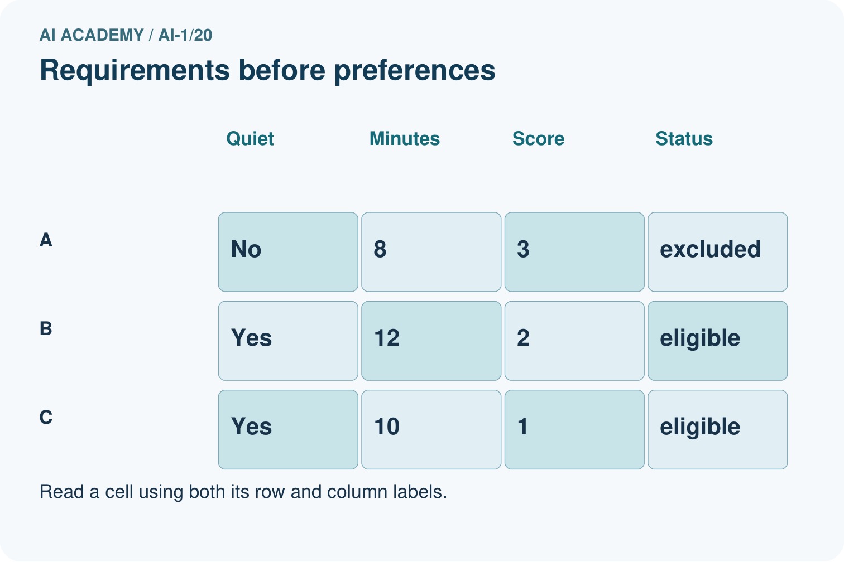
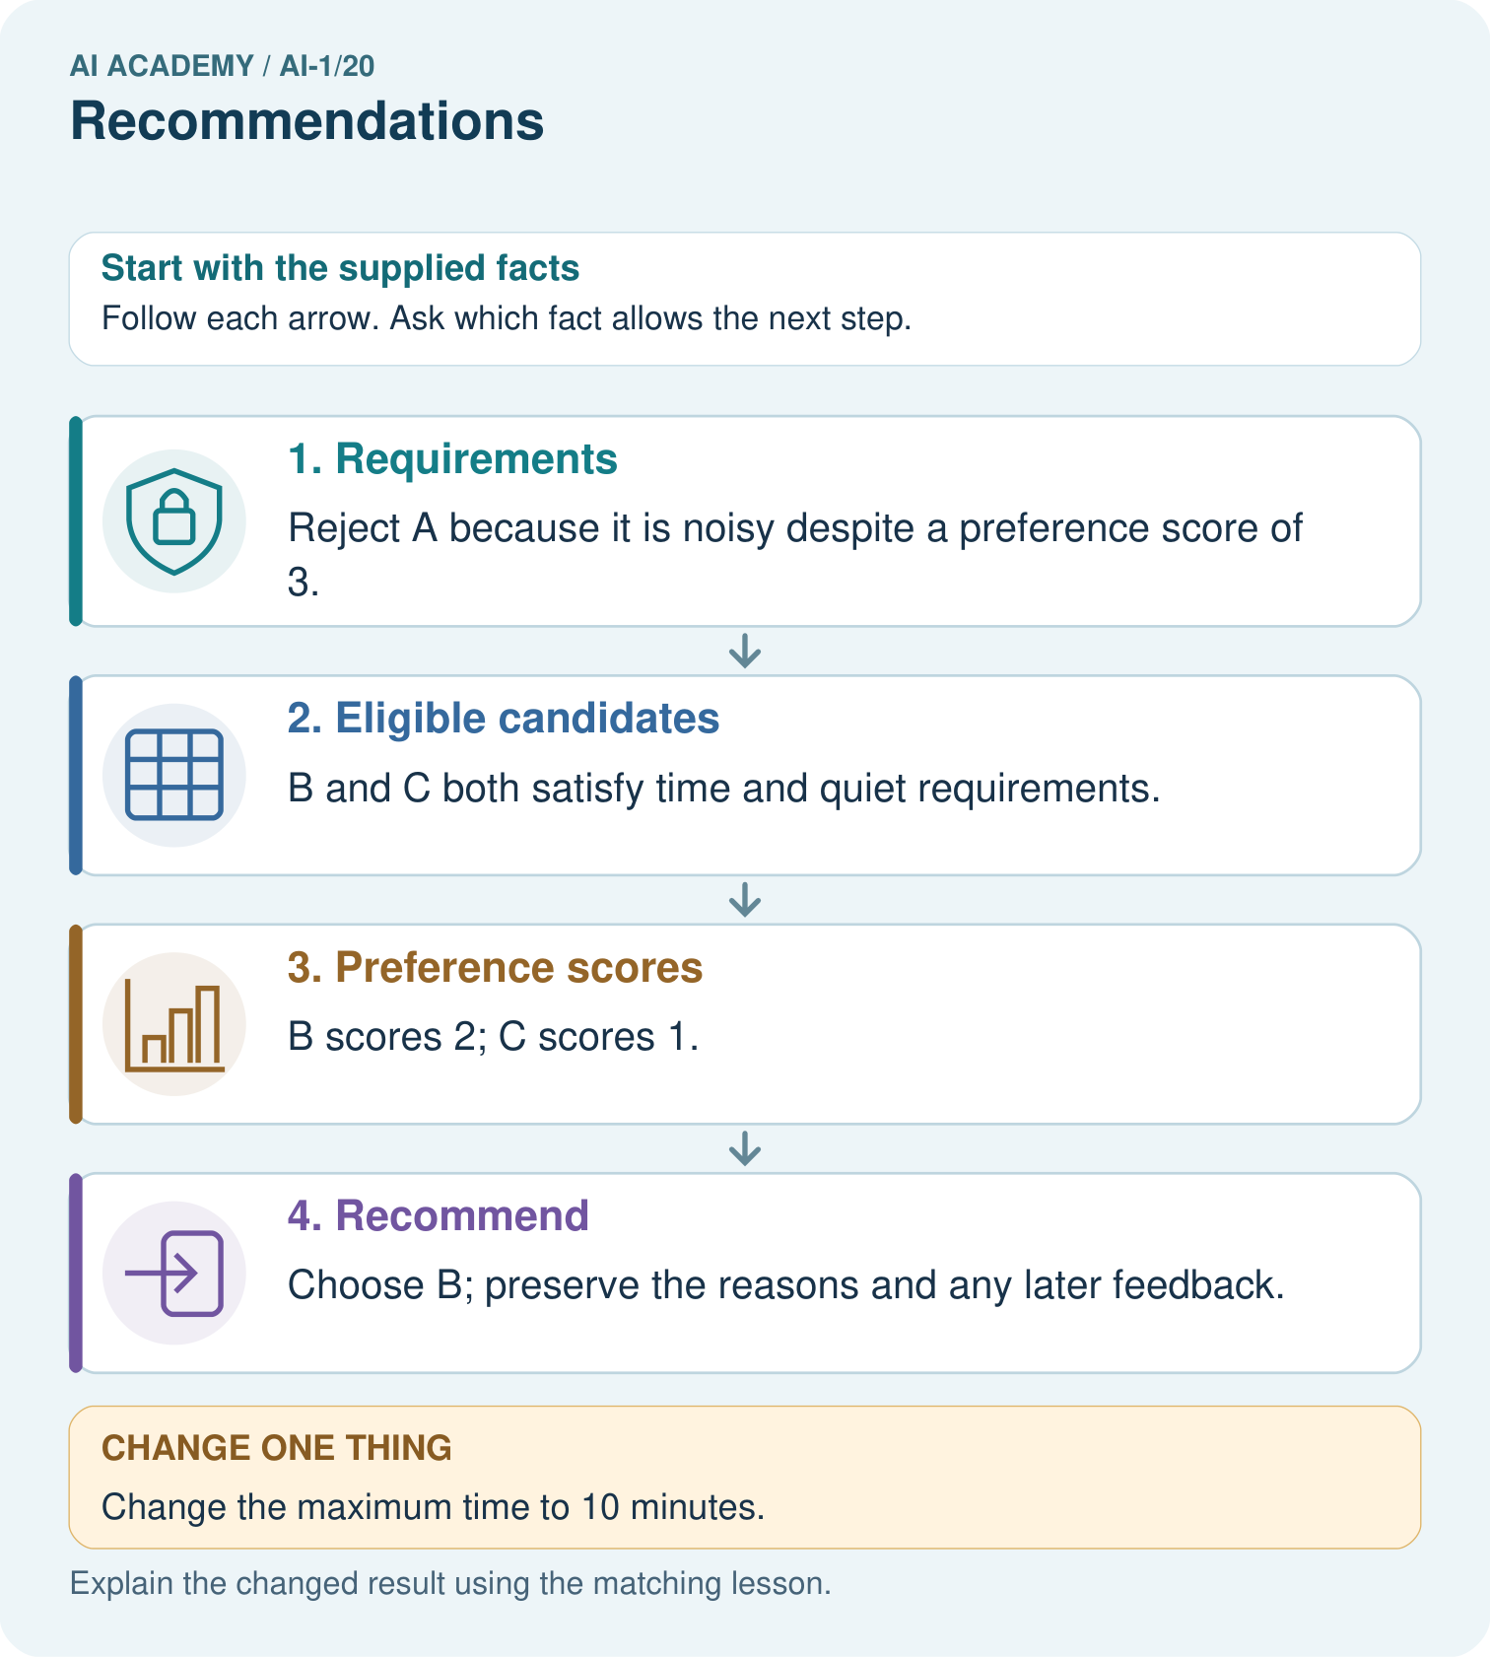
Why does the recommendation change without changing anyone’s preferences?

My picture-based explanation and changed-case prediction
________________________________________________________________
________________________________________________________________
________________________________________________________________
________________________________________________________________
________________________________________________________________
________________________________________________________________
Support used: alone / hint / worked example. This record is practice evidence.
Project connection: Separate sorter requirements, preferences and observed feedback; document why a suggestion was eligible.

