AI ACADEMY · WORKBOOK · ai-1/25

Generate, Retrieve, or Calculate?
Project: Helpful Classroom Sorter

01. Recall and choose your starting point
Try the recall before opening notes. Then use a different colour or a labelled second line to correct your explanation.

Privacy by Choosing Less
Without opening the old lesson, explain one key idea from Privacy by Choosing Less. Give an example and a mistake that the idea helps you avoid.

My remembered idea, example and correction
________________________________________________________________
________________________________________________________________
________________________________________________________________

Missing and Unbalanced Examples
Without opening the old lesson, explain one key idea from Missing and Unbalanced Examples. Give an example and a mistake that the idea helps you avoid.

My remembered idea, example and correction
________________________________________________________________
________________________________________________________________
________________________________________________________________

Similarity
Without opening the old lesson, explain one key idea from Similarity. Give an example and a mistake that the idea helps you avoid.

My remembered idea, example and correction
________________________________________________________________
________________________________________________________________
________________________________________________________________

02. Practise with fading help
Use W2: Separate a correct sum from a correct answer for Generation retrieval and calculation. Record the answer once; the lesson and workbook refer to the same attempt.
Given inputs | Procedure I chose | Middle steps | Result and check

The step I completed without help, and the hint I needed
________________________________________________________________
________________________________________________________________
________________________________________________________________

03. Individual reasoning check
Use the worked case for Generation retrieval and calculation. Proposed explanation: “Retrieving a record proves it is current”. Decide whether this explanation is supported. Point to the step or supplied fact that decides; explain your repair if needed.

My explanation before partner discussion
________________________________________________________________
________________________________________________________________
________________________________________________________________
________________________________________________________________

04. Independent transfer case

Independent case: Trace a new library workshop
Current fictional record B lists a library workshop on Friday in Room 5: five tables with six places each, with four places reserved for helpers. B replaces old record A, which lists Room 3. A draft says “Thursday in Room 3, with 30 places remaining and a free bus home.” Retrieve the current day and room, calculate the non-helper places, write a corrected factual sentence and identify the detail that cannot be supported by B.

My independent explanation, trace and limits
________________________________________________________________
________________________________________________________________
________________________________________________________________
________________________________________________________________
________________________________________________________________
________________________________________________________________
________________________________________________________________
Attempt this case before feedback. Record any help. Earlier examples below are further practice; a case already practised with feedback cannot establish fresh transfer.

05. Your learning target
Three tasks are: invent a school motto, find the exact fire-drill meeting point in a supplied handbook, and divide 84 stickers among 7 teams. Choose generation, retrieval or calculation for each. Which outputs need checking?

06. Solve the given case
A learner needs a new poem, 18+7, and a passage from the class handbook.
Choose the operation for each.
Show your trace, calculation or evidence

Write or draw your reasoning and evidence.
________________________________________________________________
________________________________________________________________
________________________________________________________________
________________________________________________________________
________________________________________________________________

07. Check a changed case
Choose a method for each task: invent a dragon story; find the library's posted hours; compute 7 plus 5. Explain why the methods differ.
My independent answer and reason

Write or draw your reasoning and evidence.
________________________________________________________________
________________________________________________________________
________________________________________________________________
________________________________________________________________
________________________________________________________________

Week 25 Test and reflect

08. Design a revealing test
Create a changed input, boundary case or missing-information case. Write the expected answer or safe response before testing.
Test record | My evidence
Changed input or condition
Expected answer or fallback
Observed result
Why the result occurred

09. Project checkpoint
Label every sorter component as generate, retrieve, calculate, fixed rule, learned prediction, or human decision.
The project change and evidence I will keep

Write or draw your reasoning and evidence.
________________________________________________________________
________________________________________________________________
________________________________________________________________
________________________________________________________________
________________________________________________________________

10. Self check
I can explain the mechanism. I can show evidence. I can handle a changed case. I can name a limit. Mark each as not yet, with help or independently, and attach supporting work.
Teacher review ____________________ Next step ____________________

11. Transfer practice from the original programme
Three tasks are: invent a school motto, find the exact fire-drill meeting point in a supplied handbook, and divide 84 stickers among 7 teams. Choose generation, retrieval or calculation for each. Which outputs need checking?

My independently reasoned answer
________________________________________________________________
________________________________________________________________
________________________________________________________________
________________________________________________________________
________________________________________________________________
________________________________________________________________
________________________________________________________________
Record support used: none, hint or teacher explanation.

12. W1 Name the operation and its evidence
For each task name the main operation and a suitable check: find the room listed in N2; work out six tables of four places minus three reserved places; suggest an inviting title for the event. Can an application combine these operations?

My reasoning and evidence
________________________________________________________________
________________________________________________________________
________________________________________________________________
________________________________________________________________
________________________________________________________________
________________________________________________________________

13. W2 Separate a correct sum from a correct answer
A calculator correctly returns 24 for 6 × 4. A pupil reports this as the number of non-helper places available. Explain the problem and write the correct expression, result and meaning.

My reasoning and evidence
________________________________________________________________
________________________________________________________________
________________________________________________________________
________________________________________________________________
________________________________________________________________
________________________________________________________________

14. W3 Inspect a record and a draft
N1 lists Room 2. N2 explicitly replaces N1 for this event and lists Wednesday in Room 4. A draft says Thursday in Room 2 with free snacks. Identify the supported corrections and the unsupported detail. Explain why finding N1 successfully would not settle the current-room question.

My reasoning and evidence
________________________________________________________________
________________________________________________________________
________________________________________________________________
________________________________________________________________
________________________________________________________________
________________________________________________________________

15. W4 Trace a new library workshop
Current fictional record B lists a library workshop on Friday in Room 5: five tables with six places each, with four places reserved for helpers. B replaces old record A, which lists Room 3. A draft says “Thursday in Room 3, with 30 places remaining and a free bus home.” Retrieve the current day and room, calculate the non-helper places, write a corrected factual sentence and identify the detail that cannot be supported by B.

My reasoning and evidence
________________________________________________________________
________________________________________________________________
________________________________________________________________
________________________________________________________________
________________________________________________________________
________________________________________________________________
________________________________________________________________
________________________________________________________________

16. W5 Do not infer a method from its output
Two applications both display “26 places remain.” Only one provides record B and a trace showing 5 × 6 − 4. What can and cannot be concluded from their matching sentences? Describe how you would check the numerical claim without relying on either application’s assurance.

My reasoning and evidence
________________________________________________________________
________________________________________________________________
________________________________________________________________
________________________________________________________________
________________________________________________________________
________________________________________________________________

17. Feedback, return check and learning record
Evidence | My record
Worked alone / hint / model
First step I repaired and why
New case checked later; date and result
What I can now explain without notes
One remaining question
Revisit this idea with your teacher after a delay. Familiarity is different from explaining and using it on a changed case.

18. Pictorial case practice: Generate, Retrieve, or Calculate?
A fictional craft invitation combines three different operations.
Approved record C: Tuesday, Hall 4, three tables with four learner places each.
Two places are reserved for helpers; no snack information is supplied.
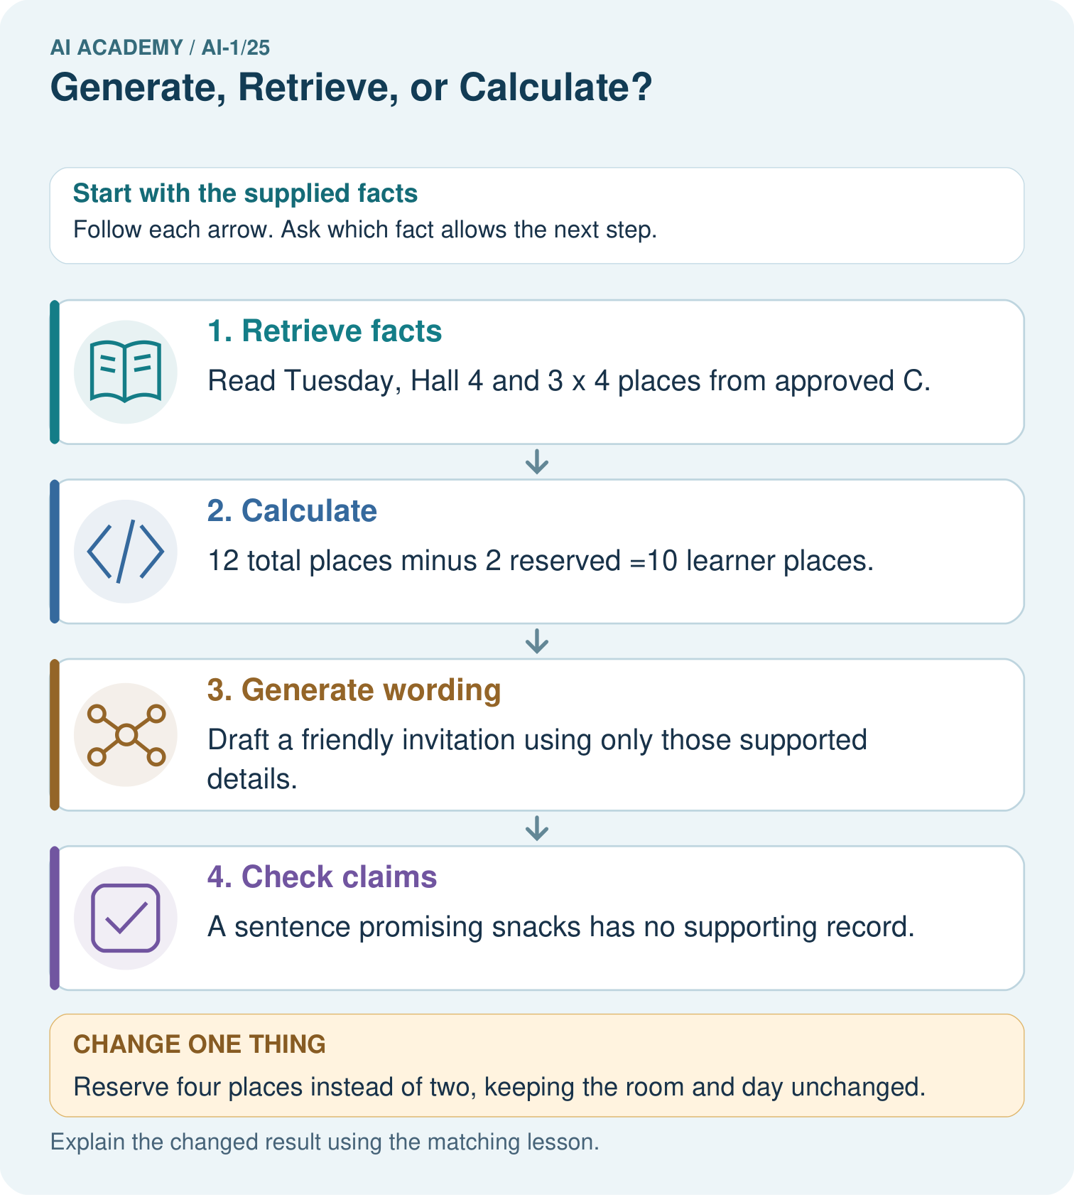
Label each arrow with its operation. Can the system add snacks because invitations often mention them?

My picture-based explanation and changed-case prediction
________________________________________________________________
________________________________________________________________
________________________________________________________________
________________________________________________________________
________________________________________________________________
________________________________________________________________
Support used: alone / hint / worked example. This record is practice evidence.
Project connection: Use the sorter’s approved catalogue for facts, explicit calculations for scores and checked prose for explanations.

