AI ACADEMY · WORKBOOK · ai-1/29

Find a Real Problem
Project: Helpful Classroom Sorter

01. Recall and choose your starting point
Try the recall before opening notes. Then use a different colour or a labelled second line to correct your explanation.

Humans Set Boundaries
Without opening the old lesson, explain one key idea from Humans Set Boundaries. Give an example and a mistake that the idea helps you avoid.

My remembered idea, example and correction
________________________________________________________________
________________________________________________________________
________________________________________________________________

Prompts Are Design Instructions
Without opening the old lesson, explain one key idea from Prompts Are Design Instructions. Give an example and a mistake that the idea helps you avoid.

My remembered idea, example and correction
________________________________________________________________
________________________________________________________________
________________________________________________________________

Fair for Whom?
Without opening the old lesson, explain one key idea from Fair for Whom?. Give an example and a mistake that the idea helps you avoid.

My remembered idea, example and correction
________________________________________________________________
________________________________________________________________
________________________________________________________________

02. Practise with fading help
Use W2: Identify claims beyond the evidence for A problem worth solving. Record the answer once; the lesson and workbook refer to the same attempt.
Given inputs | Procedure I chose | Middle steps | Result and check

The step I completed without help, and the hint I needed
________________________________________________________________
________________________________________________________________
________________________________________________________________

03. Individual reasoning check
Use the worked case for A problem worth solving. Proposed explanation: “Using AI is itself the outcome”. Decide whether this explanation is supported. Point to the step or supplied fact that decides; explain your repair if needed.

My explanation before partner discussion
________________________________________________________________
________________________________________________________________
________________________________________________________________
________________________________________________________________

04. Independent transfer case

Independent case: Frame a different problem independently
In a fictional equipment cupboard exercise, eight teams choose a box from a list. Three boxes do not contain the items required by the corresponding request; five do. The teacher permits a paper box-finder using fictional item requests and an inventory. Write a brief naming the user difficulty, evidence, desired outcome, necessary information, an excluded action and a simple alternative. Identify one cause or benefit that these counts do not establish.

My independent explanation, trace and limits
________________________________________________________________
________________________________________________________________
________________________________________________________________
________________________________________________________________
________________________________________________________________
________________________________________________________________
________________________________________________________________
Attempt this case before feedback. Record any help. Earlier examples below are further practice; a case already practised with feedback cannot establish fresh transfer.

05. Your learning target
Students spend three minutes finding returned books. Compare shelf labels with an AI locator. Define one fair success test before choosing a solution.

06. Solve the given case
Shared markers are often lost because tray labels are unclear.
State the need before selecting AI.
Show your trace, calculation or evidence

Write or draw your reasoning and evidence.
________________________________________________________________
________________________________________________________________
________________________________________________________________
________________________________________________________________
________________________________________________________________

07. Check a changed case
Learners often cannot find borrowed classroom books. Define the problem before choosing an AI tool. Suggest one simple solution to compare with AI.
My independent answer and reason

Write or draw your reasoning and evidence.
________________________________________________________________
________________________________________________________________
________________________________________________________________
________________________________________________________________
________________________________________________________________

Week 29 Test and reflect

08. Design a revealing test
Create a changed input, boundary case or missing-information case. Write the expected answer or safe response before testing.
Test record | My evidence
Changed input or condition
Expected answer or fallback
Observed result
Why the result occurred

09. Project checkpoint
Choose the Classroom Sorter's real user and measurable need; keep an AI-free solution option open.
The project change and evidence I will keep

Write or draw your reasoning and evidence.
________________________________________________________________
________________________________________________________________
________________________________________________________________
________________________________________________________________
________________________________________________________________

10. Self check
I can explain the mechanism. I can show evidence. I can handle a changed case. I can name a limit. Mark each as not yet, with help or independently, and attach supporting work.
Teacher review ____________________ Next step ____________________

11. Transfer practice from the original programme
Students spend three minutes finding returned books. Compare shelf labels with an AI locator. Define one fair success test before choosing a solution.

My independently reasoned answer
________________________________________________________________
________________________________________________________________
________________________________________________________________
________________________________________________________________
________________________________________________________________
________________________________________________________________
________________________________________________________________
Record support used: none, hint or teacher explanation.

12. W1 Write the problem without prescribing a tool
Use the ten-request activity log to write a problem statement with a user, setting and observed difficulty. Explain why “Build an AI app” is not yet a problem statement.

My reasoning and evidence
________________________________________________________________
________________________________________________________________
________________________________________________________________
________________________________________________________________
________________________________________________________________
________________________________________________________________

13. W2 Identify claims beyond the evidence
A team says that the four mismatches prove every pupil dislikes the catalogue and that a recommender will fix the problem. Identify two unsupported conclusions and state what the log actually establishes.

My reasoning and evidence
________________________________________________________________
________________________________________________________________
________________________________________________________________
________________________________________________________________
________________________________________________________________
________________________________________________________________

14. W3 Choose information that serves the outcome
The paper project must suggest an activity compatible with available time and a quiet-room requirement. Choose relevant inputs from minutes available, quiet required, pupil name and home address. State the output and a simpler alternative to a recommender. Explain one boundary.

My reasoning and evidence
________________________________________________________________
________________________________________________________________
________________________________________________________________
________________________________________________________________
________________________________________________________________
________________________________________________________________

15. W4 Frame a different problem independently
In a fictional equipment cupboard exercise, eight teams choose a box from a list. Three boxes do not contain the items required by the corresponding request; five do. The teacher permits a paper box-finder using fictional item requests and an inventory. Write a brief naming the user difficulty, evidence, desired outcome, necessary information, an excluded action and a simple alternative. Identify one cause or benefit that these counts do not establish.

My reasoning and evidence
________________________________________________________________
________________________________________________________________
________________________________________________________________
________________________________________________________________
________________________________________________________________
________________________________________________________________
________________________________________________________________
________________________________________________________________

16. W5 Measure help as well as avoided errors
For W4, a proposed box-finder never selects a wrong box because it always reports no match. Explain why counting only wrong suggestions would hide a failure. Name two results to record on test requests and explain why the original three-of-eight observation is not already an evaluation of the new tool.

My reasoning and evidence
________________________________________________________________
________________________________________________________________
________________________________________________________________
________________________________________________________________
________________________________________________________________
________________________________________________________________

17. Feedback, return check and learning record
Evidence | My record
Worked alone / hint / model
First step I repaired and why
New case checked later; date and result
What I can now explain without notes
One remaining question
Revisit this idea with your teacher after a delay. Familiarity is different from explaining and using it on a changed case.

18. Pictorial case practice: Find a Real Problem
A fictional class loses time finding the correct craft tray.
In eight recorded requests, three selected trays lack a required tool; five match.
The teacher permits a paper finder using fictional requests and an approved tray list, with no pupil names.
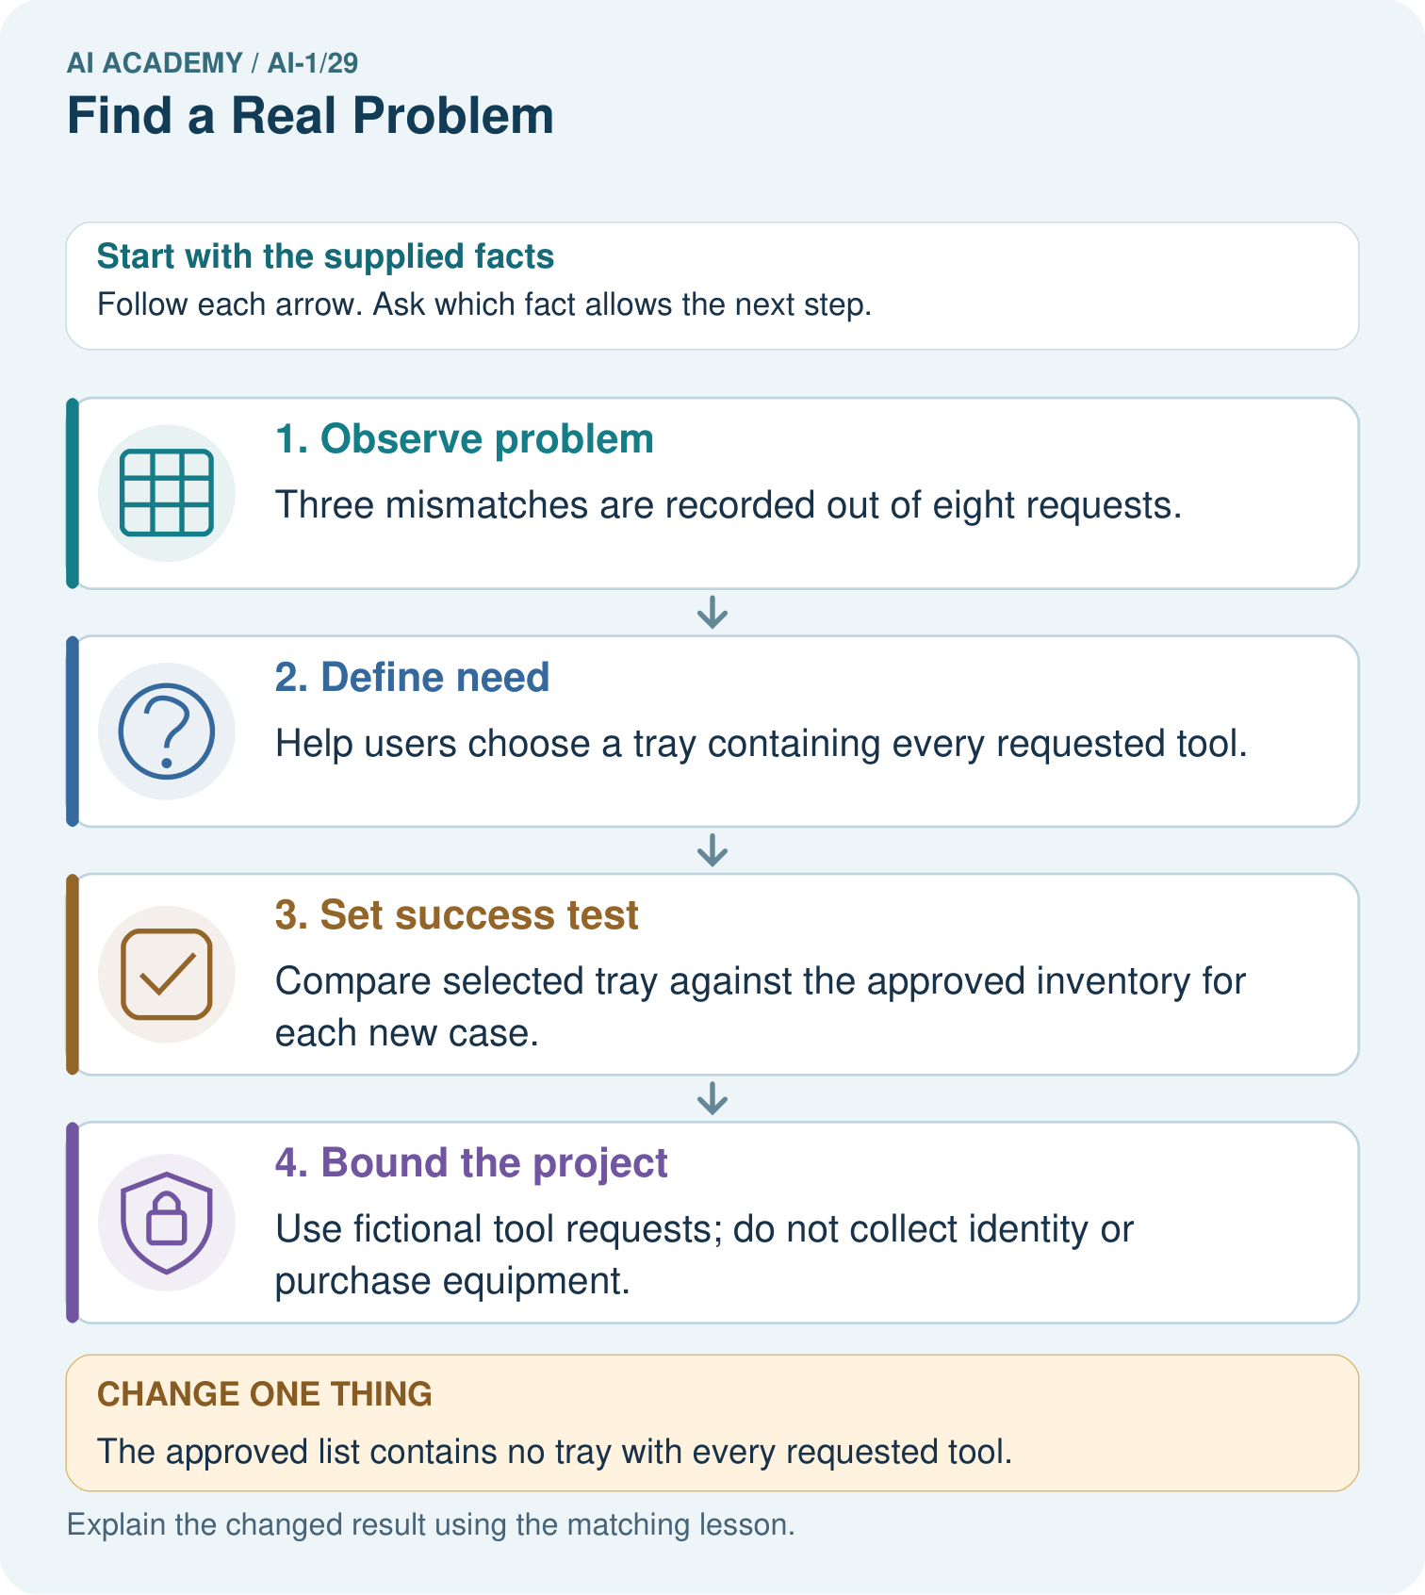
Write a one-sentence project goal and say what evidence would count as a failure.

My picture-based explanation and changed-case prediction
________________________________________________________________
________________________________________________________________
________________________________________________________________
________________________________________________________________
________________________________________________________________
________________________________________________________________
Support used: alone / hint / worked example. This record is practice evidence.
Project connection: For the Helpful Classroom Sorter, retain the problem record, permitted scope, baseline and observable acceptance criteria.

