AI ACADEMY · WORKBOOK · ai-1/30

Choose Inputs and Outputs
Project: Helpful Classroom Sorter

01. Recall and choose your starting point
Try the recall before opening notes. Then use a different colour or a labelled second line to correct your explanation.

Find a Real Problem
Without opening the old lesson, explain one key idea from Find a Real Problem. Give an example and a mistake that the idea helps you avoid.

My remembered idea, example and correction
________________________________________________________________
________________________________________________________________
________________________________________________________________

Verify Important Outputs
Without opening the old lesson, explain one key idea from Verify Important Outputs. Give an example and a mistake that the idea helps you avoid.

My remembered idea, example and correction
________________________________________________________________
________________________________________________________________
________________________________________________________________

Privacy by Choosing Less
Without opening the old lesson, explain one key idea from Privacy by Choosing Less. Give an example and a mistake that the idea helps you avoid.

My remembered idea, example and correction
________________________________________________________________
________________________________________________________________
________________________________________________________________

02. Practise with fading help
Use W2: Run the baseline on three requests for Requirements and a simple baseline. Record the answer once; the lesson and workbook refer to the same attempt.
Given inputs | Procedure I chose | Middle steps | Result and check

The step I completed without help, and the hint I needed
________________________________________________________________
________________________________________________________________
________________________________________________________________

03. Individual reasoning check
Use the worked case for Requirements and a simple baseline. Proposed explanation: “Quiet required No excludes quiet activities”. Decide whether this explanation is supported. Point to the step or supplied fact that decides; explain your repair if needed.

My explanation before partner discussion
________________________________________________________________
________________________________________________________________
________________________________________________________________
________________________________________________________________

04. Independent transfer case

Independent case: Build a baseline for a different catalogue
A paper room recommender uses R1 first, capacity 6, quiet Yes; then R2, capacity 10, quiet No. Valid requests give a whole group size from 1 to 12 and Quiet required Yes or No. A room fits when capacity is at least group size and the quiet condition is met; choose the first fitting room. Record outputs and reasons for 6 people Yes, 8 people No and 8 people Yes. Explain how a manual baseline can be compared fairly with a prototype. No real booking is allowed.

My independent explanation, trace and limits
________________________________________________________________
________________________________________________________________
________________________________________________________________
________________________________________________________________
________________________________________________________________
________________________________________________________________
________________________________________________________________
Attempt this case before feedback. Record any help. Earlier examples below are further practice; a case already practised with feedback cannot establish fresh transfer.

05. Your learning target
Design a paper/plastic sorter that receives an object description. Include a mixed paper-and-plastic cup. Specify inputs, outputs and the uncertain-case action. Is the owner's name useful?

06. Solve the given case
A sorter suggests paper or plastic trays using material observations.
Name an input, output and unnecessary input.
Show your trace, calculation or evidence

Write or draw your reasoning and evidence.
________________________________________________________________
________________________________________________________________
________________________________________________________________
________________________________________________________________
________________________________________________________________

07. Check a changed case
A paper sorter must suggest pencil tray or book shelf. Choose one needed input and state the output. What should happen if the picture is blocked?
My independent answer and reason

Write or draw your reasoning and evidence.
________________________________________________________________
________________________________________________________________
________________________________________________________________
________________________________________________________________
________________________________________________________________

Week 30 Test and reflect

08. Design a revealing test
Create a changed input, boundary case or missing-information case. Write the expected answer or safe response before testing.
Test record | My evidence
Changed input or condition
Expected answer or fallback
Observed result
Why the result occurred

09. Project checkpoint
Freeze the sorter's v1 input list, output contract, and not-sure behavior.
The project change and evidence I will keep

Write or draw your reasoning and evidence.
________________________________________________________________
________________________________________________________________
________________________________________________________________
________________________________________________________________
________________________________________________________________

10. Self check
I can explain the mechanism. I can show evidence. I can handle a changed case. I can name a limit. Mark each as not yet, with help or independently, and attach supporting work.
Teacher review ____________________ Next step ____________________

11. Transfer practice from the original programme
Design a paper/plastic sorter that receives an object description. Include a mixed paper-and-plastic cup. Specify inputs, outputs and the uncertain-case action. Is the owner's name useful?

My independently reasoned answer
________________________________________________________________
________________________________________________________________
________________________________________________________________
________________________________________________________________
________________________________________________________________
________________________________________________________________
________________________________________________________________
Record support used: none, hint or teacher explanation.

12. W1 Make a requirement checkable
Replace “suggest a good activity” with the time condition, quiet condition and tie rule used in this project. Explain why Quiet required No permits B1 as well as non-quiet activities when their times fit.

My reasoning and evidence
________________________________________________________________
________________________________________________________________
________________________________________________________________
________________________________________________________________
________________________________________________________________
________________________________________________________________

13. W2 Run the baseline on three requests
Using the catalogue, record the baseline output and reason for 10 minutes with quiet required, 8 minutes with quiet not required, and 7 minutes with quiet not required. Identify which no-match result is justified and why.

My reasoning and evidence
________________________________________________________________
________________________________________________________________
________________________________________________________________
________________________________________________________________
________________________________________________________________
________________________________________________________________

14. W3 Separate invalid input from no matching option
Compare a request with blank minutes and Quiet required Yes to a request with 0 minutes and Quiet required Yes. What should the baseline record for each? Explain why these are different outcomes even though neither produces an activity suggestion.

My reasoning and evidence
________________________________________________________________
________________________________________________________________
________________________________________________________________
________________________________________________________________
________________________________________________________________
________________________________________________________________

15. W4 Build a baseline for a different catalogue
A paper room recommender uses R1 first, capacity 6, quiet Yes; then R2, capacity 10, quiet No. Valid requests give a whole group size from 1 to 12 and Quiet required Yes or No. A room fits when capacity is at least group size and the quiet condition is met; choose the first fitting room. Record outputs and reasons for 6 people Yes, 8 people No and 8 people Yes. Explain how a manual baseline can be compared fairly with a prototype. No real booking is allowed.

My reasoning and evidence
________________________________________________________________
________________________________________________________________
________________________________________________________________
________________________________________________________________
________________________________________________________________
________________________________________________________________
________________________________________________________________
________________________________________________________________

16. W5 Challenge an unfair comparison
Team A tests a prototype on five easy requests and the manual baseline on five different requests, then reports only the prototype’s successful outputs. Identify two changes needed for a fair comparison. If both methods then meet all requirements, what can and cannot be concluded about compatibility?

My reasoning and evidence
________________________________________________________________
________________________________________________________________
________________________________________________________________
________________________________________________________________
________________________________________________________________
________________________________________________________________

17. Feedback, return check and learning record
Evidence | My record
Worked alone / hint / model
First step I repaired and why
New case checked later; date and result
What I can now explain without notes
One remaining question
Revisit this idea with your teacher after a delay. Familiarity is different from explaining and using it on a changed case.

18. Pictorial case practice: Choose Inputs and Outputs
A fictional classroom chooses a storage bin for model parts.
Catalogue order: B1 capacity 5, B2 capacity 9. Valid request is a whole part count 1–12.
Return first bin with capacity at least the count; none if neither fits; clarify invalid input.
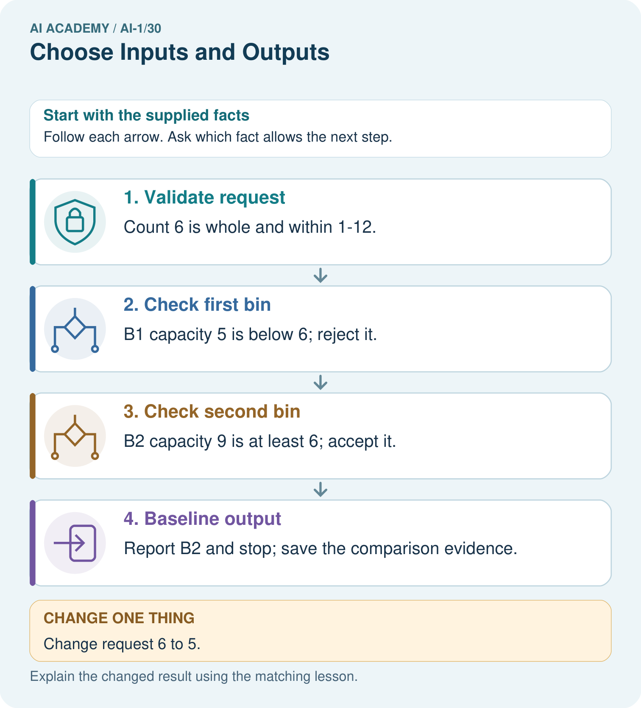
Trace requests 10 and blank. Why should they not receive the same explanation?

My picture-based explanation and changed-case prediction
________________________________________________________________
________________________________________________________________
________________________________________________________________
________________________________________________________________
________________________________________________________________
________________________________________________________________
Support used: alone / hint / worked example. This record is practice evidence.
Project connection: Document sorter schema, catalogue order, acceptance rule and all output types; use a manual trace as the comparison baseline.

