AI ACADEMY · WORKBOOK · ai-1/35

Improve One Cause
Project: Helpful Classroom Sorter

01. Recall and choose your starting point
Try the recall before opening notes. Then use a different colour or a labelled second line to correct your explanation.

Test Edge Cases and Fairness
Without opening the old lesson, explain one key idea from Test Edge Cases and Fairness. Give an example and a mistake that the idea helps you avoid.

My remembered idea, example and correction
________________________________________________________________
________________________________________________________________
________________________________________________________________

Build a Paper Prototype
Without opening the old lesson, explain one key idea from Build a Paper Prototype. Give an example and a mistake that the idea helps you avoid.

My remembered idea, example and correction
________________________________________________________________
________________________________________________________________
________________________________________________________________

Find a Real Problem
Without opening the old lesson, explain one key idea from Find a Real Problem. Give an example and a mistake that the idea helps you avoid.

My remembered idea, example and correction
________________________________________________________________
________________________________________________________________
________________________________________________________________

02. Practise with fading help
Use W2: Check the repair and earlier behaviour for Improving and checking regressions. Record the answer once; the lesson and workbook refer to the same attempt.
Given inputs | Procedure I chose | Middle steps | Result and check

The step I completed without help, and the hint I needed
________________________________________________________________
________________________________________________________________
________________________________________________________________

03. Individual reasoning check
Use the worked case for Improving and checking regressions. Proposed explanation: “One repaired example proves improvement everywhere”. Decide whether this explanation is supported. Point to the step or supplied fact that decides; explain your repair if needed.

My explanation before partner discussion
________________________________________________________________
________________________________________________________________
________________________________________________________________
________________________________________________________________

04. Independent transfer case

Independent case: Audit a different proposed repair
Equipment catalogue E lists E1 first with capacity 4 and E2 second with capacity 8. Valid whole group sizes are 1 to 10. Choose the first capacity at least the group size, or no match; invalid input needs clarification. Old U0 uses strictly greater capacity and stops at the first fit. Proposed U1 includes equality but keeps searching and returns the last fit. Independently compare U0, U1 and the requirement for groups 8 and 3. Identify the repair and regression, propose U2 and give one validation check. No booking occurs.

My independent explanation, trace and limits
________________________________________________________________
________________________________________________________________
________________________________________________________________
________________________________________________________________
________________________________________________________________
________________________________________________________________
________________________________________________________________
Attempt this case before feedback. Record any help. Earlier examples below are further practice; a case already practised with feedback cannot establish fresh transfer.

05. Your learning target
Version A makes four errors. Version B makes one after lighting, labels and rules all change. What can you conclude, and how would you isolate the effect of lighting?

06. Solve the given case
The team changes lighting, labels and rules together; errors fall from four to one.
Can it identify the cause of improvement?
Show your trace, calculation or evidence

Write or draw your reasoning and evidence.
________________________________________________________________
________________________________________________________________
________________________________________________________________
________________________________________________________________
________________________________________________________________

07. Check a changed case
Dim photos fail. You change the lighting and all decision rules together; performance improves. Can you tell which change helped? Design a clearer comparison.
My independent answer and reason

Write or draw your reasoning and evidence.
________________________________________________________________
________________________________________________________________
________________________________________________________________
________________________________________________________________
________________________________________________________________

Week 35 Test and reflect

08. Design a revealing test
Create a changed input, boundary case or missing-information case. Write the expected answer or safe response before testing.
Test record | My evidence
Changed input or condition
Expected answer or fallback
Observed result
Why the result occurred

09. Project checkpoint
Create sorter version 2 with one evidence-linked change and a before/after test table.
The project change and evidence I will keep

Write or draw your reasoning and evidence.
________________________________________________________________
________________________________________________________________
________________________________________________________________
________________________________________________________________
________________________________________________________________

10. Self check
I can explain the mechanism. I can show evidence. I can handle a changed case. I can name a limit. Mark each as not yet, with help or independently, and attach supporting work.
Teacher review ____________________ Next step ____________________

11. Transfer practice from the original programme
Version A makes four errors. Version B makes one after lighting, labels and rules all change. What can you conclude, and how would you isolate the effect of lighting?

My independently reasoned answer
________________________________________________________________
________________________________________________________________
________________________________________________________________
________________________________________________________________
________________________________________________________________
________________________________________________________________
________________________________________________________________
Record support used: none, hint or teacher explanation.

12. W1 Write the change record
Use S0’s failure on 10 Yes with catalogue B version 1. Record the expected and incorrect outputs, the faulty time comparison, the exact S1 correction and the other conditions that must remain. Explain what old evidence to preserve.

My reasoning and evidence
________________________________________________________________
________________________________________________________________
________________________________________________________________
________________________________________________________________
________________________________________________________________
________________________________________________________________

13. W2 Check the repair and earlier behaviour
Plan and operate the S1 repair and regression set described in the lesson, using the appropriate catalogue version for each case. Record expected and observed results separately with reasons and traces. Summarise full passes over all attempted cases, list unrun cases separately and identify any remaining failures. Do not replace observed mistakes with worked answers.

My reasoning and evidence
________________________________________________________________
________________________________________________________________
________________________________________________________________
________________________________________________________________
________________________________________________________________
________________________________________________________________

14. W3 Reject a repair that breaks quiet requests
T1 accepts equal times but omits the quiet check. Explain why it passes 10 Yes yet fails 9 Yes. Use S0’s earlier correct result for 9 Yes to justify the word regression. What should change in T1, and which two cases should be rerun first?

My reasoning and evidence
________________________________________________________________
________________________________________________________________
________________________________________________________________
________________________________________________________________
________________________________________________________________
________________________________________________________________

15. W4 Audit a different proposed repair
Equipment catalogue E lists E1 first with capacity 4 and E2 second with capacity 8. Valid whole group sizes are 1 to 10. Choose the first capacity at least the group size, or no match; invalid input needs clarification. Old U0 uses strictly greater capacity and stops at the first fit. Proposed U1 includes equality but keeps searching and returns the last fit. Independently compare U0, U1 and the requirement for groups 8 and 3. Identify the repair and regression, propose U2 and give one validation check. No booking occurs.

My reasoning and evidence
________________________________________________________________
________________________________________________________________
________________________________________________________________
________________________________________________________________
________________________________________________________________
________________________________________________________________
________________________________________________________________
________________________________________________________________

16. W5 Protect the meaning of final evaluation
After seeing a reserved final case fail, a team edits its candidate, reruns that same case and calls the result “a successful unseen test of the new version”. Explain what is wrong and what should be recorded instead. State what must be saved before an evaluation begins.

My reasoning and evidence
________________________________________________________________
________________________________________________________________
________________________________________________________________
________________________________________________________________
________________________________________________________________
________________________________________________________________

17. Feedback, return check and learning record
Evidence | My record
Worked alone / hint / model
First step I repaired and why
New case checked later; date and result
What I can now explain without notes
One remaining question
Revisit this idea with your teacher after a delay. Familiarity is different from explaining and using it on a changed case.

18. Pictorial case practice: Improve One Cause
A fictional quiet-activity chooser has a boundary bug and a proposed repair.
A: quiet Yes, 8 minutes; B: quiet No, 5 minutes. Request quiet required Yes.
U0 accepts only duration<available time. U1 fixes ≤ but accidentally removes the quiet requirement.
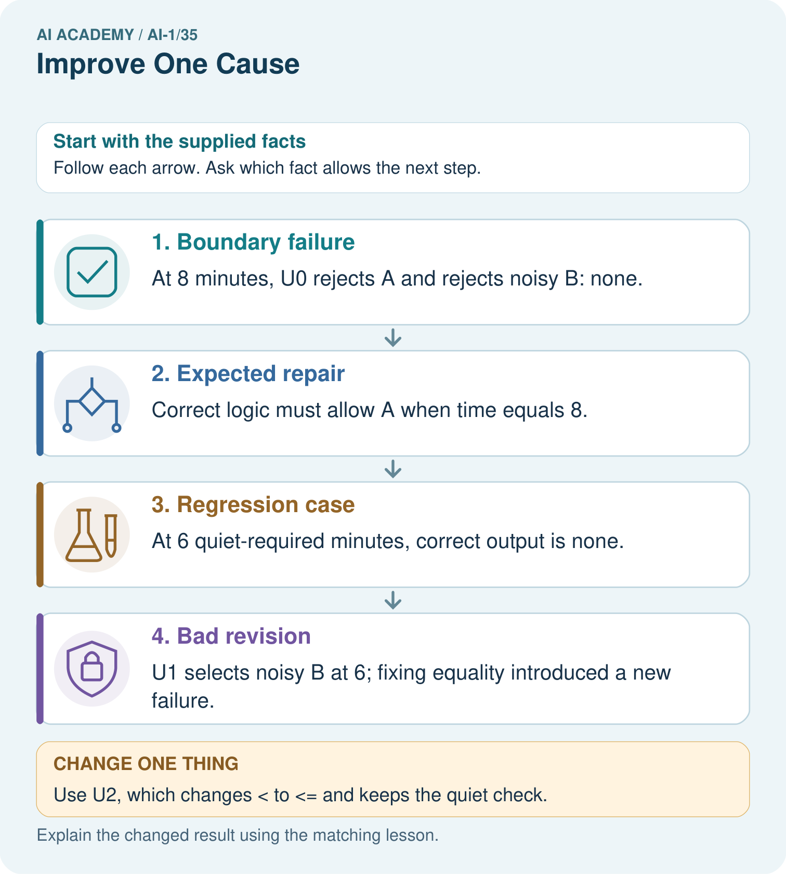
Explain why “our repaired version now picks something” is not enough to show success at 6.

My picture-based explanation and changed-case prediction
________________________________________________________________
________________________________________________________________
________________________________________________________________
________________________________________________________________
________________________________________________________________
________________________________________________________________
Support used: alone / hint / worked example. This record is practice evidence.
Project connection: Maintain sorter regression tests and compare complete version traces, retaining new failures rather than hiding them.

