AI ACADEMY · WORKBOOK · ai-2/5

Loops and Stopping
Project: Transparent Book Recommender

01. Recall and choose your starting point
Try the recall before opening notes. Then use a different colour or a labelled second line to correct your explanation.

Trace Tables
Without opening the old lesson, explain one key idea from Trace Tables. Give an example and a mistake that the idea helps you avoid.

My remembered idea, example and correction
________________________________________________________________
________________________________________________________________
________________________________________________________________

Decompose a Goal
Without opening the old lesson, explain one key idea from Decompose a Goal. Give an example and a mistake that the idea helps you avoid.

My remembered idea, example and correction
________________________________________________________________
________________________________________________________________
________________________________________________________________

02. Practise with fading help
Use W2: Trace before running for Loops and trace tables. Record the answer once; the lesson and workbook refer to the same attempt.
Given inputs | Procedure I chose | Middle steps | Result and check

The step I completed without help, and the hint I needed
________________________________________________________________
________________________________________________________________
________________________________________________________________

03. Individual reasoning check
Use the worked case for Loops and trace tables. Proposed explanation: “The stop value is included”. Decide whether this explanation is supported. Point to the step or supplied fact that decides; explain your repair if needed.

My explanation before partner discussion
________________________________________________________________
________________________________________________________________
________________________________________________________________
________________________________________________________________

04. Independent transfer case

Independent case: Changed independent case
Start count at 1. While count < 8, add 3. Trace the condition and values. What happens if the condition becomes count != 8?

My independent explanation, trace and limits
________________________________________________________________
________________________________________________________________
________________________________________________________________
________________________________________________________________
________________________________________________________________
________________________________________________________________
________________________________________________________________
Attempt this case before feedback. Record any help. Earlier examples below are further practice; a case already practised with feedback cannot establish fresh transfer.

05. Your learning target
Trace count=0; while count<4: count=count+2. List values tested by the condition and final count. Would replacing <4 with !=5 terminate?

06. Solve the given case
Start n=0; while n<3, add 1 and record n.
List records and stopping condition.
Show your trace, calculation or evidence

Write or draw your reasoning and evidence.
________________________________________________________________
________________________________________________________________
________________________________________________________________
________________________________________________________________
________________________________________________________________

07. Check a changed case
Start at count 0. While count is less than 3, add 1 and display count. List the displays and the stopping value.
My independent answer and reason

Write or draw your reasoning and evidence.
________________________________________________________________
________________________________________________________________
________________________________________________________________
________________________________________________________________
________________________________________________________________

Week 5 Test and reflect

08. Design a revealing test
Create a changed input, boundary case or missing-information case. Write the expected answer or safe response before testing.
Test record | My evidence
Changed input or condition
Expected answer or fallback
Observed result
Why the result occurred

09. Project checkpoint
Loop through every candidate book, update its score, then stop at the end of the list.
The project change and evidence I will keep

Write or draw your reasoning and evidence.
________________________________________________________________
________________________________________________________________
________________________________________________________________
________________________________________________________________
________________________________________________________________

10. Self check
I can explain the mechanism. I can show evidence. I can handle a changed case. I can name a limit. Mark each as not yet, with help or independently, and attach supporting work.
Teacher review ____________________ Next step ____________________

11. Transfer practice from the original programme
Trace count=0; while count<4: count=count+2. List values tested by the condition and final count. Would replacing <4 with !=5 terminate?

My independently reasoned answer
________________________________________________________________
________________________________________________________________
________________________________________________________________
________________________________________________________________
________________________________________________________________
________________________________________________________________
________________________________________________________________
Record support used: none, hint or teacher explanation.

12. W1 Explain the range
List the values supplied by range(2, 5) and explain why 5 is absent. How many times does its body run?

My reasoning and evidence
________________________________________________________________
________________________________________________________________
________________________________________________________________
________________________________________________________________
________________________________________________________________
________________________________________________________________

13. W2 Trace before running
Copy the worked script. Change the range to range(2, 5). Record turn, total before and total after each iteration. Predict the single output, then run and compare.

My reasoning and evidence
________________________________________________________________
________________________________________________________________
________________________________________________________________
________________________________________________________________
________________________________________________________________
________________________________________________________________

14. W3 Repair the reset
For the faulty script with range(1, 4), record total after each addition. Explain the wrong final output and remove only the faulty reset.

My reasoning and evidence
________________________________________________________________
________________________________________________________________
________________________________________________________________
________________________________________________________________
________________________________________________________________
________________________________________________________________

15. W4 Build a repeated addition independently
A box starts with 5 counters. Each round adds 2 counters. Use rounds = 3, an initialized total and for turn in range(rounds). Print the final total once after the loop. Trace the totals and predict fresh runs with rounds 0, 1 and 3. Assume rounds is a nonnegative integer.

My reasoning and evidence
________________________________________________________________
________________________________________________________________
________________________________________________________________
________________________________________________________________
________________________________________________________________
________________________________________________________________
________________________________________________________________
________________________________________________________________

16. W5 Check a contract limitation
In your counter script, range(-2) performs no iterations. Does returning the initial 5 make negative rounds valid? Explain what the script checks and what it assumes.

My reasoning and evidence
________________________________________________________________
________________________________________________________________
________________________________________________________________
________________________________________________________________
________________________________________________________________
________________________________________________________________

17. Feedback, return check and learning record
Evidence | My record
Worked alone / hint / model
First step I repaired and why
New case checked later; date and result
What I can now explain without notes
One remaining question
Revisit this idea with your teacher after a delay. Familiarity is different from explaining and using it on a changed case.

18. Pictorial case practice: Loops and Stopping
A fictional counter starts at 12 and decreases while above a boundary.
Python: count=12; while count>3: count=count-4; print after the loop.
The condition is checked before each subtraction.
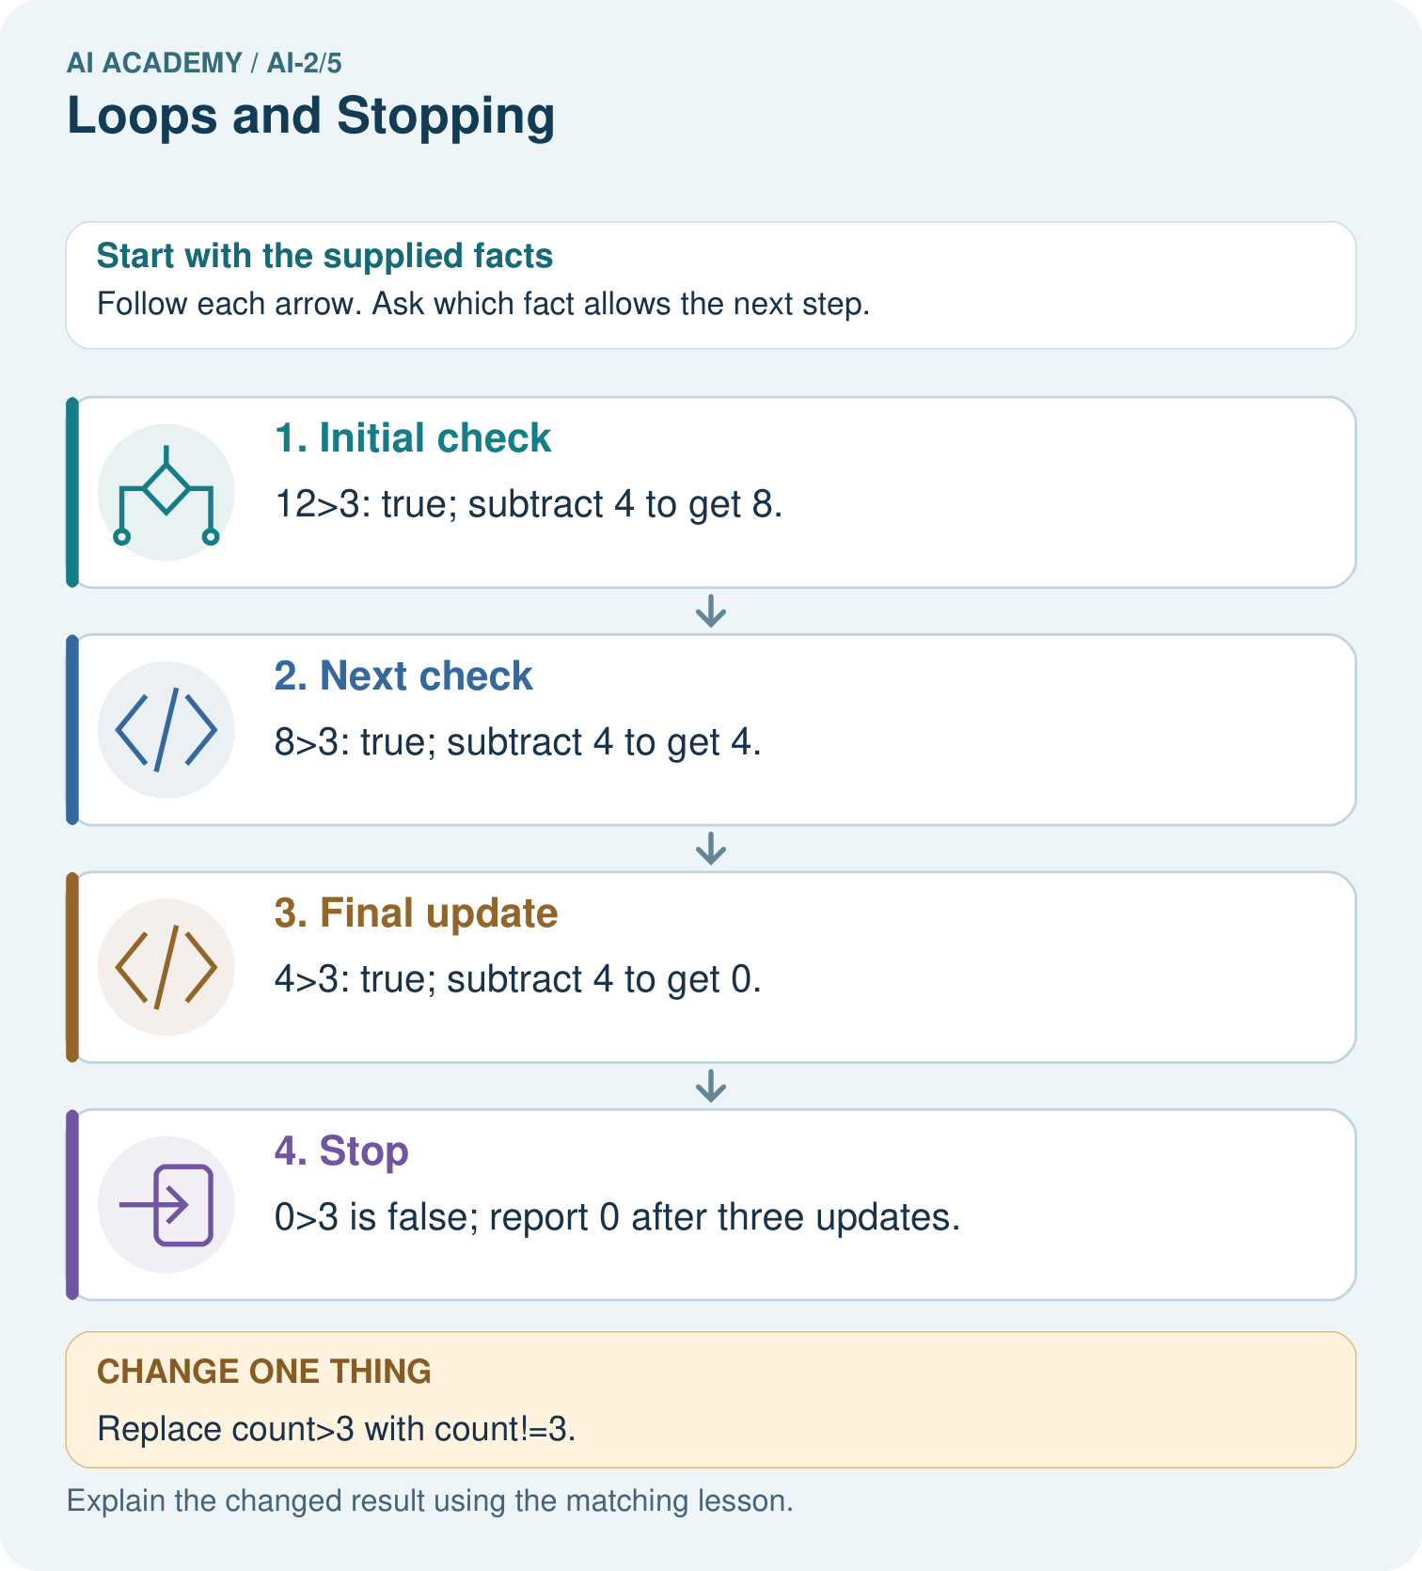
Why is report 0 correct for the original loop, and why is equality-only stopping risky here?

My picture-based explanation and changed-case prediction
________________________________________________________________
________________________________________________________________
________________________________________________________________
________________________________________________________________
________________________________________________________________
________________________________________________________________
Support used: alone / hint / worked example. This record is practice evidence.
Project connection: Use progress and stopping arguments for any repeated recommender process; test inputs that require zero, one and several updates.

