AI ACADEMY · WORKBOOK · ai-2/9

Features and Distractors
Project: Transparent Book Recommender

01. Recall and choose your starting point
Try the recall before opening notes. Then use a different colour or a labelled second line to correct your explanation.

Operational Labels
Without opening the old lesson, explain one key idea from Operational Labels. Give an example and a mistake that the idea helps you avoid.

My remembered idea, example and correction
________________________________________________________________
________________________________________________________________
________________________________________________________________

Debugging Strategies
Without opening the old lesson, explain one key idea from Debugging Strategies. Give an example and a mistake that the idea helps you avoid.

My remembered idea, example and correction
________________________________________________________________
________________________________________________________________
________________________________________________________________

Branching Logic
Without opening the old lesson, explain one key idea from Branching Logic. Give an example and a mistake that the idea helps you avoid.

My remembered idea, example and correction
________________________________________________________________
________________________________________________________________
________________________________________________________________

02. Practise with fading help
Use W2: Prove that one measurement is insufficient for Features and useful distinctions. Record the answer once; the lesson and workbook refer to the same attempt.
Given inputs | Procedure I chose | Middle steps | Result and check

The step I completed without help, and the hint I needed
________________________________________________________________
________________________________________________________________
________________________________________________________________

03. Individual reasoning check
Use the worked case for Features and useful distinctions. Proposed explanation: “A stronger model can always recover an omitted measurement”. Decide whether this explanation is supported. Point to the step or supplied fact that decides; explain your repair if needed.

My explanation before partner discussion
________________________________________________________________
________________________________________________________________
________________________________________________________________
________________________________________________________________

04. Independent transfer case

Independent case: Changed independent case
Training covers show space books only on yellow backgrounds and animal books only on blue backgrounds. Design two controlled comparisons to test whether a classifier uses the intended subject.

My independent explanation, trace and limits
________________________________________________________________
________________________________________________________________
________________________________________________________________
________________________________________________________________
________________________________________________________________
________________________________________________________________
________________________________________________________________
Attempt this case before feedback. Record any help. Earlier examples below are further practice; a case already practised with feedback cannot establish fresh transfer.

05. Your learning target
All animal books in training have green covers. How could you test whether a recommender is using subject or cover colour? Supply two diagnostic test descriptions.

06. Solve the given case
Target: includes animal characters. Fields: animal tag, cover colour and shelf number.
Choose useful evidence and possible distractions.
Show your trace, calculation or evidence

Write or draw your reasoning and evidence.
________________________________________________________________
________________________________________________________________
________________________________________________________________
________________________________________________________________
________________________________________________________________

07. Check a changed case
Predict whether a book is short using page count and cover colour. Which feature directly supports the defined label? Give a counterexample to colour.
My independent answer and reason

Write or draw your reasoning and evidence.
________________________________________________________________
________________________________________________________________
________________________________________________________________
________________________________________________________________
________________________________________________________________

Week 9 Test and reflect

08. Design a revealing test
Create a changed input, boundary case or missing-information case. Write the expected answer or safe response before testing.
Test record | My evidence
Changed input or condition
Expected answer or fallback
Observed result
Why the result occurred

09. Project checkpoint
Use explainable traits that connect to the reader’s stated preferences.
The project change and evidence I will keep

Write or draw your reasoning and evidence.
________________________________________________________________
________________________________________________________________
________________________________________________________________
________________________________________________________________
________________________________________________________________

10. Self check
I can explain the mechanism. I can show evidence. I can handle a changed case. I can name a limit. Mark each as not yet, with help or independently, and attach supporting work.
Teacher review ____________________ Next step ____________________

11. Transfer practice from the original programme
All animal books in training have green covers. How could you test whether a recommender is using subject or cover colour? Supply two diagnostic test descriptions.

My independently reasoned answer
________________________________________________________________
________________________________________________________________
________________________________________________________________
________________________________________________________________
________________________________________________________________
________________________________________________________________
________________________________________________________________
Record support used: none, hint or teacher explanation.

12. W1 Separate inputs from the target
For the fixed-orientation card task, fits requires length at most 12 cm and width at most 8 cm, including equality. Choose the measurements needed as inputs from length, width, colour, card number and the final inspection sticker. State the target label and write the feature record for a 12 cm by 8 cm red card using a defined order.

My reasoning and evidence
________________________________________________________________
________________________________________________________________
________________________________________________________________
________________________________________________________________
________________________________________________________________
________________________________________________________________

13. W2 Prove that one measurement is insufficient
Invent two cards with the same width but different correct labels under the card guide. Give both lengths and widths and justify the labels. Explain why a system receiving only width cannot always label both correctly.

My reasoning and evidence
________________________________________________________________
________________________________________________________________
________________________________________________________________
________________________________________________________________
________________________________________________________________
________________________________________________________________
________________________________________________________________

14. W3 Challenge an apparent colour shortcut
A practice set contains three blue cards that fit and three red cards that are too large. A helper uses blue means fits and red means too large. Create a new card that this helper mislabels. Explain why the perfect practice score did not establish that colour was a reliable feature for this task.

My reasoning and evidence
________________________________________________________________
________________________________________________________________
________________________________________________________________
________________________________________________________________
________________________________________________________________
________________________________________________________________

15. W4 Design a record for a new task
A fictional display tray accepts a tile if its height is at most 9 cm and its thickness is at most 2 cm, including equality. Other dimensions are fixed. Before checking, you can record height, thickness and pattern name. A pass sticker is added afterward. Choose inputs with units. Construct two tiles with the same height but different labels. Then label a 9 cm high, 2 cm thick striped tile and explain why the sticker is unsuitable as an input before checking.

My reasoning and evidence
________________________________________________________________
________________________________________________________________
________________________________________________________________
________________________________________________________________
________________________________________________________________
________________________________________________________________
________________________________________________________________
________________________________________________________________

16. W5 Notice when the task changes
The delivery station now sorts cards into red and blue bins instead of checking dimensions. Which previously unneeded feature becomes useful? Explain why length and width alone may now be insufficient. Give two cards that support your explanation.

My reasoning and evidence
________________________________________________________________
________________________________________________________________
________________________________________________________________
________________________________________________________________
________________________________________________________________
________________________________________________________________

17. Feedback, return check and learning record
Evidence | My record
Worked alone / hint / model
First step I repaired and why
New case checked later; date and result
What I can now explain without notes
One remaining question
Revisit this idea with your teacher after a delay. Familiarity is different from explaining and using it on a changed case.

18. Pictorial case practice: Features and Distractors
A fictional book-topic classifier sees mystery books with triangular logos and science books with circular logos.
Training contains no mystery-circle or science-triangle covers.
Goal is to identify topic from actual subject information, not publisher logo. New controlled test outputs have not been supplied.
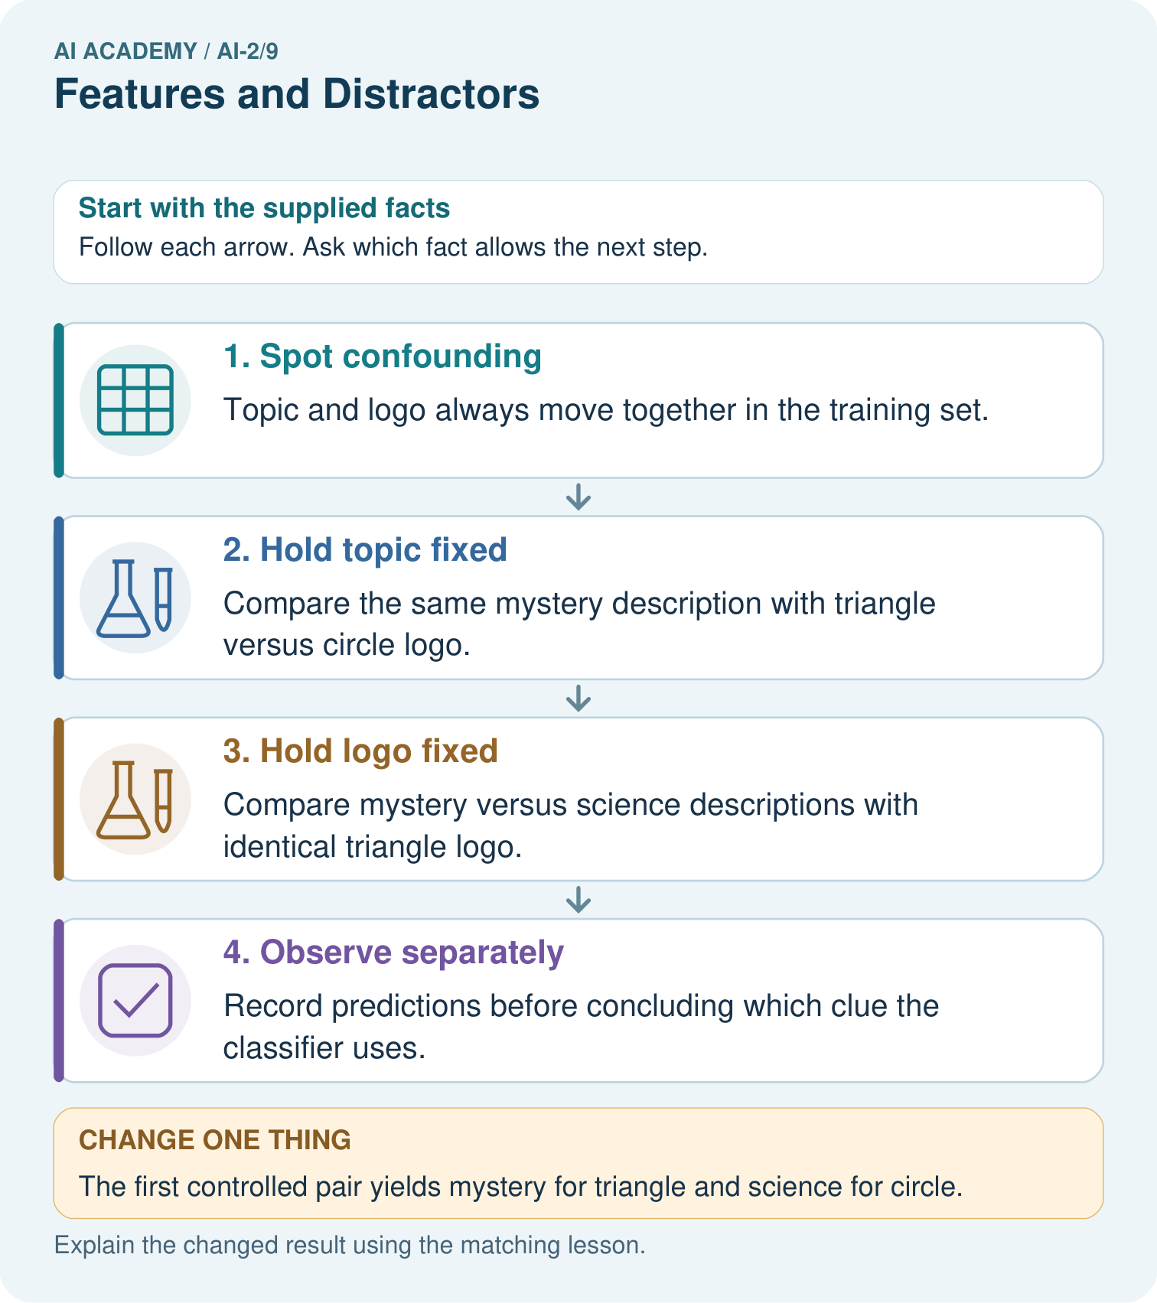
Does this one pair prove the classifier always ignores subject? Explain a narrower claim.

My picture-based explanation and changed-case prediction
________________________________________________________________
________________________________________________________________
________________________________________________________________
________________________________________________________________
________________________________________________________________
________________________________________________________________
Support used: alone / hint / worked example. This record is practice evidence.
Project connection: Test recommender features for shortcuts, keeping relevant subject information separate from superficial catalogue styling.

